Tab 1
9996 Shardul Sant

Client.c

#include<stdio.h>
#include<rpc/rpc.h>
#include "rpcint.h"

int *func_1_svc(int *a, struct svc_req *x) {
static int b; // Static so it persists across calls
b = (*a) * (*a); // Calculate square of input
return &b; // Return pointer to static variable
}

Server.c

#include<stdio.h>
#include<rpc/rpc.h>
#include "rpcint.h"

int main() {
CLIENT *c1;
int n, *result;

c1 = clnt_create("127.0.0.1", PROGRAM, VERSION, "udp");
if (c1 == NULL) {
clnt_pcreateerror("Error creating RPC client");
return 1;
}

printf("Enter a number: ");
scanf("%d", &n);

result = func_1(&n, c1);
if (result == NULL) {
clnt_perror(c1, "RPC call failed");
return 1;
}

printf("Result is: %d\n", *result);

clnt_destroy(c1);
return 0;
}
Rpcint.x

program PROGRAM
{
version VERSION
{
int func(int)=1;
}=1;
}=0x200002;

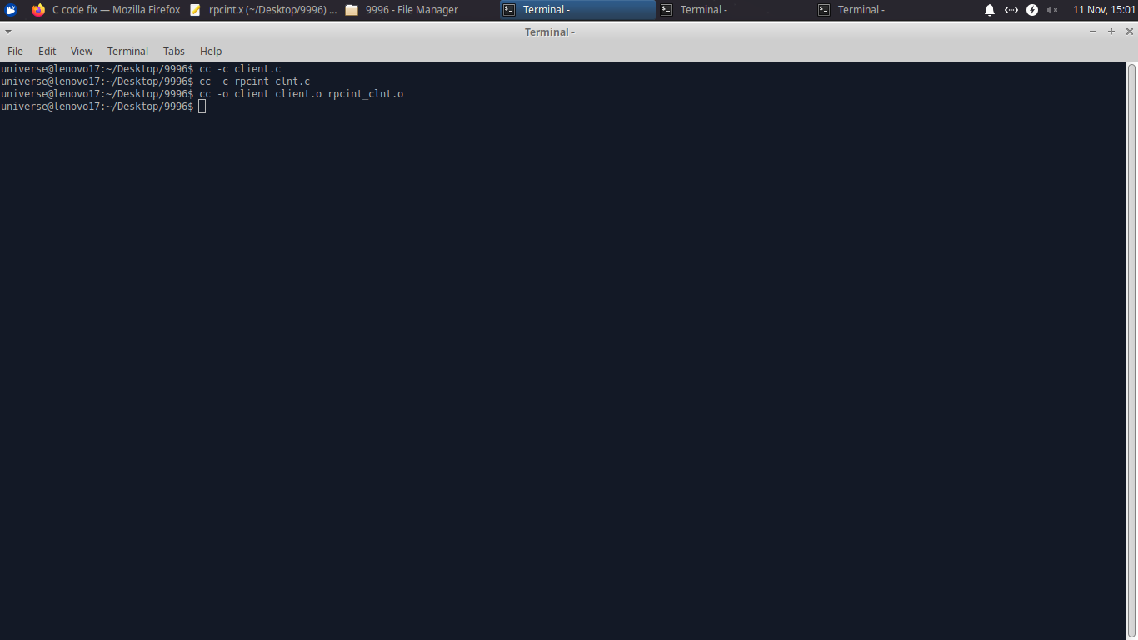
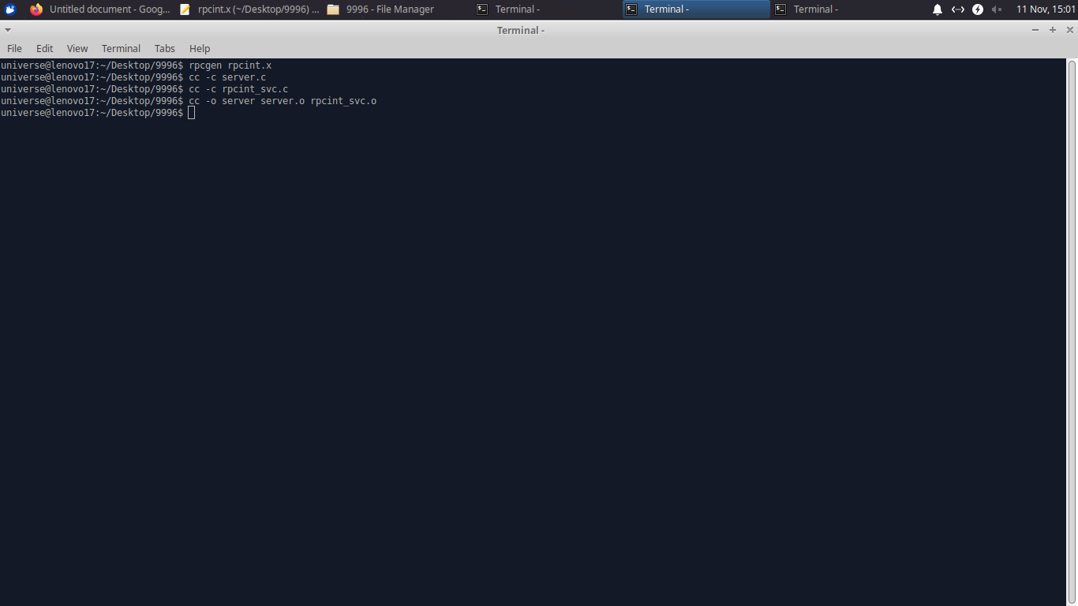

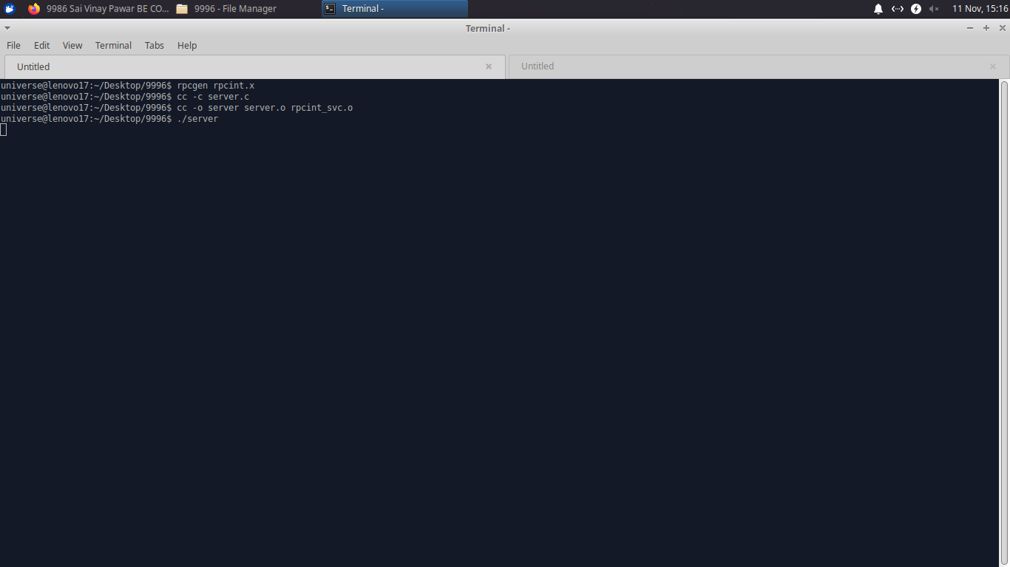
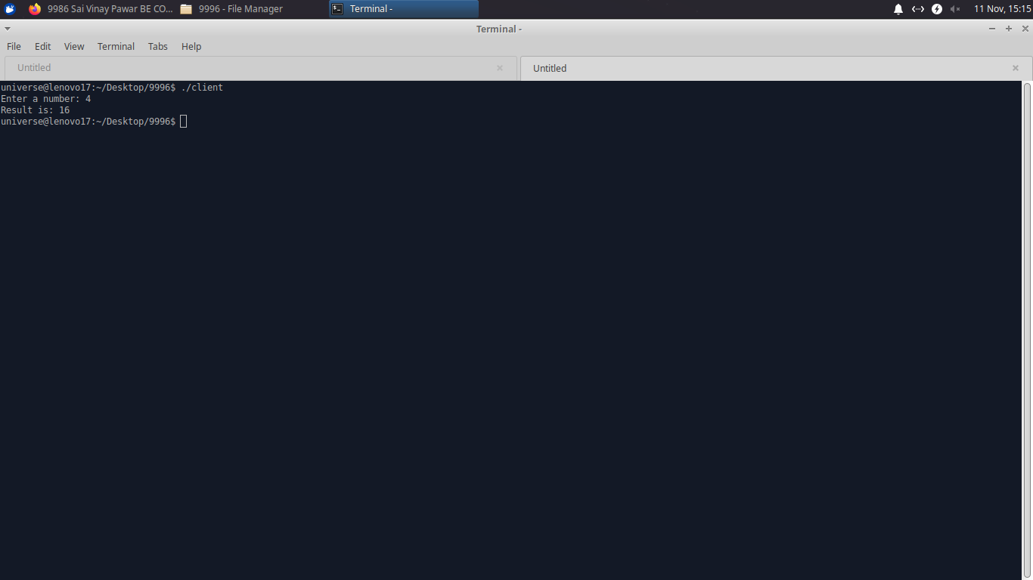

Tab 2
9964 Anish Ashish Godse BE COMPS B

Client.c

#include<stdio.h>
#include<rpc/rpc.h>
#include "rpcint.h"

int *func_1_svc(int *a, struct svc_req *x) {
static int b; // Static so it persists across calls
b = (*a) * (*a); // Calculate square of input
return &b; // Return pointer to static variable
}

Server.c

#include<stdio.h>
#include<rpc/rpc.h>
#include "rpcint.h"

int main() {
CLIENT *c1;
int n, *result;

c1 = clnt_create("127.0.0.1", PROGRAM, VERSION, "udp");
if (c1 == NULL) {
clnt_pcreateerror("Error creating RPC client");
return 1;
}

printf("Enter a number: ");
scanf("%d", &n);

result = func_1(&n, c1);
if (result == NULL) {
clnt_perror(c1, "RPC call failed");
return 1;
}

printf("Result is: %d\n", *result);

clnt_destroy(c1);
return 0;
}
Rpcint.x

program PROGRAM
{
version VERSION
{
int func(int)=1;
}=1;
}=0x200002;

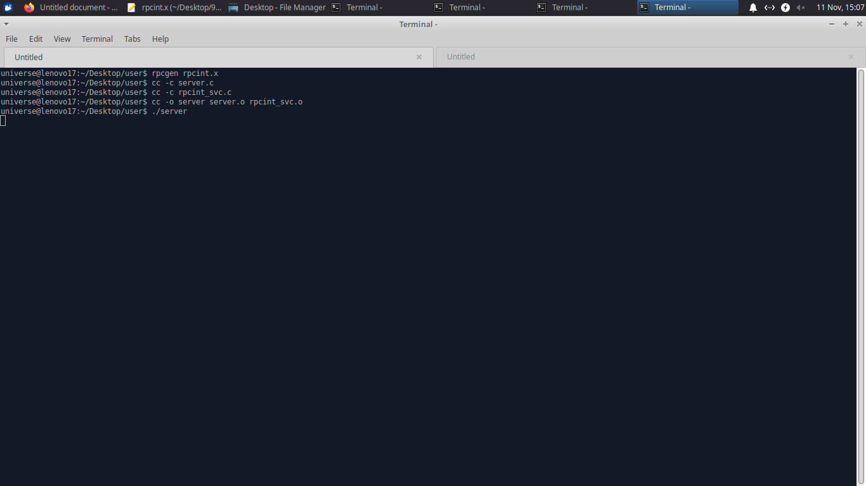

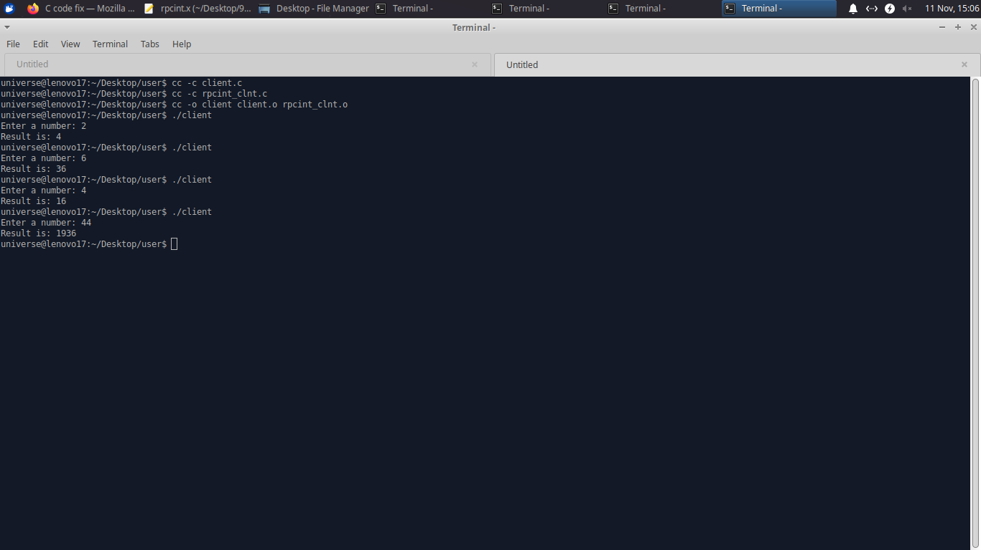

Tab 3

Client.c

#include<stdio.h>
#include<rpc/rpc.h>
#include "rpcint.h"

int *func_1_svc(int *a, struct svc_req *x) {
static int b; // Static so it persists across calls
b = (*a) * (*a); // Calculate square of input
return &b; // Return pointer to static variable
}

Server.c

#include<stdio.h>
#include<rpc/rpc.h>
#include "rpcint.h"

int main() {
CLIENT *c1;
int n, *result;

c1 = clnt_create("127.0.0.1", PROGRAM, VERSION, "udp");
if (c1 == NULL) {
clnt_pcreateerror("Error creating RPC client");
return 1;
}

printf("Enter a number: ");
scanf("%d", &n);

result = func_1(&n, c1);
if (result == NULL) {
clnt_perror(c1, "RPC call failed");
return 1;
}

printf("Result is: %d\n", *result);

clnt_destroy(c1);
return 0;
}
Rpcint.x

program PROGRAM
{
version VERSION
{
int func(int)=1;
}=1;
}=0x200002;





