FR. CONCEICAO RODRIGUES COLLEGE OF ENGINEERING
Department of Computer Engineering
Academic Year 2025-26

Rubrics for Lab Experiments

Class | : B.E. Computer  Engineering | Subject Name :BDA Lab
Semester | : VII | Subject Code :CSL702

Practical No: | 3
Title: | Write a program in python to implement Word Count using MapReduce
Date of Performance: | 23-7-25
Roll No: | 9913
Name of the Student: | Mark Lopes
Evaluation:

Performance Indicator | Below average | Average | Good | Excellent | Marks
On time Submission (2) | Not  submitted (0) | Submitted after  deadline (1) | Early or on time submission(2) | ---
Test cases and output  (4) | Incorr ect output (1) | The expected output is verified only a for  few test cases (2) | The expected output is Verified for all test cases but is not presentable (3) | Expected output is obtained for all test cases. Presentable and easy to follow (4)
Coding efficiency (2) | The code is not structured at all (0) | The code is structured but not efficient (1) | The code is Structured and efficient. (2) | -
Knowledge(2) | Basic concepts not clear  (0) | Understood the basic concepts  (1) | Could explain the concept with  suitable example (1.5) | Could relate the theory with real world application(2)
Total

Signature of the Teacher:

Aim:Write a program in python to implement Word Count using MapReduce

Objective:
- Understand WordCountAggregationAlgorithm
- Use MapReduce framework for WordCount
- Write python program to find WordCount

Input:
Subject name is Big data analytics. Big data analytics Subject is in final year.

Output:
Subject 2
name 1
is 2
Big 2
data 2
analytics 2
in 1
final 1
year 1

Result: Implementation of the solution for above problem and attach input, program, intermediate and output files.



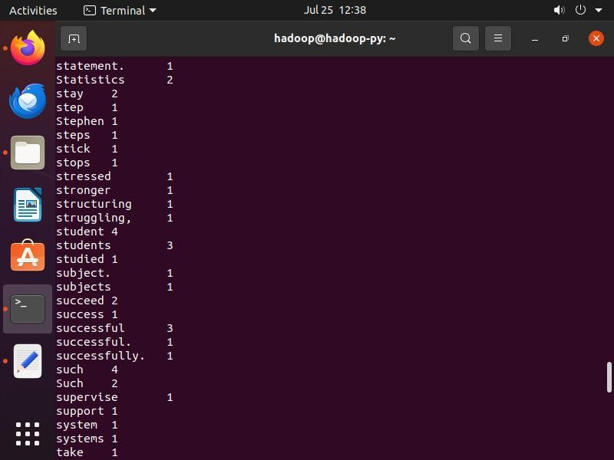
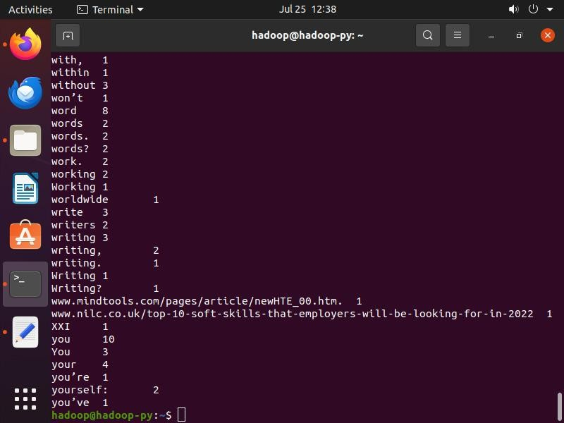

Mapper.py
import sys
for line in sys.stdin:
# to remove leading and trailing whitespace line = line.strip()
# split the line into words words = line.split()

for word in words:
print('%s\t%s' % (word, 1))

Reducer.py
from operator import itemgetter import sys

current_word = None current_count = 0
word = None

for line in sys.stdin:
line = line.strip()
word, count = line.split('\t', 1)
try:
count = int(count) except ValueError:
continue

if current_word == word: current_count += count
else:
if current_word:
print('%s\t%s' % (current_word, current_count)) current_count = count

current_word = word

if current_word == word:
print('%s\t%s' % (current_word, current_count))

