FR. CONCEICAO RODRIGUES COLLEGE OF ENGINEERING
Department of Computer Engineering
Academic Year 2025-26

Rubrics for Lab Experiments

Class | : B.E. Computer  Engineering | Subject Name :BDA Lab
Semester | : VII | Subject Code :CSL702

Practical No: | 5
Title: | Write a command to perform insert, create,  update and delete Cassandra
Date of Performance: | 05-08-2025
Roll No: | 9913
Name of the Student: | Mark Lopes
Evaluation:

Performance Indicator | Below average | Average | Good | Excellent | Marks
On time Submission (2) | Not submitted  (0) | Submitted after  deadline (1) | Early or on time submission(2) | ---
Test cases and output  (4) | Incorr ect output (1) | The expected output is verified only a for  few test cases (2) | The expected output is Verified for all test cases but is not presentable (3) | Expected output is obtained for all test cases. Presentable and easy to follow (4)
Coding efficiency (2) | The code is not structured at all (0) | The code is structured but not efficient (1) | The code is Structured and efficient. (2) | -
Knowledge(2) | Basic concepts not clear  (0) | Understood the basic concepts  (1) | Could explain the concept with  suitable example (1.5) | Could relate the theory with real world application(2)
Total

Signature of the Teacher:

Experiment No 5

Aim: Write a program to insert, search, update, delete and aggregate data using MongoDB
NoSQL Database

Objective:
- Understand NoSQL databases architecture
- Understand commands to insert document using MongoDB
- Understand commands to search document using MongoDB
- Understand commands to update document using MongoDB
- Understand commands to delete document using MongoDB
- Understand commands to implement aggregates using MongoDB

Input&amp; Output:
Commands to install mongodb
$Ps –ef|grep mongo
$Sudo apt-get update
$Sudo apt-get install mongodb
$Sudo service mongod start
$mongoimport –db test –collection restaurants --drop --file
/home/fcrit/Desktop/primer- dataset.json
Commands to create documents using mongodb
$mongo
&gt;show db
&gt;show collections &gt; use test
&gt;db.restaurants.insert() db.restaurants.insert(
{
&quot;address&quot;: {
&quot;street&quot;:&quot;2 Avenue&quot;,

&quot;zipcode&quot;:&quot;10075&quot;, &quot;building&quot;:&quot;1480&quot;, &quot;coord&quot;: [ -73.9557413, 40.7720266 ],
},
&quot;borough&quot;:&quot;Manhattan&quot;, &quot;cuisine&quot;:&quot;Italian&quot;,

&quot;grades&quot;: [
{
&quot;date&quot;:ISODate(&quot;2014-10-01T00:00:00Z&quot;), &quot;grade&quot;:&quot;A&quot;,
&quot;score&quot;:11
},
{
&quot;date&quot;:ISODate(&quot;2014-01-16T00:00:00Z&quot;), &quot;grade&quot;:&quot;B&quot;,
&quot;score&quot;:17
}
],
&quot;name&quot;:&quot;Vella&quot;, &quot;restaurant_id&quot;:&quot;41704620&quot;
}
)
&gt;db.restaurants.find()
{&lt;field1&gt;:&lt;value1&gt;,&lt;field2&gt;:&lt;value2&gt;,...} db.restaurants.find({&quot;borough&quot;:&quot;Manhattan&quot;}) db.restaurants.find({&quot;grades.score&quot;:{$gt:30}}) db.restaurants.find({&quot;grades.score&quot;:{$lt:10}})
Logical AND db.restaurants.find({&quot;cuisine&quot;:&quot;Italian&quot;,&quot;address
.zipcode&quot;:&quot;10 075&quot;})
Logical OR db.restaurants.find(
{$or:[{&quot;cuisine&quot;:&quot;Italian&quot;},{&quot;address.zipcode&qu ot;:&quot;10075&quot;}]}
)

Sort query result db.restaurants.find().sort({&quot;borough&quot;:1,&quot;address.zipcode&q uot;:1})
&gt;db.restaurants.update() db.restaurants.update(
{&quot;name&quot;:&quot;Juni&quot;},
{
$set:{&quot;cuisine&quot;:&quot;American (New)&quot;}
}
)
Multiple documents

db.restaurants.update(
{&quot;address.zipcode&quot;:&quot;10016&quot;,cuisine:&quot;Other&quo t;},
{
$set:{cuisine:&quot;Category To Be Determined&quot;},
$currentDate:{&quot;lastModified&quot;:true}
},
{multi:true}
)
&gt;db.restaurants.remove()
db.restaurants.remove({&quot;borough&quot;:&quot;Manhattan&quot;}) db.restaurants.remove({&quot;borough&quot;:&quot;Queens&quot;},{justOn e:true})
db.restaurants.remove({}) Drop table db.restaurants.drop()
Result: Implementation of the solution for above problem and attach commands with output

Experiment No 5
Aim: Write a command to perform insert, create, update and delete Cassandra (NoSQL)
database
- Understand NoSQL databases architecture
- Understand commands to create database using cassendra
- Understand commands to insaert data using cassendra
- Understand commands to update data using cassendra
- Understand commands to delete data using cassendra Steps for creating database:
Using Docker run Cassandra commands:
Commands for simple database creation:
- Sudo apt install docker.io
- sudo docker pull Cassandra:latest
- sudo docker run –d – name cassandra-node –p 9042:9042 cassandra (note: 9042 port reserverd for Cassandra)
- sudo docker exec –it cassandra-node bash
- cqlsh (note: cqlsh-&amp;gt;Cassandra query language shell)
- create keyspace test with replication={‘class’: ‘SimpleStrategy’,

‘replication_factor’:1};
(note:keyspace means database,here name of database is test)
- use test;
- create table student(s_id int primary key,s_name text,s_city text);
- insert into student(s_id,s_name,s_city)values(1,’ABCD’,’Mumbai’);
- insert into student(s_id,s_name,s_city)values(2,’PQRS’,’Pune’);
- select * from student;

Result: Implementation of the solution for above problem and attach commands with output
Conclusion:

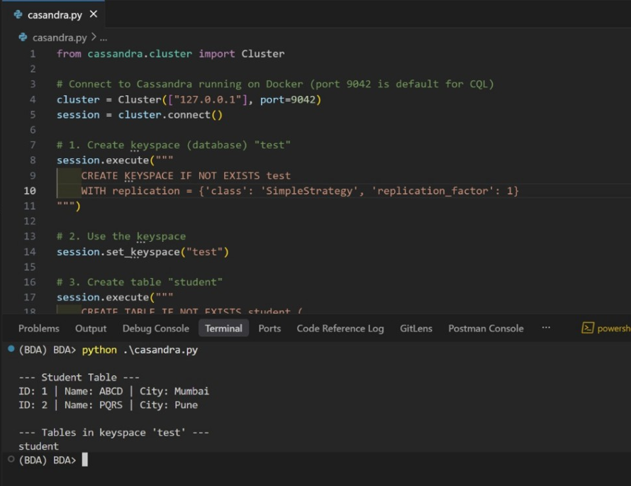

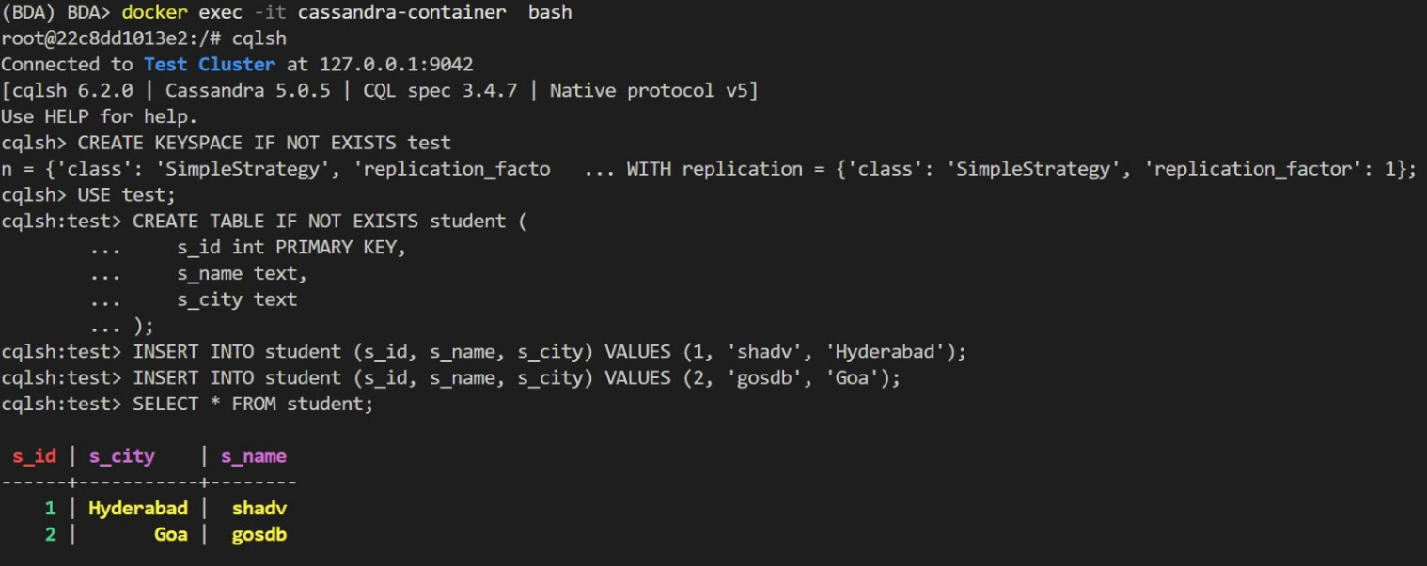

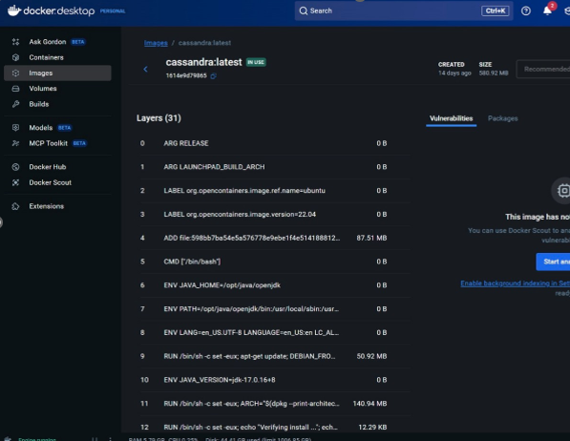
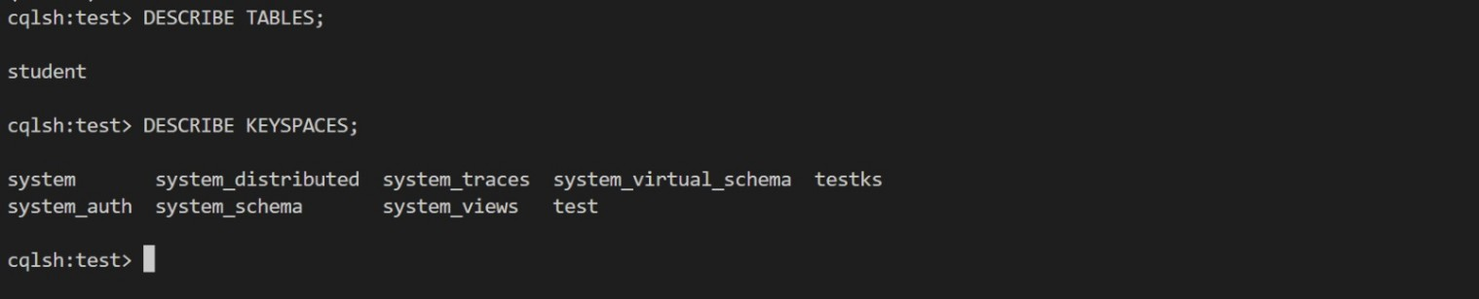

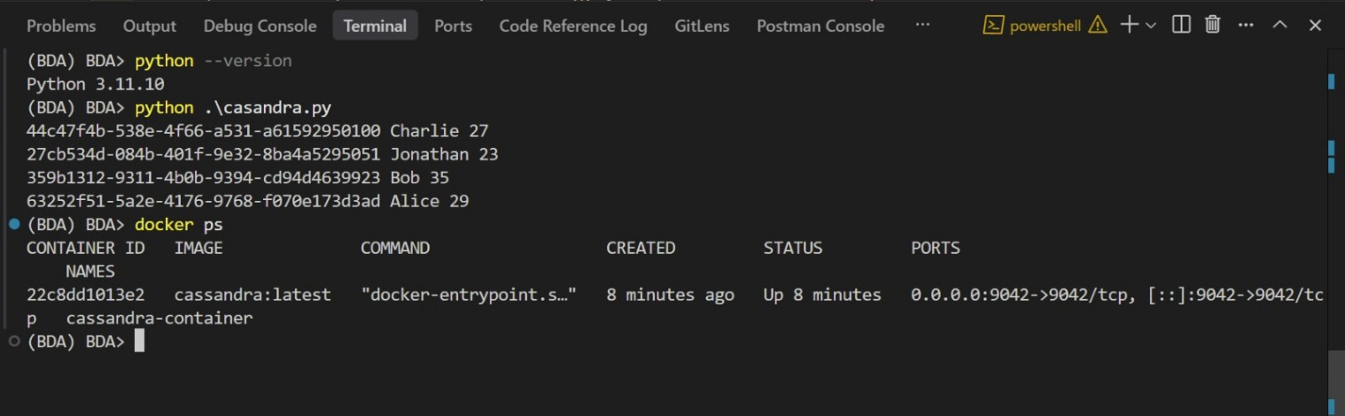

PART-B

