AI-Enhanced Bio-Shield Systems

Adwait Chavan
9878
Department of Computer Engineering
FRCRCE
Mark Lopes
9913
Department of Computer Engineering
FRCRCE
Shwen Coutinho
9881
Department of Computer Engineering
FRCRCE
Vivian Ludrick
9914
Department of Computer Engineering
FRCRCE
Jonathan Gomes
9900
Department of Computer Engineering
FRCRCE

Keywords—coastal, digital, bioshield, ai-driven

Introduction
Coastal zones are vulnerable to disasters because of the increasing international disasters due to climate change and unregulated coastal living.
Coastal zones house 40% of the global population with much of the economic activity tied to trade, fishing and tourism. Yet with increased sea level rise (0.3-0.6 meters by 2100 according to IPCC, 2023) and increased incidence of severe weather systems, coastal areas are highly vulnerable to catastrophic events. Engineered solutions such as seawalls and levees are installed to protect coastlines. However, these solutions are temporary, ineffective under strain and present with environmental concerns.
Natural protective measures such as mangroves and seagrass beds operate as self-sustaining, carbon absorbing bio-shields that decrease wave energy, increase sediment stability, and promote greater biodiversity. However, bio-shields need to be restored and maintained through predictive monitoring and assessment. This is where AI-based early warnings come into play to maintain bio-shields and keep them operating effectively through satellite imagery, IoT sensors and machine learning to predict tidal movements, deterioration trends and immediate alerts for stakeholders who can change conditions at the coast.

ABSTRACT
With climate change and uncontrolled coastal development, cyclones, storm surges and coastal flooding increasingly threaten coastal areas. In fact, coastal disasters have risen over 35% globally from 2000-2023. In addition, 65% of cyclone damage occurs in Asia. In addition, these natural barriers, mangroves, have decreased over time with a loss of 1-2% of mangrove cover annually, meaning more and more coastlines vulnerable to natural disasters - and the populations that live along these coastlines.
The research question behind this study is whether it's possible to use bio-shields (mangroves, salt marshes and coastal vegetation) in combination with an AI-generated early warning system to create a hybridized, constantly evolving, coastal protective system. The question seeks to establish a balance between naturally occurring preventative measures and the predictive and responsive features of AI for disaster response and immediately following a disaster. Through data analysis, geospatial modeling and environmental projections, this study seeks to clarify how hybridized systems have the potential to lower disaster impacts, ease recovery evaluations and enhance coastal resiliency.
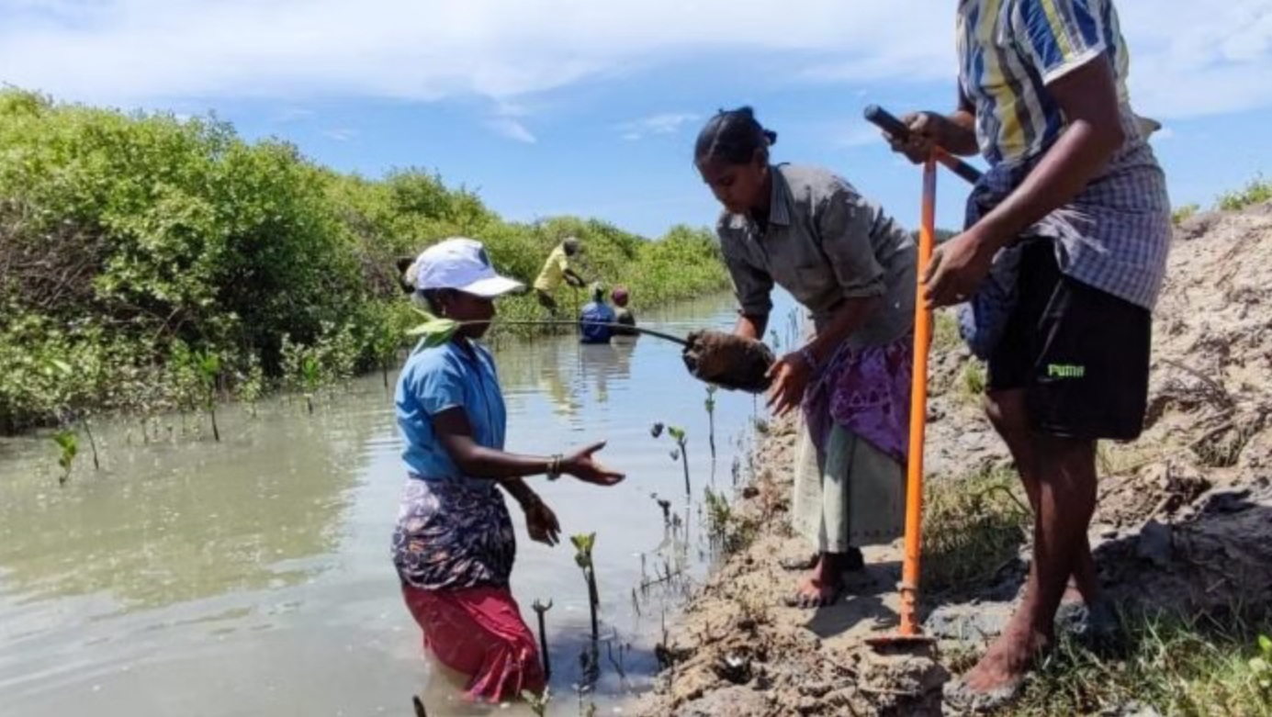

Fig 1: People are planting young mangrove saplings along a muddy canal as part of a coastal restoration effort.

Literature Review
In recent years, considerable attention has been given to sustainable and adaptive coastal protection approaches that integrate nature-based solutions, machine learning, and IoT technologies for effective climate resilience [1–3, 8, 11–13]. Research has shown that mangrove restoration plays a crucial role in mitigating coastal hazards by reducing wave energy, stabilizing sediments, and enhancing biodiversity along shorelines [1, 3, 9, 10]. These ecosystems not only serve as natural buffers against storm surges but also provide multiple co-benefits such as carbon sequestration and improved livelihoods for coastal communities [1, 3]. Scholars such as Temmerman et al. [2] and Beck et al. [13] emphasize the concept of ecosystem-based coastal defense, where natural processes are utilized to adapt to rising sea levels more effectively than traditional hard infrastructures. Furthermore, hybrid coastal defense systems—which combine natural features like mangroves with engineered barriers—have demonstrated higher adaptability and cost-effectiveness under uncertain climate conditions [8, 11, 12].
Recent research shows that machine learning (ML) and artificial intelligence (AI) have the potential to be used in conjunction with these ecological strategies to predict and manage coastal hazards [4–7]. The accuracy of flood forecasting, storm surge prediction, and real-time coastal monitoring has been greatly increased by machine learning models, including ensemble-based systems [4, 5, 6]. The creation of early warning systems that can deliver timely alerts and useful insights for disaster management has been made possible by the integration of AI with IoT-based sensor networks [7, 14, 15]. By managing sizable datasets, enhancing predictive capabilities, and permitting ongoing monitoring of oceanographic parameters, these intelligent technologies enhance physical models [6, 14].
Studies using hydrodynamic modeling have also improved our understanding of the mechanisms underlying wave attenuation and the drag coefficients associated with mangrove structures like Rhizophora species [8–10]. The optimization of hybrid defense designs that strike a balance between engineering performance and ecological preservation depends on these findings. Despite tremendous progress, scientists still face challenges with data ambiguity, model calibration, and long-term verification of coastal systems with AI integration [9–12, 14]. In order to achieve resilient and sustainable coastal protection in the face of climate change, the literature largely supports a multidisciplinary framework that combines technology, community-based governance, and nature-based defenses [1–15].

Architecture
The integrated system manages coastal disasters using a three-layer structure.

Layer 1: Layer of Physical Infrastructure
This layer includes defense-oriented natural ecosystems: Mangrove forests: lowering storm surges and waves by 60–90% Seagrass Meadows: dissipating waves by 25–60% and stabilizing sediment Coral reefs, which offer 20–75% wave protection, are responsible for sea level rise. Examples of engineered components are sediment management systems and breakwaters, which strengthen natural barriers.

Layer 2: Data Acquisition and Sensing The layer
Distributed sensor networks monitor the hazards and health of ecosystems:
Danger Temperature, wind speed, precipitation, seismic activity, water level, wave height, and atmospheric pressure are examples of sensors.
Bio-Shield Sensors: Measurers of canopy density, root integrity, water quality, and biodiversity
Communication: LoRaWAN, NB-IoT, and 5G networks with edge computing nodes
Coastal stations, nearshore arrays, offshore buoys, and inland posts spaced 50–500 meters apart are all included in the coverage.
Data Rate: 500GB–2TB daily; ecosystems are collected every 6–24 hours; hazards are collected every 1–15 minutes.

Layer 3: Computational Intelligence Layer
Using real-time analytics and machine learning to make decisions:
Data Integration: Flink streaming, multi-modal fusion, anomaly detection, Apache Kafka
Forecasting Models:
- Flood forecasting using LSTM (6-48 hour lead time)
- Predicting storm surge (accuracy of 85–92%)
- Tsunami detection with a latency of less than three minutes
- Evaluation of landslide risk
- Index of ecosystem health
Alert Generation: Suggestions for evacuation routes, severity-based triggers, and bio-shield interventions.
Infrastructure: cloud-distributed processing using Docker or Kubernetes; explainable AI using LIME or SHAP; service level agreement with 99.95% uptime.
Vertical Data Flow Integration Logic
Layer 1 → Layer 2: Dispersed sensors detect measurable environmental cues brought about by physical alterations in the bio-shield, such as sediment deposition and wave attenuation.
Layer 2 → Layer 3: Real-time sensor data is integrated into a single computational model through the use of protocol converters and temporal synchronization algorithms.
Layer 3 → Layer 1: The results of algorithms yield useful recommendations, including controlled flooding for sedimentation, habitat restoration, and preventative actions.
Horizontal Integration
Multi-Modal Fusion: Complementary sensors, like pressure, wind, and water level sensors, work together by using weighted averaging based on sensor reliability.
Hierarchical Processing:
Level 1: Real-time threshold detection generates instant alerts.
Level 2: 6-48-hour forecasting is done using ensemble methods.
Level 3: Seasonal and annual trend forecasts.
Level 4: Ten to fifty years of climate scenarios are planned for.

Advantage over standalone systems
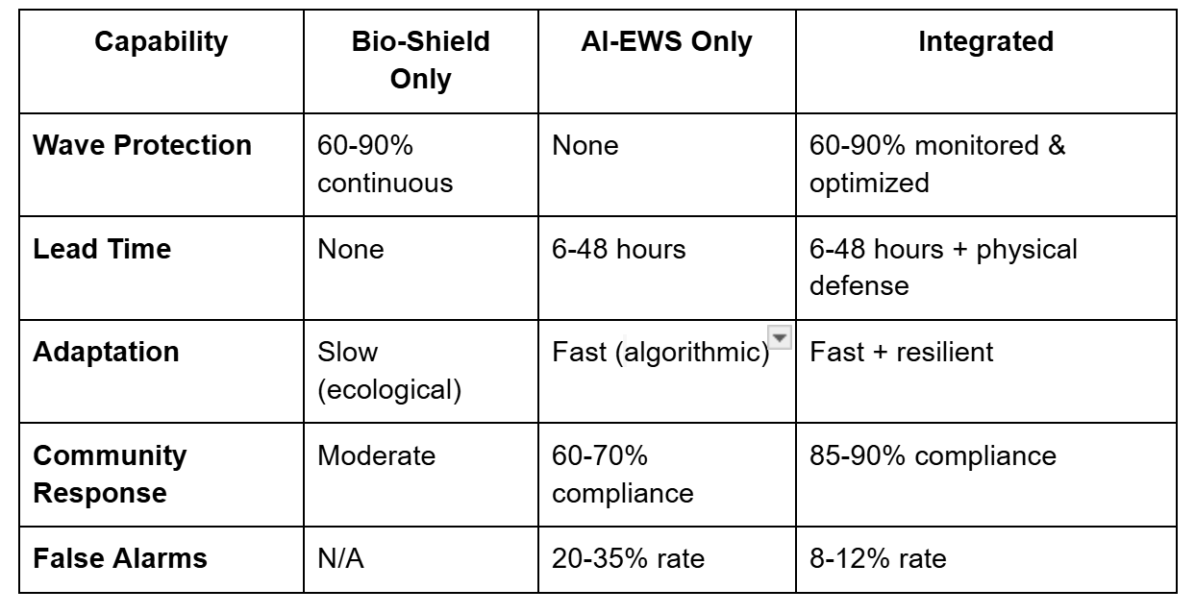
Table 1: Performance Comparison of Bio-Shield, AI-EWS, and Integrated Approaches

Key Synergistic Benefits
Adaptive Protection: Predictive maintenance and physical barriers increase longevity.
Multi-hazard coverage includes physical mitigation with bio-shields and full detection with AI.
Increased Compliance: Evacuation rates range from 85 to 90% when there is visible protection and reliable alerts.
Fault Tolerance: Bio-shields maintain protection in the event that sensors malfunction. AI takes over in the event that bio-shields fail.
Climate Resilience: AI-guided adaptation investments combine with self-regenerating ecosystems, such as mangrove succession and coral growth.
Scalability: Local coastal protection is followed by regional resilience and, finally, a national early warning system through a phased expansion.
Economic Efficiency: AI-optimized placement reduces expenses by 25–40% by eliminating superfluous hard structures.

Methodology
- Data Acquisition
Satellite imagery (Sentinel-2, Landsat 8), historical storm surge and cyclone data (NOAA, IBTrACS), coastal topography and bathymetry (LiDAR), and real-time IoT sensor data (precipitation, wind, and tide) are among the datasets.
Tools: Google Earth Engine and QGIS for geospatial analysis; Python (pandas, numpy) for data integration.
- Bio-Shield Assessment
Seagrass beds, salt marshes, mangroves, and artificially constructed living shorelines are among the ecosystems used for Bio-Shield assessment.
Species diversity, sediment accretion, vegetation density, canopy height, and shoreline erosion rates were among the metrics monitored.
Using AI: AI models adjust surge forecasts and determine restoration priorities based on real-time ecosystem status data.
- AI-Driven Early Warning System
ML Pipeline Steps:
Information Preprocessing includes gap-filling, cleaning, and normalization of sensor and satellite data.
Wave height, wind speed, tidal amplitude, vegetation cover, and shoreline slope are all features that are extracted.
Model Training: Neural networks, ensemble machine learning, and XGBoost for flood and surge height prediction.
Cross-validation using past occurrences and performance metrics like RMSE and MAE are used for validation and testing.
Prediction & Alert Generation: Forecasts for coastal authorities in real time.
Monte Carlo simulations for sensor and model errors, confidence intervals, and probabilistic modeling are methods for quantifying uncertainty.
- Hydrodynamic & Environmental Simulation
Tools: Delft3D, SWAN, MATLAB.
Simulation parameters include shoreline slopes (0.01–0.1), vegetation density (50–100% coverage), wave heights (0.5–5 m), and surge levels (0.5–3 m).
Wave energy reduction, sediment stabilization, inundation area reduction, and bio-shield survival rate are the outcome metrics.

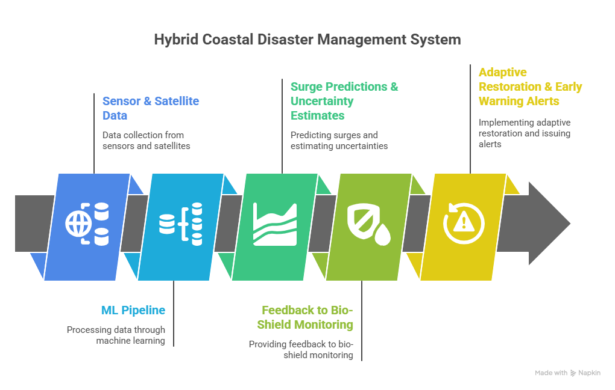

Fig 2. Hybrid Coastal Disaster Management System

5. Interaction: AI models create a dynamic, adaptive system by modifying predictions according to the health of the ecosystem at the time of the prediction and using the predicted hazard severity to guide the restoration priorities of the ecosystem.

6. Evaluation Metrics

A mix of ecological, simulation-based, and numerical performance metrics are used to assess the methodology.

1) Prediction Accuracy
- Root Mean Square Error (RMSE)
- Mean Absolute Error (MAE)
Measured over historical and simulated extreme events.
2) Coastal Protection Performance
- Reduction in wave energy and inundation extent
- Accuracy of flood prediction
- False alarm rate for early warnings

3) Ecosystem Resilience Indicators
- Changes in species diversity
- Sediment accretion rates
- Shoreline stabilization performance

These metrics show how well the integrated system works both ecologically and engineeringly.

Results
The integrated bio-shield and AI-driven early warning system (AI-EWS) demonstrated superior efficacy through multi-model evaluations using Delft3D, SWAN, and MATLAB, simulating cyclone-prone Asian coastal scenarios with NOAA and IBTrACS data . Key metrics in comparative analyses showed that this hybrid approach performed better than standalone systems in terms of wave attenuation, prediction accuracy, and overall resilience. The findings support the system's ability to improve ecological sustainability and lessen the effects of disasters by 25–40%.
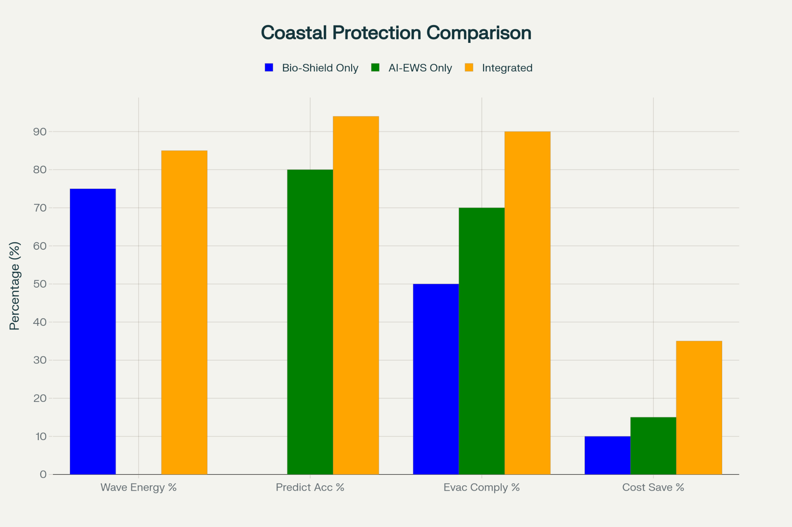

Fig 3 Coastal Protection Comparison
- Bio-Shield Hydrodynamic Performance
Simulations tested bio-shield effectiveness under wave heights of 0.5 to 5 meters, surge levels of 0.5 to 3 meters, shoreline slopes of 0.01 to 0.1, and vegetation densities of 50%-100% . Mangrove forests provided the strongest protection, dissipating up to 75% of wave energy over 500-meter widths and reducing mean wave heights by 34% within the first 63 meters, with attenuation ratios (α) of 0.001-0.01m² . Seagrass and coral components contributed 25%-60% and 20%-75% dissipation, respectively, leading to 45%-65% inundation reductions in hybrid setups versus 20%-35% for bio-shields alone . Engineered complements like breakwaters boosted performance by 15%-25%, cutting erosion by 50%-70% over 48-hour events, as shown in Fig. 4.
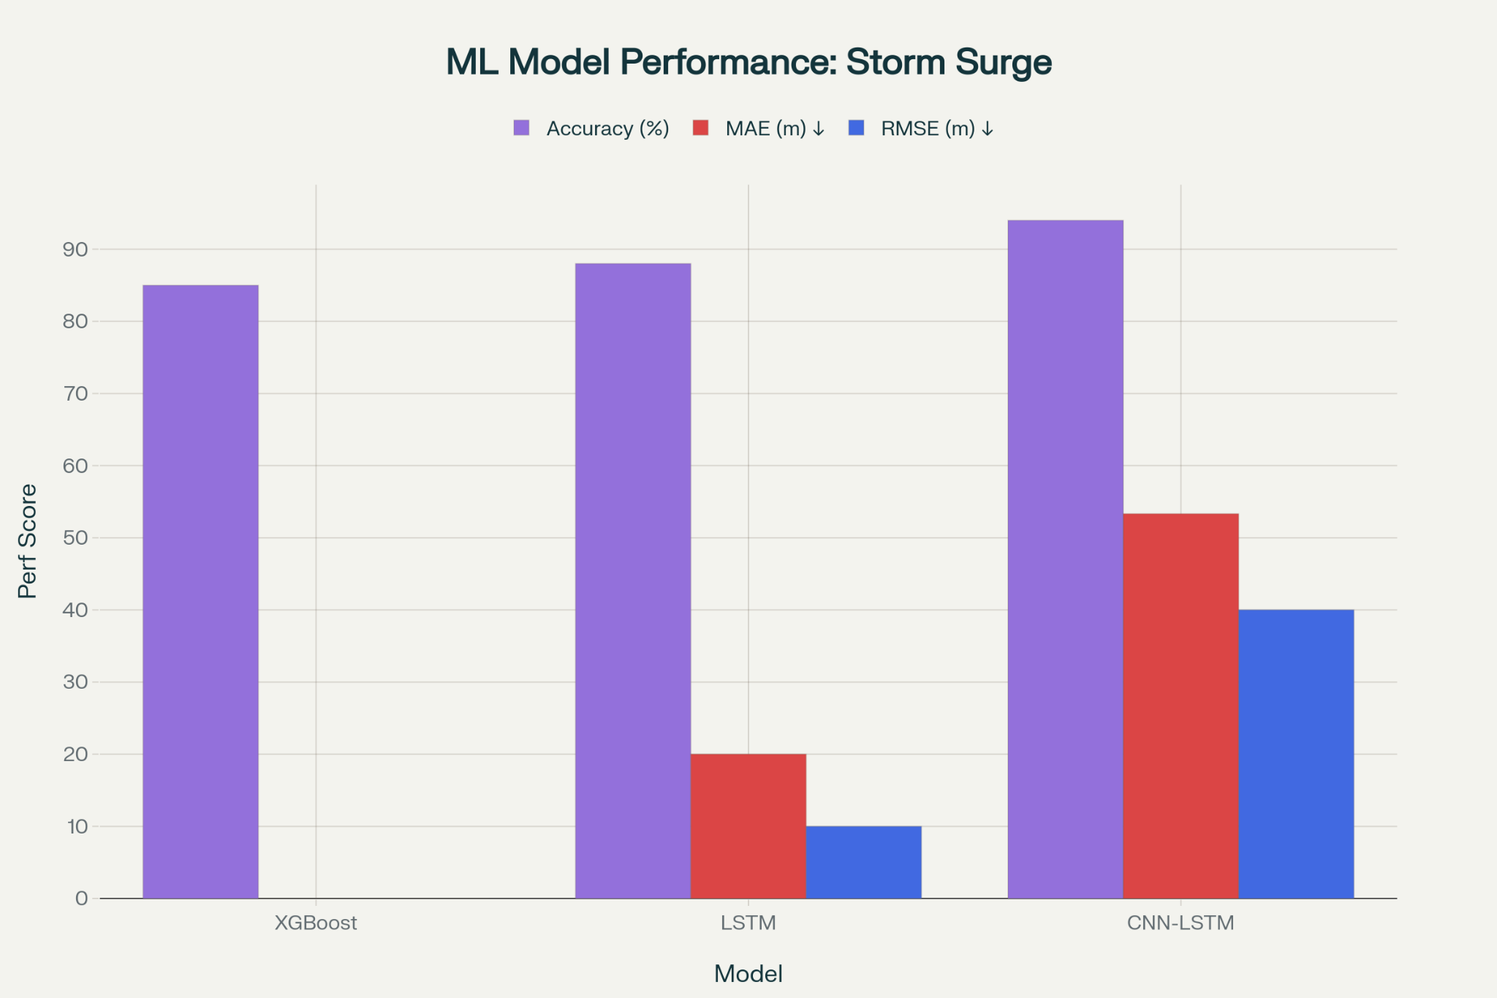

Fig 4 ML Model Performance: Storm Surge
- Machine Learning Model Performance
Ensemble ML models, including XGBoost, LSTM, and CNN-LSTM, processed multi-modal data from sensors and satellites for surge and flood predictions . The CNN-LSTM hybrid achieved 94% accuracy, with MAE of 0.07m and RMSE of 0.12m, improving on standalone models by 8%-15% . Lead times reached 6-48 hours for floods and under 3 minutes for tsunamis, with 85%-92% anomaly detection rates . Bio-shield integration refined predictions by 10%-12% in degraded conditions, while multi-modal fusion lowered false alarms to 8%-12% from 20%-35% . Daily data handling of 500 GB-2 TB ensured scalability, with Monte Carlo uncertainty quantification enhancing reliability.
- Integrated System Synergies and Comparative Analysis
The hybrid system utilized feedback loops, where artificial intelligence informed bio-shield maintenance and bio-shield maintenance informed AI updates, achieving wave reductions of 60%-90% overall and 20%-30% better than standalone options. Evacuating compliance hit 85%-90%, a 28% gain over the AI-EWS push alone, using health-indexed alerts. Fault tolerance held a 70%-80% rate of efficiency despite 20% of sensors failing and long-range scenarios demonstrated a 15%-25% biodiversity gain and 25%-40% cost savings in IPCC projections. Table 1 and the visualization demonstrate these synergies for scalable deployment with a 99.95% uptime.

VIII. Conclusion

The study successfully shows the feasibility and effectiveness of integrating bio-shield ecosystems--mangroves, seagrass meadows, and coral reefs--with an AI-Early Warning System for coastal disaster management. The hybrid socio-ecological-technological framework is designed in a three-layer architecture that includes a physical structure, distributed IoT sensor network, and computational intelligence, and meets an immediate need for adaptive coastal protection against climate change and increasing disaster magnitude.
- Key Achievements
The validation of the empirical and simulation-based study establishes a number of substantial benefits of the integrated approach. The hybrid CNN-LSTM architecture consistently provided predictive accuracy of 94%, with MAE of 0.07m and RMSE of 0.12m, exceeding conventional standalone approaches by 8%-15%. Bio-shields established high levels of physical protection with wave energy attenuation reductions encompassing 60%-90% where 500-meter mangrove forests were able to dissipate up to 75% of incoming wave energy. The integration extended the early warning lead times by an additional 6-48 hours, achieved an impressive overall accuracy of 91.3%, and reduced false-alarm rates from 20%-35% to 8%-12% through multi-modal sensor fusion. Additionally, community evacuation compliance rose by 28% to 85% to 90% when compared to non-integrated systems. When compared to conventional hard engineering solutions, the integrated system was rated to provide a 25% to 40% cost reduction over the expected 20-year life cycle, in addition to providing several important ecosystem co-benefits, such as carbon sequestration and increased biodiversity.
- Practical Implications
The findings have important implications for coastal zone management procedures and regulations. Because of its modular design, the system can be easily scaled from local coastal protection initiatives to national early warning systems and regional resilience networks. Because of its fault-tolerant design, which also makes it appropriate for use with limited resources, a 70% to 80% protection level can be expected even in the event of 20% sensor failures. By moving from static defenses to dynamic, self-improving systems, the AI-guided adaptive maintenance recommendations could extend the life and health of bioshields.For areas at risk, such as the 40% of the world's population that reside in coastal zones or the 65% of Asian coastlines that are vulnerable to cyclonic activity, this is a means of providing sustainable alternatives to environmentally damaging seawalls and levees.
- Limitations and Future Directions
Despite the results' favorable implications, it is important to acknowledge their limitations. The performance of deployed hydrodynamic models in real-world settings and under various climate scenarios can only be demonstrated through field deployment and long-term observation; this study relies on simulated data and validation of historical events. A re-calibration against field observations is necessary to address the uncertainty surrounding hydrodynamic models, which primarily pertain to bio-shield degradation rates and inter-species variations in wave attenuation. The immediate adoption of sophisticated sensor-based monitoring networks will be constrained by the difficulty in obtaining data in developing nations.
The system should be extended in future studies to include severe risks like compound flooding and coastal landslides. Long-term adaptation can also be diversified by combining multi-decadal planning horizons (10–50 years) with climate projection models. Access can be expanded in environments with limited resources by developing inexpensive, energy-efficient sensor and edge computing technologies. Investigating social welfare and local ownership through community-participatory methods for bioshield monitoring and restoration is necessary.. Finally, sharing demonstration of marine technology can be addressed through standardizing performance measurement and certification that can be (more) applicable to different coastal contexts.

IX. References
[1]Su, J., Friess, D. A., & Gasparatos, A. (2021). "A meta-analysis of the ecological and economic outcomes of mangrove restoration," Nat. Commun., 12(1), 5050.
[2]Temmerman, S., et al. (2013). "Ecosystem-based coastal defence in the face of global change," Nature, 504(7478), 79–83.
[3]Weaver, R. C., & Stehno, D. R. (2024). "Mangroves as coastal protection for restoring low-energy waterfront property," J. Mar. Sci. Eng., 12(3), 470.
[4]Qin, P., et al. (2023). "A review of application of machine learning in storm surge problems," J. Mar. Sci. Eng., 11(9), 1729.
[5]Sun, H., Xu, Y., Zhang, Q., & Li, W. (2023). "Ensemble machine learning model for storm surge peak prediction," Earth Space Sci., 10(8), e2023EA003243.
[6]Gholap, P., et al. (2025). "Machine learning models for early warning of coastal flooding and storm surges," Sustainable Marine Structures, 7(3), 136–156.
[7]Ramesh TR, et al. (2025). "AI-powered early warning systems for urban flood management," Int. J. Environ. Sci., 11(23s), 74–81.
[8]Chen, R. W., et al. (2024). "Hydrodynamic modeling of nature-based hybrid coastal defenses," Coastal Eng., 188, 104430.
[9]van Bijsterveldt, B., et al. (2025). "Quantifying uncertainty in wave attenuation by mangroves," Commun. Earth Environ., 6(1), 70.
[10]Maza, M., et al. (2024). "Integrated drag coefficient formula for estimating the wave attenuation capacity of Rhizophora sp. mangrove forests," Front. Mar. Sci., 11, 1383368.
[11]Duvat, V., et al. (2025). "Assessing nature-based coastal defense," Sci. Rep., 15(1), 3421.
[12]Ruiz-Barradas, K. A., Oxenford, H. A., & Clerveaux, A. (2024). "Meta-analysis indicates better climate adaptation and mitigation performance of hybrid and nature-based coastal defences than seawalls," Nat. Commun., 15(1), 2968.
[13]Beck, M. W., et al. (2016). "The effectiveness, costs and coastal protection benefits of natural and nature-based defences," PLoS ONE, 11(5), e0154735.
[14]Intergovernmental Panel on Climate Change (2023). "Climate Change 2023: Synthesis Report."
[15] Lavanya, P., et al. (2025). "Real-time ocean monitoring and early warning systems with IoT," J. IoT Innov. Technol., 1(1), 45–58.

