SMA
Experiment 1
Name: Mark Lopes
Roll No: 9913
Div: BE Comps A (Batch C)
CASE STUDY: Genshin Impact
1. List each company and their social media accounts.
Twitter
https://x.com/GenshinImpact
Youtube:
https://www.youtube.com/GenshinImpact
Instagram:
https://www.instagram.com/genshinimpact
Facebook
https://www.facebook.com/Genshinimpact/
2. Find as many counts for each social media account as described in the section onmeasuring success.
Twitter:
5.6 M followers
Instagram:
4.3 M
Youtube:
8.05 M Subs
3. How often does the company interact on their social network site? Is it many times aday, a few times a week, or never?
Twitter:
Few times a month.
Instagram:
Thrice a week.
YouTube:
Twice Per Week.

4. What kind of interaction is the company doing? Broadcast, request for input, direct interaction, or a combination? Provide an example of each.
1.Releasing the new content trailers through yt
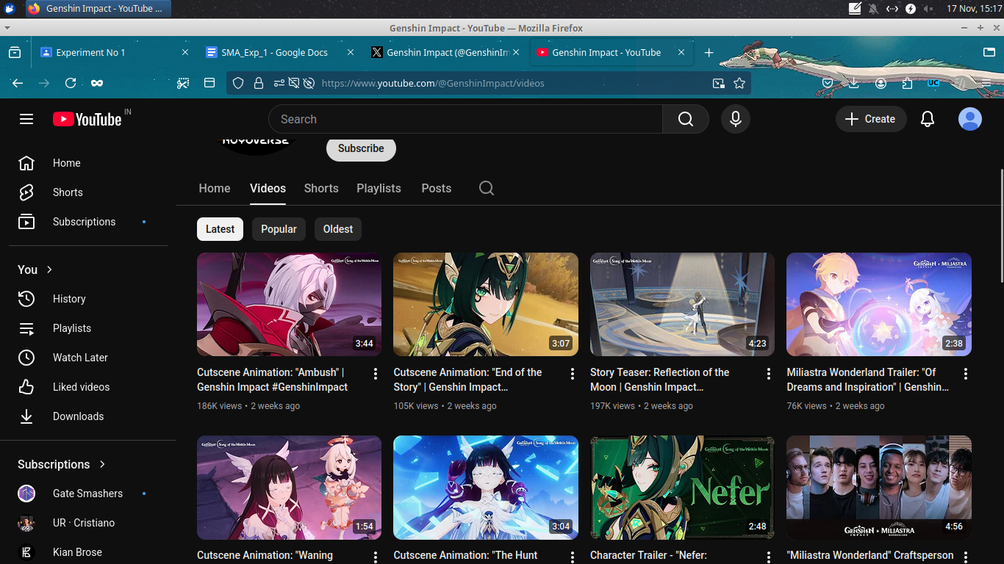2. Sharing their events on X.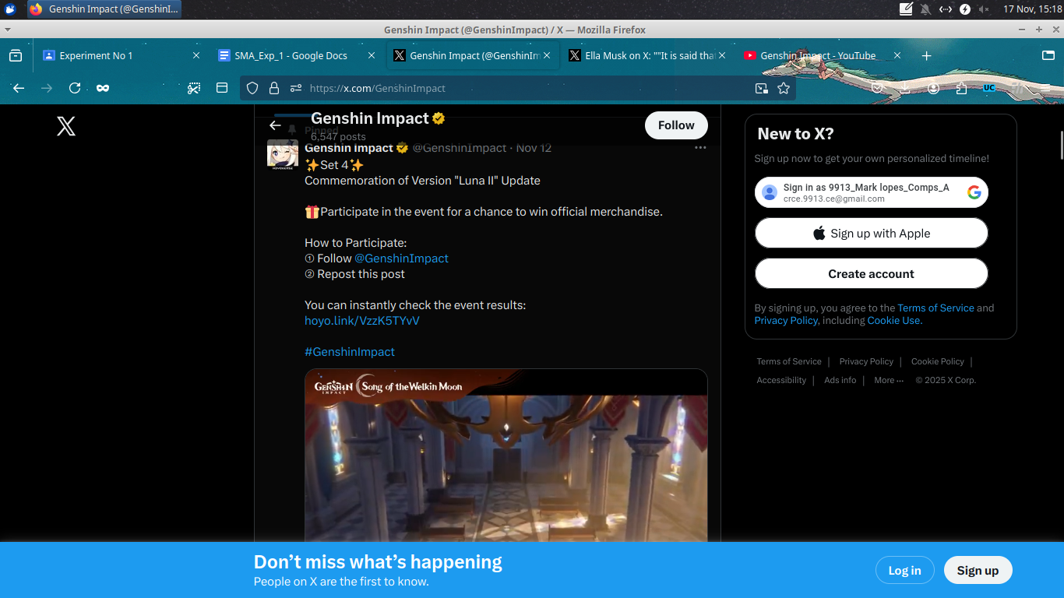

Assess the company’s social media strategy. What are they doing well andwhy? Whatcould they do better, why would that be better, and how should they doit?

Instagram
Genshin Impact uses high-quality character art, reels, and event highlights to maintain strong visual engagement. Their posts leverage fan-favorite characters and seasonal content to build excitement. This works well because Instagram is a visual platform and character-driven content resonates with fans.
Could improve: Incorporate more behind-the-scenes or creator-focused content to humanize the brand and deepen community connection.

Twitter (X)
They frequently post announcements, event updates, and character teasers. This keeps players informed in real time and builds hype.
Could improve: Increase interactive content (polls, Q&As, community challenges) to boost engagement and make players feel more involved.

Facebook
Genshin uses Facebook for trailers, animated shorts, and event notifications. Video content performs well here and reinforces brand recall.
Could improve: Add more localized content or region-specific posts to better engage diverse global audiences.

YouTube
Their YouTube strategy focuses on high-quality trailers, character demos, and music videos across multiple playlists. This helps fans easily find specific content and supports long-term viewership.
Could improve: More behind-the-scenes content (dev diaries, making-of videos) would strengthen transparency and deepen fan loyalty.

ii) Social Media analytics tools (facebook insights, google analytics netlytic etc) iv) Applications of Social media analytics for business.
Netlytic analysis for shopify
https://www.noxinfluencer.com
For Youtube
It shows the current subs and AVG views which are 197.9k which is quite high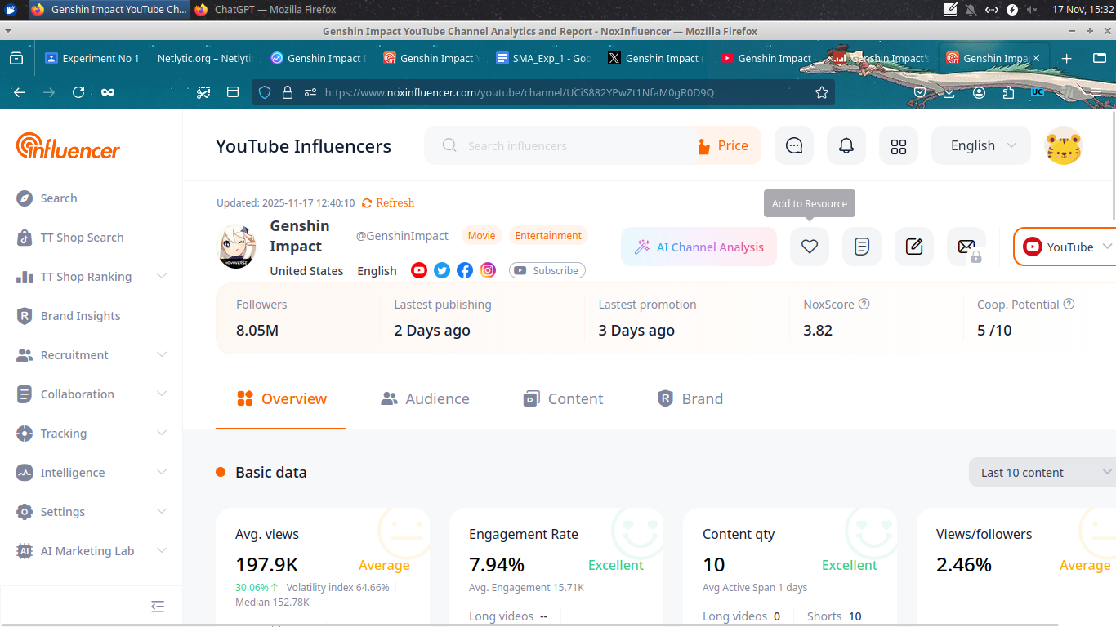

For instagram
It shows the number of followers and AVG views on the page and the engagement rate which looks good
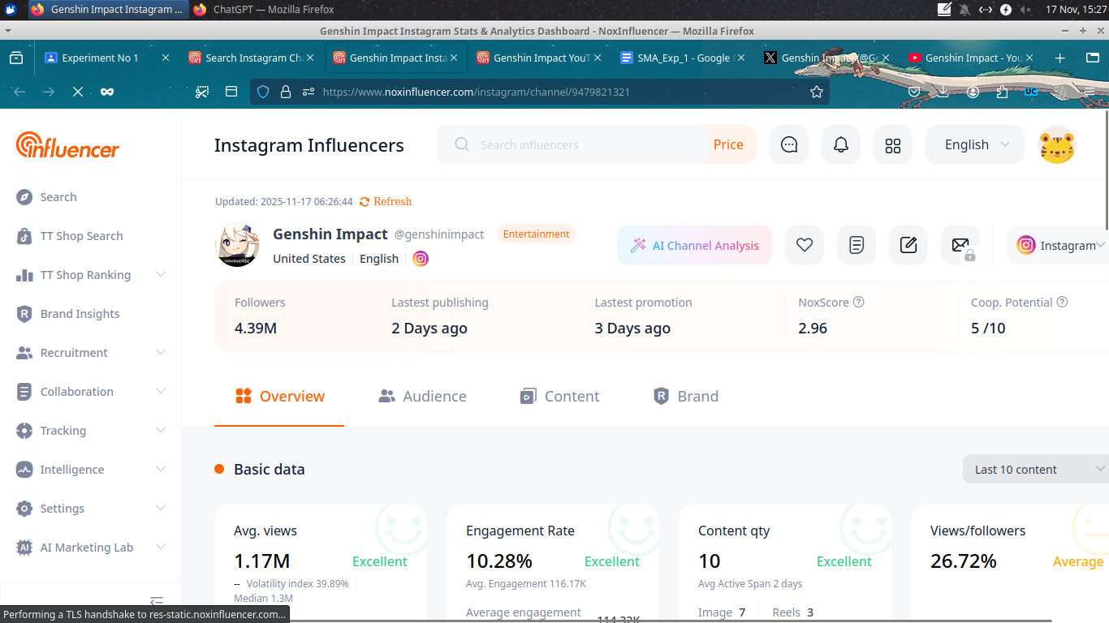
https://instrack.app/
Instagram
It shows the number of followers and following and also the number of posts it has made
It also shows the followers growth the engagement rate, avg likes and AVG comments
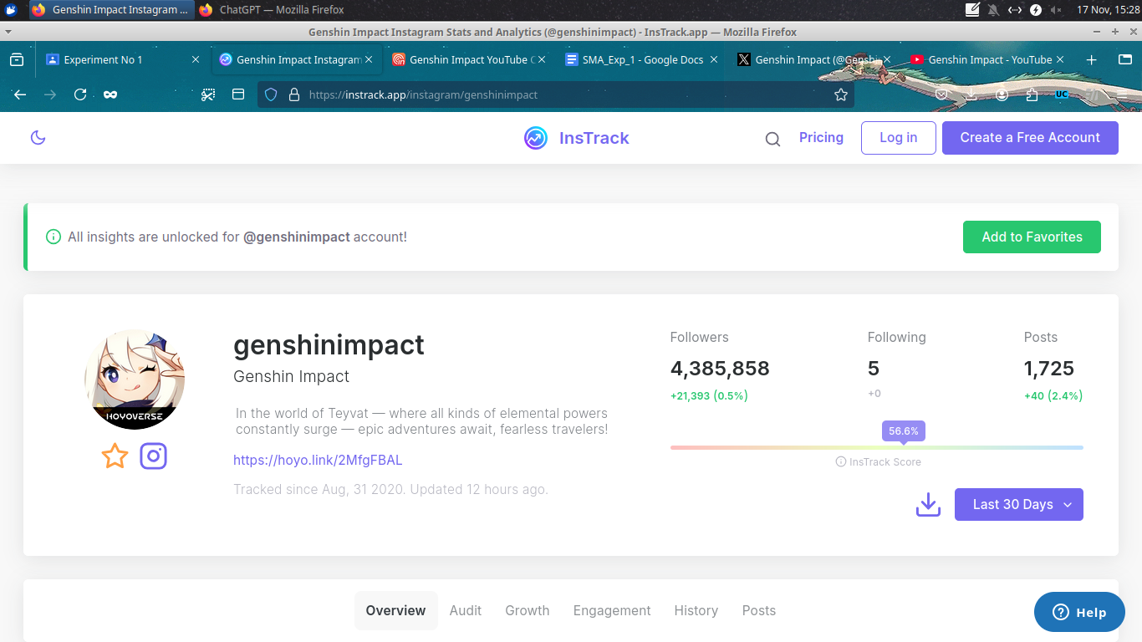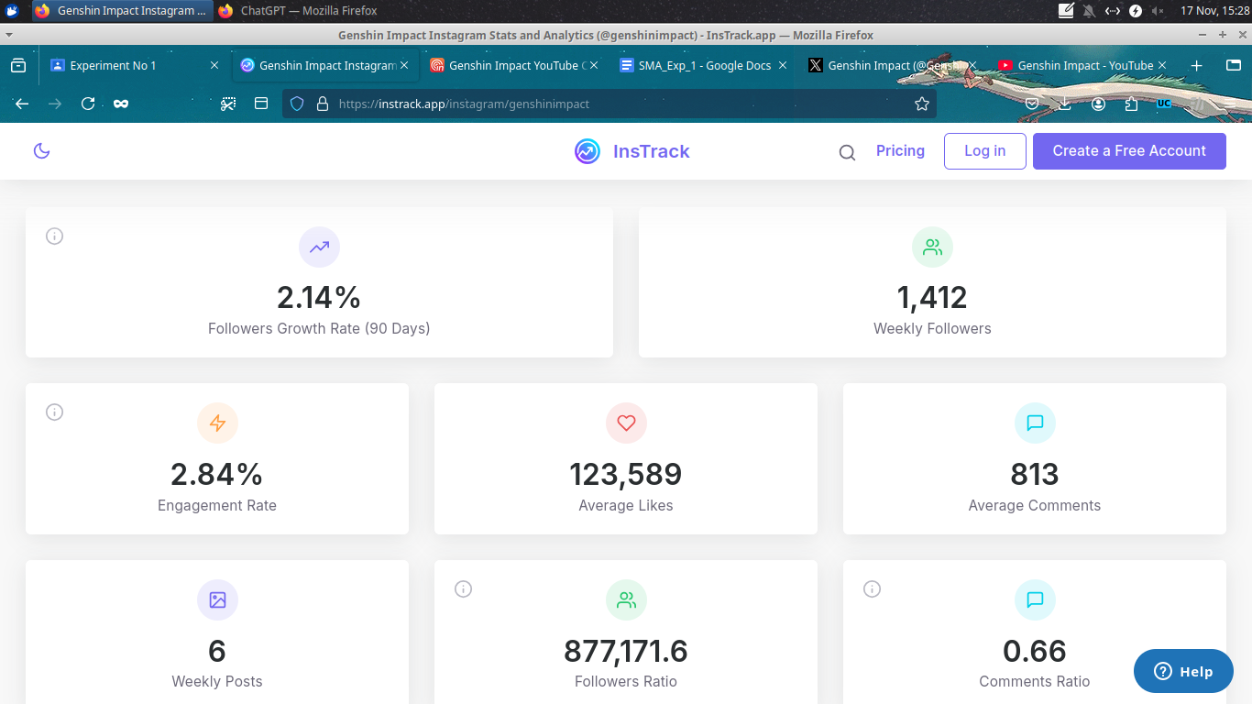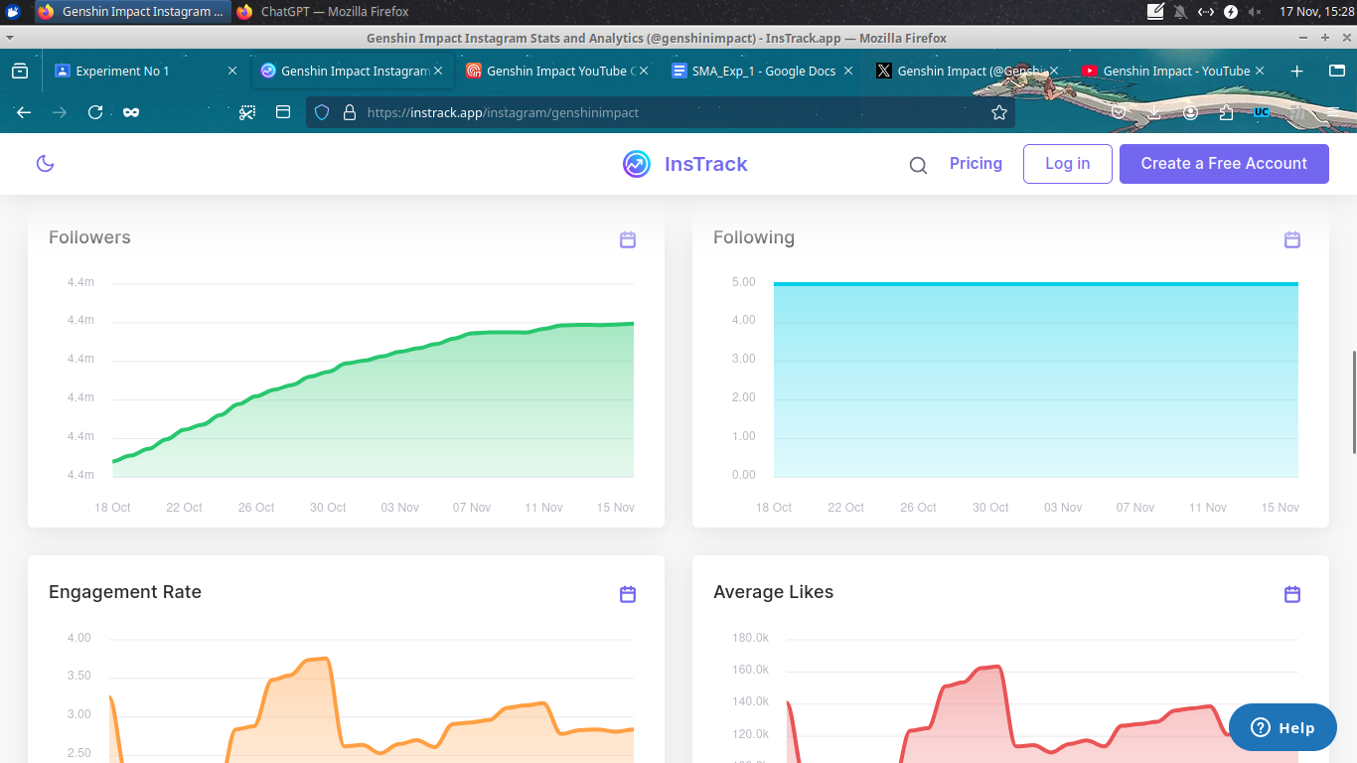

https://socialblade.com/
This gives a grade for this account which is B+. It also has ranks for games, subs and views. It also shows the amount earned per month.
