**GREEN CERTIFICATIONS FOR ORGANIZATIONS: DRIVING SUSTAINABLE BUSINESS PRACTICES**

**PROJECT TEAM**

* **Team:** H
* **Team Members:**
  + Joshua Dmello (9886) - Introduction & Steps to Achieve Certification
  + Shwen Coutinho (9881) - Role of Environment Managers & Importance of Green Certification
  + Mark Lopes (9913) - Certification Bodies & Key Sustainable Practices
  + Vivian Ludrick (9914) - Benefits to the Organization & Case Study
  + Jonathan Gomes (9900) - Understandings from Case Study & Conclusion

**Presentation Date:** 9/06/2025  
**Course:** Environmental Management  
**Branch:** Computer A

**EXECUTIVE SUMMARY**

Green certifications have emerged as fundamental drivers of organizational sustainability and environmental responsibility in the modern business landscape. This comprehensive report examines the critical role of green certifications in organizational transformation, analyzing their implementation processes, benefits, and real-world applications. As regulatory pressures intensify and consumer expectations evolve, green certifications serve as essential frameworks for organizations to demonstrate their commitment to environmental stewardship while achieving operational excellence and competitive advantage.

**SECTION 1: INTRODUCTION TO GREEN CERTIFICATES**

*Presenter: Joshua Dmello (9886)*

**1.1 Definition and Basic Explanation**

Green certificates are tradable commodities and formal recognitions that validate an organization's commitment to environmental sustainability and responsible business practices. These certifications serve multiple purposes in the contemporary business environment:

**Core Definition:**

* **For Renewable Energy:** 1 certificate = 1 GigaWattHour of electricity generated from renewable sources
* **For Organizations:** Formal validation of sustainable practices, environmental management systems, and ecological responsibility

**Key Characteristics:**

* Third-party verification and assessment
* Standardized criteria and benchmarks
* Continuous monitoring and improvement requirements
* Market differentiation and credibility enhancement
* Regulatory compliance facilitation

**1.2 Types of Green Certificates**

**Energy-Based Certificates:**

* Renewable Energy Certificates (RECs)
* Carbon Credits and Offsets
* Energy Efficiency Certifications

**Organizational Certifications:**

* Environmental Management System certifications
* Sustainable building and infrastructure certifications
* Industry-specific sustainability standards
* Social and environmental responsibility certifications

**1.3 Historical Context and Evolution**

**Timeline of Development:**

* **1990s:** Emergence of ISO 14001 environmental management standards
* **2000s:** Introduction of LEED green building certification
* **2010s:** Expansion of sector-specific certifications
* **2020s:** Integration of ESG (Environmental, Social, Governance) frameworks
* **2025:** Focus on circular economy and net-zero commitments

**SECTION 2: ROLE OF ENVIRONMENT MANAGERS**

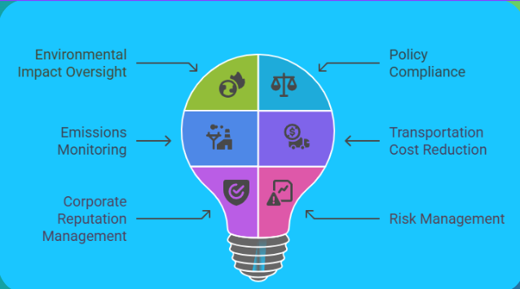

*Presenter: Shwen Coutinho (9881)*

**2.1 Definition and Core Responsibilities**

An environment manager oversees and implements sustainable practices within an organization, ensuring compliance with environmental regulations while working systematically to reduce the organization's ecological impact.

**Primary Functions:**

* Developing and implementing environmental management systems
* Ensuring regulatory compliance and risk mitigation
* Leading sustainability initiatives and green certification processes
* Monitoring environmental performance and reporting
* Stakeholder engagement and communication

**2.2 Key Competencies and Skills**

**Technical Expertise:**

* Environmental science and engineering knowledge
* Regulatory framework understanding
* Data analysis and reporting capabilities
* Project management and implementation skills

**Leadership Qualities:**

* Cross-functional team coordination
* Change management and organizational transformation
* Strategic planning and goal setting
* Communication and stakeholder engagement

**2.3 Strategic Role in Certification Process**

**Pre-Certification Phase:**

* Conducting initial environmental assessments
* Identifying gaps and improvement opportunities
* Developing implementation roadmaps
* Building organizational buy-in and support

**Certification Implementation:**

* Leading cross-functional teams
* Coordinating with external certification bodies
* Managing documentation and evidence collection
* Ensuring compliance with certification requirements

**Post-Certification Management:**

* Continuous monitoring and improvement
* Regular audits and assessments
* Maintaining certification standards
* Driving ongoing sustainability initiatives

**SECTION 3: IMPORTANCE OF GREEN CERTIFICATION**

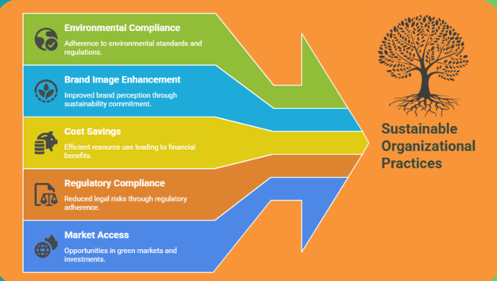

*Presenter: Shwen Coutinho (9881)*

**3.1 Strategic Business Importance**

Green certifications have evolved from optional sustainability initiatives to strategic business imperatives that drive competitive advantage and organizational resilience.

**Market Positioning Benefits:**

* Enhanced brand reputation and credibility
* Differentiation in competitive markets
* Access to environmentally conscious consumer segments
* Premium pricing opportunities for certified products/services

**3.2 Regulatory and Compliance Advantages**

**Risk Mitigation:**

* Proactive compliance with environmental regulations
* Reduced likelihood of regulatory penalties and fines
* Streamlined reporting and documentation processes
* Enhanced regulatory relationship management

**Example Impact:** LG Polymers faced ₹30 crores in compensation post-leak, highlighting the critical importance of environmental compliance and certification.

**3.3 Financial and Operational Benefits**

**Cost Reduction Opportunities:**

* Energy efficiency improvements (typically 15-25% savings)
* Waste reduction and resource optimization
* Lower insurance premiums and operational risks
* Access to green financing and incentives

**Revenue Enhancement:**

* Market access to sustainability-focused customers
* Government contract preferences for certified organizations
* Enhanced investor confidence and capital access
* Tax benefits and regulatory incentives

**3.4 Stakeholder Value Creation**

**Employee Engagement:**

* Attraction and retention of sustainability-focused talent
* Enhanced organizational culture and purpose
* Improved workplace satisfaction and productivity
* Professional development and skill enhancement opportunities

**Community and Social Impact:**

* Positive community relations and social license to operate
* Contribution to global sustainability goals
* Enhanced corporate social responsibility profile
* Long-term environmental stewardship
* 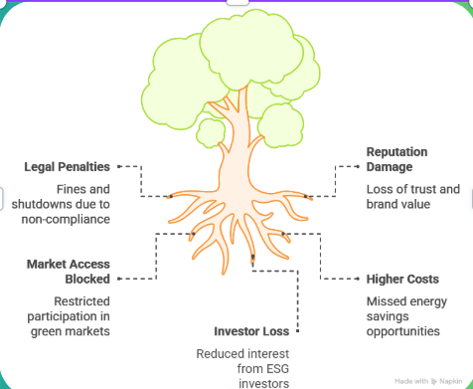

**SECTION 4: CERTIFICATION BODIES AND STANDARDS**

*Presenter: Mark Lopes (9913)*

**4.1 Major Global Certification Bodies**

**ISO 14001 - Environmental Management Systems:**

* Global standard for managing environmental responsibilities
* Focus on continual improvement and regulatory compliance
* Applicable across all industries and organizational sizes
* Over 300,000 certified organizations worldwide

**LEED (Leadership in Energy and Environmental Design):**

* Popular in building and construction sectors
* Rates sustainability of building design, operation, and maintenance
* Four certification levels: Certified, Silver, Gold, Platinum
* Over 95,000 certified projects in 165+ countries

**BREEAM (Building Research Establishment Environmental Assessment Method):**

* Widely used in Europe and internationally
* Assesses energy, water use, materials, and innovation
* Covers new construction, refurbishment, and in-use assessments
* 2.3 million certified buildings worldwide

**4.2 Specialized Certification Programs**

**Energy Star:**

* Energy efficiency label by U.S. EPA
* Covers 70+ product categories
* Prevented 3.5 billion tons CO2 emissions (1992-2018)
* $450 billion in energy savings since inception

**B Corporation Certification:**

* Measures social and environmental impact
* Comprehensive assessment across governance, workers, community, environment, customers
* Over 4,000 certified B Corps globally
* Focus on stakeholder capitalism and purpose-driven business

**Green America Certification:**

* Focus on social and environmental responsibility
* Small and medium enterprise specialization
* Supply chain sustainability requirements
* Community impact and fair trade emphasis

**4.3 Industry-Specific Standards**

**Manufacturing and Industrial:**

* ISO 50001 (Energy Management Systems)
* OHSAS 18001/ISO 45001 (Occupational Health and Safety)
* Cradle to Cradle Certified (Circular Design)

**Service and Technology:**

* Green Globe (Tourism and Hospitality)
* EPEAT (Electronics Environmental Assessment)
* TCO Certified (IT Product Sustainability)

**4.4 Regional and National Programs**

**India-Specific Certifications:**

* IGBC (Indian Green Building Council)
* CII-ITC Centre of Excellence for Sustainable Development
* BEE Star Rating (Bureau of Energy Efficiency)

**European Standards:**

* EU Ecolabel
* EMAS (Eco-Management and Audit Scheme)
* Green Key (International eco-label for tourism)

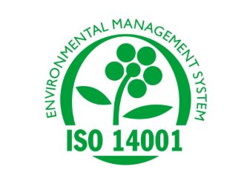 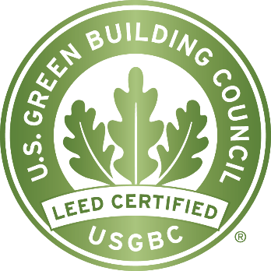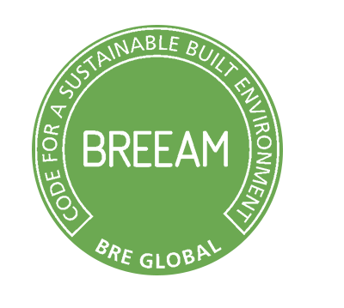

**SECTION 5: STEPS TO ACHIEVE CERTIFICATION**

*Presenter: Mark Lopes (9913)*

**5.1 Strategic Planning and Preparation**

**Step 1: Set Environmental Goals**

* Define measurable objectives (energy reduction, waste minimization, carbon footprint reduction)
* Align goals with organizational strategy and values
* Establish baseline measurements and target improvements
* Ensure management commitment and resource allocation

**Step 2: Choose Suitable Certification Standard**

* Evaluate organizational sector and specific requirements
* Consider budget, resources, and implementation timeline
* Assess regulatory and client expectations
* Evaluate geographical relevance and market recognition

**5.2 Team Formation and Assessment**

**Step 3: Form a Green Team**

* Appoint qualified environment manager as team leader
* Build cross-functional team including operations, maintenance, HR, compliance
* Define roles and responsibilities for implementation
* Establish communication and reporting structures

**Step 4: Conduct Initial Assessment**

* Evaluate current environmental performance
* Identify areas requiring improvement and investment
* Document existing policies, procedures, and practices
* Assess resource usage, waste generation, and compliance status

**5.3 Gap Analysis and Planning**

**Step 5: Gap Analysis**

* Compare current practices with certification requirements
* Identify specific gaps and improvement opportunities
* Prioritize actions based on impact and feasibility
* Develop detailed implementation timeline and budget

**5.4 Implementation and Documentation**

**Step 6: Implement Sustainable Practices**

* Deploy energy efficiency measures and renewable energy systems
* Establish waste reduction and recycling programs
* Implement water conservation and management systems
* Integrate sustainable sourcing and procurement practices

**Step 7: Staff Training and Monitoring**

* Organize comprehensive training programs for all employees
* Ensure understanding of sustainability policies and procedures
* Establish monitoring systems for key performance indicators
* Implement regular review and improvement processes

**5.5 Certification Process**

**Step 8: Internal Audit and Documentation**

* Conduct thorough internal audit of all systems and processes
* Document compliance evidence and improvement initiatives
* Prepare comprehensive certification application materials
* Address any identified gaps or non-conformances

**Step 9: Apply to Certifying Body and Undergo Audit**

* Submit formal application with required documentation
* Participate in external audit process with certification body
* Address audit findings and recommendations
* Achieve final certification approval and recognition

**SECTION 6: KEY SUSTAINABLE PRACTICES**

*Presenter: Joshua Dmello (9886)*

**6.1 Energy Efficiency and Renewable Energy**

**Energy Management Strategies:**

* LED lighting systems and smart lighting controls
* Solar power installation and renewable energy procurement
* Building automation and energy management systems
* Equipment efficiency upgrades and optimization

**Impact Metrics:**

* Typical energy cost reduction: 20-30%
* Carbon footprint reduction: 15-40%
* Return on investment: 2-5 years

**6.2 Water Conservation and Management**

**Water Efficiency Measures:**

* Rainwater harvesting and collection systems
* Greywater recycling and treatment systems
* Water-efficient fixtures and appliances
* Leak detection and prevention programs

**Conservation Benefits:**

* Water usage reduction: 20-50%
* Wastewater treatment cost savings
* Enhanced drought resilience
* Regulatory compliance improvement

**6.3 Waste Reduction and Circular Economy**

**Waste Management Hierarchy:**

* Waste prevention and source reduction
* Reuse and repurposing initiatives
* Comprehensive recycling programs
* Zero-waste-to-landfill goals

**Circular Economy Integration:**

* Product lifecycle extension strategies
* Material recovery and recycling systems
* Supplier collaboration for waste reduction
* Innovative packaging and material solutions

**6.4 Sustainable Sourcing and Procurement**

**Responsible Sourcing Practices:**

* Eco-friendly and recycled material procurement
* Fair-trade and ethical supplier selection
* Local sourcing and supply chain optimization
* Supplier sustainability assessment and development

**Supply Chain Sustainability:**

* Vendor sustainability requirements and standards
* Regular supplier audits and assessments
* Collaborative sustainability improvement programs
* Transparency and traceability systems

**6.5 Carbon Management and Climate Action**

**Carbon Reduction Strategies:**

* Comprehensive carbon footprint assessment
* Science-based emissions reduction targets
* Carbon offset and neutrality programs
* Climate risk assessment and adaptation planning

**Monitoring and Reporting:**

* Regular greenhouse gas emissions tracking
* Third-party verification and validation
* Public sustainability reporting and transparency
* Stakeholder engagement and communication

**6.6 Social Responsibility and Community Engagement**

**Social Impact Initiatives:**

* Fair labor practices and worker safety
* Community development and investment programs
* Diversity, equity, and inclusion initiatives
* Stakeholder engagement and consultation processes

**Benefits Integration:**

* Enhanced reputation and social license
* Improved employee engagement and retention
* Stronger community relationships
* Risk mitigation and resilience building

 

**SECTION 7: BENEFITS TO THE ORGANIZATION**

*Presenter: Vivian Ludrick (9914)*

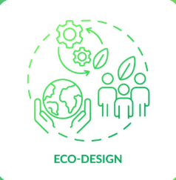

**7.1 Financial Performance and Cost Management**

**Operational Cost Reduction:**

* Energy efficiency improvements typically reduce costs by 20%
* Waste reduction and resource optimization savings
* Lower insurance premiums due to reduced environmental risks
* Reduced regulatory compliance costs and penalties

**Revenue Enhancement Opportunities:**

* Premium pricing for certified products and services
* Access to sustainability-focused market segments
* Government contract preferences and procurement advantages
* Enhanced investor confidence and capital access

**7.2 Risk Management and Compliance**

**Environmental Risk Mitigation:**

* 50% reduction in environmental incidents for certified companies
* Proactive compliance with evolving regulations
* Enhanced emergency preparedness and response capabilities
* Reduced liability and legal exposure

**Regulatory Advantage:**

* Streamlined regulatory reporting and compliance processes
* Positive relationships with regulatory authorities
* Early adoption of emerging environmental standards
* Reduced regulatory scrutiny and oversight

**7.3 Market Position and Competitive Advantage**

**Brand Reputation and Market Differentiation:**

* Enhanced brand credibility and consumer trust
* Competitive advantage in sustainability-conscious markets
* Improved customer loyalty and retention
* Media recognition and positive publicity

**Market Access and Expansion:**

* Entry into green procurement programs
* International market access through recognized certifications
* Partnership opportunities with sustainability-focused organizations
* Enhanced stakeholder relationships and trust

**7.4 Human Capital and Organizational Culture**

**Talent Attraction and Retention:**

* 5% annual increase in demand for sustainability expertise in Europe
* Enhanced ability to attract top talent
* Improved employee engagement and job satisfaction
* Professional development and skill enhancement opportunities

**Organizational Culture Benefits:**

* Stronger sense of purpose and mission alignment
* Enhanced innovation and creativity
* Improved collaboration and teamwork
* Positive workplace culture and employee pride

**7.5 Stakeholder Value and ESG Performance**

**Investor Relations and Capital Access:**

* Enhanced ESG ratings and sustainability scores
* Access to green financing and sustainable investment funds
* Reduced cost of capital and improved credit ratings
* Long-term value creation and resilience

**Benefits Distribution Analysis:**

* Compliance: 30%
* Cost Savings: 20%
* Reputation Enhancement: 20%
* Risk Management: 15%
* Stakeholder Trust: 15%

**SECTION 8: CASE STUDY ANALYSIS**

*Presenter: Vivian Ludrick (9914)*

**8.1 Success Stories in Green Certification**

**IKEA - Comprehensive Sustainability Certification:**

* Certifications: LEED, FSC (Forest Stewardship Council)
* Implementation: Renewable energy, sustainable materials, circular design
* Results: Significant energy cost reduction, enhanced brand appeal to eco-conscious consumers
* Impact: Global leadership in retail sustainability

**Microsoft - Technology Sector Leadership:**

* Certifications: LEED, Carbon Credits, ISO 14001
* Implementation: Carbon negative commitment, renewable energy transition
* Results: Strengthened reputation, enhanced talent attraction
* Impact: Industry benchmark for technology sustainability

**Emerald Packaging - Manufacturing Innovation:**

* Certification: Alameda County Green Business Program
* Implementation: Waste reduction, compostable packaging development
* Results: Lower waste costs, innovation in sustainable packaging
* Impact: Market leadership in sustainable packaging solutions

**Playa Hotels & Resorts - Tourism Sustainability:**

* Certification: Green Globe Certification
* Implementation: Energy efficiency, water conservation, waste reduction
* Results: Reduced utility costs, attraction of eco-conscious travelers
* Impact: Enhanced guest satisfaction and operational efficiency

**8.2 Implementation Challenges and Solutions**

**Common Implementation Challenges:**

* Initial certification costs and resource requirements
* Employee resistance to change and new procedures
* Complex documentation and compliance requirements
* Ongoing monitoring and maintenance costs

**Successful Solution Strategies:**

* Phased implementation approach with clear milestones
* Comprehensive employee training and engagement programs
* Investment in technology and automation systems
* Regular review and continuous improvement processes

**8.3 Quantified Business Impact**

**Financial Performance Metrics:**

* Average operational cost reduction: 15-25%
* Energy savings: 20-40% reduction in consumption
* Waste disposal cost reduction: 30-50%
* Insurance premium reductions: 10-20%

**Market Performance Indicators:**

* Customer satisfaction improvement: 15-30%
* Brand recognition and recall enhancement
* Market share growth in sustainability-focused segments
* Premium pricing capabilities: 5-15% above market rates

**SECTION 9: UNDERSTANDINGS FROM CASE STUDY - VISAKHAPATNAM GAS LEAK**

*Presenter: Jonathan Gomes (9900)*

**9.1 Critical Safety and Environmental Lessons**



The Visakhapatnam gas leak incident provides crucial insights into the importance of environmental management and safety protocols in industrial operations.

**Key Learning 1: Restarting Factories After Lockdown Requires Thorough Inspection**

* ✅ Long shutdowns can damage critical systems and infrastructure
* ✅ Comprehensive system checks must be conducted before restarting operations
* ✅ Pipelines, valves, sensors, and safety systems require detailed inspection
* ✅ Preventive maintenance schedules must account for extended shutdown periods

**Key Learning 2: Chemical Storage Conditions Must Be Constantly Monitored**

* ⚠️ Styrene and similar chemicals require precise temperature and pressure control
* ⚠️ IoT sensors and automated alarm systems are essential for continuous monitoring
* ⚠️ Regular manual inspections must complement automated systems
* ⚠️ Emergency response protocols must be immediately accessible and functional

**9.2 Safety Protocol and Compliance Requirements**

**Key Learning 3: Negligence in Safety Protocols Leads to Disasters**

* ❌ Single points of failure can cause widespread environmental and human harm
* ❌ Safety compliance must be strictly enforced at all organizational levels
* ❌ Regular internal and external audits are essential for identifying risks
* ❌ Cost-cutting measures must never compromise safety and environmental standards

**Key Learning 4: Worker Training on Emergency Handling is Critical**

* 🧑‍🏫 Workers are often the first responders in emergency situations
* 🧑‍🏫 Regular safety drills and emergency response sessions are mandatory
* 🧑‍🏭 All employees must be trained on proper use of emergency equipment
* 🧑‍🏭 Communication protocols and evacuation procedures must be well-practiced

**9.3 Environmental Management System Implications**

**Integration with Green Certification Requirements:**

* Environmental management systems must include comprehensive risk assessment
* Safety protocols and environmental protection are interdependent requirements
* Regular monitoring and auditing are essential components of certification maintenance
* Emergency preparedness and response capabilities are critical certification criteria

**Regulatory Compliance and Certification Synergies:**

* Green certifications enhance environmental risk management capabilities
* Certified organizations typically have better emergency response systems
* Continuous monitoring requirements in certifications prevent safety incidents
* Third-party audits in certification processes identify potential safety risks

**9.4 Prevention and Mitigation Strategies**

**Technology Integration:**

* Advanced monitoring systems with real-time data analytics
* Predictive maintenance systems to prevent equipment failures
* Automated safety shutdown systems for emergency situations
* Digital twin technology for system simulation and risk assessment

**Organizational Preparedness:**

* Comprehensive emergency response plans and procedures
* Regular training and simulation exercises for all personnel
* Clear communication channels with local authorities and communities
* Robust supply chain risk management and vendor assessment

**SECTION 10: CONCLUSION AND TAKEAWAYS**

*Presenter: Jonathan Gomes (9900)*

**10.1 Strategic Imperatives for Green Certification**

Green certifications have evolved from optional sustainability initiatives to strategic business imperatives that drive organizational success and resilience in the modern economy.

**Key Strategic Insights:**

💡 **Industrial Safety and Environmental Management are Inseparable:** The Visakhapatnam case demonstrates that environmental management systems and safety protocols must be integrated and rigorously enforced to prevent catastrophic incidents.

🏭 **Infrastructure Investment is Essential:** Companies dealing with hazardous substances must continuously upgrade infrastructure and monitoring systems to maintain certification standards and prevent environmental incidents.

📢 **Transparency and Communication Build Trust:** Open communication with stakeholders, including local communities, regulators, and employees, is essential for maintaining social license to operate and certification credibility.

**10.2 Implementation Recommendations**

**For Organizations Pursuing Certification:**

1. **Start with Leadership Commitment:** Ensure top management fully supports and champions the certification process
2. **Invest in Qualified Personnel:** Hire or train dedicated environment managers with appropriate expertise
3. **Adopt Phased Implementation:** Begin with foundational certifications like ISO 14001 before pursuing specialized standards
4. **Integrate Technology:** Leverage IoT, AI, and digital systems for continuous monitoring and improvement
5. **Build Cultural Change:** Engage all employees in sustainability initiatives and create accountability systems

**For Environment Managers:**

1. **Develop Cross-Functional Expertise:** Build knowledge across environmental science, business strategy, and regulatory frameworks
2. **Focus on Continuous Improvement:** Establish systems for ongoing monitoring, assessment, and enhancement
3. **Strengthen Stakeholder Relationships:** Build positive relationships with regulators, communities, and certification bodies
4. **Embrace Innovation:** Stay current with emerging technologies and best practices in sustainability management

**10.3 Future Outlook and Trends**

**Emerging Trends in Green Certification:**

* **Digital Integration:** Blockchain verification, AI-powered monitoring, and IoT-enabled real-time reporting
* **Circular Economy Focus:** Certifications increasingly emphasizing waste reduction, recycling, and circular design principles
* **Climate Action Integration:** Net-zero commitments and science-based targets becoming standard requirements
* **Social Impact Expansion:** Integration of social responsibility and community impact metrics in environmental certifications

**Market Projections:**

* Continued growth in consumer demand for certified sustainable products and services
* Increasing regulatory requirements linking environmental certification to market access
* Expanding investor focus on ESG performance and certified sustainability practices
* Growing talent shortage in sustainability expertise (18.7% projected shortage by 2030)

**10.4 Critical Success Factors**

**Essential Elements for Certification Success:**

1. **Leadership Commitment:** Unwavering support from senior management and board level
2. **Resource Allocation:** Adequate budget, personnel, and technology investments
3. **Cultural Integration:** Embedding sustainability into organizational DNA and daily operations
4. **Stakeholder Engagement:** Active involvement of employees, customers, suppliers, and communities
5. **Continuous Improvement:** Commitment to ongoing enhancement and innovation in sustainability practices

**10.5 Final Recommendations**

🛡️ **The Visakhapatnam tragedy serves as a critical wake-up call:** Organizations must ensure that environmental management and safety protocols are rigorously implemented and maintained, especially during uncertain times such as pandemics, shutdowns, or operational disruptions.

**Call to Action:**

* Organizations should view green certification not as a compliance burden but as a strategic opportunity for competitive advantage, risk mitigation, and stakeholder value creation
* Environment managers must position themselves as strategic business partners, demonstrating the clear linkage between environmental performance and business success
* The integration of safety, environmental management, and business strategy is essential for long-term organizational sustainability and resilience

**"Sustainability is no longer a choice—it's a business imperative. Green certifications provide the roadmap for organizations to thrive in an environmentally conscious world while contributing to global sustainability goals."**

**REFERENCES**

[1] Nature Berkeley. (2000). Environmental Certification Systems and Green Business Practices. https://nature.berkeley.edu/classes/es196/projects/2000final/godshall.pdf

[2] International Journal of Multidisciplinary Research. (2024). Green Building Certifications and Sustainable Development. https://www.ijfmr.com/papers/2024/6/32427.pdf

[3] ArXiv. (2023). Artificial Intelligence in Environmental Management and Sustainability Assessment. https://arxiv.org/pdf/2301.03291

[4] Sciendo. (2024). Real Estate Valuation and Environmental Certification Impact. https://sciendo.com/article/10.2478/remav-2024-0003

[5] MDPI Sustainability. (2024). Organizational Green Certifications and Business Performance. https://www.mdpi.com/2071-1050/16/3/1129

[6] Science Direct. (2024). Environmental Management Systems and Organizational Sustainability. https://www.sciencedirect.com/science/article/pii/S2352710224019697