**Investigation into Three Types of Nuclear Voltaic Batteries**

Mark Luke

*\*Affiliation Information, Street Address/Box Number, City, State Postal Code, Email address*

*†Second Affiliation, Street Address, City, State Postal Code, Email address*

INTRODUCTION

The need for batteries with high energy densities and long operating life is ever increasing as military and medical demands grow. Nuclear voltaic batteries are potential solutions for many of these applications. Many have already been used for pacemakers, space missions, and remote laboratories. The different types of nuclear batteries are fairly application specific, as some work well in micro-scale, and others when a large amount of power is required. This abstract explores and compares three different kinds of nuclear batteries: Radioisotope thermoelectric generators, alphavoltaics, and reciprocating electromechanical generators.

**DISCUSSION**

The first type of battery being examined in this abstract is a radioisotope thermoelectric generator (RTG). A RTG utilizes a radioisotope to produce a temperature gradient between the ends of a thermocouple. This temperature gradient produces a usable voltage via the Seebeck effect. NASA, with the help of contractors, has designed and used these RTGs in many of their long term space missions. Two of these are the General Purpose Heat Source Radioisotope Thermoelectric Generator (GPHS-RTG), and the Multi-Mission Radioisotope Thermoelectric Generator (MMRTG). The former is no longer in production, being replaced by the MMRTG for Mars Missions. Both RTGs use a Pu-238 source as it is an alpha emitting isotope (~5.6 MeV), has a long half-life (87.7 years), and has low gamma and neutron radiation. These characteristics make Pu-238 an ideal source to be used in space applications because of its long half-life and low shielding requirements.

The GPHS-RTG was used for the Galileo mission to Jupiter- Cassini mission to Saturn, and New Horizons missions to Pluto. Figure 1 below shows a cross section of the GPHS-RTG.

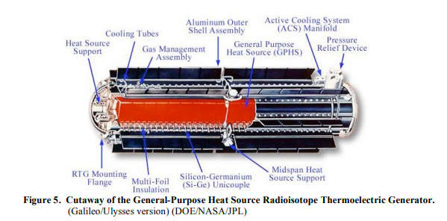

Fig 1. Cross sectional view of the GPHS-RTG system [2].

The GPHS-RTG consists of two units, the thermopile used to generate current and the heat source to create a temperature gradient. The thermopile is 572 thermoelectric elements that use different kinds of semiconductor alloys to create the voltage output to power the different missions. Design of the heat source was primarily concerned with the safety of the radioisotope and keeping it concealed upon any unexpected impact. Five components made up the GPHS – the fuel (Pu-238 enriched to 83.5 percent), cladding, a graphite impact shell, a carbon-bonded carbon fiber insulation, and a fabric aeroshell [2]. In the event of an ejection, the aeroshell would be able to withstand reentry heating and stresses, while the graphite impact shell would contain the source during impact. Figure 2 below shows an expanded view of the GPHS.

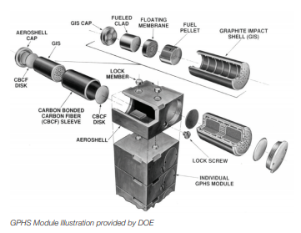

Fig 2. Expanded view of GPHS [2].

Overall, the GPHS-RTG was rated for 300 Watts electric (We) and 4410 Watts thermal (Wt), giving an efficiency of 6.8 percent. With a mass of 55.9 kg and volume of 0.17 m3, the energy density of the system is 1715 We/m3 [2].

The successor to the GPHS-RTG is the MMRTG. The design of the RTG itself is similar, using the same type of heat source (eight GPHS [1]), and slightly different thermopile system. A vacuum sealed container is used for the thermoelectric converter to allow the MMRTG to survive in harsher environments, specifically Mars. Characteristics of this battery include powers of 114 We, 2000 Wt, an efficiency of 5.7 percent, mass of 45 kg, volume of 0.21 m3, and energy density of 537 We/m3 [1]. While these seem substantially worse than the GPHS-RTG, the lower weight and ability to withstand harsher environments make the MMRTG desirable for missions to extraterrestrial worlds.

Next, an alphavoltaic battery was investigated. Alphavoltaics are expected to produce much high energy density batteries due to having a higher decay energy than betavoltaics. However, because of this energy discrepancy, radiation hardness of the semiconductor material must be high to withstand damage from the alpha particles. Am-241, the source used in smoke detectors, was chosen due to its long half-life, availability, and energy density. Diamond doped with Boron was chosen as the conversion material due to its radiation hardness, wide band-gap, and high carrier mobility [3]. Using SRIM, the design of the converter was optimized for maximum alpha energy deposition in the depletion region (about 1 μm thick). A quasi-vertical configuration of the device is used for simplicity of manufacturing. Below in Figure 3, a cross section of the device is shown.

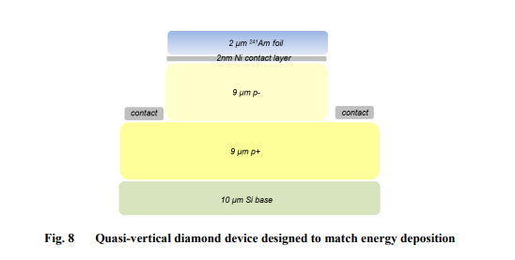

Fig 3. Schematic of quasi-vertical diamond device [3].

With 1 Curie (Ci) of Am-241 lain on top of the Schottky contact, theoretical power and efficiency was found for a 1 cm2 device. Total power from decay is approximately 30 mW, with 5.6 mWe being deposited in the depletion region. By using ten of these devices at 1 mm thick, a power density of 25 mWe/cm3 can be achieved [3]. This power density is much higher than the batteries mentioned previously, but the scale and manufacturing process for this kind of battery make it difficult to increase in size for larger applications. These batteries would likely be used for powering small electronics for military or medical use.

The final type of battery researched was a reciprocating electromechanical nuclear battery. This kind of battery combines concepts of nuclear, mechanical and electrical engineering to create a small, long lasting battery for microsystems that can operate in a wide range of temperatures. The idea behind the battery is a cantilever beam with piezoelectric material and a radiation collector attached, with source just under the collector. Figure 4 shows a schematic of the design.

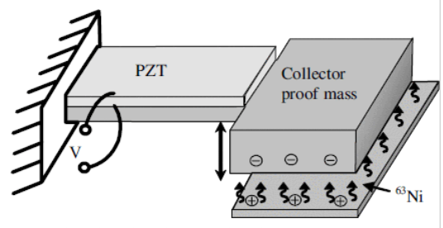

Fig 4. Schematic of reciprocating electromechanical nuclear battery [4].

As the source, in this case Ni-63, emits low energy beta particles, the collector builds up a negative charge and source builds a positive charge. This discrepancy in charge pulls the two together until they touch, where the charge is neutralized. The cantilever beam then springs back, producing an oscillating voltage due to the piezoelectric material experiencing mechanical stress. For this type of battery and under vacuum pressure, efficiency was found to be 3.7 percent, with a power output of 1.13 μW per oscillation [4]. Energy density is estimated at 5 W/m3 per vibration cycle.

Table 1 below summarizes the different battery characteristics discussed in this paper.

|  |  |  |
| --- | --- | --- |
| TABLE I. Nuclear Voltaic Battery Characteristics | |  |
| Battery | Energy Density (W/m3) | Efficiency |
| GHPS-RTG | 1715 | 6.8 |
| MMRTG | 537 | 5.7 |
| Alphavoltaic | 25000 | 44.2** |
| Reciprocating Electromechanical | 5* | 3.7 |
| *per vibration cycle |  |  |
| **theoretical efficiency |  |  |

RESULTS

The batteries discussed have great potential for a variety of applications needing a long lasting, reliable energy source. RTGs can be used for larger applications requiring powers over hundreds of Watts and in harsh environments. Alphavoltaics and reciprocating electromechanicals have great potential for use in micro-electronics that need high energy densities to reduce weight and increase operating lifetime of equipment. Manufacturing of the micro nuclear voltaic batteries poses a problem for mass production, as they require advanced material processes.

**REFERENCES**

1. “Multi-Mission Radioisotope Thermoelectric Generator (MMRTG),” NASA-2013, National Aeronautics and Space Administration (2019).

2. G. L. BENNETT, J. L. LOMBARDO, R. J. HEMLER, G. SILVERMAN, C. W. WHITMORE, W. R. AMOS, E. W. JOHNSON, A. SCHOCK, R. W. ZOCHER, T. K. KEENAN, J. C. HAGAN, R. W. ENGLEHART, “Mission of Daring: The General-Purpose Heat Source Radioisotope Thermoelectric Generator,” AIAA-2006, American Institute of Aeronautics and Astronautics (2019).

3. J. LANGLEY, M. LITZ, J. RUSSO, W. RAY JR, “Design of Alpha-Voltaic Power Source Using Americium-241 and Diamond with a Power Density of 10 mW/cm3,” ARL-2017, Army Research Lab (2019).

4. R. DUGGIRALA, R. POLCAWICH, E. ZAKAR, M. DUBEY, H. LI, A. LAL, “MEMS Radioisotope-Powered Piezoelectric μ – Power Generator (RPG),” IEEE-2006, Institute of Electrical and Electronics Engineers (2019).