Lotus Live Plugin
Functional Specification

fdsfdsfdsfds

Revision: 1.0.1
Date of Issue: 06/17/2011
Revision Status: draft

Document Control Information

Document Author: Zhang Peng (pzzhang@cn.ibm.com)
Component Lead: Bo Min Nie(niebomin@cn.ibm.com)

Document Approver(s): (All Approvers are required. Records of each approver must be maintained in the Lineitem DB.)

Approver Name | Role
Zhao Xia

Document Mandatory Reviewers: (Records of each required reviewer must be maintained in the Lineitem DB.)

Mandatory Reviewer Name | Role
Yan Ji
Yong Lin Ma

Document Reviewers: (Records of each required reviewer could be maintained in the Lineitem DB..)

Reviewer Name | Role

Summary of Changes:

The Document Author is authorized to make the following types of changes to the document without requiring that the document be re-approved:

- Editorial, formatting, and spelling
- Clarification
- Document structure

To request a change to this document,
- Contact the Document Author or Component Lead
- Once this document is approved, any Change Request need be submitted in the Change Request DB to get CCB decision. When CR is approved, the Document Author revises this FS with updating the table below.

Changes to this document are summarized in the following table in chronological order.

Revision | Date | Created by | Short Description of Changes (with CR# if have)
1.0 | 6/17/10 | Zhang Peng | draft
Document Source:

Table of Contents
1.Introduction 4
Purpose 4
Scope 4
Definitions, Acronyms, and Abbreviations 4
References 4
2. Overall Description 4
2.2 Functions and subsets 5
Use-Case Model Survey 13
2.3 Assumptions, Constrains and Dependencies 13
Specific Requirements 13
Use-Case Reports 13
Functionality 17
Interfaces 17
Performance 17
Usability - Accessibility 17
Usability - Others 17
Globalization (G11N) 17
Security 17
Supportability [Maintainability] 18
Installability 18
Design Constraints 18
Software Reuse and Componentization 18
On-line User Documentation and Help System Requirements (guideline) 18
Purchased Components 18
Licensing Requirements 18
Legal, Copyright, and Other Notices 18
Applicable Standards 18
Supporting Information 18

Functional Specification

Introduction

Purpose
This document defines the requirement of lotus Live plugin applied for Symphony standalone and embedded Symphony, including functional and nonfunctional requirements, design constraints, and other factors necessary to provide a complete and comprehensive description of the requirements. This document is for code designer, tester, customer and other people who care about the feature.

Scope
This function specification describes the necessity of Lotus Live plugin in Symphony standalone and embedded Symphony, provides the new features for communicating with Lotus Live Cloud using the Lotus Live service, introduces how to upload/download/share files and integrate meetings using Lotus Live APIs. Besides that, it makes sure the UI consistency with the Symphony and Notes products and summarizes the use cases we should considered.

Definitions, Acronyms, and Abbreviations
LL: Lotus Live.
REST: REpresentational State Transfer

References
Lotus Live API and Extensions.

2. Overall Description
Lotus Live(LL) APIs enable the applications residing outside LL to access content, LL plugin integrates LL features into Symphony products. With LL plugin, symphony products can be easily extended into cloud area, users can edit/view the same document among different places and different devices, and fast spread their interests and knowledge with others via document sharing.

2.1 Related LL APIs

Description | Command
Share this file with someone | POST to https://apps.lotuslive.com/files/atom/file/{fileId}/shares
Share this collection with someone | POST to https://apps.lotuslive.com/files/atom/collection/{collectionId}/shares
Get a list of your files | GET to https://apps.lotuslive.com/files/atom/{userId}/files
Get a list of your collections | GET to https://apps.lotuslive.com/files/atom/{userId}/collections
Get media associated with a file entry | GET to http://apps.lotuslive.com/files/atom/file/{fileId}/media
Upload a new version of this file | PUT to http://apps.lotuslive.com/files/atom/file/{fileId}/media
Create new collection | POST to https://apps.lotuslive.com/files/atom/{userId}
Delete file share | DELETE to http://apps.lotuslive.com/files/atom/file/{fileId}/shares/{shareId}
Get a list of your files and collections | GET to https://apps.lotuslive.com/files/atom/{userId}
Get shares for collection | GET to https://apps.lotuslive.com/files/atom/collection/{collectionId}/shares
Get shares for file | GET to https://apps.lotuslive.com/files/atom/file/{fileId}/shares
Get file share details | GET to http://apps.lotuslive.com/files/atom/file/{fileId}/shares/{shareId}
Get Collection share details | GET to http://apps.lotuslive.com/files/atom/collection/{collectionId}/shares/{shareId}

2.2 Functions and subsets

2.2.1 UI Contributions

The main presentation layer for User Interface contributed by LL plugin contains:

ShelfView Contributions, MainToolbar Contributions and Preference Page Contributions.

Shelf View Contributions

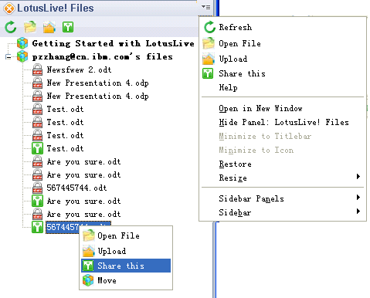

LL plugin contributes a Shelf View called Lotus Live! Files view(LL view) to Symphony. The LL view contains the LL File list viewer, the View Toolbar and the drop down menu bar.

a) LL File List Viewer

Nodes. LL File List Viewer has two types of Nodes, Collection Node and File Node. Collection is the group of files, which is consistent with the Lotus Live definitions. The sub node of Collection are file nodes, represents the files under the same collection. We treate Files Group as a special collection(In online version of LL, the representation for Files is different.). The collections and Files listed in the LL File List Viewer has the one-one relationship with the files stored in Lotus Live Cloud.

The files are sorted in a Latest-First order, the newly created file listed in the top of the file list. This is consistent with the Atom feeds.

Tooltip. LL File List Viewer enables tooltip for each file Node. The tooltip shows detailed information for the collections and files, users can easily hover the mouse to collection or file nodes to show more information for them.
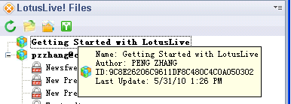
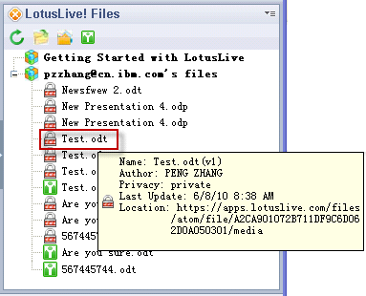

Cotext Menu.

The Context Menu only applied for the LL File Node to Complete tasks for the file. Selection for multi files is not supported. No Context Menu shows when current selection object is collection.

The Context Menu item include: “Open File” item, “Share this” item, “Upload” item and “Move” item.

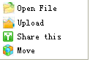
The detailed definitions are list in the following table:

Item | Behavior | Enable When | Scope
“Open File” item | Open a remote LL file. | One LL file node from LL files View was selected. Otherwise disabled. | The Lotus Live view.  Actions for these items can not apply to current opened document.
“Share this” item | Share a remote LL file
“Upload” item | Upload a new version to the remote from Local file store.
“Move” item | Move file from one LL connection to another.

b) LL files View Toolbar.

The Lotus Live View Toolbar provides the alternative way for LL file manipulate other than Context Menu. When no file selected, the toolbar items are disabled. The LL view Toolbar item only applies to the selected LL file Node.

The View tool bar items include: “Open File” item, “Share this” item, “Upload” item and “Refresh” item.

The detailed definitions are list in the following table:

Item | Behavior | Enable When | Scope
“Open File” item | Open a remote LL file. | One LL file node from LL files View was selected. Otherwise disabled. | The Lotus Live view.  Actions for these items can not apply to current opened document.
“Share this” item | Share a remote LL file
“Upload” item | Upload a new version to the remote from Local file store.
“Refresh” item | Get the latest remote information and refresh the LL files View. | Always enable in LL files View.

c) LL files View Drop Down Menu Bar.

Besides all the items exist in LL View Toolbar and Default ShelfView, tusers can reference help from this menu bar.

The View bar items include: “Open File” item, “Share this” item, “Upload” item and “Refresh” item.

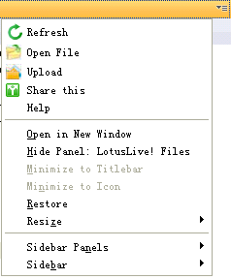

The detailed definitions are list in the following table:
Item | Behavior | Enable When | Scope
“Open File” item | Open a remote LL file. | One LL file node from LL files View was selected. Otherwise disabled. | The Lotus Live view.  Actions for these items can not apply to current opened document.
“Share this” item | Share a remote LL file
“Upload” item | Upload a new version to the remote from Local file store.
“Refresh” item | Get the latest remote information and refresh the LL files View. | Always enable in LL files View.
“Help” item | Show the help information for LL plugin. | Always enable in LL files View. | The Lotus Live view.

Preference Page Contribution

LL plugin needs the LL account for using LL services. Thus it contributes to the Symphony Preference page for LL account settings as a seamless integration. The preference page automatically pops up when using for the first time, after that the preference page can be accessed via File->Preferences.
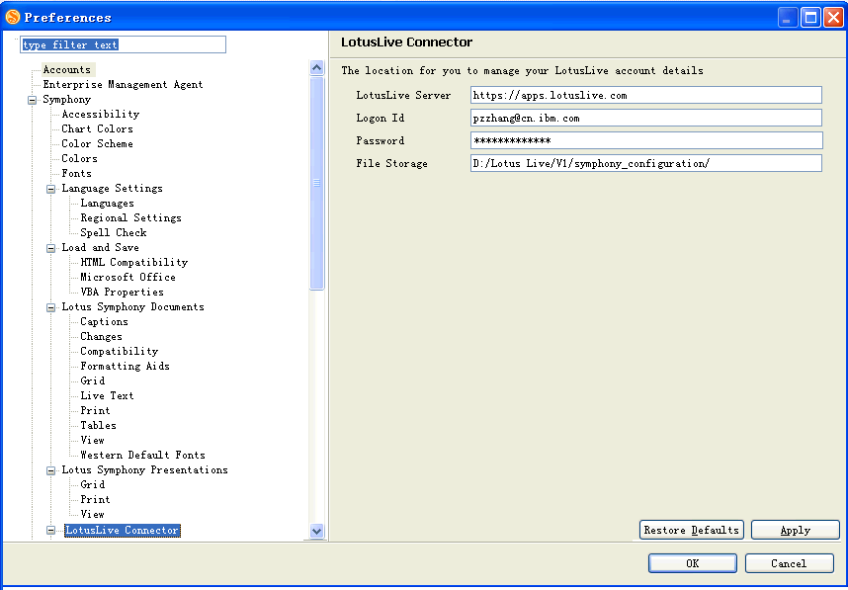

Main Toolbar Contributions

LL plugin cotributes a set of Toolbar to the main menu. Those toolbar items whose context is the opened symphony document are sensitive for the opened view. Only the focus is in Symphony document view, these toolbar items can be enabled.
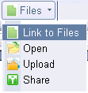
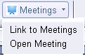


The main tool bar items contains two subset: Files subset and Meetings subset. The files subset include: “Link to Files” item, “Upload” item, “Share” item. And the meetings subset include: “Link to meetings” item, “Open Meeting” item.

The following are the details for all the toolbar items.
Item | Behavior | Enable When | Scope
“Lotus Live about” item | Show Lotus Live help. | Always enable in the main tool bar. | The whole window.
“Link to Files” item | Open the URL link for the Lotus Live files. | Always enable in the main tool bar. | The whole window.
“Upload” item | Upload current opened document to the remote side. | Enable when there are symphony documents opened. | The current opened document.
“Share” item | Share current opened document to the remote side. | Enable when there are symphony documents opened. | The current opened document.
“Link to Meetings” item | Open the URL link for the Lotus Live files. | Always enable in LL files View. | The whole window.
“Open Meetings” item | Pass the user verification information to the Lotus Live, and directly open the host meeting page in the browser. | Always enable in LL files View. | The whole window.
“LL preference” item | Configure the Lotus Live settings. | Always enable in LL files View. | The whole window.

2.2.2 Enable Communications with Lotus Live.

LL service provided the REST style APIs, the LL plugin use these APIs for the communication with LL server. For the file or collection information, the LL service adopted Atom feeds and protocol for the file transfer.

Account Configurations

The LL plugin uses LL account for the server authentication. When the first time the LL plugin was enabled(UnFold the shelf view), it will automatically pops up the Configuration Preference page.(Reference the Preference Page Configuration Figure).

In the Configuration page, users need to provides their LL server URL, their Login Id, their Password for the basic authentication of LL server. After applying the settings, a password Key will be stored into the Symphony key store for account management.

There is another field, “File Storage”. This field asks for a local storage directory, under which the downloaded LL file will be stored.

After the Click of “OK” button, if the account settings was changed, the LL view will refresh it's collection and file list to fetch the latest information for the newly used account.

LL View File Operations

Open File

This operation can open a file that shown in the LL viewer file list, that is, in the LL server. When a LL file selected, the Open File action will be enabled, by executing the open action, the selected file will be downloaded as a local copy. The downloaded local copy will be stored under the directory configured in the Preference page.

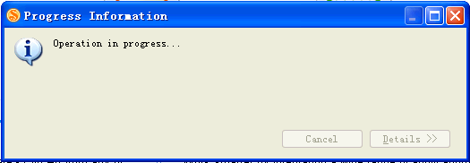
While downloading, A progress dialog will be shown to indicate the downloading and opening process. After that, the local stored file will be opened in the Left side.

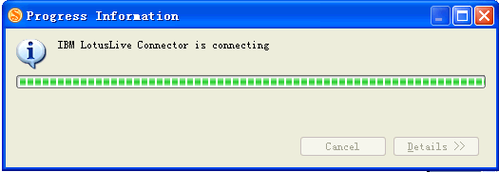

Editing the file will only directly changes the local copy, but when the save action performs, a confirm dialog will be pop up to ask whether applying the change to the LL server.
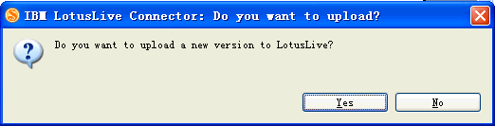

If we close the file and don't make any change to the server, then the next time when we open from local file store or open through the recent files, the update dialog can not be shown, the modification has no relationship with the remote one. Only re-open from the LL viewer file list can enable the remote file's update.

Move File

File can be moved from one collection to the other collection. We can enable this feature either by drag&drop the file from one collection to another in the LL list viewer, or by using the View Context/Toolbar/DropDownBar “Move” item.

The Move action will move both change local side and the server side list structure.

Upload File

In LL, file have version property to indicate how many times it was changed. We can access this operation via via LL the View Context/Toolbar/DropDownBar “Upload” item. The upload will still pops up the progress dialog for processing, and when upload completed, a new information dialog will be shown:
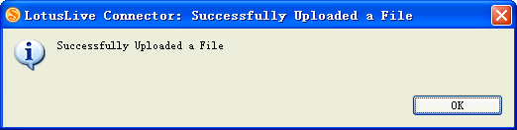

The upload action will not create a new server copy with the increased version, but overwrite the original version. That means, we can not find the old version through the server.

After the upload, the file's version increased. Users can capture this change through file details:
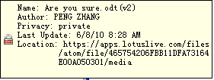

Share File

In LL, file have it's privacy property. The default property is private, means only the person who uploaded the file can access that file. After uploaded the file, we can share the file with others via LL ids. This feature can be enabled via LL the View Context/Toolbar/DropDownBar “Share” item.

By executing the “Share” item, a dialog pops up for inputting the LL ids users want to share with:
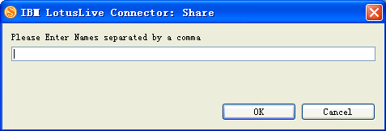

LL plugin enables the search API to acquire the closest 9 LL ids for choose when user inputting the LL ids. The LL ids inputted will be included for share list of the file. Those who owns the LL ids can access the file after successfully execution of the “Share” item.

Show File Details

When mouse stopped at a LL collection node and LL file node, Details for that Collection/File will be shown for 10 seconds(if mouse not moved during this time).

For collection, it includes: Name/Author/ID/LastUpdated.
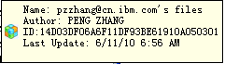

For file, it includes: Name(Version)/Author/Privacy/LastUpdated date/Server Location.
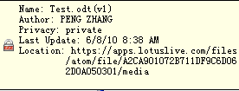

Opened Local File Operations

The operations for opened local file can be accessed via main toolbar items. This includes Upload and Share function.

Local File Upload

After opening a local file, the upload item in the main tool bar will be enabled. By executing this feature, the File will be uploaded into the server side, and the LL Viewer List in the LL View will be refreshed, newly uploaded file will be shown in the LL viewer list.

During the process, the same dialogs will be shown as the Upload File for the LL view.

Local File Share.

The local file share feature is the combination of 2 actions: upload the file into the server, and share the server file with others. The first step is the same as Local File Upload function, the second step is the same as the share file.

Other integrated LL features

Besides the file upload/download/share, LL plugin provides some other convenient functions.

Links to the Files

Users can locates the Files Location of Lotus Live via the “Main Toolbar Files”->“Link to Files” item. This will open the files collection in the website. The action behavior for this item follows the Symphony and Notes rules:
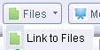

1. When the Symphony or Notes Preference Web browser settings is configured as “Use the browser embedded in this client”, the New web page will be opened in a new tab of the application window.

2. If configured as “Use the browser I have set as the default for this operating system”, then the new page will be opened in the default browser.
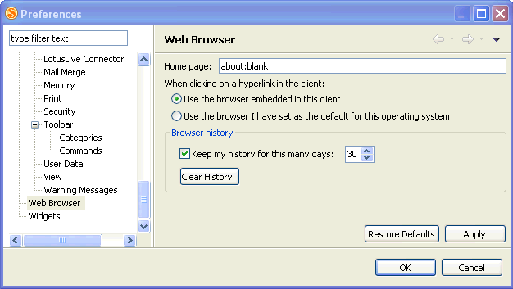

Links to the Meetings

The link to Meetings feature is similar as Link to files, the only difference is the link URL is Lotus Live meetings place.


If no cache stored in the browser, the login will not be automatically completed, the Lotus Live will first ask for credentials in the website. After that, the meetings page will be shown for Hosting or Joining the a meeting.
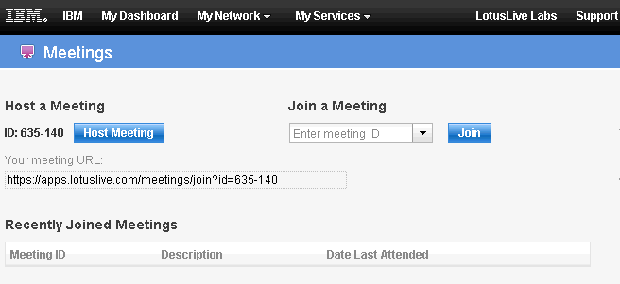

Open Meetings

Open Meetings feature enables user to directly host a meeting without re-input any login information. It uses the LL Meetings API to pass the authentication information to the server.
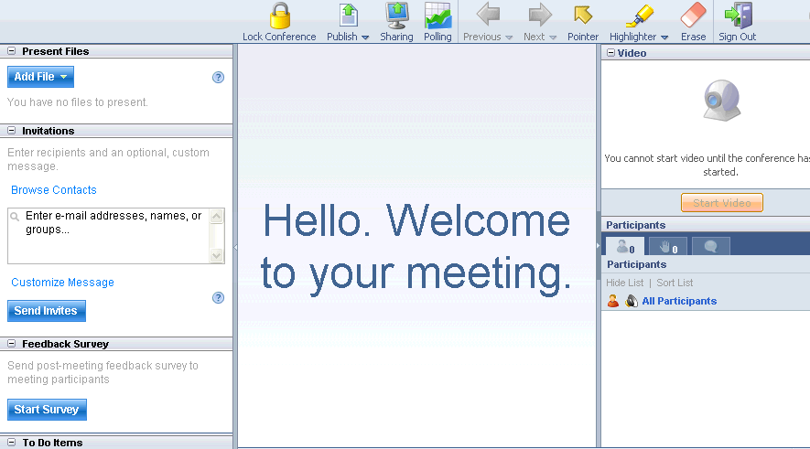

Use-Case Model Survey
Please refer to the session 3.1 to get the detail use case scenarios. If it does not mention the use case is applied to embedded Symphony or Symphony standalone, it means both.

2.3 Assumptions, Constrains and Dependencies
Assumptions
- The Used Lotus Live API will not be changed before Symphony 3.0 GA.
- Symphony has no significant change for API structure and UI style before 3.0 GA.
Constrains
- Constraints on Lotus Live API.
- Constrains on Symphony Java API.
- The tight schedule for Symphony GA.
Dependencies
- The provided features by Symphony LL plugin depend on the Lotus Live provided APIs.
- Symphony APIs: com.ibm.symphony.javaapi, com.ibm.symphony.javaapi.ui. Symphony Personally settings: com.ibm.symphony.personality.
- XPD accounts functionality, UI functionality.

Specific Requirements

Use-Case Reports

Scenario 1 : Accounts Configuration
Use Case NO. | Use Case steps | Result for each step
Case 1. | 1. Open the Lotus Live View for the first time.(No Accounts set before).  2. Input the LL server url, LL id, password and local copy repository location.  3. Click OK. | 1. Preference page for accounts will be shown automatically.  2. Default location is in the Symphony workspace.  3. The LL view will be updated, and the LL Collections and LL Files List will be shown. The list contains all the supported lists and files that listed in https://apps.lotuslive.com/files and https://apps.lotuslive.com/collections.
Case 2. | Open the Lotus Live View.(Accounts has been already set before). | The LL view will be shown, with the LL Collections and LL Files List shown.
Case 3 | 1.Open File->Preference, locate to the Lotus Live Connections Page.  2.Change the LL account settings. Input another LL id and password. Click OK. | 1. In the right side, the settings configured will be shown.  2. The LL view will be updated, and the LL Collections and LL Files List for the new accoutns will be shown.
Case 4 | 1.Open File->Preference, locate to the Lotus Live Connections Page.  2.Change the the local file settings. Input another location for local copy repository. | 1. In the right side, the settings configured will be shown.  2. The new files will be stored in the new location which is exactly the same as the new Location settings.

Scenario 2 : Open a remote document
Use Case NO. | Use Case | Result for each step
Case 1 | 1. Open the Lotus Live view. Select one LL ducument.  2. Double click the document or click the view toolbar item or context menu item “Open File”. | 1. Items include “Open File”, “Upload”, “Share this” in the view toolbar is enabled. Items include “Open File”, “Upload”, “Share this” and “Move” in the context menu is enabled.  2. A dialog for progress will be shown, after that, the local copy of the remote file will be opened.  Viewing from file systems, an local copy of remote file will be downloaded into configured repository.
Case 2 | 1. Open an existed LL document shown in the LL View.  2. Double click the LL document again from the LL View. | 1. A dialog for progress will be shown, after that, the local copy of the remote file will be opened.  Viewing from file systems, an local copy of remote file will be downloaded into configured repository.  2. The focus moved to the opened LL document. No more tab created in Symphony View Perspective.
Case 3 | 1. Open an existed LL document shown in the LL View.  2. Close the document, and double click the LL document again from the LL View. | 1. A dialog for progress will be shown, after that, the local copy of the remote file will be opened.  Viewing from file systems, an local copy of remote file will be downloaded into configured repository.  2. A dialog for progress will be shown, after that, another local copy of the remote file will be opened.  Viewing from file systems, another local copy of remote file will be downloaded into configured repository. The former copy has no relationship with the remote file.

Scenario 3 : Move Remote File
Use Case NO. | Use Case | Result for each step
Case 1 | 1. Select an existed document from one LL collection,  2. Drap&drop it into another LL collection.  2. Double click the LL File. | 1.The View toolbar/Context Menu/Popdown items are enabled by the selection.  2. The LL file will be placed in the new collection.  3. Symphony opens the remote local copy of the double clicked LL File.
Case 2 | 1. Select an existed document from one LL collection.  2. Click “Move” item from the Cotext Menu.  3. Input another existing Collection Name, click OK.  4. Double click the document. | 1.The View toolbar/Context Menu/Popdown items are enabled by the selection.  2. A dialog for inputting other collections will be shown.  3. The LL file will be placed in the new collection.  4. Symphony opens the remote local copy of the double clicked LL File.

Scenario 4 : Share Remote File
Use Case NO. | Use Case | Result for each step
Case 1 | 1. Select an existed document from one LL collection,  2. Click “Share” item from the Cotext Menu/Toolbar view item.  3. Input another LL id, click OK. | 1.The View toolbar/Context Menu/Popdown items are enabled by the selection.  2. A dialog for inputting the LL id will be shown.  3. The selected file icon changed. It's state become shared. Others will receive an email for the sharing.

Scenario 5 : Upload a new version of Remote File
Use Case NO. | Use Case | Result for each step
Case 1 | 1. Select an existed document from one LL collection.  2. Click “Upload” item from the Cotext Menu/Toolbar view item. | 1.The View toolbar/Context Menu/Popdown items are enabled by the selection.  2. A dialog indicating progress will be shown, after that, a dialog informs the upload successful. After the update, Hover the LL file, it's version will be increased.

Scenario 6 : Upload a local file
Use Case NO. | Use Case | Result for each step
Case 1 | 1. In the home page, Open a local file from local file system.  2. Click “Upload” from the Main toolbar item.  3. Close the local file. | 1.The “Upload” and “Share” item in the main toolbar is enabled by the selection.  2. A dialog indicating progress will be shown, after that, a dialog informs the upload successful. After the update, the LL view will be automatically refreshed, the newly uploaded file will be listed under the “Files” tab.  3. The tab returned into the Hope page. The “Upload” and “Share” item in the main toolbar is disabled.
Case 2 | 1. In the home page, Open a local file from local file system.  2. Click “Upload” from the Main toolbar item.  3. Make some change in the content ,and click “Upload” again.  4. Close the local file.  5. Double click the uploaded file in the LL Files View list. | 1.The “Upload” and “Share” item in the main toolbar is enabled by the selection.  2. A dialog indicating progress will be shown, after that, a dialog informs the upload successful. After the update, the LL view will be automatically refreshed, the newly uploaded file will be listed under the “Files” tab.  3. A dialog indicating progress will be shown, after that, a dialog informs the upload successful. After the update, the LL view will be automatically refreshed. The version for the uploaded file has been increased.  4. The tab returned to home page. The “Upload” and “Share” item in the main toolbar is disabled by the selection.  5. The “Upload” and “Share” item in the main toolbar is enabled by the selection. And the opened document is the last updated document.

Scenario 7 : Share a local file
Use Case NO. | Use Case | Result for each step
Case 1 | 1. In the home page, Open a local file from local file system.  2. Click “Share” from the Main toolbar item.  3. Input LL accounts for sharing, click “OK”.  4. Close the local file. | 1.The “Upload” and “Share” item in the main toolbar is enabled by the selection.  2. A dialog indicating progress will be shown, after that, a dialog for inputting LL account shows up.  3. the LL view will be automatically refreshed, the newly shared file will be listed under the “Files” tab with the “Share” icon.  4. The tab returned into the Hope page. The “Upload” and “Share” item in the main toolbar is disabled.
Case 2 | 1.In the home page, open a local file from local file system.  2. Click “Upload” from the main toolbar item.  3. Click “Share” from the Main toolbar item.  4. Input LL accounts for sharing, click “OK”. | 1.The “Upload” and “Share” item in the main toolbar is enabled by the selection.  2. A dialog indicating progress will be shown, after that, a dialog informs the upload successful. After the update, the LL view will be automatically refreshed, the newly uploaded file will be listed under the “Files” tab.  3. a dialog for inputting LL account shows up.  4. the LL view will be automatically refreshed, the newly shared file will be listed under the “Files” tab with the “Share” icon.

Scenario 8 : Close a remote document/uploaded or shared local document
Use Case NO. | Use Case | Result for each step
Case 1 | 1. Open an existed LL document shown in the LL View.  2. Edit the opened document, and save it.  3. Click Yes.  4. Reopen the document from the LL View. | 1. A dialog for progress will be shown, after that, the local copy of the remote file will be opened. The “Share” and “Upload” item will be enabled from the main toolbar.  Viewing from file systems, an local copy of remote file will be downloaded into configured repository.  2. A dialog pops up, asking for whether save the document to the remote side.  3. Tab closed. If no other Symphony document open ,the “Share” and “Upload” item will be disabled. The modified document is updated to the remote side.  4. The document opened, with the changes made in the last time. The “Share” and “Upload” item will be enabled from the main toolbar.
Case 2 | 1. Open an existed LL document shown in the LL View.  2. Edit the opened document, and save it.  3. Click No.  4. Reopen the document from the LL View. | 1. A dialog for progress will be shown, after that, the local copy of the remote file will be opened. The “Share” and “Upload” item will be enabled from the main toolbar.  Viewing from file systems, an local copy of remote file will be downloaded into configured repository.  2. A dialog pops up, asking for whether save the document to the remote side.  3. Tab closed. If no other Symphony document open ,the “Share” and “Upload” item will be disabled. The modified document will not be updated to the remote side.  4. The document opened, with original text before the change. The “Share” and “Upload” item will be enabled from the main toolbar.
Case 3 | 1. Open a local file from local file system.  2. Click “Upload” from the Main toolbar item.  3. Edit the opened document, and save it.  4. Click Yes.  5. Reopen the document from the LL View. | 1.The “Upload” and “Share”item in the toolbar is enabled by the selection.  2. A dialog indicating progress will be shown, after that, a dialog informs the upload successful. After the update, the LL view will be automatically refreshed, the newly uploaded file will be listed under the “Files” tab.  3. A dialog pops up, asking for whether save the document to the remote side.  4. Tab closed. If no other Symphony document open ,the “Share” and “Upload” item will be disabled. The modified document is updated to the remote side.  5. The document opened, with the changes made in the last time.The “Share” and “Upload” item will be enabled from the main toolbar.
Case 4 | 1. Open a local file from local file system.  2. Click “Share” from the Main toolbar item.  3. Input LL accounts for sharing, click “OK”.  4. Edit the opened document, and save it.  5. Click No.  6. Reopen the document from the LL View. | 1.The “Upload” item in the toolbar is enabled by the selection.  2. A dialog indicating progress will be shown, after that, a dialog for inputting LL account shows up.  3. the LL view will be automatically refreshed, the newly shared file will be listed under the “Files” tab with the “Share” icon.  4. A dialog pops up, asking for whether save the document to the remote side.  5 Tab closed. If no other Symphony document open ,the “Share” and “Upload” item will be disabled. The modified document will not be updated to the remote side.  6. The document opened, with original text before the change. The “Share” and “Upload” item will be enabled from the main toolbar.

Scenario 9 : Main toolbar functionality

Use Case NO. | Use Case | Result for each step
Case 1 | 1. Keep the LL main toolbar shown. Open a embedded browser.  2. Open a symphony document.  3. Switch the tab between embedded browser and symphony document. | 1. The “Share” and “Upload” item is in disabled state.  2. The “Share” and “Upload” item will changed to enabled state.  3. The “Share” and “Upload” item will be enabled when the current tab is Symphony ducment tab, and will be enabled when the current tab is embedded browser.
Case 2 | 1. Keep the LL main toobar shown.  2. Right click the toolbar area, in the context menu uncheck the LL main toolbar.  3. Check the LL main toolbar again. | 1. The LL main toolbar is shown.  2. The LL main toolbar is removed.  3. The LL main toolbar will be shown again.
Case 3 | 1. Open a Symphony document.  2. Change the focus into LL files view.  3. Change the focus back to the Symphony document tab. | 1. All the toolbars for the Symphony document is shown.  2. All the toolbars for the Symphony document is hidden.  3. All the toolbars for the Symphony document is shown again.

Scenario 10 : Test the Links
Use Case NO. | Use Case | Result for each step
Case 1 | 1. Click “Link to files” in the main toolbar.  2. Input the correct login information and click OK. | 1. The LL Login page will be opened in the browser or new tab for Symphony.  2. The “Files” page for LL will be shown.
Case 2 | 1. Click “Link to meetings” in the main toolbar.  2. Input the correct login information and click OK. | 1. The LL Login page will be opened in the browser or new tab for Symphony.  2. The “meetings” page for LL will be shown.
Case 3 | 1. Click “Open meetings” in the main toolbar. | 1. The browser or new tab for Symphony will directly opened a page for hosting the meeting without input the login information.

Functionality
N/A

Interfaces

User Interfaces
N/A

Software Interfaces
N/A

Hardware Interfaces
N/A

Communications Interfaces
N/A

Performance
N/A

Usability - Accessibility
N/A

Usability - Others

< Usability - Others Requirement Bypass One>

Globalization (G11N)
N/A

Security
N/A
No Security need to support in Gantt chart

Supportability [Maintainability]
N/A

Installability
N/A

Design Constraints
N/A
No design constraints.

Software Reuse and Componentization
N/A

On-line User Documentation and Help System Requirements (guideline)
N/A

Purchased Components
N/A

Licensing Requirements
N/A

Legal, Copyright, and Other Notices
/*
*Copyright IBM Corp. 2008
* The source code for this program is not published or otherwise
* divested of its IBM trade secrets, irrespective of what has
* been deposited with the U.S. Copyright Office.
* All rights reserved
*/

Applicable Standards
N/A
No applicable standards need to obey

Supporting Information
N/A
No extra supporting information

