**Project timeline from Week 8 - Week 13**

**Week 8 (Now):**

* Start on Point 1 (Introduction) - Point 4 (Implementation) + Leadership components

**Week 9 (Weekend):**

* To start on the remaining parts of reports + Leadership components
* Presentation 3 Prep: Select person to interview & prepare questions for the interview

**Week 10 (Weekend):**

* The report should be at least 80% done, touch-ups making sure all is in order (Consultation) during this week would be ideal, start on presentation slides

**Week 11 (Weekend):**

* Run through the entire presentation flow at least 2~3 times to ensure we are all on the same page and can make it within the 15 mins presentation time.

**Week 12:**

* Presentation & Finishing up on presentation report

**Week 13**:

* Final presentation report submission

**Important submission & presentation dates to take note:**

* Week 9, 16~17th October: Mid term case study
* Week 10, 24~26th October: Individual reflection assignment (20% of grades)
* Week 12, Solace’s presentation
* Week 13, Solace’s report submission, Leaders’ presentation

**Duration of Presentations**

Duration of each presentation is 15 minutes followed by a 5-10 minute Q&A.

All members in your team must present. Do be neat and presentable and dressed appropriately for your presentations. We expect our IP or their representatives to be present for both presentations.

**Presentation 2 (Week 12)**

Presentation 2 is for your team to present your suggested solutions, implementation plans and other details to the Industry Partner and representatives from SMUX and related stakeholders.

Suggestions on what to include in your presentation 2:

1. After your presentation in week 6, your team would proceed to work on the project in greater depth and also collect more information. SO in presentation 2 you may want to share with us briefly on your week 6 proposals or any changes on the project focus you may have made between week 6 and week 12. Please do share the data you have collected further, any interviews or research or surveys you have conducted, your needs analysis and any other pertinent information useful to the IP and any stakeholders.

2. Present your suggested solutions or ideas. Some teams may have many suggestions or ideas. You may choose to prioritize your suggestions or ideas and provide specifics or details on the more outstanding/sustainable suggestions or ideas your team has developed. This should form a substantial part of presentation 2.

3. Please suggest evaluation metrics on how to measure the success/sustainability of your selected ideas/suggestions. Cost-effectiveness is one metric most organizations are interested in.

4. In addition please highlight related issues and challenges that may be encountered in implementing your ideas.

5. You may include other information which you think is useful to the Industry Partner.

# 

# Leadership part

**First component (Part 1) -- Reflection on the project**

This component shall cover the group project your team has undertaken. In this component you shall describe the process your group has gone through to take this project from ideation to completed proposals. You could describe both the primary and secondary information you have researched. For example from the talk given by the Industry Partner and other sources you may have consulted. The written report should be written clearly in such a manner that anyone who has not attended your two presentations could fully comprehend the rationale, the project process, the challenges, the benefits, the solutions, the metrics and other relevant information related to your group project.

In other words, your team could reflect on the following aspects: Was the proposed idea or ideas workable/useful to the Industry Partner? Did the team foresee any challenges and benefits of the proposed idea? Did the team consider how to measure the effectiveness of their proposed idea? Was the idea proposed original and unique or is it a “run-of-the-mill” idea? Could the team have done better overall in proposing this idea?

**Second Component (Part 2) – Reflection on working as a team and the leadership paradigm your team has experienced**

The second component shall focus on the team process and leadership your team has experienced in undertaking this project. You could reflect on the whole process of working as a team from start to finish. You could consider if your team has maximized your experiences working together? What were the challenges faced? How did your team manage these challenges?

You should also discuss lessons learnt on leadership from working both internally as a team and with external parties e.g. the targeted beneficiaries, Industry Partner, other stakeholders. Please cite evidence to support your discussions.

Two (2) appropriate concepts, theories and models that we have learned from the course must be used to analyze your team process and experience. You will find a list of the theories, concepts that you may consider using in elearn.

**Something to note in your written report**

When writing your report please pay attention to the following: is your idea clearly articulated/written? Is the writing style captivating and interesting? Is the report complete and thorough? Is the report free of glaring grammatical / typo errors?

The proportion of the project and the team process should be about 50:50 or 40:60 or 60:40..

**Planned content page for LTB report**

Executive summary

**Leadership part** **3**

**1. Introduction** **6**

1.1 Background of Solace 6

1.2 Problem statement & Objectives 6

**2. Market Research** **7**

2.1 Social Trends 7

2.2 Psychological Trends 8

2.3 Beneficiaries 9

**3. Project Connection** **9**

3.1 Well Rounded Service 10

3.1.2. Repackaged pro-bono funeral services 10

3.1.1 Partnering service providers 11

Free Food for All 11

3.2 Reaching Solace’s beneficiaries 12

3.2.1 Partnering Organizations 13

NTUC Health 13

Agency for Integrated Care (AIC) 13

**4. Action Plan** **14**

4.1 Proposed organization structure 14

4.1 Implementation Schedule 14

5. Operational Plan 14

5.1 Manpower requirements 14

4.5 Stakeholders 17

**5. Feasibility** **19**

5.1 Metrics of success 19

5.2 Pilot Plan: Short Term & Long Term 21

5.4 Expected challenges 22

**6. Justification** **22**

6.1 Barriers 22

6.2 Benefits 22

6.2.1 Service Providers 22

6.2.2 Partnering Organizations 23

6.3 New opportunities 23

**7. Conclusion** **23**

**Leadership reflection (First & Second component)** **24**

**Team Reflection** **27**

**Reflection on the Project** **27**

**Reflection using Leadership Concepts** **27**

# 

# 1. Introduction

## 1.1 Background of Solace

Solace is a social enterprise established in 2019 by Mr. Damien Tee. The mission of Solace is to provide funeral service to all Singaporeans regardless of religion, ethnic background or social standing. The targeted ‘clients’ are the financially disadvantaged families with elderlies. In other words, Solace’s main objective is to provide pro bono funeral service to the needy in their end-of-life journey.

**Refined problem statement:**

We aim to connect Solace with relevant stakeholders & organizations and help them to extend their services to a greater percentage of their target beneficiaries in a sustainable manner

* Sustainable: Considering each pro-bono costs about 800~1000 to conduct, if we want to be able to help an increased % of our targeted beneficiaries (Current 10, future more) and at least maintain that level of help, we will need ways to support our initiative since we are intending on doing this in the long run (10 years)
* Connect - Identifying and establishing a working relationship with stakeholders and organizations who can aid our goal

## 1.2 Problem statement & Objectives

**Social enterprises** are defined as a business which has specific social objectives which serve as its primary purpose. In general, social enterprises seek to maximize profits while maximizing benefits to society and the environment. The profits earned are principally used to fund its social programs

Solace Services is a Singapore-based social enterprise founded by Mr Damien Tee with the intention of providing pro bono funeral services for Solace’s beneficiaries, the financially disadvantaged and elderly. Solace’s current goal is to increase the number of pro-bono funeral services conducted from 4, as of 2020, to 10/year by the end of 2022, in spite of financial, psychological and social barriers that they must overcome.

Based on our research, financial, psychological and social barriers here refers to the following:

1. **Social barriers:** Refers to the general perception of Singaporeans towards pro-bono services and funerals. Within Singapore’s society, topics related to death and the undertaker industry have always been a taboo topic which no one likes to talk about, this has resulted in a sizable lack of information regarding the undertaker industry (cite).
2. **Psychological barriers:** Refers to the price-quality correlation where consumers tend to associate the level of quality/satisfaction of a product to be linearly related to its price levels
3. **Financial** **barriers:** Refers to the financial capabilities of Solace’s target clientele who are the financially disadvantaged and elderly.

As such, this proposal seeks to aid Solace in improving their credibility and image as a pro-bono funeral service provider to counter all current and potential barriers they may face, such that Solace would be able to reach out to a greater number of their target beneficiaries in the future. To achieve this, we have 3main objectives

1. Aid Solace in improving and providing a more well rounded pro-bono funeral service
2. Aid Solace in increasing its credibility as a pro-bono service provider
3. To aid and establish Solace as a place which the community can approach for pro-bono funeral services.

## 

# 2. Market Research

Prior to conducting any form of situational analysis of Solace’s idiosyncratic issues and problems, our group has researched 3 different trends that we deemed most prevalent in the mentalities of consumers of funeral services- namely, psychological, social and industry trends.

Conducting market research on these three sectors is especially vital, as we need to analyse how our potential problem analysis will tie into these respective trends, and whether it will be feasible and effective in the long run. Firstly, psychological trends within this report would refer to studied recurring thought processes of potential consumers. Secondly, social trends can be defined as a study of consistent repetitive behavior/ orientation of human beings in society. *Lastly, industry trends for the context of this report would refer to any form of patterns that can be extrapolated or drawn out from information regarding the funeral field. (idk if i shld put any in)*

## 2.1 Social Trends

Within Singapore’s society, death has always been a taboo topic that no one likes to talk about. In the words of Associate Professor Tan Kok Yang, ‘Many Singaporeans remain superstitious and regard death as an inauspicious and taboo subject’ (Rice Media, 22 May 2021). The taboo subject of death leads it to having a very hush nature in Singapore, where a large majority of Singaporeans prefer to avoid the topic altogether, considering its touchy and sensitive nature. As such, the research and findings about what families and friends of the deceased want most is a topic that researchers and analysts tend to stay away from, causing a sizable lack of information and statistics as compared to other industries.

Our group has therefore formulated this report around 3 main assumptions regarding Singaporeans’ perspectives towards funerals

1. They would provide as much of their personal financial capacity to acquire a funeral service standard that they deem to be good
2. They would prefer more well-rounded funeral services where everything is provided, rather than sorting for individual caterers/ service providers (cremation, food, flowers, legal services)
3. They believe that social enterprises that provide pro-bono services do not provide services that are of as high quality as other businesses in the same industry

In society, there is a very common but subtle theme that the dead should be accorded nothing but the best, from the quality of funeral services, to the standards of religious leaders in charge of mourning their deaths, as well as the attitude and respect from funeral goers. ‘Death with dignity and the sanctity of life’, beautifully surmises how most of the human race treats death. That those who pass on should do so with dignity, and it is the responsibility of the living to ensure that the dead should be sent off with respect and solemnity. This would tie in with a psychological trend known as the *price-quality* correlation later on, and would be elaborated upon there.

## 2.2 Psychological Trends

A very prevalent psychological trend present would be the *price-quality correlation*. The price-quality correlation refers to a psychological trend where consumers tend to associate the level of quality/ satisfaction that one derives from a good to be linearly linked to its price levels (The Price Quality Relationship: Vaughn C. Judd).

The price-quality correlation is a very popular pattern of perspective present in most, if not all industries, and should be taken into account, especially for Solace Funeral Services considering the pro-bono nature of some aspects of their services. Figure 2.1, as shown below, depicts the stances that companies should take when their goods and services have been over/under priced in relation to their quality level. In all 4 boxes, one can see that price and quality would be raised/ lowered together, indicating a linear relationship between these two variables.

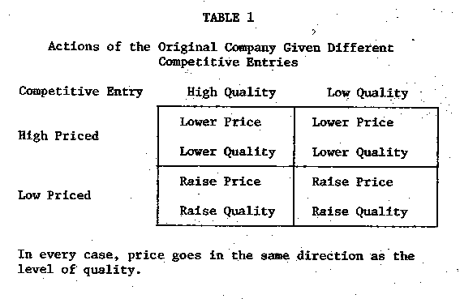

Figure 2.1: Research of the relationship between price and quality of consumer goods (Association of Consumer Research)

This ties in with Solace’s current position in the market being more un-favourable than most, especially when considering that under the price-quality correlation and the social trends elaborated on in the previous segment, potential consumers would prefer to spend more money in order to procure a higher standard of services, as life and death are considered sacred, and they would like to provide the best services for their departed friends and family.

This would in turn, contradict with Solace’s pro bono cremation services, as humans subconsciously link price to quality, and the notion that a service is pro-bono may unfortunately lead to a negative connection within the psyche of the consumers. While understanding that Solace provides mainly for the underprivileged and the financially distressed, it may remain a possibility that even such financially disadvantaged households would potentially intentionally incur greater costs in procuring more pricey services which they assume would have a higher quality.

## 2.3 Beneficiaries

Solace’s main target beneficiaries are financially disadvantaged families in Singapore living with elderlies. A family can be classified as such when their monthly household income drops below $1900 or a monthly income per capita of $650 and below ([cite](https://blog.seedly.sg/low-income-singapore-families-parents-financial-assistance/)).

With the current pandemic, the financial predicament faced by this group of beneficiaries has worsened, where the median household income of families which have sought help from Beyond Social Services fell from $1,600 during pre-Covid to $500 which is an alarming decline. The following are some of the different challenges faced by Solace’s beneficiaries:

1. **Financial Distress**

Financially disadvantaged families with unstable/inadequate income often struggle with their finances and unexpected crises such as retrenchment, sudden illnesses, epidemics can easily upend the family financial situation overnight. Particularly, the elderly, with chronic health issues or those with multiple dependents are at a greater risk of financial distress.

1. **Lack of social participation in the community**

Another challenge faced by financially disadvantaged families is their lack of social participation in the community through recreational activities, such as taking part in block parties and cultural festivals. This lack of social participation will lead to these families being disconnected from their community. Additionally, this may result in a lack of knowledge of where they can go when they require help (i.e., financial/social support) or they might not even know the existence of such services.

**2.4 Problem Analysis**

To surmise points covered in points 2.1 to 2.3, Solace’s main problem arose from the lack of compatibility between its business model and consumer trends within the industry. The notion that consumers would want to obtain a high standard of funeral services for the deceased, coupled with the stereotype that more expensive services provide a higher quality of service, people would rather purchase more expensive funeral packages instead of seeking out Solace’s pro bono services. The mismatch between Solace as a social enterprise and consumer expectations in the funeral industry can therefore be attributed to the fact that potential beneficiaries believe that Solace’s services are cheap, and therefore lack quality. The only way that Solace can go about rectifying this problem is through finding ways to display to potential beneficiaries that they uphold a high standard of quality for their services.

# 

# 3. Project Connection

To address the issues identified above regarding Solace’s current situation and their difficulties in overcoming the social, psychological, and financial barriers faced by Solace and their beneficiaries, our team has come up with Project Connection. This project is named after Solace’s goal of reaching out and connecting to a greater number of their targeted beneficiaries.

Project Connection is focused on the goal of aiding Solace to overcome the different social, psychological, and financial barriers which are faced by Solace and their beneficiaries as identified earlier. To achieve that goal, Project Connection is split into two phases which are the following:

1. Improvement of Solace’s pro-bono services through partnerships with relevant service providers. These service providers are those who are able and willing to contribute their resources (i.e catering and flowers) to provide more well-rounded pro-bono services conducted by Solace
2. Enhancing Solace’s credibility and reach to their target beneficiaries by partnering with reputable and charitable organizations

## 3.1 Phase 1: Well Rounded Service

The average cost of hosting a funeral service in Singapore starts from $3,800. This includes various costs of items such as tentage rental to the manpower required for a funeral service. Due to the high production costs of a funeral service, Solace’s limited financial capacity limits the number of services they can provide pro-bono. Following the notion that consumers will want to obtain a high standard of funeral service for the deceased, and the deep rooted belief that low price services equate to low quality of service, it is highly likely that Solace’s beneficiaries will perceive their services as insufficient.

To address this, Phase 1 of Project Connection aims to find and work with like-minded, charitable organizations that are willing to contribute their resources to Solace’s pro-bono funeral services. This will aid in improving and supplementing Solace’s pro-bono funeral services so as to better serve their beneficiaries.

Based on the initial survey (Fig _) which was done to understand the public’s expectation of a funeral, we found that the top 4 services/items which people expect to see at a funeral service are Flower wreaths, Catering services, Portable toilets and Funeral tentages.

### 

Based on these expectations, we have contacted and will be working with the following service providers to supplement and improve Solace’s pro-bono funeral services

### 3.1.1 Partnering service providers

#### Free Food for All

Free Food For All (FFFA) is a registered charity with the goal of providing free halal meals to the less fortunate. In total, they have helped over 100,000 households in Singapore. They have placed heavy emphasis on aiding the elderly, disabled and financially disadvantaged individuals which is similar to that of Solace’s target beneficiaries. We will be working with FFFA to provide catering for the bereaved family during the wake conducted by Solace.

Food is often provided at wakes and funerals as a way for the bereaved families to show their appreciation for their friends and families for making the effort to pay their final respects to the deceased despite their busy schedule (Cite). Due to its high costs, catering is not included within Solace’s pro-bono service, thus we are looking to work with Free Food For All (FFFA)

#### Floristique Singapore

Floristique is a one-man business operated by the Owner, Wendy. Wendy operates Floristique with the belief that there are flowers appropriate for every occasion from weddings to condolences. The flowers curated at Floristique come in many different shapes and sizes and are often sold at affordable prices as compared to other boutique flower businesses. Floristique also offers a wide range of condolences flower stands with the most affordable one being $59 (Fig _).

Condolence flowers have been sent as a tradition to funerals and homes of the bereaved because of their symbolic meanings as a way of expressing feelings and messages to loved ones (Cite). Currently, Solace does not provide any form of condolence flowers for their pro-bono funerals, as such we are looking to work with Floristique.

We are looking to work with Florisque to send one condolence flower stand/bouquet to the bereaved family on the day of the wake. Friends and family of the bereaved liaise with Floristique to purchase condolences flowers at a lower price to send to the bereaved family.

#### Memories of Life Pte Ltd by CCK Marble

Memories of Life is a local company that specializes in producing engraved products for cremation at Columbariums and offers a wide variety of works ranging from keepsake jewellery to customized tombstones to scattering of ashes inland. (Memories of Life, n.d.) Their mission is to help their customers keep memories of their loved ones who have passed away with honour. They offer 925 silver finished jewelry pieces like bracelets and necklaces that are usually priced at about S$100.

Keepsake or memorial jewelry made from ashes obtained from the cremation process can be made as a way to keep their departed loved ones close to them and preserve special memories. Since Solace currently does not provide any form of memorabilia for friends and family of the bereaved, we are looking to work with Memories of Life to provide the former with a small momento that holds sentimental value in remembrance of the deceased. These pieces can also serve as family heirlooms in the future.

Based on the initial survey which we have conducted, over 60% of our respondents mentioned that they are interested in purchasing/getting a keepsake jewellery to remember their belated loved ones.

We hope to liaise with Memories of Life to provide these small tokens of remembrance at a discounted price as our targeted demographic are underprivileged and may not be able to afford them at their usual prices.

### 3.1.2 Repackaged pro-bono funeral services

We will repackage Solace’s pre-existing pro-bono services in addition to those of the service providers we intend to work with, into 3 categories: Pre-funeral, Funeral and Post-funeral Services where the Pre and Post-funeral segments are optional. The services provided in each category are as follows:

|  | **Pre-funeral planning** | **Funeral Service** | **Post-funeral Services** |
| --- | --- | --- | --- |
| **Proposed Services** | Nil | * Complimentary Food Catering service * Complimentary Flower wreath services | * Subsidized/ Complimentary keepsake jewellery |
| **Existing**  **Service** | * Subsidized advance planning consultations (i.e., Will writing) * Subsidized rates of Letter of Administration (LPA) | * Cremation Services * Rituals * 1-day wake | * Subsidized Grief counselling with Solace’s partnered counsellors |

## Through this, Project Connection will be able to help Solace in providing a more well-rounded, pro-bono funeral package that encompasses a wider range of services to cater to the needs and wants of their beneficiaries.

## 3.2 Phase 2: Reaching Solace’s beneficiaries

In the survey which we have conducted, only a mere 10% out of our 100 respondents were aware of the existence of pro-bono funeral services (Refer to __), showing the lack of awareness & publicity of Solace’s pro-bono services.

Additionally, as mentioned above, Solace’s beneficiaries and interested parties may perceive Solace’s pro-bono services as insufficient due to the price-quality correlation and the limited services which Solace provide.

To overcome this issue, the Phase 2 of Project Connection will be focused on enhancing Solace’s credibility as a pro-bono service provider and the quality of their services. Additionally, phase 2 will be aiding Solace in increasing its reach to a greater number of its target beneficiaries.

This will be done by partnering with reputable and charitable organizations that are in close proximity to Solace’s beneficiaries. These partners will be able to act as a bridge between Solace and their beneficiaries, where partners can easily refer beneficiaries to Solace if they require Solace’s pro-bono services.

Solace will be able to conduct talks at these organizations with regards to the services they provide such as the importance of advance planning and in turn increasing the publicity and the credibility of Solace as a pro-bono organization.

**3.2.1 Marketing materials / content to be covered during talks**

The following are key content which will be covered by Solace during its talks at AIC and NTUC Health centres.

| **Content to be covered** | **Description** |
| --- | --- |
| **Importance of advance planning** | Advance care planning is a process of formal decision making to aid patients establish decisions about their future care or the inevitable death. These decisions will take effect when patients lose the capacity to make decisions for themselves.  Under Solace’s website, advance planning would include the following services:   1. **Legal matters**: Wills & lasting power of attorneys, ensures that the one’s wishes will be granted in the event that they are unable to do so 2. **Financial planning:** Relates to assert distribution such as remaining wealth and asserts. 3. **Funeral planning:** Planning the details of one’s funeral when the inevitable happens |
| **Services offered by Solace** | The following services are currently offered by Solace at a reduced rate to eligible parties   1. **Legal services**: services related to wills, lasting power of attorneys (LPA) & letters of administrations. Law firms partnering with Solace are offering reduced rates for LPA writing and free first time consultation regarding letters of administration. 2. **Financial advisory:** Solace are working with professional advisors to aid in estate planning / retirement planning 3. **Funeral preplanning:** preparation/decisions about planning a funeral for oneself can be made in advance with Solace. In such cases, payment for the funeral is not needed in advance 4. **Grief counselling:** Grief counselling is provided at a reduced rate for each counselling session with Solace’s partnered counsellors. |
| **Availability & eligibility of Solace’s Pro-bono service package** | For eligible individuals/families, they can consider the proposed repackaged pro-bono services mentioned earlier (Refer to point 3._) |

The following is a proposed brochure which will be given out during the talks. The brochure will be providing attendees with information regarding the importance of advance planning as well as the various services offered by Solace. 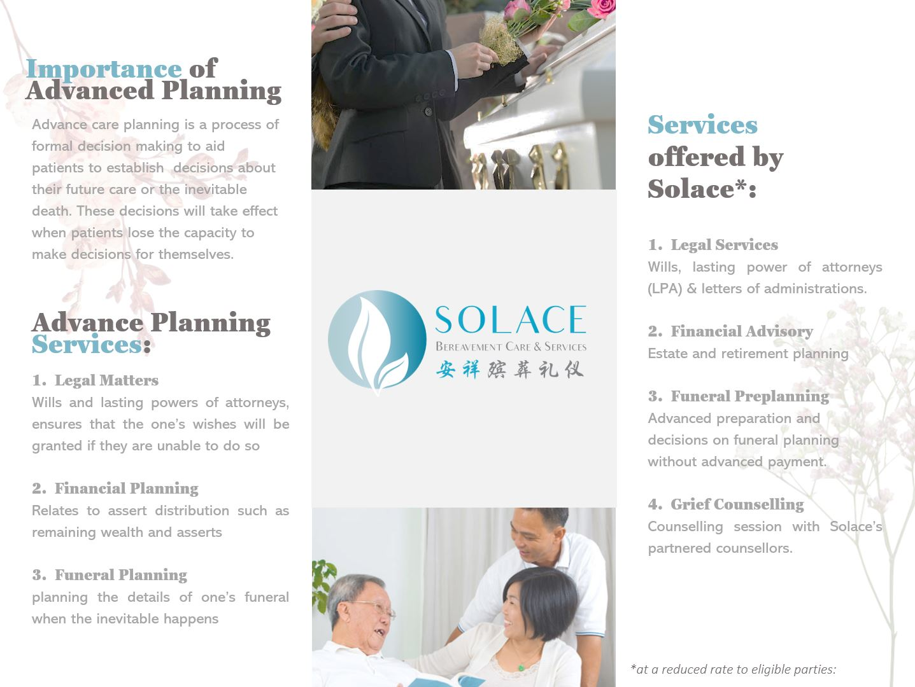

## 

## 3.2.1 Partnering Organizations

The two organizations which Project Connection is working with to tackle this issue are NTUC Health and The Agency for Integrated Care (AIC)

### NTUC Health

NTUC Health is an NTUC social enterprise that provides a comprehensive and integrated suite of quality and affordable health and eldercare services to meet the growing needs of families and their dependents. NTUC Health is one of the largest senior day cares, nursing home and home personal care providers in Singapore. NTUC Health provides financial assistance and subsidies to those who require their services but are hindered by their financial circumstances.

As a senior day care provider, NTUC Health is consistently in close contact with Solace Beneficiaries, elderly from a low income background. Thus, in situations of an untimely death and the family of the bereaved is not able to afford additional funeral expenses, NTUC Health can liaise with Solace directly to offer Solace’s pro bono services to the bereaved family.

### Agency for Integrated Care (AIC)

AIC is an organization with the aim of creating a vibrant care community for its people to live comfortably and age gracefully. They do so by coordinating and supporting efforts in integrating care to achieve the best care outcomes for their clients. Their main activities include reaching out to caregivers and seniors with information on staying active and connecting them with services they require. This is done with the main focus of bringing care services and information closer to those in need.

As an organization, AIC’s values and mission are perfectly aligned with that of Solace. Hence, both organizations have a common vision towards helping more people of low-income backgrounds. **This way, Solace is able to reach out to a larger target audience.**

# 4. Action Plan

## 4.1 Implementation Schedule

As mentioned above, Project Connection has the main objective of aid Solace in overcoming the different social, psychological and financial barriers faced by Solace and their beneficiaries. This will be done using a two pronged approach. The first phase will be focused on working with reputable and charitable service providers to contribute resources and further improve Solace’s pro-bono services. The second phase is focused on working with organizations who are in close contact with Solace’s beneficiaries, enabling Solace to connect with a greater number of their beneficiaries while providing them with information regarding the importance of advanced planning and will writing.

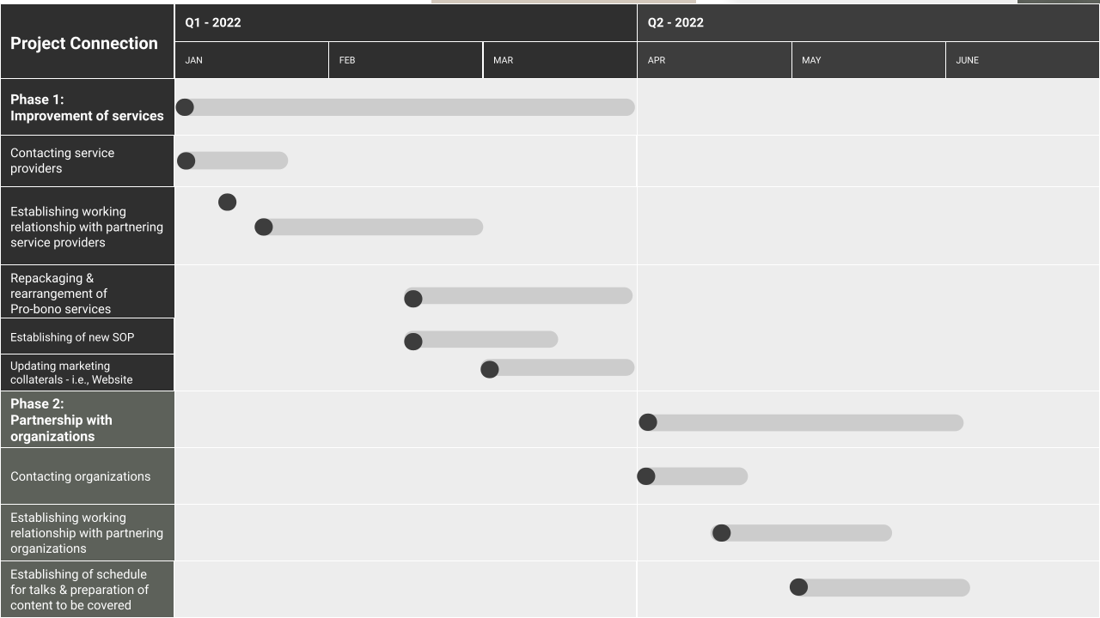

The following is a proposed schedule and timeline for Project Connection

Following this schedule, if the preparation work for Project Connection starts in January 2022, Phase 1 is expected to be completed by May 2022 while Phase 2 is expected to be completed by the end of May 2022, Once the two phases have been completed, the preparation of Project Connection is completed.

The proposed talks at partnering organizations can commence and we will track the success of Project Connection using our metric of success (Refer to point)

# 

## 

## 4.5 Stakeholders

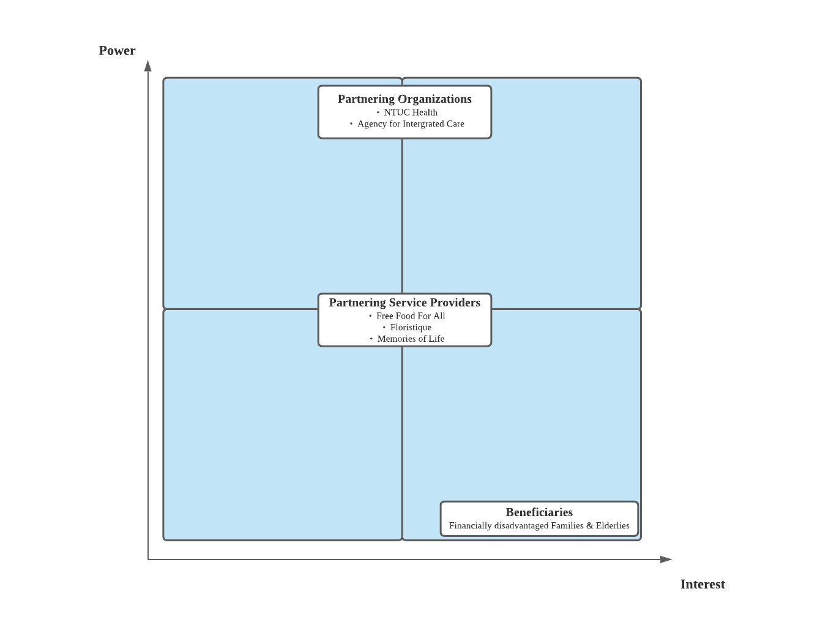

The graph above depicts the level of power and interest we classify our potential stakeholders as having in relation to Project Connection. Beneficiaries are shown to have high interest but low power, Partnering service providers have medium power and interest while Partnering Organizations have high power but medium interest.

4.5.1 Beneficiaries - Elderly from low-income backgrounds **(low power, high interest)**

Beneficiaries have a low level of influence over Project Connection due to their financially disadvantaged nature. However, they maintain a high level of interest in the project as the results of Project Connection would have a direct impact on the quality of service they would potentially receive. Should Project Connection prove to be effective in addressing the current issue that Solace is faced with, future beneficiaries would be able to enjoy the benefits of a well-rounded funeral arrangement, hence their position on the graph.

4.5.2 NTUC Health **(medium interest and high power)**

NTUC Health holds a high degree of power over the project due to their financial prowess, coupled with the extent of their reach. With a large amount of financial reserves and a huge platform, NTUC Health is not only able to assist Solace financially, but also through communicating with needy seniors under their care to relay them information regarding Solace’s services.

Nevertheless, it should also be noted that NTUC Health works with a large array of organizations, thereby causing their vested interest in Project Connection to be relatively average. Regardless, NTUC Health still holds a high degree of influence over the project due to the strength of NTUC as an entity in and of itself. As such, we have determined NTUC Health as an organization having high power, but medium interest.

4.5.3 AIC **(medium interest and high power)**

Much like NTUC Health, AIC is also an organization with a fairly large reach, and decent financial capabilities. Through collaboration with Solace, AIC would be able to attain its goal of bringing partners together by connecting people to the services they require. However, AIC also has an extremely large clientele, making it unlikely that their interest in Project Connection would be sustainable over an extensive period of time. As such, AIC is classified as having high power, but medium interest- the same as NTUC Health.

4.5.4 Free Food for All **(medium power and medium interest)**

Free Food for all is a non-profit, charitable organization. As such, their degree of financial leverage is not as high as that of AIC’s or NTUC Health’s. However, by working with Solace, Free Food for All could potentially capitalize on its doings as a charitable organization in helping the underprivileged to raise awareness. However, Free Food for All’s interest in partnering with Solace is also limited due to their business structures; Charitable organizations must face copious amounts of red tape in order to partner with any other entity that is not a charity. As such, Free Food for All is placed under having medium power and medium interest.

4.5.5 Floristique & Memories of Life **(medium power and medium interest)**

Floristique & Memories of Life would potentially be interested in working with Solace due to the publicity they could gain while helping lower-income families. This has the potential to be a strong PR move, positively impacting their company’s reputation by partnering with a social enterprise that aims to help the underprivileged and disadvantaged. However, as a fully functioning business, their interest in the project may be hindered by the financial costs that come with it. As such, we have placed Floristique & Memories of Life as having medium power and interest, along with Free Food for All.

By conducting a stakeholder analysis, we are able to understand the various stakeholders of the project and to what extent they can affect the project as well as what their interests are. By using the power interest grid, Solace can identify and target key stakeholders for maximum benefits and success.

# 5. Operational Plan

## 5.1 Proposed organization structure

The above is a proposed organization chart for Solace and the proposed partners suggested, including the liaison for each of the partners. These partners will aid Solace in improving Solace’s pro-bono services as well as aid Solace in reaching out to a greater percentage of their target beneficiaries.

## 5.1 Manpower requirements

To achieve Project Connection objectives in aiding Solace to increase the number of pro-bono funeral services to 10/year through partnership with various reputable and charitable service providers and organizations, it would require the creation of new roles within Solace Service to aid Damien and support these suggested partnerships.

Table _: Supporting roles for partnerships with service providers & organizations

| **Role** | **Job Description** | **Number of employees required** |
| --- | --- | --- |
| Service provider coordinator | * Gather requirements/request for each pro-bono funeral service done by Solace Service, plan out the requirements & additional resources required other than the resources currently contributed by Solace. * Responsible for liaising and coordinating with Solace’s partnering service providers (Free Food For All, Floristique, Memories of Life) to fulfill additional requirements/resource for each funeral (if any) | 2 |
| Organization coordinator | * Responsible for liaising and coordinating with Solace’s partnering organizations (NTUC Health & AIC) to arrange for workshops/talks to be conducted by Mr Damien. * Responsible for curating the content/information to be conveyed during talks at partnering organizations. These information would include the important of advance planning and will writing | 2 |
| Marketing Coordinator | * Responsible for curating Solace’s marketing collaterals and content to be covered during talks at partnering organizations | 2 |

**5.2 Resource Requirements**

The following are the additional resources required for each pro-bono service conducted by Solace after the implementation of Project Connection & partnership with the service providers mentioned above. These costs will be borne by the service providers themselves or at a subsidized rate for beneficiaries. For any additional requirements/resources, depending on the arrangement and circumstances, it will be arranged to be borne by either the client or by Solace.

| **Partnering Service Provider** | **Resource required** | **Quantity** | **Unit Cost** | **Total Costs** |
| --- | --- | --- | --- | --- |
| Free Food For All  (FFFA) | Pre-packaged food packets   * Wok Hei’s Grilling chicken egg fried rice | 30 | $5.00/Packet | $150.00 |
| Floristique | Condolence Flower Stand | 1 | $59.00 | $59.00 |
| Memories of Life | Keepsake bracelet  ​​ | 1 | $100.00 | $100.00 |

The following are some of the additional resources which will be required by Solace to implement Project Connection. The costs of these resources will be borne by Solace fully.

| **Resource required** | **Quantity** | **Unit Cost** | **Total Costs** |
| --- | --- | --- | --- |
| Marketing collaterals - Brochure | 300 | $22.00/300 pcs | $22.00 |
| Hotjar Web Analytic services  (Metric of Success, refer to Point 5) | - | $39.00/month | $39.00/month |

## 4.5 Stakeholders



The graph above depicts the level of power and interest we classify our potential stakeholders as having in relation to Project Connection. Beneficiaries are shown to have high interest but low power, Partnering service providers have medium power and interest while Partnering Organizations have high power but medium interest.

4.5.1 Beneficiaries - Elderly from low-income backgrounds **(low power, high interest)**

Beneficiaries have a low level of influence over Project Connection due to their financially disadvantaged nature. However, they maintain a high level of interest in the project as the results of Project Connection would have a direct impact on the quality of service they would potentially receive. Should Project Connection prove to be effective in addressing the current issue that Solace is faced with, future beneficiaries would be able to enjoy the benefits of a well-rounded funeral arrangement, hence their position on the graph.

4.5.2 NTUC Health **(medium interest and high power)**

NTUC Health holds a high degree of power over the project due to their financial prowess, coupled with the extent of their reach. With a large amount of financial reserves and a huge platform, NTUC Health is not only able to assist Solace financially, but also through communicating with needy seniors under their care to relay them information regarding Solace’s services.

Nevertheless, it should also be noted that NTUC Health works with a large array of organizations, thereby causing their vested interest in Project Connection to be relatively average. Regardless, NTUC Health still holds a high degree of influence over the project due to the strength of NTUC as an entity in and of itself. As such, we have determined NTUC Health as an organization having high power, but medium interest.

4.5.3 AIC **(medium interest and high power)**

Much like NTUC Health, AIC is also an organization with a fairly large reach, and decent financial capabilities. Through collaboration with Solace, AIC would be able to attain its goal of bringing partners together by connecting people to the services they require. However, AIC also has an extremely large clientele, making it unlikely that their interest in Project Connection would be sustainable over an extensive period of time. As such, AIC is classified as having high power, but medium interest- the same as NTUC Health.

4.5.4 Free Food for All **(medium power and medium interest)**

Free Food for all is a non-profit, charitable organization. As such, their degree of financial leverage is not as high as that of AIC’s or NTUC Health’s. However, by working with Solace, Free Food for All could potentially capitalize on its doings as a charitable organization in helping the underprivileged to raise awareness. However, Free Food for All’s interest in partnering with Solace is also limited due to their business structures; Charitable organizations must face copious amounts of red tape in order to partner with any other entity that is not a charity. As such, Free Food for All is placed under having medium power and medium interest.

4.5.5 Floristique & Memories of Life **(medium power and medium interest)**

Floristique & Memories of Life would potentially be interested in working with Solace due to the publicity they could gain while helping lower-income families. This has the potential to be a strong PR move, positively impacting their company’s reputation by partnering with a social enterprise that aims to help the underprivileged and disadvantaged. However, as a fully functioning business, their interest in the project may be hindered by the financial costs that come with it. As such, we have placed Floristique & Memories of Life as having medium power and interest, along with Free Food for All.

By conducting a stakeholder analysis, we are able to understand the various stakeholders of the project and to what extent they can affect the project as well as what their interests are. By using the power interest grid, Solace can identify and target key stakeholders for maximum benefits and success.

# 5. Feasibility

## 5.1 Pilot Plan: Short Term & Long Term

Project Connection will be implemented as a three-year pilot project to test its social impacts in aiding Solace to achieve their goal of increasing the number of pro-bono services they have organized.

Throughout the three year period, the Project Connection will continually seek new partnerships with various service providers and charitable organizations who are willing to aid Solace in their journey to help a bigger number of their target beneficiaries.

At the end of every year of the pilot project, we will be evaluating Project Connection based on the evaluation metrics we have set out. Our metrics of success include the number of pro-bono funerals held by Solace in that year. Additionally, we will be gathering feedback from the beneficiaries which Solace have aided, and the partners of Project Connection on how Project Connection can be further improved.

Based on the feedback received, impacts of Project connection and using our evaluation metrics, it will be used to measure the success of Project Connection. Our team will come together again to discuss the improvements & changes that Project Connection needs to make before it can implement a long-term plan by Solace to achieve their objectives of increasing their reach to beneficiaries.

## 5.2 Metrics of success

5.2.1 Number of Pro-bono cases received

It is cardinal to align Solace’s goals with our measures of success to evaluate the efficacy of our project, so as to ensure that our proposed methods do indeed help Solace increase the number of pro-bono funeral services provided. The target set by Solace to have at least 10 funerals per year from the current total of 4 from 2019 to 2021 , would be our overall goal and thus the determining factor of whether our entire project is successful.

Being able to attain this 150% increase in funerals provided will not only indicate Solace’s success in heightening their market presence for their well-rounded services and widening their outreach through liaising with partnering organisations, but also will testify to Solace’s sustainability as a social enterprise since the provision of such services would incur a high cost. Since our project is a 3-year pilot plan, we intend to evaluate our progress on a yearly basis where we will set annual targets on an incremental basis such that we can meet our target of 10 funerals in the 3rd year of our project. The following will be the annual targets set in our 3-year plan:

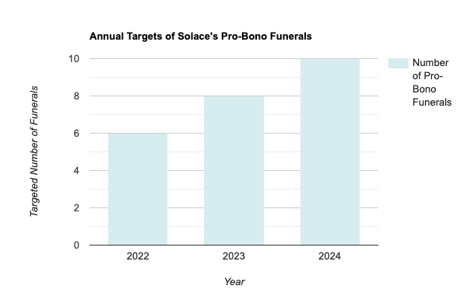

An additional basis of evaluation is finding out how the families of the deceased (new customers) came to know about Solace’s services - through liaising with homes, recommendation by friends or families, through word of mouth and as such. By conducting surveys on customers' decisions to engage Solace as a funeral provider, we can thus evaluate the effectiveness of our methods by analyzing the responses of prospective customers in the survey. (if this part is ok then can show an example of survey qns lol) Additionally, Solace could also encourage its clients to engage in a post-service evaluation questionnaire to determine which parts of Solace’s services they find lacking, such that said services can be adjusted for the benefit of future clients.

Questions to asked for survey

5.2.2 Web traffic analytics

Although the ultimate goal of Project Connection is to assist Solace in reaching their eventual target of 10 pro-bono funerals per year, Project Connection should also be based on metrics that assess its individual success. As Project Connection’s effectiveness is heavily reliant on a more positive brand portrayal through increased credibility and heightened adaptability of services, a separate measure of success can be employed through web traffic analysis. If Project Connection has succeeded in its goal of improving Solace’s brand image, it would definitely pique the interest of prospective customers. As such, our second metric of success would be the web traffic on Solace’s website which will be mainly based off

1. Web traffic
2. Number of clicks

Solace can engage websites such as hotjar that specialises in data analytics, Hotjar specializes in data analytic services such as Heatmaps, to track users movements and clicking activity on their clients’ websites to accurately analyse the number and behaviours of website visitors. Solace will then be able to monitor the web traffic of their site if there were to be any increase following the launch of our pilot program.

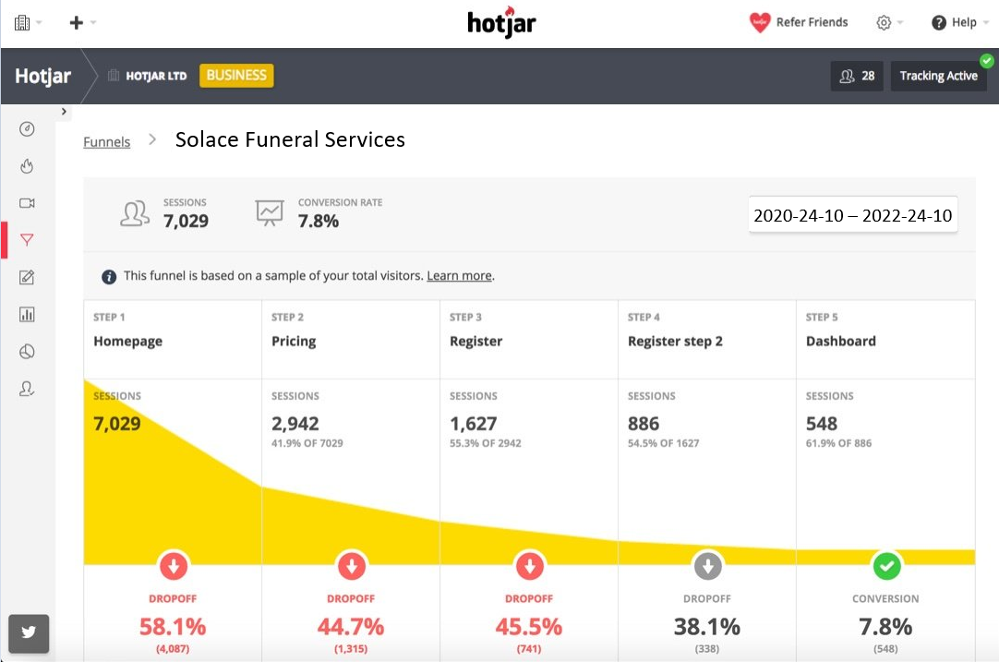

(some label)

The following are the targeted increase in website visits on an annual basis during the course of our pilot project which will be considered successful if at least 2 out of 3 annual targets are achieved. The graph below shows an annual increase of 50% from the previous year.

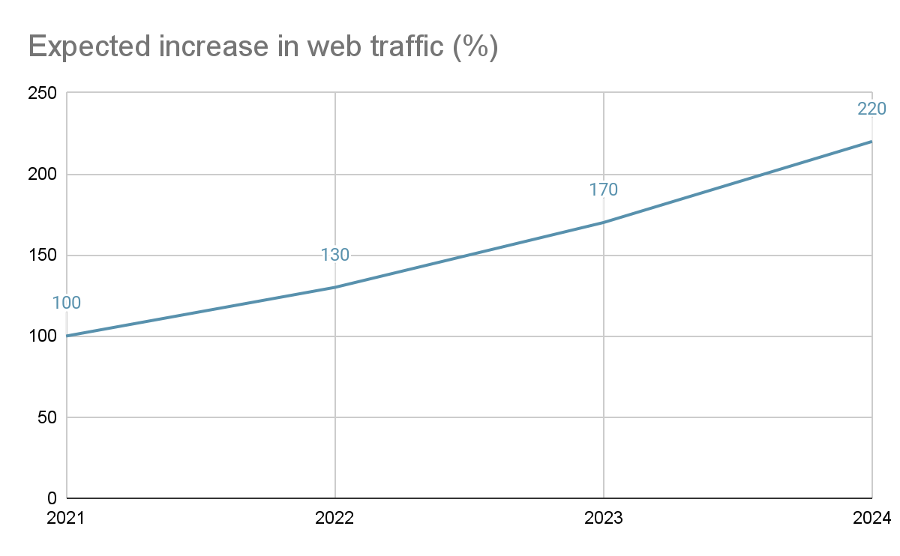

## 

## 5.3 Expected challenges

The following are some of the challenges we expect to face during the execution of Project Connection.

### 5.3.1 Limited advanced notice

Based on the interview which we have done with Mr. Nizar Shariff, we realized that the certain services provided by our partnering service providers will require advance reservations. In the case of Free Food For All (FFFA), they will prefer to have at least 2~3 days of advance notice for their preparations. However, given the nature of the undertaker industry, it is hard to provide advance notice of when a funeral will be required/conducted. Additionally, it would be difficult to determine the exact number of people attending the funeral, which prevents the accurate prediction for the amount of food catering required.

To tackle this challenge, we will be working with FFFA to tap on their connections with their partner food suppliers. By tapping on to FFFA’s connections, it will be easier to prepare the required amount of food catering required for each funeral on a short notice.

### 5.3.2 Deep rooted beliefs

Beliefs are formed by thinking the same thoughts over and over again. They are part of our daily inner dialogue, excuses and rationalizations. In most situations, we don’t even think of them as “beliefs” but instead as a form of “reality”. The nature of beliefs make it one of the hardest things to change in a person (cite).

As discussed earlier, the belief of price-quality correlation is deeply rooted in our society where people tend to associate low-price services with low quality. Additionally, based on our survey (Fig. ) there is also a common belief within our society where “the dead should always be accorded the best send off”. Given the difficulty of changing such deeply-entrenched beliefs, we expect Solace to face significant challenges in overcoming these challenges and deep rooted beliefs despite their good will and efforts.

To tackle this challenge, we have introduced Project Connection to further improve on Solace’s existing pro-bono funeral services as well as increase their credibility and awareness through partnerships with charitable organizations. Although Project Connection is expected to aid Solace, due to the nature of deep rooted beliefs, we expect it to take some time before Solace will be able to see success from the implementation of Project Connection.

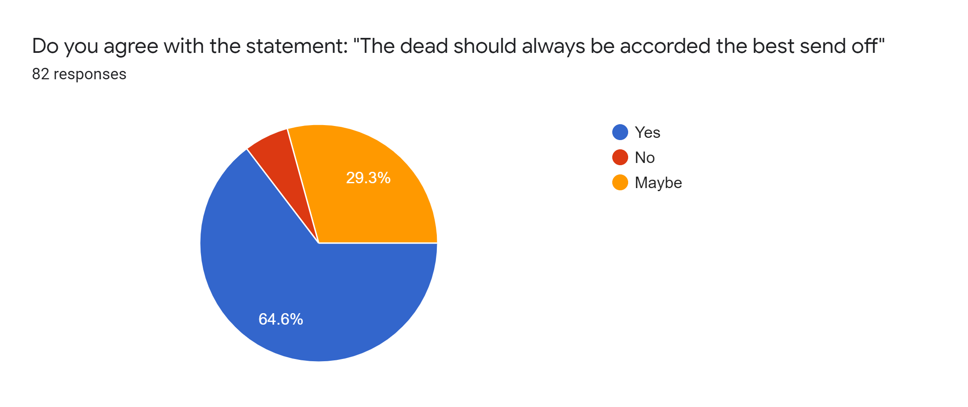

**5.4.3 Limited Funding**

With the implementation of Project Connection, we expect the number of beneficiaries and pro-bono funeral services to increase. However, given Solace Services current business structure as a social enterprise providing pro-bono funeral services, Solace only has a limited amount of funding available to fund their pro-bono services. Thus, this limits the number of beneficiaries which Solace can aid and provide their services to.

However, with the implementation of Project Connection, we expect Solace Service’s client base to eventually expand, thus increasing their profitability. With an increased profitability, the amount of beneficiaries they will be able to aid will eventually increase as well.

# 6. Justification

## 6.1 Barriers

Firstly, Social Barriers is a very common problem when it comes to funerals. Deaths in Singapore can be a sensitive topic especially among the elderlies. Secondly, Psychological Barrier associates price with quality. A lower price will raise beneficiaries’ concern about the quality of the funeral. Lastly, Financial Barriers refers to the financial capability of Solace’s target group. Solace mainly targets the lower income hence the budget for the funeral has to be kept at a reasonable and affordable price for them to have a proper send off.

## 6.2 Benefits

Through working together with service providers, it meets the expectations of the business while partnering with other organizations accomplishes Solace’s mission.

### 6.2.1 Service Providers

Solace’s intended audience are the people from low-income backgrounds. By collaborating with charities and service providers who can provide low-priced products that help to reduce our costs to alleviate the financial obstacles of our beneficiaries. In our survey, 95.1% of people see flowers at funerals and 72% of people commonly see catering services during funerals. Through this, we have found . By working together with these service providers, it allows Solace to have a higher adjustment space in price which could potentially be used to help others in the future.

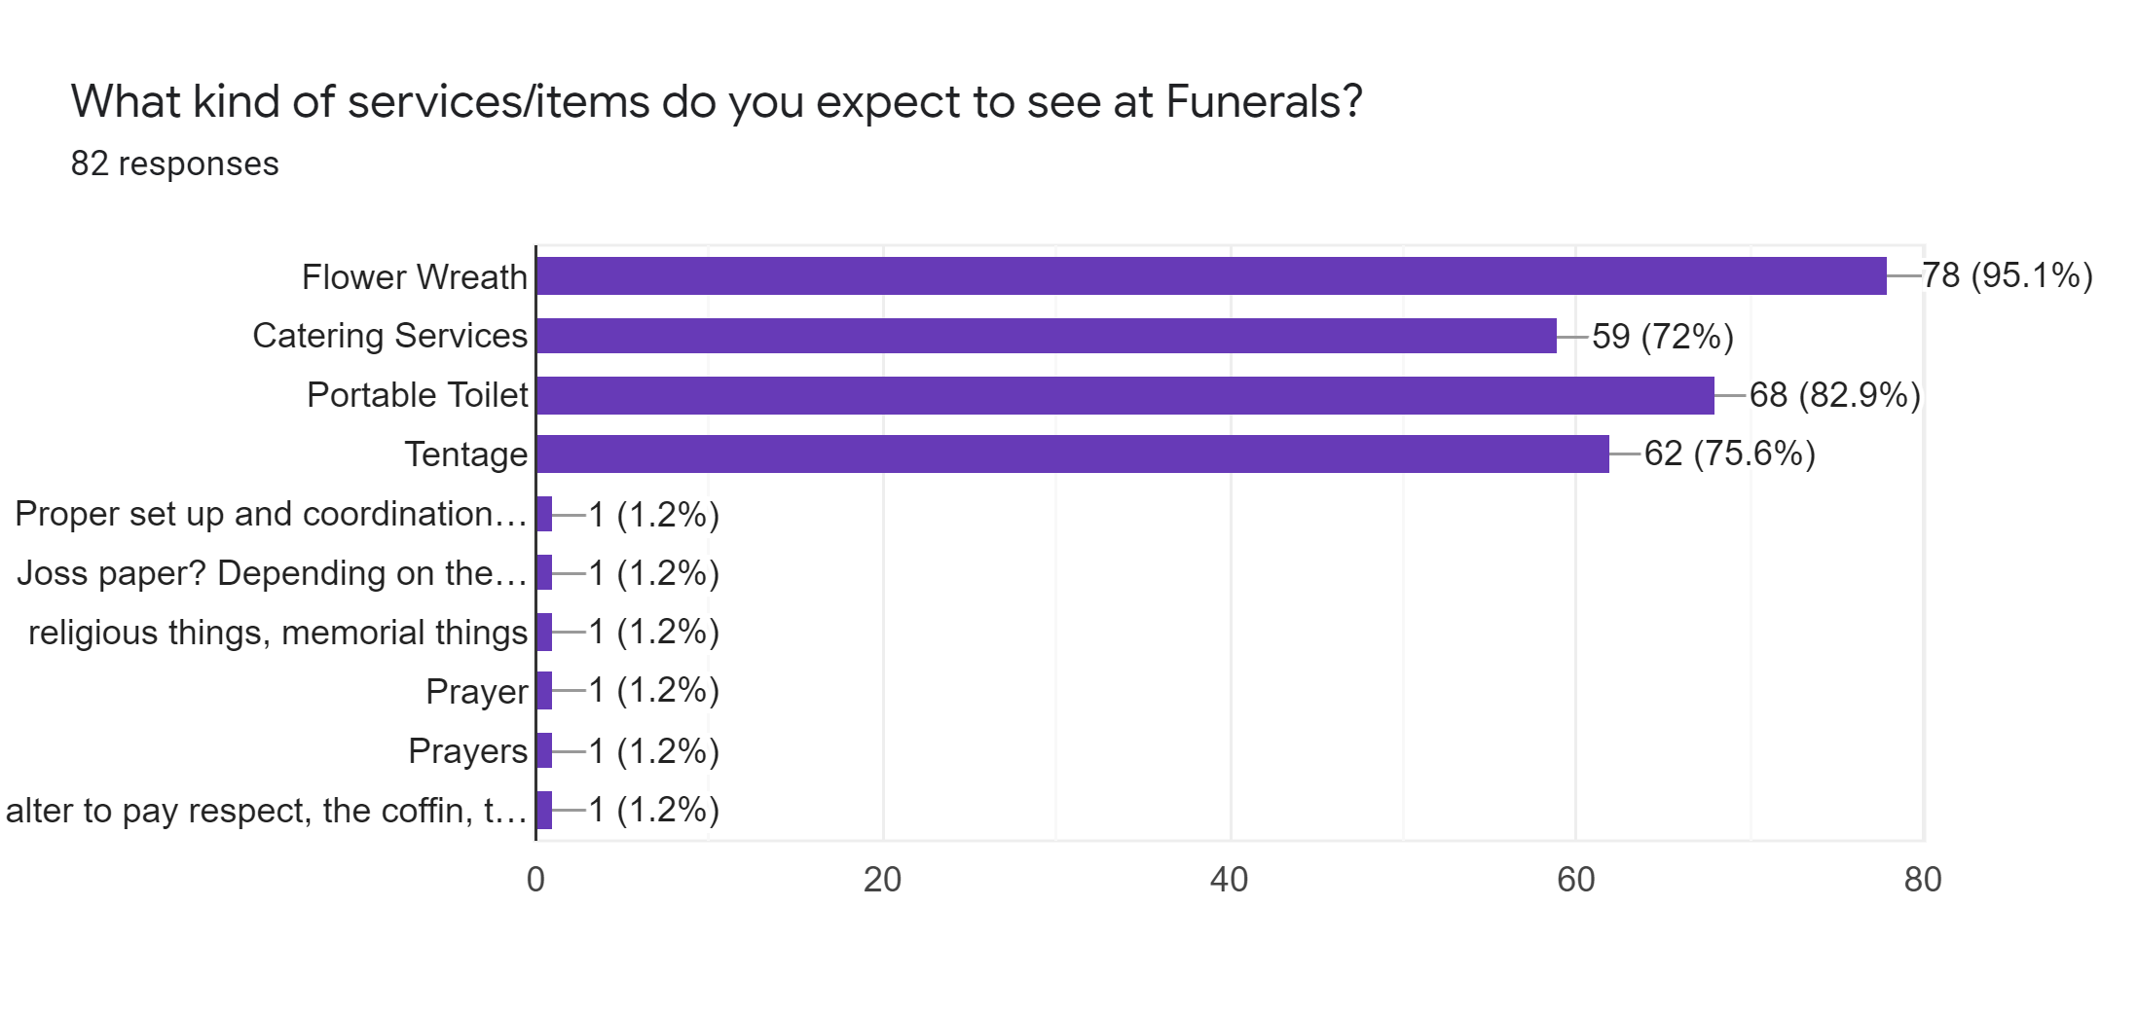

### 6.2.2 Partnering Organizations

Through aliancing with companies that are aligned with Solace’s values and missions, it allows Solace to reach out more beneficiaries. AIC and NTUC Health have an elderly customer base and are in line with Solace's values. We can expand Solace’s customer base by cooperating with these two organizations to increase the opportunities of contacting beneficiaries and raising Solace’s brand awareness.

## 6.3 New opportunities

Since AIC and Solace’s target groups are about the same, AIC would know of other partnerships that could also potentially be a partnering organization or service provider of Solace. This way, more service providers would be more aware of Solace’s service and might offer to collaborate with them to further improve their funeral services. This would help Solace reach out to more people and with more people involved, Solace would be able to help a larger number of people at a lower cost. Through the survey, 82.9% of the people said that portable toilets and 75.6% of people said that tentage is an essential part of funerals. We can work together with these service providers to achieve a more well-rounded funeral. For partnering organizations, AIC only works together with the low-income aging population. However, we aim to target anybody with low-income status. Hence, through them, we will be able to find other organizations that work together with different low socioeconomic age groups.

# 7. Conclusion

The selflessness of Solace in putting the emotional weights off grieving families has undeniably been a great deal of contribution to the society; and ensuring tenability in their services will further bring a significant amount of benefits for many in need. The challenge for Solace then comes in when they are met with social, psychological, and financial barriers. It is therefore important that Solace is able to tackle these barriers in an effective and sustainable way. Through our team’s thorough research, we believe that the best course of actions that Solace can consider in extending reach is by providing a broader pro-bono service, establishing their credibility and creating a cordial community for potential customers. We believe that everyone is deserving of a respectful and dignified send-off; notwithstanding shortcomings, this is made possible with Project Connection.

# 

# Leadership reflection (First & Second component)

1. Reflection on the project (timeline basis) ~ 500-600 words

* Our initial problem statement was to discuss the feasibility of forming an alliance with the members of the Association of Funeral Directors in Singapore in order to expand the concept pioneered by Solace in the undertaking industry. We initially also discussed the realistic organisation structure to suggest for Solace both as a sole player and as an alliance with other industry partners.
  + We soon realised that we had difficulties with the aspect of forming an alliance with the Association of Funeral Directors in Singapore.
  + It was mentioned by Damien that funeral directors are actually in close contact with each other, all the funerals are working by themselves etc so there’s no point in trying partners, that’s why Hanoi had to change our problem statement.
* After establishing the new problem statement, another problem arose, which was the fact that none of us really knew where to start, given that none of us had a clear understanding of what the funeral industry does. So then we decided to lay down the foundations of these projects:
  + We first established the goals of Solace and their objectives. Apart from secondary research through data found in their website, we listened to Mr. Damien during in-class sessions as well as the Q&A sessions that were held during class.
  + We did secondary research on how pro-bono funeral service functions in terms of planning and operations.
  + We then researched the beneficiaries of pro-bono services such as Solace. From there, we planned out the intention of possible collaborations with Solace in order to reach and provide for a greater percentage of their target beneficiaries in a sustainable manner.
  + We established that our beneficiaries would be families who are financially unstable and elderly with no families. Once we’ve figured that out, we decided on industries who pose as potential alliances, which would be pro-bono food services (to enable the provision of more well rounded pro-bono funeral service), hospices, nursing homes and caregiver organisations.

1. Reflection on working as a team and the leadership paradigm your team has experienced (leadership concepts) ~ 1500 words

* Show growth from a group to a team
* Focus on how our members were interdependent (due to external commitments, occasionally some members were unable to attend meetings so we did our part to inform them on what was discussed and how the tasks assigned were assigned moving forward so that no member is left out because of any circumstances that prevented them from joining us). and had complementary skills that supported one another instead of merely performing within our own responsibility -> cross help with other tasks other than those we were initially assigned to. Give eg. & initially vey hierarchical bc kan always took charge bt slowly we started to shift to a more participative and empowerment-oriented leadership style - reinforced by autonomy we had to make decisions when making decisions wrt our allocated tasks
* Some element of team at the start bc we worked in pairs when it came to allocation of work so somewhat a collective responsibility. Shared sense of mission n support for one another bc we always made sure each member would class part at least once
* Enjoyed the advantages of team work such as self-motivation and empowerment & constant sense of support and encouragement strengthened our sense of satisfaction. And also some disadvantages during class activity time cos given the limited time n tasks we have, some members who didnt get a chance to write stuff but this issue was overcome bc they would then assume the responsibility of present to ensure loafing was prevented. On the other hand, to ensure groupthink was kept to a minimum, we also constantly assured one another that everyone’s opinions mattered even if it contrasted with the majority so we developed a habit to voice out our thoughts if we had the slightest doubt so that we could hear and understand from another perspective.

Characteristics of an Effective team

1. Diversified team mix - talk abt our members' roles (team charter) and how we have diff strengths that contributed greatly to the team. -> tho this clearly defines our roles and responsibilities we still exemplified that we were still bonded by a common goal of wtv by helping others when they needed help. Group members trusting one another to complete our tasks well and on time also showed we were an effective team.
2. Positive interpersonal relationships bc we were understanding towards each other with other commitments so we were able to be open and honest when we could not come for mtg or needed help.
3. Details such as the agenda and objectives, time and place of meetings were made and decided quickly through telegram poll functions to see when we were all free to meet and all objectives of meetings were met everytime. Meetings were efficient as everyone was focused on tasks at hand and we minimised any distractions to ensure that no time would be wasted unnecessarily.

Team- centred decision making

1. Our decision quality was better as compared to if we had followed a leader-centered decision making model bc everyone gave their own 2 cents so like we could explore perspectives we as members could not have thought of as individuals. Being responsible for our the teams effort instead of our own assigned tasks made us more cohesive as a team as well as we didnt see ourselves as individuals of a team but as one. There were disadvantages as well bc we had an equal number of opposing views of a certain idea the jewelry shit and we took quite a few weeks to come to a decision to fuck it.

Self managed team

1. We were flexible and roles were interchangeable as not only did we work with other members for each task along the way, we took on different roles within the team when the opportunity arose - give some bs example. -> made us different from conventional teams
2. Characteristics of SMT demonstrated: 1. Effective communication bc we always made sure that members were aware of what changes n updates were made and we always discussed any doubts qns in the group to ensure we communicated as a team n by being open and accountable we also developed trust within the group that we were giving our best to achieve our common goal. This avoided any conflicts bc we were understanding and built a foundation of trust within our group so problems like suspecting fellow members of slacking would not arise
3. Further testified by witnessing and enjoying the benefits of smt like greater sense of ownership of our work and sense of gratification when we achieved a milestone - successfully got an interview that made us feel v proud and motivated as compared to week 6 when we first found out other teams had already progressed fast enough to get interviews which made us v discouraged initially. 808 words

Communication

1. One underlying throughout the whole process of working together was communication which was imperative to ensuring the group’s effective progress. Our members demonstrated the ability to listen to one another and be a supportive teammate -> crucial in building the rapport between us. This applies to listening patiently to the other alternative opinions and concerns of each suggestion, followed by subsequent discussion on the proposed idea that builds on as we continue to evaluate.

Contingency Theories

1. Using the Hersey & Blanchard’s Situational leadership theory, Kan<3 used a delegating leadership style to lead our group in accomplishing our tasks along the timeline of deadlines we set for ourselves. Achievement-oriented leadership? The task structure in this case was one where our allocated tasks were non-repetitive as we worked with diff members to do diff tasks - give eg. We were open to a leadership style that leaned towards one that was autocratic esp since in a situation where there were many sudden changes and things that didnt go as planned, we were more comfortable with trusting our leader in our decision making - high follower ability. Also suitable bc us as followers were open and flexible, easy going so such a leadership style complemented by our personalities. We were working around tight schedules as we had ongoing projects and with the upcoming midterms and reflection due, an autocratic leadership style was even more effective. That being said, based on the Tannenbaum and Schmidt’s Leadership Continuum Model, the group was 3rd on the scale which meant the leader presented ideas and was open for questions and inputs. This gave room for more participative style.

# Team Reflection

# Reflection on the Project

# Reflection using Leadership Concepts

1. Self-Managed Team & Team Leadership
2. Communication and conflict management skills