Fake News Detection

Rawan Sayed: **one hot encoding**

Mina Hany: **Bag of Words Features**

Mark Magdy: **Co-occurrence Matrix**

Mustafa Adel: **Term frequency-inverse document frequency**

Supervisor: Dr. Wesam Ahmed

Group Number: 3

Submission date: May 12th, 2025

Chapter 1

Introduction

In this project, we aim to classify news articles as either fake or real by building machine learning and deep learning models. To achieve accurate and reliable results, we followed a systematic approach that includes data preprocessing, feature extraction, and modeling.

1. Data Preprocessing: -

Before feeding the data into any model, we cleaned and normalized the text to improve the quality of the input.

2. Feature Extraction

After preprocessing, we transformed the text data into numerical features suitable for machine learning algorithms.

3. Modeling

We experimented with a range of models to classify the news articles:

4 Machine Learning models and 2 Deep Learning models.

Chapter 2

Code Implementation

Preprocessing:

1. All text was converted to lowercase.
2. Remove punctuation and numbers.
3. Remove stop words using NLTK library.
4. Each word was lemmatized using NLTK library (Lemmatization).
5. The text was split into individual words using NLTK library (tokens).

Visualization:

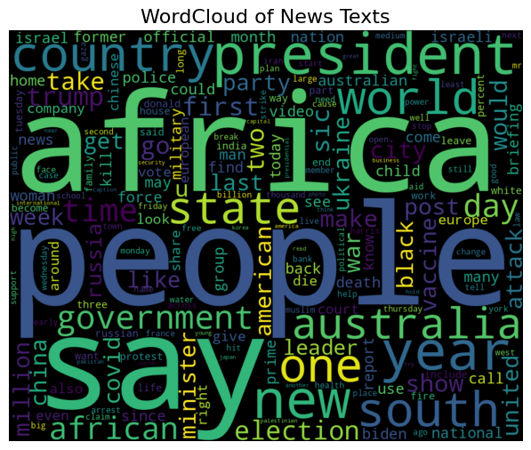

Figure 2.1: Word cloud

Text Transformation:

We used three transformation techniques: -

1. Tokenization (splitting text into tokens)

2. Converting text to lowercase

3. Lemmatization

• **One hot encoding:**

1.Logistic Regression:

|  |  |  |  |  |  |  |  |
| --- | --- | --- | --- | --- | --- | --- | --- |
| Model | Training Accuracy | Testing Accuracy | Accuracy | Recall | Precision | F1-measure | AUC Value |
| Logistic | 96.92% | 92.25% |  | 95.78% | 91.23% | 93.45% | 97.89% |

|  |  |
| --- | --- |
|  |  |
| Figure 1.1: Logistic Regression with one hot encode confusion matrix | Figure 1.2: Logistic Regression with one hot encode Roc curve |

2. random forest (RF) Algorithm:

|  |  |  |  |  |  |  |  |
| --- | --- | --- | --- | --- | --- | --- | --- |
| Model | Training Accuracy | Testing Accuracy | Accuracy | Recall | Precision | F1-measure | AUC Value |
| RF | 88.54% | 86.14% |  | 93.91% | 83.97% | 88.66% | 94.4% |

|  |  |
| --- | --- |
|  |  |
| Figure 1.3: random forest (RF) Algorithm with one hot encode confusion matrix | Figure 1.4: random forest (RF) Algorithm with one hot Roc curve |

3. naive Bayes algorithm:

|  |  |  |  |  |  |  |  |
| --- | --- | --- | --- | --- | --- | --- | --- |
| Model | Training Accuracy | Testing Accuracy | Accuracy | Recall | Precision | F1-measure | AUC Value |
| NB | 96.92% | 93.25% |  | 92.66% | 95.51% | 94.06% | 93.36% |

|  |  |
| --- | --- |
|  |  |
| Figure 1.5: naive Bayes with one hot encode confusion matrix | Figure 1.6: NB with BOW Roc curve |

4. SVM algorithm:

|  |  |  |  |  |  |  |  |
| --- | --- | --- | --- | --- | --- | --- | --- |
| Model | Training Accuracy | Testing Accuracy | Accuracy | Recall | Precision | F1-measure | AUC Value |
| SVM | 92.32% | 90.42% |  | 93.77% | 90.03% | 91.86% | 89.8% |

|  |  |
| --- | --- |
|  |  |
| Figure 1.7: SVM with one hot encode confusion matrix | Figure 1.8: SVM with BOW Roc curve |

1. Dense Neural Network:

|  |  |  |  |  |  |  |  |
| --- | --- | --- | --- | --- | --- | --- | --- |
| Model | Training Accuracy | Testing Accuracy | Accuracy | Recall | Precision | F1-measure | AUC Value |
| Dense | 93.13% | 90.26% |  | 91.7% | 91.44% | 91.57% | 96.38% |

|  |  |
| --- | --- |
|  |  |
| Figure 1.9: Dense Neural Network with one hot encoding confusion matrix | Figure 1.10: Dense Neural Network Roc curve |

2. ResNet:

|  |  |  |  |  |  |  |  |
| --- | --- | --- | --- | --- | --- | --- | --- |
| Model | Training Accuracy | Testing Accuracy | Accuracy | Recall | Precision | F1-measure | AUC Value |
| ResNet | 96.98% | 92% |  | 92.42% | 93.70% | 93.06% | 97.37% |

|  |  |
| --- | --- |
|  |  |
| Figure 1.11: ResNet with one hot encode confusion matrix | Figure 1.12: ResNet Roc curve |

|  |  |  |  |  |  |  |  |
| --- | --- | --- | --- | --- | --- | --- | --- |
| Model | Training Accuracy | Testing Accuracy | Accuracy | Recall | Precision | F1-measure | AUC Value |
| Logistic | 96.92% | 92.25% |  | 95.78% | 91.23% | 93.45% | 97.89% |
| RF | 88.54% | 86.14% |  | 93.91% | 83.97% | 88.66% | 94.4% |
| NB | 97.12% | 93.45% |  | 92.87% | 94.65% | 94.24% | 93.56% |
| NB | 96.92% | 93.25% |  | 92.66% | 95.51% | 94.06% | 93.36% |
| Dense | 93.13% | 90.26% |  | 91.7% | 91.44% | 91.57% | 96.38% |
| ResNet | 96.98% | 92% |  | 92.42% | 93.70% | 93.06% | 97.37% |

* Bag of Words

1.Logistic Regression:

|  |  |  |  |  |  |  |  |
| --- | --- | --- | --- | --- | --- | --- | --- |
| Model | Training Accuracy | Testing Accuracy | Accuracy | Recall | Precision | F1-measure | AUC Value |
| Logistic | 94.33% | 90.58 |  | 92.49% | 92% | 91.64% | 97.13% |

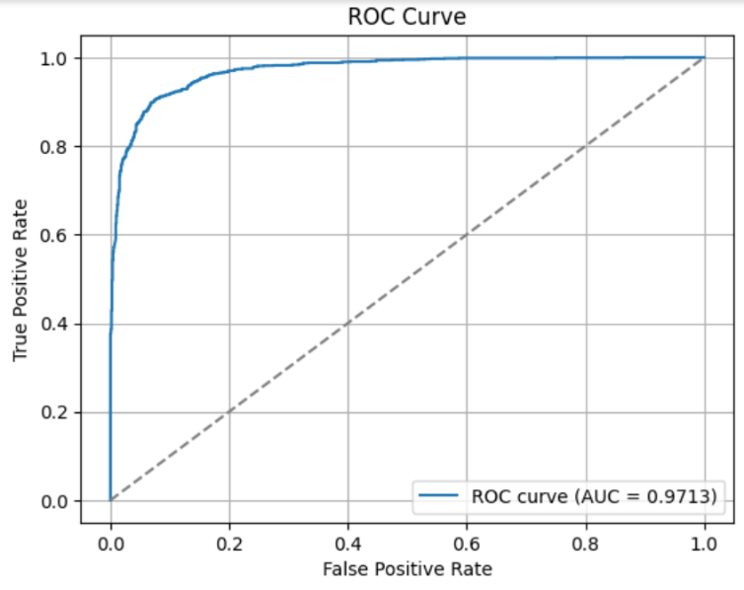

Fig 2.2 : confusion matrix for logistic regression

Fig 2.1 :ROC curve for logistic regression

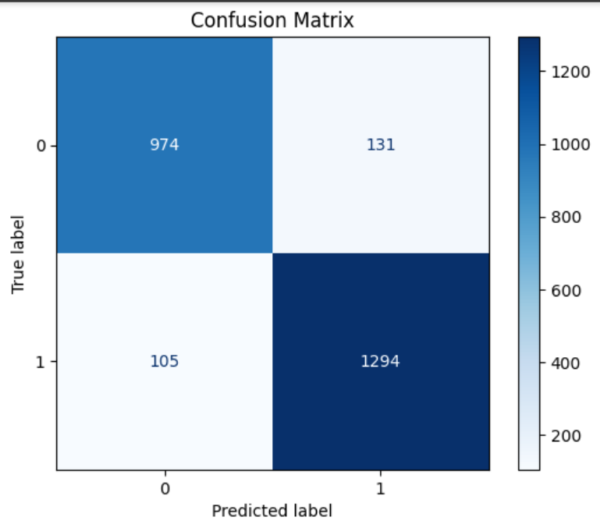

2. Naive Bayes Algorithm:

|  |  |  |  |  |  |  |  |
| --- | --- | --- | --- | --- | --- | --- | --- |
| Model | Training Accuracy | Testing Accuracy | Accuracy | Recall | Precision | F1-measure | AUC Value |
| Naïve Bayes | 92.40% | 90.69% |  | 89.85% | 93.00% | 91.52% | 96.54% |

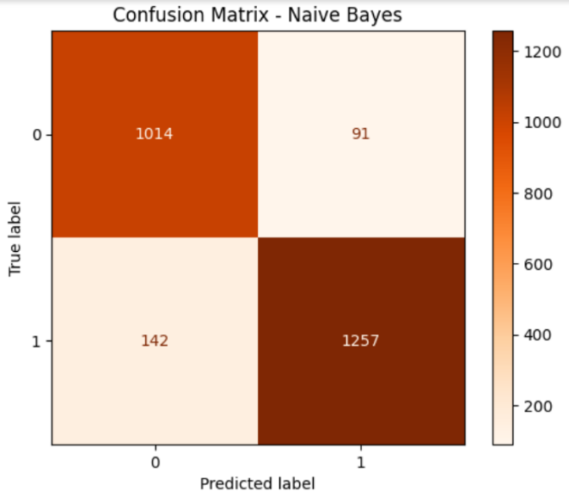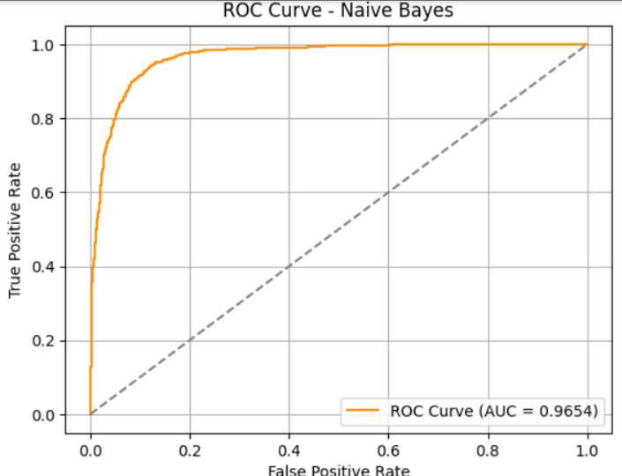

Fig 2.3 : Naïve Bayes ROC curve

Fig 2.4 : Naïve Bayes Confusion matrix

3. support vector machine:

|  |  |  |  |  |  |  |  |
| --- | --- | --- | --- | --- | --- | --- | --- |
| Model | Training Accuracy | Testing Accuracy | Accuracy | Recall | Precision | F1-measure | AUC Value |
| SVM | 95.7% | 91.49% |  | 93.92% | 92.00% | 92.50% | 97.46% |

Fig 2.5 : SVM confusion matrix

Fig 2.6 : SVM ROC curve

4. XG Boost algorithim:

|  |  |  |  |  |  |  |  |
| --- | --- | --- | --- | --- | --- | --- | --- |
| Model | Training Accuracy | Testing Accuracy | Accuracy | Recall | Precision | F1-measure | AUC Value |
| XG Boost | 92.49% | 89.66% |  | 94.21% | 92.00% | 91.05% | 96.01% |

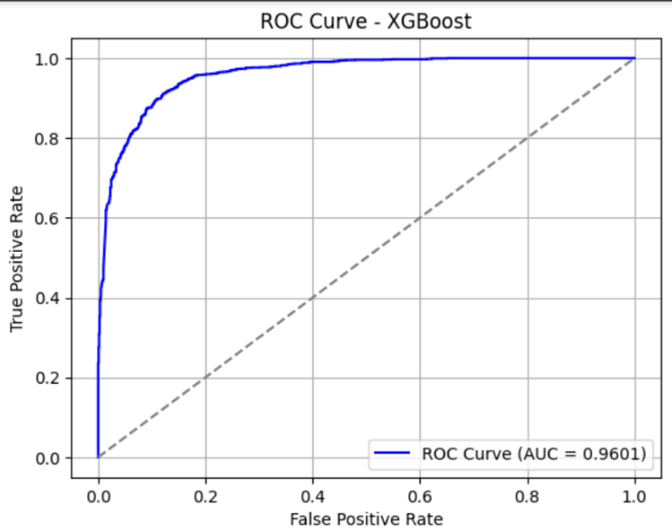

Fig 2.8 : XG Boost confusion matrix

Fig 2.7 : XG Boost ROC curve

5. Auto Encoder

|  |  |  |  |  |  |  |  |
| --- | --- | --- | --- | --- | --- | --- | --- |
| Model | Training Accuracy | Testing Accuracy | Accuracy | Recall | Precision | F1-measure | AUC Value |
| AutoEncoder | 97.30% | 91.69% |  | 94% | 92.00% | 92.67% | 97.45% |

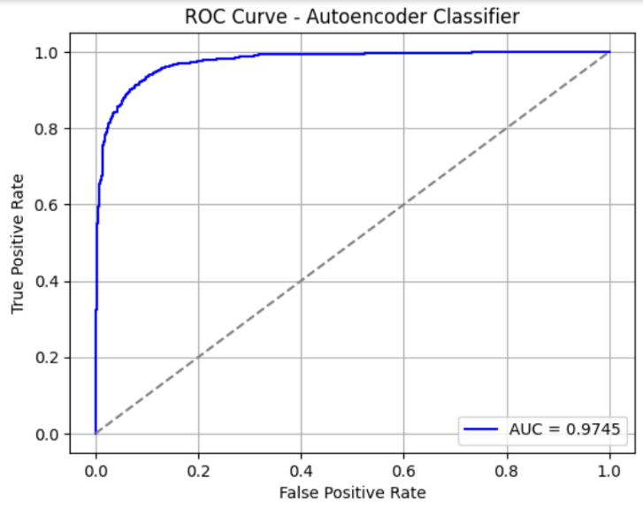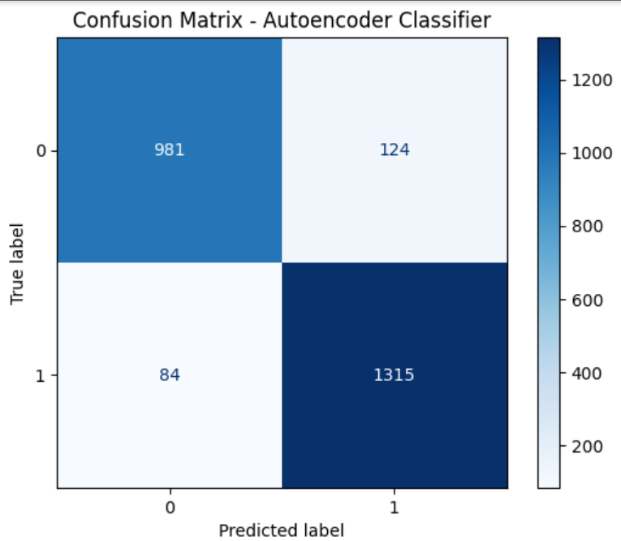

Fig 2.10 : Auto Encoder confusion matrix

Fig 2.9 : Auto Encoder ROC curve

6. FFNN:

|  |  |  |  |  |  |  |  |
| --- | --- | --- | --- | --- | --- | --- | --- |
| Model | Training Accuracy | Testing Accuracy | Accuracy | Recall | Precision | F1-measure | AUC Value |
| Feed forward NN | 96.36% | 91.33% |  | 93.28% | 91.00% | 92.33% | 97.38% |

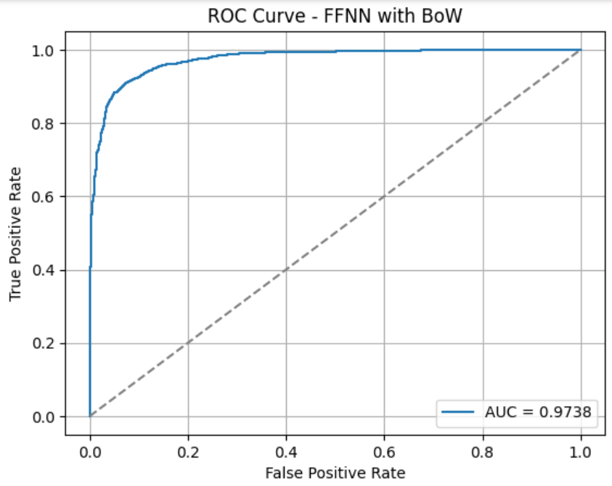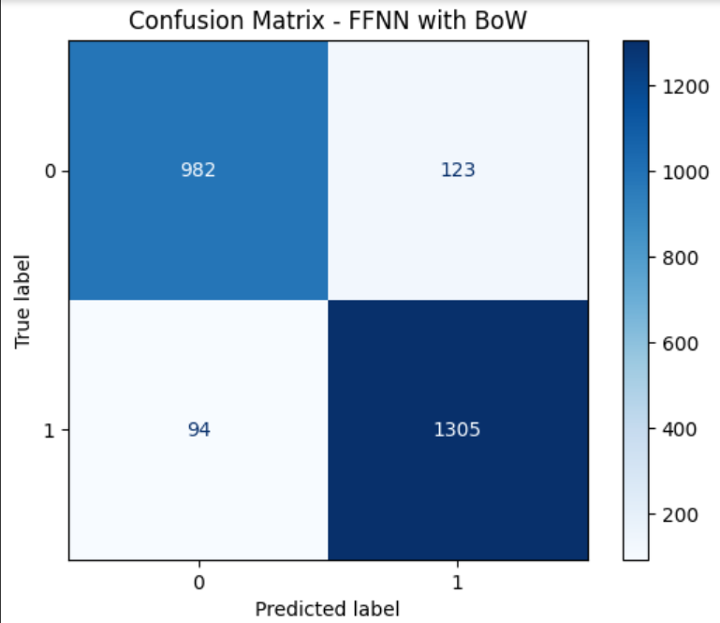

Fig 2.12: FFNN confusion matrix

Fig 2.11 : FFNN ROC curve

|  |  |  |  |  |  |  |  |
| --- | --- | --- | --- | --- | --- | --- | --- |
| Model | Training Accuracy | Testing Accuracy | Accuracy | Recall | Precision | F1-measure | AUC Value |
| Logistic | 94.33% | 90.58 |  | 92.49% | 92% | 91.64% | 97.13% |
| Naïve Bayes | 92.40% | 90.69% |  | 89.85% | 93.00% | 91.52% | 96.54% |
| SVM | 95.7% | 91.49% |  | 93.92% | 92.00% | 92.50% | 97.46% |
| XG Boost | 92.49% | 89.66% |  | 94.21% | 92.00% | 91.05% | 96.01% |
| AutoEncoder | 97.30% | 91.69% |  | 94% | 92.00% | 92.67% | 97.45% |
| Feed forward NN | 96.36% | 91.33% |  | 93.28% | 91.00% | 92.33% | 97.38% |

• **Co-occurrence Matrices:**

1.Logistic Regression:

|  |  |  |  |  |  |  |  |
| --- | --- | --- | --- | --- | --- | --- | --- |
| Model | Training Accuracy | Testing Accuracy | Accuracy | Recall | Precision | F1-measure | AUC Value |
| Logistic | 93.26% | 92.97% |  | 95.50% | 92.56% | 94.01% | 97.98% |

2.  Random Forest Model:

|  |  |  |  |  |  |  |  |
| --- | --- | --- | --- | --- | --- | --- | --- |
| Model | Training Accuracy | Testing Accuracy | Accuracy | Recall | Precision | F1-measure | AUC Value |
| Random Forest | 94.33% | 90.10% |  | 94.05% | 89.35% | 91.64% | 95.92% |

3.  Support Vector Machine (SVM):

|  |  |  |  |  |  |  |  |
| --- | --- | --- | --- | --- | --- | --- | --- |
| Model | Training Accuracy | Testing Accuracy | Accuracy | Recall | Precision | F1-measure | AUC Value |
| SVM | 97.82% | 92.25% |  | 95.02% | 91.84% | 93.40% | 95.49% |

4.  Naive Bayes Model:

|  |  |  |  |  |  |  |  |
| --- | --- | --- | --- | --- | --- | --- | --- |
| Model | Training Accuracy | Testing Accuracy | Accuracy | Recall | Precision | F1-measure | AUC Value |
| Naive Bayes | 94.00% | 91.45% |  | 91.70% | 93.38% | 92.53% | 97.18% |

4.  Naive Bayes Model:

|  |  |  |  |  |  |  |  |
| --- | --- | --- | --- | --- | --- | --- | --- |
| Model | Training Accuracy | Testing Accuracy | Accuracy | Recall | Precision | F1-measure | AUC Value |
| XGBoost | 95.61% | 91.01% |  | 95.09% | 89.92% | 92.43% | 97.04% |

1.  Dense Neural Network:

|  |  |  |  |  |  |  |  |
| --- | --- | --- | --- | --- | --- | --- | --- |
| Model | Training Accuracy | Testing Accuracy | Accuracy | Recall | Precision | F1-measure | AUC Value |
| DNN | 95.85% | 92.41% |  | 95.22% | 91.92% | 93.54% | 97.63% |

2.  LSTM Model:

|  |  |  |  |  |  |  |  |
| --- | --- | --- | --- | --- | --- | --- | --- |
| Model | Training Accuracy | Testing Accuracy | Accuracy | Recall | Precision | F1-measure | AUC Value |
| LSTM | 98.45% | 92.97% |  | 95.22% | 92.78% | 93.99% | 97.85% |

|  |  |  |  |  |  |  |  |
| --- | --- | --- | --- | --- | --- | --- | --- |
| Model | Training Accuracy | Testing Accuracy | Accuracy | Recall | Precision | F1-measure | AUC Value |
| Logistic | 93.26% | 92.97% |  | 95.50% | 92.56% | 94.01% | 97.98% |
| Random Forest | 94.33% | 90.10% |  | 94.05% | 89.35% | 91.64% | 95.92% |
| SVM | 97.82% | 92.25% |  | 95.02% | 91.84% | 93.40% | 95.49% |
| Naive Bayes | 94.00% | 91.45% |  | 91.70% | 93.38% | 92.53% | 97.18% |
| XGBoost | 95.61% | 91.01% |  | 95.09% | 89.92% | 92.43% | 97.04% |
| DNN | 95.85% | 92.41% |  | 95.22% | 91.92% | 93.54% | 97.63% |
| LSTM | 98.45% | 92.97% |  | 95.22% | 92.78% | 93.99% | 97.85% |

* **Term frequency-inverse document frequency**

|  |  |  |  |  |  |  |
| --- | --- | --- | --- | --- | --- | --- |
| Model | Training Accuracy | Testing Accuracy | Recall  Accuracy | Precision Accuracy | F1-measure Accuracy | AUC Value |
| Logistic Model | 95.89% | 92.37% | 95.94% | 90.96% | 93.38% | 98% |
| Nave Bayes Model | 94.35% | 92.49% | 93.95% | 92.76% | 93.35% | 98% |
| Support Vector Machine(SVM) | 99.62% | 93.65% | 95.94% | 92.97% | 94.43% | 98% |
| Random Forest | 92.62% | 89.18% | 89.89% | 90.73% | 90.31% | 96% |
| LSTM | 97.97% | 92.85% | 94.73% | 92.69% | 93.7% | 97% |
| RNN | 98.4% | 92.17% | 93.95% | 92.24% | 93.09% | 96% |

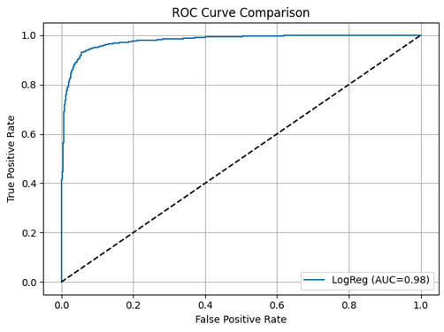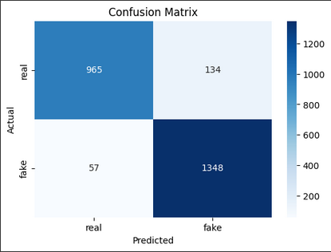

Fig 3.1: Logistic Regression Roc curve Fig3.2: Logistic Regression Confusion Matrix

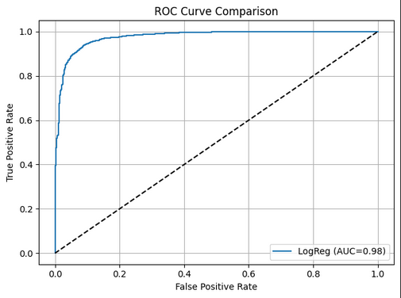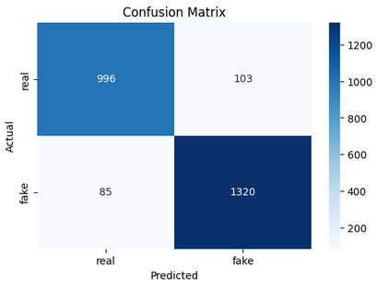

Fig 3.3: Nave Bayse Roc curve Fig 3.4: Nave Bayes Confusion Matrix

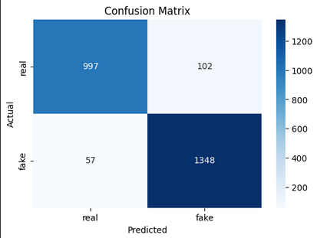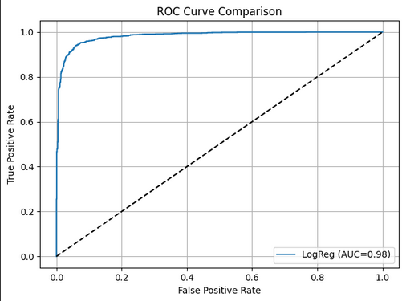

Fig 3.5: SVM Roc curve Fig 3.6: SVM Confusion Matrix

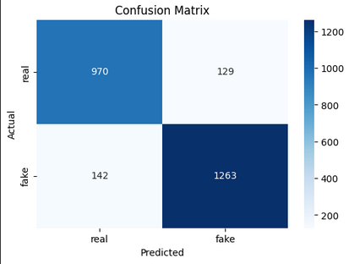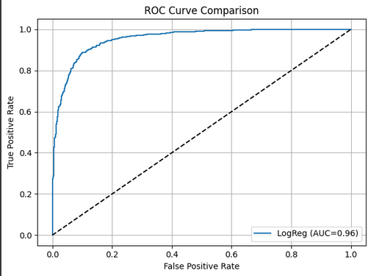

Fig 3.7: Random Forest Roc curve Fig 3.8: Random Forest Confusion Matrix

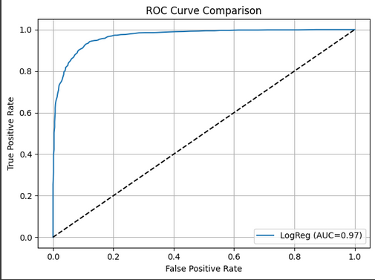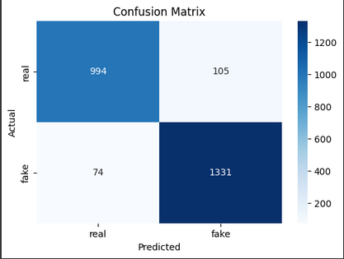

Fig 3.9: LSTM Roc curve Fig 3.10: LSTM Confusion Matrix

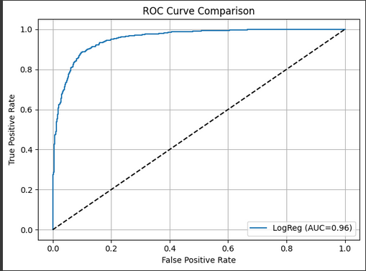

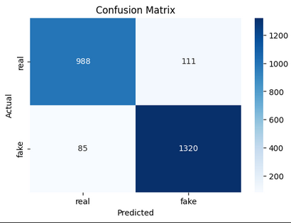

Fig 3.11: RNN Roc curve Fig 3.12: RNN Confusion Matrix