Memory

Process:

New: the creation of process

Fork() system call

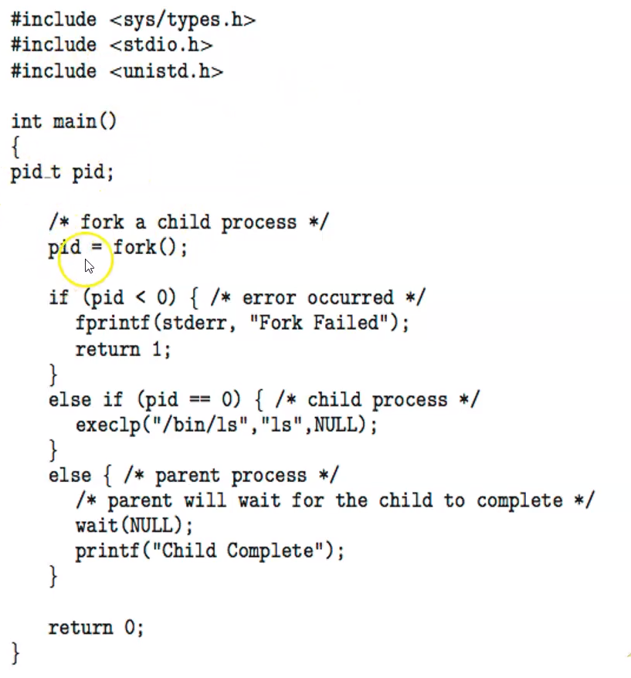

Running: the process is being executed

Exec() system call

Ready: waiting to be assigned to a processor

Waiting: waiting for some events to occur

Terminated: finished execution

wait() return from child to parents

exit() system call

First **new** a process, once admitted the process is ready.

This process can now be scheduled to dispatch for **running**

While the process is **running**

if it is being interrupt then

it will go back to **ready**

If the process is getting an IO or **waiting** for an event then

It will be moved to **waiting**

Once the event completed or got IO

Move to **ready**

Until all instructions executed the process **terminates**