The amount of water the air can carry based on temperature:

np.exp(1.56065404) * np.exp(6.90219321e-02 * z) * np.exp(-2.38543241e-04 * z**2)

$m = e^{1.56065404}*e^{6.90219321*10^{-2}* T}*e^{-2.38543241*10^{-4} * T^{2}}$

Where m is $g/m^{3}$**this works at ranges -20 to 60 C**

The density of air based on temperature:

1.44685243e-05 * T**2 -4.72481940e-03 * T + 1.29255728

<https://en.wikipedia.org/wiki/Humidity>

There are several empirical formulas that can be used to estimate the equilibrium vapor pressure of water vapor as a function of temperature. The [Antoine equation](https://en.wikipedia.org/wiki/Antoine_equation) is among the least complex of these, having only three parameters (A, B, and C). Other formulas, such as the [Goff–Gratch equation](https://en.wikipedia.org/wiki/Goff%E2%80%93Gratch_equation) and the [Magnus–Tetens approximation](https://en.wikipedia.org/wiki/Clausius%E2%80%93Clapeyron_relation#Meteorology_and_climatology), are more complicated but yield better accuracy.[[citation needed](https://en.wikipedia.org/wiki/Wikipedia:Citation_needed)]

The [Arden Buck equation](https://en.wikipedia.org/wiki/Arden_Buck_equation) is commonly encountered in the literature regarding this topic:[[19]](https://en.wikipedia.org/wiki/Humidity#cite_note-FOOTNOTEBuck19811527%E2%80%931532-19)



Where T is the dry-bulb temperature expressed in degrees Celsius (°C), P is the absolute pressure expressed in millibars, and ${e^{*}}_{w}$ is the equilibrium vapor pressure expressed in millibars. Buck has reported that the maximal relative error is less than 0.20% between −20, and +50 °C (−4, and 122 °F) when this particular form of the generalized formula is used to estimate the equilibrium vapor pressure of water.  
(<https://en.wikipedia.org/wiki/Vapour_pressure_of_water>

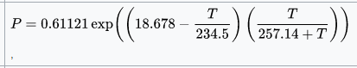

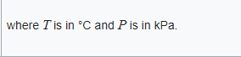)

Humid air is less dense than dry air because a molecule of water ([M](https://en.wikipedia.org/wiki/Molecular_mass) ≈ 18 [u](https://en.wikipedia.org/wiki/Atomic_mass_unit)) is less massive than either a molecule of [nitrogen](https://en.wikipedia.org/wiki/Nitrogen) (M ≈ 28) or a molecule of [oxygen](https://en.wikipedia.org/wiki/Oxygen) (M ≈ 32). About 78% of the molecules in dry air are nitrogen (N2). Another 21% of the molecules in dry air are oxygen (O2). The final 1% of dry air is a mixture of other gases.

<https://en.wikipedia.org/wiki/Electromagnetic_absorption_by_water>

[Standard (atmospheric optical) codes](https://en.wikipedia.org/wiki/Atmospheric_radiative_transfer_codes) are assigned to absorption bands as follows. 0.718 μm (visible): α, 0.810 μm: μ, 0.935 μm: ρστ, 1.13 μm: φ, 1.38 μm: ψ, 1.88 μm: Ω, 2.68 μm: X.

The infrared spectrum of liquid water is dominated by the intense absorption due to the fundamental O-H stretching vibrations.

In the near-infrared range liquid water has absorption bands around 1950 nm (5128 cm−1), 1450 nm (6896 cm−1), 1200 nm (8333 cm−1) and 970 nm, (10300 cm−1).[[19]](https://en.wikipedia.org/wiki/Electromagnetic_absorption_by_water#cite_note-Carter1993-19)[[20]](https://en.wikipedia.org/wiki/Electromagnetic_absorption_by_water#cite_note-Rossel1998-20)[[15]](https://en.wikipedia.org/wiki/Electromagnetic_absorption_by_water#cite_note-Jacquemoud2003-15) The regions between these bands can be used in [near-infrared spectroscopy](https://en.wikipedia.org/wiki/Near-infrared_spectroscopy) to measure the spectra of aqueous solutions, with the advantage that glass is transparent in this region, so glass cuvettes can be used.

The absorption intensity is weaker than for the fundamental vibrations, but this is not important as longer path-length cuvettes can be used. The absorption band at 698 nm (14300 cm−1) is a 3rd overtone (n=4).

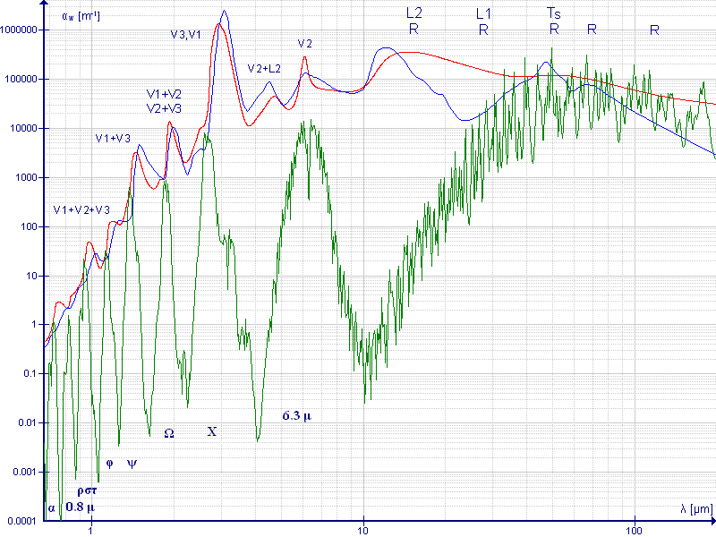

<https://en.wikipedia.org/wiki/Near-infrared_spectroscopy>

Near-infrared spectroscopy is based on molecular overtone and combination vibrations. Such transitions are [forbidden](https://en.wikipedia.org/wiki/Forbidden_transition) by the [selection rules](https://en.wikipedia.org/wiki/Selection_rule) of [quantum mechanics](https://en.wikipedia.org/wiki/Quantum_mechanics). As a result, the [molar absorptivity](https://en.wikipedia.org/wiki/Molar_absorptivity) in the near-IR region is typically quite small.[[citation needed](https://en.wikipedia.org/wiki/Wikipedia:Citation_needed)] One advantage is that NIR can typically penetrate much further into a sample than [mid infrared](https://en.wikipedia.org/wiki/Infrared_spectroscopy) radiation. Near-infrared spectroscopy is, therefore, not a particularly sensitive technique, but it can be very useful in probing bulk material with little or no sample preparation.

The molecular overtone and combination bands seen in the near-IR are typically very broad, leading to complex spectra; it can be difficult to assign specific features to specific chemical components. [Multivariate](https://en.wikipedia.org/wiki/Multivariate_statistics) (multiple variables) calibration techniques (e.g., [principal components analysis](https://en.wikipedia.org/wiki/Principal_components_analysis), [partial least squares](https://en.wikipedia.org/wiki/Partial_least_squares), or [artificial neural networks](https://en.wikipedia.org/wiki/Artificial_neural_networks)) are often employed to extract the desired chemical information. Careful development of a set of calibration samples and application of multivariate calibration techniques is essential for near-infrared analytical methods.[[1]](https://en.wikipedia.org/wiki/Near-infrared_spectroscopy#cite_note-Balabin_2007-1)