Info BEP

# 

Eddy Covariance **3**

Wikipedia Eddy Covariance **4**

Eddy Covariance Youtube **5**

Beer-Lambert’s Law Wikipedia **6**

Wikipedia water absorbtie **7**

Relative Humidity Effect on the High-Frequency Attenuation of Water Vapor Flux Measured by a Closed-Path Eddy Covariance System **9**

Opportunistic remote sensing of rainfall using microwave links from cellular communication networks **10**

Scintillometry in urban and complex environments: a review **11**

Carbon in de lucht **13**

Scintillometer **14**

The Practical Application of Scintillometers in Determining the Surface Fluxes of Heat, Moisture and Momentum **15**

Wavelength-Modulation Laser Hygrometer for Ultrasensitive Detection of Water Vapor in Semiconductor Gases **16**

Water Vapor Profiling Using a Widely Tunable, Amplified Diode-Laser-Based Differential Absorption Lidar (DIAL) **17**

On the Nature of Light and Its Interaction with Atmospheric Particles **18**

Absorption measurements of water-vapor concentration, temperature, and line-shape parameters using a tunable InGaAsP diode laser **22**

Absorption spectra of atmospheric gases in the IR, visible and UV **23**

Computing Refractive Index Structure Parameter Cn2 in a Numerical Weather Prediction Model **24**

A low-cost, high-speed, near-infrared hygyrometer **25**

On demand webinar: Measuring Laser Beam Power with Photodiode Sensors – How to Get it Right **26**

Photodiodes - (working & why it's reverse biased) | Semiconductors | Physics | Khan Academy **27**

**Humidity control in the laboratory using salt solutions** **28**

**Clausius Clapeyron relation** **29**

**MOSFET** **30**

# 

# Eddy Covariance

Een methode om de flux in een bepaald gebied te meten.  
Flux van lucht: gas concentration, pressure, temperature, and humidity

# Wikipedia Eddy Covariance

<https://en.wikipedia.org/wiki/Eddy_covariance>

Een methode om de flux in een bepaald gebied te meten.  
Flux van lucht: gas concentration, pressure, temperature, and humidity  
Je meet 2 fluxen (in en uit) en zo kan je kijken wat er in en uit je systeem gaat.

Ook de mathematische manier wordt uitgelegd: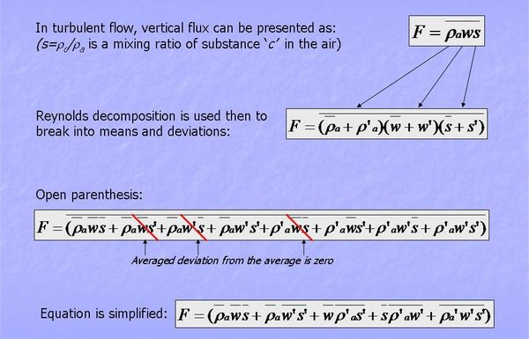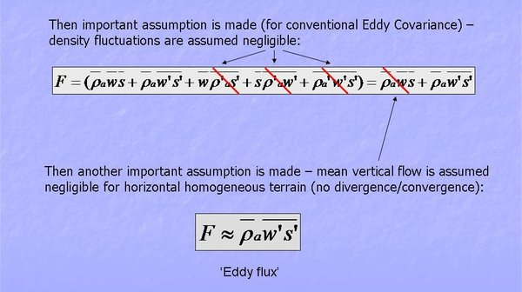

# Eddy Covariance Youtube

Theorie en implementatie:

<https://www.youtube.com/watch?v=w0JWK95Sj84>

- EC gaat vooral om onderzoek rondom het ecosysteem

- Flux meten, zodat je weet wat erin en eruit gaat (H2O, CO2, CH4)

- verschillende wind lagen

- eddy is de windwervel

System design

<https://www.youtube.com/watch?v=2aZXtWC-3dQ>

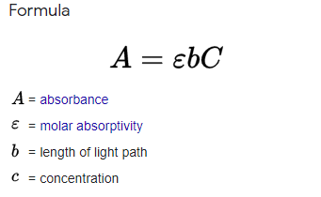

- als we iets gaan maken

GAS ANALYSERS (34:30)

Lambert's Law

Je gebruikt rho omdat je de density meet

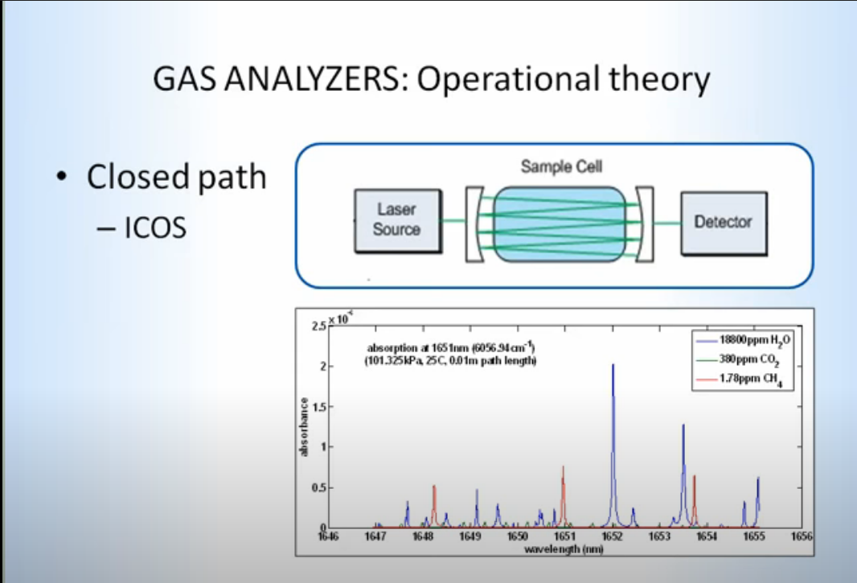

Closed path GA ziet er het beste uit

Meer stroom tho :(

# Beer-Lambert’s Law Wikipedia

<https://en.wikipedia.org/wiki/Beer%E2%80%93Lambert_law>

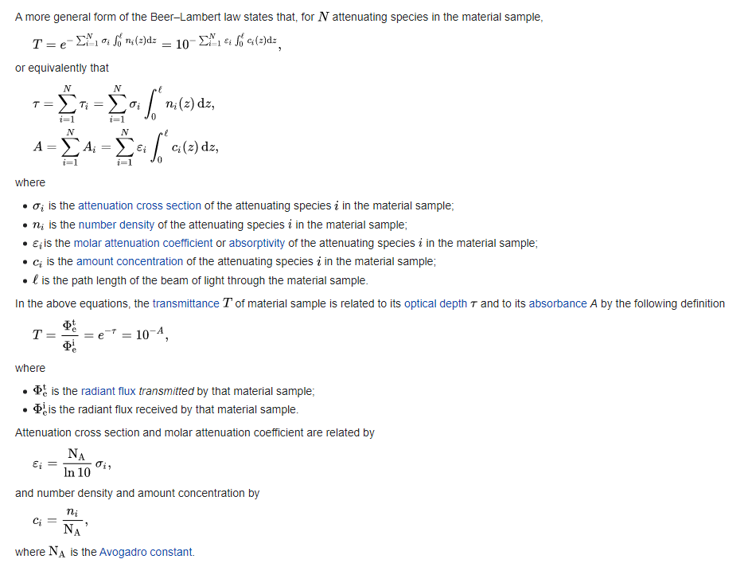

# Wikipedia water absorbtie

<https://en.wikipedia.org/wiki/Electromagnetic_absorption_by_water>

Wikipedia Evapotranspiration

<https://en.wikipedia.org/wiki/Evapotranspiration>

The most direct method of measuring evapotranspiration is with the [eddy covariance](https://en.wikipedia.org/wiki/Eddy_covariance) technique in which fast fluctuations of vertical wind speed are correlated with fast fluctuations in atmospheric water [vapor density](https://en.wikipedia.org/wiki/Vapor_density). This directly estimates the transfer of water vapor (evapotranspiration) from the land (or canopy) surface to the atmosphere.

# Relative Humidity Effect on the High-Frequency Attenuation of Water Vapor Flux Measured by a Closed-Path Eddy Covariance System

<https://www.researchgate.net/profile/Jukka-Pumpanen/publication/228067695_Relative_Humidity_Effect_on_the_High-Frequency_Attenuation_of_Water_Vapor_Flux_Measured_by_a_Closed-Path_Eddy_Covariance_System/links/5509c9480cf20ed529e220b3/Relative-Humidity-Effect-on-the-High-Frequency-Attenuation-of-Water-Vapor-Flux-Measured-by-a-Closed-Path-Eddy-Covariance-System.pdf>

* Age of sampling tube is important
* Leuning and Judd (1996) compared transfer functions for the sampling tube before and after cleaning it and observed a degradation of the response time ts 5 (2pfc) 21 of H2O for the dirty sampling tube. They emphasized that the rates of physical absorption and desorption of water vapor to and from the walls of the gas tubing and filters could change, because of the presence of dust, pollen, and salt crystals in the walls of the tubing (Leuning and Judd 1996)

# Opportunistic remote sensing of rainfall using microwave links from cellular communication networks

<https://wires.onlinelibrary.wiley.com/doi/full/10.1002/wat2.1289>

Dit artikel kijkt naar de mogelijkheid om regen te meten via de telefoontorens.

K-Band 10s-GHz ~ 1cm λ kan regen zien en scatteren.

Je kijkt naar hoeveel regen er kan vallen en je zorgt dat je SN-Ratio hoog blijft, dus λ hoger houden dan regen.

Maar hogere frequentie is natuurlijk meer info.

The fundamental quantity in studies of rain-induced attenuation of microwave signals is the so-called specific attenuation

Kijken naar hoe regen in verhouding staat tot signal attenuation (verzwakking). (MATH)

Absorption band:

For water vapor this band is centred around 22.2 GHz (1.35 cm) and for oxygen around 60 GHz (0.5 cm)

# Scintillometry in urban and complex environments: a review

PDF IN DE DRIVE

Scintillometer kijk naar de refractive index van lucht voor turbulentie.

The amount of scattering depends on the refractive index (n) of air parcels, which depends on their density (ρ) which, in turn, depends on their temperature (T) and water vapour content (specific humidity, q). From the fluctuations in T and q, surface fluxes can be obtained using Monin-Obukhov similarity theory (MOST).  
MOST werkt blijkbaar alleen als alles perfect is

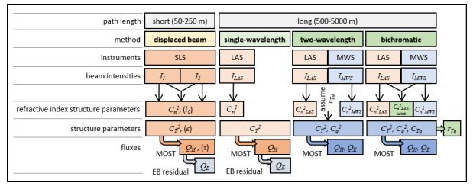

In the infrared region, refractive index fluctuations are mainly caused by changes in air temperature with humidity having a much smaller effect.

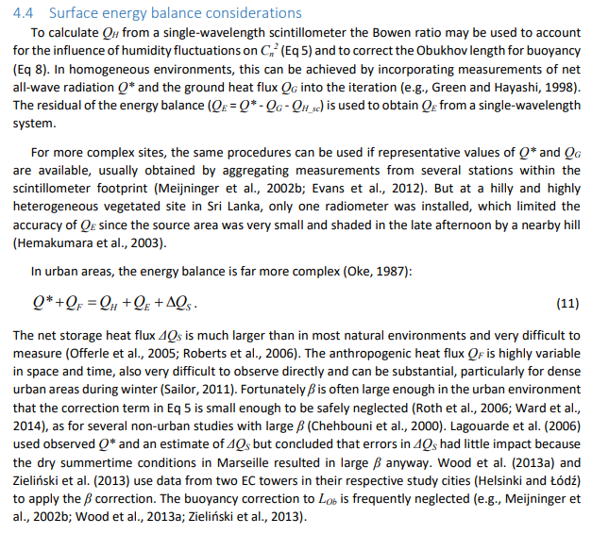

# Carbon in de lucht

<https://www-ncbi-nlm-nih-gov.tudelft.idm.oclc.org/pmc/articles/PMC6174548/>

# Scintillometer

<https://www.meteo-julianadorp.nl/Meteo-instrumenten/Scintillometer.html>

Een formule:



# The Practical Application of Scintillometers in Determining the Surface Fluxes of Heat, Moisture and Momentum

<https://edepot.wur.nl/194568>

Page 13:

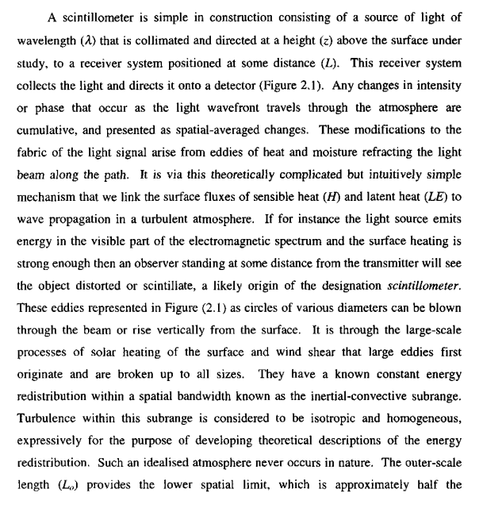

# Wavelength-Modulation Laser Hygrometer for Ultrasensitive Detection of Water Vapor in Semiconductor Gases

<https://www.researchgate.net/publication/5495533_Wavelength-Modulation_Laser_Hygrometer_for_Ultrasensitive_Detection_of_Water_Vapor_in_Semiconductor_Gases>

uses near-infrared InGaAsP diode lasers near 1392.5 nm

Goede referenties staan hierin

Teveel tekst

# Water Vapor Profiling Using a Widely Tunable, Amplified Diode-Laser-Based Differential Absorption Lidar (DIAL)

<https://journals.ametsoc.org/view/journals/atot/26/4/2008jtecha1201_1.xml>

Laser 820-840nm voor water vapour ([Obland 2007](https://journals.ametsoc.org/view/journals/atot/26/4/2008jtecha1201_1.xml#i1520-0426-26-4-733-Obland1); ORNCS)

The three primary criteria for the selection of the water vapor absorption line include the temperature sensitivity, line strength, and absence of nearby absorption features ([Machol et al. 2004](https://journals.ametsoc.org/view/journals/atot/26/4/2008jtecha1201_1.xml#i1520-0426-26-4-733-Machol1); [Obland 2007](https://journals.ametsoc.org/view/journals/atot/26/4/2008jtecha1201_1.xml#i1520-0426-26-4-733-Obland1); ORNCS; [Repasky et al. 2004](https://journals.ametsoc.org/view/journals/atot/26/4/2008jtecha1201_1.xml#i1520-0426-26-4-733-Repasky1)). The online wavelength chosen for the water vapor DIAL instrument has a wavelength of 828.187 nm (828.0069 nm) in a vacuum (air) while the offline wavelength was chosen to be 828.287 nm (828.1069 nm) in a vacuum (air). The temperature neutral point for this absorption feature, as seen in [Fig. 1](https://journals.ametsoc.org/view/journals/atot/26/4/2008jtecha1201_1.xml#i1520-0426-26-4-733-f01), for the ground-state energy of 212.2 cm−1 ranges from 275 K at 0.25 atm to 350 K at 1 atm. At a temperature of 296 K and a pressure of 1 atm, the line strength associated with the water vapor absorption feature used for the DIAL measurements presented in this paper is S = 1.477 × 10−23 cm−1 (mol cm−2) −1, the full width at half maximum line width is 0.1937 cm−1, and the ground-state energy is E″ = 212.2 cm−1 ([Rothman et al. 2003](https://journals.ametsoc.org/view/journals/atot/26/4/2008jtecha1201_1.xml#i1520-0426-26-4-733-Rothman1)).

Dit artikel gaat wel over een joekel van een apparaat

# 

# On the Nature of Light and Its Interaction with Atmospheric Particles

# 

<https://www-sciencedirect-com.tudelft.idm.oclc.org/science/article/pii/B9780128044506000024#c0010>

Deze patst ook ammonia dat groeit als de RH omhoog gaat.

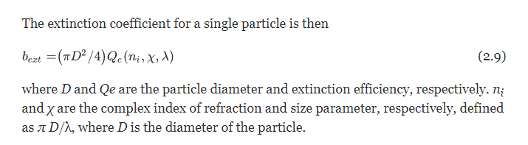

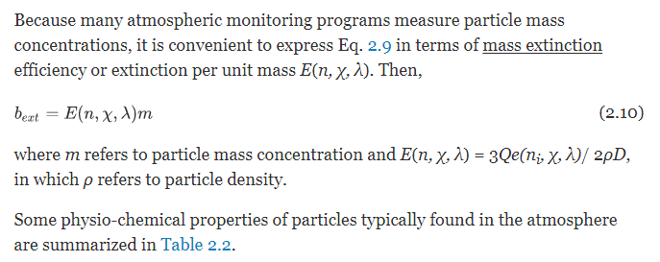

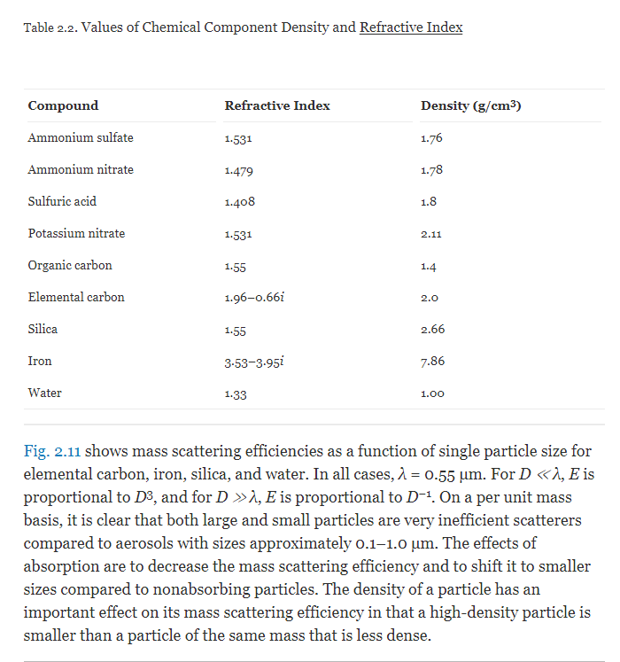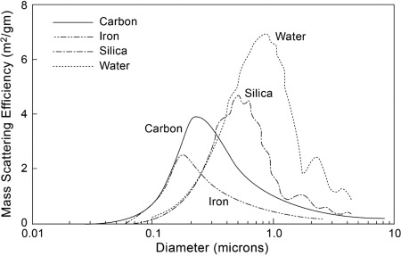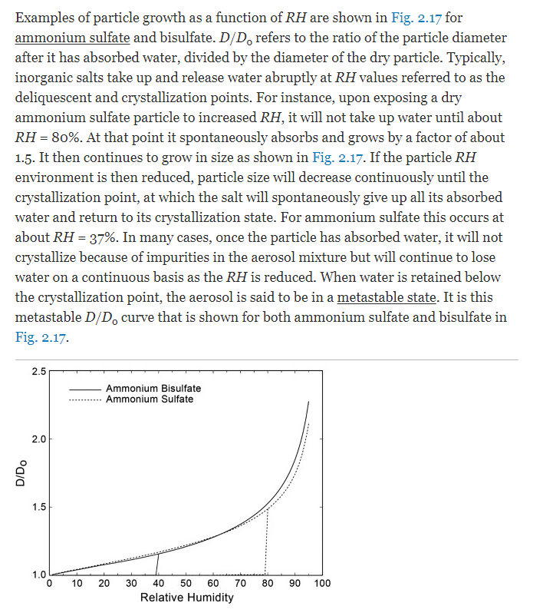

# 

# Absorption measurements of water-vapor concentration, temperature, and line-shape parameters using a tunable InGaAsP diode laser

<https://www.osapublishing.org/ao/ViewMedia.cfm?uri=ao-32-30-6104&seq=0&guid=05d51217-ead9-4f15-9ede-d6ece7fe91ee>

# Absorption spectra of atmospheric gases in the IR, visible and UV

<http://irina.eas.gatech.edu/EAS8803_SPRING2012/Lec7.pdf>

# Computing Refractive Index Structure Parameter Cn2 in a Numerical Weather Prediction Model

<https://agupubs-onlinelibrary-wiley-com.tudelft.idm.oclc.org/doi/full/10.1029/2020GL089168#:~:text=The%20refractive%20index%20structure%20parameter,weather%20prediction%20(NWP)%20models>.

# A low-cost, high-speed, near-infrared hygyrometer

<https://aip-scitation-org.tudelft.idm.oclc.org/doi/pdf/10.1063/1.1146028>

s we shall demonstrate---LEDs can be suitable for absorption spectroscopy of water vapor in the near-infraredwavelength region where there is a dense population of absorption lines.[14,15]

# On demand webinar: Measuring Laser Beam Power with Photodiode Sensors – How to Get it Right

<https://www.youtube.com/watch?v=j7-DxH1HICQ>

* Background subtraction
* Power sensor
* 1/e^2
* 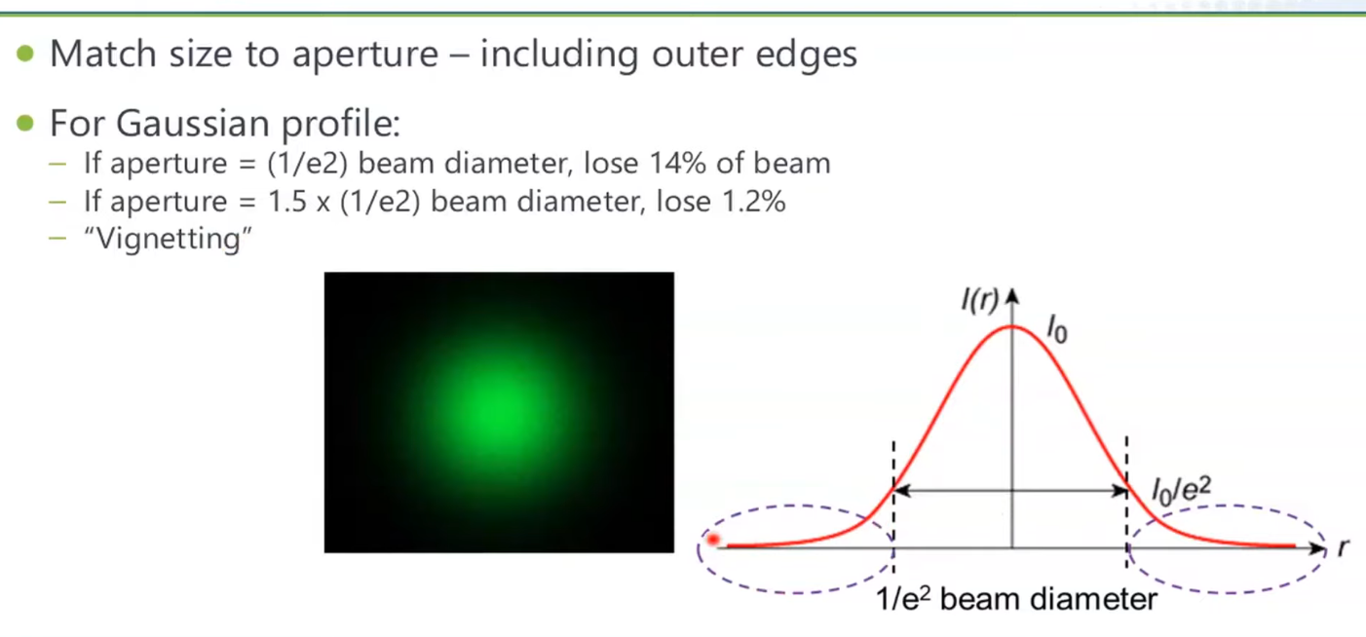

# 

# Photodiodes - (working & why it's reverse biased) | Semiconductors | Physics | Khan Academy

<https://www.youtube.com/watch?v=KgKcbW77txY>

# Humidity control in the laboratory using salt solutions

[https://onlinelibrary-wiley-com.tudelft.idm.oclc.org/doi/pdf/10.1002/jctb.5010170901#:~:text=The%20control%20of%20humidity%20in,salt%20solutions%20is%20critically%20discussed.&text=Any%20salt%20solution%20at%20a,defines%20a%20fixed%20relative%20 humidity](https://onlinelibrary-wiley-com.tudelft.idm.oclc.org/doi/pdf/10.1002/jctb.5010170901#:~:text=The%20control%20of%20humidity%20in,salt%20solutions%20is%20critically%20discussed.&text=Any%20salt%20solution%20at%20a,defines%20a%20fixed%20relative%20humidity).

Douw gewoon een zout solution in een doos en de RH veranderd.

O hier staat t ook: <https://www.engineeringtoolbox.com/salt-humidity-d_1887.html>

# Clausius Clapeyron relation

<https://en.wikipedia.org/wiki/Clausius%E2%80%93Clapeyron_relation>

# MOSFET

<https://www.electronicshub.org/mosfet-as-a-switch/>