**PLEASE CHECK IF YOU CAN BUILD THE FIRMWARE FOR FLYMAPLE WITH THE ORIGINAL CODE BEFORE DOING THIS MODIFICATION**

* Copy the follow files into the **ArduCopter** directory: **Multi_Controller.h**, **control_multi_controller.pde**, **motors_new.pde**
* Copy the following folders into libraries**: PID_Controller, IB_Controller**, **MotorSpeed.**
* Modify the **ArduCopter.pde** as shown below

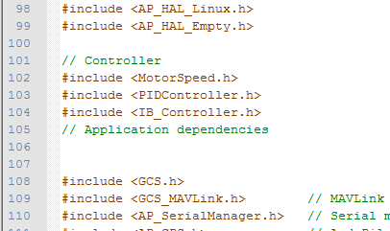

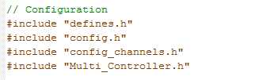

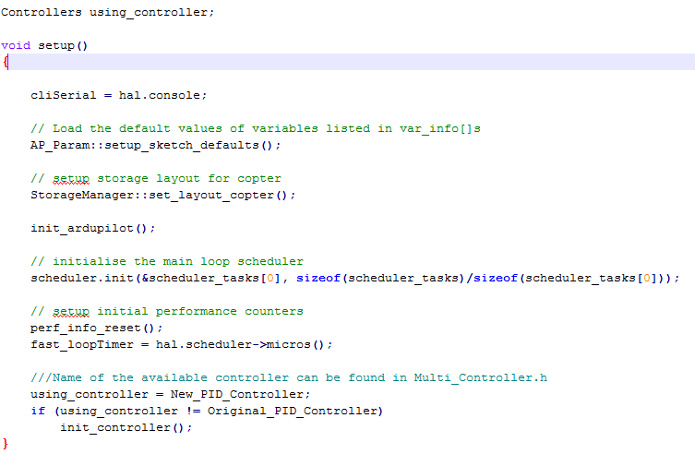

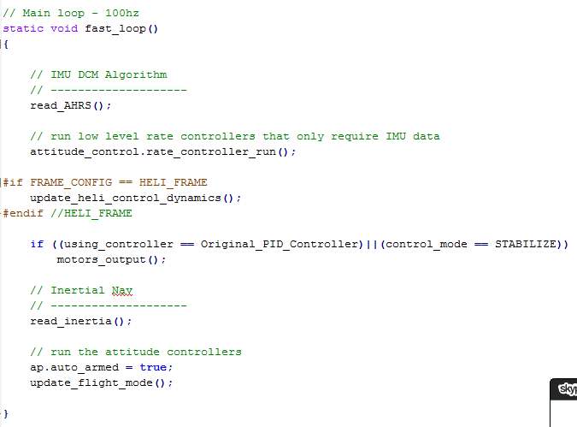

* Modify flight_mode.pde as shown in the file new_flight_mode.pde. There are **new_althold_run()**, **new_auto_run(), new_loiter_run(), new_land_run(), new_rtl_run(), new_poshold_run()**.
* Copy the code of **new_PosHold.pde** to end of control_poshold.pde as shown below

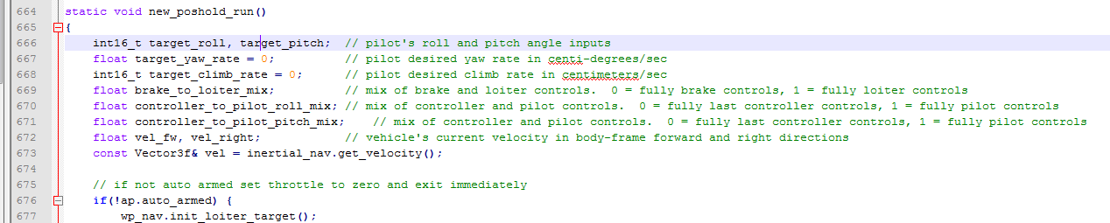

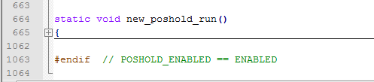

* Copy the code of **new_AC_AttitudeControl.h** to **AC_AttitudeControl.h** in **libraries** as shown below

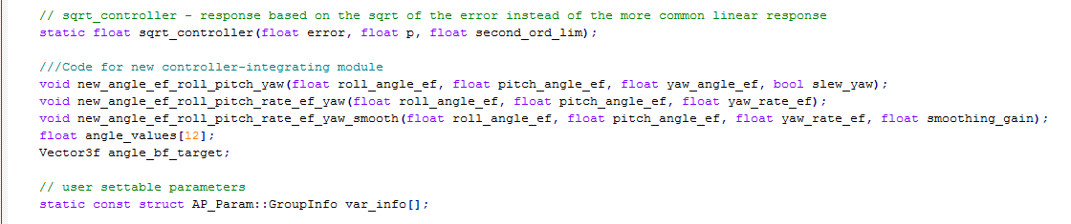

* Copy the code of **new_AC_AttitudeControl.cpp** (all of them)to the end of the **AC_AttitudeControl.cpp** in **libraries** as shown below

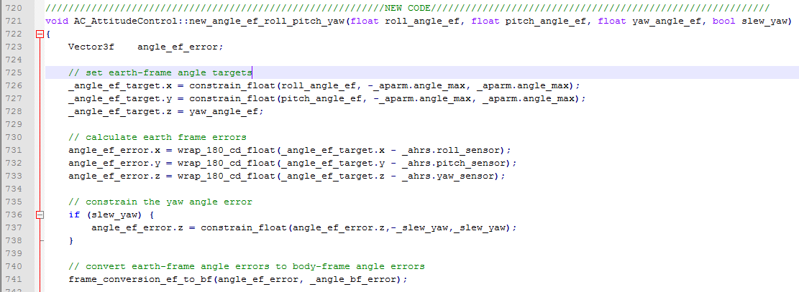

* Copy the code of **new_AC_PosControl.h** to **AC_PosControl.h** in **libraries** as shown below

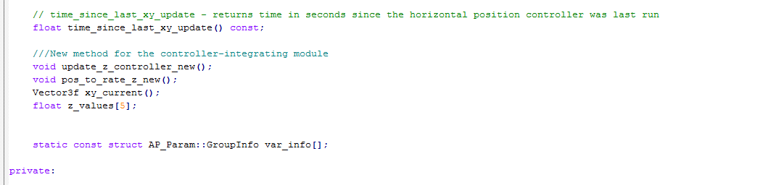

* Copy the code of **new_AC_PosControl.cpp** (all of them)to the end of the **AC_PosControl.cpp** in **libraries** as shown below

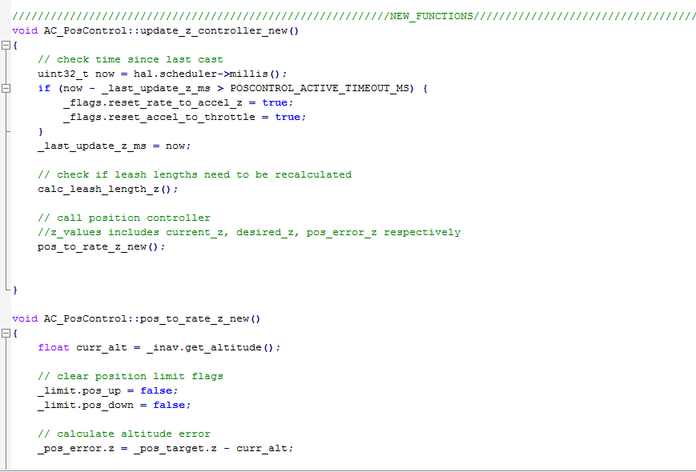

* In case there is no RC receiver, modified the Radio.pde likes the figure below (do not need to do if there is a RC receiver)

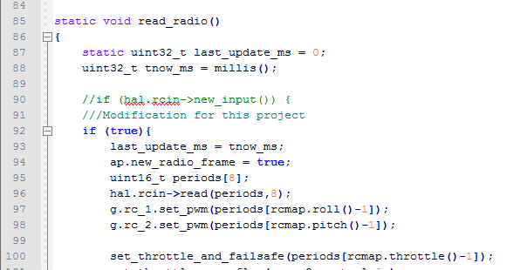

NOW THE NEW MODULE IS IN THE FRAMEWORK AND READY TO USE.

IF THERE IS ANY ERROR, PLEASE FEEL FREE TO FIX THIS MANUAL OR CONTACT ME VIA **ahxd005@yahoo.com**