***Beacate***

**Preliminary Design Document**

Version 1.0

*10/22/2016*

Contents

I. Requirements

A. Functional Requirements

B. Non-Functional Requirements

C. Constraints

II. Specification

A. Functional Requirement Specifications

B. Non-Functional Requirement Specifications

III. Preliminary Design

A. Use Case Diagrams

B. Class Diagram

C. Sequence Diagrams

D. State Diagrams

# Requirements

## Functional Requirements

***1.1.*** *Beacons will be used as a point of reference, and will handle the role of navigating from one point to another (Sadman Ahmed)*

*Reason: It will be the main input that determines the user location in within the mapped area.*

***1.2.*** *The Beacons can also be connected to the user’s schedule as a point of location for that specific event.(Amr Naser)*

*Reason: to be make Beacons more personalized and represent a certain importance to the user.*

***1.3.*** *Share location feature will be added as well (Gibran).*

*Reason: to give the user the ability to locate himself easily relating to other users.*

***1.4.*** *Each user will have the ability to mark the Beacon as a parking spot. (Anthony)*

*Reason: Help the user determine where he/she parked their car in an indoor parking garage.*

***1.5.*** *Beacons should be in a reasonable distance from each other. Not too far nor too close (Gibran).*

*Reason: Or else the system won’t be accurate or be too costly to build*

***1.6.*** *Must be able to give location in real time.(Sadman Ahmed)*

*Reason: Any slower would be poor performance.*

***1.7.*** *Be able to add notes at beacons (Amr Naser)*

*Reason: To add landmarks or signs without recoding or massive updates.*

***1.8.*** *The Beacate GUI should consists of the following pages:*

***1.8.1.*** *Home Page (Amr Naser)*

***1.8.2.*** *Navigation Page (Sadman Ahmed)*

***1.8.3.*** *Schedule Page (Gibran)*

***1.8.4.*** *Notes Page (Amr Naser)*

***1.8.5.*** *Parking spot Page (Anthony)*

*Reason: it will provide the interface where the user interacts with the application and use its functionalities.*

***1.9.*** *Determine the area to be mapped area and create a floor plan picture that can be used in the application. (Anthony)*

## Non-Functional Requirements

### *2.1 Appearance Requirements*

*· The product will consist of a number of Beacons that are the size of 12 x 10 inch at most.*

*· The number of Beacons should be able to cover the targeted area as far as signal.*

*· The Beacons should add a colorful scene to the targeted area.*

### *2.2 Style Requirements*

*· The Product will contain an iOS application that is compatible with Iphone 6/7 devices.*

*· The application icon shall represent the desired functionality with an appropriate image.*

*· The GUI shall contain a main page where the user can enter their desired destination.*

### *2.3 Ease of use Requirements*

*· The product shall be easy to use for the ages of 14 years and up.*

*· The product shall determine the user's position within the system accurately within 3-meter distance from the Beacon.*

*· The user shall have a 5% or lower error rate while using the product.*

*· The product shall not require any training, and shall be useful as an indoor navigation tool*

### *2.4 Personalization and internationalization Requirements*

*· The initial release of the product will only support English as a language.*

*· All distance shall be measured in Meters.*

## ***2.5*** ***Understandability and politeness requirements***

*· The Product shall have no terms or concepts to be learned.*

*· The product shall be understandable for all users.*

## ***2.6*** ***Accessibility Requirements***

*· The product shall be available in the App store for free after final release.*

*· The product will be only compatible with the set up environment that it was intended to navigate.*

*· The product will not accommodate people with special needs in its first release.*

*· Charge of the beacons should last for 2 years before needed to recharge or replace.*

## Constraints

***3.1*** ***Functionality***

*o The distance that each beacon can be placed from each other and still work.*

*o The distance you can be from a beacon to start navigation 40-50 meters.*

*o Accuracy to user location up to 3 meters.*

*o Should have an error rate less than 5%.*

***3.2*** ***Off-the-Shelf Software***

*o Swift/Xcode programming is used to write the GUI, implementation, data.*

*o IBeacon SDK is provided with the beacons, where the SDK should act as a system level software that would help us interact with the Beacon and its sensors settings.*

***3.3******Schedule Constraints***

*o The order in which the beacon will send a signal to each different user.*

*o The amount of pings that will be sent over a time to keep checking where the user is in relation to the beacons and destination.*

***3.4******Maintainability***

*o Battery life is an average of 2 years.*

***3.5******Budget***

*o Initial budget to be in the $300 range for the first prototype and will increase depending on the need*

# Specification

## Functional Requirement Specifications

**4.1** **Convenient Navigation. (Sadman Ahmed)**

We are planning to create an application where the user can navigate with utmost convenience. The beacons will be used to precisely locate the user and guide the user wherever the user wants to go. An easy search around the place or a fixed location saved before can be navigate through the app very easily. Even a shared location from another user can also be navigate easily through the app. An interactive map will be added for the user to look around them.

**4.2** **Event and Time management.(Amr Naser)**

Time is valuable and everyone always wants to be on time. In our busy life we always have tons of event and we can’t always remember all of them.For instance college students have more than 4 classes each week and all of them at a different time and location. A calendar app may be able to note down all the events and location but it can’t navigate to your precise location at the same time. With our app the user will be able to add class schedules, meeting schedule, events, etc and the app will give a reminder to the user before the event and the user can navigate when they reach the building to their certain location. Even inside an unknown building when the user wants to locate the nearest restroom or the vending machine they can find it and navigate there through our app easily.

**4.3** **Sharing location (Gibran)**

Sharing location outdoor is nothing new since anyone can do it via different app. But inside a building sharing the precise location exactly which room or where you are is a new feature that will be added to our application where the user can easily share location anyone else having the same app.

**4.4**  **Customize beacons. (Anthony)**

The main hardware of our app is beacons. As a developer we will customize how the beacon should work for user’s convenience. But we want the user to have certain ability to customize the beacon based on their convenience. For this section, the application will have the functionality to mark the user's parking spot inside an indoor parking and then be able to use the system to navigate back to that spot.

**4.5** **Beacons should be in a reasonable distance from each other. Not too far nor too close.(Gibran)**

Beacons will know which beacons are close to it. Beacons can hold a small amount of data about their location and distance. Using arithmetic formula, the product can map to its next location for the route. For example, there are Beacons A, B, C in a line and order. A will know where B is but not C and vise vita. B will know both A and C. This system should prevent issues with routing since each beacon knows the next location to on route.

**4.6** **Must be able to give location in real time (Sadman)**

Since the product is using the beacons for location, the calculations should be done quick enough to give real time location. This is one of the main reasons for using beacons. The application should give the user the most precise location rather than an approximate radius of user location. With the help of beacon’s proximity sensor the application should respond and give the user most precise location in real time. The map will display the user movement to show the exact location in every moment inside the building.Being any slower than real time will make the product unattractive and a minor failure.

**4.7** **Adding notes (Amr Naser)**

Beacons cannot hold notes, however they can determine location and connectivity to that Beacon, we want to give the user the ability to add a note which can be referenced by a specific Beacon, so for example room A434 is a class that is canceled, the user will have the ability to add a note that it's canceled.

**4.8** **Beacate GUI**

**5.8.1** The Beacate GUI will consists of a numbers of pages like any other phone application, the main page would be the home screen page of the application which will consists of a back ground picture as well as a search bar and a drop menu**.(Amr Naser)**

**5.8.2** The second page will handle the navigation directions, it will come into the picture when the user search a location within the mapped area **(Sadman Ahmed)**

**5.8.3**  Event Page “schedule “which will show the events on the user schedule as well as the ability to add or navigate to another event**.(Gibran)**

**5.8.4**  the notes screen which shows what notes is associated with what location **(Amr naser)**

**5.8.5**  The Parking spot screen includes adding a parking spot or navigating to an existing one**.(Anthony)**

**4.9** **Mapped Area and Floor Plan (Anthony)**

In this part, we will need to determine the exact area the application will be navigating and servicing, as well as mapping that area into a floor plan so that it can be added to the application to point out locations.

## Non-Functional Requirement Specifications

### 5.1 Appearance Specification (Amr Naser)

o The used Beacons will have a similar look and a specific size, and will have a specific number that is enough to cover the desired area. Each beacon will be colored to leave a colorful effect on the mapped area, and they all will be placed on the ceiling as well as the walls if needed

### 5.2 Style specifications (Sadman ahmad)

o Beacate will work on most iOS running IPhones, where the application Icon will be unique to the application and will show on the phone screen along with other applications. The GUI of the application is very important, where it will consist of a main screen as well as a user profile that can be customized based on the user needs. The main will contain a search bar as well as a relative background.

### 5.3 Ease of use Specifications (Anthony)

o The Beacate application will be a very easy to use application, where we estimate that any user around the age of 14 years old will be capable of using it and taking advantages of its features. We have set the error rate to be as low as 5% so that the user can have a great experience. The Beacate application is only intended to be used in the mapped area where it received part of its input from the positioned Beacons. It will not require any training but a help section will be added for more clarifications.

### 5.4 Personalization and internationalization Specifications (Gibran)

o Beacate will follow the International system units for measurements where meter will be used, and the English language will be the only used language in building the application as well in the application itself and its GUI.

## **5.5 Understandability and politeness Specifications (Amr Naser)**

o Beacate will not have any terms or methodology to be learned by the user, where all the vocabulary and terms are known to any everyday user and does not need any tech savvy users.

## **5.6 Accessibility Specifications(Sadman Ahmad)**

o After release, the Beacate application can be found and downloaded from the apple store with no fees or costs, however it will only be useful if used in the environment it was intended for, to clarify; the area has to be mapped with Beacons that were programmed by for the application, and in our product it will be used only for a certain area in the college of computer department. The Product will not have any features to accommodate people with special needs, so there will be no voice commands. The Battery charge is expected to last for 2 years.

# Preliminary Design

## Use Case Diagrams

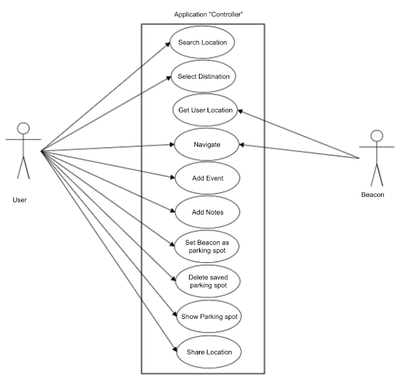

***Case Diagram for Beacate***

## Class Diagram

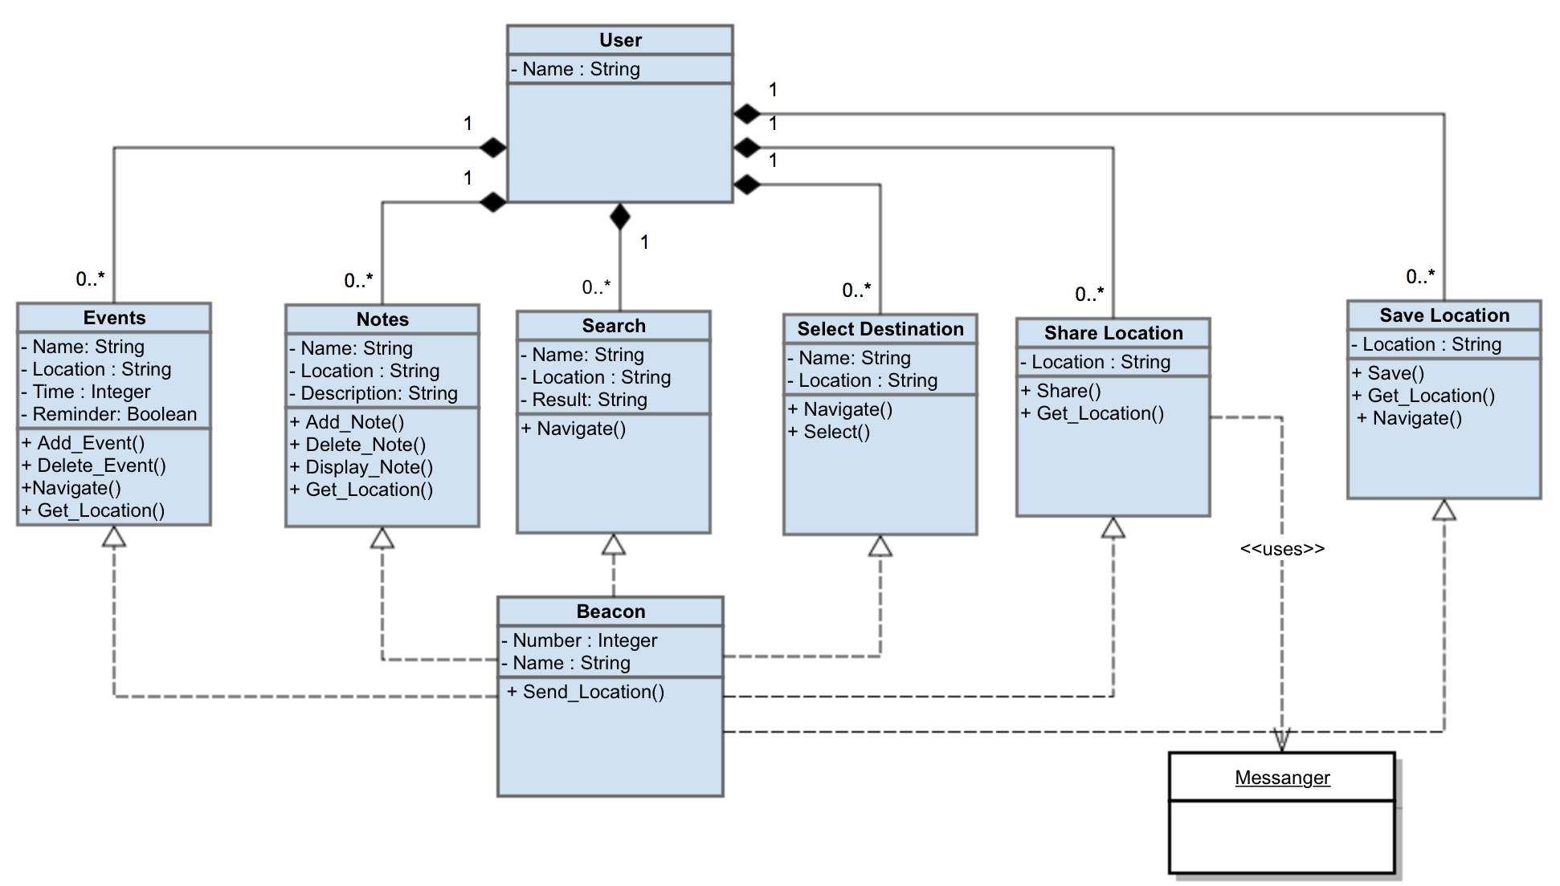

***Class Diagram for Beacate***

## Sequence Diagrams

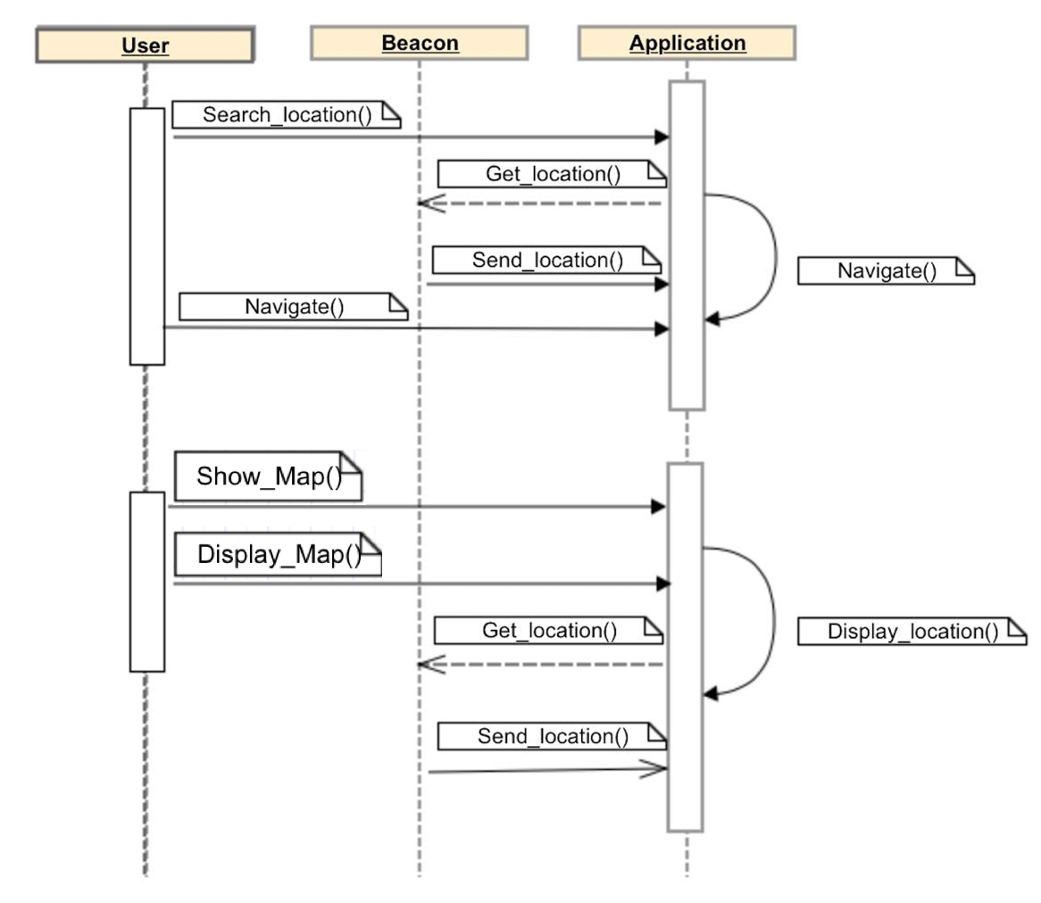

***Sequence Diagram for Navigating between locations***

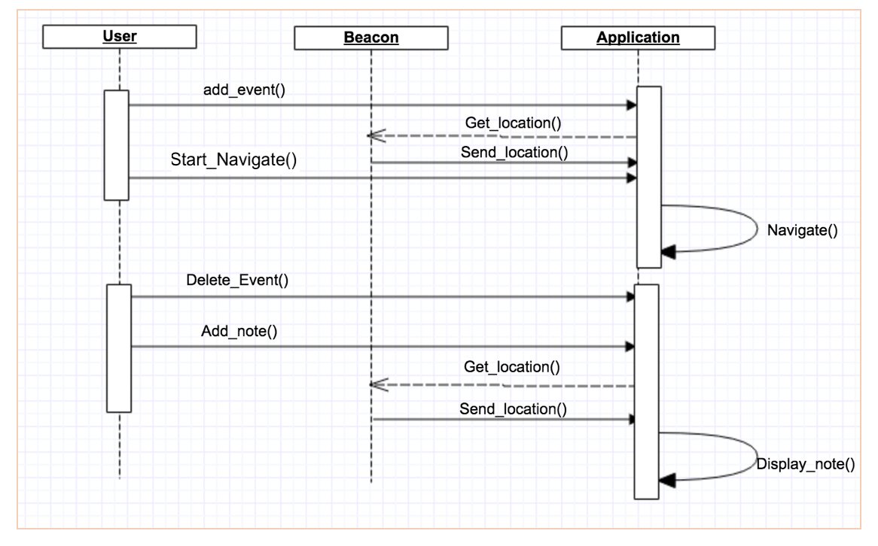

***Sequence Diagram for adding events and notes***

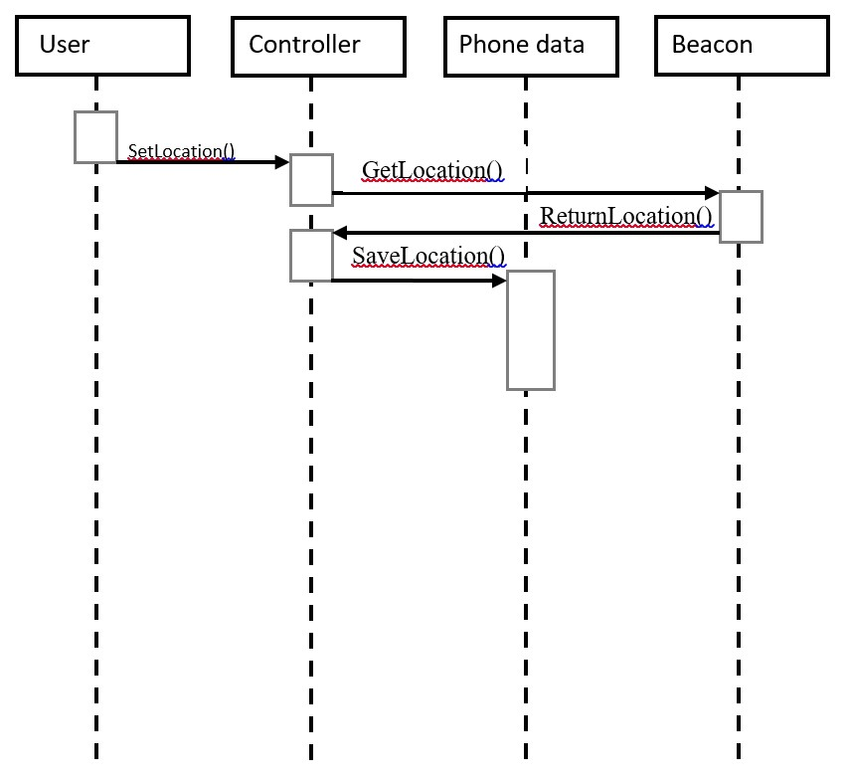

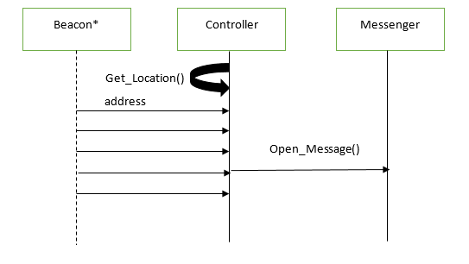

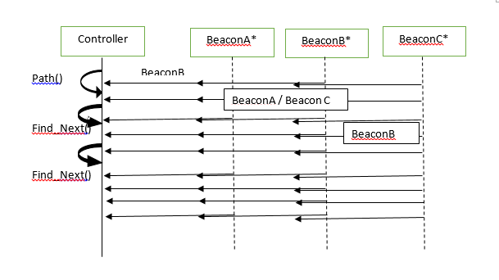

***Sequence Diagram for Sharing location***

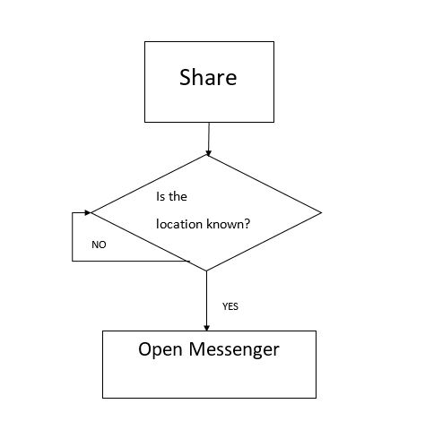

***Active Diagram for Sharing Location***

## State Diagrams

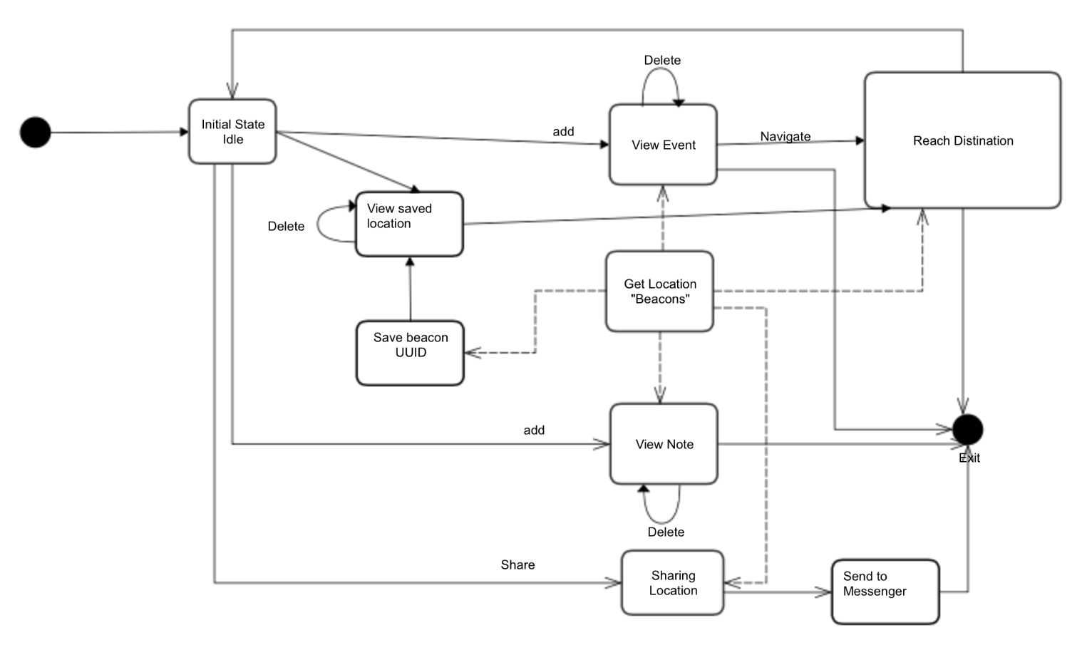

**State Diagram for Beacate**

## VI. Detailed Design

## A. Block Diagrams

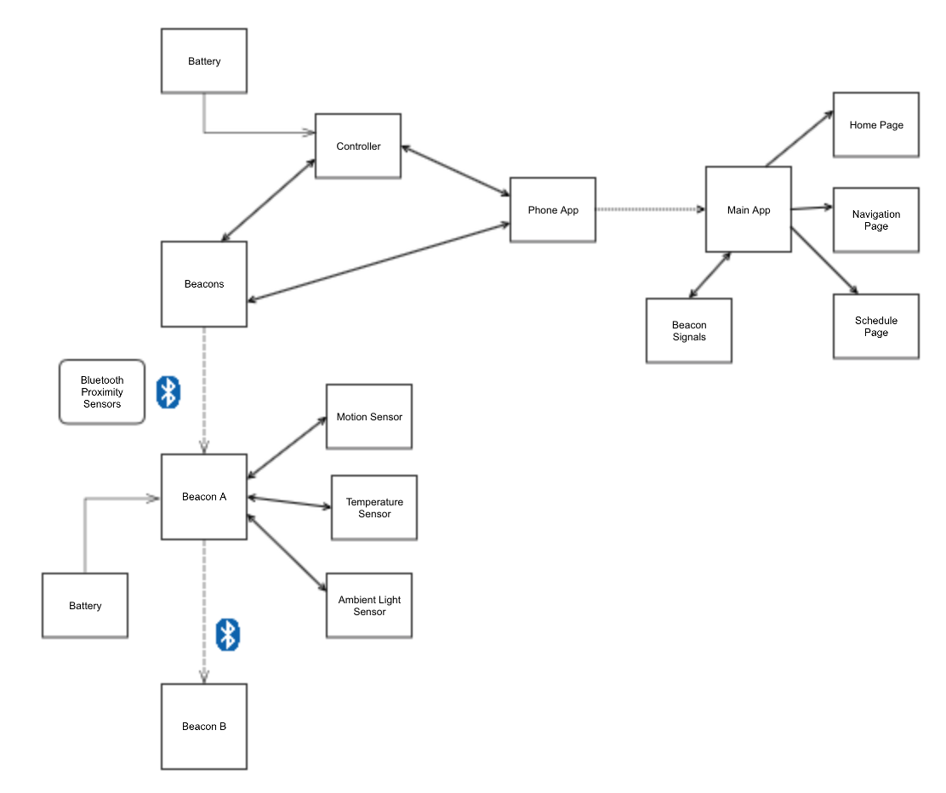

**Block Diagram of Beacate**

## B. Activity Diagrams

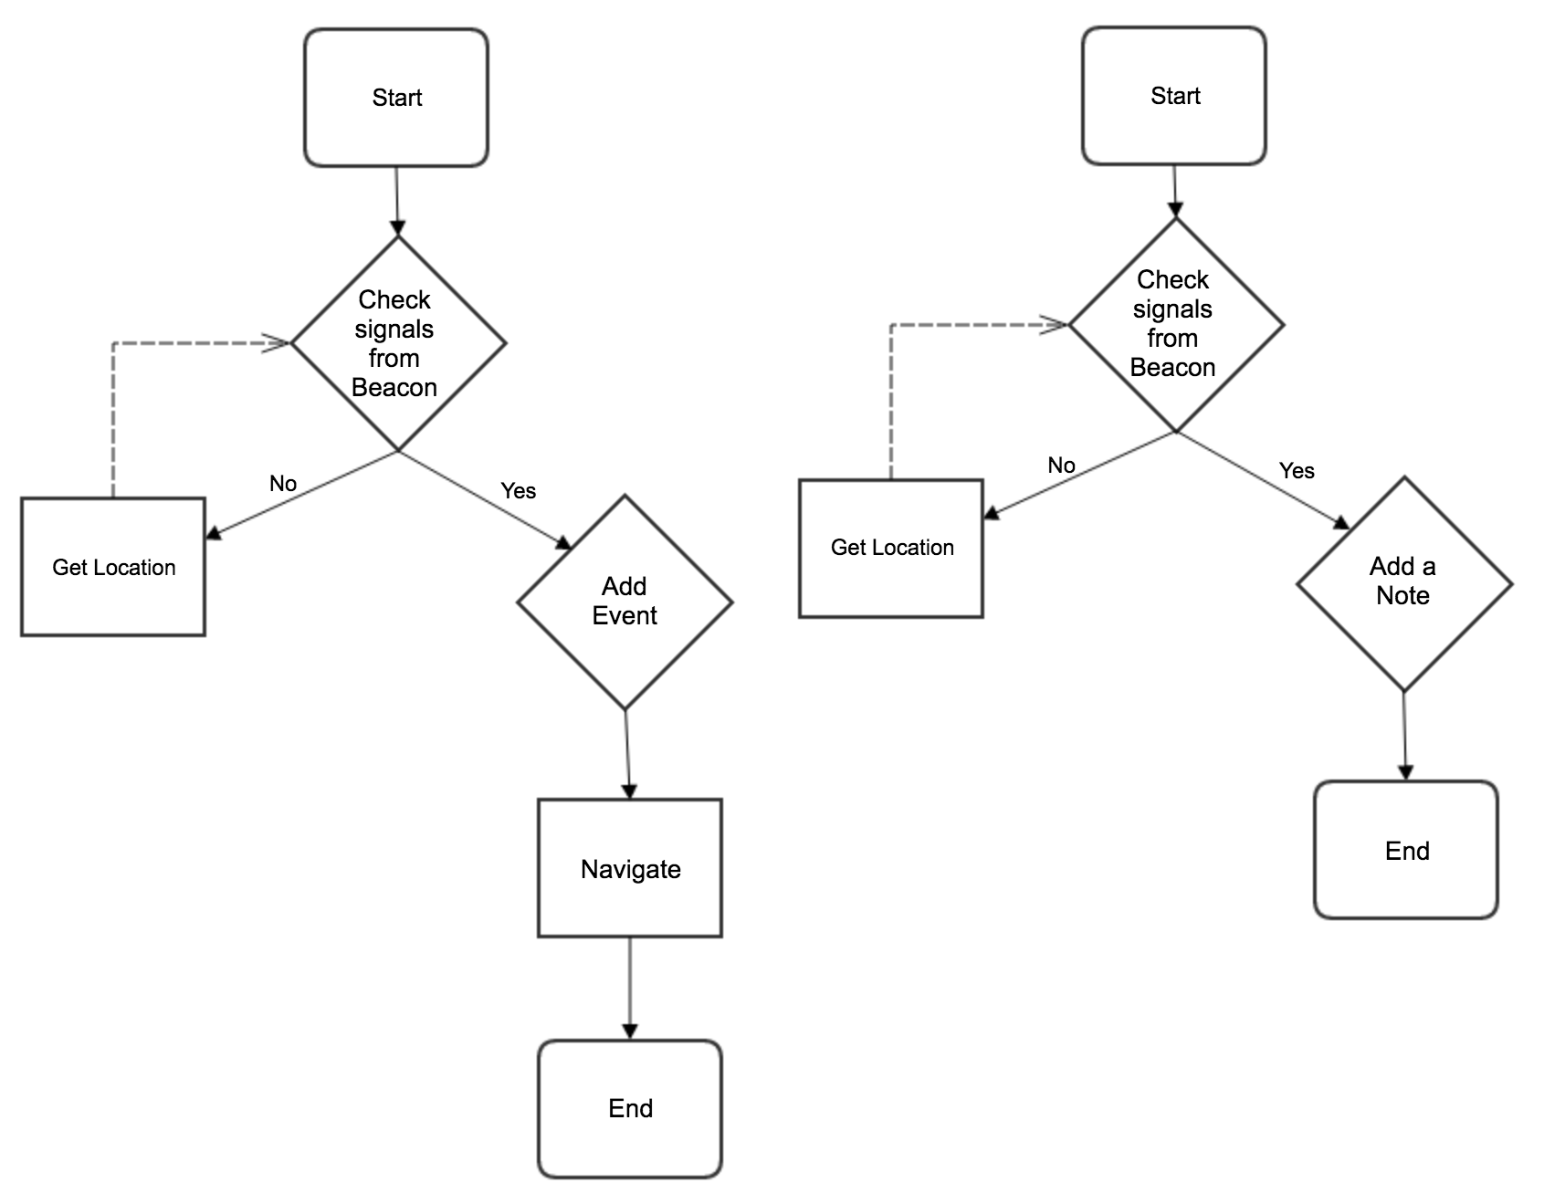

***Activity Diagram for adding events and notes***

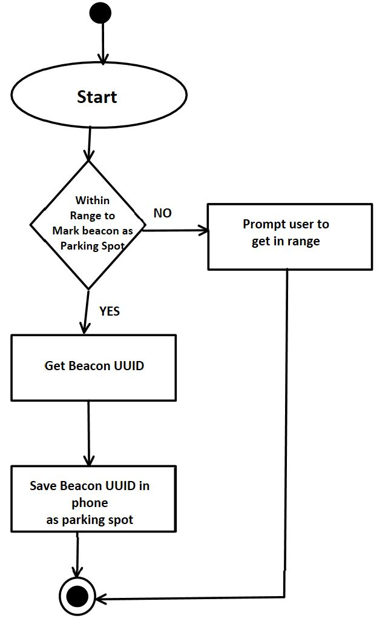

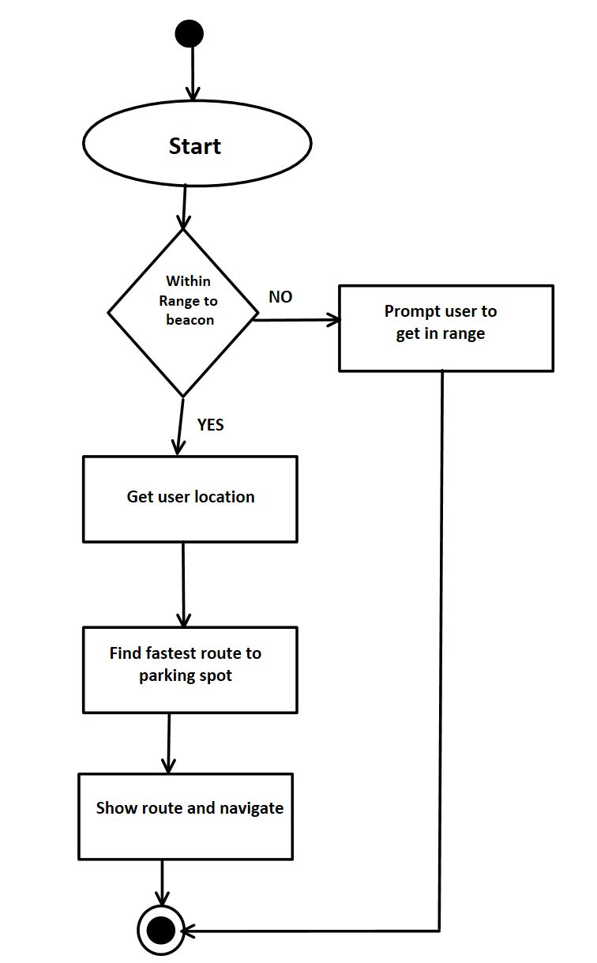

**Activity Diagram for Parking Spot location**

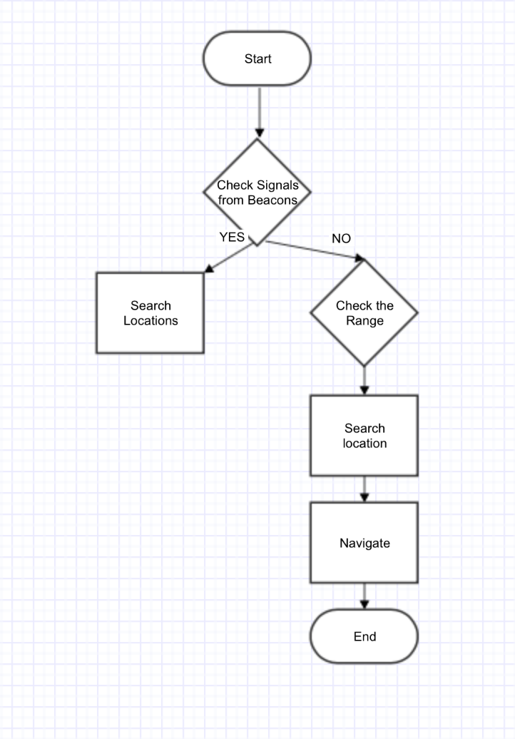

**Activity Diagram for Search Location and Navigate**

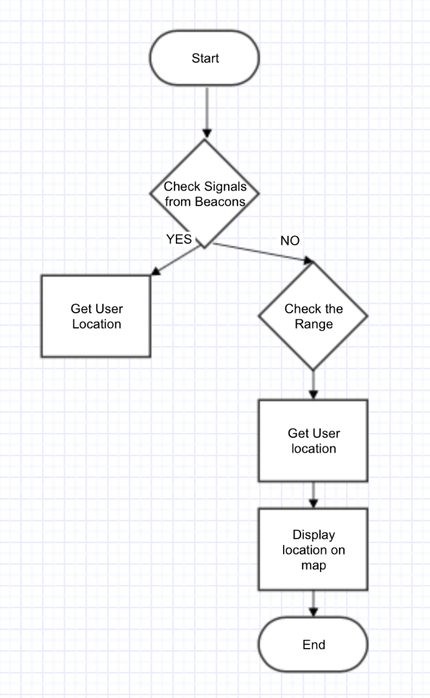

**Activity Diagram for Getting User Location**