** MICROBIOLOGY SPECIMEN COLLECTION AND TRANSPORT GUIDE**

**Urine Culture**

**Specimen Type:** Urine

**Expected Turnaround Time:** Prelim 24 hours, Final 2 days

**Container:** Vacutainer gray-top urine culture transport tube with preservative (preferred)

**Instructions:** Clean catch or catheterized urine in sterile urine transport vial

**Use:** Isolate and identify potentially pathogenic organisms. Susceptibility testing on significant pathogens will be performed at an additional charge.

**Methodology:** Conventional culture

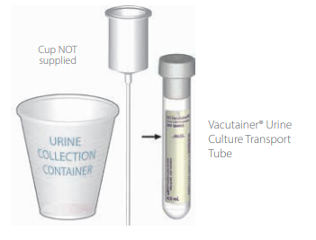

KPS- Hays Location KPS – Wichita Location

**1212 E 27th Street 8201 E 34th CIR North**

**Unit B BLDG 1300 STE 1301**

**Hays, KS 67601 WWW. KSPATH.COM Wichita, KS 67226**

**Wound Aerobic Culture:**

**Specimen Type:** Pus, tissue, or other material properly obtained from an abscess, biopsy, aspirate, drainage, exudate, lesion, or wound.

**Expected Turnaround Time**:Prelim 24 hours, Final 3-5 days

**Container:** Culture swab (RED) Amies Liquid

**Instructions:** Remove white cap from top of transport tube and discard. Holding shaft by end with colored cap, collect specimen with the swab. Insert swab (still attached to red cap) firmly into the sponge in the transport tube. Take care to avoid touching swab by any part but the red cap. Do not break or cut the shaft. Transport at room temperature after collection.

**Use:** Isolate and identify potentially pathogenic organisms. Susceptibility testing on significant pathogens will be performed at an additional charge.

**Methodology:** Conventional culture

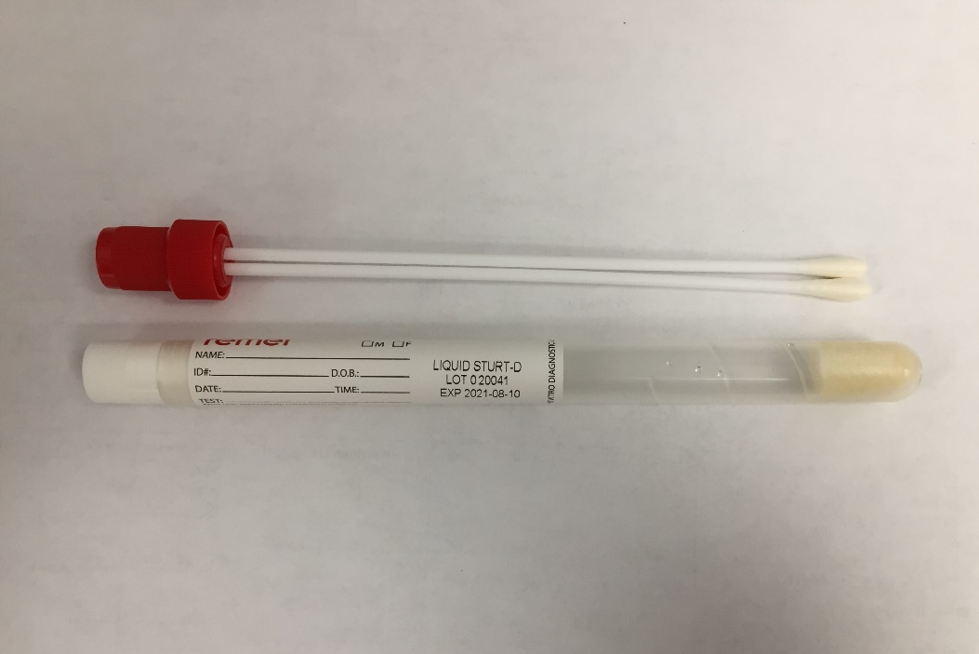

**Wound (Aerobic and Anaerobic) Culture**

**Specimen Type:** Pus, tissue, or other material properly obtained from an abscess, biopsy, aspirate, drainage, exudate, lesion, or wound.

**Expected Turnaround Time:** Prelim 24 hours, Final 3-5 days

**Container: Preferred collection:** (RED) Liquid Amies twin **AND (**BLUE) Amies Clear Gel culture swabs

**Alternate collection**: If only one swab can be collected, - Use (BLUE) Amies Clear Gel culture swab

**Instructions:** Remove white cap from top of transport tube and discard. Holding shaft by end with colored cap, collect specimen with the swab. Insert swab (still attached colored cap) firmly into the sponge/gel in the transport tube. Take care to avoid touching swab by any part but the colored cap. Do not break or cut the shaft. Transport at room temperature after collection.

**Use:** Isolate and identify potentially pathogenic organisms. Susceptibility testing on significant pathogens will be performed at an additional charge.

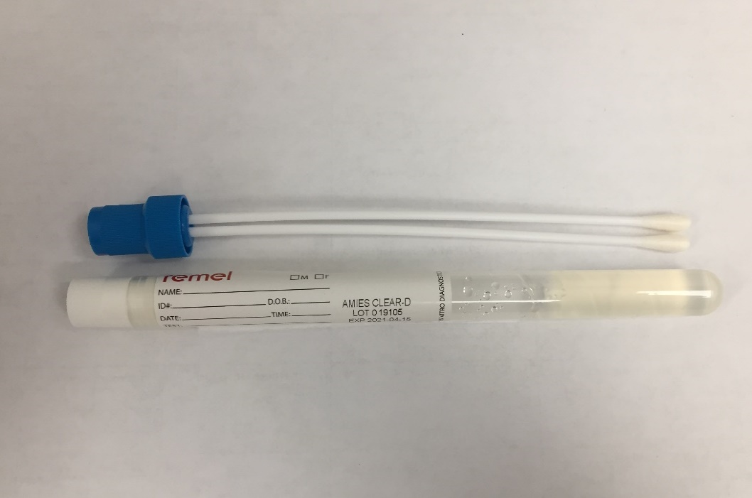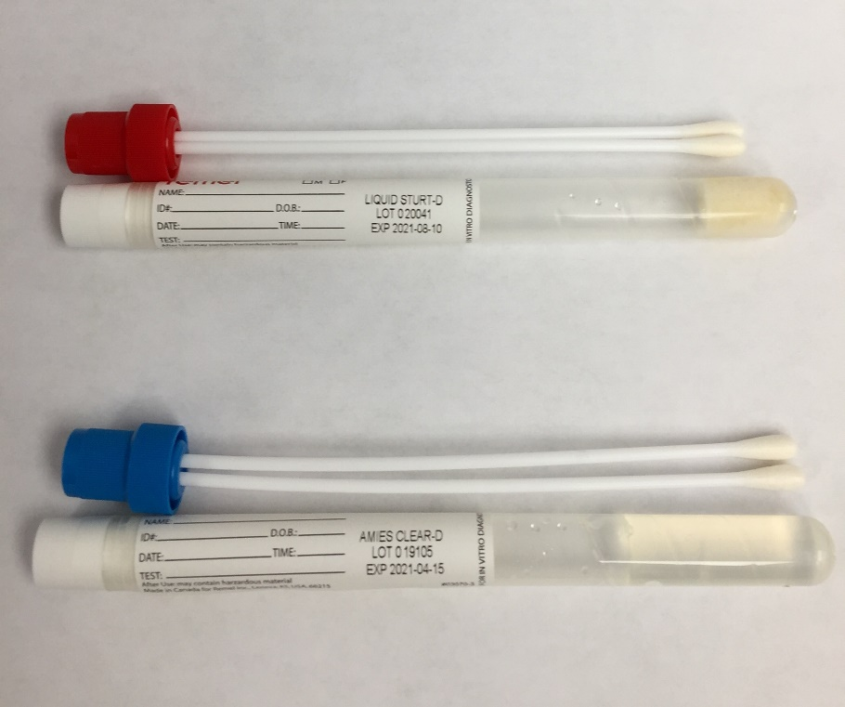**Methodology:** Conventional culture

**Preferred: Both RED Liquid Amies & (BLUE) Clear Amies Gel Alternate: (BLUE) Clear Amies Gel**

**(If only one swab can be collected.)**

**Anaerobic Culture (only)**

**Specimen Type:** Pus, tissue, or other material properly obtained from an abscess, biopsy, aspirate, drainage, exudate, lesion, or wound.

**Expected Turnaround Time:** Prelim 24 hours, Final 3-5 days

**Container:** (BLUE) Clear Amies Gel culture swab

**Instructions:** Remove white cap from top of transport tube and discard. Holding shaft by end with colored cap, collect specimen with the swab. Insert swab (still attached to blue cap) firmly into the gel in the transport tube. Take care to avoid touching swab by any part but the blue cap. Do not break or cut the shaft. Transport at room temperature after collection.

**Use:** Isolate and identify potentially pathogenic organisms. Susceptibility testing on significant pathogens will be performed at an additional charge.

**Methodology:** Conventional culture

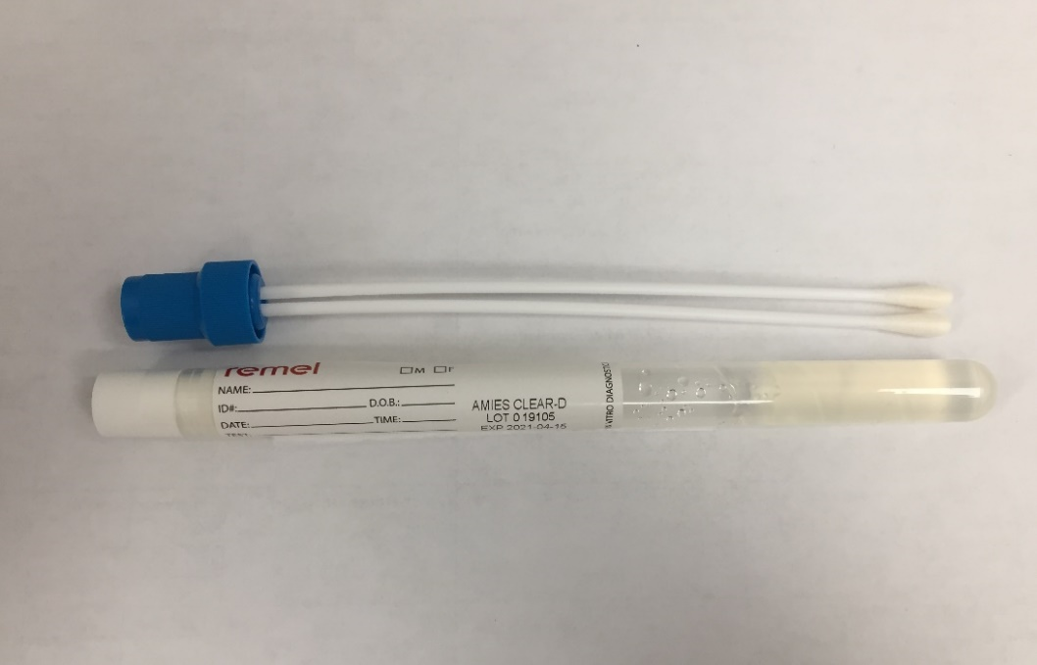

**Blood Culture:**

**Specimen Type:** Whole Blood

**Expected Turnaround Time:** Prelim 24 hours, Final 5 days from incubation

**Instructions:** Draw 16-20 ml in syringe, transfer 8-10 mL each to aerobic (green) and anaerobic (orange) bottle. The aerobic bottle has no minimum volume requirement. If low volume sample is obtained – only fill green aerobic bottle. Maintain at room temperature. DO NOT REFRIGERATE *** See attached Biomerieux flyer “RECOMMENDATIONS FOR BLOOD CULTURE COLLECTION” A) USING A WINGED BLOOD COLLECTION SET, B) USING NEEDLE AND SYRINGE <https://www.biomerieux-diagnostics.com/sites/clinic/files/9313564-010-gb-d_-_blood_culture_flyer_final_ok.pdf>

**Use:** Isolate and identify potentially pathogenic organisms causing bacteremia. Susceptibility testing on significant pathogens will be performed at an additional charge.

**Methodology**: Continuous blood culture monitoring system

