Leave module enhancements
- Leave to days dapat pumaparehas sa leave from day once ginalaw yung from na date. (para avoid back date)
- Same sa overtime, idisplay kung meron na naka file na leave upon selecting ng from date.
- Same sa overtime, display filling rules
- Same sa overtime, display shift schedule and selected date remarks
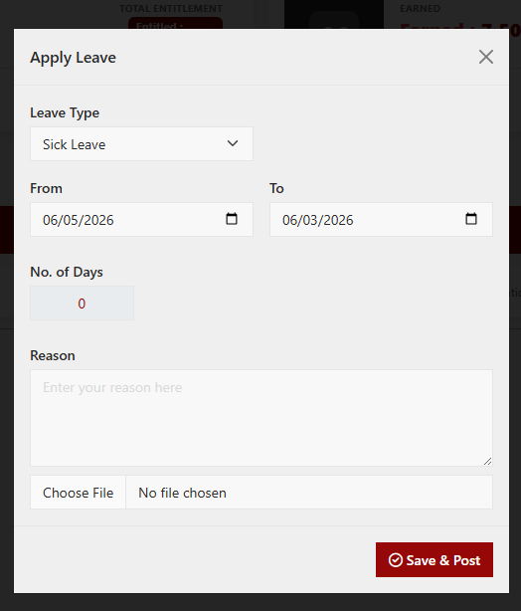

Bugs
- Save & post not working, need mo pa ipost yung leave
- Attaching of document error
- Attached document not viewable

