

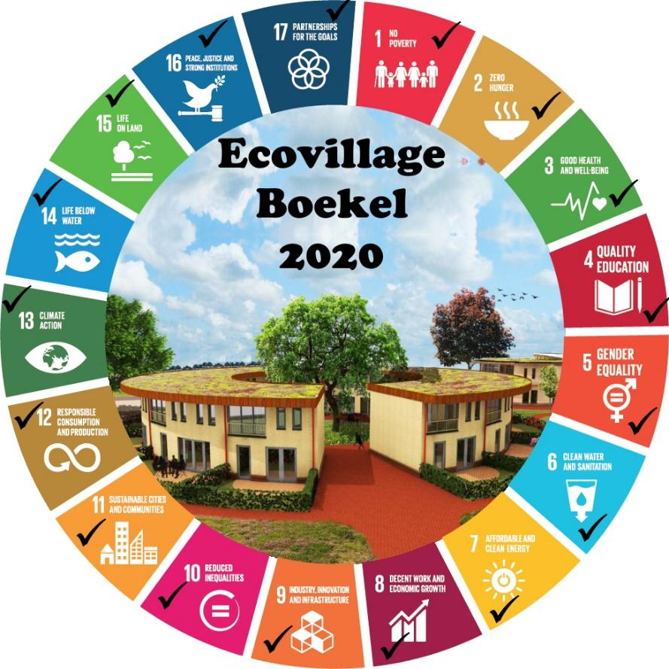

Contents

1. Project Goal **2**

2. Planning and Requirement Analysis **2**

2.1 System Request 2

2.2. Research Questions 4

2.3. Feasibility Analysis 4

2.4 Eliciting Requirements 5

3.Project Methodology **6**

3.1 SGN Goal Matching with Mega Project for Artificial Intelligent 6

3.2 AI apply method with Agile into the project 7

4. Performance Measurement **7**

4.1 Datasets 7

4.2 Modelling 10

4.2.1 Possible Algorithms 0

4.3 Risk Analysis 0

5. Minimum Viable Product & GUI Design **1**

6. Software Solution **3**

6.1 Ten Reasons why our project needs a software solution: 3

6.2 Our Software Solution: 4

7. Basic Flowchart for Software **5**

**8.System Environment Diagram** **7**

**Temporary GUI designs** **8**

8. Bibliography **10**

## 1. Project Goal

The goal of the Boekel Ecovillage **EcohomeAI** solution is that it should be a system that improves the air quality inside of the houses of the ecovillage and it should achieve this by collecting data from multiple indoor sensors, weather reports and the user. The system should act upon the data that it collected by recommending solutions to any problems that may arise such as dry air conditions. By tracking all the key pollution markers; particulate matter PM2.5, NO2, O3, SO2 and CO gases, you can see a complete and accurate picture of the air you breathe and where improvements could be made.

The strategic goal of the team involves the below mentioned factors.

* **Power to the user health**: Recognize virus index to Manage the health of worker and employee in coronavirus risk mitigation. Apply machine learning to measure the combination of index and giving advices.
* **Artificial Intelligent in your eyes**: Short term event prediction and filter the noise.
* **AI on Air quality**: Air Quality Data Analytic combine with prediction.
* **Holistic and calibrated data**: based on the professional monitor devices sensors from uHoo

## 

## 2. Planning and Requirement Analysis

The team consists of the following team members each from different domains.

|  |  |
| --- | --- |
| **Team Members** | **Research** |
| Juan Jacques Ludick | Software Research |
| Yanislava Stefanova | Cyber Security Research |
| Mark / Nguyen Phat Thien Phuc | Artificial Intelligence Research |
| Akshara Shukla | Artificial Intelligence Research |
| Mel Ouwen | Systems and Network Research |
| Dylan Zeiss | Software Research |

### 2.1 System Request

**Project Sponsor:**

The steering committee of Boekel Ecovillage (Ad Vlems).

**Business need:**

* The need is for the system to control, monitor and improve the quality and humidity of the air in the houses in the ecovillage.
* To allow the residents of the ecovillage to be able to access and manage this data efficiently and securely.
* The product needs to have a predictive AI system that can make weather predictions into the future and suggestions based on the environmental data collected by the sensors.

**Business requirements:**

* It should produce management reports
* It should give clients an easier way to manage the sensors in their home.
* It should provide a safer and cleaner environment for the Boekel Ecovillage residents.
* It should receive data from sensors in the homes in the Boekel Ecovillage and from weather reports in the area.
* It should be able to automatically recommend potential courses of action for any event that may arise such as the air being too dry in a home or in multiple homes.

**Business Value:**

* Increase in air quality.
* It would increase the morale of the residents who live in the Boekel Ecovillage.
* Increased worker efficiency.

**Special Issues:**

After analysing the situation of the Eco Village in Boekel for implementing several sensors on different rooms and their aim to provide their residents with the best air purified homes, the following identified issues are listed which provided the team a clear overview of the current situation.

**Data from devices lack coordination with outside data:**

There is a device that collects massive from the indoor condition. Are linked with outdoor conditions to provide detailed information such as weather, house, virus warning, and global data.

**Device data are not fully interactive:**

The data shown in the software of the devices is just explicit raw basic data visualization. IT will not show any science or deep understanding of what is happening in the particular area.

**Device sensor cannot bring any right prediction or health suggestion to the customer:**

They do have some functions in the application which help customers benefit from that. However, it is still not actively developed by giving any good insight into where they are living.

**The software was weakly on the implementation of AI:**

The current software mainly shows the static exposed and raw data. And AI has not detailed to give any particular action for the user.

Additionally, a mind map was developed for a better classification of different areas which will be covered.

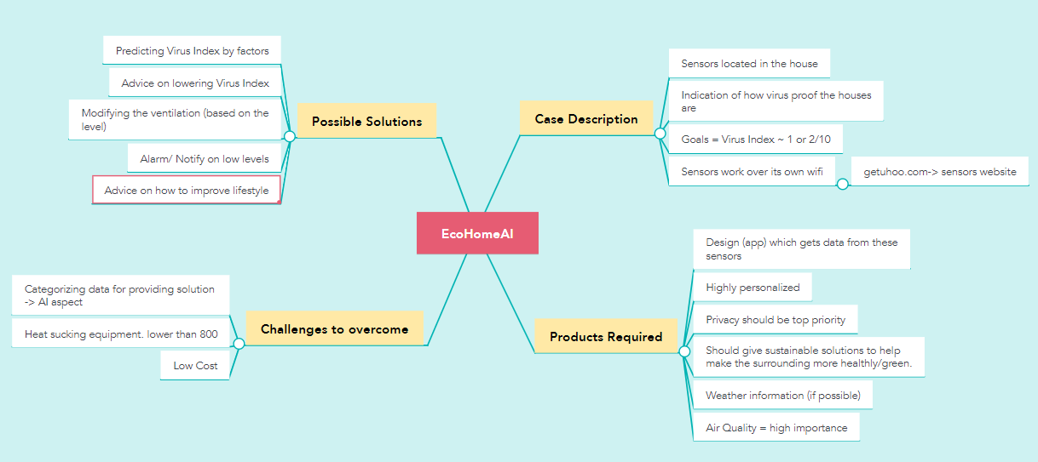

### 2.2. Research Questions

* Which machine learning algorithm or techniques are used to predict air quality in the eco village domain?
* How do the proposed methods handle or predict the different sustainable outcomes and into what categories?
* What resolutions were made with the proposed techniques?
* What steps are taken if the data collected from the sensors are not appropriate?

### 2.3. Feasibility Analysis

**Technical feasibility**

* Boekel Ecovillage should have all the technical resources to implement the AI system and maintain it.
* They must have the technical resources improve the current air quality and comfort.
* They need a storage space for all the data that has been collected.
* The product should have a way to operate offline.
* The product should be able to be installed in the designated round living complexes and be able to connect to uHoo air quality sensors independently.

**Economic feasibility**

Cost:

* Technological costs increase
* Database set up costs
* Increase in electricity consumption.

Benefits:

* Improvement in air quality
* Improvement in resident happiness
* It could attract more investors.

**Organizational Feasibility:**

The residents of Boekel Ecovillage would prefer a system that is convenient for them as they will be the ones operating the product system and they will be living in the area where the product is active. The product must be simple to understand and maintain as well as smart enough to implement a predictive AI system that can make weather predictions into the future and suggestions based off the environmental data collected by the sensors.

**Legal Feasibility**

* All user information needs to be kept confidential.
* All staff that will work with the system would have to sign a confidentiality agreement.
* Data would have to be encrypted and stored on a secure database on site or on a secure database using a trusted cloud service provider. The terms of this agreement would be outlined within the SLA.
* Only Authorised personnel should have access to the system itself and the system should keep track of who is using it.
* Only high-ranking staff should be able to perform maintenance.
* Agreements with providers must be kept in a secure location.
* Clients must have multiple ways of proving it is in fact them trying to login.

### 2.4 Eliciting Requirements

The process of gathering requirements by communicating with the customers is known as eliciting requirements. How have decided to elicit our requirements and develop or product?

We Decided to use a combination of rapid throwaway prototyping, Evolutionary prototyping and Interviewing the stakeholders.

The main benefits of throwaway prototyping are:

* you reduce risk in a project by quickly stepping through the initial development phases.
* you are selecting (or at least you better be) a prototyping language or framework that allows you to rapidly development your application and meet your prototyping goals.
* you can usually select a programming language that lends itself to being thrown away – further reducing the incentive to try and “make it work’. Yes, programmers and companies can easily be “hoarders” if they are not careful.
* The last primary benefit, is that it is in-itself an agile development exercise for the participants and stakeholders in a project that helps define goals, realize potential pitfalls, and generate better risk assessment or the project as a whole.

The downsides and risks associated with throwaway prototyping are:

* You must commit time and resources to undertake this effort.
* You may not be using the prototyping time to maximum efficiency; however, throwaway prototyping does not mean you throw and bunch of things at a wall (metaphorically speaking) and see if they stick. This is not a reason to not have a well thought out plan and execute according to the goals you want to achieve.

The advantages of evolutionary prototyping are:

* The delivery of the system is sped up
* The user engages with the system
* The system is more likely to meet the user requirements

The downside associated with evolutionary prototyping is:

* Knowing when it is necessary to stop tweaking the system and finish the development.

The advantages of interview studies, are noted below:

* It provides flexibility to the interviewers
* The interview has a better response rate than mailed questions, and the people who cannot read and write can also answer the questions.
* The interviewer can judge the non-verbal behaviour of the respondent.
* The interviewer can decide the place for an interview in a private and silent place, unlike the ones conducted through emails which can have a completely different environment.
* The interviewer can control over the order of the question, as in the questionnaire, and can judge the spontaneity of the respondent as well.

None of the disadvantages of interviews apply to our project.

## 3.Project Methodology

**Technical apply on AI process:**

The technical aim includes performing analysis with Jupiter Notebook in Python, Tableau, and co-ordination into the software after all AI method apply to bring the simple user interface for end-user.

Task Defined in teamwork:

|  |  |
| --- | --- |
| **Data Engineer** | **Machine Learning** |
| Akshara will handle the main part of Data EDA analysis and preparing data. Mark will handle the feature function. | Mark and Akshara both developing the concept of AI solution into the Device and software. |

### 3.1 SGN Goal Matching with Mega Project for Artificial Intelligent

This section discusses how our solution is going to be corresponding to the different sustainable development goals (SDGs).

The project would have multi-discipline, and the core of AI had the care of sustainability product. It perpetrates how we can educate humans and users about climate. Also, with the implementation, we will suggest an eco-friendly user interface. Hence, the mindful of different factors such as goal 12, responsible consumption, and production. The ability to use the product with easy-to-read and adaptability with green environment. CO2 emission data is another key to magnifying and identifying how the manager will construct the house and check progress.

The function of AI on the device can broaden more to goal 11 Sustainable cities and communities. AI solutions elicit and inspire how a user can impact to eco-system. Knowing how to modify the house system, manage the virus index from the house to breathe the healthy air by advice from the software indifference are of the village. In short, the team helps eco-village technical solutions interact with the problem that the globe is facing. Making the excellent quality to satisfied level for each goal is our mission.

### 3.2 AI apply method with Agile into the project

Since the approach is highly going to be working in an agile environment to ensure the product we are delivering is fully up to the mark of our client, we have broken down the measures we will be taking into considering when applying various machine learning algorithms in developing our Artificial Intelligence.

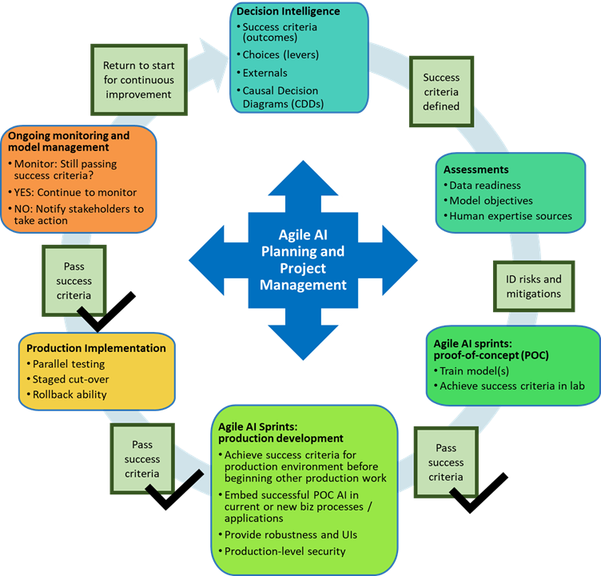

Figure 1. Agile AI method for ECO village in Artificial Intelligent

## 4. Performance Measurement

### 4.1 Datasets

We have been provided with the dataset of minute-by-minute record of the key air quality parameters in the bedroom and living room from our client for the month of January 2021. Both of the datasets include approximately 34485 rows.

Both datasets data includes minute by minute record of the necessary air quality measuring variables which include:

|  |  |  |  |
| --- | --- | --- | --- |
| ***Type of Data*** | **Definition** | **Affective** | **Solution Approach.** |
| ***Date and Time*** | The time frame for the month of January. | Minute by Minute data of every key air quality measuring parameters would help in better accuracy. | Prediction and accuracy percentage. |
| ***Temperature*** | Measured in Celsius, the temperature of the rooms with installed sensors | On multiple room and area. | Predictive and coordinate with index outside |
| ***Relative Humidity*** | The measurement of amount of water vapors in the air. | Checking precipitation and give the advice if rain happening. | Air Quality Prediction |
| ***PM 2.5*** | Particulate Matter 2.5, an air pollutant which reduce visibility and cause air to be hazy when levels are elevated and is prone of lungs and heart. | Predicting its value and suggesting on how to lower its magnitude. | Air Quality Analytic |
| ***CO2*** | The natural greenhouse gas, carbon di oxide. | Predicting its value and suggesting on how to lower its magnitude. | Air Quality Analytic |
| ***TVOC*** | Total Volatile Organic Compounds (tVOC) is the total concentration of all volatile organic compounds such as benzene, ethylene, glycol etc. present in the air. | Predicting its value and suggesting on how to lower its magnitude. | Air Quality Prediction |
| ***Air Pressure*** | Measured by a device called barometer is the pressure within the atmosphere within the atmosphere of Earth. | Predicting its value and suggesting on how to lower its magnitude. | Air Quality Analytic |
| **CO** | The odorless and colorless gas, carbon monoxide. | Predicting its value and suggesting on how to lower its magnitude. | Air Quality Prediction |
| **Ozone** | Ozone (O3) is the highly reactive gas corresponds directly to causing chest pain, shortness of breath and throat irritation when inhaled. | Predicting its value and suggesting on how to lower its magnitude. | Air Quality Analytic |
| **NO2** | Nitrogen Oxide is used as the indicator for the larger group of nitrogen oxides. It primarily gets in the air from the burning of various fossil fuels. It can also cause reduced lung function, increased asthma attacks when present in abundant. | Predicting its value and suggesting on how to lower its magnitude. | Build Air Quality Prediction |
| **Virus Index** | These levels are determined based on scientific analysis of five air quality factors which includes temperature, relative humidity, PM2.5, Carbon Dioxide, and Nitrogen Dioxide. | Checking the eco-system of air virus index, would be relate with corona advices. | Apply for virus prediction index. |

Figure 2 Table of Data and Approach Solution

The organization providing the sensors is uHoo and they essentially came up with their own virus index by measuring the above listed variables which is mentioned below. This index will fundamentally be used in classifying whether a specific room is healthy or not.

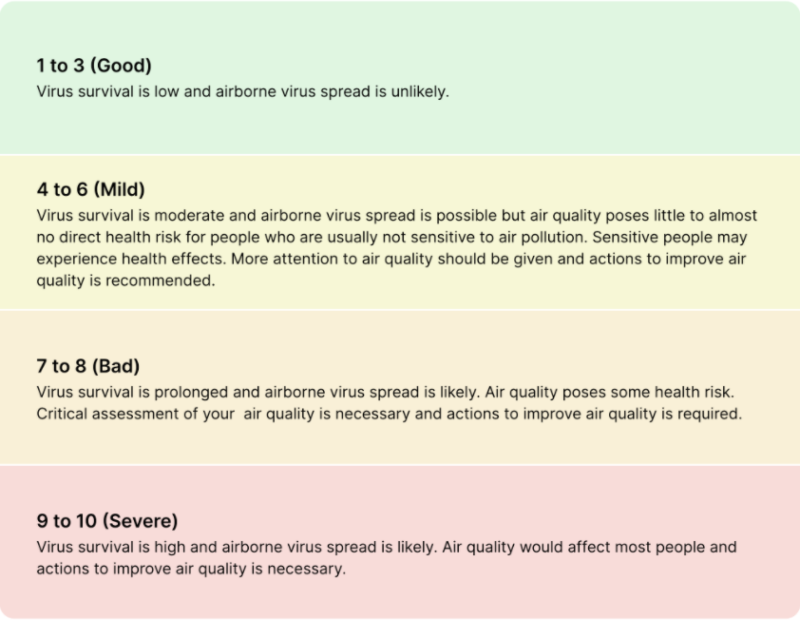

In the process of performing our exploratory data analysis, both of the datasets will be divided into separate training and testing data samples. The goal would be finding if there exists any biasedness and to implement an algorithm in the model to decrease variance, bias and improve predictions. Additionally, the size of the training set will be greater than the testing set in order to avoid overfitting and gain better accuracy percentage.

### 4.2 Modelling

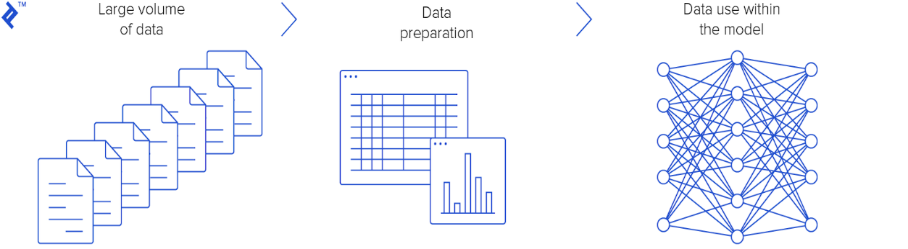



First,we are going to be working with the data collected from the device called GitUhoo, it might give massive data involving different factors. During the device-organized process, they might have some errors or missing values that we must deal with. Therefore, dealing with data preparation such as cleaning and visualizing on how the data will be captured and appear in software based on our software and infrastructure will develop in the next two months. After giving the conclusion or any specific user advice, the modelling of data is picked up. The project will be dealing with big data; the more the house gets old, the more data collected from the device. Mainly data server will develop to storge the data.

|  |  |
| --- | --- |
| **RATING** | **MEANING** |
|  |  |
| **Excellent** | According to current research, negative impacts on ecosystems are unlikely. |
| **Fine** | All values are under the legal health protection limits. Effects on ecosystems can no longer be ruled out. |
| **Moderate** | The health protection limits are mostly still met. Effects on ecosystems are increasingly possible. |
| **Poor** | The measured values are at the level of health protection limit values. Health impairments of sensitive persons may occur sporadically. |
| **Very Poor** | The health protection limits have been exceeded. Health impairments of sensitive persons are possible. The population is increasingly informed about the pollutant situation. |
| **Severe** | The measured values are at alarming levels. The health protection thresholds are clearly exceeded. Health impairments of all persons are possible. |

Air quality will follow the method of combination with different data, we calculate the data training set and giving the statistic to measure the accuracy and making prediction from modelling. Our air quality index is calculated based on the averages of all pollutant concentrations measures in a full hour, a full 8 hours. Move for the predictive on AI part for next 8hr in a day, next 24 hr. (e.g., between 9:00Am and 10:00 AM)

|  |  |  |  |  |  |  |  |  |  |  |  |
| --- | --- | --- | --- | --- | --- | --- | --- | --- | --- | --- | --- |
| **RATING** | **O3 (ΜG/M³)** | **PM2.5 (ΜG/M³)** | **PM2.5 (ΜG/M³)** | **PM10 (ΜG/M³)** | **PM10 (ΜG/M³)** | **NO2 (ΜG/M³)** | **SO2 (ΜG/M³)** | **CO (MG/M³)** | **CO (MG/M³)** | **NH3 (ΜG/M³)** | **VOC (INDEX)** |
|  |  |  |  |  |  |  |  |  |  |  |  |
| **Timeframe** | 1h / 24h | 1h | 24h | 1h | 24h | 1h / 24h | 1h / 24h | 1h | 8h | 1h / 24h | 1h / 24h |
| **Calculation method** | max. hourly value | average | average | average | average | max. hourly value | max. hourly value | average | average | max. hourly value | max. hourly value |
| **Excellent** | 0 - 33 | 0 - 7 | 0 - 5 | 0 - 12 | 0 - 10 | 0 - 25 | 0 - 25 | 0 - 2 | 0 - 1 | 0 - 3 | 0 - 50 |
| **Fine** | 33 - 65 | 7 - 15 | 5 - 10 | 12 - 25 | 10 - 20 | 25 - 50 | 25 - 50 | 2 - 4 | 1 - 2 | 3 - 7.5 | 51 - 100 |
| **Moderate** | 65 - 120 | 15 - 30 | 10 - 20 | 25 - 50 | 20 - 35 | 50 - 100 | 50 - 120 | 4 - 8 | 2 - 4 | 7.5 - 37.5 | 101 - 150 |
| **Poor** | 120 - 180 | 30 - 55 | 20 - 25 | 50 - 90 | 35 - 50 | 100 - 200 | 120 - 350 | 8 - 30 | 4 - 10 | 37.5 - 15,000 | 151 - 200 |
| **Very Poor** | 180 - 240 | 55 - 110 | 25 - 60 | 90 - 180 | 50 - 100 | 200 - 400 | 350 - 500 | 30 - 100 | 10 - 30 | 15,000 - 150,000 | 201 - 300 |
| **Severe** | from 240 | from 110 | from 60 | from 180 | from 100 | from 400 | from 500 | from 100 | from 30 | from 150,000 | 301 - 500 |



#### 4.2.1 Possible Algorithms

According to the report of machine learning algorithms in air quality modelling which was published in 2019 from Global J.Envision.

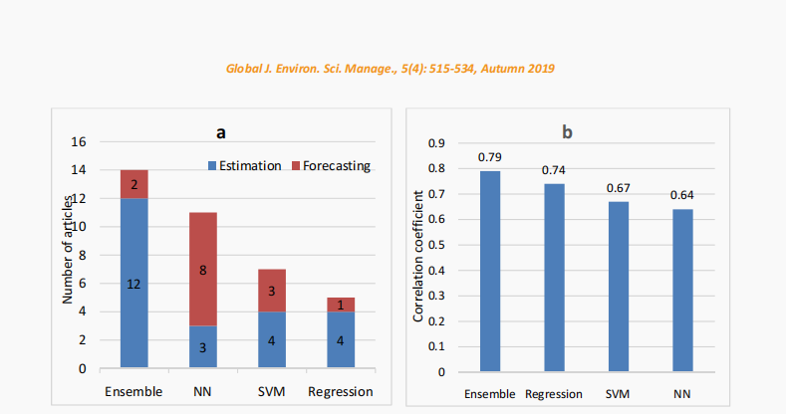



Possible Algorithms to be implemented:

* **K- Nearest -Number:** From the research we can come out the thought and some comparison. Algorithm to apply into the notebook and prediction should stay on high level of correlation coefficient. As the diagram it show that NN (K-nearest-neighboured ) show that they achieved 64% percent. And following by that is SVM, it called as support vector machine. Following the visualization graph, we can have the our come that NN help us forecast the virus index and temperature, humidity with 8/4 percent.
* **Ensemble:** we will use for estimation the data of PM2.5, and temperature, air pressure, CO2 which relate with the health of people. The progress of ensemble packing with multiple method algorithm (Bagging, Regression, Decision Tree, … ). With 79% of accuracy level based of correlation coefficient. It is strongly number to convince our AI to apply it into the modelling progress.
* **SVM, Regression, Classification:** multiple of supervised learning during the progressing will be applied to give the estimation of data in different index. They have the strong support for ensemble method.

### 4.3 Risk Analysis

Following is the risk analysis performed for being aware of the possible risks that may arise and how we can appropriately avoid them.

|  |  |  |  |  |  |
| --- | --- | --- | --- | --- | --- |
| **REF/ID** | **RISK DESCRIPTION** | **RISK SEVERITY** | **RISK LIKELIHOOD** | **USER IMPACT** | **MITIGATIONS** |
| 01 | The dataset provided includes biasedness towards one specific air quality measuring parameter. | TOLERABLE | POSSIBLE | **HIGH** | Applying a machine learning algorithm which will help in making the data fairer and more trusted. |
| 02 | Lack of variance in model. | UNDESIRABLE | POSSIBLE | **HIGH** | Reanalyse the machine learning model and exercise the different data types of present. |
| 03 | Low accuracy rate | UNDESIRABLE | PROBABLE | **EXTREME** | Opting for another algorithm which provides better accuracy percentage. |

## 5. Minimum Viable Product & GUI Design

From the algorithm prediction we can bring out some of advice and solution for current activity follow 4 categorical which give the quality advices for customer in specific moment.

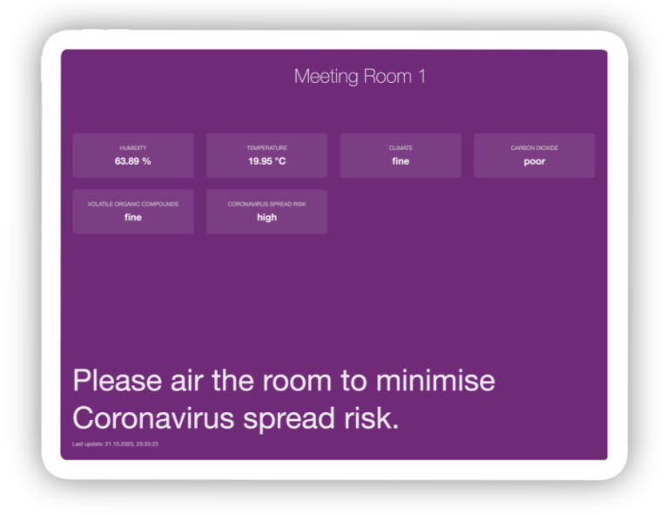

***General – Asthma – Children-Elderly***

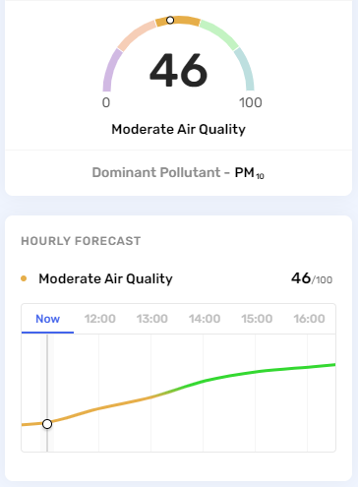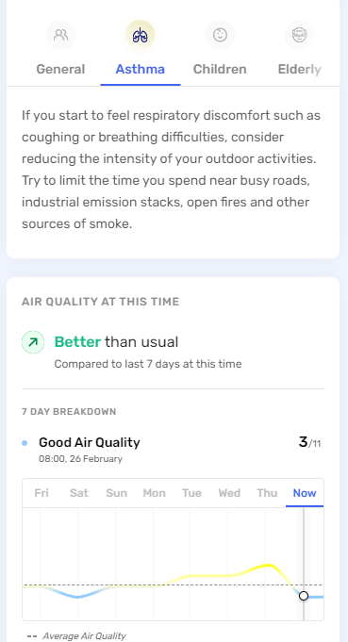



## 6. Software Solution

### 6.1 Ten Reasons why our project needs a software solution:

1. Built According to your Requirements.

Custom software creation ensures that your company's apps and services can be fully adapted to your needs. It's simple to use and can be applied through your entire business. When it comes to tech, each organization is different, and it's difficult to find a one-size-fits-all solution for everyone. Working with personalized goods not only provides you with a lot of potential for expansion, but it also shows that you support your company's development and success.

1. Custom Software are more Secure.

External hacking risks are minimized when software is designed specifically for your business.

With a personalized software solution, you can encrypt all of your company's data and rest assured that it is safe. Since your product is not available for use by other businesses, the improved protection provided by a custom designed application is unrivalled by any other commercial software.

1. You Can be part of the Design Process.

Nobody knows the industry as you do. You will participate in the process by recommending appropriate functionalities if you invest in custom software creation.

1. Lower Costs

Frequently, the basic software license necessitates the procurement of additional hardware in order to work properly, which may add up to a considerable cost. Custom software creation is very useful and important for companies because it needs less investment than fixed or readily available software. One of the most significant considerations that a business seeks is Return On Investment. A software solution speeds up your workflow, increasing your return on investment.

1. An Advantage Over Your Competition

The standard software solution's first aim is to make your company more effective and usable, giving you an edge over your competitors. Pre-existing apps would most likely be similar to or equivalent to what the rivals are already using. When you have the same resources at your side, you're less likely to be able to successfully distinguish yourself and progress up the market. You will achieve dominance if you have an effective service as a result of the business processes being streamlined.

1. Automation of day-to-day activities

Some tasks in an organization are replicated over and over. Any of them can be automated, freeing up time that can be used to find potential clients, improve employee training, or add new services to what you already sell. If you want to automate your day-to-day business activities, custom software can be a valuable resource.

1. Decrease human error.

When the organization is run by hand, the chances of human error are far higher. You can avoid those errors from being fatal to your company by using a software solution.

1. Integration with other software.

Pre-made software isn't always compatible with your hardware. Custom software creation provides an atmosphere in which it is easier to integrate the product with other software already in use. Custom software removes the need for integration and can seamlessly integrate into any business's software environment, allowing for seamless integration with other software packages.

1. Safety technical support.

A major benefit is that you will have access to a professional support team that was active in the application creation process, ensuring that all of the concerns are easily resolved.

1. Custom Software License Agreement.

When you build custom software for your business, you own the software as well as the code that supports it, giving you more power.

### 6.2 Our Software Solution:

We plan on creating an application that can be accessed via any web browser that would allow the user to interact with the data that the uHoo collects through its sensors to help aid in increasing the standard of living for any user who has the product. This application can be expanded on and adapted into an app that can be available for users to download through the app store on their mobile device.

Our software solution will work as follows; data the sensors capture are sent every minute to a database that is connected to our application our application will then make use of AI to create an eco ‘best friend’ that will provide the users with solutions to problems they may face in their household when it comes to air quality.

Security plays an important part in our software solution, passing data through fire walls and ‘clean’ coding will allow us to maintain a standard that can keep the users important data safe and secure.

The solution will be comprised of standard programming languages but the most prevalent one would be Python as all team members are comfortable with the langue and we feel as if it would best encapsulate all the aspects from AI to storge.

## 7. Basic Flowchart for Software

The software flowchart for our software solution is rather simple as the entire solution is basically a IFTTT (If Not This Then That). It starts with the sensors on the uHoo device collection all the data it can from the air, whether that be air pressure, humidity or COVID index level. This data is the processed into useful information that is stored on a database which can either be the cloud or a physical solution such as a server or Arduino. Once stored the information is then shared with the program that we are developing to help improve the air quality and thus improve the overall standard of living, this program will make use of AI to help aid in providing the best possible solution to the user, this solution is based on several factors whether that be financial status, time of day or past solutions accepted by the user. Once a suitable suggestions is decided by the AI it presents it to the user which can either be feasible and accepted by the user or not feasible and declined by the user, if the suggestion were to be declined the AI would go back and come up with the next best solution that the user is more likely to accept, this would continue in a ‘loop’ until the user id finally happy with the suggestion. When the user accepts the suggestion, it is thought that the user would commence with what they were asked and an increase in air quality would be seen and collected by the sensors. Depending on what suggestion the user accepted, the answer would be stored and sent back to the database to help improve the AI’s decision-making next time.

Although basic it is thought that this process would occur often as its important for the AI to make less ‘mistakes’ in its suggestions to minimize the number of times the user will not accept the suggestion it provides.

## 8.System Environment Diagram

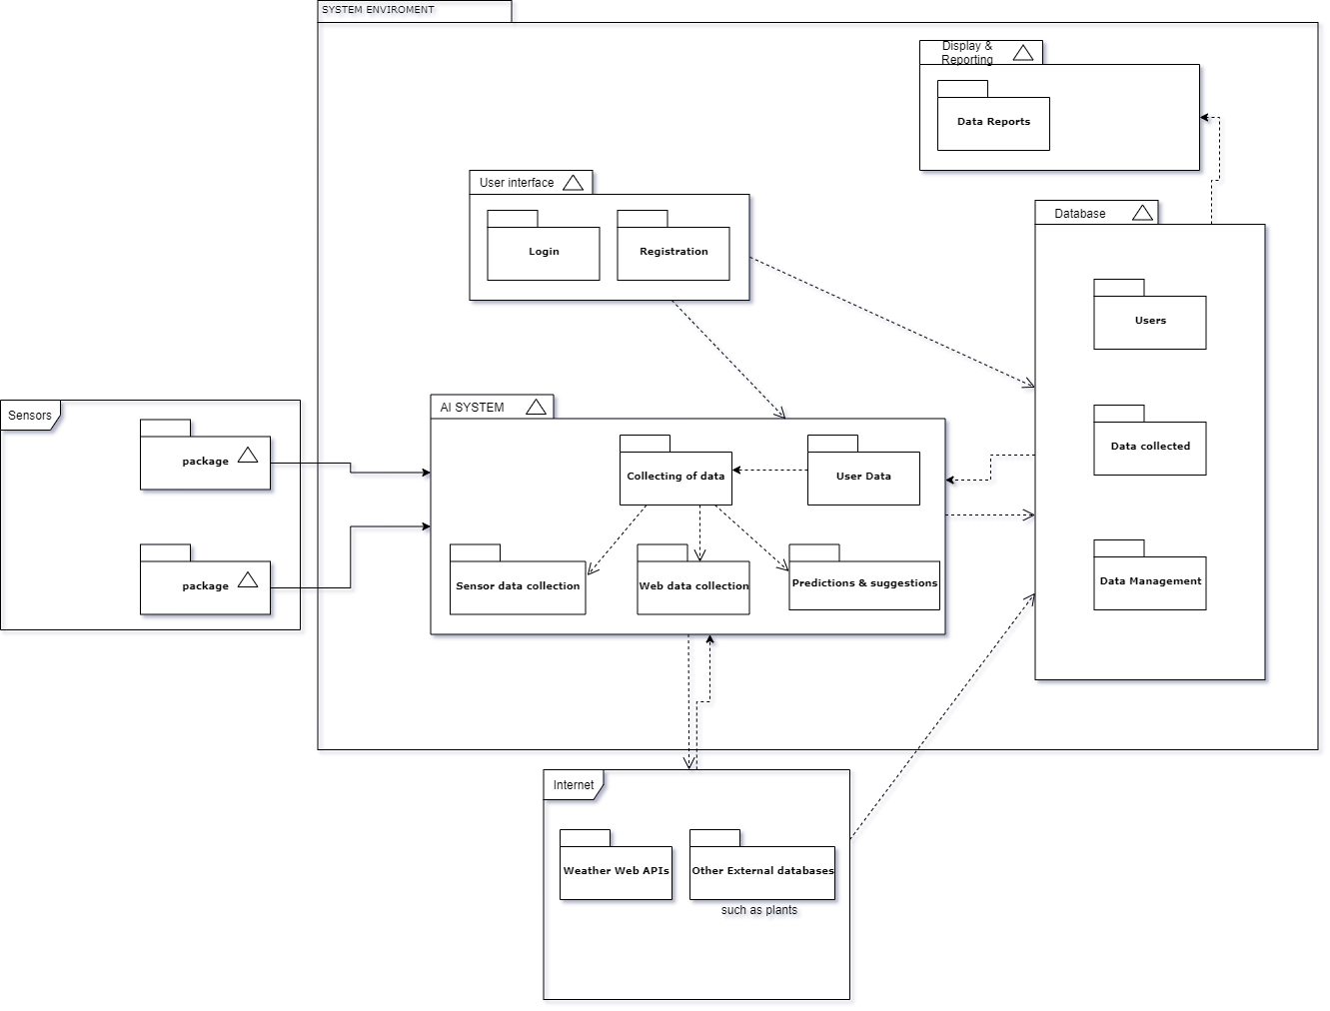

## Temporary GUI designs

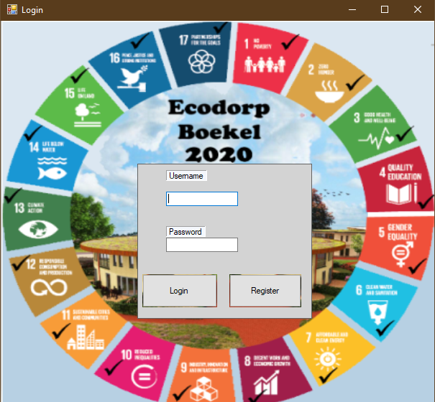

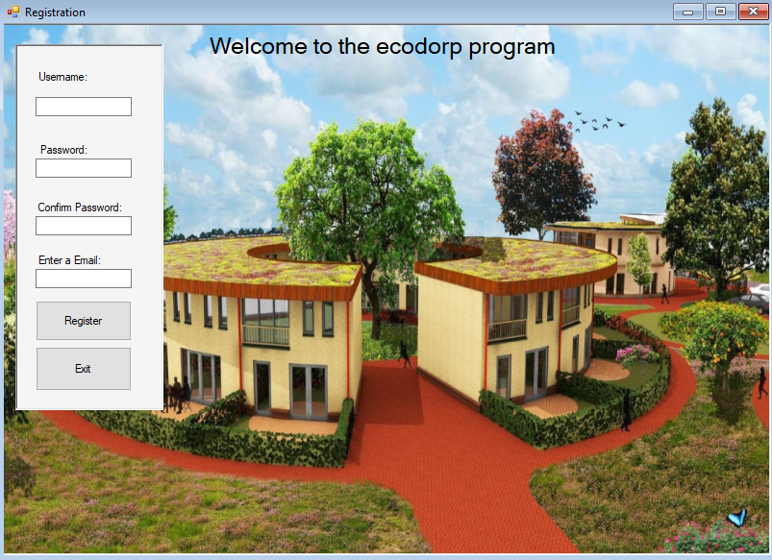

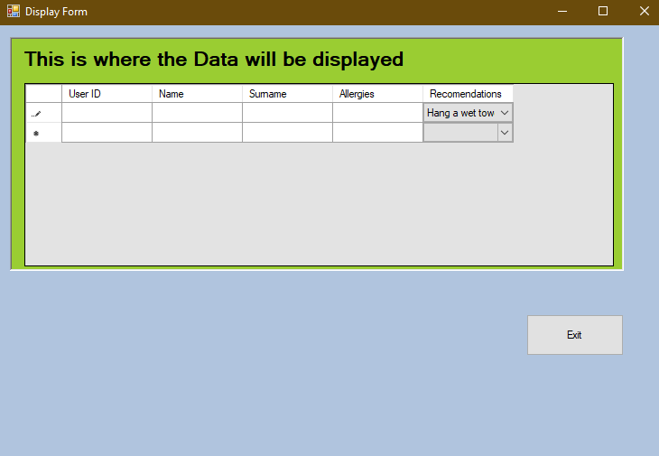

## 8. Bibliography

Bailey, K. (. (n.d.). *www.sociologygroup.com*. Retrieved from sociologygroup.com: https://www.sociologygroup.com/advantages-disadvantages-interview-research/

Department of Health in the US. (n.d.). *www.health.state.mn.us*. Retrieved from health.state.mn.us: https://www.health.state.mn.us/communities/environment/air/toxins/voc.htm

Ecodorp Boekel. (n.d.). *www.ecovillageboekel.nl*. Retrieved from ecovillageboekel.nl: https://www.ecovillageboekel.nl/how-build-ecovillage-go-with-flow/

FDGweb. (2021). *www.fdgweb.com*. Retrieved from fdgweb.com: https://www.fdgweb.com/throwaway-prototyping/#:~:text=The%20main%20benefits%20of%20throwaway,and%20meet%20your%20prototyping%20goals.

Mauro Castelli, F. M. (2020). *www.hindawi.com*. Retrieved from hindawi.com: https://doi.org/10.1155/2020/8049504

teach-ict.com. (n.d.). *www.teach-ict.com*. Retrieved from teach-ict.com: https://www.teach-ict.com/as_a2_ict_new/ocr/A2_G063/331_systems_cycle/prototyping_RAD/miniweb/pg3.htm

USA.gov. (n.d.). *www3.epa.gov*. Retrieved from epa.gov: https://www3.epa.gov/region1/airquality/pm-human-health.html