NET-Hook Project Setup

Contents

Overview 2

Visual Studio Setup 2

Project Setup 3

Debug Setup 8

Post-Build Events 9

Adding an Add-In to Mastercams’s UI 9

# Overview

This document outlines the steps required to build and deploy this example NET-Hook Add-In project.

# Visual Studio Setup

Visual Studio usually must be running in administrator mode (as Administrator) for this project to build properly. The Post-Build commands copy files over into the Mastercam\chooks folder, so you may need Admin privileges to have this succeed.

See: Post-Build Events

The easiest way to do this is to setup your Visual Studio shortcut to always run as Administrator by doing the following…

1. Right-click on your Visual Studio shortcut and select Properties.
2. In the Properties dialog, click the Shortcut tab.
3. Click the Advanced… button.
4. Check the Run as administrator option in Advanced Properties dialog.
5. Click OK to close the Advanced Properties dialog.
6. Click OK again to save and close the shortcut properties.

# Project Setup

This NET-Hook project was written in Visual Studio 2019 and targets the .NET 4.6.1 Framework as well as the Mastercam NET-Hook 3.0 library (**NETHook3_0.dll**). This project may work with other versions of Mastercam, but **Mastercam 2020** is the focus of this example.

1. Make sure the reference to the **NETHook3_0** library is valid. If there is a warning symbol displayed on the **NETHook3_0** reference in the Solution Explorer, or if you receive errors/warnings, such as the one below, when building the project, the path to your **NETHook3_0.dll** file may need to be re-established.

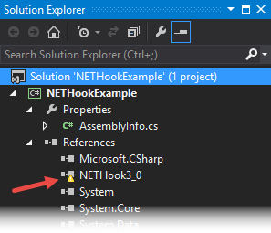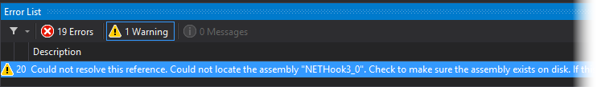

This can be done in the **Solution Explorer** by removing the existing **NETHook3_0** reference and then re-adding it per the steps below.

1. If necessary, expand the main project node.  
   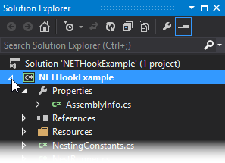
2. Expand the **References** node.  
   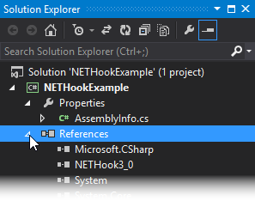
3. Right-click on the **NETHook3_0** reference and click **Remove.**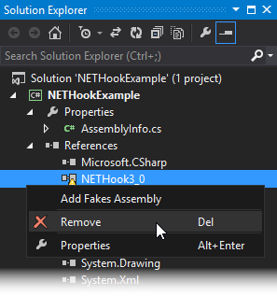
4. Right-click on the **References** node and click **Add Reference…**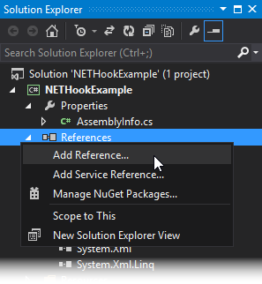
5. In the **Reference Manager** dialog, click the **Browse…** button.  
   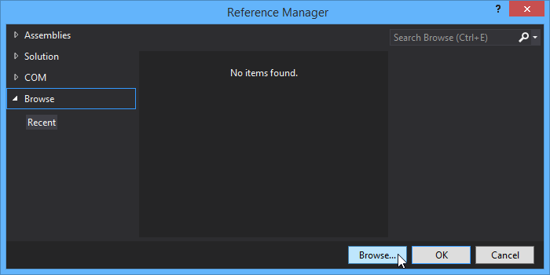
6. Browse to the Mastercam installation folder (**e.g., C:\Program Files\Mastercam 2020\Mastercam**), select the **NETHook3_0.dll** file and click **Add.**  
   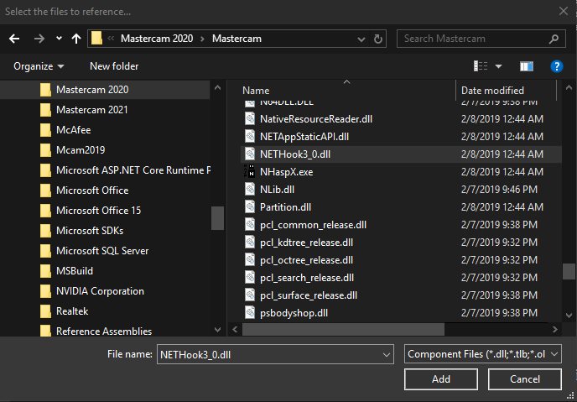
7. In the **Reference Manager** dialog, ensure that **NETHook3_0.dll** is checked and click **OK.**  
   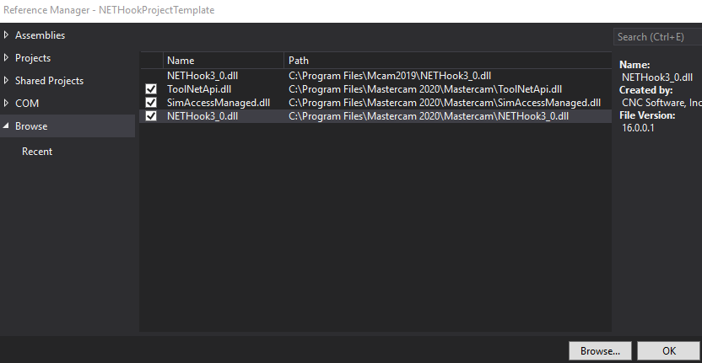

The **NETHook3_0** reference should then appear in the **References** list without the warning symbol.

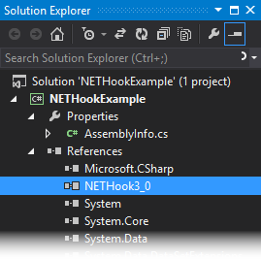

# DEBUG Setup

Set the project to start Mastercam.exe as an external program. To do this, go to PROJECT menu in Visual Studio and then select the [project name] Properties… In the Debug properties section, use the browse button to set the Start external program property to the path to your Mastercam.exe

(e.g. " C:\Program Files\Mastercam 2020\Mastercam\Mastercam.exe").

Then do the same to set the Working directory property to the Mastercam installation folder. (e.g. “C:\Program Files\Mastercam 2020\Mastercam”) as shown below.

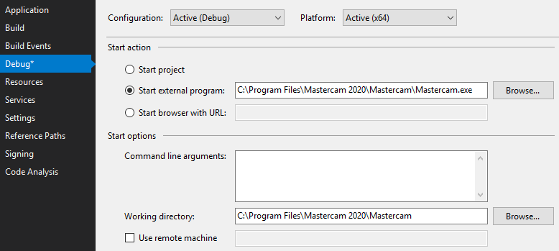

# Post-BUILD Events

You can have post-build event that copy the add-in’s compiled DLL and its and FTfiles to your Mastercam installation. To do this, go to PROJECT menu in Visual Studio and then select the [project name] Properties… In the **Build Events** properties section, click the **Edit Post-build…** button then enter the following two lines into the **Post-Build Event Command Line** field as shown below.

*copy "$(TargetPath)" "* ***C:\Program Files\Mastercam 2020\Mastercam\chooks****"*

*copy "$(ProjectDir)Resources\FunctionTable\$(TargetName).ft" "* ***C:\Program Files\Mastercam 2020\Mastercam \chooks****"*

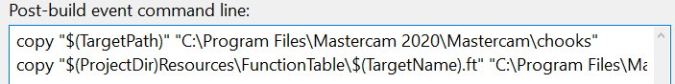

Note that “**C:\Program Files\Mastercam 2020\Mastercam***”* is the path to your Mastercam installation folder and may vary. **Visual Studio usually must be running as Administrator for the post-build events to succeed, as regular user permissions on your system may not allow for copying files to the destination folder. See:** **Visual Studio Setup**

# ADDING AN Add-IN to MASTERCAM’S UI

If you use the project’s post build step, the add-in’s DLL and FT files will be copied automatically to the correct location otherwise, you will need to copy the DLL and the FT file to your **C:\Program Files\Mastercam 2020\Mastercam\chooks** folder. This will allow the NET-Hook commands specified in the FT file to be added to the ribbon/ribbon tab, quick access toolbar and context menu (reference the Mastercam online help documentation on how to customize the ribbon, etc.)

If you encounter any issues with what is (or not) documented here, please let us know!

[SDK@mastercam.com](mailto:SDK@mastercam.com?subject=Mastercam%202018%20C-Hook%20SDK)

CNC Software, Inc. | 671 Old Post Road | Tolland, CT 06084 | USA   
Phone: 860.875.5006 | Fax: 860.872.1565 | [www.mastercam.com](http://www.mastercam.com/)

[](http://www.mastercam.com/)