PASAKAY
System Defense Documentation
SSLTODA tricycle driver directory · La Salle College Antipolo · Grade 12 STEM
Driver app · Customer app · System Admin console
Generated from repository main @ commit 30d550a · October 17, 2026
Interactive sources: Mermaid flowcharts in docs/system-analysis/flowcharts; ERD (docs/defense/database-erd.dbml) opens in dbdiagram.io

Contents
1 · Project Overview
2 · System Architecture
3 · Database Design
4 · Application Workflows
5 · Feature Implementation
6 · Technology Stack
7 · Testing and Validation
8 · Limitations and Scope
9 · Defense Questions and Answers
10 · Defense Presentation Outline
Appendix A · Supporting diagrams (docs/system-analysis)
Appendix B · Claim-to-evidence traceability map

1 · Project Overview

1 · Project Overview
PASAKAY is a mobile application system developed by Grade 12 STEM students of La Salle College Antipolo as an academic research project (School Year 2026–2027). "Pasakay" is Filipino for "to hoist/assist onto a ride". The system supports SSLTODA — the Special Local Tricycle Operators and Drivers' Association of Barangay San Luis, Antipolo City — which operates tricycles from five terminals in the barangay.

The problem it addresses
Before this system, a commuter in Barangay San Luis had no reliable way to reach the right tricycle driver. Drivers rotate through shifts at five different terminals, so a commuter who needs a ride at a specific time would have to physically go to a terminal and guess which drivers are on duty. There is no public directory of drivers, no record of who handles which shift, and no research data about how commuters actually contact drivers.
PASAKAY turns the association's paper roster into a searchable digital directory. A commuter selects a terminal, sees the drivers assigned to that terminal and the current shift, and can contact them by tapping a button that opens the phone's own dialer or SMS app. The system records usage so the research team can evaluate how the association's services are used.

Who uses it
Role | Who | What they do
Commuter | Residents and visitors of Barangay San Luis | Register (pending admin approval), browse terminals, view drivers per shift, call/SMS drivers, request rides, rate drivers, receive notifications
Driver | Registered SSLTODA members mapped to one terminal and one shift | Log in with mobile number + password, accept or reject ride requests, complete or dispute trips, request shift changes, read reviews
System admin | The research team's designated administrator | Approve accounts, manage drivers/commuters/terminals/shifts, resolve disputes, moderate reviews, log privacy requests, monitor usage and audit logs

The applications
All three share one Supabase backend:
- Pasakay driver app (`apps/driver`) — Android APK. Drivers sign in with
their registered mobile number and password.
- Pasakay customer app (`apps/customer`) — Android APK. Commuters sign in
with their registered mobile number and password.
- Pasakay admin console (`apps/admin`) — a web app deployed to GitHub
Pages at https://marksangil.github.io/Pasakay/, for the research team.

What is actually implemented (verified in code)
- Account registration with server-side validation; accounts start
pending_verification and must be approved by the admin before login.
- Login via mobile number + password (converted internally to a Supabase Auth
email identity), with a pre-login status gate for pending/suspended accounts.
- Driver directory browsing: terminals → shifts → drivers, with the driver's
TODA plate number, rating, and current terminal.
- Direct contact via the device's Phone and SMS apps (passthrough, not
in-app calling).
- Ride request lifecycle: request → driver accepts/rejects → booking with
status tracking → completion, dispute (flag), or passenger report → driver rating from reviews.
- Reviews: one per completed booking, 1–5 stars plus optional text, with
driver-reported review reports.
- Notifications both in-app (Supabase Realtime) and push (Firebase Cloud
Messaging through Supabase Edge Functions).
- Schedule-driven shift reminders and change notifications generated by
database triggers and a scheduled job.
- A system admin console covering: overview metrics, driver CRUD + TODA
verification, commuter access control, terminal and shift management (including shift-change requests), booking settings, review moderation, dispute resolution, and usage/audit monitoring.
- Foreground-usage tracking (sessions + heartbeats) for both passenger and
driver apps, and an action audit log (which screens and key actions were used) for research evaluation.
- Legal texts (Terms, Privacy Policy) built into both mobile apps, including
research-team contact details and a consent flow at signup.

What the system deliberately does not do
These exclusions are stated in the in-app Terms and Conditions and match the code — they are design decisions, not failures:
- No GPS tracking, navigation, or fare computation. The apps never read
the device location permission and never track any vehicle.
- No online booking or digital payment. The apps do not collect money.
- No in-app calls or stored messages. Communication is handed off to the
device's own apps; only the fact that a contact action was used is logged (an action name and timestamp, never message content or call audio).
- No government/agency data feeds. Driver verification (TODA plate and
identity) is a manual administrative check against the association's own records, as documented in the migration file.

Technologies and services (verified versions)
Technology | Role
Flutter (Dart SDK ^3.13.2) | all three apps, one codebase each target
Supabase (PostgreSQL, Auth, Realtime, Edge Functions, Storage-less) | backend: data, auth, live updates, push
PostgreSQL functions, triggers, row-level security, pg_cron | business logic and access control in the database
Firebase Cloud Messaging (firebase_messaging ^16, firebase_core ^4) | device push notifications (two projects: driver + passenger)
go_router ^18 / flutter_riverpod ^3 | navigation and app state
GitHub Pages + GitHub Actions | admin console hosting and deployment
url_launcher ^6 | opens the device dialer/SMS apps

The student-facing documentation set (this folder) describes the implemented system as it exists in commit 0df2a87 of this repository. Wherever a claim came only from project documentation rather than code, it is flagged as unverified in SOURCE-TRACEABILITY.md.

2 · System Architecture

2 · System Architecture

The one-sentence architecture
PASAKAY is three Flutter clients (two Android apps and one web app) that talk to a single Supabase project: the mobile apps call the database directly for reads and workflow actions, and every row they can see is filtered by the database itself, so the server — not the app — decides what each user is allowed to do.

Architecture diagram
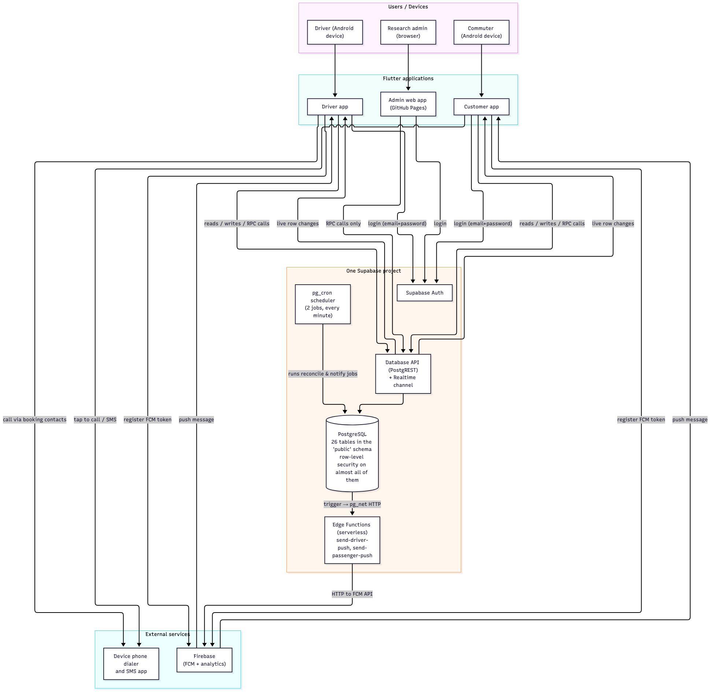
Figure 1. Component and data-flow architecture

What each colored block means, in plain English

The three applications
- Driver app — what a tricycle driver installs on their phone. Its home
screen is the Bookings tab: incoming ride requests appear there in real time, and once a request is accepted, the trip's status card appears underneath. Other tabs show reviews, past trips ("Recents"), notifications, and the driver's own profile.
- Customer app — what a commuter installs. Its home screen is the
Terminals list; from there they drill into a terminal, see the drivers on the current shift, open a driver's profile, and contact or request a ride from that driver. Other tabs: History (their bookings), Review, Notifications, Profile.
- Admin web app — a browser console for the research team's administrator.
Every screen is a thin wrapper over PostgreSQL functions (RPCs); the admin app never reads or writes tables directly except a few list screens, so the database enforces each rule ("you may only delete a terminal with no drivers", for example).
There is no custom web server in this project. The phrase "backend" here means the Supabase-hosted PostgreSQL database plus a small set of serverless functions.

The database (the core of the system)
The interesting design fact for a defense: most business rules live inside the database, not in the Flutter code. Twenty-six tables are grouped in the public schema, and nearly all of them have Row Level Security (RLS) — PostgreSQL policies that automatically hide or block rows a user doesn't own. On top of the tables sit 94 PostgreSQL functions that implement the real workflows:
- register_driver / register_commuter validate mobile numbers, unique
usernames, TODA plates and terminals, create the auth user and the profile row in one transaction.
- create_ride_request, accept_ride_request, reject_ride_request,
complete_booking, flag_booking, report_driver_booking, submit_booking_review implement the ride lifecycle and throw descriptive exceptions when a rule is violated ("Driver is outside their scheduled operating period", "The dispute window for this booking has expired").
- reconcile_ride_workflow runs every minute (via pg_cron, the database
scheduler) to expire old pending requests, auto-complete BOOKED bookings that were never finished and never flagged, and mark completed bookings as review-eligible.
- admin_* functions (28 of them) power the admin console, and each one
re-checks that the caller really is a system admin via assert_system_admin() / is_system_admin().

Authentication and authorization
- Authentication (who you are) is done by Supabase Auth: the driver or
commuter logs in with mobile number + password, which the app converts into a fixed email identity (e.g. 09181234567@<role-domain>), matching how the account was provisioned at registration.
- Authorization (what you may do) happens in two layers: RLS policies
filter every direct table read/write to the user's own rows (commuter_id = auth.uid()), and the workflow functions re-verify role and status inside the transaction, so a theoretically modified app could still not accept somebody else's request.
- The admin identity is just a row in an admins table linked to the same
auth system; every admin function calls assert_system_admin() first.
- The pre-login gate (get_login_status) checks whether the account is
pending, suspended or deactivated before showing Supabase's raw "account banned" error, so users get a readable message.

External services
Service | Used for | What the system would lose without it
Supabase Auth | password logins | sign-in
Supabase Postgres (+ RLS + functions) | all data and business rules | everything
Supabase Realtime | live updates of requests/bookings/notifications | live feel; apps fall back to manual refresh
Supabase Edge Functions + pg_net | turning "a notification row was inserted" into an FCM push | push notifications (in-app notifications still work)
Firebase Cloud Messaging | delivering pushes to Android devices | push notifications
GitHub Pages + Actions | hosting the admin console | admin app deployment (nothing runtime)
Device dialer / SMS apps | actual communication | the core "contact the driver" action

Dependencies and limitations of this architecture
- Internet is mandatory. Every screen reads from the database; offline
use shows empty data or an error state (the repos wrap failures and the UI shows previous or empty snapshots).
- The anon key is public. Mobile apps ship the Supabase anon key, which
is designed for this: security comes from RLS, not key secrecy. Passwords, service-role keys and FCM server credentials are never in the client.
- Push delivery depends on FCM availability, and call/SMS passthrough
depends on the device having a SIM/dialer — mobile Wallets without SIM cannot contact drivers.
- The admin console is hosted on GitHub Pages, so it is public — but it
shows nothing without an admin login, and every admin operation is blocked server-side by assert_system_admin().

Where the detailed diagrams live
docs/system-analysis/flowcharts/ contains six validated diagrams that go deeper: system context, startup, authentication, the ride workflow, database interactions, and foreground activity/audit tracking. The one-page end-to-end user journey is docs/system-analysis/flowcharts/end-to-end-flow.mmd.

3 · Database Design

3 · Database Design
The authoritative source for this chapter is the live Supabase PostgreSQL database (read on 2026-10-17 through standard catalog views — read-only queries only). The checked-in migrations (apps/admin/supabase/migrations/, 34 files) describe how each object got there. Nothing was applied to the database while documenting it.

How the database is organized
One project database, three relevant layers:
- `public` schema (ours) — 26 tables, 4 enums, 94 functions, 9 triggers,
43 RLS policies, and 2 scheduled jobs. This is every table described below.
- `auth` schema (Supabase) — the login identity table auth.users. We
never modify it; one trigger on it (on_auth_user_created_pasakay → handle_pasakay_auth_user()) creates the matching profile row and stamps the role metadata when a signup is confirmed.
- no views — all list/report queries are functions returning JSON.

The tables (26), grouped by purpose

Core roster (who's who)
Table | Purpose (one line) | Key columns | Primary key | Foreign keys (enforced)
terminals | the 5 physical tricycle terminals | terminal_name (unique) | terminal_id | —
shifts | the 3 operating shifts | shift_start_time, shift_end_time, label, unique pair of times | shift_id | —
drivers | one row per registered driver | full_name, contact_number, plate_number (NOT NULL), toda_number, terminal_id, shift_id, current_terminal_id, username (unique), status enum, is_active, average_rating, review_count, license_verified (legacy) | driver_id | → terminals (2 links), → shifts, → auth.users
commuters | one row per registered commuter | full_name, contact_number, email_address, username (unique), status enum, status_reason | commuter_id | → auth.users
admins | system admin accounts | email (unique), username (unique), is_active | admin_id | → auth.users

The auth.users links are identity bindings: signup provisions both the auth record and the profile row, and they stay in sync through the handle_pasakay_auth_user() trigger. Deleting a profile row requires admin action (the apps call admin-managed deletion, not direct deletes).

Ride workflow (the central chain)
Table | Purpose | Constraints that matter
ride_requests | commuter → driver request, one of PENDING / ACCEPTED / REJECTED / EXPIRED / CANCELLED | check on status; expires_at NOT NULL; partial unique index: only one `PENDING` per (commuter, driver)
bookings | created when a request is accepted; BOOKED → COMPLETED / FLAGGED / CANCELLED | request_id unique (1:1 with ride_requests); check on status; review_eligible_at NOT NULL (review window start)
booking_events | append-only journal of every workflow step (REQUEST_CREATED, BOOKING_ACCEPTED, TRIP_COMPLETED, …) with details JSONB | FKs to bookings/ride_requests are ON DELETE SET NULL so history survives record deletion
reviews | commuter's rating of a completed trip | rating CHECK (rating BETWEEN 1 AND 5); partial unique index reviews_one_per_booking gives one review per completed booking
review_reports | a driver disputing/consumer flagging a review | status OPEN/RESOLVED/DISMISSED; partial unique index: one OPEN report per (review, driver)

Contact/notification
Table | Purpose
device_tokens / commuter_device_tokens | FCM tokens per driver/commuter device (token unique per platform table)
notifications | in-app rows per recipient_id (+recipient_type: driver/commuter), with optional dedupe_key (unique where not null) to stop duplicate reminders
notification_event_log | server-side record of which notification events were sent (no client access)
app_notification_settings | global switches (e.g. push endpoint on/off)
driver_notification_preferences / commuter_notification_preferences | per-user category toggles (schedule reminders, followed-driver availability …)
commuter_followed_drivers | commuter ↔ driver "follows" (composite PK of both IDs)

Research/ops support
Table | Purpose
driver_shift_requests | driver asks for a different shift; admin approves/rejects (status pending/approved/rejected, admin_note)
driver_activity_sessions / driver_activity_heartbeats | foreground usage: one row per app open, heartbeats every ~30 s
commuter_activity_sessions / commuter_activity_heartbeats | same mechanism for the passenger app
user_audit_logs | "which screens and actions were used": user_id, user_role (check: driver/commuter), action (check: ≤64 chars), detail JSONB, occurred_at — deliberately no FK, because it must keep logging users that are later deactivated
device_logs | technical device info report (optional crash logs)
privacy_requests | research-team Data-Privacy-Act workflow: subject, request type enum, status enum, retention decisions

Relationships, with a practical example
Enforced foreign keys (36 total). Example chain for a single trip:
commuters (Ana) ←─ ride_requests ─→ drivers (Juno)
│ 1:1 (unique FK)
▼
bookings ──╮ 0:1 (nullable FK)
▼
reviews (+ review_reports)

When Ana taps "Request ride", create_ride_request(Ana, Juno) validates that they don't already have a pending pair (ride_requests_one_pending_per_pair) and inserts a row whose commuter_id must exist in commuters and whose driver_id must exist in drivers — the FKs guarantee no ghost rider. When Juno accepts, accept_ride_request updates the same request and inserts the matching bookings row (the unique FK makes it impossible to have two bookings for one request). When the trip completes and Ana reviews, the review row's booking_id points at that booking, and the refresh_driver_rating trigger updates Juno's average_rating and review_count in drivers — so the rating commuters see is always computed from real rows, never hand-edited.
Constraints the panel may ask about
- drivers_active_requires_license: a driver cannot be set active without
the verification flag — the admin really must verify.
- Deleting a terminal: enforced in the admin_delete_terminal function
(it fails while drivers still reference it) — a delete-guarantee in code rather than a database ON DELETE rule.
- commuter_followed_drivers has a composite primary key
(commuter_id, driver_id), which is how "follow" is prevented from being duplicated.
*Relationships that are not enforced* (documented, not drawn as FKs — the user_audit_logs, device_logs, notifications, and notification_event_log tables all have user_id-style columns but no foreign keys, because they must survive account deletion and they key off a role column, like user_role, which the apps supply):

How the code reads/writes this database
- Mobile apps mostly use RPC functions for anything with rules (ride
actions, registration) and direct RLS-guarded table queries for plain lists (drivers roster, their own bookings/history/notifications).
- Admin app is almost entirely RPC-based (28 admin_* functions), plus a
handful of direct selects guarded by the is_system_admin() policy.
- Never in the client: passwords (only during the initial sign-in call),
service-role keys, or admin-only tables.

Operations summary
Operation | Where implemented
Reads browsing data | list_terminal_shift_drivers, direct RLS-guarded selects
Ride lifecycle writes | create_ride_request, accept_ride_request, reject_ride_request, complete_booking, flag_booking, report_driver_booking
Review writes | submit_booking_review (+ trigger updates), report_review
Account writes | register_driver, register_commuter, admin status functions
Hourly-ish housekeeping | reconcile_ride_workflow (cron, every minute)
Push dispatch | trg_notifications_dispatch_push → dispatch_notification_push → Edge Functions

ERD
The complete ERD, in DBML format validated against dbdiagram.io, is in `database-erd.dbml` (database-erd.dbml). Paste the whole file into dbdiagram.io (https://dbdiagram.io/d/new). It contains every column, PK, FK, unique constraint, and index of the verified live schema.
Full details of every function, trigger and policy are in `../system-analysis/database/database-implementation.md` (../system-analysis/database/database-implementation.md).

4 · Application Workflows

4 · Application Workflows
Each workflow below traces a real user click through the code to the database, including the failure paths. Every table row of Mermaid was validated with mermaid-cli; deeper diagrams live in ../system-analysis/flowcharts/.

4.1 Registration → admin approval
Initiated by: commuter or driver, in the signup screen of their app. Starts in: apps/<role>/lib/features/signup/ → AuthService.signUp. User provides: full name, mobile number, password; drivers also provide TODA plate number and pick a terminal; both may add an email.
Validations: mobile normalize (PhoneUtils.normalize, PH format enforced), TODA plate acceptance (AuthValidators.normalizeTodaPlate, freeform but not empty), and the strongest set inside register_driver / register_commuter: duplicate username/phone/email blocking, driver must have valid plate + existing terminal, and the password policy. The auth user is provisioned via provision_auth_user, its role metadata is stamped, and the profile row is created with status = 'pending_verification'.
Failure paths: any RPC raise becomes a friendly error in the login screen (AuthFlowException); the account is not left half-created because the provisioning and profile insert happen inside one function.
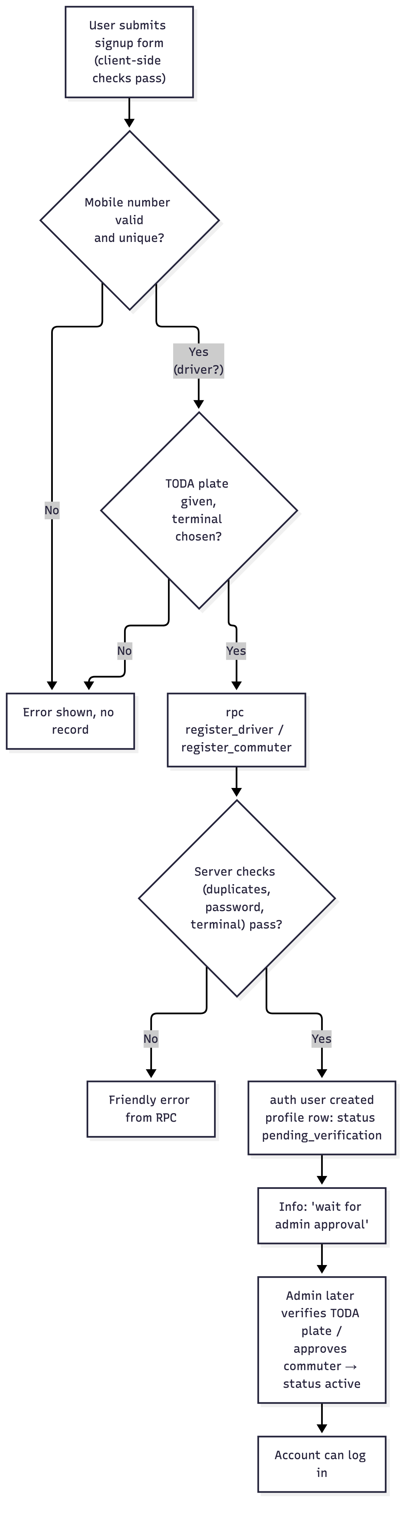
Figure 2. Registration and admin-approval flow

4.2 Login
Initiated by: the user on /login (LoginScreen). What runs: SessionController.login → AuthService.login:
- get_login_status — friendly gate for pending/suspended/deactivated.
- resolve_auth_email — mobile → provisioned email identity.
- auth.signInWithPassword — the actual credential check.
- Role assertion — if the account belongs to the other role, the app
signs out and says so.
- On success the driver/commuter profile is fetched, the driver's shift
status is checked (is_driver_on_shift), an audit entry is written, and the foreground-activity session starts.
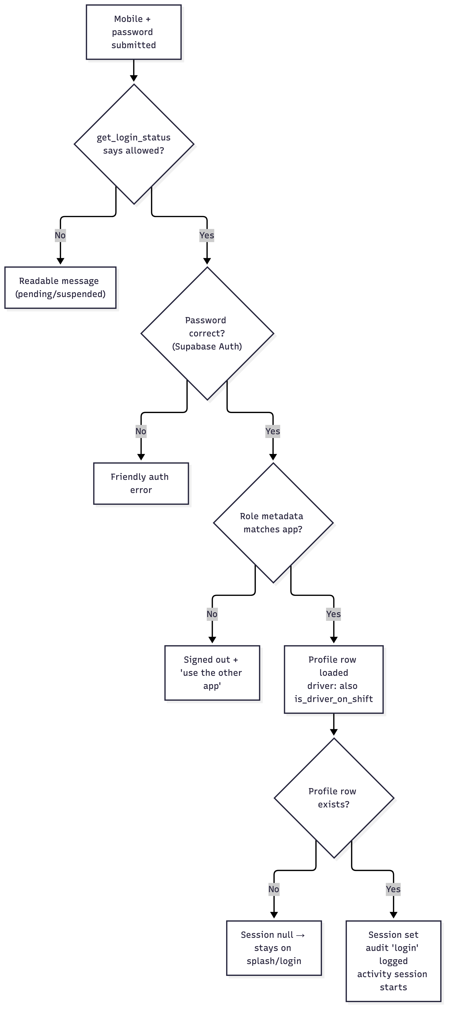
Figure 3. Login flow with pre-gates and role assertion

4.3 Ride request → booking → completion (the core loop)
Reference implementations:
- Customer side: apps/customer/lib/services/customer_repository.dart
(createRideRequest, fetchDriverRequestContext, realtime subscriptions).
- Driver side: apps/driver/lib/services/driver_repository.dart
(acceptRideRequest L140, rejectRideRequest L148, completeBooking L172, flagBooking L160).
- Server rules: 20260915130000_ride_request_booking_flow.sql
(create_ride_request L240, accept_ride_request L341, reject_ride_request L445, reconcile_ride_workflow L145 — cron every minute).
What the commuter can and cannot do: request only when the driver is actually is_active, within their scheduled window (is_driver_on_shift logic), available for another request, and not in cooldown; the messenger may cancel before acceptance only by waiting for expiry (there is no cancel RPC).
Failures are user-visible by design, e.g. "Please wait before requesting this driver again" (cooldown), "Driver is outside their scheduled operating period".
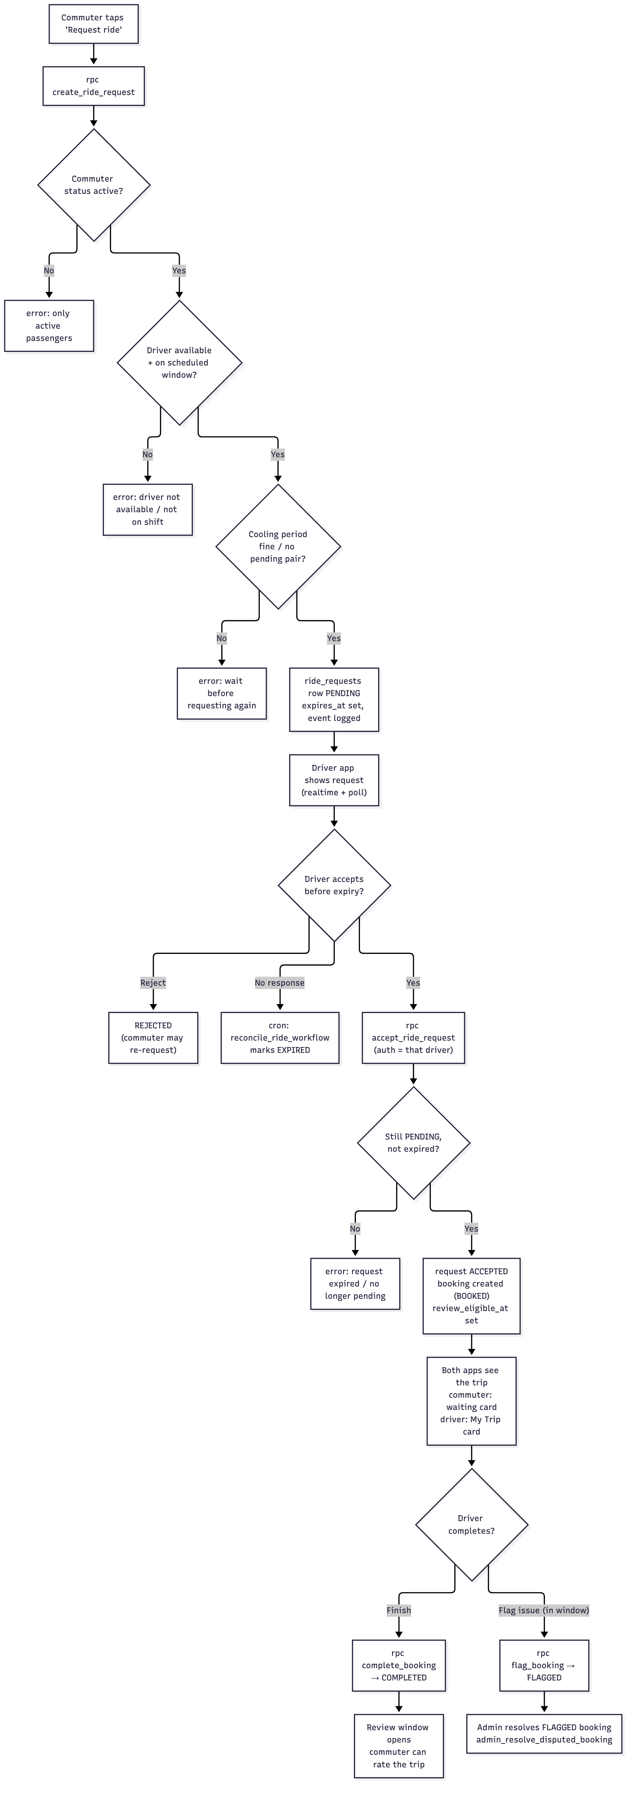
Figure 4. Ride request, booking, completion and dispute paths

4.4 Review a trip (and report a review)
submit_booking_review rejects anything that is not the owner reviewer, is not on a COMPLETED booking, is before review_eligible_at, or duplicates an existing review for that booking. The same migration wires in review_reports (driver or commuter contesting) and the admin_resolve_review_report admin action.
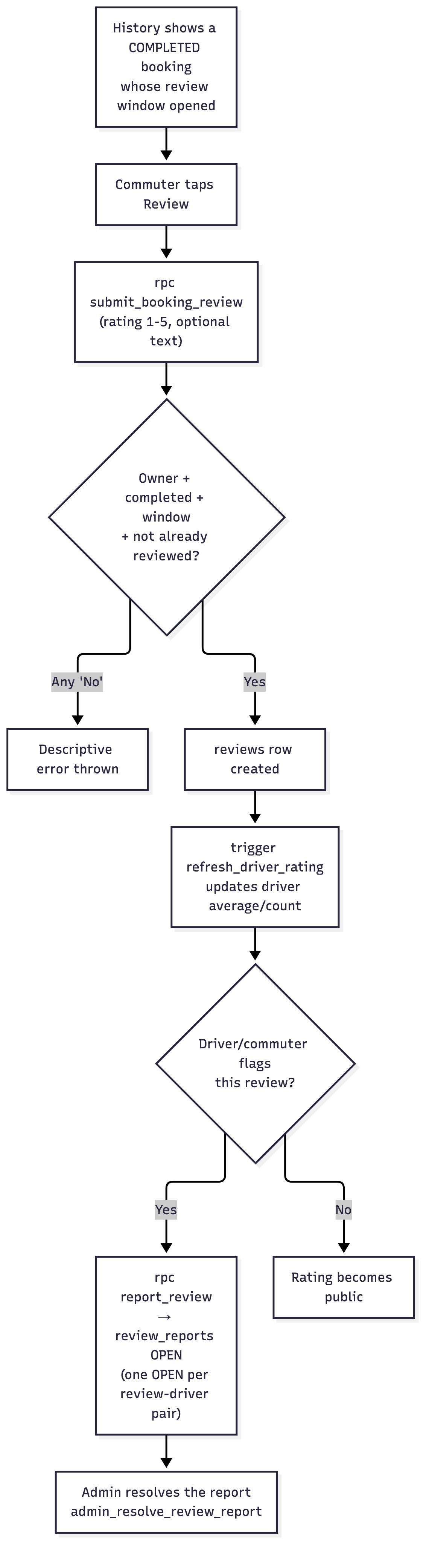
Figure 5. Review submission and review-report flow

4.5 Notifications (in-app + push)
- A state change (shift updated / request accepted / trip finished /
schedule day starting) calls emit_notification from a database function or trigger, which respects per-user preference toggles (driver/commuter_pref_enabled) and dedupes repeated reminders via dedupe_key.
- emit_notification inserts into notifications.
- The trg_notifications_dispatch_push trigger calls
dispatch_notification_push, which uses pg_net to POST to the matching Supabase Edge Function (send-driver-push / send-passenger-push). The Edge Function looks up the recipient's FCM tokens from device_tokens/commuter_device_tokens and forwards the push to Firebase.
- On the device, PushNotificationService also taps to route into the app
(deep link via onOpenRoute in both mobile apps).
What happens if FCM or an Edge Function is unavailable: the notifications write itself does not fail the user's action because push dispatch is asynchronous; the in-app row still exists. Push retries are unverified — the Edge Functions call FCM once and log server-side errors; there is no retry queue in this codebase.

4.6 Admin actions
The admin console covers: overview metrics, driver management (create, edit, verify TODA plate, suspend/activate, delete, reset password), commuter access control, terminal add/rename/delete (guarded), shift label/time edits (3 fixed shifts!) and driver shift-change requests, booking settings (dispute window, request expiry, cooldown, review delay), review moderation, dispute resolution, and privacy-request logging.
Every admin call is funneled through functions that call assert_system_admin() — a malicious or mistake-prone client cannot bypass it because the check runs inside the database.

4.7 Foreground tracking + audit logging (both mobile apps)
Independent of any user-visible feature and used purely for the research evaluation: a Timer sends a heartbeat every ~30 s while the app is in the foreground; when the app is minimized the session ends with reason background. Sessions/heartbeats write through report_driver_activity / report_commuter_activity (role deduced from the auth id server-side). The same pattern also powers the audit trail — screens and key in-app actions (login/logout, opening the booking/terminals screens, submitting a review, calling the driver, etc.) are recorded in user_audit_logs through report_user_audit_log. Audit failures are silent by design: logging never blocks the user's action.

4.8 What is not traceable end-to-end
- Push delivery confirmation (relying on FCM logs; no in-repo evidence).
- Exact handling of FCM deep-link routes for every notification category
(routing code exists and is unit-tested for known categories, but no push-through delivery test).
- apps/admin/lib/features/privacy and .../diagnostics screens are
not wired into the admin router (see docs/defense/08-limitations-and-scope.md); their effects were not exercised at runtime during this documentation pass.

5 · Feature Implementation

5 · Feature Implementation
One block per major implemented feature, in the standard structure. Evidence anchors are inline; supporting citations gathered in SOURCE-TRACEABILITY.md.

5.1 Account registration with admin approval
Purpose: let residents and SSLTODA drivers self-register while keeping the association's roster accurate — nobody becomes visible in the app until the admin verifies them.
User interaction: the commuter enters name + mobile (+ optional email) and password; the driver additionally provides their TODA plate number and picks their terminal. Both see a success screen telling them an administrator must approve the account.
Implementation:
- Client: apps/*/lib/features/signup/signup_screen.dart,
apps/*/lib/services/auth_service.dart (signUp), apps/*/lib/core/utils/auth_validators.dart, apps/*/lib/core/utils/phone_utils.dart.
- Server: register_driver / register_commuter functions
(20260915160000_self_register_confirmed_accounts.sql, 20260915190000_signup_real_email_auth.sql, 20260915250000_optional_email_required_ph_mobile.sql, 20260915290000_verify_driver_requires_ssltoda.sql).
Data handling: one auth user (Supabase-managed auth.users), one profile row (drivers/commuters). The pickup information is served from terminals during signup. Live check that usernames/phones/emails are unique through check_registration_availability.
Validation and access control: password policy, PH mobile normalize, unique constraints (drivers_username_key, commuters_username_key), driver status forced to pending_verification, drivers_active_requires_license check (a driver can't be activated until TODA verification flag is set). Anonymous users can call registration freely — the rate-limiting and abuse protection comes from Supabase Auth defaults (unverified beyond the platform).
Limitations: email is optional (phone-only accounts get a synthesized auth email); no email verification letter path. The "verification" is manual — no external TODA/government database is contacted (stated in the Terms).

5.2 Login and session state
Purpose: the daily "who are you" step, with clear error messages for pending/suspended accounts.
User interaction: mobile number + password. Wrong password, wrong app, pending, suspended and deactivated accounts all get specific messages.
Implementation: SessionController (Riverpod async notifier, replaces state with the profile row or null), AuthService.login (gate → resolve email → sign in → role assert). Admin variant uses admin email + admins row check. Files: apps/{driver,customer}/lib/core/providers/session_provider.dart, apps/admin/lib/core/providers/session_provider.dart.
Data handling: reads drivers or commuters row for the signed-in uid, plus admins.active check for the admin path; nothing is written client-side except the audit row (via report_user_audit_log).
Validation and access control: get_login_status (pre-gate), resolve_auth_email (maps mobile to the provisioned identity), role assertion (userMetadata['role']), RLS on the profile tables (*_select_own).
Limitations: if Supabase Auth is unreachable, the app is stuck at splash with a config error screen (no offline mode). Drivers' remaining shift time is computed server-side (is_driver_on_shift); a stale client copy isn't an authoritative source.

5.3 Terminal → driver browsing (commuter)
Purpose: let a commuter find who to contact.
User interaction: Terminals tab → tap a terminal → see drivers (primarily filtered by the current shift) → tap a driver → profile with plate, TODA number, rating, current terminal, availability, Follow button and a large contact card.
Implementation: apps/customer/.../terminals/, driver_list/, driver_profile/; data from fetchTerminals (direct select on terminals), fetchDrivers → list_terminal_shift_drivers (server-computed: driver row + shift + is_driver_on_shift state), fetchDriver for the details screen.
Data handling: reads only (plus the commuter's own follows table for the Follow state). Ratings shown come from the trigger-maintained drivers.average_rating/review_count.
Validation and access control: RLS: terminals_read_all and drivers_read_all; the follow insert policies restrict to commuter_id = auth.uid().
Limitations: the list is scoped by the terminal you stood on first — there is no search-by-name across all terminals in the commuter app (the admin has global driver search instead). Plate number display includes legacy "Plate No." formatting from before TODA plate replaced license plates.

5.4 Direct contact: Call / SMS passthrough
Purpose: connect commuter ↔ driver through the phone system without the app holding the conversation.
User interaction: tapping Call opens the device dialer pre-filled with the driver's number; tapping Message opens the default SMS app with a pre-written message body. On the driver app, the latter is also how drivers contact the commuter of an active trip.
Implementation: apps/*/lib/core/utils/contact_launcher.dart using url_launcher (tel: / sms: URIs, unit-tested in apps/driver/test/widget_test.dart "builds dialable tel and sms URIs").
Data handling: reads only drivers.contact_number / commuters. No call or SMS content is ever transmitted over our backend; an audit row recording that the action happened (call_driver / sms_driver) is the only trace.
Validation and access control: the phone number comes from the verified driver profile, not from the commuter. The report_user_audit_log action is fire-and-forget, so a failed log can't block a call.
Limitations: does nothing if the device has no SIM/dialer app; the app cannot confirm the call actually happened. Disclosed in the Privacy Policy ("Phone Permission").

5.5 Ride-request + booking lifecycle
Purpose: actual tricycle-hailing support between the association's registered drivers and a commuter, with clear states both sides can trust.
User interaction: detailed in §4.3 — commuter requests, driver sees a card in Bookings tab with Accept/Reject, then the trip lands in "My Trip", whose card flips around COMPLETE when the driver taps Done, FLAGGED when either party marks an issue, or auto-COMPLETES when the cron decides.
Implementation: server functions in 20260915130000_ride_request_booking_flow.sql (list in §3), client repos apps/customer/lib/services/customer_repository.dart and apps/driver/lib/services/driver_repository.dart, driver UI apps/driver/lib/features/bookings/bookings_screen.dart, apps/driver/lib/features/booking_details/booking_details_screen.dart, commuter realtime in apps/customer/lib/core/providers/ ride providers.
Data handling: ride_requests (one PENDING per pair), bookings (unique per request), booking_events journal every transition (with details JSONB including actor + reason), reconcile_ride_workflow for babysitting (expiry, auto-complete, review-eligibility).
Validation and access control: all state transitions are server-authored, never written directly by the app: only the target driver can accept their own request, only their commuter can report it, only within a set window (dispute_window_minutes); pending requests are visible only to the pair involved (ride_requests_select_own), and commuters can see only their own bookings (bookings_select_own).
Limitations: commuter cannot cancel a pending request proactively (no cancel_ride_request — the cancel status exists but is only reachable through admin action; so a wrong tap means waiting for expiry). The completed-only window for flagging (the full dispute window may be about longer than documented; see admin_set_booking_settings defaults) is server-tuned rather than fixed in code.

5.6 Reviews, ratings and review reports
Purpose: let commuters give feedback and the association spot problems.
User interaction: after a trip completes, History-entry shows a "Review" button; the commuter submits 1–5 stars + optional text. Drivers view reviews in their Reviews tab; either side can report a review, which the admin resolves.
Implementation: submit_booking_review, report_review, admin_delete_review, admin_set_review_hidden; triggers refresh_driver_rating (updates drivers.average_rating/review_count) and reviews_one_per_booking partial unique index. Client screens: apps/customer/.../review/, apps/driver/.../reviews/, apps/admin/.../reviews/reviews_screen.dart.
Data handling: one row per completed booking; anonymous display — the review list for other commuters shows the driver name but never the reviewer's identity (20260915310000_anonymous_driver_reviews.sql).
Validation and access control: RPC-side checks (owner/completed/window/ rating 1–5/unique); RLS reviews_insert_own; the admin-delete path hides rather than hard-deletes (consistent with the research data-retention rules).
Limitations: no commuter-side "edit my review" (delete only in admin; resubmission grace covered by one-per-booking rule); hidden reviews remain in the DB (data-retention policy).

5.7 Notifications (in-app + push)
Purpose: keep both sides aware without both sitting in the app.
User interaction: bell icon + system push. Tapping a push routes to the relevant screen (onOpenRoute): schedule → driver profile, request → driver bookings, review/reply → commuter review. The Notification screen lists rows, moves messages to read state (markNotificationsRead).
Implementation: emit_notification + notifications table + subscribeNotifications realtime channels + PushNotificationService (FCM token registration through register_driver_device_token / register_commuter_device_token), db triggers trg_drivers_notify_changes / trg_shifts_notify_changes / schedule processor (process_schedule_notifications cron) making the actual calls at scheduled times; Edge Functions (send-driver-push, send-passenger-push) forward to FCM with the correct recipient tokens.
Data handling: notifications rows (recipient-scoped, read state), FCM token tables, app_notification_settings keys (global toggles that the notification functions consult).
Validation and access control: recipient-only read/update policies (notifications_own, notifications_update_own), per-user preference gates (driver/commuter_pref_enabled), dedupe via notifications_dedupe_key_uidx.
Limitations: two separate Firebase projects (driver + passenger); edge-function secrets must be set manually in the Supabase dashboard (documented in apps/customer/README.md). No offline queue — push dispatch is best-effort; a missed push is still an unread in-app notification.

5.8 Admin console
Purpose: the research team's control panel for roster management and research monitoring.
User interaction: list screens with pull-to-refresh and search: Overview (usage + booking metrics), Drivers (+ per-driver detail sheet), Commuters, Terminals, Shifts (incl. incoming shift-change requests), Booking settings, Reviews, Disputed bookings, Review reports, plus sidebar-audit access and password change.
Implementation: apps/admin/lib/features/*, one repository (drivers select + 34 RPC call sites in apps/admin/lib/services/admin_repository.dart), models parsing JSON returned by the admin_* functions.
Data handling: reads via admin_overview, admin_list_reviews, admin_driver_activity_list, admin_commuter_activity_list, admin_user_audit_logs, etc.; writes via admin_create_driver, admin_update_driver, admin_set_driver_status, admin_verify_driver_license (stores toda_number), admin_create_terminal, admin_update_shift, admin_review_shift_change_request, admin_resolve_disputed_booking, admin_resolve_review_report, admin_set_booking_settings, admin_log_privacy_request and friends.
Validation and access control: admin login gating (must have an admins row with is_active), then assert_system_admin() inside each function; deletion guards (terminal-with-drivers is blocked server-side); The privacy-request workflow stores "deletion may be retained for the study" in the migration header comment of 20260911000000_admin_system.sql.
Limitations: two screens exist but are not routed — PrivacyScreen and DiagnosticsScreen (apps/admin/lib/features/privacy/privacy_screen.dart, .../diagnostics/diagnostics_screen.dart) — privacy and device-log content behind them cannot be reached from the admin UI. No dark mode. The drivers list soft-live-activity column polls every 5 minutes (screen-local timer).

5.9 Foreground-usage tracking + audit log (research instrumentation)
Purpose: let the researchers evaluate how the app was used, without tracking GPS or message content.
User interaction: invisible.
Implementation: apps/{driver,customer}/lib/services/{driver,commuter}_activity_tracker.dart (Riverpod singleton, AppLifecycleListener, UUID session ids, report_driver_activity/report_commuter_activity, get_driver_activity_config for server-tunable heartbeat/timeout), apps/{driver,customer}/lib/services/user_audit_trail.dart (UserAuditTrail.log, fire-and-forget ScreenAudit widget mixin). Admin surface: live activity columns and per-user Activity dialogs (/commuters, /drivers/:id) plus the report viewer (admin_user_audit_logs).
Data handling: driver_activity_sessions, commuter_activity_sessions (open-ended with end_reason logout|background), *_heartbeats (30-second spaced), user_audit_logs. Sessions self-report last_heartbeat_at; the admin "state" is computed at read time (active now / inactive if the last beat is older than the timeout or the session is closed).
Validation and access control: all writes go through SECURITY DEFINER functions that resolve the user role from auth.uid(); unauthenticated calls are rejected; row policies keep each user's own rows visible.
Limitations: tracking is opt-in only in the sense that it's part of the consent text (Privacy Policy records "Records of in-app actions…"); logging failures are silently dropped; a device clock skew or no-network period can leave a session open for longer than reality (the timeout rule closes it at read time).

5.10 Legal texts + consent
Purpose: Data Privacy Act compliance — show what data is collected, why, and get explicit consent before signup.
User interaction: Terms & Privacy Policy screens accessible from both mobile apps (and referenced before signup); the text is compiled into the app (storage: lib/core/utils/legal_content.dart per app). It includes the research-team contact emails and the moderator's DPO email.
Implementation: shared legal_content.dart file, identical between the customer app and driver app (checked-in file, no fetch-from-server step).
Data handling: only report_user_audit_log inserts documented data; crash/device info uploads through device_logs (optional, insert-own).
Validation and access control: the signup flow displays the link to the Privacy Policy and Terms; the consent text is listed verbatim at the bottom of the Privacy Policy. RLS restricts no legal tables because they aren't stored in the DB at all (static in-app text).
Limitations: the legal text lives in the compiled APK, so changing it means shipping a new APK; privacy-request handling (what a user does to invoke their DPA rights) depends on the admin console (the corresponding admin screen is in the codebase but not routed — see 5.8).

6 · Technology Stack

6 · Technology Stack
Every entry below is verified in pubspec.yaml / migration files / workflow configuration — the "where" column names the actual usage in this repo. Where no design rationale exists in the repository or project documentation, the entry states its technical purpose without inventing a selection story.

6.1 Applications
Technology | Version (constraint) | Used in | Technical purpose | Depends on it
Flutter framework + Dart | SDK ^3.13.2 | all three apps | one shared framework for both Android targets and the admin web build | everything client-side
flutter_riverpod | ^3.4.3 | all three | app state (session, trackers, repositories are injected providers) | every screen and service
go_router | ^18.0.1 | all three | declarative navigation plus deep-link routes from notifications | router providers (app_router.dart)
supabase_flutter | ^2.17.2 | all three | Supabase client: auth, PostgREST, realtime channels | the entire backend contract
flutter_dotenv | ^6.0.1 | all three | loads .env (URL/anon key) at startup | SupabaseConfig.initialize
google_fonts | ^8.2.1 | all three | app typography | UI theme
intl / timeago | ^0.20.3 / ^3.7.1 | mobiles | dates, relative times | booking cards, activity lists
url_launcher | ^6.3.2 | mobiles | opens dialer/SMS apps | contact feature
shared_preferences | ^2.5.5 | customers | the on-device recent-contact list (privacy choice: stays on the device) | customer loadRecent
firebase_core ^4 / firebase_messaging ^16 / flutter_local_notifications ^19 |  | mobiles | FCM token registration + foreground push + local notifications | push notifications
cupertino_icons |  | all | iconography | UI

6.2 Backend services (Supabase project)
Capability | Object(s) that use it | Notes
Supabase Auth | sign-in/signup, handle_pasakay_auth_user trigger | password provider only
PostgreSQL + Row Level Security | 26 public tables, 43 policies | access control can't be bypassed by the client
Database functions (SECURITY DEFINER) | 94 functions — registration, ride workflow, admin operations, activity/audit | the "server code" of this project
Triggers | 9 public + 1 auth-table | updated-at stamps, notification fan-out, rating aggregation
pg_cron | pasakay-process-schedule-notifications, pasakay-reconcile-ride-workflow (both * * * * *) | scheduled server-side work without any app running
pg_net | push dispatch | async HTTP from inside the database
Edge Functions (Deno) | send-driver-push, send-passenger-push | forwards FCM messages using service-account secrets set in the dashboard
Realtime (Postgres changes) | notifications, ride requests, bookings channels in both mobile apps | live updates without polling

6.3 CI/CD and hosting
Technology | Where | Purpose
GitHub Actions (.github/workflows/deploy-admin.yml) | admin app only | builds the Flutter web release on every push to main that touches apps/admin/**, injecting Supabase URL/anon key from repo secrets
GitHub Pages (gh-pages branch) | admin app | public hosting of the admin console at https://marksangil.github.io/Pasakay/
Debug APK (built locally with Flutter/Gradle) | mobiles | the driver and customer test builds; no store build pipeline exists

6.4 Development tools (verified in repo)
- Flutter SDK 3.13+ toolchain (flutter build apk --debug, flutter test,
flutter analyze — used during development; results in 07-testing-and-validation.md).
- flutter_lints ^6 — lint rules in every analysis_options.yaml.
- Git monorepo layout — apps/{driver,customer,admin} + .github/ +
docs/.

6.5 Not used (and therefore not claimed)
The system does not use: GPS/location libraries, external REST APIs besides Supabase and FCM/Google-style endpoints, custom web servers, JWT manual verification (Supabase Auth issues and refreshes tokens itself), or any message routing engine — the Terms exclude GPS/booking dispatch, and the pubspec.yaml files confirm no such dependency exists.

7 · Testing and Validation

7 · Testing and Validation
This chapter reports exactly what test code exists in the repository, which tests were actually executed by the developer, and what that does (and does not) establish. No test results were invented. Where no evidence exists, that is stated.

7.1 What exists in the repository
Seven test source files, all runnable with plain flutter test (no extra plugins declared):
App | File | Count | What it verifies
driver | apps/driver/test/widget_test.dart | 5 | PH-mobile normalization, dialable tel:/sms: URI construction (ContactLauncher), TODA plate validator (empty rejected, freeform accepted, whitespace-collapsed)
driver | apps/driver/test/notification_event_type_test.dart | 5 | deterministic per-day/shift dedupe keys, notification routing (deep-link target per event), explicit-route override, new-request and review deep links
customer | apps/customer/test/widget_test.dart | 2 | phone → commuter auth-email mapping; plain-email login identity
customer | apps/customer/test/history_screen_test.dart | 5 | widget tests: bookings render after load, cancel-during-load safety (dispose mid-load), error state on failure, empty state, auto-open review for completed booking
customer | apps/customer/test/notification_event_type_test.dart | 2 | followed-driver availability routing, dedupe-key composition
admin | apps/admin/test/widget_test.dart | 8 | driver form validation (name/TODA + plate required, PH contact format, password length on create, terminal + shift must be chosen), payload parsing for nested shift/terminal, status-label mapping stays within the allowed actions, audit log parsing (accepts both role id keys, label coverage for known actions)

27 test cases total (5 + 5 + 2 + 5 + 2 + 8).
No integration test suite, no end-to-end suite and no screenshot/golden tests exist in the repository. There are no CI jobs that run tests — the GitHub Action only builds and deploys the admin web app.

7.2 What was actually executed (developer-run, session of 2026-10-17)
Executed locally with the Flutter toolchain (stable, matching the environment.sdk constraint) during the documentation/editing session:
Command (per app) | Result
cd apps/customer && flutter analyze | 0 errors
cd apps/customer && flutter test | 9 / 9 passed
cd apps/driver && flutter analyze | 0 errors
cd apps/driver && flutter test | 10 / 10 passed
cd apps/admin && flutter analyze | 0 errors
cd apps/admin && flutter test | 8 / 8 passed

These executions are documented in the development transcript; they were not run through CI, so a fresh flutter test run reproduces them only if the environment matches. There is no report artifact committed to the repo.
Manual verification performed and documented during the same session (not automated anywhere):
- Fresh debug APKs built from a clean main tree for both mobile apps
(build outputs are not committed).
- Live-database smoke checks (read-only) confirming the audit/commuter-activity
RPCs exist and reject unauthenticated calls.
- GitHub Pages deployment observed green (admin console renders).

7.3 What the tests do and do not establish
Established by the tests above: input normalization (mobile, TODA plate, dial URIs), notification routing/dedupe-key invariants, driver-form validation rules, history-screen behaviors including failure and empty states, audit-log row parsing. These are exactly the fiddly pure-logic pieces of the client.
Not established by these tests:
- Server-side workflows (create_ride_request, accept_ride_request,
reconcile_ride_workflow, RLS policies) are not covered by any test script in the repository.
- Push delivery end-to-end is untested in repo code (originates outside the
repo: FCM projects + Edge Function secrets).
- The admin server functions' authorization behavior (assert_system_admin)
has no automated test.
- Concurrency/soak behavior (many simultaneous requests to one driver) is
unsubstantiated — the DB constraints guarantee single pending pair and ONE accept wins (accept_ride_request re-checks status inside the transaction), but there is no load test.

7.4 Manual verification already documented vs not performed
Evidence level | Scope
Documented manual checks (this repo's development session) | clean APK builds, DB RPC existence/permission smoke test, Pages deploy, endpoints' read-only liveness
Documented but not exhaustive | ride flows exist live and RPC smoke checks ran, but individual real-device journey scenarios were ad hoc
Not performed (no evidence) | load/soak tests of the cron reconciliation against backlog data; behaviour of process_schedule_notifications with zero followers; comprehensive offline-device UX

7.5 Validation rules that double as tests (non-executable)
The material layer that enforces most business rules is the database schema itself (despite no test suite exercising it):
- unique partial indexes controlling one pending request per pair and one
review per booking;
- CHECK constraints enumerating every status/domain value;
- RCS ownership policies;
- delete-guards implemented server-side.
These are constraints that would make the risky scenarios fail closed, but adherence is a property of the schema rather than a verifiable test — a "what if two taps race" answer must cite the constraints and their transaction semantics, not a test result.

8 · Limitations and Scope

8 · Limitations and Scope
Statuses used in the table: Implemented (verified in code and wired in), Partially implemented (code exists but incomplete/unreachable), Not implemented (planned/excluded, no code), Unverified (no repository evidence either way).
Item | Current status | Evidence | Explanation
Commuter registration + admin approval gate | Implemented | register_commuter (migration 20260915160000…), commuters_insert_own policy, admin commuter functions | accounts are pending_verification until the admin sets them active; login blocked until then
Driver registration + TODA plate requirement | Implemented | register_driver, 20261015000000_toda_plate_replaces_license.sql, 20260915290000_verify_driver_requires_ssltoda.sql | plate (freeform TODA number) replaces the old driver's license login; license collection is deprecated, plate stored in drivers.toda_number
Login (mobile + password) both apps, admin email login | Implemented | apps/*/lib/services/auth_service.dart, apps/admin/lib/core/providers/session_provider.dart | with pre-login status gate, role assertion, and profile fetch
Terminal → shift → driver browsing | Implemented | list_terminal_shift_drivers, customer driver_list screen | primary commuter journey
Call / SMS passthrough | Implemented | apps/*/lib/core/utils/contact_launcher.dart, url_launcher | opens device apps; no in-app calling
Ride request → booking lifecycle | Implemented | 20260915130000_ride_request_booking_flow.sql + client repos | full state machine incl. reconciliation cron
Trip dispute (flag) + admin resolution | Implemented | flag_booking, admin_resolve_disputed_booking, /disputed-bookings screen | only inside the configured window
Commuter side explicit "cancel request" | Partially implemented | ride_requests_status_check allows CANCELLED; only admin action writes it | commuter cannot proactively cancel a pending request; it waits for expiry (see create_ride_request/accept_ride_request — no cancel RPC)
Reviews + rating aggregates | Implemented | submit_booking_review, refresh_driver_rating trigger, reviews_one_per_booking | one review per completed booking
Review reports + admin resolution | Implemented | report_review, admin_resolve_review_report, /review-reports screen | hides/deletes reviews resolves reports
In-app notifications (Realtime) | Implemented | notifications table + realtime channels in both apps | recipient-scoped reads
Push notifications (FCM via Edge Functions) | Implemented pipeline, delivery Unverified | 20260915120000_notification_push_pg_net_trigger.sql, edge functions, token tables | code path complete; end-to-end delivery depends on FCM + secrets configured in dashboard
Schedule-change / reminder notifications | Implemented | trg_drivers_notify_changes, trg_shifts_notify_changes, process_schedule_notifications cron | shift + availability + schedule events
Shift-change requests to admin | Implemented | request_driver_shift_change, admin_review_shift_change_request, /shifts screen | fixed to the 3 seeded shifts
Booking settings (windows/cooldowns) | Implemented | admin_set_booking_settings, /booking-settings screen | includes zero-allowed fix (20260917000000_allow_zero_booking_settings.sql)
Admin driver CRUD + commuter access control | Implemented | admin_create_driver, admin_update_driver, admin_set_*_status, admin screens | suspended accounts can't sign in (get_login_status gate)
Terminal delete guard, shift edit guard | Implemented | admin_delete_terminal, admin_update_shift | delete blocked while drivers exist; only the 3 seeded shifts editable
Foreground-usage tracking (driver + commuter) | Implemented | *_activity_sessions/_heartbeats, trackers, get_driver_activity_config | read-time staleness; heartbeat timeout tunables
Action audit log (screens + key actions) | Implemented | user_audit_logs, report_user_audit_log, ScreenAudit mixin, admin viewers | privacy-disclosed; opt-out is not offered in-app
Terms & Privacy Policy in-app texts + consent | Implemented | apps/{driver,customer}/lib/core/utils/legal_content.dart | compiled into the app; changing text = new APK
Privacy-request workflow (DPA) backend | Implemented | privacy_requests, admin_log_privacy_request, admin_process_deletion | admin-side records exist
Privacy-request admin screen | Partially implemented | apps/admin/lib/features/privacy/privacy_screen.dart — no route in app_router.dart | file exists; not reachable in the UI
Diagnostics screen (device logs viewer) | Partially implemented | apps/admin/lib/features/diagnostics/diagnostics_screen.dart; device_logs_select_admin policy | same: DB + policy ready, screen not routed
Web/online booking, dispatch, GPS, payments | Not implemented by design | in-app terms lists them as excluded; no code path anywhere | out of project scope (documented boundary)
Offline mode | Not implemented | screens show error/empty states | internet required
Email verification letters | Not implemented | 20260915210000_signup_admin_approval_no_email_auth.sql header | approval replaces email confirmation
Admin dark mode / multi-admin roles | Not implemented | single is_system_admin() gate | one admin principal assumed
Automated CI test run | Not implemented | .github/workflows/deploy-admin.yml only builds/deploys admin | tests are run manually
Automated DB/RPC test suite | Not implemented | no files under any test/ cover database internals | correctness rests on schema constraints
Push deep-link routing for all event types | Unverified | routing unit tests cover known categories (notification_event_type_test.dart); no end-to-end push test | routing for every event type not exercised end-to-end
Cron auto-complete behaviour under backlog | Unverified | reconcile_ride_workflow logic inspected; no runtime test | correctness argued from code, not evidence

Security limitations supported by the evidence
- The anon key ships in the APKs by design. Security rests on RLS + RPC
role checks; a determined user can inspect traffic but not bypass policy.
- Admin's session persistence relies on Supabase Auth token storage on
the device; no step-up re-authentication on the admin console beyond initial login.
- No rate limiting of our own beyond Supabase Auth's built-in limits;
cooldowns exist per ride-request, not per brute-force attempt.
- Audit entries are client-initiated (through an RPC) — a malicious
client could skip logging; the logs are evidence, not a tamper-proof record (server-side session/heartbeat staleness mitigates some of this).

Known technical limitations
- Devices need internet + SIM for the core "contact driver" action.
- Admin console lives on a public URL but is permissioned by the database.
- Notification dispatch is fire-and-forget: FCM outages lose pushes (in-app
rows still exist).
- TODA plate data quality (freeform strings, e.g. SSLTODA No. 00876) relies
on admin discipline; uniqueness of plates is not enforced as UNIQUE.

Areas requiring further verification (honest gaps)
- End-to-end push delivery rates (FCM console metrics vs Supabase logs).
- process_schedule_notifications behaviour with zero followers/no
follow preferences set.
- Multi-device simultaneous login behaviour of the activity tracker
(two foreground devices → two sessions — likely both counted; not tested).
- The unrouted Privacy/Diagnostics admin screens (dead code today).

9 · Defense Questions and Answers

9 · Defense Questions and Answers
Answers are grounded in this repository as of commit 0df2a87. Where the honest answer is "we don't have evidence for that", the answer says so — saying so is expected in a defense.

A. Project purpose and scope
Q1. Why build another "hailing" app if there are already ridesharing apps? A: This is not a ridesharing product. It digitizes an association's own driver roster at barangay-terminal level for contact-first communication. There is no fare engine, no dispatch, no payment — the in-app Terms exclude them. Panels often probe for scope creep; the answer demonstrates the Terms and the code agree (no location permission in either app manifest).
Q2. Who exactly is a "user" of the admin console, and why is it a web app? A: One research-team administrator. It's web (Flutter web on GitHub Pages) because the admin manages from a laptop with better searching/editing than a phone form — and the same Supabase project is reused, so no extra backend.
Q3. What does "SSLTODA" mean and why does verification matter here? A: Special Local Tricycle Operators and Drivers' Association. TODA plate verification is the manual act of checking a driver's plate/registration against the association's roster. It's a research-prototype control: the "No LTFRB/government lookup" limitation is documented in the first migration file itself.

B. System architecture
Q4. Where does the "server logic" live — is there a backend server? A: There is no self-managed server. Business logic in SECURITY DEFINER PostgreSQL functions (94 of them) inside Supabase; the two scheduled jobs run under pg_cron; push is dispatched from a database trigger through pg_net to two Deno Edge Functions. All verifiable in apps/admin/supabase/migrations/.
Q5. Why is the state of a trip not computed inside Flutter? A: Because the state machine must be authoritative and race-safe. Both apps are installed on consumer devices; if any screen computed acceptance locally, two simultaneous "accept" clicks could corrupt state. The database function accept_ride_request re-checks status inside the transaction, so exactly one of two racing accepters wins; the other gets a clear error.
Q6. What if a passenger loses internet while waiting for a request? A: The request stays server-side (row in ride_requests with expires_at). If the driver accepts, the push may be missed — but on reconnect the waiting screen's realtime subscription re-syncs, and the History list (which calls reconcile_ride_workflow) reflects the truth. Push delivery is best-effort (limitation documented in 08-limitations-and-scope.md).

C. Database design and relationships
Q7. Why no foreign key on `user_audit_logs.user_id`? A: Deliberate. Audit rows must survive account deletion, and user_id may point into either drivers or commuters (polymorphic via user_role column). Enforcing one FK target would break the mirror design; the check constraint restricts the role text and the client never writes the ids (server resolves them from auth.uid()).
Q8. Why does `bookings.request_id` have a UNIQUE constraint (1:1)? A: The booking is the materialized acceptance of one request. One request can only produce one trip, so the FK is unique — it makes double-booking impossible at schema level, not just in code.
Q9. Explain composite keys in this project. A: commuter_followed_drivers uses (commuter_id, driver_id) as the PK — a follow is the pair. This prevents duplicate follows and gives a natural index for "all followers of driver X".
Q10. What stops one commuter from spam-creating requests? A: Three layers: (1) ride_requests_one_pending_per_pair partial unique index (only one PENDING request to a given driver at a time); (2) the cooldown key from admin_set_booking_settings (p_request_cooldown_minutes) enforced inside create_ride_request; (3) RLS keeps only your own rows visible.

D. Authentication and security
Q11. Users log in with a mobile number — how is that stored in an email-based auth system? A: Supabase Auth signs in with an email+password pair. The registration function provisions the auth user with a deterministic identity (normalized-phone@<role-domain>) and stores role metadata. At login the app resolves the phone to that email via resolve_auth_email before calling signInWithPassword. Files: auth_service.dart (both apps), apps/customer/test/widget_test.dart ("phone maps to commuter auth email").
Q12. How is unauthorized access prevented? A: Per row, at the database: 43 RLS policies (owner-only for almost all tables; admin checks via is_system_admin(); peer checks on bookings and requests). Admin functions call assert_system_admin() internally. The admin web key is the same anon key as the apps, so a public console cannot read anything without a signed-in admin.
Q13. Passwords — where are they stored? A: Only inside Supabase Auth, hashed by the platform. Our tests only pass plaintext at the sign-in call; profile tables contain no credential columns (you can confirm in database-erd.dbml: drivers and commuters have no password field). Admin password reset uses dedicated functions (admin_reset_*_password).
Q14. What about the audit log — isn't that surveillance? A: It's disclosed in the in-app Privacy Policy ("Records of in-app actions… "), covers screens + a fixed set of key actions only, stores ids and labels (never message bodies or location), and is scoped to the research evaluation, with a documented retention/withdrawal path (privacy_requests). Opt-out is not offered (limitation honestly documented).

E. Workflows and business logic
Q15. Walk me through what happens after a driver taps Accept. A: The app calls accept_ride_request(p_request_id); the function (SECURITY DEFINER) re-authenticates the driver, checks the request is still PENDING and unexpired, updates the request to ACCEPTED, inserts the bookings row (BOOKED) with review_eligible_at, and journals a booking event. Failures: "Request is no longer pending", "This request has expired", or a permission error — all surfaced to the UI (driver_repository.dart L140-147).
Q16. What happens if the driver never responds? A: The cron job pasakay-reconcile-ride-workflow (every minute) expires it: reconcile_ride_workflow() sets EXPIRED on pending requests whose expires_at passed. The commuter's waiting screen also shows the countdown, and calling reconcile_ride_workflow on read keeps stale rows out of view.
Q17. How does a booking age into a review? A: The same reconciliation: review_eligible_at = confirmed time + settings delay. A COMPLETED booking exposes a review row only after that timestamp (submit_booking_review raises otherwise); the daily auto-complete path marks overdue COMPLETED-not-reviewed bookings through that same clock — see the bookings_review_due_idx partial index used for that "review due" query.
Q18. If the commuter reports "not delivered but marked COMPLETED", what happens? A: report_driver_booking (available within the passenger-report window) records the passenger name + details; a driver dispute uses flag_booking within the admin-configured window and flips the booking to FLAGGED; the admin sees it in /disputed-bookings with the event journal and resolves with admin_resolve_disputed_booking (complete or cancel).

F. Technology choices
Q19. Why Flutter and why three separate apps instead of one? A: Flutter gives one codebase for both Android apps plus the admin web build. They are separate apps because their users, navigation and permissions differ (driver sees bookings; commuter sees terminals; admin is a console). The repo shows this folder split (apps/{driver,customer,admin}) and the environment blocks are identical (Dart ^3.13.2).
Q20. Why store business rules in the database rather than Dart? A: Because the rules must hold regardless of which client talks to the database: the same tables are updated by two mobile apps, a web console and server-side cron. Centralizing in SQL functions means there is exactly one place a rule can be violated and one place the error text lives.
Q21. Why is Firebase in the project if everything else is Supabase? A: Firebase is used only for Cloud Messaging (device push), the standard user-facing Android push path. The two roles deliberately live on separate Firebase projects (pasakay-passenger documented in apps/customer/README.md) to keep token scope isolated.

G. Testing and validation
Q22. What evidence shows the app actually works? A: Three layers we can honestly cite: (1) 27 automated tests across the three apps, all passing in the last documented run (see 07-testing-and-validation.md); (2) the schema's own constraints acting as guards for race conditions; (3) manual smoke testing on real devices and the live database during development. We do not have an automated end-to-end suite or CI jobs for tests — that is a stated gap.
Q23. What is NOT tested automatically that you wish were? A: The ride-state machine's database functions and the RLS policies (the most security-critical parts). The trade-off we took was schema-level constraints (unique partial indexes, checks) as runtime guards; a next-step improvement is pgTAP-style database tests.

H. Limitations and future improvements
Q24. What are the system's main limitations? A: Summarized in 08-limitations-and-scope.md: no offline mode; commuter cannot cancel a pending request; the admin Privacy and Diagnostics screens exist as files but aren't routed; push delivery depends on FCM; the audit log can be skipped by a hostile client (it is evidence, not a security wall); registration requires admin internet access for every new account.
Q25. How would the system handle more users? A: Traffic today is research-scale. Scaling levers already present: Postgres indexes for list queries (38 non-constraint indexes, reviewed), read-time staleness instead of background sweeps for activity, and reconciliation batch functions. Honest unknowns: Edge Function cold starts per push and Postgres connection limits under many Realtime channels — neither has been load-tested (documented as unverified).
Q26. What would you add next (and why didn't you)? A: (1) Route the admin Privacy and Diagnostics screens (code exists); (2) commuter "cancel pending request" before accepting; (3) automated database tests. Each was deferred to keep the approved scope freeze and avoid behavior changes during research deployment.
Q27. What happens if Supabase is down? A: Sign-in fails with a friendly error; already-signed-in users see empty or stale data with the previous or an error snapshot (repos wrap failures; SessionController never silently fakes a session). Nothing critical writes to the device except recent contacts and FCM tokens (customer app keeps recent contacts in shared preferences locally).
Q28. A reviewer sees two processes accepting the same request — who wins? A: Exactly one wins; the loser gets "Request is no longer pending" because accept_ride_request re-validates inside the transaction (row-locked update). Both sides' UIs then re-sync through Realtime. This is a transactional guarantee, not luck.

10 · Defense Presentation Outline

10 · Defense Presentation Outline
Suggested flow for a 15–20-minute defense: about 16 slides. Slide bodies stay short; the "speaker notes" carry the substance. Diagrams noted below already exist in this repo and render in Mermaid Live Editor or dbdiagram.io.
# | Slide title | Main points | Visual | Speaker notes | Source
1 | Title | PASAKAY — SSLTODA driver directory + ride contact, La Salle College Antipolo, Grade 12 STEM | System logo + apps side-by-side | One sentence: "We turned a paper tricycle roster into a working directory with contact actions and evaluation data." | docs/defense/01
2 | The problem | New drivers shift across 5 terminals; commuters can't reach the right driver; research needs usage data | before/after sketch | Explain barangay context; state the two goals: communication aid + research data | 01-project-overview.md, admin/supabase/migrations/20260911000000 comment header
3 | Scope and boundaries | What it IS: directory, contact, ride request, reviews. What it is NOT: no GPS, no payment, no booking engine | three red "X" chips + three green chips | Repeat the Terms line; this is a plan we kept, verified in code (no location permission) | lib/core/utils/legal_content.dart (terms), docs/system-analysis/database/schema.dbml
4 | Three applications, one backend | Driver APK, Customer APK, Admin web on GitHub Pages | 02 diagram | Emphasize one Supabase project; no custom server | docs/defense/02-system-architecture.md
5 | Architecture in one diagram | UI → repositories → Supabase DB (RLS + functions); cron; Edge Functions; FCM | the mermaid 02 diagram verbatim | Walk one arrow slowly (commuter tap → DB write → trigger → FCM push) | 02-system-architecture.md
6 | Where the rules live | 26 tables, 94 functions, 43 RLS policies, 2 cron jobs | counts Mosaic | "The database refuses what the app shouldn't do"; examples: pending-pair index, accept race, admin gate | 03-database-design.md, ../system-analysis/database/database-implementation.md
7 | Data model tour | roster (terminals/shifts/profiles) → ride chain (requests→bookings→events→reviews) → support (tokens/notifications/audit) | docs/defense/database-erd.dbml screenshot | Show the 1:1 bookings↔requests link (unique FK), follow-table composite PK | 03-database-design.md
8 | Workflow: getting contact info | terminal tap → driver list → profile → Call/SMS taps passthrough | end-to-end excerpt or phone screenshot | Point out audit logging ("call_driver") happens without capturing conversations | 04-application-workflows.md §4, contact_launcher.dart
9 | Workflow: ride request lifecycle | create → accept/reject/expiry → booking → complete/flag → review | core-workflows.mmd excerpt | Mention the every-minute reconciliation cron — "the system polices itself" | 20260915130000_ride_request_booking_flow.sql, docs/system-analysis/flowcharts/core-workflows.mmd
10 | Failure paths the panel will ask about | expired request, cooldown, race accept, offline | one-node "errors we show" | Quote actual error strings ("Driver is outside their scheduled operating period") | 04-application-workflows.md, Q15-Q16, Q28
11 | Keeping accounts safe | registration validation, admin approval, password hashing by Supabase, RLS per row, admin re-checks | auth flow excerpt of authentication.mmd | Do a live claim: pending account cannot log in (get_login_status gate + DB status) | 04 §4.2, 20260915210000 migration
12 | Notifications both ways | in-app rows + FCM pushes + preference settings + dedupe | push screenshot | Two Firebase projects (driver/passenger); retries are best-effort (honest) | 04 §4.5, apps/customer/README.md
13 | Research instrumentation | activity sessions/heartbeats + action audit log + admin activity columns | activity-audit.mmd | Describe read-time staleness (no sweeper) and 5-minute admin sweep | driver_activity_tracker.dart, user_audit_trail.dart
14 | Testing evidence | 27 automated tests (list of the 6 files), all passing; analyzer 0 errors; manual DB smoke tests | counts table | Honest gaps: no e2e/CI test jobs, no DB test suite — stated, not hidden | 07-testing-and-validation.md
15 | Limitations we own | unrouted admin Privacy/Diagnostics screens; no commuter cancel; FCM dependency; offline = error states | limitation table truncated to 5 rows | Frame as "documented, not hidden", cite the status table | 08-limitations-and-scope.md
16 | Conclusion + roadmap | research goals met within scope; next: route admin privacy screens, commuter cancel, DB tests | one line each | Invite questions; key backup slides: SLIDE 5 diagram, ERD, error-string deck | 01, 08, Q24–Q26

Backup-slides worth having on hand
- Full architecture diagram (02-system-architecture.md).
- DBML ERD open in dbdiagram.io (docs/defense/database-erd.dbml).
- Error-string list from the migration files (concrete proof the rules live
server-side).
- The 08-limitations-and-scope.md table (in full).

Head-off THESE questions with prepared evidence
Likely question | Where the answer lives
"Show me where the cancel rule is." | ride_requests_status_check check constraint; absence of a client cancel RPC; Q8/Q24
"What if two drivers/two users race?" | Q28, accept_ride_request re-check in transaction
"Where are passwords stored?" | Q13, ERD has no password columns
"How do you know the app hasn't been modified maliciously?" | Q12, Q14 + RLS + admin gate — be candid that audit is evidence, not a wall
"What research data did you collect?" | Be specific and honest: audit rows + activity sessions only; no effectiveness studies have been performed — do NOT claim outcomes

Appendix A · Supporting diagrams (docs/system-analysis)
These validated diagrams are the deeper versions referenced by chapters 2–5. Their Mermaid sources live in docs/system-analysis/flowcharts/ and render in the Mermaid Live Editor.
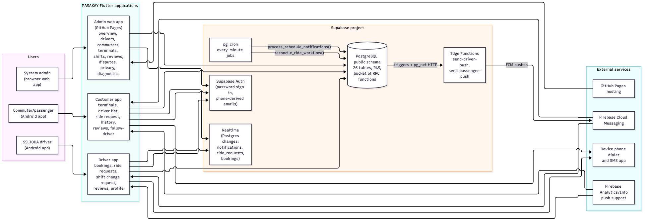
Figure 6. System context: every actor, application, service and one-way data flow (drilled-down version of Figure 1).
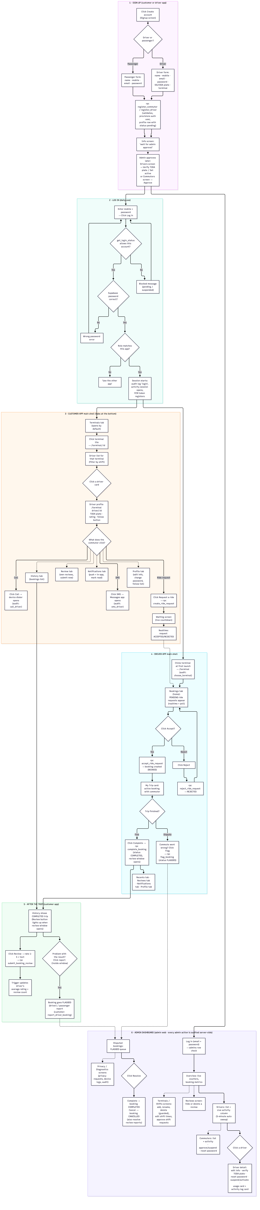
Figure 7. One-page end-to-end journey: what each of the three apps does, click by click.
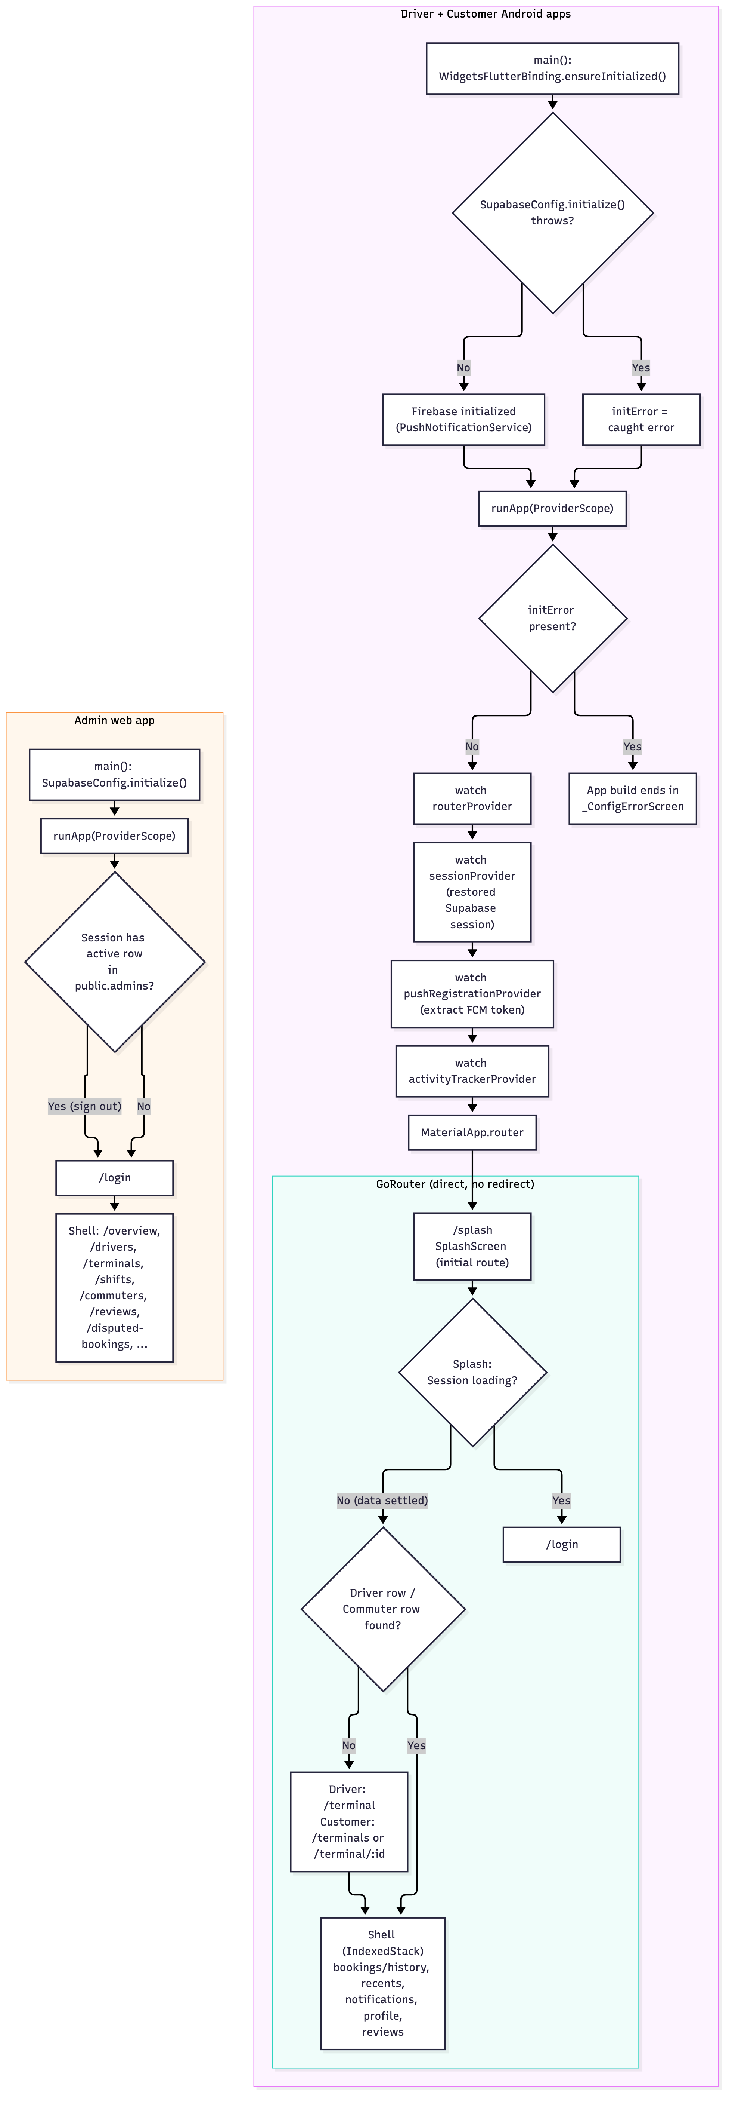
Figure 8. Application startup sequence for both mobile apps and the admin console.
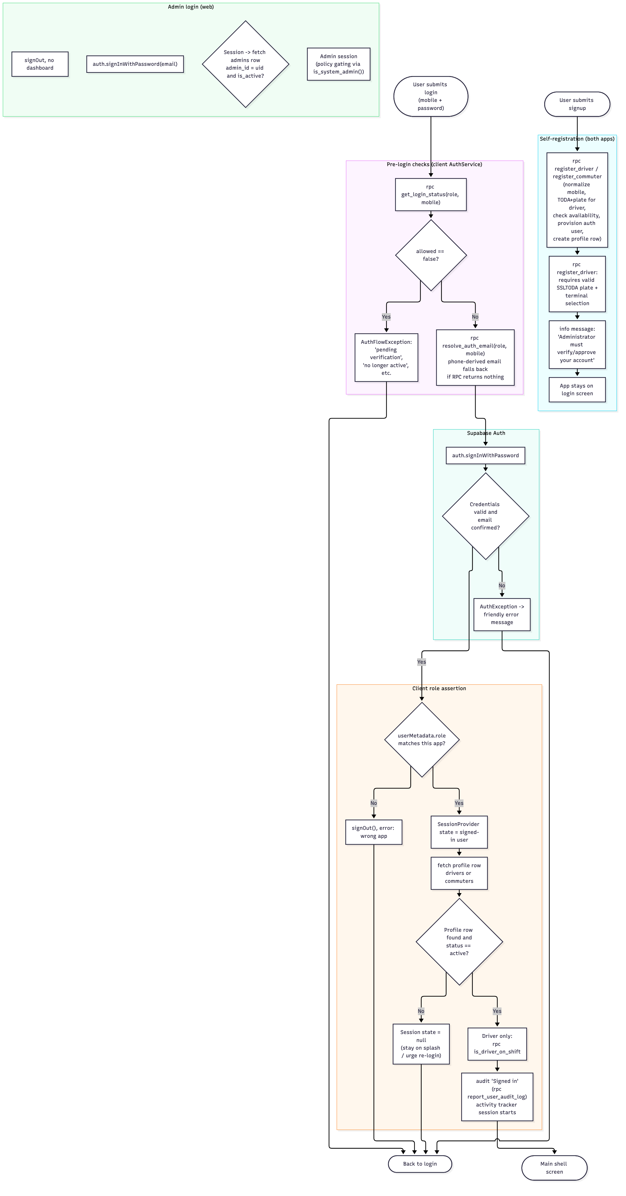
Figure 9. Authentication details: status pre-gate, mobile-to-email resolution, password check, role assertion.
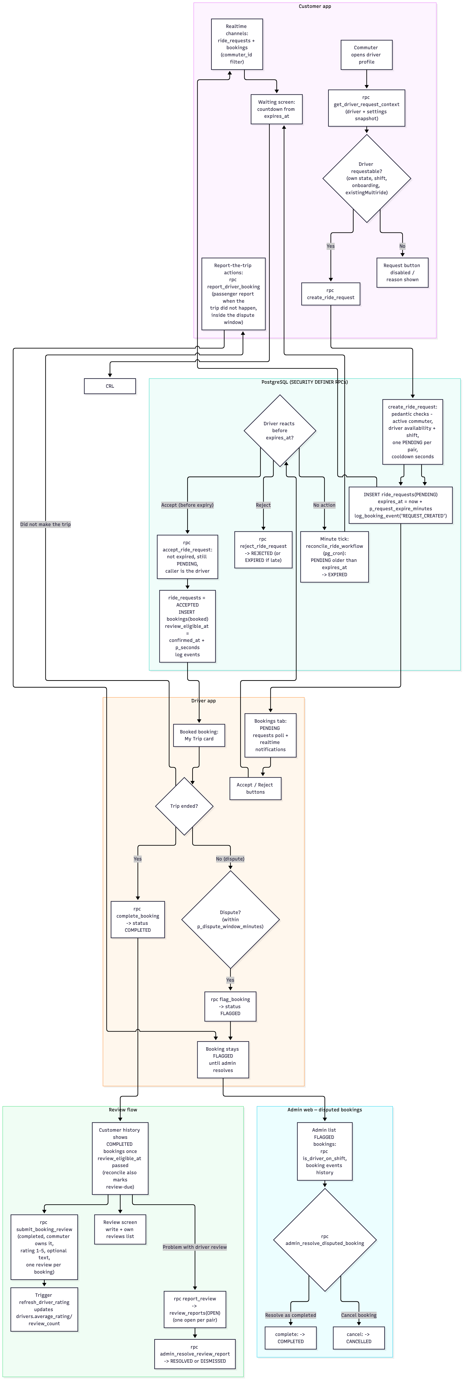
Figure 10. The ride/review/notification workflows with server-side decision points.
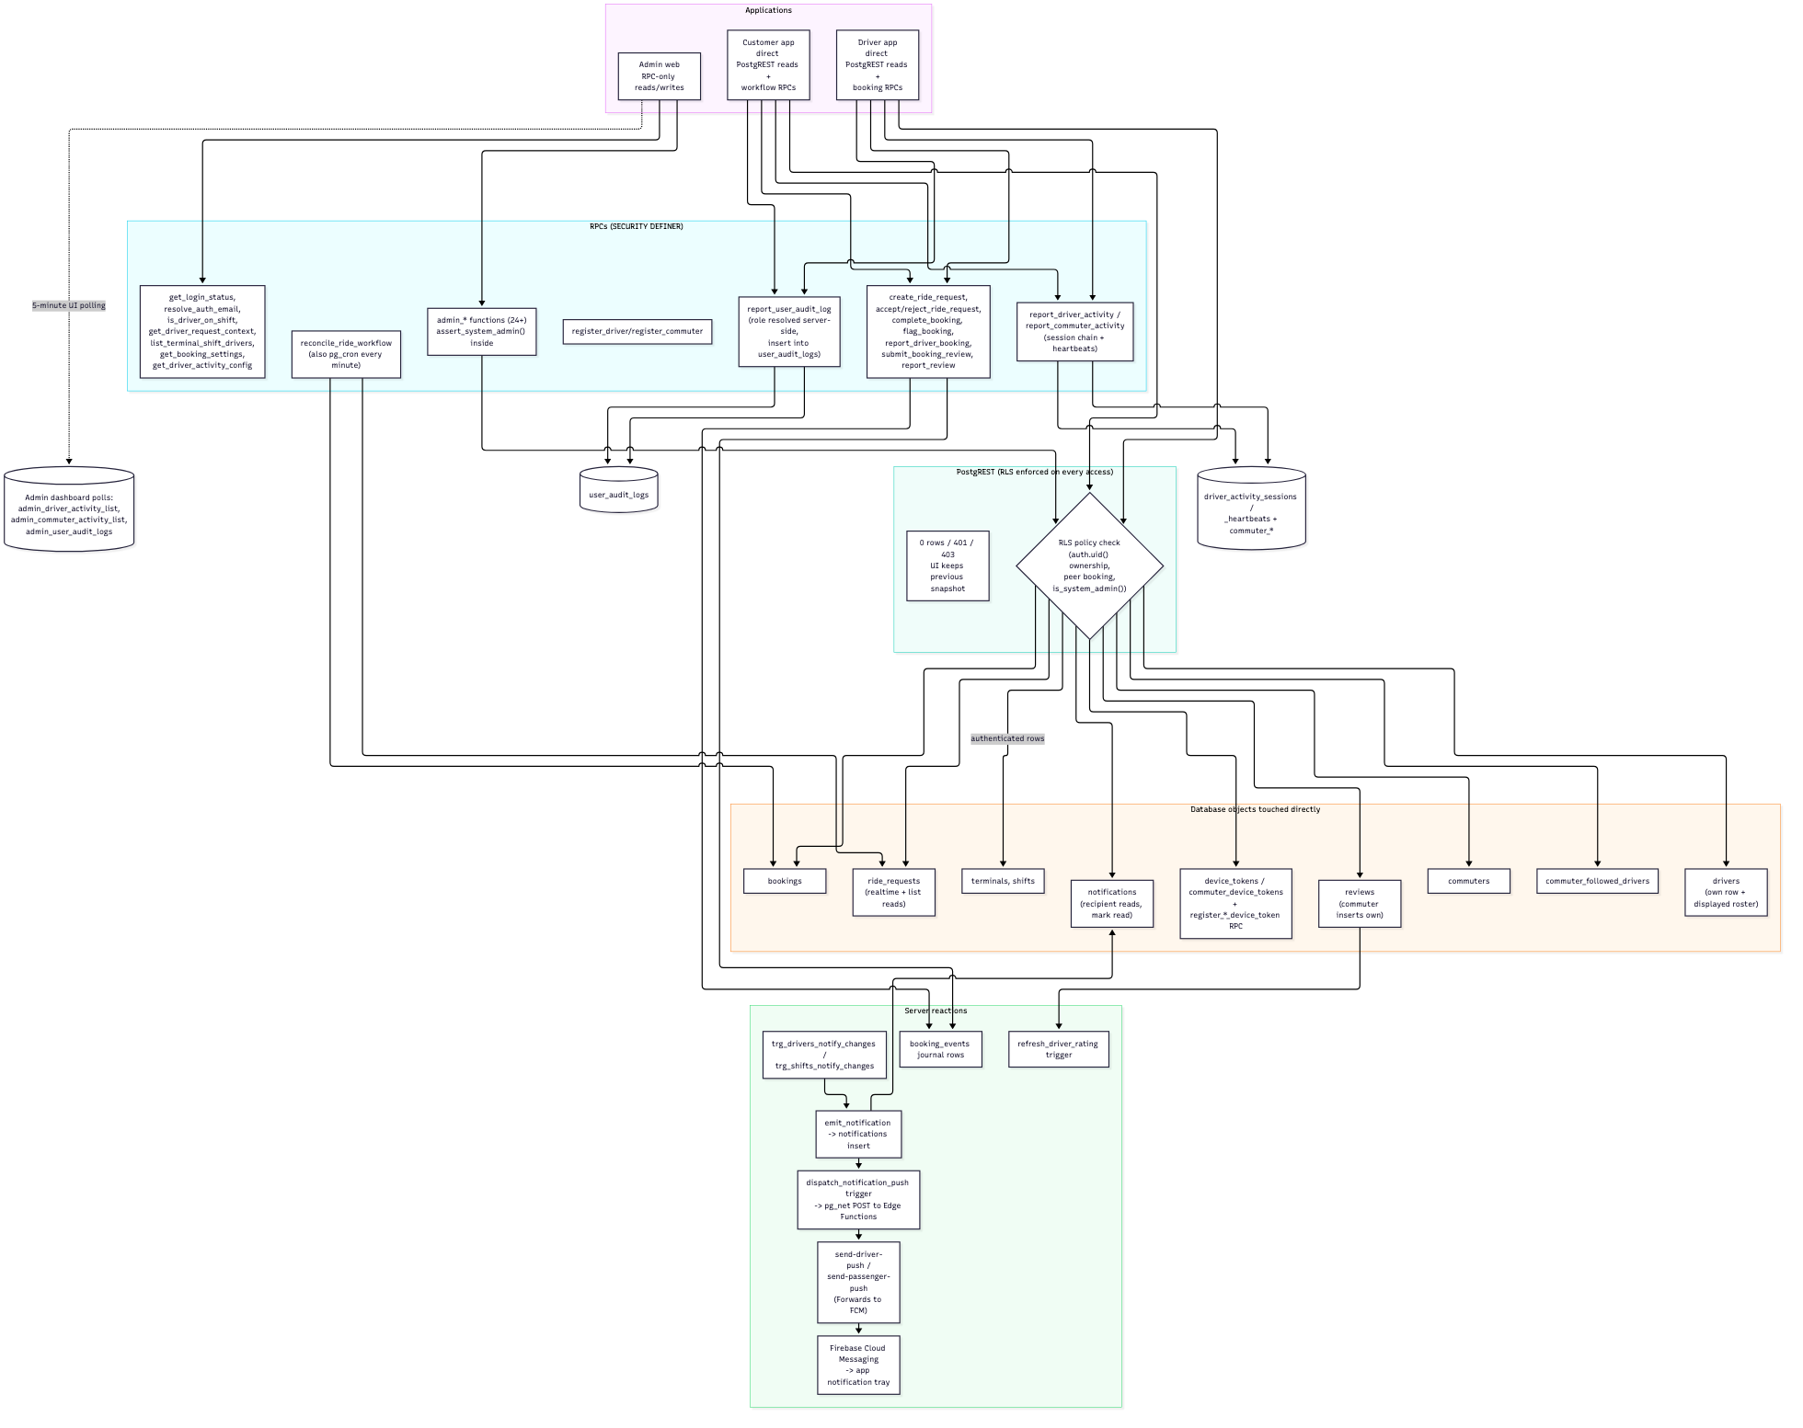
Figure 11. Which tables and functions each app reads and writes.
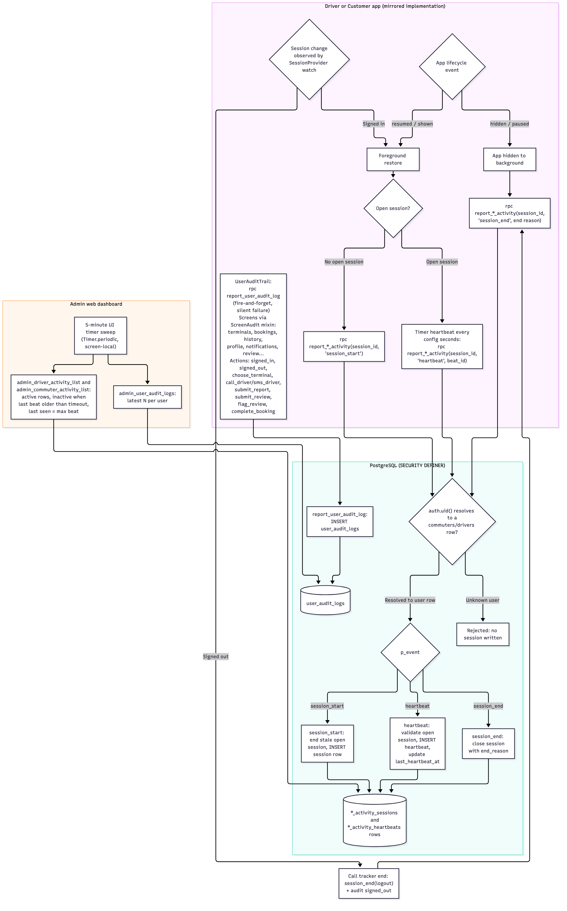
Figure 12. Foreground-activity sessions, heartbeats and the action audit trail.

Appendix B · Claim-to-evidence traceability map

Defense Documentation — Source Traceability
Each significant claim used anywhere in docs/defense/ maps to its evidence. Statuses: Verified (inspected code/schema/live DB), Inferred (indirect evidence), Unverified (no repository evidence). Line anchors are valid for commit 0df2a87 and may drift afterward.
# | Claim | Source file / object | Anchor | Status
1 | Three apps share one Supabase project | apps/*/lib/services/supabase_config.dart, apps/*/pubspec.yaml | supabase_flutter ^2.17.2 in all three | Verified
2 | Dependency list and versions | apps/{driver,customer,admin}/pubspec.yaml | environment.sdk ^3.13.2 + dep list | Verified
3 | Mobile login is mobile-number based | apps/{driver,customer}/lib/services/auth_service.dart | _resolveLoginEmail (driver L19-38, customer L18-42), signInWithPassword (driver L70, customer L77) | Verified
4 | Pre-login status gate | both auth_service.dart | _assertLoginAllowed (driver L42-60, customer L46-67), RPC get_login_status | Verified
5 | Role assertion on wrong app | auth_service.dart | _assertDriverRole L149-158, _assertCommuterRole L147-156 | Verified
6 | TODA plate replaces driver's license | 20261015000000_toda_plate_replaces_license.sql; live drivers.toda_number | RPC signature p_toda_number | Verified
7 | Driver requires verification to be active | 20260911000000_admin_system.sql; live drivers_active_requires_license | constraint definition | Verified
8 | Registration provisions auth user + profile + role | 20260915190000_signup_real_email_auth.sql; live trigger | on_auth_user_created_pasakay on auth.users → handle_pasakay_auth_user | Verified
9 | Signup validation (mobile, TODA plate) | apps/{driver,customer}/lib/core/utils/{phone_utils,auth_validators}.dart | tests in apps/driver/test/widget_test.dart | Verified
10 | Ride request validations + error strings | 20260915130000_ride_request_booking_flow.sql | create_ride_request L240, raises L266-299, accept_ride_request L341/L380-395/L398-401, reject_ride_request L445-479 | Verified
11 | Reconciliation cron every minute | live cron.job catalog | pasakay-reconcile-ride-workflow, * * * * * | Verified
12 | Reconciliation behavior (expire / auto-complete / review due) | 20260915130000... L145-215 | reconcile_ride_workflow body inspected | Verified (logic); no repo test exercises it at runtime
13 | One PENDING request per pair | live index ride_requests_one_pending_per_pair | WHERE status='PENDING' | Verified
14 | One review per booking | live index reviews_one_per_booking | WHERE booking_id IS NOT NULL | Verified
15 | Rating aggregation trigger | 20260915320000_driver_rating_aggregates.sql; live trigger | reviews_refresh_rating on reviews | Verified
16 | Anonymous-safe review display | 20260915310000_anonymous_driver_reviews.sql | select policy hides reviewer identity | Verified
17 | Bookings/requests visible to pair + admins | live policies | bookings_select_own, ride_requests_select_own | Verified
18 | Realtime channels in customer app | apps/customer/lib/services/customer_repository.dart | subscribeNotifications L172-190, subscribeRideRequestUpdates L192-218, subscribeBookingUpdates L220-246 | Verified
19 | Driver booking actions are RPCs | apps/driver/lib/services/driver_repository.dart | accept_ride_request L140, reject_ride_request L148, flag_booking L160, complete_booking L172 | Verified
20 | Commuter ride RPCs | apps/customer/lib/services/customer_repository.dart | create_ride_request L372, submit_booking_review L411, report_driver_booking L426, reconcile_ride_workflow L394 | Verified
21 | Contact passthrough (tel/sms) | apps/*/lib/core/utils/contact_launcher.dart + url_launcher | AuthService.openCall/openSms | Verified
22 | Follow / unfollow driver | customer_repository.dart L248-272 | commuter_followed_drivers | Verified
23 | Admin gate in every admin function | live function list; assert_system_admin / is_system_admin | inspected via live pg_proc + migration sources | Verified
24 | Admin driver CRUD / status / verify RPCs | apps/admin/lib/services/admin_repository.dart | call sites L225-532 | Verified
25 | Admin activity/audit lists + 5-minute sweep | admin_repository.dart L532/L562; apps/admin/lib/features/{drivers,commuters} screens | screen-local Timer.periodic | Verified
26 | Two admin screens exist but are not routed | apps/admin/lib/features/privacy/privacy_screen.dart, .../diagnostics/diagnostics_screen.dart, app_router.dart | no route or instantiation references | Verified (not wired)
27 | Privacy-request workflow backend | privacy_requests table, admin_log_privacy_request, admin_process_deletion | live schema + 20260911000000 header comment | Verified
28 | Foreground tracker architecture (both apps) | apps/driver/lib/services/driver_activity_tracker.dart, apps/customer/lib/services/commuter_activity_tracker.dart | AppLifecycleListener L37/L38, _startSession L102/L103, "don't resurrect" comment L116/L117, heartbeat timer L141-161 | Verified
29 | Audit trail subsystem | apps/{driver,customer}/lib/services/user_audit_trail.dart | report_user_audit_log L23, ScreenAudit mixin L43 | Verified
30 | A hostile client can skip audit logging | design of silent fire-and-forget logging | user_audit_trail.dart L17-40 | Inferred
31 | Privacy Policy discloses action logging | apps/{driver,customer}/lib/core/utils/legal_content.dart | "Records of in-app actions…" bullet | Verified
32 | Push chain endpoints | 20260915120000_notification_push_pg_net_trigger.sql | L39/L41 Edge Function URLs | Verified
33 | FCM token registration and storage | apps/{driver,customer}/lib/services/push_notification_service.dart; register_{driver,commuter}_device_token RPCs | token tables verified live | Verified
34 | Push actually delivered to devices | FCM projects + dashboard edge secrets | configuration outside the repository | Unverified
35 | 27 test cases, all passing on 2026-10-17 | 6 test files; executed locally in the development session | results documented in the session transcript; no artifact in the repo | Verified (execution)
36 | No integration/e2e/database test suites | find apps/*/test (7 files, all listed in 07) | repo inspection | Verified
37 | GitHub Actions only deploys admin web | .github/workflows/deploy-admin.yml | single workflow file | Verified
38 | Admin deploy injects env from repo secrets | same workflow | L26-36 .env write + --base-href build | Verified
39 | No secrets or personal data in the defense docs | docs/defense/* | reviewed contents | Verified
40 | Legal texts identical across the two mobile apps | apps/{driver,customer}/lib/core/utils/legal_content.dart | byte-identical copies maintained in session | Verified
41 | Commuter cannot cancel a pending request | RPC surface grep shows no client cancel call; CANCELLED status written only by admin action | absence-based | Inferred
42 | Recent contacts stay on the device | customer_repository.dart L116-136 | SharedPreferences only | Verified
43 | driver_shifts table access is dead code | apps/driver/lib/services/driver_repository.dart L61-78; no such table/view live | complete catalog listing | Verified
44 | No GPS/location usage | Android manifests, pubspec deps, Terms text | no location dependency anywhere | Verified
45 | Performance numbers / effectiveness outcomes | none | no such evidence exists in the repo | Unverified (claimed nowhere)

Companion documents
- ../system-analysis/TRACEABILITY.md — the deeper evidence map (36 refs,
26 tables, DB drill-down), cited throughout docs/defense/.
- ./database-erd.dbml — identical copy of
../system-analysis/database/schema.dbml, validated with @dbml/core (dbmlv2): 27 tables, 2 schemas parsed successfully.
- ../system-analysis/flowcharts/*.mmd — six validated diagrams plus
end-to-end-flow.mmd.

