# Features

1. Has a input for to create a new todo.
2. You can Create, Edit, and Delete todos.
3. Being able to give a title
4. Able to add tags, and assign color to tag
5. Drag and drop tags
   1. Being able to re-organize tags
   2. Drag and drop tag for deletion
6. Add ability to complete todo
   1. When todo in complete a line will stripe through text
7. When mouse hovers over todo red X should appear if clicked then you’ll be able to delete todo

# How should the app be designed?

The app will be a mobile first web app, then later on a react-native version will be built

# Things I need designed by a designer

* Logo, showing DONE but in a cute box.
* How will the Main home page look and some functionality of that
* Color scheme…

# List for all planned pages with some details about each

* Login page will have to do a signup page as well.
* Todo page creation page, with ability to click on todos on side to see full screen
* Graph page showing how many todos have been completed and how many todos you need to complete

# User story for logging in

1. When user navigates to the site?
   1. There should be a login portal, that asks for username/email and password.
   2. As well This app should give the ability to use 3rd party authentication
      1. GitHub
      2. Google
      3. Twitter
2. What should be a good template or feel for the login
   1. 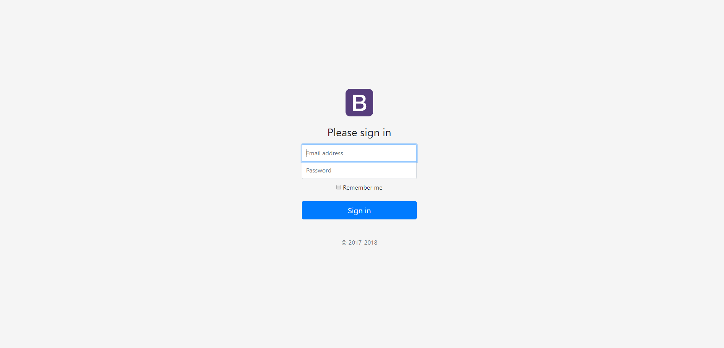Note I want to add the floated labels as well
   2. And the issue of adding 3rd party authentication, I will add that after I add a database with property entities.
   3. For design just add “login with GitHub” or any other 3rd party authentication as buttons below sign-in, as well I use the codewars login page as inspiration as well.

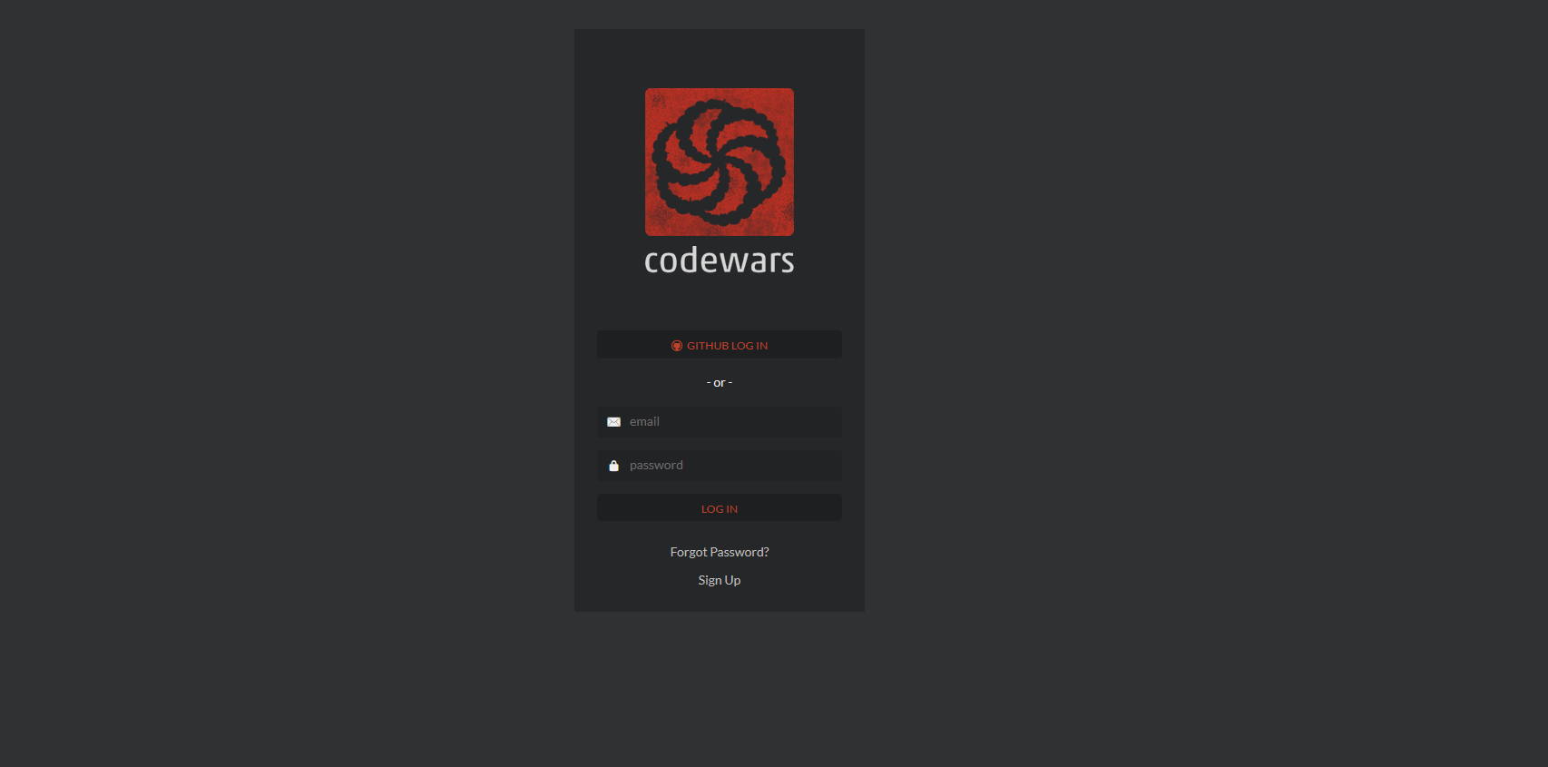

# User story for successful login what is the main home app look like?

Verbal description:

When the user logs in then, there should be a input box in the center, with a two sidebars outer most sidebar will have to do with settings profile etc.… and inner sidebar should have to do all todos and the ability drag and drop for manual deletion or drag/drop deletion, I’m thinking that my home page should be similar to Boostnote, and Cacher IO. But this app will be just todos. Chores schedules and such… What about a calendar? Maybe that could be some additional functionality later when the main part of the app is done.

Inspiration for Main page:

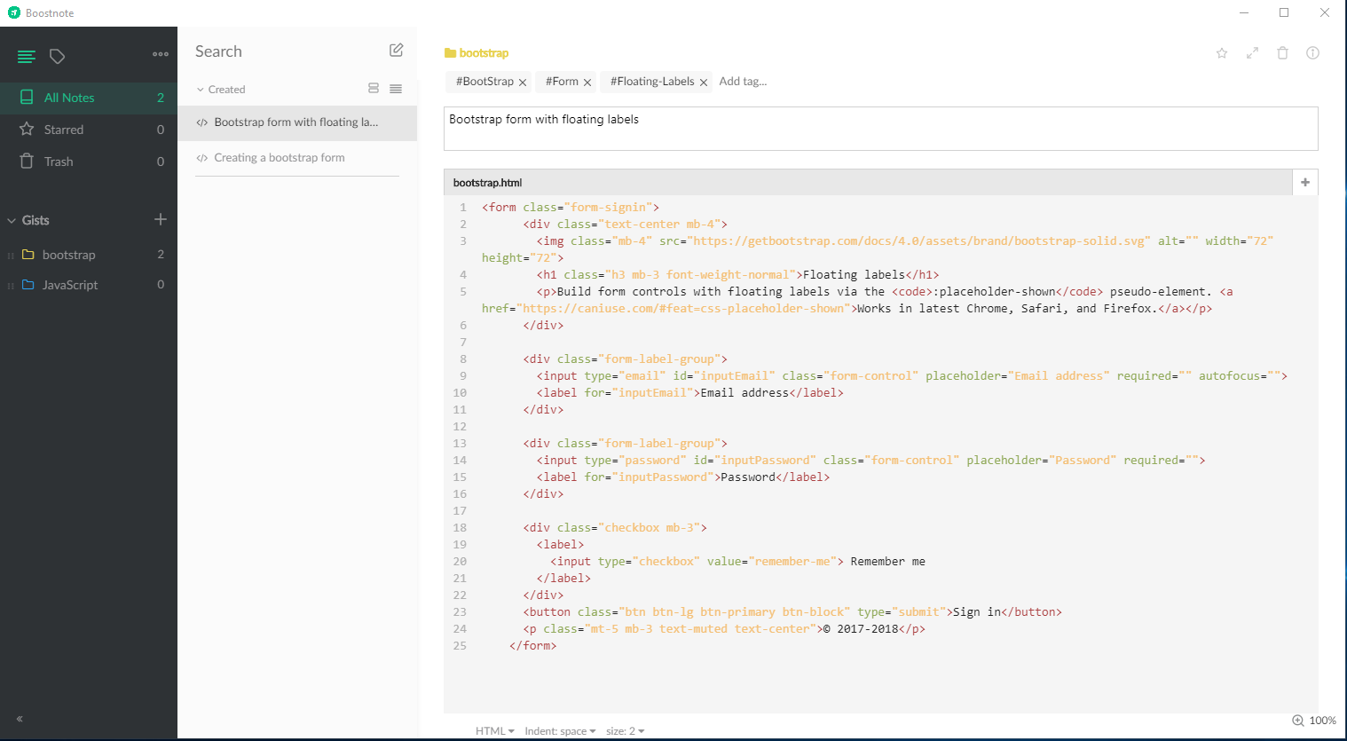

Inspiration for Board page:

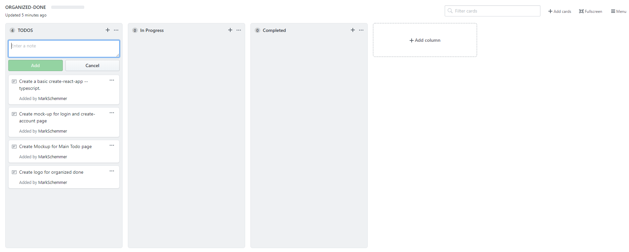

What is the color Scheme:

I’m thinking about using some sort of boot strappy theme such as GitHub uses

Green for success,

Blue sign in button

Red for Delete

Silver greyish background color

# Technology stack for this project

* React, axios, react-router-dom
* TypeScript, adding ability to write pure es6 in ts file as well.
* MongoDb
* Express
* Node
* Jest
* Enzyme
* Redux, redux-logger, redux-thunk
* BootStrap for styling might add scss as well.