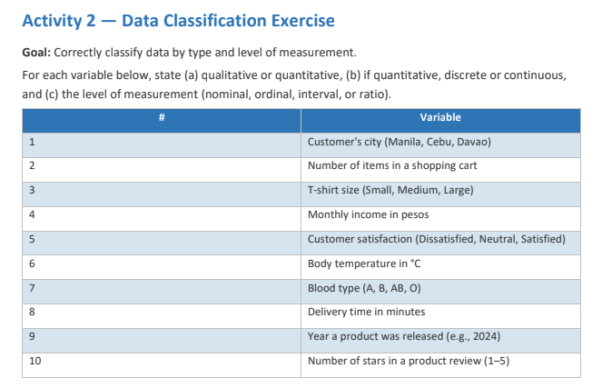

- Qualitative, nominal
- Quantitative, Discrete, ratio
- Qualitative, Ordinal
- Quantitative, Continuous, ordinal
- Qualitative, Ordinal
- Quantitative, Continuous, interval
- Qualitative, ordinal
- Quantitative, Discrete, Ratio
- Qualitative, Ratio
- Quantitative, Continuous, Ratio

