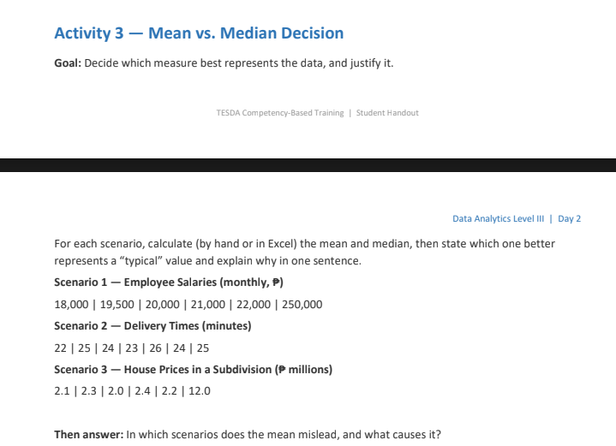
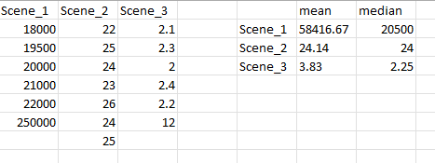
Scenario 1 & 2 represents a better “Typical” value compare to Scenario 3.
Scenario 3 misleads its mean variance, cause is we intentionally inputted a higher variable from these lower dataset variables given; that leads as to “why does the mean is equivalent to 3.83?”, is what I guess.

