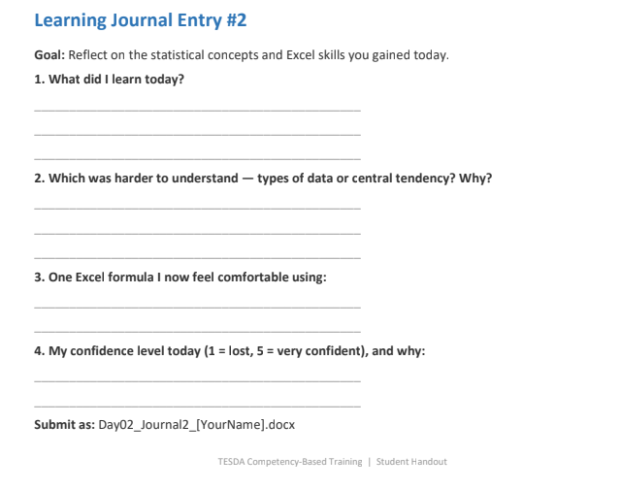
- We were taught about the basics of excel and statistical concepts, how to easily calculate and select rows in three commands is a very helpful way to make things easier when handling large data sets.
- For this, I don’t know. But I guess what’s hard for me is when we will tackle the SQL integration and Python API, I do have a few backgrounds in Python in coding though for automation purpose and else. As a game developer, using python for API JSON server purpose via renderer for practice is pretty much of a game changer.
- All of it. Am a li’l advanced and going back to basics is the most intriguing part. Never forget the basics indeed.
- 4.5; It’s because of the cold atmosphere I guess? Might as well get myself a jacket the next class.

