Day 5 SQL Practice Exercises - Answers and Outputs

Exercise 1 - INSERT INTO

Query:
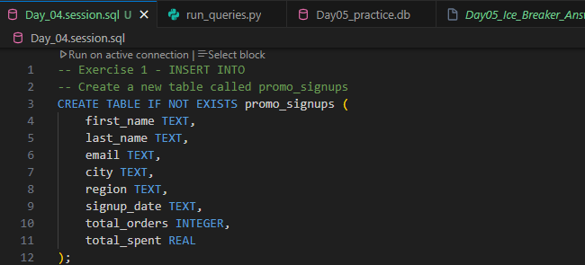

Result:
*(Query executed successfully. -1 rows affected)*

Query:
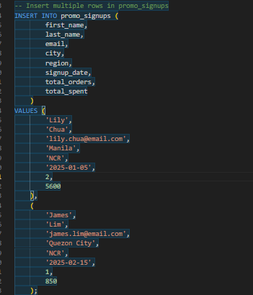

Result:
*(Query executed successfully. 2 rows affected)*

Query:

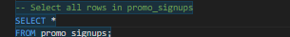

Result:
first_name | last_name | email | city | region | signup_date | total_orders | total_spent
Lily | Chua | lily.chua@email.com | Manila | NCR | 2025-01-05 | 2 | 5600.0
James | Lim | james.lim@email.com | Quezon City | NCR | 2025-02-15 | 1 | 850.0
Lily | Chua | lily.chua@email.com | Manila | NCR | 2025-01-05 | 2 | 5600.0
James | Lim | james.lim@email.com | Quezon City | NCR | 2025-02-15 | 1 | 850.0

Exercise 2 - WHERE (AND / OR / IN)

Query:

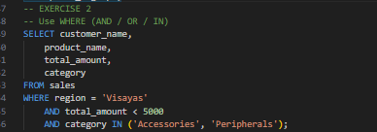

Result:
customer_name | product_name | total_amount | category
Juan Dela Cruz | Laptop Stand | 1500.0 | Accessories
Christine Go | Mouse Pad XL | 1350.0 | Accessories
Christine Go | Webcam HD | 1800.0 | Accessories
Kenneth Sy | Keyboard Mechanical | 2500.0 | Accessories
Miguel Torres | Mouse Pad XL | 900.0 | Accessories
Daniel Tan | Webcam HD | 3600.0 | Accessories

Exercise 3 - BETWEEN / date ranges

Query:

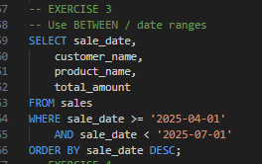

Result:
sale_date | customer_name | product_name | total_amount
2025-06-20 | Roberto Flores | Headset HyperX | 7600.0
2025-06-15 | Angela Rivera | USB Flash Drive 64GB | 3800.0
2025-06-10 | Daniel Tan | Laptop Lenovo | 35000.0
2025-06-05 | Patricia Lim | Wireless Mouse | 2550.0
2025-06-01 | Rafael Aquino | Tablet Samsung | 18000.0
2025-05-20 | Isabella Cruz | Mouse Pad XL | 1800.0
2025-05-15 | Miguel Torres | SD Card 128GB | 1360.0
2025-05-10 | Sofia Mendoza | Printer Canon | 8500.0
2025-05-05 | Carlos Garcia | USB-C Hub | 1200.0
2025-05-01 | Ana Reyes | Laptop Stand | 3000.0
2025-04-20 | Juan Dela Cruz | External SSD 500GB | 3200.0
2025-04-15 | Maria Santos | Headset HyperX | 3800.0
2025-04-10 | Patrick Ong | Monitor 24-inch | 25000.0
2025-04-05 | Nicole Ramos | Webcam HD | 1800.0
2025-04-01 | Leo Pascual | Desktop PC Ryzen 5 | 42000.0

Exercise 4 - IN / NOT IN

Query:

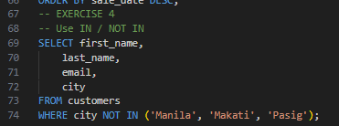

Result:
first_name | last_name | email | city
Juan | Dela Cruz | juan.delacruz@email.com | Cebu City
Ana | Reyes | ana.reyes@email.com | Davao City
Sofia | Mendoza | sofia.mendoza@email.com | Quezon City
Miguel | Torres | miguel.torres@email.com | Cebu City
Rafael | Aquino | rafael.aquino@email.com | Davao City
Daniel | Tan | daniel.tan@email.com | Iloilo City
Christine | Go | christine.go@email.com | Cebu City
Marco | Villanueva | marco.villanueva@email.com | Quezon City
Kenneth | Sy | kenneth.sy@email.com | Cebu City
Grace | Domingo | grace.domingo@email.com | Davao City
Leo | Pascual | leo.pascual@email.com | Quezon City
Nicole | Ramos | nicole.ramos@email.com | Cagayan de Oro

Exercise 5 - LIKE

Query:

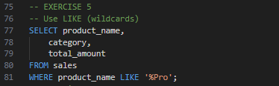

Result:
*No rows returned.*

Exercise 6 - ORDER BY and LIMIT

Query:

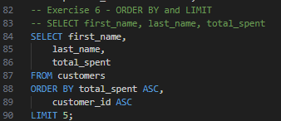

Result:
first_name | last_name | total_spent
Christine | Go | 4050.0
Nicole | Ramos | 4200.0
Joy | Bautista | 5850.0
Angela | Rivera | 16100.0
Sofia | Mendoza | 16750.0

Exercise 7 - GROUP BY

Query:

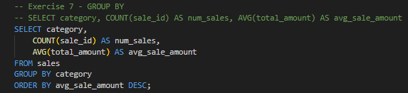

Result:
category | num_sales | avg_sale_amount
Electronics | 16 | 24718.75
Storage | 10 | 3292.0
Accessories | 24 | 2660.4166666666665

Exercise 8 - HAVING

Query:

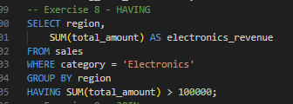

Result:
region | electronics_revenue
NCR | 251500.0
Visayas | 113500.0

Exercise 9 - JOIN

Query:

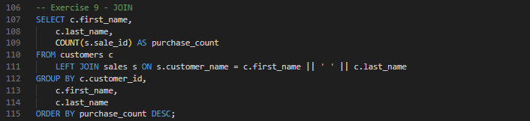

Result:
first_name | last_name | purchase_count
Maria | Santos | 3
Juan | Dela Cruz | 3
Ana | Reyes | 3
Carlos | Garcia | 3
Sofia | Mendoza | 3
Miguel | Torres | 3
Isabella | Cruz | 3
Rafael | Aquino | 3
Patricia | Lim | 3
Daniel | Tan | 3
Angela | Rivera | 2
Roberto | Flores | 2
Christine | Go | 2
Marco | Villanueva | 2
Joy | Bautista | 2
Kenneth | Sy | 2
Grace | Domingo | 2
Leo | Pascual | 2
Nicole | Ramos | 2
Patrick | Ong | 2

Exercise 10 - CASE WHEN

Query:

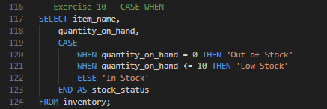

Result:
item_name | quantity_on_hand | stock_status
Wireless Mouse Logitech | 120 | In Stock
Laptop Lenovo IdeaPad | 15 | In Stock
USB-C Hub 7-in-1 | 80 | In Stock
Monitor 24-inch LG | 8 | Low Stock
Mechanical Keyboard RGB | 45 | In Stock
Webcam HD 1080p | 35 | In Stock
Printer Canon Inkjet | 5 | Low Stock
External SSD 500GB | 22 | In Stock
Headset HyperX Cloud | 18 | In Stock
Tablet Samsung Galaxy | 3 | Low Stock
Mouse Pad XL | 200 | In Stock
USB Flash Drive 64GB | 150 | In Stock
Laptop Stand Aluminum | 30 | In Stock
SD Card 128GB | 60 | In Stock
Desktop PC Ryzen 5 | 2 | Low Stock
Bluetooth Speaker JBL | 25 | In Stock
Portable Charger 20000mAh | 55 | In Stock
HDMI Cable 2m | 90 | In Stock
Webcam Stand Adjustable | 40 | In Stock
External HDD 1TB | 12 | In Stock
Laptop Bag 15-inch | 70 | In Stock
Monitor Arm Single | 10 | Low Stock
Ethernet Cable 5m | 100 | In Stock
Docking Station USB-C | 7 | Low Stock
Surge Protector 6-outlet | 45 | In Stock

Exercise 11 - COALESCE

Query:

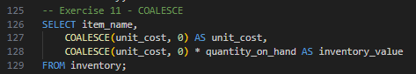

Result:
item_name | unit_cost | inventory_value
Wireless Mouse Logitech | 550.0 | 66000.0
Laptop Lenovo IdeaPad | 30800.000000000004 | 462000.00000000006
USB-C Hub 7-in-1 | 750.0 | 60000.0
Monitor 24-inch LG | 9500.0 | 76000.0
Mechanical Keyboard RGB | 1800.0 | 81000.0
Webcam HD 1080p | 1200.0 | 42000.0
Printer Canon Inkjet | 6500.0 | 32500.0
External SSD 500GB | 2400.0 | 52800.0
Headset HyperX Cloud | 2800.0 | 50400.0
Tablet Samsung Galaxy | 15400.000000000002 | 46200.00000000001
Mouse Pad XL | 280.0 | 56000.0
USB Flash Drive 64GB | 220.0 | 33000.0
Laptop Stand Aluminum | 950.0 | 28500.0
SD Card 128GB | 420.0 | 25200.0
Desktop PC Ryzen 5 | 37400.0 | 74800.0
Bluetooth Speaker JBL | 2200.0 | 55000.0
Portable Charger 20000mAh | 980.0 | 53900.0
HDMI Cable 2m | 350.0 | 31500.0
Webcam Stand Adjustable | 650.0 | 26000.0
External HDD 1TB | 2800.0 | 33600.0
Laptop Bag 15-inch | 850.0 | 59500.0
Monitor Arm Single | 1500.0 | 15000.0
Ethernet Cable 5m | 180.0 | 18000.0
Docking Station USB-C | 4500.0 | 31500.0
Surge Protector 6-outlet | 650.0 | 29250.0

Exercise 12 - UPDATE / DELETE

Query:

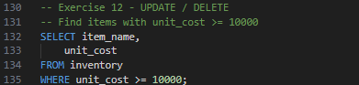

Result:
item_name | unit_cost
Laptop Lenovo IdeaPad | 30800.000000000004
Tablet Samsung Galaxy | 15400.000000000002
Desktop PC Ryzen 5 | 37400.0

Query:
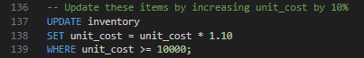
*(Query executed successfully. 3 rows affected)*

Query:

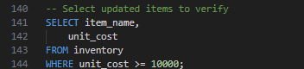

Result:
item_name | unit_cost
Laptop Lenovo IdeaPad | 33880.00000000001
Tablet Samsung Galaxy | 16940.000000000004
Desktop PC Ryzen 5 | 41140.0

Exercise 13 - ALTER TABLE

Query:
**Error executing query:** duplicate column name: membership_tier

Query:

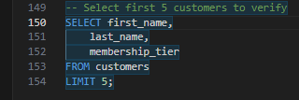

Result:
first_name | last_name | membership_tier
Maria | Santos | Standard
Juan | Dela Cruz | Standard
Ana | Reyes | Standard
Carlos | Garcia | Standard
Sofia | Mendoza | Standard

