Day 6 Activity 2 - Your First Queries
Name: Mark Jhon Angelo Cruz

9. Show ALL columns and rows of the employees table. How many rows are there?

Query:
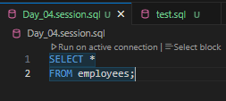

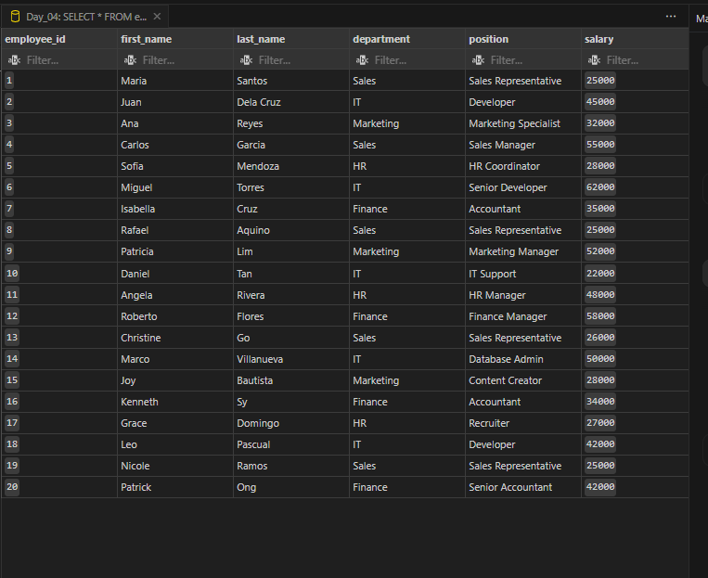

10. Show only first_name, last_name, and department for all employees.

Query:

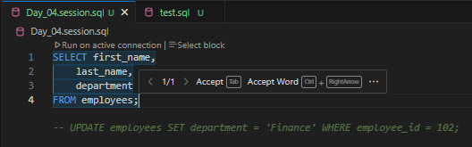
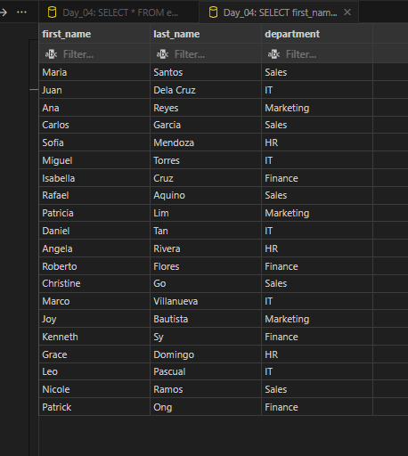

11. Show only product_name and price for all products.

Query:

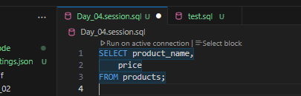
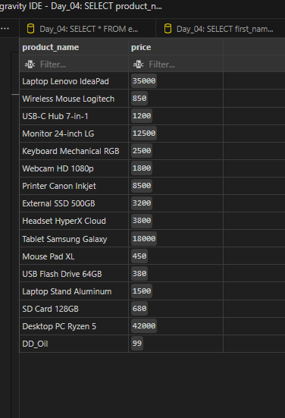

12. Which employees work in Manila? (Show first_name, last_name, city.) How many are there?

Query:

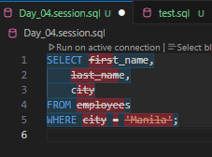
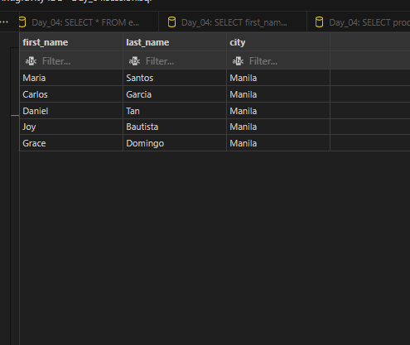

13. Which employees earn MORE than P40,000? (Show first_name and salary.) How many?

Query:

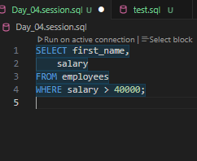

Result:
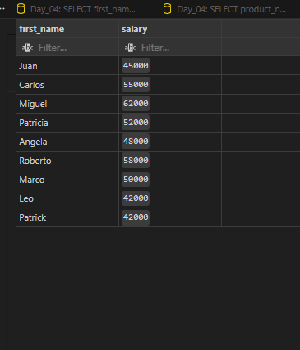

14. List everyone in the IT department. (Show first_name and position.)

Query:

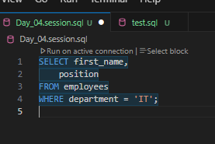

Result:
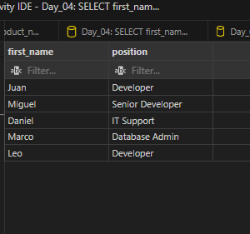

15. Which products cost P1,000 or LESS? (Show product_name and price.)

Query:

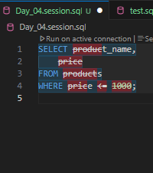
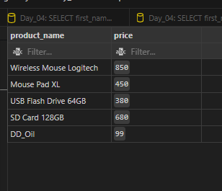

16. Which products have FEWER than 10 units in stock? (Show product_name and stock_qty.)

Query:

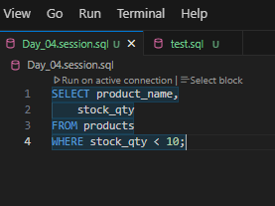
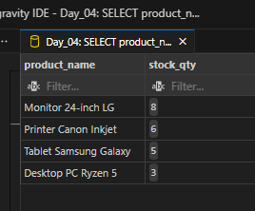

17. count how many employees do NOT work in Makati.

Query:

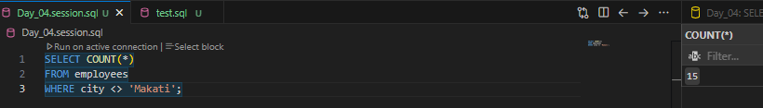

18. Managers earn P50,000 or more in this company. Write ONE query that shows first_name, last_name, and salary of everyone earning at least P50,000.

Query:

