Assignment Description:

* Every student will first identify their main computing environment i.e. Windows or MacOS or *nix, and so on.
* Students can then discover all forms of access control systems on their main computing environment. The discovery must be documented with screenshots.
* Students then categorize the discovered access control systems into DAC, MAC, RBAC, or other access control models.
* Finally, students will evaluate the discovered access control systems from the lens of a malicious agent. That is, the evaluation should try to identify any weaknesses in the access control options.

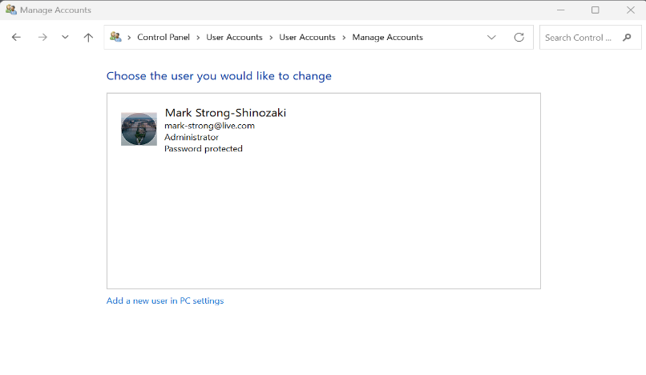User Account Control (UAC)

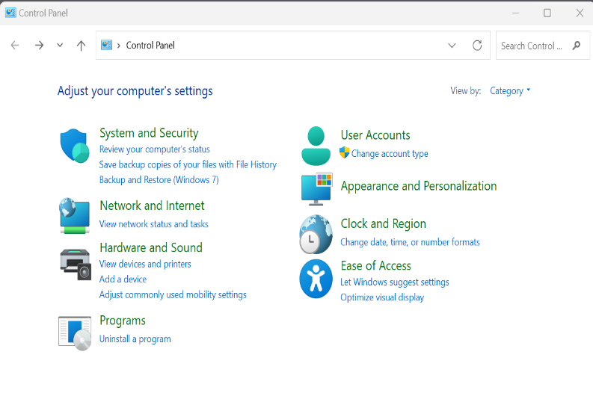

User Account Control (UAC):

* Access Control System: DAC (Discretionary Access Control)
* Description UAC is primarily a DAC mechanism. It allows or restricts actions based on the discretion of the user or administrator. It prompts users for consent or admin credentials to perform certain actions, giving them discretionary control.

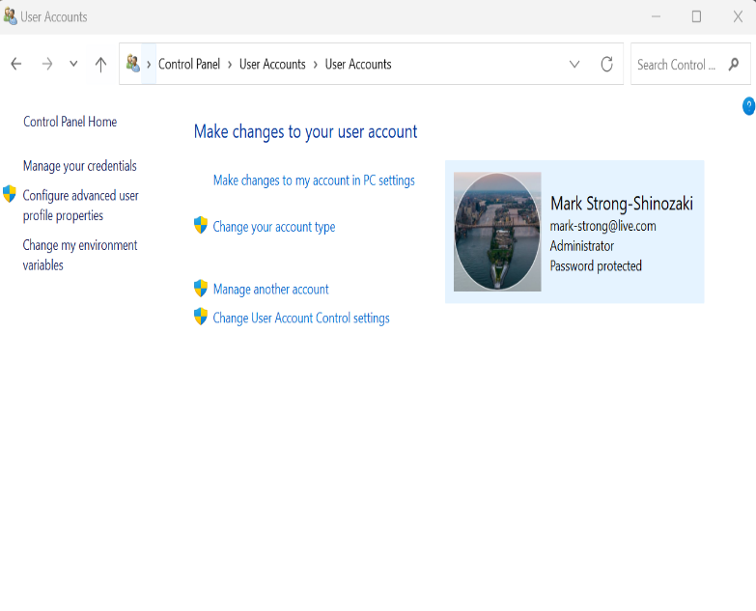

NTFS Permissions

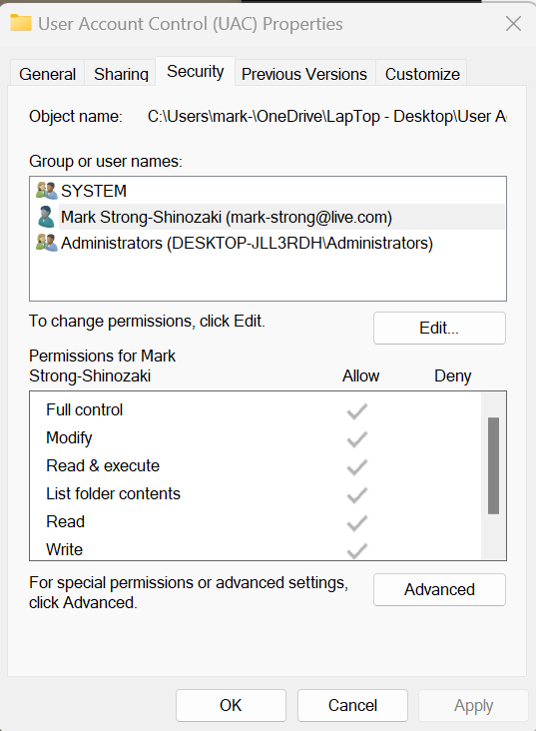

NTFS Permissions :

* Access Control System: DAC (Discretionary Access Control)
* NTFS permissions grant or deny access to files and folders based on the discretion of the owner or administrators. Users with appropriate permissions can modify access to resources.

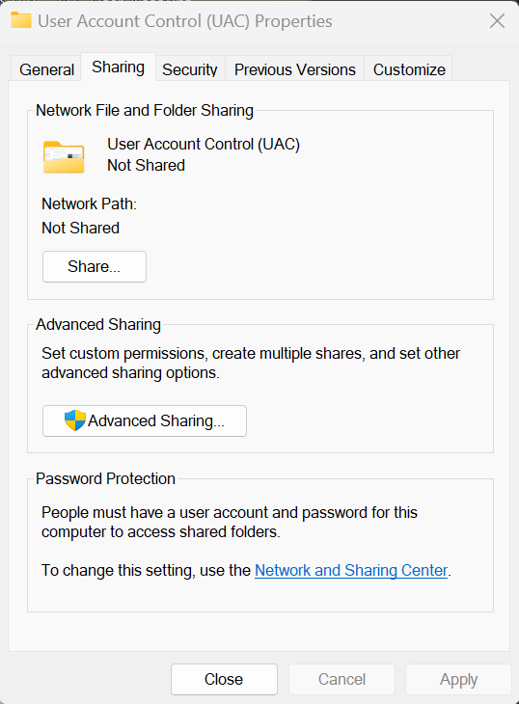Share Permissions

Share Permissions :

* Access Control System: DAC (Discretionary Access Control)
* Share Permissions control access to shared resources, such as folders, on a network. Like NTFS permissions, share permissions are based on the discretion of the resource owner or administrators

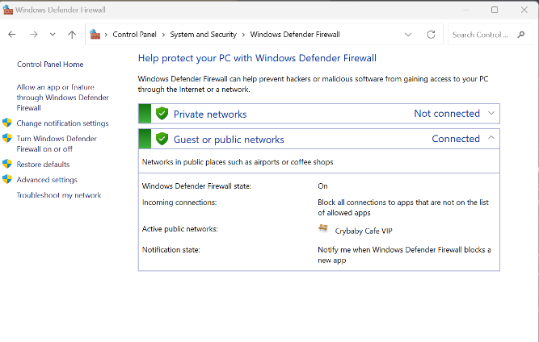Windows Firewall

Windows Firewall:

* Access Control System: RBAC (Role-Based Access Control)
* The Windows Firewall allows or blocks network traffic based on rules set by the user of administrator. This control is discretionary because its based on the choices made by the system administrator.

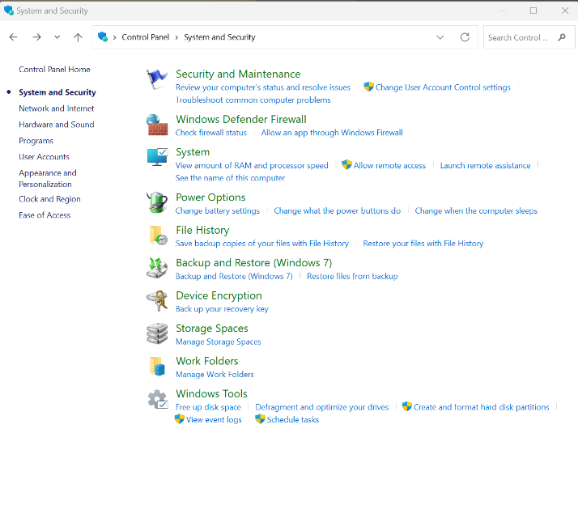

User Right Assignments

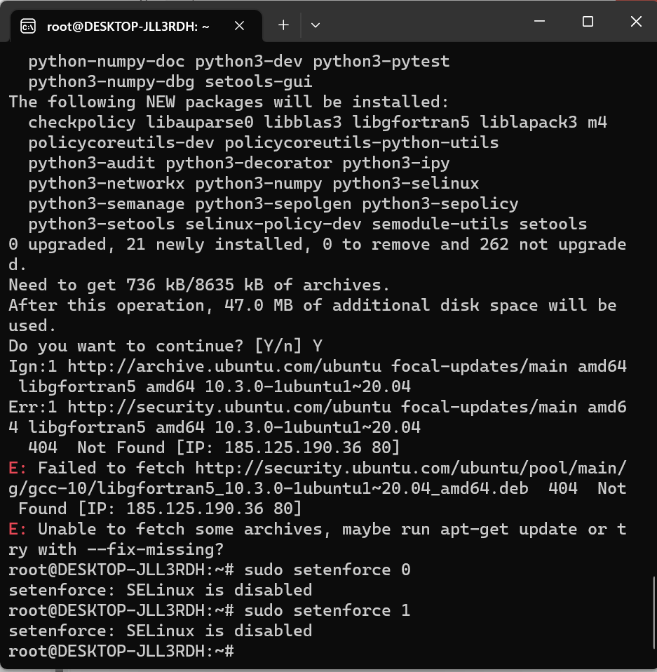

Windows Firewall:

* Access Control System: MAC (Mandatory Access Control)
* MAC is a more complex access control model commonly associated with high-security environments. In the example on the left, I tried to set up or config SELinux.