ENGINEERING VALIDATION REPORT

PocketLab DMM Resistance Measurement Proof of Concept
  - ADS1220 breadboard validation and provisional Rev A switching architecture
Project: PocketLab modular test platform
Test platform: ESP32 NodeMCU-32S + genuine ADS1220IPWR on a breadboard breakout
Report date: August 8, 2026
Status: Proof of concept successful; final parts and protection network pending schematic review

Executive conclusion
Outcome: The tested resistance architectures provide credible overlapping coverage from continuity/near-zero resistance through approximately 10 MΩ. The genuine ADS1220 successfully supported both IDAC-based ratiometric measurements and a separate supply-ratiometric voltage-divider method.

The breadboard work was intentionally architectural, not a final accuracy qualification. One-percent resistors, jumper/contact resistance, solderless-breadboard leakage, and unguarded high-impedance nodes dominate several observed errors. Those limitations do not invalidate the topology; they define what the first precision PCB must improve.

1. Test platform and common settings
Item | Bench configuration
ADC | ADS1220IPWR, 24-bit delta-sigma ADC, TSSOP-16
Controller | ESP32 NodeMCU-32S
Supplies | 3.3 V analog and digital rails; common analog/digital ground on breadboard
SPI | Mode 1 (CPOL=0, CPHA=1), 1 MHz
Conversion | 20 SPS, normal mode, continuous conversion; typically 10 samples/report
Serial interface | 115200 baud; configurable divider firmware supports rref, samples, interval, predict, start/stop, once, status, regs, and adcreset
Safety state | Unprotected bench circuit. Tests used only unpowered resistors and discharged components.

2. Pin assignments

ADS1220IPWR TSSOP-16 and ESP32 wiring
Pin | ADS1220 signal | Bench connection | Function
1 | SCLK | ESP32 GPIO 18 | SPI clock
2 | CS | ESP32 GPIO 27 | Active-low chip select
3 | CLK | DGND | Internal oscillator used
4 | DGND | Ground | Digital ground
5 | AVSS | Ground | Analog ground
6 | AIN3 / REFN1 | Unused | Reserve/test point on PCB
7 | AIN2 | IDAC Node A | IDAC1 injection point in ratiometric ohms mode
8 | REFN0 | AGND | External reference low
9 | REFP0 | Rref top / 3.3 V | Rref node in IDAC mode; excitation rail in divider mode
10 | AIN1 | Node B / AGND | Negative ADC input; grounded in divider mode
11 | AIN0 / REFP1 | Node A / divider junction | Positive ADC input
12 | AVDD | 3.3 V | 100 nF or larger to AVSS
13 | DVDD | 3.3 V | 100 nF or larger to DGND
14 | DRDY | ESP32 GPIO 26 | Dedicated data-ready, active low
15 | DOUT / DRDY | ESP32 GPIO 19 | SPI MISO
16 | DIN | ESP32 GPIO 23 | SPI MOSI

Pin numbers above are for the PW (TSSOP-16) package used in the breadboard build. Any adapter/header numbering should be checked against the adapter schematic before PCB capture.

3. Tested resistance configurations

A. IDAC verification with 9.99 kΩ reference
Purpose: verify that the genuine ADS1220 correctly produces its low excitation-current settings before relying on ratiometric resistance measurements. IDAC1 was routed directly to REFP0 with 9.99 kΩ from REFP0 to REFN0/AGND. The 10 µA, 50 µA, and 100 µA settings correspond to nominal reference voltages of 0.0999 V, 0.4995 V, and 0.9990 V.
Interpretation: The genuine ADS1220 corrected the abnormal 10 µA behavior seen on the earlier third-party module, clearing the internal IDAC for continued range development.

B. IDAC/ratiometric resistance mode
Wiring and equation:
Node/path | Connection
Node A | AIN2 (IDAC1 output) tied to AIN0; Rx connects from Node A to Node B
Node B | AIN1 tied to REFP0; Rref connects from Node B to REFN0/AGND
Measurement | ADC measures AIN0 − AIN1 while REFP0 − REFN0 is the external reference
Equation | Rx = (ADC code / 2²³) × Rref / PGA gain

Because the same IDAC current passes through Rx and Rref, absolute IDAC-current error largely cancels. Tested range configurations included 21.6 kΩ / 50 µA and 100.6 kΩ / 10 µA. The latter used registers 00 04 41 60 at gain 1 and was exercised across the resistor set below.
Comparison value | ADS1220 mean | Approx. FS use | Observation
99.8 Ω | 100.940 Ω | 0.100% | Low ADC utilization; lead/contact/offset effects dominate
1.003 kΩ | 1.005676 kΩ | 1.000% | After subtracting the same-setup short mean, result was approximately 1.0028 kΩ
4.74 kΩ | 4.752627 kΩ | 4.724% | Stable proof-of-concept response
9.90 kΩ | 9.897055 kΩ | 9.838% | Close agreement at gain 1
21.49 kΩ | 21.475935 kΩ | 21.348% | Stable midrange response

The gain-1 short averaged 2.876 Ω with 0.160 Ω batch-to-batch standard deviation. That offset is not a universal correction; it changes with gain, switch path, probes, and physical connections. Low-ohm production measurements therefore require per-range zeroing and automatic PGA selection. True sub-ohm accuracy would require a later Kelvin/four-wire mode.

C. 1.000 MΩ supply-ratiometric divider mode
Connection/setting | Divider-mode assignment
AIN0 (pin 11) | Junction of 1.000 MΩ reference and Rx
AIN1 (pin 10) | AGND
REFP0 (pin 9) | Same 3.3 V excitation rail feeding Rref
REFN0 (pin 8) | AGND
IDACs | Disabled
Registers | 01 04 40 00: AIN0−AIN1, gain 1, PGA bypassed, external REFP0/REFN0
Equation | k = ADC code / 2²³; Rx = Rref × k / (1 − k)

Fluke reading | ADS1220 mean | Difference | Divider ratio | Interpretation
100.6 kΩ | 100.0879 kΩ | −0.51% | 9.10% | Clean lower overlap with IDAC ranges
467 kΩ | 462.628 kΩ | −0.94% | 31.63% | Stable mid-divider result; modest upward settling drift
9.80 MΩ | 9.6159 MΩ | −1.88% | 90.58% | Successful multi-megaohm measurement; leakage and near-full-scale sensitivity visible

The increasing negative error with resistance is consistent with leakage becoming more influential, while the nominal 1 MΩ reference value, Fluke uncertainty, ADC input current, and breadboard contamination also contribute. The 9.80 MΩ reading operated near 91% of ADC full scale, making the calculated resistance highly sensitive to small ratio errors. A 10 MΩ reference is therefore recommended for the upper range.

4. Coverage demonstrated and proposed range map
Target region | Method | Provisional configuration | Evidence/status
Continuity to ~1 kΩ | IDAC, ratiometric | 10 kΩ precision Rref; ~100 µA; higher PGA gain | Partially demonstrated; low-ohm accuracy needs zeroing and gain
~1 kΩ to 10 kΩ | IDAC, ratiometric | 10 kΩ precision Rref; 100 µA; auto gain | Topology and excitation verified
~10 kΩ to 100 kΩ | IDAC, ratiometric | 100 kΩ precision Rref; 10 µA | Validated from 100 Ω through 21.49 kΩ; electrical headroom supports extension
~100 kΩ to 3–5 MΩ | Voltage divider, ratiometric | 1 MΩ precision Rref; 3.3 V excitation/reference | Validated at ~100 kΩ and 467 kΩ; 10 MΩ measurement also succeeded with reduced accuracy
~3 MΩ to 20 MΩ+ | Voltage divider, ratiometric | 10 MΩ precision Rref; guarded high-Z path | Recommended next range; not yet tested

Range policy: Use overlapping ranges and autorange toward the center of ADC span. Avoid relying on results below roughly 1% or above roughly 90% of full scale when a neighboring range is available.

5. Provisional Rev A switching architecture
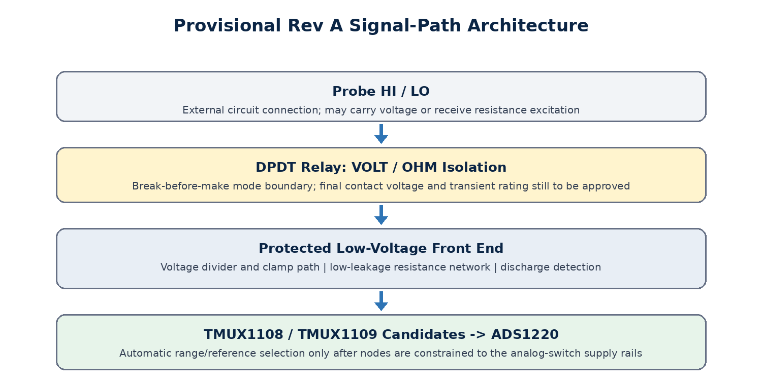
Figure 1. Proposed separation between the hazardous/probe-level mode boundary and the protected low-voltage range-selection network.

Relay: voltage/ohms mode boundary
Use a DPDT, break-before-make relay to select the probe pair between the voltage-measurement front end and the powered resistance-measurement front end. Mechanical contacts provide galvanic separation from the low-voltage analog switches and prevent the ADS1220 IDAC from being connected to an energized voltage source during normal operation.
- Default/fail-safe state should be voltage mode or fully disconnected, with resistance excitation disabled during boot, reset, brownout, and relay transitions.
- Firmware must disable both IDACs, wait for the relay to settle, verify the selected state where possible, and only then enable the chosen resistance range.
- Include a transistor or MOSFET coil driver, flyback suppression, a defined MCU pull state, and local supply decoupling. Do not drive the 3 V coil directly from an MCU pin.
- The Panasonic TQ2-3V remains a useful prototype candidate: sealed, 2 Form C (DPDT), break-before-make, 3 V coil, and 140 mW rated coil power. Its published nominal resistive switching capacity is 1 A at 30 VDC. Final approval depends on the exact location of the relay relative to the input protection/divider and the product’s maximum DC input and transient requirements.
Purchasing gate: Do not commit the TQ2-3V as the final probe-level relay until the voltage-mode protection/divider schematic proves that every contact operating and transient condition is within the relay’s ratings. If the relay directly sees the planned ~70 V input, select or validate a relay specifically for that DC voltage and measurement-category environment.

Analog multiplexers: automatic resistor and topology ranges
Candidate | Topology | Best provisional role | Reason / constraint
TMUX1108PWR | Single 8:1 precision multiplexer | Select one of several reference/excitation branches or calibration/open positions | Very low leakage, break-before-make, enable-all-off state; 0–VDD signal path only
TMUX1109PWR | Dual 4:1 / differential 4:1 precision multiplexer | Switch two related low-voltage nodes together, such as ADC input/reference or paired topology nodes | Coordinated dual channels reduce GPIO and timing mismatch; same rail-limit restriction

Both TI parts are strong candidates because their typical leakage is in the picoamp region, they are bidirectional and break-before-make, and they include an enable state that disconnects all channels. At 3.3 V, however, their analog signal pins must remain within the switch supply rails. They are not input-protection devices and must sit behind the relay and protection/scaling network.
- Do not automatically assume the TMUX on-resistance is harmless in the continuity/low-ohm path. TMUX1108 is typically about 4 Ω at a 3.3 V supply under its datasheet test condition. Place it so its resistance is calibrated as part of Rref/path resistance, or bypass it with a lower-resistance solution for the lowest range.
- For the 1 MΩ and 10 MΩ divider ranges, leakage is more important than on-resistance. Keep the high-impedance node short, guarded, clean, and separated from relay-coil and digital traces.
- Reserve explicit all-off/open, short-calibration, 10 kΩ, 100 kΩ, 1 MΩ, and optional 10 MΩ states. Unused channels can become test or future ranges only after leakage impact is reviewed.
- Add 0 Ω links and test points so each range can be isolated from the switch during bring-up. This allows direct resistor testing before attributing errors to the multiplexer.

6. Recommended Rev A implementation plan
- Freeze the functional range plan. Adopt overlapping low/mid IDAC ranges plus 1 MΩ and 10 MΩ divider ranges. Treat Kelvin measurement as a future enhancement, not a Rev A blocker.
- Complete the voltage-input protection and divider schematic first. Establish maximum input, transient goals, discharge detection, current limiting, creepage/clearance, and the voltage actually appearing at the mode relay and TMUX nodes.
- Draw the full switching truth table. For every relay and TMUX state, define probe connection, ADC inputs, reference selection, IDAC route, expected node voltages, boot state, and forbidden transitions.
- Select precision references. Use low-tempco 0.05% or 0.01% parts where cost permits; provide 10 kΩ, 100 kΩ, 1 MΩ, and optional 10 MΩ footprints. Store measured/calibrated value per assembled board.
- Prototype the uncertain switching functions quickly. Validate TMUX leakage at ~10 MΩ, low-range series resistance/zero repeatability, relay-mode isolation, and relay-driver behavior before the consolidated DigiKey order.
- Lay out the analog section for measurement integrity. Separate high-Z nodes from digital/relay traces, add guard copper where useful, omit solder mask only when justified, provide cleaning access, and place decoupling and RC filters at the ADC pins.
- Implement safe autoranging firmware. Start de-energized, open analog switches before changing range, wait for settling, reject overrange/negative ratios, and fall back to voltage/disconnected mode after faults or reset.
- Calibrate and verify the PCB by range. Record zero/path resistance, Rref value, gain/offset constants, leakage behavior, repeatability, temperature drift, and cross-checks against the Fluke and a better reference instrument when available.

7. Rev A acceptance targets
Gate | Acceptance evidence
Coverage | Continuity/near-zero through at least 10 MΩ with no manual rewiring
Autoranging | Stable range selection with overlap and no IDAC exposure during switching
Mode safety | Ohms excitation cannot be enabled while the voltage path or an overvoltage condition is present
Low-ohm behavior | Repeatable software-zero result; continuity response target defined separately from precision resistance
High-ohm behavior | 1 MΩ and 10 MΩ ranges characterized for leakage after PCB cleaning and environmental exposure
Serviceability | Test points and 0 Ω isolation links allow each reference and switch path to be measured independently
Documentation | Per-range register map, switching truth table, calibration constants, and protection assumptions captured in the schematic notes

Appendix A. Test artifacts and source documents
The following firmware files preserve the breadboard configurations summarized in this report. Serial measurement logs from the working sessions were reduced into the result tables above; the PCB design should retain new raw logs by board serial number and range.
Firmware artifact | Purpose
ADS1220_9k99_IDAC_Range_Test.ino | Direct 10 µA / 50 µA / 100 µA IDAC verification with 9.99 kΩ
ADS1220_21k6_50uA_Ratiometric_Test.ino | 21.6 kΩ / 50 µA ratiometric resistance configuration
ADS1220_100k6_10uA_Ratiometric_Test.ino | 100.6 kΩ / 10 µA multi-resistor configuration
ADS1220_Serial_Configurable_Resistance_Divider.ino | Serial-configurable 1 MΩ supply-ratiometric divider configuration

Manufacturer references
Texas Instruments, ADS1220 datasheet (Rev. D, May 2026)
Texas Instruments, TMUX1108 datasheet (Rev. B)
Texas Instruments, TMUX1109 datasheet (Rev. A)
Panasonic Industry, TQ2-3V product specifications

