FUNCTION GENERATOR PROTOTYPE
Final sine-output, calibration, power-noise, and envelope characterization
Field | Value
Project | PocketLab modular electronics platform
Prototype | AD9833 + ISL23415 + AD5626 + TLV9154 + TMA 0505D
Controller used for tests | ESP32; Bluetooth stopped for analog baseline and final waveform tests
Measurement instrument | Digilent Analog Discovery 3 / WaveForms
Purpose | Freeze the breadboard revision and preserve design evidence for a future function-generator cartridge

Executive summary
The prototype met its central goal: a digitally controlled bipolar sine output with accurate amplitude and offset control. Replacing the X9C with the ISL23415 materially improved amplitude calibration, while a simple input filter on the isolated DC-DC converter reduced converter-coupled supply noise to near the background level. Within the recommended output envelope, the final waveform is clean, symmetric, and stable.
- Calibrated normal sine range: 1–9 Vpp; representative 5.00 Vpp request measured 5.002 Vpp (+0.04%).
- Recommended zero-offset ceiling: about 9.5 Vpp. Compression begins above this region; 10 Vpp is experimental over-range.
- Practical unclipped envelope: Vpp/2 + |offset| ≤ approximately 4.7 V.
- TMA input filter retained: 4.7 Ω series resistance with 47 µF || 100 nF directly at the converter input.
- Full-amplitude sine performance is clean through roughly 10 kHz; degradation begins near 50 kHz.
- At 100 kHz, usable amplitude is strongly amplitude-dependent: about 1 Vpp remains sinusoidal, while 2 Vpp and above become progressively triangular.
- The high-frequency limitation was localized to TLV9154 Amp D (pins 12–14), the approximately ×19.6 gain stage.
- Large 60 ms supply dips were traced to the temporary ESP32 BLE controller and are deferred because the modular system will use an nRF52832 base unit.

1. Prototype configuration
Block | Implementation / role
DDS | AD9833 sine/triangle source
Amplitude control | ISL23415 SPI digital potentiometer; replaced X9C103S
Offset control | AD5626 12-bit DAC
Analog chain | TLV9154 quad op-amp; Amp D gain ≈ 19.56
Analog supply | TMA 0505D isolated converter producing approximately ±5 V
Converter input filter | Shared 5 V → 4.7 Ω → TMA VIN, with 47 µF || 100 nF to TMA input ground
Final output | TLV9154 pin 7, referenced to analog common
Quiet-test control | USB serial at 115200 baud with btStop() executed at end of setup()

2. Amplitude calibration and clean baseline
The ISL23415 calibration reduced normal-range amplitude error to less than about 0.85%, with most residual errors below one hardware wiper step (roughly 40–45 mV at the output). Endpoint behavior must be interpreted separately: the 0 Vpp setting retains feedthrough/noise and is not a true mute, while the 10 Vpp setting enters compression.
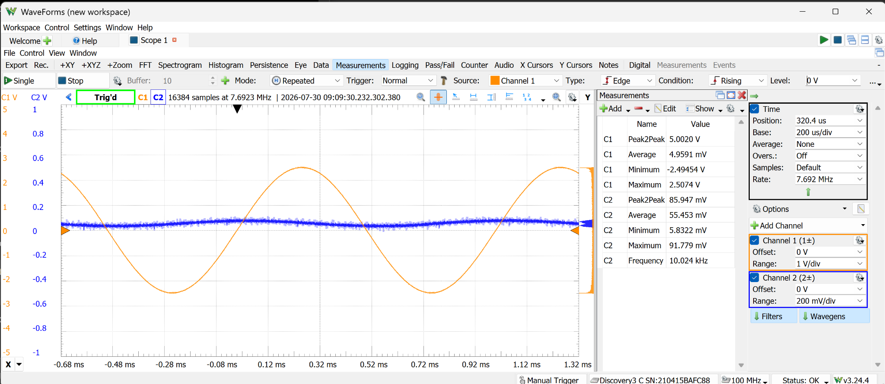
Figure 1. Quiet analog baseline with BLE stopped: 5.00 Vpp requested, 5.002 Vpp measured, +4.96 mV average offset.
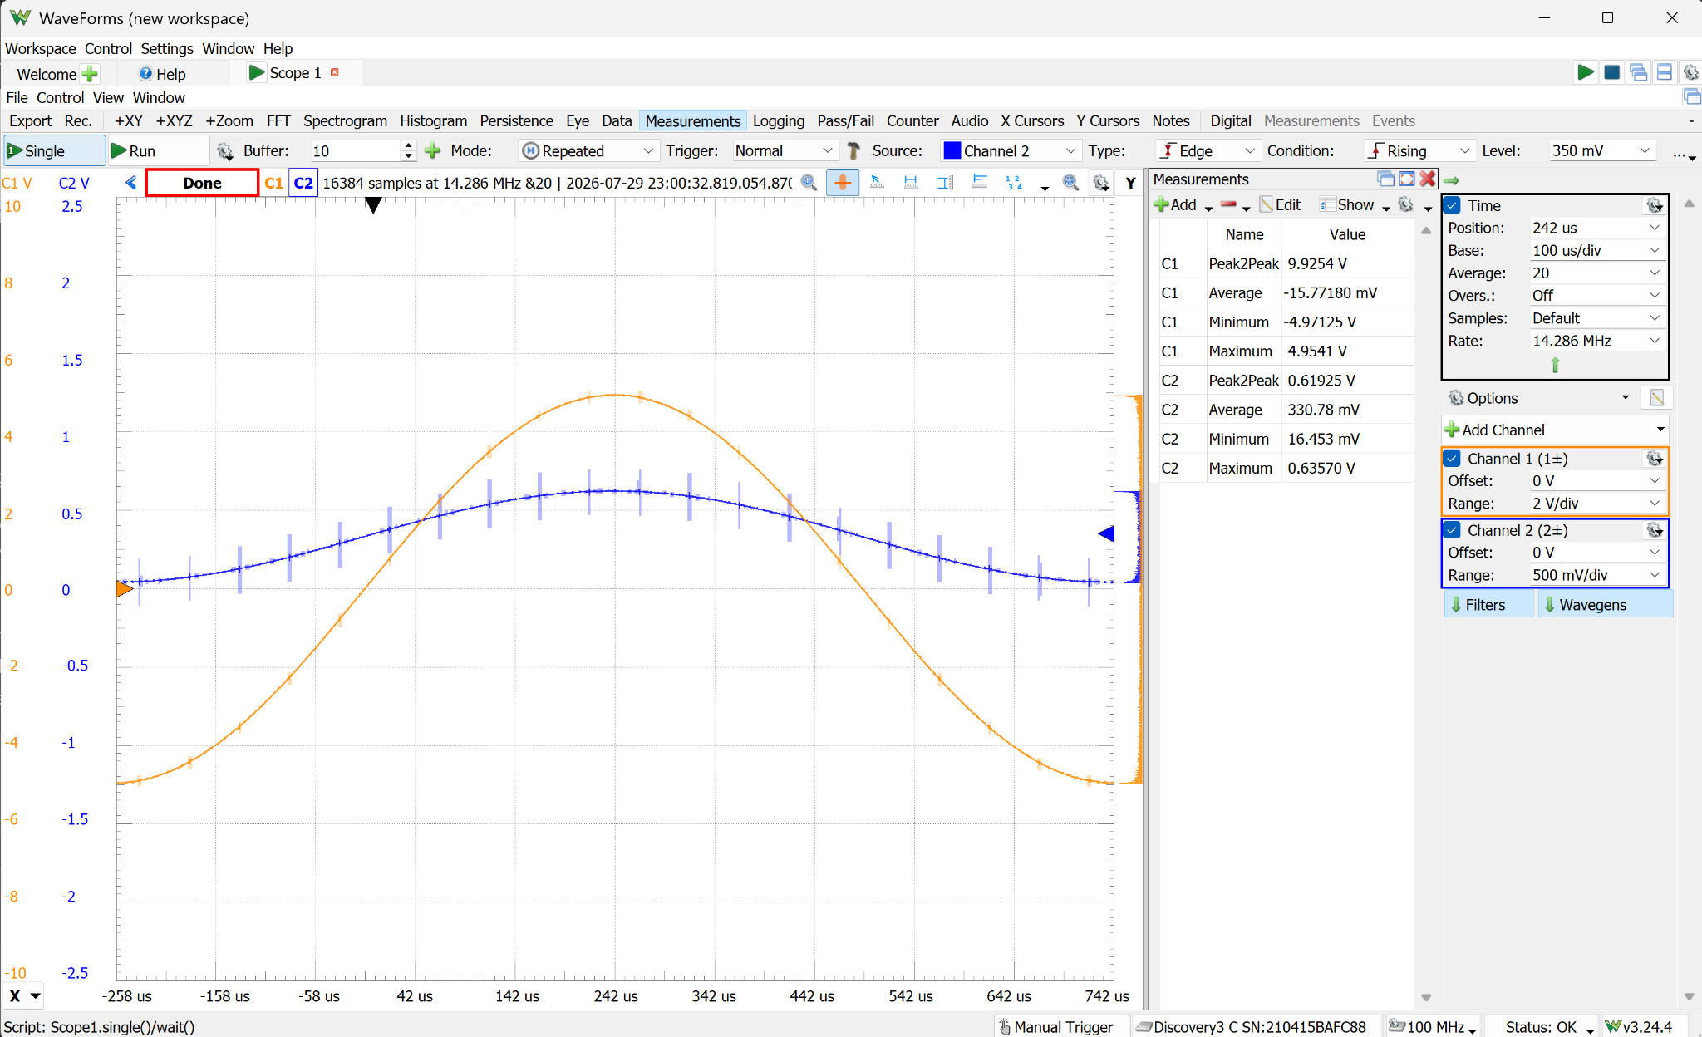
Figure 2. Near the upper zero-offset limit: approximately 9.93 Vpp measured under scope-only loading.

3. Power-noise diagnosis and correction
Two distinct power disturbances were identified. First, the TMA 0505D injected switching-current noise backward onto the shared 5 V rail. Disconnecting only its ± outputs did not stop the converter; disconnecting TMA VCC reduced the shared-rail noise by roughly an order of magnitude. Second, active ESP32 Bluetooth produced much larger periodic supply dips at about a 60 ms interval. These sources were separated experimentally.
Condition | Shared 5 V | TMA V+ | Interpretation
TMA powered, before input filter | ≈51.9–62.1 mVpp | ≈9.3 mVpp in one averaged capture | Converter pulsed input current dominates shared-rail noise
TMA VCC disconnected | ≈6 mVpp | Not powered | Confirms TMA as dominant broadband source
After 4.7 Ω + 47 µF || 100 nF | 7.87 mVpp | 9.53 mVpp | ≈85% reduction; close to converter-off baseline
BLE connected | ≈114–115 mVpp | ≈116–119 mVpp | Regular ≈60 ms radio-current transient
Phone disconnected / advertising | 166.5 mVpp | 176.9 mVpp | Radio remains active; transient changes and grows
btStop() | 11.56 mVpp | 11.66 mVpp | Large periodic BLE dips disappear

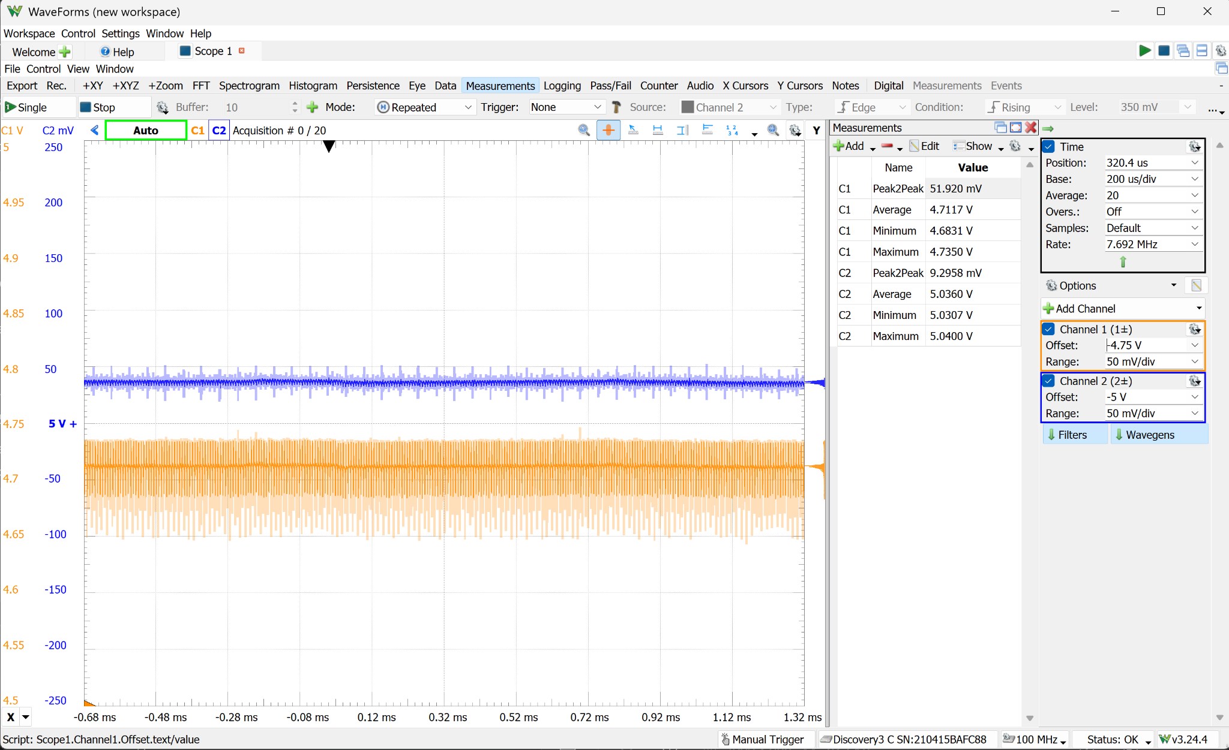
Figure 3. Before the converter input filter: shared ESP32/USB 5 V rail measured 51.9 mVpp while TMA V+ measured 9.30 mVpp.
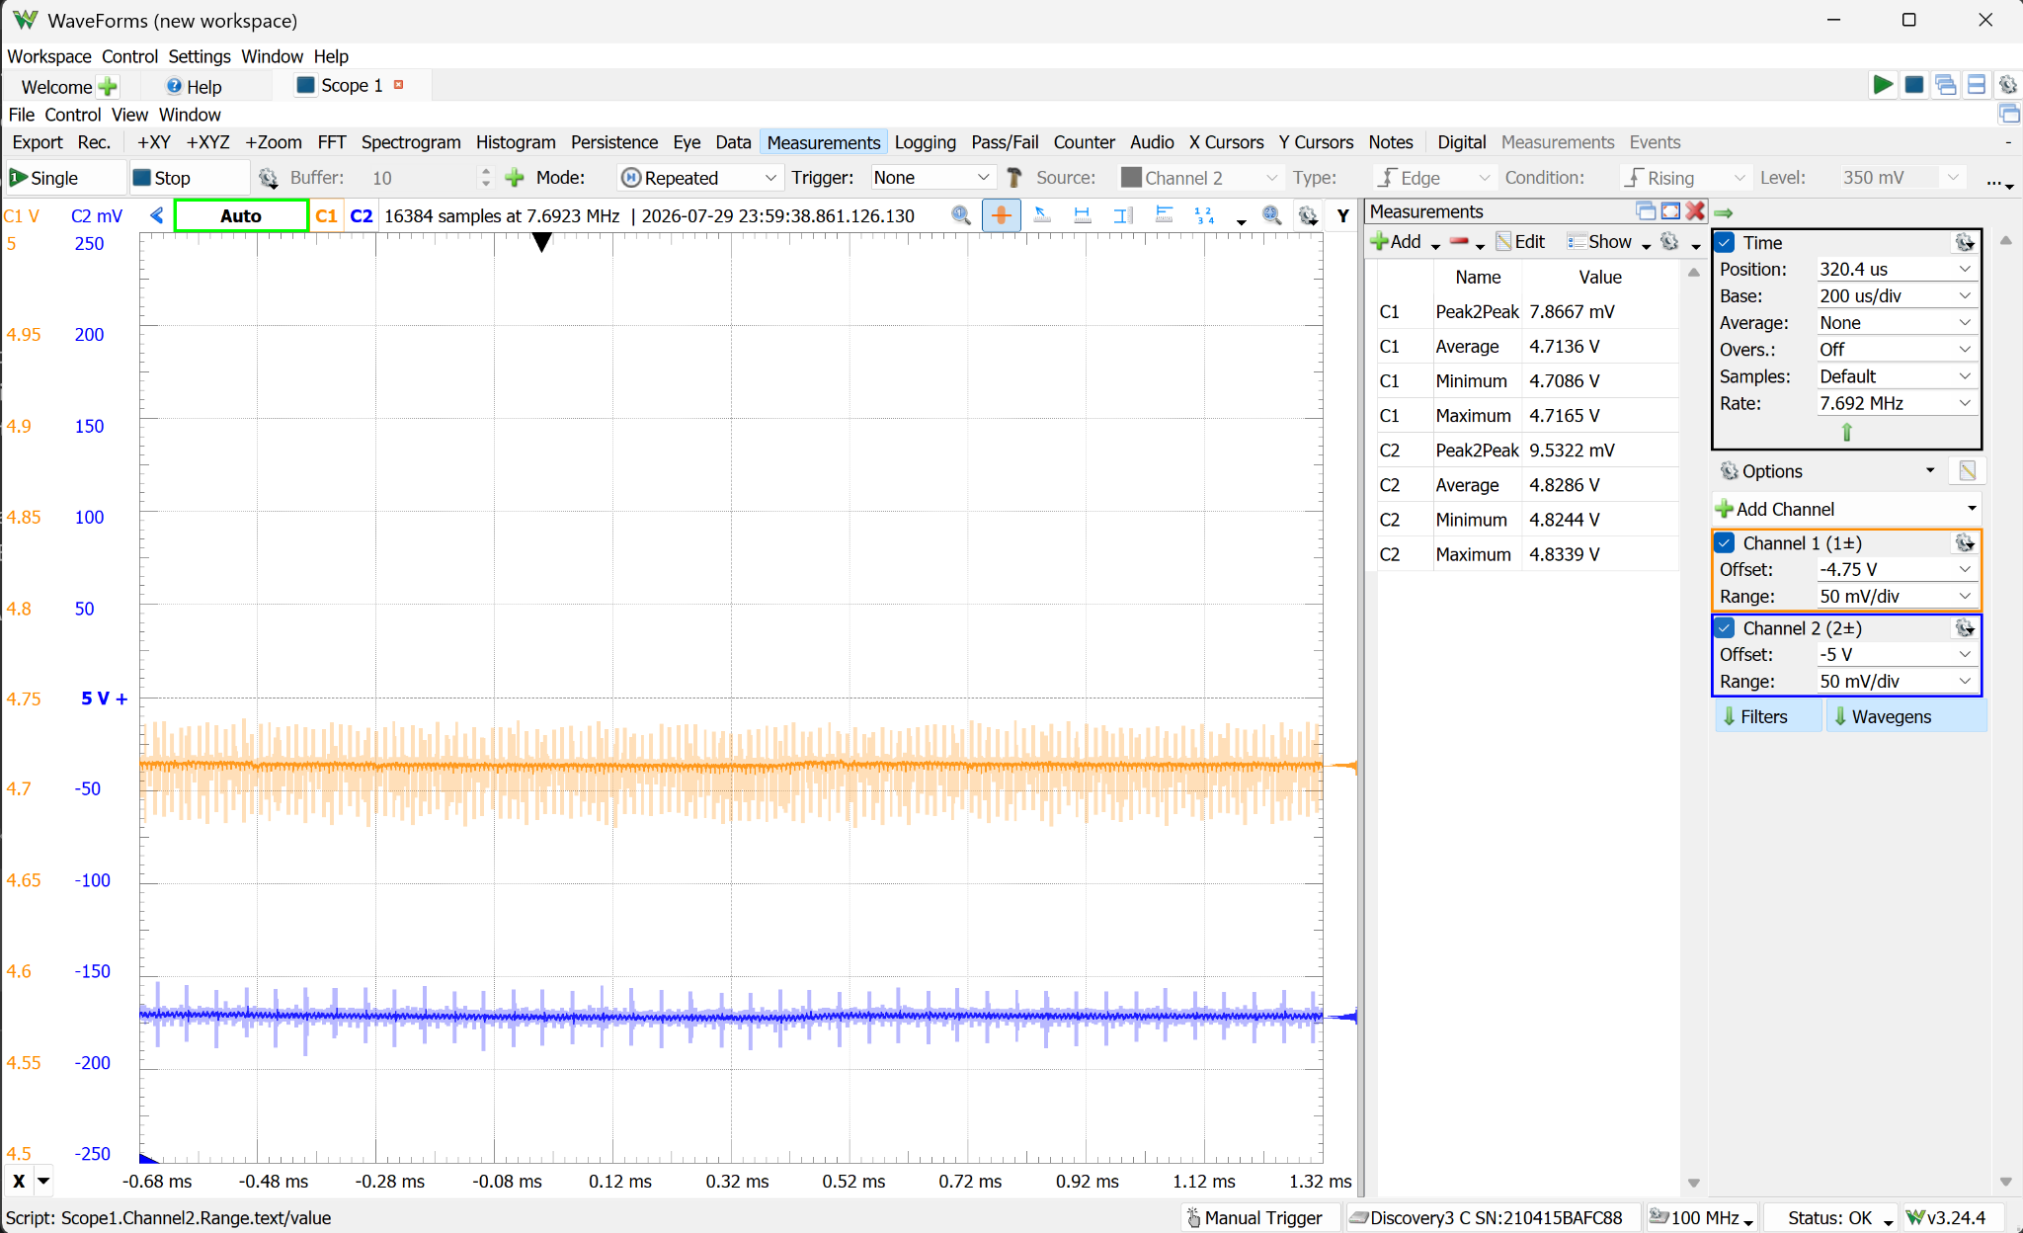
Figure 4. After the 4.7 Ω + 47 µF || 100 nF input filter: shared rail 7.87 mVpp and TMA V+ 9.53 mVpp.
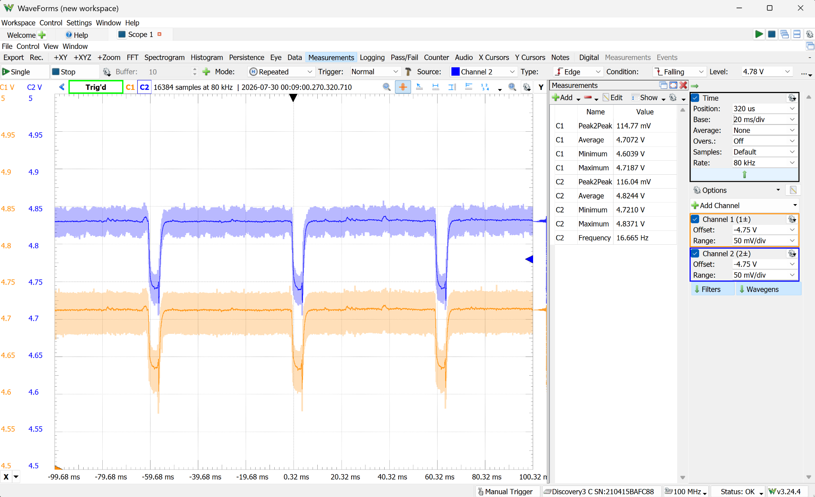
Figure 5. BLE connected: aligned ≈60 ms downward transients on the shared 5 V and TMA V+ rails.
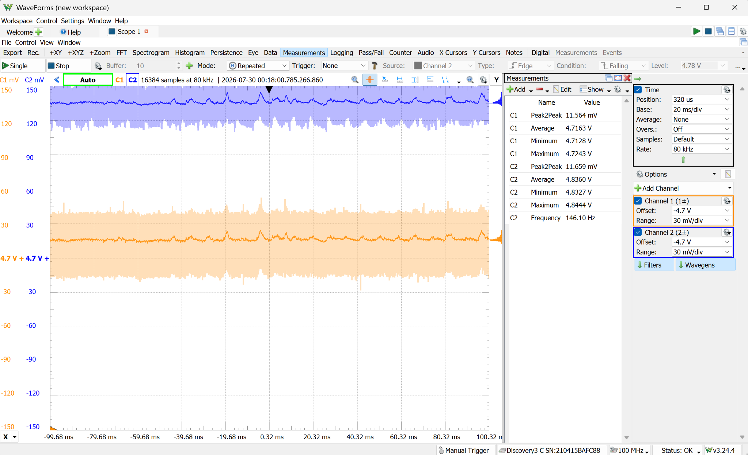
Figure 6. btStop(): the large BLE transients vanish, leaving approximately 11.6 mVpp background disturbance.
The measured drop across the 4.7 Ω resistor was 170.9 mV, corresponding to 36.4 mA converter input current and only about 6.2 mW resistor dissipation. The filter is therefore suitable for retention in the next revision, subject to rechecking TMA input voltage under worst-case cartridge load.

4. Amplitude and offset envelope
Requested | Measured Vpp | Average | Min / max | Result
2 Vpp, +2 V | 1.9738 V | +1.988 V | +1.003 / +2.977 V | Clean
2 Vpp, −2 V | 1.9720 V | −2.005 V | −2.990 / −1.018 V | Clean
6 Vpp, +1 V | 5.9871 V | +1.001 V | −1.991 / +3.996 V | Clean
6 Vpp, −1 V | 5.9817 V | −1.005 V | −3.992 / +1.989 V | Clean
8 Vpp, +1 V | 7.8359 V | +0.988 V | −2.998 / +4.838 V | Positive clipping
8 Vpp, −1 V | 7.8484 V | −0.996 V | −4.851 / +2.998 V | Negative clipping

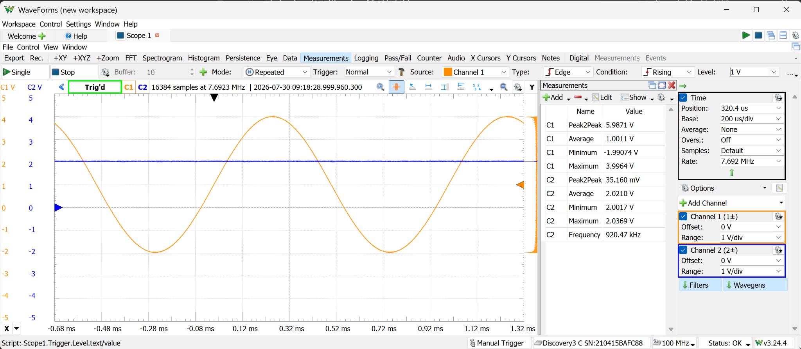
Figure 7. Clean representative envelope point: 6 Vpp with +1 V offset.
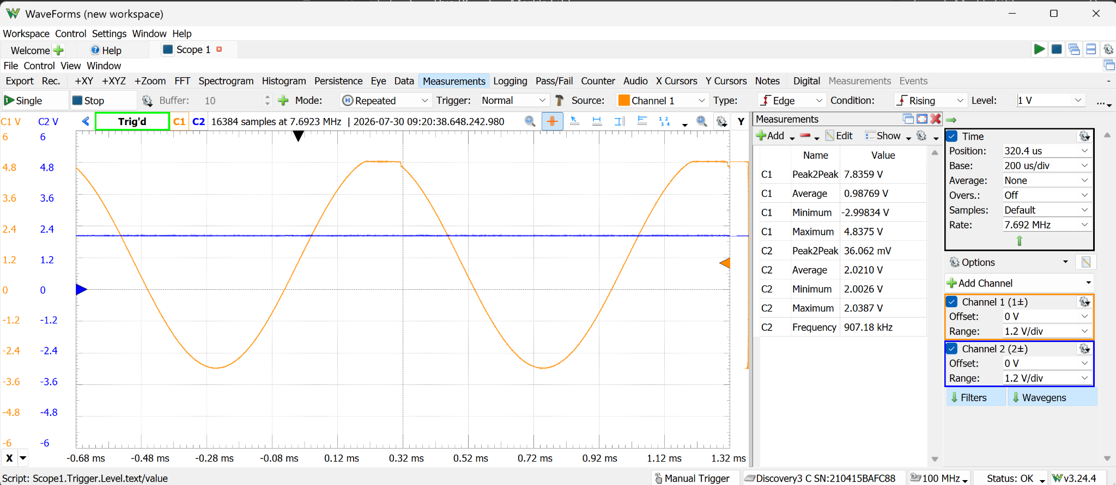
Figure 8. Over-range condition: 8 Vpp with +1 V offset clips near the measured +4.84 V positive ceiling.
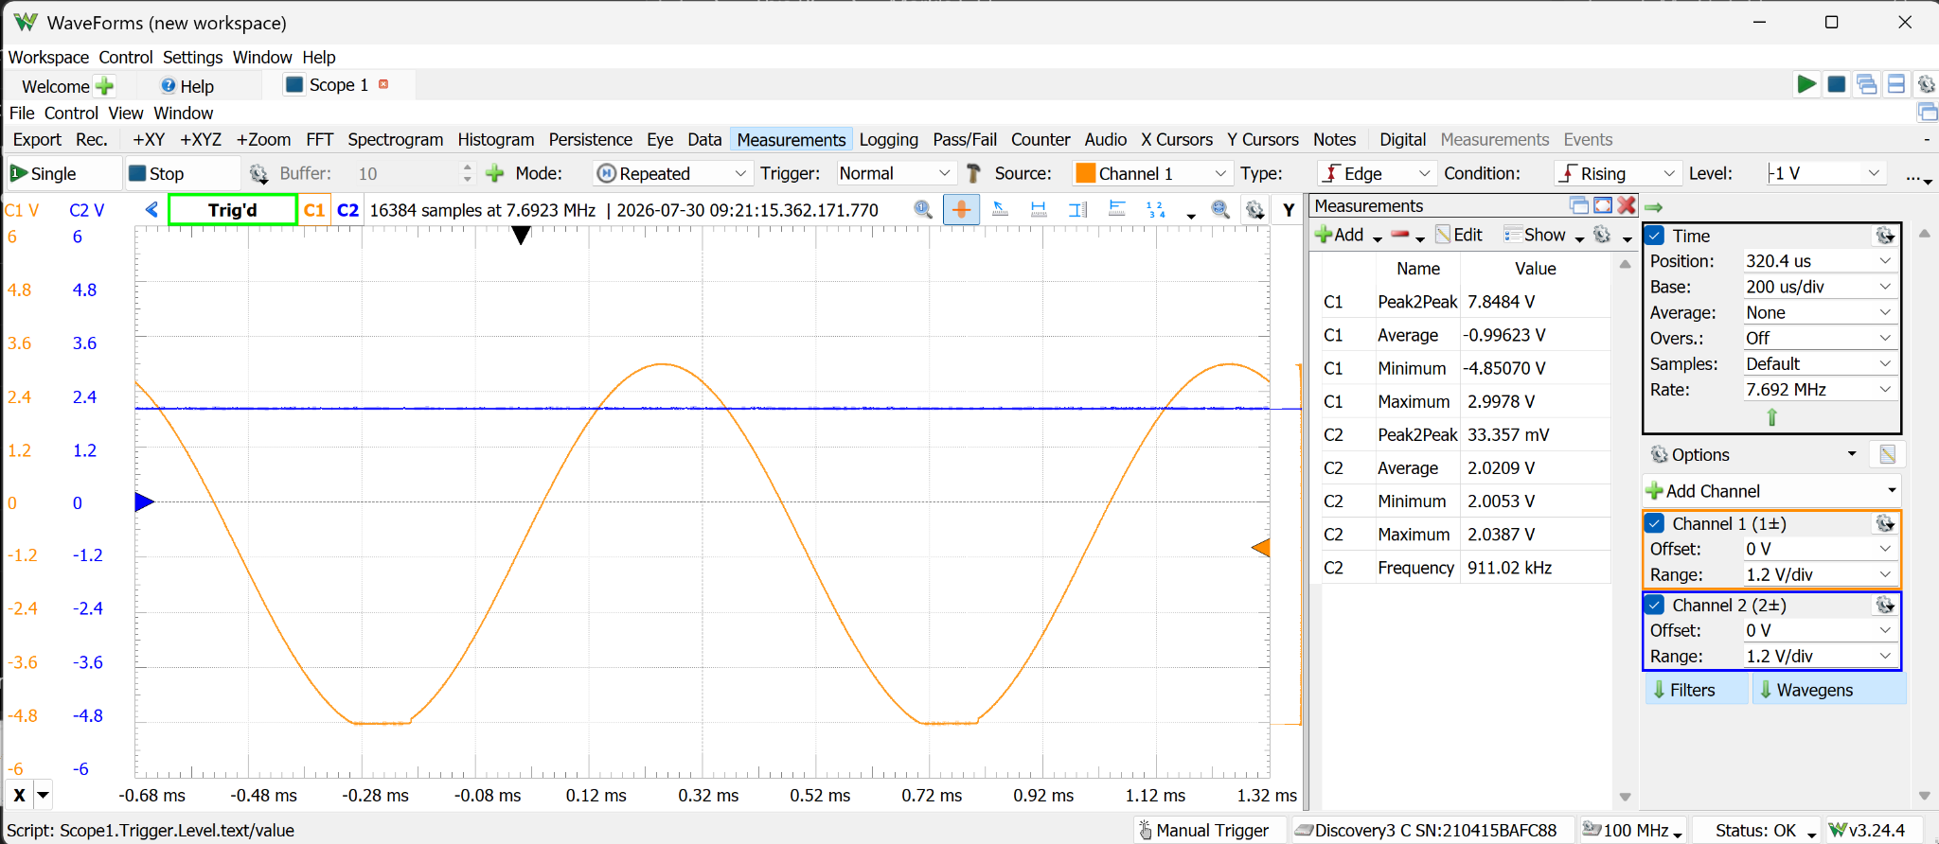
Figure 9. Symmetric over-range result: 8 Vpp with −1 V offset clips near −4.85 V.
The observed positive and negative clipping limits are closely matched. A conservative firmware/app warning boundary is:
Vpp / 2 + |Voffset| ≤ 4.7 V

5. Sine-wave frequency response
Frequency | Requested | Measured output | Observation
10 Hz | 4 Vpp | 3.955 Vpp | Clean
100 Hz | 4 Vpp | 3.950 Vpp | Clean
1 kHz | 4 Vpp | 3.959 Vpp | Clean
10 kHz | 4 Vpp | 3.980 Vpp | Clean
50 kHz | 4 Vpp | 3.851 Vpp | Mild attenuation/distortion begins
100 kHz | 4 Vpp | 2.374 Vpp | Severe triangular distortion
500 kHz | 4 Vpp | ≈0.448 Vpp | Strong attenuation; not a precision sine
1 MHz | 4 Vpp | ≈0.193 Vpp | Not usable as a precision sine

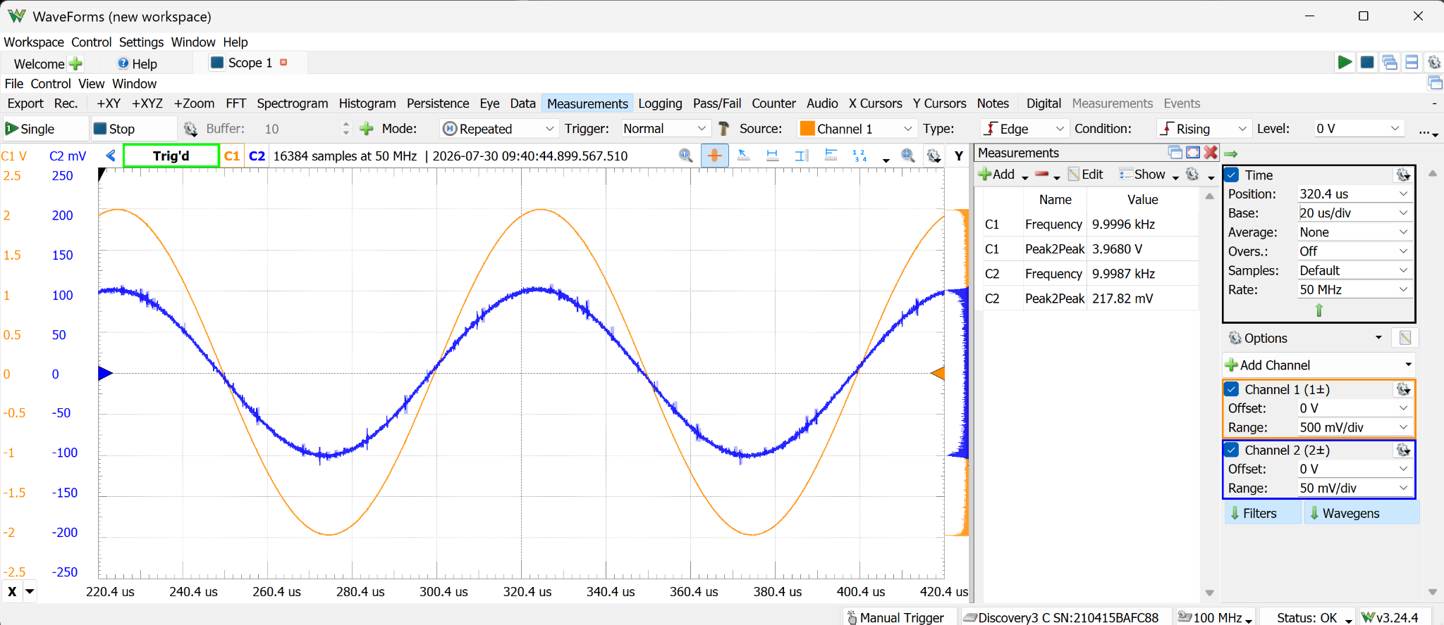
Figure 10. At 10 kHz, Amp A (pin 1) and the final output remain clean.
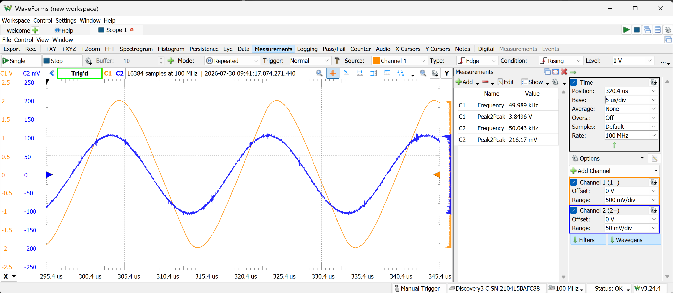
Figure 11. At 50 kHz, Amp A remains clean while the final output begins to deform.
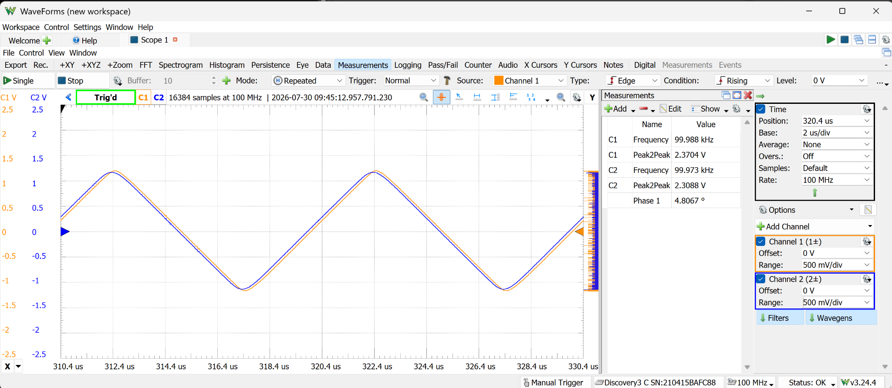
Figure 12. At 100 kHz, pin 14 and pin 7 share the same triangular distortion, localizing the limitation to Amp D.

6. Amplitude-dependent 100 kHz behavior
The 100 kHz limitation is not a simple fixed RC roll-off. Pin 1 remains reasonably sinusoidal and loses only about 2.3% between 10 and 100 kHz, while the output shape degrades strongly as requested amplitude increases. Pin 14 already contains the distortion and pin 7 reproduces it, identifying the high-gain Amp D stage—not the ISL23415, coupling network, final summing stage, or new power-supply capacitors—as the dominant bottleneck.
100 kHz request | Pin 7 | Pin 14 | Waveform
1 Vpp | 0.902 Vpp | 0.896 Vpp | Convincingly sinusoidal
2 Vpp | 1.758 Vpp | 1.746 Vpp | Noticeably more triangular
4 Vpp | 2.370–2.374 Vpp | 2.309 Vpp | Severely triangular

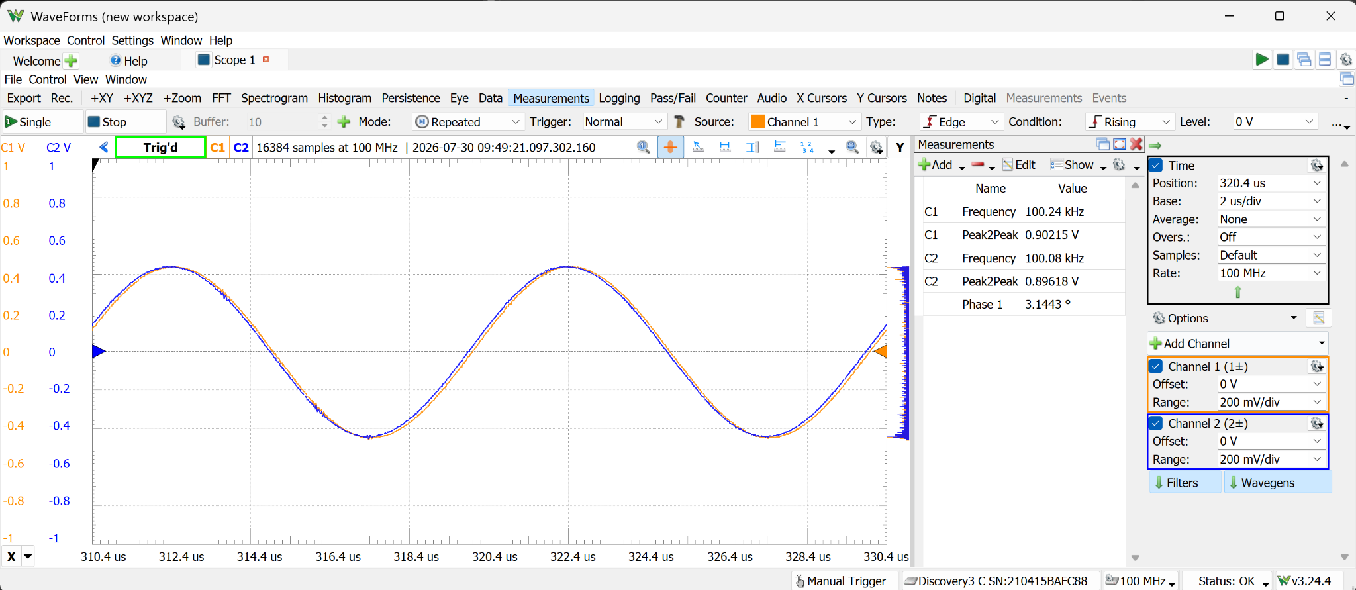
Figure 13. At 100 kHz and 1 Vpp requested, pin 14 and pin 7 remain reasonably sinusoidal.
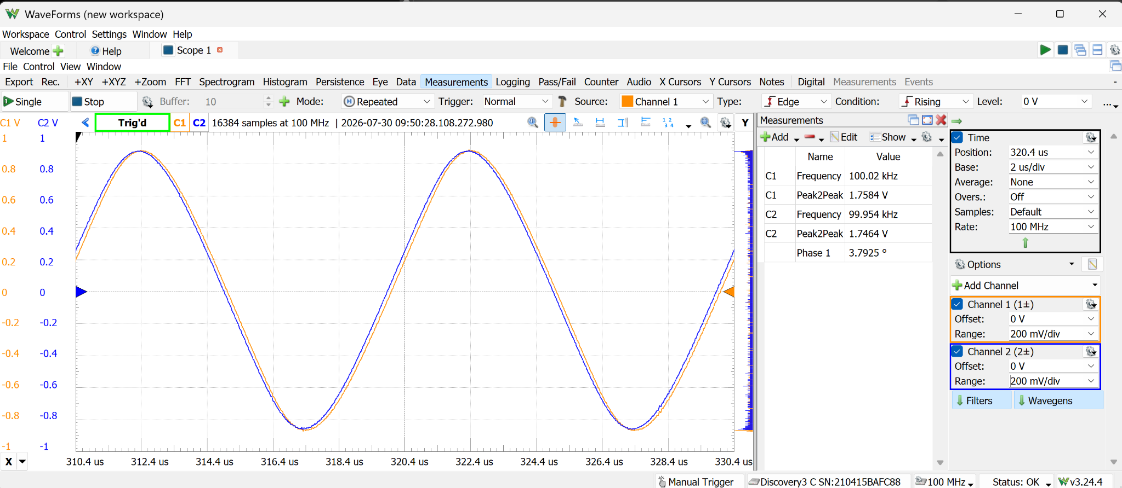
Figure 14. At 100 kHz and 2 Vpp requested, the same nodes become visibly triangular.

7. Frozen prototype specification
Parameter | Recommended characterization
Waveform covered by this report | Sine
Calibrated normal amplitude | 1–9 Vpp
Recommended zero-offset ceiling | ≈9.5 Vpp
Experimental upper region | Above ≈9.5 Vpp; compression/clipping expected
Mute behavior | Use OUTPUT OFF; 0 Vpp command is not a true mute
Usable output envelope | Vpp/2 + |offset| ≤ approximately 4.7 V
Recommended sine bandwidth | Full calibrated amplitude through ≈10 kHz
Extended sine operation | Around 50 kHz with degradation; at 100 kHz use ≈1 Vpp if sinusoidal shape matters
High-frequency limitation | TLV9154 Amp D high-gain stage; amplitude-dependent large-signal/loop-performance limit
Recommended load | ≥10 kΩ based on prior load characterization
TMA input filter | 4.7 Ω + 47 µF || 100 nF; retain
Temporary-controller noise | ESP32 BLE transients documented but not optimized; defer to nRF52832 base integration

8. Implications for the future modular cartridge
- Preserve the converter input filter and use a short, low-impedance return to the base-unit power-entry/star point.
- Separate the nRF52832 digital supply branch from the TMA/analog branch and place local bulk plus 100 nF decoupling at each branch.
- Keep SPI traces and the BLE antenna away from Amp D and the high-impedance amplitude-control nodes.
- If a future cartridge requires clean multi-volt output above 10–50 kHz, redesign Amp D for lower per-stage gain, higher large-signal bandwidth, and controlled PCB layout.
- Carry forward the measured calibration table, but recalibrate after PCB layout, component tolerance changes, and connector/load changes.
- Treat 10 Vpp and out-of-envelope offset combinations as user-visible experimental over-range settings, not rated output.

9. Remaining work deliberately deferred
This report freezes the successful sine-output and power-noise characterization. The following items should be completed only when the generator cartridge is revisited, unless needed for an immediate demonstration:
- Triangle-wave sweep and explicit distortion limits.
- Square-wave level, duty-cycle, and rise/fall characterization.
- Repeat startup/output-disable and representative 10 kΩ/1 kΩ load checks on the final PCB.
- A/B noise comparison using the Adafruit nRF52832 Feather base controller.
- PCB-specific gain-stage redesign if wider full-amplitude bandwidth becomes a product requirement.

Conclusion
The breadboard function generator is a successful prototype and a strong basis for a future PocketLab cartridge. The ISL23415 provided the needed amplitude resolution, the bipolar offset envelope is predictable and symmetric, and the dominant converter noise mechanism was identified and corrected with a compact filter. The remaining principal limitation is well bounded: clean multi-volt sine generation is reliable through about 10 kHz, while higher-frequency performance becomes amplitude-dependent due to the high-gain Amp D stage. This is sufficient to freeze the revision and proceed to ADS1220/nRF52832 DMM development.

