Lab – Graphics, Animation, Touch, and MultiMedia

Graphics, Animation, Touch, and Multimedia

# Objectives:

This week’s lab is aimed at getting a better understanding of Graphics, Animation, Touch, and Multimedia. Upon completion of this lab you should understand how to display and animate images within your application, have the app respond to touch input, and have it play simple sound effects.

# Exercise:

In this Lab, you'll create an application that displays, animates and manipulates Bubbles. The application’s user interfaces will have a main display area that is initially empty as shown below.

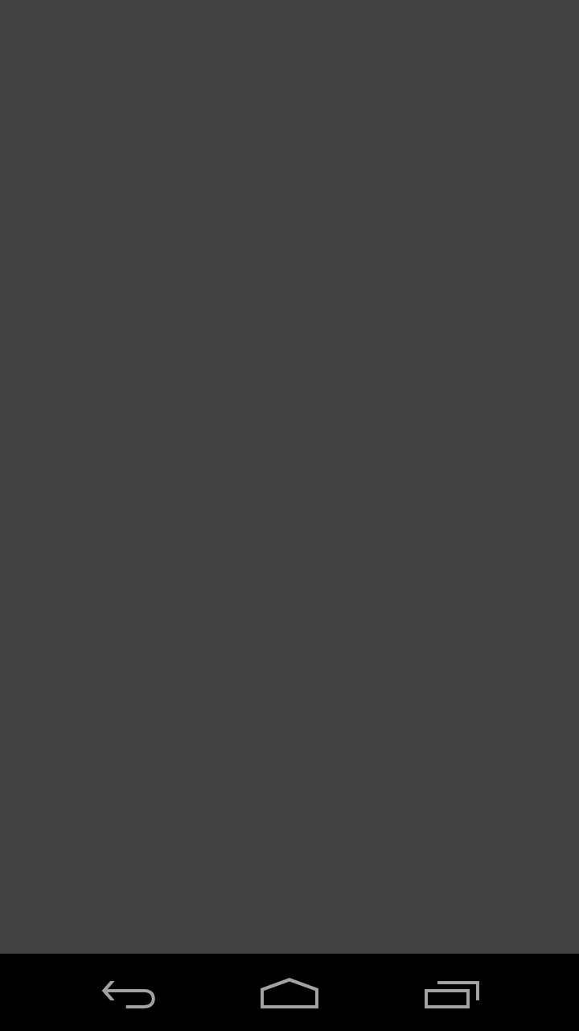

When the user touches this empty screen, one new bubble should appear on the display As shown below. The bubble should then begin to move around the screen. The Bubble’s size, direction and speed should be randomized within limits explained in source code skeleton.

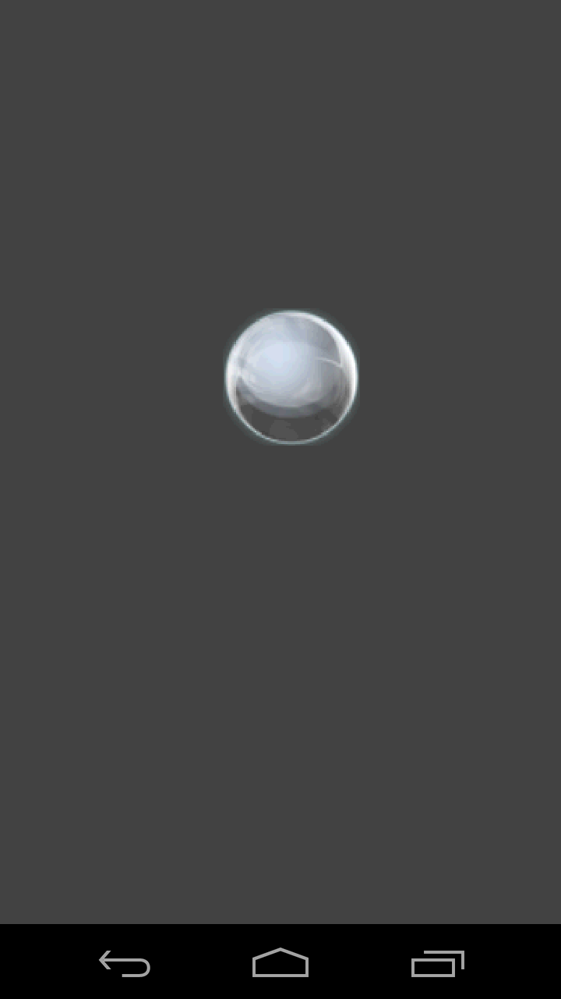

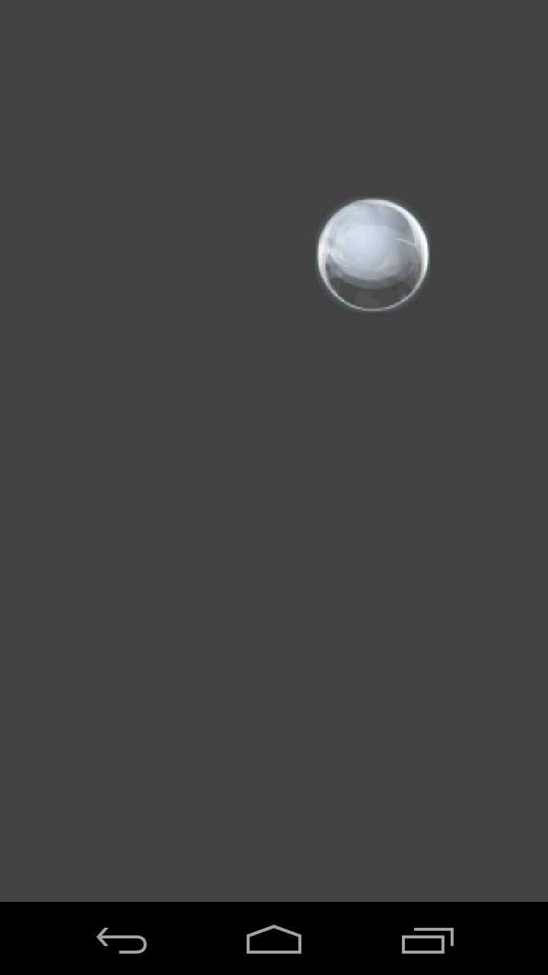Assuming the Bubble’s initial direction is up and to the right, the Bubble shown above might be in the location shown below after a couple seconds.

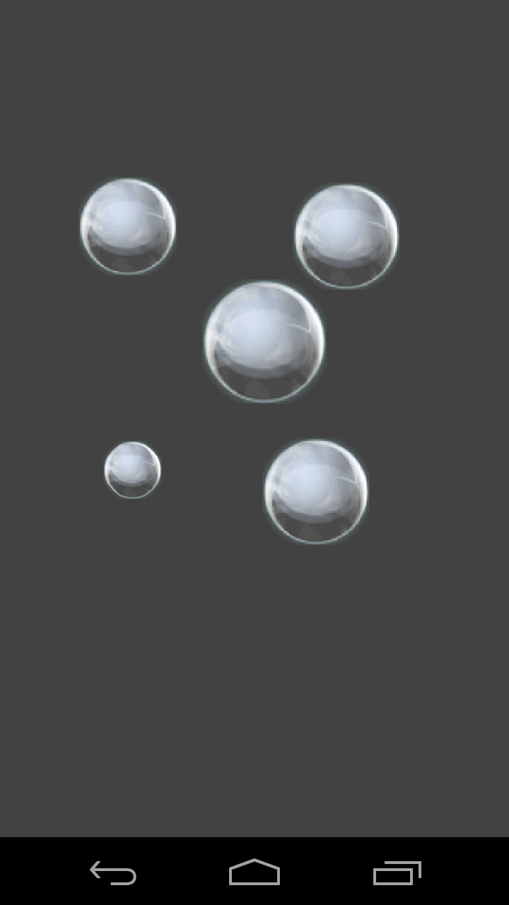As the user continues to touch empty spaces on the screen, more bubbles should be added.

If the user presses the screen at a location already occupied by a bubble, then the bubble should “pop.” That is, it should be removed from the screen and a bubble popping sound should be played. The sound file is in the skeleton code in the /res/raw/bubble_pop.wav file.

In addition, if the user executes a "fling" gesture starting at a location already occupied on the screen, then the application should change the bubbles current direction and speed to match the direction and speed of the fling gesture.

See the GraphicsLab.mp4 screencast to see the app in operation.

# Tips:

Each time your app adds a new bubble, it should create a new BubbleView. The BubbleView class handles drawing, moving and redrawing the bubble, and also initiates removing the bubble from the main View and playing the popping sound.

New BubbleViews must be added to the app's main view, called mFrame, otherwise they won't be visible.

You also need to keep track of the Bubbles as they move off the screen. Once a BubbleView moves completely off screen, its movement calculations should stop and it should be removed from the app's main View.

When a BubbleView is created, its size, movement direction and speed, and rotation speed are randomized, within bounds described in the skeleton code. We have added some special modes to facilitate testing, so we don't expressly test for this behavior in your app. The app will show the menu if the user hits the back button. Click "Quit" in the menu to exit the application.

When a BubbleView changes position, you must notify the system that it has changed, otherwise it will not be redrawn.

# Implementation Notes:

1. Download the application skeleton files and import them into your IDE.
2. Look for comments containing the string "TODO" and follow the associated instructions.

# Testing:

The test cases for this Lab are in the Lab7_GraphicsLabTest project. You can run the test cases either all at once, by right-clicking the project folder and then selecting Run As > Android JUnit Test, or one at a time, by right-clicking on an individual test case class and then continuing as before. The test classes are Robotium test cases.

# Warnings:

1. These test cases have been tested on a Galaxy Nexus AVD emulator with API level 18. To limit configuration problems, you should test your app against a similar AVD.
2. These test cases assume a display screen of at least 550x550 pixels.
3. On some emulators "fling" gestures will sometime report erroneous fling velocities or fail to recognize the fling. Keep an eye out for this erroneous behavior when you're running the BubbleActivityFling test case. The BubbleActivityFling test case should 1) create a new BubbleView, 2) recognize a fling gesture, and 3) remove the BubbleView from mFrame when the BubbleView leaves the screen.

# Submission

To submit your work you will need to submit the GraphicsLab project files we've asked you to modify. These files should be stored in specific directories as described below and then compressed in a zip file. Then you will submit this zip file to the Coursera system. The automatic grading system will test your submission and give you feedback. This process may take some time, especially if many students are submitting at the same time.

To make sure your submission is correctly graded, pay attention to the following aspects:

1. Your project files must be in a zip file named GraphicsLabSubmit.zip.
2. The zip file should have the following directory structure:  
   GraphicsLabSubmit/

- GraphicsLab/

- BubbleActivity.java

1. Each new submission will overwrite any previous submissions.