Lab: Simple Calculator

Objectives:

Create an application from scratch featuring a creative user interface that you've designed yourself. Use what you learned in the User Interface Classes Lesson to modify, layouts, colors, positioning and more. For example, here's a screenshot of a basic app that I created.

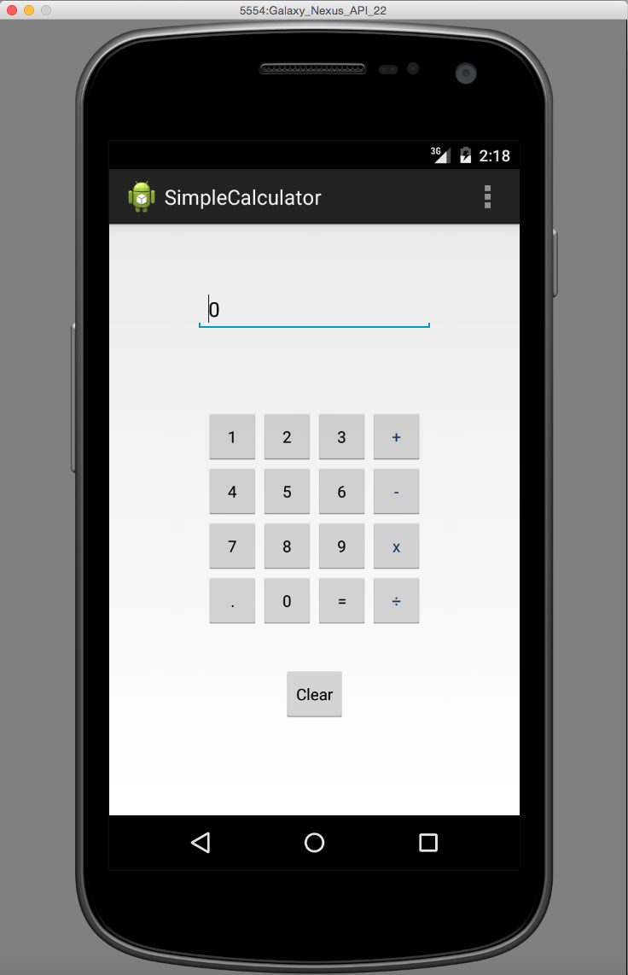

When the application is in portrait mode, its user interface consists of several areas: there is one area that shows the current value for a calculation being performed. Below that there are also multiple elements that correspond to numerical input values and arithmetic operations to be applied. At the very bottom there is another element clears the entire current calculation.

When the user selects the arithmetic operation, such as "+" to be performed, the input field should become blank. When the user selects the "=" operation to be performed, the value of the current calculation should be displayed.

See the SimpleCalculator.mp4 screencast which illustrates the application's basic functionality.



Importantly, this application uses an expanded layout when in the landscape orientation. This layout is different from the layout used when the device is portrait. Specifically, the layout should take advantage of the wider display area as illustrated below:

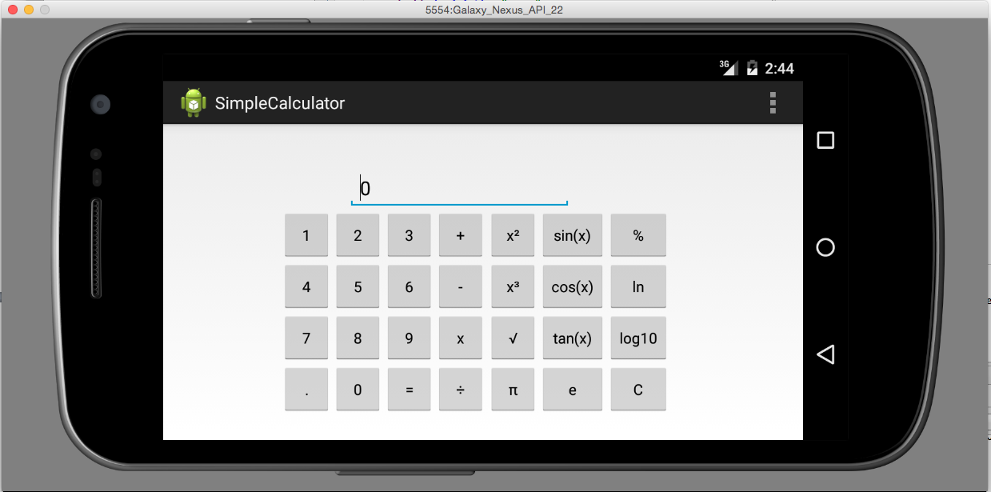

As you can see, when in landscape mode, the application uses the screen's additional width to display additional mathematical functionality.

Your application must implement all the functions shown above, but can and should vary in the visual layout. See the assignment web page for the grading rubric.

Submission

To submit your work you will need to export your SimpleCalculator project as a compressed zip file. Then you will submit this zip file to the Coursera system. Grading for this assignment will be done using Peer Assessment. That is, students will review each other's code and give feedback.