Research Paper Recommendation System
Combining Paper Text and the Citation Graph on OGB ogbn-arxiv
Project Report: Design, Implementation and Results
Group 4
Muhammad Hamid · Mark Karu Wagh · Aditya Shashikant Randive
IE7275 Machine Learning and Data Analytics
Northeastern University · November 2026

Contents
1. Executive Summary
2. Project Overview
2.1 Problem statement
2.2 Dataset
2.3 Objectives
3. From Proposal to Implementation
4. Data Acquisition and Preparation
4.1 Loading and text join
4.2 Data quality checks
4.3 Task formulation
4.4 Time-aware split
4.5 Leakage control
5. Exploratory Data Analysis
5.1 Findings
6. Models
6.1 Popularity baseline
6.2 Content-based models
6.3 Graph-based models
6.4 Graph Neural Network: inductive directional GraphSAGE
6.5 Hybrid score fusion
7. Evaluation Protocol
8. Results
8.1 Overall comparison
8.2 Text-only vs graph-only vs hybrid
8.3 How should the query be represented?
8.4 Fusion weights and normalisation
8.5 GNN design choices and training
8.6 Effect of the time mask
8.7 Who benefits? Breakdowns and popularity bias
8.8 Qualitative examples
9. Discussion
9.1 Why the fusion works
9.2 Why the GNN falls short
9.3 Normalisation matters as much as the model
9.4 Accuracy versus popularity bias
9.5 Cold start
10. Limitations and Future Work
10.1 Limitations
10.2 Next steps
11. Conclusion
12. Deliverables and Reproducibility
Appendix A. Hyper-parameters

1. Executive Summary
This project builds and compares a family of research-paper recommenders on the OGB ogbn-arxiv citation network. The central question is whether combining what a paper is about (its title and abstract) with how it is connected (the citation graph) produces better recommendations than content-only, graph-only and popularity-based approaches. Following our proposal, we implemented the full pipeline as a tested, reproducible Python codebase: data loading and a text join for all 169,343 papers, exploratory analysis, a strictly time-aware and leakage-tested task definition, a shared full-ranking evaluation harness, eleven model families across content, graph and hybrid approaches, ablations, error breakdowns and qualitative examples.
Headline result. A validation-tuned fusion of MiniLM text similarity, Personalized PageRank (PPR) and a small popularity term is the best model on every metric. On the 5,000 held-out 2019 test queries it reaches NDCG@20 = 0.338, Recall@20 = 0.401 and MRR = 0.517. That is +19% NDCG@20 over the strongest single signal (PPR, 0.285), +92% over the best sentence-embedding text model (MiniLM, 0.176) and four times the popularity baseline (0.084). Text and graph are complementary: the graph finds the established papers of a sub-field, while text finds topically close papers that have rarely or never been cited.
What did not work as hoped. Our directional, inductive GraphSAGE GNN, which uses MiniLM embeddings as node features, learns a useful hybrid representation (NDCG@20 = 0.151 ± 0.003 over 3 seeds, better than node2vec). It does not beat PPR or the text models on test. The main cause is a distribution shift: 63% of its top-10 slots go to 2018 papers, which were never candidates during training. We also replaced the planned SPECTER2 encoder with MiniLM, because encoding the corpus with SPECTER2 needed over four hours on our hardware. Finally, score fusion only works with rank-based normalisation; with z-scores the fused model is worse than PPR alone.
The rest of this report describes the problem and dataset, maps the proposal onto what was built, walks through data preparation, exploratory analysis, models and evaluation, presents the results and ablations, and closes with a discussion, the limitations and the next steps.

2. Project Overview

2.1 Problem statement
Thousands of new Computer Science papers appear on arXiv every month, far more than any researcher can read. A recommender that surfaces the papers a researcher most likely needs, given what they have already read, saves time and helps them avoid missing important related work. Two complementary signals are available:
- Content. What a paper is about, expressed in its title and abstract. Text similarity can find papers on the same topic even if nobody has connected them yet. However, it cannot tell an influential paper from an obscure one, and different communities describe the same idea in different words.
- Citation graph. How papers are connected. If the papers a researcher has read are often cited together with another paper, that paper is probably relevant, even when its wording is different. However, the graph is sparse for new papers (the cold-start problem) and favours already-popular work.
Research question. Does combining semantic information from paper text with citation-network information produce better recommendations than content-only, graph-only and popularity-based baselines, when evaluated in a realistic, time-aware setting?

2.2 Dataset
We use ogbn-arxiv from the Open Graph Benchmark (OGB). Each node is an arXiv Computer Science paper and each directed edge A → B means that paper A cites paper B. Every paper has a 128-dimensional feature vector, built as the average of skip-gram word embeddings of its title and abstract, and a publication year. The raw titles and abstracts are distributed separately (titleabs.tsv.gz) and are joined to nodes through the official nodeidx2paperid mapping.
Component | Contents | Role in this project
Citation graph | 169,343 nodes, 1,166,243 directed citation edges | Graph baselines (co-citation, coupling, PPR, node2vec), GNN message passing, popularity counts
Node features | 128-d averaged skip-gram vectors of title + abstract | Content baseline (raw and mean-centred)
Publication year | 1971–2020 (one year per paper) | Time-aware split, candidate masking, leak-free graphs
Titles and abstracts | titleabs.tsv.gz joined via nodeidx2paperid (0 papers missing) | TF-IDF, BM25, MiniLM embeddings; GNN node features
Table 1. Components of the ogbn-arxiv dataset and how each is used.

2.3 Objectives
- Define a realistic, time-aware recommendation task in which no future information can leak into any model, and verify this with automated tests.
- Build and tune a popularity baseline, content-only models (TF-IDF, BM25, OGB features, sentence embeddings) and graph-only models (co-citation, bibliographic coupling, Personalized PageRank, node2vec).
- Build two hybrid models, validation-tuned score fusion and an inductive GNN that uses text embeddings as node features, and compare them with the baselines on Recall@K, NDCG@K and MRR.
- Analyse when and why each signal helps through ablations, breakdowns by query and target type, a popularity-bias analysis and qualitative examples.

3. From Proposal to Implementation
The proposal described content-only and graph-based baselines, followed by a hybrid of text embeddings and GNN representations, evaluated with Recall@K, MRR and NDCG@K. The table records how each item was carried out and where the implementation deviated from the plan.
Proposal item | Status | How it was implemented / deviation
Use ogbn-arxiv with raw titles and abstracts | Done | All 169,343 papers joined to their text (0 missing); graph kept directed
Recommend papers from a researcher's previously read papers | Done | A paper's reference list stands in for the reading history: 50% revealed as history, 50% hidden as targets
Time-aware evaluation using publication years | Done | Train ≤ 2017, validation 2018, test 2019; candidates restricted to older papers; leak-free graphs asserted by unit tests
Content-only baselines from titles/abstracts | Done | TF-IDF, BM25, OGB features (raw and centred), MiniLM; each with own / history / combined query
Text embeddings (SPECTER2 planned) | Deviation | Replaced by MiniLM (all-MiniLM-L6-v2) because SPECTER2 needed > 4 h on an Apple M4 without CUDA; SPECTER2 code is implemented and resumable
Graph-based baselines | Done | Co-citation, bibliographic coupling, Personalized PageRank, node2vec (3 seeds)
Popularity baseline | Done | Citation counts on the time-valid graph
Hybrid: text embeddings + GNN | Done | Directional inductive GraphSAGE on MiniLM features with cold-start queries, 3 seeds, early stopping
Hybrid score fusion | Added | MiniLM + PPR (± popularity) with log-rank normalisation; weights tuned on validation. Best model overall
Metrics Recall@K, MRR, NDCG@K | Done | K ∈ {10, 20, 50}, exact full ranking over all eligible candidates; metric code unit-tested
Ablations and error analysis | Mostly done | Text vs graph vs hybrid, query representation, fusion normalisation, GNN design, time mask, breakdowns, popularity bias. History-fraction and min_refs sensitivity are implemented but not run
GNN as a fusion component | Validation only | Tuned on validation (NDCG@20 0.378 vs 0.377); test run left as future work
Table 2. Proposal items and their implementation.

4. Data Acquisition and Preparation

4.1 Loading and text join
The dataset is downloaded automatically through the OGB loader. The titles and abstracts arrive as a gzipped archive and are joined to node indices through the official mapping. Both are cached locally (data/arxiv_cache.npz and data/arxiv_text.parquet) so later runs start in seconds. A paper's text is its title followed by its abstract (170 words on average). The graph is kept directed: the undirected version used in OGB node-classification examples would mix “cites” and “is cited by”, which matters both for modelling and for leakage control.

4.2 Data quality checks
Check | Result
Duplicate edges | 0
Self-citations | 0
Empty titles / empty abstracts | 0 / 0
Citing paper newer than cited (expected direction) | 87.1%
Same-year citations | 11.1%
Citing paper older than cited (data noise) | 1.8%
Table 3. Data quality checks on the citation edges and text.
The checks confirm the edge direction and show no duplicates, self-loops or missing text. The 1.8% of edges that point “into the future” are an artefact of year-level timestamps and paper revisions. These edges, and same-year citations, can never be valid recommendations under our time-aware protocol, so no further cleaning is needed at the dataset level. Filtering happens only when queries are defined.

4.3 Task formulation
ogbn-arxiv has no real users, so, as specified in the proposal, a paper's reference list stands in for a researcher's reading history:
- A query is a paper P with at least min_refs = 5 eligible references. A reference is eligible if it is an in-dataset paper published strictly before P.
- P's eligible references are randomly split with a fixed seed into a revealed history set (50%) and a hidden target set (50%).
- The model receives P's title and abstract plus the history, and must rank all candidates (every paper published before P, excluding P and its history) so that the targets come first.
Candidates must be older than the query, otherwise a model could recommend papers that did not exist yet. A same-year reference could therefore never be ranked, so only strictly older references count as history or targets. This keeps 1,016,324 of the 1,166,243 citations (87.1%).

4.4 Time-aware split
The split matches OGB's official time split. Validation and test are capped at 5,000 randomly chosen queries each for speed (15,072 and 25,296 are available). The code supports the full sets with one configuration flag. The split is built once, saved to disk, and every model uses the same file.
Split | Query years | Queries | Mean history | Mean targets | Total targets | Mean candidates
Train | 2001–2017 | 21,640 | 4.7 | 4.8 | 104,742 | 16,722
Validation | 2018 | 5,000 | 6.3 | 6.4 | 31,880 | 90,941
Test | 2019 | 5,000 | 7.1 | 7.2 | 35,885 | 120,740
Table 4. Query split statistics.

4.5 Leakage control
Two kinds of graph are built from the directed citations, and every graph statistic used by any model comes from one of them:
Graph | Edges kept | Edges | Used for
Training graph | Citations made by papers from ≤ 2017 | 378,578 (32.5%) | Training node2vec and the GNN; validation-time statistics
Evaluation graph (test) | Citations made by papers published before 2019, minus all outgoing citations of every validation and test query | 554,591 (47.6%) | Test-time popularity, co-citation, PageRank, node2vec refit, GNN neighbourhoods
Table 5. Leak-free graphs. For validation, the evaluation graph equals the training graph.
The test evaluation graph adds the citations of non-query 2018 papers, which was genuinely available before 2019; without it, 2018 papers (25.2% of test targets) would be isolated nodes. Because every outgoing edge of every evaluation query is removed, no hidden target edge can ever be seen, and every edge's citing paper is older than the queries evaluated on that graph. These properties are asserted in tests/test_leakage.py. To show why this matters, we scored the popularity baseline with all citations, including future ones, on 1,000 test queries:
Popularity counts from | Recall@20 | NDCG@20 | MRR
Time-valid graph (used) | 0.082 | 0.082 | 0.197
All citations, leaky (not used) | 0.091 | 0.089 | 0.211
Table 6. Leakage inflates even the simplest model (about +8% NDCG@20).

5. Exploratory Data Analysis
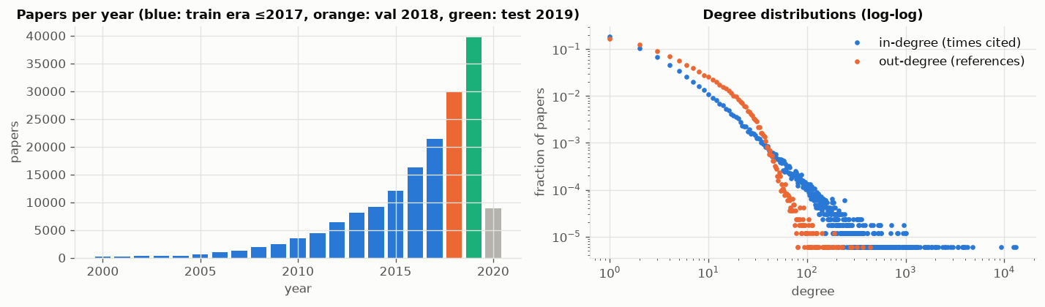
Figure 1. Left: papers per year, coloured by role (train era ≤ 2017, validation 2018, test 2019). Right: in-degree (times cited) and out-degree (references) distributions on log-log axes.
Statistic | Mean | Median | 90th pct. | 99th pct. | Max | Share with 0
In-degree (times cited) | 6.89 | 1 | 12 | 87 | 13,155 | 37%
Out-degree (references) | 6.89 | 4 | 18 | 37 | 436 | 10%
Table 7. Degree statistics of the full citation graph.

5.1 Findings
- The corpus grows quickly. 2019 alone has about 40,000 papers, more than all papers before 2014 combined. Test queries therefore have about 120,000 candidates, so the ranking task is hard.
- Citations are extremely skewed. The median paper is cited once and 37% are never cited inside the dataset, while a few papers are cited thousands of times. This is why popularity is a non-trivial baseline and why popularity bias has to be measured (Section 8.7).
- Reference lists are short. A paper has on average 6.0 eligible references (median 3), and 15% have none. The min_refs = 5 threshold leaves enough history and targets per query while keeping a large query set.
- The provided features are anisotropic. The averaged skip-gram vectors all point in nearly the same direction, which turns out to make them weak for cosine-similarity retrieval (Section 8.1).

6. Models
All models implement one interface. fit(train_graph, features, split) learns anything trainable from the training graph only; prepare(eval_graph) loads time-valid statistics for the split being evaluated; and score(queries) returns a score for every node. Ineligible candidates are masked by the shared evaluator (Section 7), never by the models.

6.1 Popularity baseline
Score(c) = log(1 + number of times c is cited in the time-valid evaluation graph). Every query receives the same ranking. This is the non-personalised reference point.

6.2 Content-based models
Each paper is represented from its title and abstract in one of four ways:
Representation | Details
TF-IDF | scikit-learn, English stop words, sublinear tf, terms in ≥ 2 documents and ≤ 50% of documents (65,641 terms)
BM25 | Okapi BM25 (k₁ = 1.5, b = 0.75) as a sparse matrix product; unit-tested to match rank_bm25 exactly
OGB features | The provided 128-d averaged skip-gram vectors, raw and mean-centred
MiniLM | sentence-transformers/all-MiniLM-L6-v2 sentence embeddings (384-d), computed once and cached to disk
Table 8. Content representations.
A query can be represented in three ways, all reported: own (P's own text), history (the mean of the history papers' vectors) and combo (α · own + (1 − α) · history, with both parts L2-normalised, which equals a weighted sum of cosine similarities; BM25 mixes max-normalised score vectors). α is tuned on validation.

6.3 Graph-based models
All graph statistics come from the time-valid evaluation graph. Let A be the directed adjacency matrix (A[i, j] = 1 if i cites j) and h the indicator vector of the history set H.
- Co-citation: score(c) = Σₓ∈H number of papers citing both x and c = (h Aᵀ A)[c].
- Bibliographic coupling: score(c) = Σₓ∈H number of references shared by x and c = (h A Aᵀ)[c]. We also report the sum of both.
- Personalized PageRank (PPR): a random walk with restart probability α to the history set, following citations in both directions, with 20 power iterations computed as batched sparse-dense products. α ∈ {0.1, 0.25, 0.5} is tuned on validation (chosen: α = 0.25).
- node2vec: 128-d embeddings (walk length 20, context 10, p = q = 1) trained on the observed graph of each evaluation split. A query is the mean of its history embeddings. Trained with 3 seeds.
Integer co-citation and coupling counts are tie-broken by popularity. Nodes that a graph method cannot reach are back-filled with popularity scores placed below all reached nodes.

6.4 Graph Neural Network: inductive directional GraphSAGE
Node features are the MiniLM text embeddings. Each layer has separate weights for “papers I cite” (references) and “papers that cite me” (citers), so the direction of citation is preserved. With L = 2 layers and 256 hidden units:
h⁰ᵥ = W_in xᵥ (+ a learnable ID embedding for papers seen in training)
hˡᵥ = hˡ⁻¹ᵥ + GELU(LayerNorm(W_self hˡ⁻¹ᵥ + W_ref · mean_{u∈refs(v)} hˡ⁻¹ᵤ + W_cit · mean_{u∈citers(v)} hˡ⁻¹ᵤ))
zᵥ = normalise(W_out hᴸᵥ)
Cold-start queries. A test paper has no edges. Its embedding is computed inductively by treating it as a temporary node whose only neighbours are its history papers (as references) and which has no citers. A unit test verifies that this equals the item embedding of a paper that cites exactly its history. Target edges are never used. The final score is ⟨q, z_c⟩ + λ · cos(x_P, x_c), where λ is a learnable weight on a text “skip” term.
Training mimics evaluation. In each epoch, 50% of training-era papers become pseudo-queries: all their outgoing edges are removed from the message-passing graph, and their references are split 50/50 into history and targets. The model is trained with mini-batch neighbour sampling (PyG NeighborLoader, fan-out [10, 5]) and a sampled-softmax loss that scores each (query, target) pair against 512 shared random time-valid negatives (temperature 0.1). BPR and BCE losses and text-similar hard negatives are implemented as options and compared in Section 8.5. Optimisation uses Adam (learning rate 10⁻³) with early stopping on validation NDCG@20 (patience 3), over 3 seeds.

6.5 Hybrid score fusion
For each query, each component's scores are normalised over the time-eligible candidates and combined linearly:
S(P, c) = w_text · norm(S_text) + w_graph · norm(S_graph) + w_pop · norm(S_pop)
S_text is the MiniLM combo similarity, S_graph is PPR and S_pop is popularity. Two normalisations are compared: per-query z-score and log-rank (norm = −log of c's rank in that component's ranking). The weights and the normalisation are chosen by grid search on validation NDCG@20 over 1,500 validation queries. The test set is used once, with the chosen weights. A second fusion adds the trained GNN as a component (GNN + PPR, and GNN + MiniLM + PPR).

7. Evaluation Protocol
- Candidates. For query P: all papers with year < year(P), minus P and its history (about 91,000 for 2018 queries and 121,000 for 2019 queries).
- Relevance. The hidden targets, with binary relevance.
- Full ranking. Every model scores every candidate, with no sampled negatives, and the exact rank of every target is computed. Ties are broken by a fixed, seeded random order shared by all models. Scoring runs in batches of 256 queries, so no N × N matrix is ever built.
- Model selection. Every hyper-parameter (α for query mixing, PPR restart, fusion weights and normalisation, GNN epoch) is chosen on the 2018 validation queries. The 2019 test queries are evaluated once per configuration. Trained models (node2vec and the GNN) are reported as mean ± standard deviation over 3 seeds.
Metric | Definition used
Recall@K | Number of targets in the top K divided by the number of targets
NDCG@K | Σ over targets ranked ≤ K of 1 / log₂(rank + 1), divided by the best achievable value for that query. Primary metric (K = 20) and the model-selection criterion
MRR | 1 / rank of the first target in the full ranking
Popularity of recommendations | Mean popularity percentile, share in the top-1% most cited, unique papers and median citations of the top-10 lists
Table 9. Evaluation metrics (averaged over queries; K ∈ {10, 20, 50}).
The metric code is verified against hand-computed examples in tests/test_metrics.py. For example, with target ranks 2 and 3 the harness returns Recall@2 = 0.5, MRR = 0.5 and NDCG@3 = (1/log₂3 + 1/log₂4) / (1 + 1/log₂3) = 0.6934, matching the hand computation. In total 22 unit tests cover the metrics, the leakage properties of the split and graphs, and the models.

8. Results

8.1 Overall comparison
Family | Model | R@10 | R@20 | R@50 | N@10 | N@20 | MRR | Val N@20
Popularity | Popularity | 0.063 | 0.085 | 0.112 | 0.078 | 0.084 | 0.197 | 0.095
Content | TF-IDF (own + history) | 0.156 | 0.216 | 0.315 | 0.158 | 0.180 | 0.323 | 0.197
Content | BM25 (own + history) | 0.153 | 0.209 | 0.304 | 0.160 | 0.180 | 0.333 | 0.194
Content | OGB features, raw (own + history) | 0.028 | 0.038 | 0.058 | 0.030 | 0.034 | 0.080 | 0.039
Content | OGB features, centred (own + history) | 0.044 | 0.063 | 0.100 | 0.045 | 0.052 | 0.113 | 0.061
Content | MiniLM (own + history) | 0.152 | 0.213 | 0.319 | 0.153 | 0.176 | 0.318 | 0.196
Graph | Co-citation | 0.185 | 0.255 | 0.353 | 0.198 | 0.222 | 0.397 | 0.253
Graph | Bibliographic coupling | 0.063 | 0.100 | 0.168 | 0.059 | 0.074 | 0.130 | 0.101
Graph | Co-citation + coupling | 0.187 | 0.259 | 0.364 | 0.199 | 0.225 | 0.395 | 0.260
Graph | Personalized PageRank | 0.248 | 0.351 | 0.505 | 0.246 | 0.285 | 0.431 | 0.333
Graph | node2vec (3 seeds) | 0.111 | 0.161 | 0.241 | 0.113 | 0.131 ± 0.003 | 0.241 | 0.146
Hybrid | GNN: directional GraphSAGE (3 seeds) | 0.133 | 0.193 | 0.302 | 0.126 | 0.151 ± 0.003 | 0.256 | 0.205
Hybrid | Fusion: MiniLM + PPR | 0.285 | 0.395 | 0.547 | 0.290 | 0.330 | 0.501 | 0.373
Hybrid | Fusion: MiniLM + PPR + popularity | 0.290 | 0.401 | 0.549 | 0.298 | 0.338 | 0.517 | 0.377
Table 10. Test results on the 5,000 queries from 2019. Content models use the validation-tuned own + history query. Trained models show mean ± std over 3 seeds. Val N@20 is NDCG@20 on the 2018 validation queries. Best model highlighted.
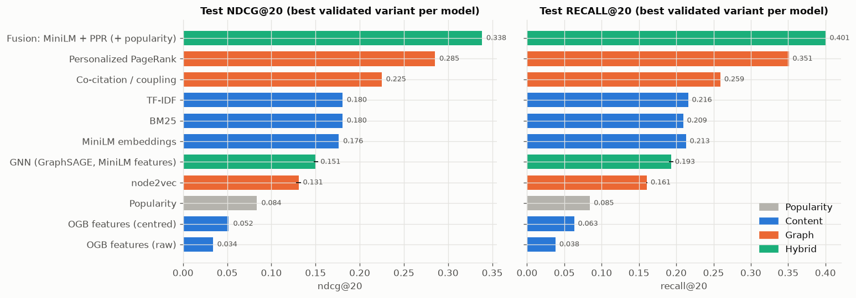
Figure 2. Test NDCG@20 (left) and Recall@20 (right) for the best validated variant of each model, coloured by family.
Content beats popularity by a wide margin. The best text models roughly double popularity (TF-IDF 0.180, BM25 0.180, MiniLM 0.176 vs 0.084). Classical sparse retrieval is as good as the small sentence-embedding model, because CS abstracts share precise technical vocabulary. The provided OGB features are the exception (0.034 raw, 0.052 centred, both below popularity): the averaged skip-gram vectors are so anisotropic that cosine similarity carries little information.
The citation graph is the strongest single signal. Co-citation alone reaches 0.222, and Personalized PageRank reaches 0.285 with Recall@50 = 0.505, +62% over the best text model. Papers cited together with a researcher's history are very likely to be cited by the researcher too. Bibliographic coupling is much weaker (0.074), and node2vec (0.131 ± 0.003) loses to the simple heuristics, because averaging a few history embeddings blurs the precise, local co-citation evidence that PPR uses directly.
Text and graph are complementary. The fusion of MiniLM and PPR reaches 0.330 (+16% over PPR), and adding a small popularity term gives the best model overall: NDCG@20 = 0.338, Recall@20 = 0.401 and MRR = 0.517. The fusion models are also the two best models on validation (0.373 and 0.377), so the choice of the best model does not depend on the test set.
The GNN learns a real hybrid signal but does not beat PPR on its own. On validation it is slightly better than MiniLM (0.205 vs 0.196), but on test it falls below it (0.151 vs 0.176). Section 8.7 shows why.

8.2 Text-only vs graph-only vs hybrid
This is the most direct test of the research question: the best validated model from each family, on the same test queries.
Family | Model | Recall@20 | NDCG@20 | MRR | NDCG@20 vs PPR
None | Popularity | 0.085 | 0.084 | 0.197 | −70.6%
Text only | MiniLM (own + history) | 0.213 | 0.176 | 0.318 | −38.2%
Text only | TF-IDF (own + history) | 0.216 | 0.180 | 0.323 | −36.7%
Graph only | Personalized PageRank | 0.351 | 0.285 | 0.431 | +0.0%
Text + graph | MiniLM + PPR | 0.395 | 0.330 | 0.501 | +15.7%
Text + graph + pop. | MiniLM + PPR + popularity | 0.401 | 0.338 | 0.517 | +18.7%
Learned hybrid | GNN (text features + graph) | 0.193 | 0.151 | 0.256 | −47.2%
Table 11. Best model per family on the 2019 test queries.
Adding the GNN as a fusion component was evaluated on validation only. GNN + MiniLM + PPR reached NDCG@20 = 0.378, against 0.377 for MiniLM + PPR + popularity and 0.375 for GNN + PPR. This is a tie within noise rather than a clear win, and the test evaluation is listed as future work.

8.3 How should the query be represented?
Model | Own text | History | Combo | Chosen | Combo vs own
TF-IDF | 0.155 | 0.129 | 0.180 | α=0.6 | +16%
BM25 | 0.153 | 0.131 | 0.180 | α=0.75 | +18%
MiniLM | 0.165 | 0.130 | 0.176 | α=0.6 | +7%
OGB features (centred) | 0.039 | 0.039 | 0.052 | α=0.5 | +33%
OGB features (raw) | 0.033 | 0.021 | 0.034 | α=0.9 | +1%
Table 12. Test NDCG@20 of content models by query representation. α is the weight on the paper's own text, chosen on validation.
For every content model, the query paper's own text is a better query than the mean of its history, and the validation-tuned combination is best, improving NDCG@20 over own text by 7% (MiniLM) to 18% (BM25), and by 33% for the weak OGB features. The chosen weight on the paper's own text is 0.5–0.75: the abstract describes the topic precisely, while the history adds the specific context of the researcher's reading.

8.4 Fusion weights and normalisation
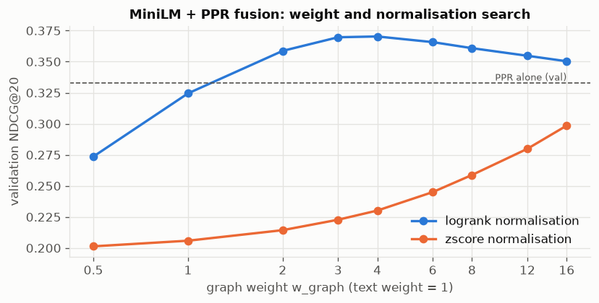
Figure 3. Validation NDCG@20 of MiniLM + PPR fusion as a function of the graph weight (text weight = 1), for z-score and log-rank normalisation, compared with PPR alone.
With z-score normalisation the fused model never reaches PPR alone, whatever the weight. PPR gives tiny scores to most of the graph and popularity back-fill values to unreachable papers, so after z-scoring almost every reached paper gets the same value and PPR's ordering is lost. Log-rank normalisation compares the components on the scale of positions in their rankings, which is robust to these heavy tails. The chosen weights are text = 1, graph = 4 (and popularity = 0.25 in the three-way model): the graph does most of the ranking, and text re-orders it and fills in papers the graph cannot reach.

8.5 GNN design choices and training
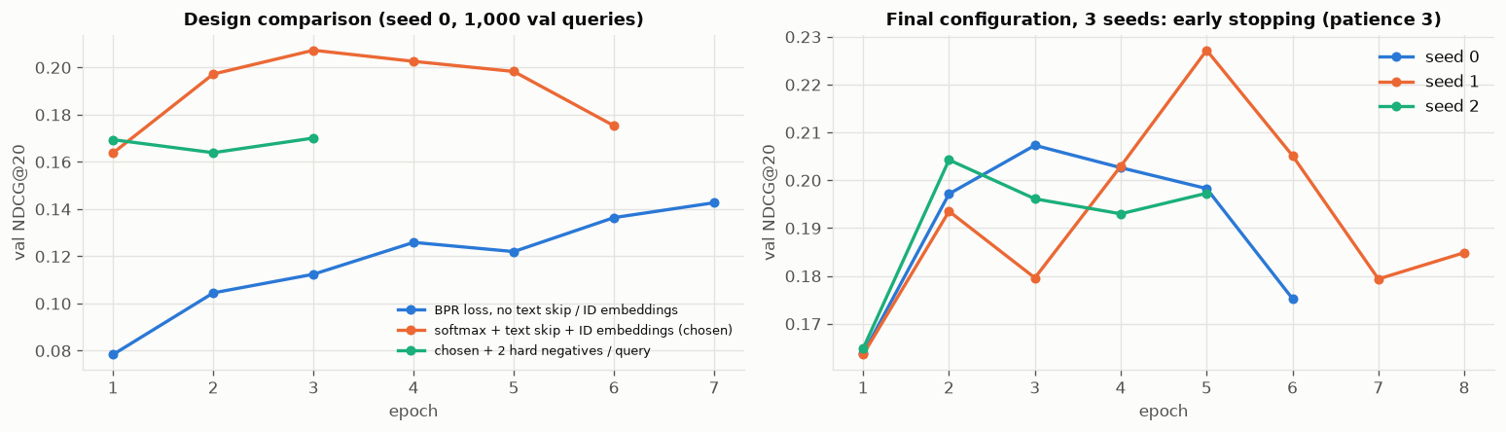
Figure 4. Left: validation NDCG@20 per epoch for three GNN designs (seed 0, 1,000 validation queries). Right: the chosen configuration over 3 seeds with early stopping (patience 3).
Seed | Val NDCG@20 | Test NDCG@20 | Test Recall@20 | Test MRR
0 | 0.199 | 0.147 | 0.189 | 0.252
1 | 0.218 | 0.152 | 0.196 | 0.256
2 | 0.196 | 0.153 | 0.195 | 0.260
Mean ± std | 0.205 ± 0.010 | 0.151 ± 0.003 | 0.193 ± 0.003 | 0.256 ± 0.003
Table 13. GNN results per seed.
- BPR against random negatives is too easy. Training loss falls below 0.03 after two epochs, and validation NDCG@20 only reaches about 0.14 after seven epochs. A sampled-softmax loss over the same negatives, together with the learnable text skip term and node ID embeddings, raises it to about 0.21.
- Hard negatives did not help. Text-similar older papers that the query does not cite lowered validation NDCG. Many of them are probably relevant papers the author simply did not cite, so treating them as negatives adds label noise.
- The model overfits after 2–5 epochs. The best epochs are 3, 5 and 2 for the three seeds; training loss keeps falling while validation NDCG drops, which is why early stopping on validation NDCG@20 matters.

8.6 Effect of the time mask
The time mask restricts candidates to papers published before the query. Removing it adds the roughly 48,600 papers from 2019–2020 as candidates, papers that a 2019 reference list could never cite.
Model | NDCG@20 with mask | NDCG@20 without | Change
Popularity | 0.084 | 0.084 | +0.0%
MiniLM (own + history) | 0.176 | 0.127 | −28.1%
Personalized PageRank | 0.285 | 0.285 | −0.1%
MiniLM + PPR + popularity | 0.338 | 0.338 | +0.0%
GNN (seed 0) | 0.147 | 0.142 | −3.3%
Table 14. Test NDCG@20 with and without the time mask.
Text similarity is hurt most: without the mask, MiniLM fills its lists with newer papers on the same topic. Graph-based models are unaffected because future papers have no edges in the time-valid graph. The mask is therefore essential for a fair evaluation of content models.

8.7 Who benefits? Breakdowns and popularity bias
We break test performance down by the number of eligible references of the query, by how well-connected the query's history is (mean in-degree of the history papers, in quartiles), and per target by how often the target is cited in the time-valid graph.
Model | 5–7 | 8–11 | 12–19 | 20+
Popularity | 0.056 | 0.075 | 0.093 | 0.113
MiniLM | 0.189 | 0.184 | 0.177 | 0.151
PPR | 0.269 | 0.289 | 0.287 | 0.296
GNN | 0.176 | 0.163 | 0.136 | 0.110
MiniLM + PPR | 0.305 | 0.330 | 0.342 | 0.342
MiniLM + PPR + pop. | 0.312 | 0.338 | 0.351 | 0.353
Table 15. Test NDCG@20 by number of eligible references of the query (1,250 / 1,211 / 1,460 / 1,079 queries).
Model | Q1 (niche) | Q2 | Q3 | Q4 (well cited)
Popularity | 0.021 | 0.068 | 0.111 | 0.135
MiniLM | 0.247 | 0.175 | 0.140 | 0.143
PPR | 0.319 | 0.273 | 0.270 | 0.278
GNN | 0.247 | 0.145 | 0.101 | 0.095
MiniLM + PPR | 0.369 | 0.327 | 0.307 | 0.316
MiniLM + PPR + pop. | 0.373 | 0.336 | 0.317 | 0.326
Table 16. Test NDCG@20 by history connectivity quartile (mean in-degree of history papers; boundaries 24, 101 and 448 citations).
Model | 0 | 1–4 | 5–19 | 20–99 | 100+
Popularity | 0.000 | 0.000 | 0.000 | 0.000 | 0.305
MiniLM | 0.293 | 0.278 | 0.241 | 0.167 | 0.072
PPR | 0.152 | 0.190 | 0.212 | 0.292 | 0.573
GNN | 0.310 | 0.205 | 0.180 | 0.144 | 0.078
MiniLM + PPR | 0.201 | 0.266 | 0.295 | 0.366 | 0.530
MiniLM + PPR + pop. | 0.177 | 0.242 | 0.277 | 0.364 | 0.586
Table 17. Share of targets ranked in the top 20, by how often the target is cited (2,819 / 5,967 / 8,069 / 8,785 / 10,245 targets).
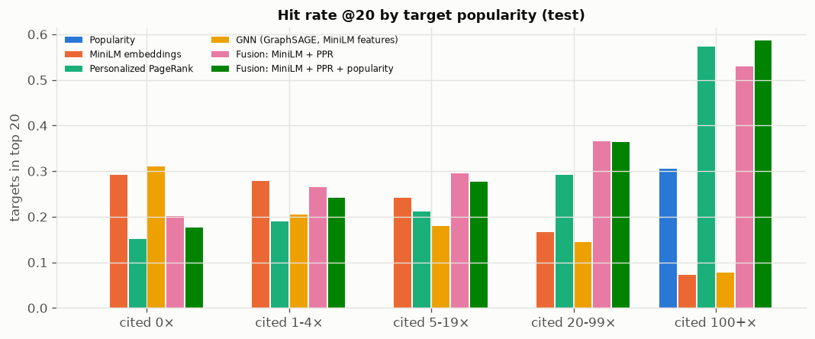
Figure 5. Hit rate in the top 20 by target popularity for each model.
Model | Mean pop. percentile | Top-10 in top-1% | Unique papers | Median cited | From 2018
Popularity | 1.00 | 100% | 17 | 2172 | 0%
MiniLM | 0.65 | 6% | 22,002 | 2 | 45%
PPR | 0.87 | 54% | 15,174 | 72 | 19%
GNN | 0.48 | 6% | 20,117 | 0 | 63%
MiniLM + PPR | 0.84 | 44% | 16,626 | 25 | 24%
MiniLM + PPR + pop. | 0.88 | 54% | 14,889 | 60 | 18%
Table 18. Popularity of the top-10 recommendations over all 5,000 test queries. For comparison, the targets themselves have a mean popularity percentile of 0.88, 41% are in the top 1% most cited, and 25% are from 2018.
- Targets are themselves popular. 41% of hidden targets are among the 1% most-cited papers, so recommending well-cited papers is partly correct, not only bias.
- Text and graph succeed on different targets. For never-cited targets, MiniLM ranks 29% in the top 20 versus 15% for PPR. For targets cited 100+ times, it is the reverse: PPR 57% vs MiniLM 7%. The MiniLM + PPR fusion is the best model for every bucket from 1 to 99 citations and lies between the two at the extremes. This complementarity is exactly why combining the signals works.
- Popularity bias differs sharply. The popularity baseline recommends only 17 distinct papers across 5,000 queries. PPR puts 54% of its top-10 slots on top-1% papers; MiniLM only 6%. The two-way fusion is less popularity-biased than PPR (44%, median 25 citations) while being more accurate; adding the popularity term moves it back to PPR's level for a small accuracy gain.
- The GNN over-recommends new, uncited papers. The median citation count of its top-10 is 0, and 63% of its slots go to 2018 papers, although only 25% of targets are from 2018. These papers are never candidates during training or validation, so at test time they have essentially no learned ID embedding and an unseen neighbourhood, and the model scores them too highly.
- Niche histories are easier. Every personalised model does best when the history consists of rarely-cited papers (fusion 0.374 in Q1 vs 0.327 in Q4). A niche history pins down a specific sub-community, while generic classic references say little about what else the author needs. Only the popularity baseline improves with connectivity.
- Longer reference lists hurt text-only models (MiniLM 0.189 → 0.151) because the targets become more diverse than one abstract describes, while PPR improves (0.269 → 0.296) because it gets more seeds.

8.8 Qualitative examples
Five randomly sampled 2019 test queries (fixed seed) with the top-10 recommendations of the best model (MiniLM + PPR + popularity fusion). Highlighted rows with ✓ are hidden targets, i.e. papers the query actually cites. “Cited” is the citation count in the time-valid graph. Titles are shown in the dataset's lower-case form.

Example 1: “multi task learning for argumentation mining”
History: 18 papers (e.g. argumentation mining in user generated web discourse; move evaluation in go using deep convolutional neural networks). Hidden targets: 17. Hits in the top 10: 3. The graph component finds standard NLP references (Natural Language Processing (Almost) from Scratch, Sequence to Sequence Learning), while the top-ranked paper is a near-duplicate topic that the authors did not cite, so it counts as a miss.
Rank | Hit | Recommended paper | Year | Cited
1 |  | multi task learning for argumentation mining in low resource settings | 2018 | 2
2 | ✓ | when is multitask learning effective semantic sequence prediction under varying data conditions | 2016 | 13
3 | ✓ | natural language processing almost from scratch | 2011 | 684
4 | ✓ | sequence to sequence learning with neural networks | 2014 | 1606
5 |  | distributed representations of words and phrases and their compositionality | 2013 | 1910
6 |  | semi supervised multitask learning for sequence labeling | 2017 | 27
7 |  | end to end sequence labeling via bi directional lstm cnns crf | 2016 | 96
8 |  | efficient estimation of word representations in vector space | 2013 | 1415
9 |  | neural machine translation by jointly learning to align and translate | 2014 | 1901
10 |  | recurrent neural network for text classification with multi task learning | 2016 | 18

Example 2: “procedural content generation from automatically generating game levels to increasing generality in machine learning”
History: 8 papers (e.g. cad2rl real single image flight without a single real image; equality of opportunity in supervised learning). Hidden targets: 8. Hits in the top 10: 2. A mixed history (game generation, fairness, data augmentation) lets field-wide classics such as Adam, Batch Normalization and VGG into the list; the hits are two rarely-cited, topically close papers found by text.
Rank | Hit | Recommended paper | Year | Cited
1 |  | the arcade learning environment an evaluation platform for general agents | 2013 | 242
2 |  | playing atari with deep reinforcement learning | 2013 | 431
3 | ✓ | evolving mario levels in the latent space of a deep convolutional generative adversarial network | 2018 | 5
4 |  | deep learning for video game playing | 2017 | 5
5 |  | vizdoom a doom based ai research platform for visual reinforcement learning | 2016 | 37
6 |  | adam a method for stochastic optimization | 2014 | 5129
7 |  | batch normalization accelerating deep network training by reducing internal covariate shift | 2015 | 2310
8 |  | revisiting the arcade learning environment evaluation protocols and open problems for general agents | 2017 | 27
9 | ✓ | a study on overfitting in deep reinforcement learning | 2018 | 4
10 |  | very deep convolutional networks for large scale image recognition | 2014 | 4748

Example 3: “mask scoring r cnn”
History: 16 papers (e.g. learning to segment object candidates; instance aware semantic segmentation via multi task network cascades). Hidden targets: 16. Hits in the top 10: 4. Four hits mix famous detection papers (Faster R-CNN, ResNet, FCN) with the rarely-cited MaskLab (7 citations). Mask R-CNN, which this paper directly extends, is ranked first but is not among its eligible references.
Rank | Hit | Recommended paper | Year | Cited
1 |  | mask r cnn | 2017 | 355
2 | ✓ | faster r cnn towards real time object detection with region proposal networks | 2015 | 1611
3 | ✓ | deep residual learning for image recognition | 2015 | 4564
4 | ✓ | masklab instance segmentation by refining object detection with semantic and direction features | 2017 | 7
5 |  | very deep convolutional networks for large scale image recognition | 2014 | 4748
6 | ✓ | fully convolutional networks for semantic segmentation | 2014 | 1850
7 |  | fast r cnn | 2015 | 980
8 |  | semantic image segmentation with deep convolutional nets and fully connected crfs | 2014 | 526
9 |  | imagenet large scale visual recognition challenge | 2014 | 2195
10 |  | simultaneous detection and segmentation | 2014 | 202

Example 4: “single particle cryo electron microscopy mathematical theory computational challenges and opportunities”
History: 5 papers (e.g. non unique games over compact groups and orientation estimation in cryo em; apple picker automatic particle picking a low effort cryo em framework). Hidden targets: 5. Hits in the top 10: 2. A niche community: all ten recommendations are specialised, rarely-cited cryo-EM papers from the right sub-field.
Rank | Hit | Recommended paper | Year | Cited
1 | ✓ | fast steerable principal component analysis | 2014 | 3
2 |  | the sample complexity of multi reference alignment | 2017 | 4
3 |  | orthogonal matrix retrieval in cryo electron microscopy | 2015 | 4
4 |  | covariance estimation using conjugate gradient for 3d classification in cryo em | 2015 | 5
5 |  | spectral methods from tensor networks | 2018 | 1
6 | ✓ | heterogeneous multireference alignment a single pass approach | 2017 | 2
7 |  | a representation theory perspective on simultaneous alignment and classification | 2016 | 4
8 |  | a max cut approach to heterogeneity in cryo electron microscopy | 2016 | 3
9 |  | continuously heterogeneous hyper objects in cryo em and 3 d movies of many temporal dimensions | 2017 | 3
10 |  | multireference alignment using semidefinite programming | 2013 | 15

Example 5: “pod positional dependency based word embedding for aspect term extraction”
History: 8 papers (e.g. dependency recurrent neural language models for sentence completion; recursive neural conditional random fields for aspect based sentiment analysis). Hidden targets: 9. Hits in the top 10: 1. The rarely-cited aspect-extraction paper ranked first is a hit; the rest of the list drifts toward generic deep-learning and NLP classics.
Rank | Hit | Recommended paper | Year | Cited
1 | ✓ | unsupervised word and dependency path embeddings for aspect term extraction | 2016 | 8
2 |  | distributed representations of sentences and documents | 2014 | 485
3 |  | aspect based sentiment analysis using a two step neural network architecture | 2016 | 1
4 |  | a unified model for opinion target extraction and target sentiment prediction | 2018 | 0
5 |  | natural language processing almost from scratch | 2011 | 684
6 |  | a convolutional neural network for modelling sentences | 2014 | 329
7 |  | deep residual learning for image recognition | 2015 | 4564
8 |  | aspect sentiment model for micro reviews | 2018 | 1
9 |  | convolutional neural networks for sentence classification | 2014 | 397
10 |  | adam a method for stochastic optimization | 2014 | 5129

Two kinds of hits. Some hits are the standard references of a sub-field, which the graph component finds through co-citation. Others are topically very close, rarely-cited papers that the text component finds. The ground truth is incomplete: several misses are clearly relevant (for example Mask R-CNN for Mask Scoring R-CNN), so the absolute scores understate how useful the recommendations are. The main failure mode is generic popular papers (Adam, Batch Normalization, VGG) that enter the list when the history is broad.

9. Discussion

9.1 Why the fusion works
The graph and text components fail in different places. PPR is excellent at recovering the established, well-cited references of a sub-field, but it cannot reach papers with no or very few citations. Text similarity finds those rarely-cited papers, but it cannot tell which of many topically similar papers a community actually cites. The breakdown by target popularity shows the two curves crossing, and the fusion follows the better of the two in most buckets. Rank-based fusion lets each component contribute what it is good at without one component's score scale dominating.

9.2 Why the GNN falls short
The GNN combines both signals in one model, yet it is weaker than either strong component. Three reasons stand out. First, a distribution shift between training and test: 2018 papers enter the candidate set only at test time, and the model ranks them too highly. Second, the strongest graph evidence is local and exact (how many history papers are co-cited with a candidate), which a mean-aggregating 2-layer GNN with sampled neighbours captures only approximately. Third, the GNN was tuned lightly: three design variants and three seeds. On validation, where there is no shift, it beats MiniLM, and as a fusion component it matches the best fusion. This suggests the learned representation is useful, but is not yet the best stand-alone ranker.

9.3 Normalisation matters as much as the model
The same two components give a worse model than PPR alone with z-scores, and the best model with log-rank normalisation. Heavy-tailed scores such as PageRank values and back-filled popularity are common in recommendation, and combining them by their raw or standardised values is fragile. Rank-based normalisation was the single most important design decision in the hybrid.

9.4 Accuracy versus popularity bias
Adding the popularity term increases accuracy slightly (NDCG@20 0.330 → 0.338) but also shifts recommendations toward the most-cited papers (top-1% share 44% → 54%). Because many targets really are highly cited, this is partly correct behaviour. A deployed system might prefer the two-way fusion, which is nearly as accurate and recommends more varied, less-cited papers.

9.5 Cold start
Every query is a brand-new paper with no citations, so the system handles query-side cold start by design, through the paper's text and its history. On the candidate side, never-cited papers are hard for graph methods, and text is the main route to them: MiniLM finds 29% of uncited targets in its top 20 and the GNN 31%, against 15% for PPR and 18% for the best fusion. Recommending new work remains the clearest open problem.

10. Limitations and Future Work

10.1 Limitations
- Proxy users. A paper's reference list stands in for a researcher's reading history. Real histories are noisier, span several topics and contain papers that are never cited. The ground truth is incomplete: a relevant paper the author did not cite counts as a miss.
- Year-level timestamps. Publication year is the only time information, so same-year references had to be excluded (11% of citations), and revisions blur the timeline (1.8% of edges point into the future).
- Text encoder. For compute reasons we used MiniLM instead of the planned SPECTER2, a scientific-document encoder trained on citations, which would likely strengthen both the text models and the GNN.
- Light GNN tuning. Only a handful of GNN configurations and three seeds were run.
- Evaluation subset and variance. Validation and test use 5,000 sampled queries each out of 15,072 and 25,296. Seed-to-seed standard deviation is 0.003 NDCG@20 or less, but no confidence intervals over queries were computed, so very small differences should not be over-interpreted.

10.2 Next steps
- Finish the SPECTER2 embeddings (encoding is resumable) and re-run the text models and the GNN on them.
- Run the implemented history-fraction (25% / 75%) and min_refs (3 / 10) sensitivity studies.
- Evaluate the GNN-based fusion on the test set, and fix the GNN's distribution shift with ID-embedding dropout or training on a rolling time window.
- Learn fusion weights per query (for example a small learning-to-rank model using history connectivity as a feature), and add diversity-aware re-ranking to reduce popularity bias.
- Evaluate on all validation and test queries and report bootstrap confidence intervals.

11. Conclusion
We built a leakage-tested, time-aware benchmark for research-paper recommendation on ogbn-arxiv and used it to answer our research question. Content alone roughly doubles the popularity baseline, with classical TF-IDF and BM25 as strong as MiniLM. The citation graph is the strongest single signal, with Personalized PageRank reaching NDCG@20 = 0.285, and simple co-citation beats learned node2vec embeddings. Combining them is best: fusion of MiniLM and PPR with a small popularity term reaches NDCG@20 = 0.338 and Recall@20 = 0.401, +19% over the best graph-only model and +92% over MiniLM. A more complex model is not automatically better: our inductive GraphSAGE hybrid learns a useful representation but does not beat a well-normalised fusion of two simple, strong components.
Answer to the research question: yes. Combining semantic and citation-network information gives clearly better recommendations than content-only, graph-only and popularity baselines in a realistic, time-aware evaluation. In our experiments the most effective combination is simple score fusion with rank-based normalisation.

12. Deliverables and Reproducibility
The project is a Python codebase with a fixed seed, pinned dependencies (Python 3.12, PyTorch 2.5.1, PyTorch Geometric 2.6.1) and on-disk caching of every expensive artefact (split, embeddings, node2vec, GNN weights). It was developed on an Apple M4 with 16 GB of RAM and no CUDA; every component falls back to CPU.
Path | Contents
src/data.py, src/graph.py | Dataset and text join, query split; leak-free training and evaluation graphs
src/evaluate.py, src/metrics.py | Full-ranking evaluator (time mask, history exclusion, exact target ranks); Recall/NDCG/MRR
src/features.py | OGB, MiniLM and SPECTER2 features with caching
src/models/ | Popularity, content, graph heuristics, node2vec, fusion, GNN
src/experiment.py | Fit → validation tuning → test, mean ± std over seeds
scripts/ | eda, embed_text, run_baselines, train_gnn, run_ablations, make_tables
configs/ | default, baselines, fusion, fusion_gnn and gnn configurations
tests/ | 22 unit tests: metrics, leakage, models
results/ | Per-run JSON and per-query arrays, tables, ablations, figures, qualitative examples
report/ | Project_Report.html (executed notebook) and this Word report
Table 19. Repository structure.
pip install -r requirements.txt # plus PyG extension wheels, see README
python -m pytest # 22 tests
python scripts/eda.py # dataset statistics, saves the split
python scripts/embed_text.py --models minilm
python scripts/run_baselines.py # all baselines (val tuning -> test)
python scripts/run_baselines.py --config configs/fusion.yaml
python scripts/train_gnn.py # GNN, 3 seeds
python scripts/run_ablations.py --parts breakdowns timemask qualitative
python scripts/make_tables.py
python report/build_report.py # HTML report

Appendix A. Hyper-parameters
Model | Chosen on validation / fixed
TF-IDF / BM25 / MiniLM | α (weight on own text) = 0.6 / 0.75 / 0.6
OGB features raw / centred | α = 0.9 / 0.5
Personalized PageRank | restart α = 0.25, 20 iterations, both directions
Fusion (text + graph) | log-rank; text = 1.0, graph = 4.0
Fusion (text + graph + popularity) | log-rank; text = 1.0, graph = 4.0, popularity = 0.25
node2vec | dim 128, walk length 20, context 10, 5 walks per node, 2 epochs, lr 0.025
GNN | MiniLM features, 2 layers, 256 hidden, fan-out [10, 5], dropout 0.1, Adam lr 10⁻³, ≤ 15 epochs, patience 3, softmax loss (τ = 0.1, 512 shared negatives), text skip, ID embeddings, 256 queries per batch
Table 20. Hyper-parameters.

