X2C Universal motor shield 

**Authors:**

Csányi Dániel (Obuda university)

Mark Wendler

mark.wendler@microchip.com

Christoph Baumgartner

[christoph.baumgartner@microchip.com](mailto:christoph.baumgartner@microchip.com)

V 0.1

15.01.2018

**RECOMMENDED READING**

X2C development board docs:

* <http://x2c.microstickplus.com/home>

Table of Contents

1 Introduction 3

2 Hardware overview 4

2.1 X2C Board 4

2.2 Parts of shield 5

2.2.1 Supply 5

2.2.2 Mosfet driver 6

2.2.3 Output stage 8

2.2.4 Phase voltage feedback 10

2.2.5 Current gain 10

2.2.6 Hall and QEI sensor 11

2.2.7 CAN Bus 12

2.3 Pin configuration 13

2.4 Board connectors 14

2.5 User interface hardware 15

2.5.1 Jumpers 15

2.5.2 Leds 15

3 Operating requirements 17

4 Electrical specifications 18

4.1 DC input ratings 18

4.2 DC output ratings 18

5 Diagram lists 19

6 Attachments 20

7 Sources 22

# Introduction

With the X2C motor driver development board we can control a BLDC (brushless DC) motor or a permanent magnet synchronous motor (PMSM). This Motorshield is a separate board from the X2C+ Development Board and this board is not contained microcontroller. The control unit is a X2C+ development board, integrated Pickit on Board programmer/debugger support. The main motor control device unit is a 16-bit dsPIC33EP256MC502.

This document is showed the Motorshield board without the X2C features.

* 1. Features overview

The key features of this board include the following:

* Motor Control Interfaces
* Three-phase inverter bridge with a power rating 48V/15A
* Hall sensors/quadrature encoder interface for sensored motor control
* Phase voltage feedback for sensorless BLDC operation
* DC bus current sesnse resistor for single shunt vector control
* Phase current sense resistor for dual shunt vector control
* Overcurrent protection
* Support for dsPIC DSCs with internal and external op amps
* Input/Output Control Switches
* LED indicators for EN/FLT
* LED indicators for PWM input
* Jumpers for sense
* Communication ports
* CAN interface port
* Power Supply Connectors
* 24V power input connector (Shield)
* Test Points

# Hardware overview

This part describes the hardware components of the X2C Motorshield. The Motorshield panel works only with the X2C+ Development Board. X2C Development board is the main control unit to provide the control signals for the motor shield.

Topics covered include:

* The schematic circuit (Attached in the supplement)
* X2C board
* Parts of shield
* Pin configuration
* Board connectors

## X2C Board

X2C+ Development Board is a cost-effective development board. The Development Board is designed to provide designers with an easy to use, economical development environment for 8 bit PIC Microcontrollers (PIC16F1885x and PIC18F2xK40), 16-bit dsPIC Enhanced Digital Signal Controllers (dsPIC33E), 16 bit PIC Enhanced Microcontrollers (PIC24E) and 32 bit PIC Microcontrollers (PIC32MX1, PIC32MM) manufactured in 28-pin SPDIP packing. It’s the perfect solution to those looking for a low-cost, easy-to-use development platform.

Some features:

* Onboard programmer/debugger PKOB
* Onboard peripherals
* No external power supply needed
* Suitable size
* Low cost

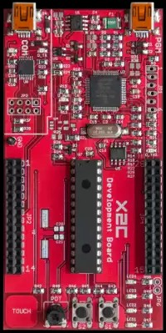

1. picture: X2C Development Board

The development Board is compatible with MPLAB X IDE. The software can run on PC to develop applications. It works at easy as Plug and Play, only connect the device to the PC and download the program to X2C. The Motorshield is had to connect to X2C Development Board that it is would be work.

## Parts of shield

The schematic circuit to separate into some main subunits according to their function.

These subunits:

1. 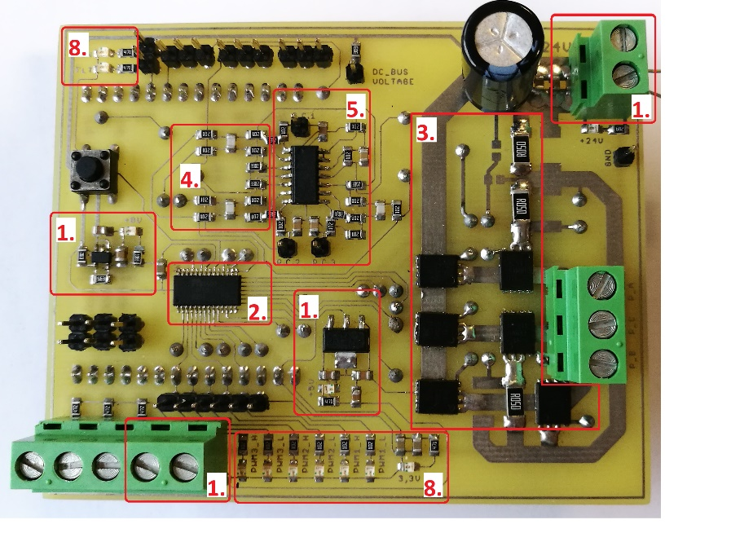Supply

2. picture: Parts of Motorshield

1. Mosfet driver
2. Output stage
3. Phase voltage feedback
4. Current gain
5. Hall and QEI sensor

(on the other side of shield)

1. CAN Bus

(on the other side of shield)

1. Supply and output feedbacks

### Supply

External supply up to 48V is required, because high output power is needed. The capacitors stabilize the voltage and filter external noises.

The second supply convert the voltage to 5V from 24V. The MCP1790 regulator provides up to 70 mA of current. The regulator has a tight tolerance output voltage load regulation of ±0.2% and a very good line regulation at ±0.0002%/V. The regulator output is stable with electrolytic capacitors.

|  |  |  |
| --- | --- | --- |
| Voltage level | Voltage source | User part |
| 24V | External | MOSFET |
| 8V | Regulator | MOSFET driver |
| 5V | Regulator | Leds, CAN, Motor sensors (CAN, HALL) |
| 3.3V | X2C | X2C, driver’s FLT pin, Current gain |

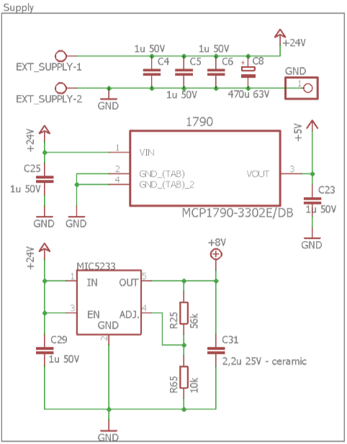

3. picture: Supply and regulators

The third voltage is the 8V, that use to Mosfet driver’s input voltage. The MIC5233 is a 100mA highly accurate, low dropout (270mV at 100mA) regulator with high input voltage. It only requires a 2.2uF capacitor for stability.

The sensors use a fourth voltage level – 3.3V, that support the X2C board.

### Mosfet driver

The three-phase Mosfet driver is a MIC4607. It features adaptive dead time and fast (35ns) propagation delay time and designed to independently drive six N-channel MOSFETs in a three phase bridge. Single PWM inputs can be separate high and low drive generated internally. High- and low-side outputs are guaranteed to not overlap in either mode. The driver includes overcurrent protection as well as a high-voltage internal diode that charges the high-side gate drive bootstrap capacitor. The programmable overcurrent protection circuit turns off all outputs during an overcurrent fault. Undervoltage protection is provided on both the low- and high side drivers. The input voltage is 8V from the regulator. The small switcing times that about 35ns, become a fast driver.

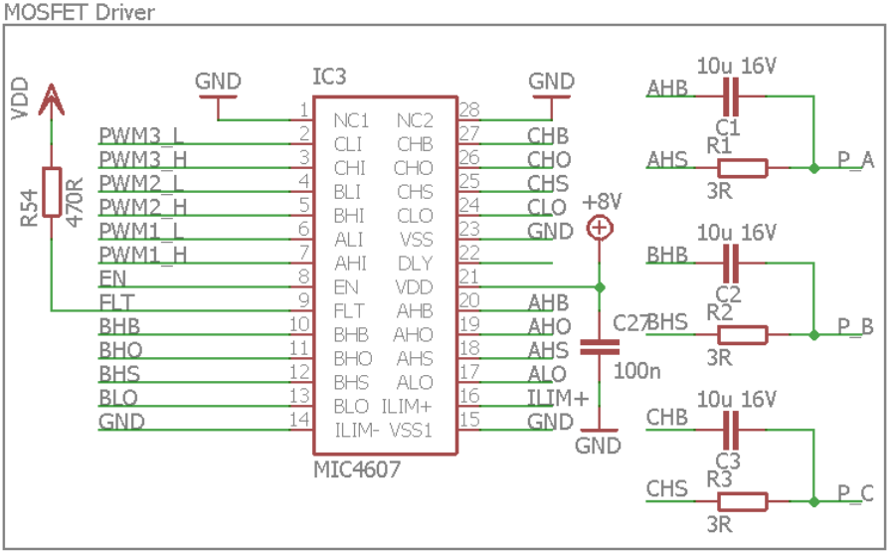

4. picture: MOSFET driver

There is one external enable pin that controls all three phases. A logic high on the enable pin (EN) allows for startup for all phases and normal operation. Conversely, when a logic low is applied on the enable pin, all phases turn-off and the device enters a low current shutdown mode. All outputs (xHO and xLO) are pulled low when EN is low.

FLT pin open-drain output is pulled low while the gate drive outputs are latched off after an over-current condition. It will de-assert once the DLY pin has reached the threshold and a rising edge occurs on any LI pin. During normal operation, the internal pull-down MOSFET is of the pin is high impedance. A pull-up resistor must be connected to this pin.

All input pins (xLI and xHI) are referenced to the VSS pin. The MIC4607 has a TTL-compatible input range and can be used with input signals with amplitude less than the supply voltage. The threshold level is independent of the VDD supply voltage and there is no dependence between and the input signal amplitude. This feature makes the driver an excellent level translator that will drive high level gate threshold MOSFETs from low-voltage PWM IC.

On the right side of the picture the external output signals attached to driver via bootstrap capacitor and a resistor. The ceramic condensator filter the noises.

|  |  |  |
| --- | --- | --- |
| **Pin number** | **Pin Name** | **Pinout description** |
| 2 | CLI | Low-Side Input for Phase C |
| 3 | CHI | High-Side Input for Phase C |
| 4 | BLI | Low-Side Input for Phase B |
| 5 | BHI | High-Side Input for Phase B |
| 6 | ALI | Low-Side Input for Phase A |
| 7 | AHI | High-Side Input for Phase A |
| 8 | EN | Active high enable input |
| 9 | FLT | Fault/pin goes low when overcurrent |
| 11 | BHO | Phase B High Side Drive Output |
| 13 | BLO | Phase B Low Side Drive Output |
| 14 | ILIM- | Differential Current-Limit Input (most -) |
| 16 | ILIM+ | Differential Current-Limit Input (most +) |
| 17 | ALO | Phase A Low Side Drive Output |
| 19 | AHO | Phase A High Side Drive Output |
| 21 | VDD | Input Supply |
| 22 | DLY | Fault Delay/connect to GND |
| 24 | CLO | Phase C Low Side Drive Output |
| 26 | CHO | Phase C High Side Drive Output |

### Output stage

The output stage principle is a three phase voltage inverter circuit that control the Mosfet driver. The N-channel MOSFET is a DMT4002LPS with very big continuously current (100A). This MOSFET has been designed to minimize the on-state resistance () and yet maintain superior switching performance, making it ideal for high efficiency power management applications.

Main features:

* Unclamped Inductive Switching
* Thermally Efficient Package
* High conversion Efficiency
* Low
* Small Package Profile

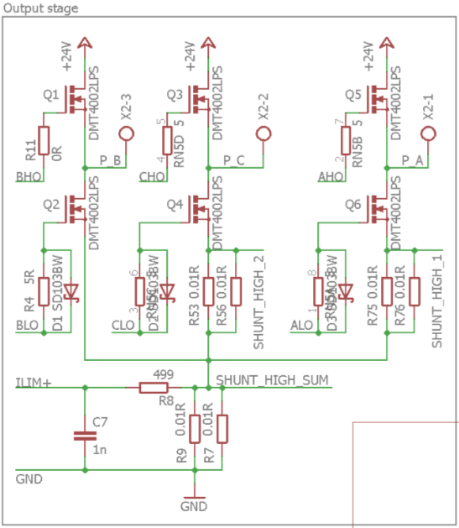

5. picture: Output stage

The ILIM+ and ILIM- pins provide a Kelvin-sensed circuit that monitors the voltage across an external current sense resistor. This resistor is typically connected between the source pins of all three low-side MOSFETs and power ground. If the peak voltage across this resistor exceeds the threshold, it will cause all six outputs to latch off when the current more than 40A.

|  |  |  |  |  |
| --- | --- | --- | --- | --- |
| **Main characteristics** | | | | |
| Characteristics | | Symbol | Value | Units |
| Max Drain-Source Voltage | |  | 40 | V |
| Max Gate-Source Voltage | |  | ±20 | V |
| Max Continuous Drain Current, | = +25  = +70 |  | 100  100 | A  A |
| Drain-Souce Breakdown Voltage |  |  | 40 | V |
| Static Drain-Source On-Resistance |  |  | 1.3 | mΩ |
| Rising Overcurrent Threshold | |  | 200 | mV |

### Phase voltage feedback

6. picture: Phase voltage feedback

The output signals are feedbacked by resistance divider. These feedbacks are connected to dsPIC microcontroller and it is processed the analog signals. The microcontroller is measured the voltages, because if the motor hasn’t got sensors, the control is generated from the phase voltages. This part is contained a supply to DC BUS. The X2C is communicated and is exchanged data with the Motorshield panel. The data transfer is operated as serial. The data is modulated to the DC BUS.

### Current gain

The MCP6024 is rail-to-rail input and output operational amplifiers with high performance.

Main features:

* Wide Bandwidth: 10 MHz
* Low Noise
* Low Offset Voltage
* Low Supply Current
* Power supply range: 2.5V to 5.5V

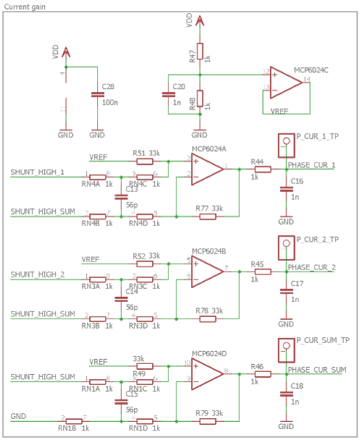

7. picture: Current gain

On low-side parts are measured the currents on A, C shunts and common sources level. . From the sum level is operated the overcurrent protection. In order to prevent damage and/or improper operation of these amplifiers, the circuit must limit the voltages at the input pins. The two resistros on the input side, limit the possible currents in or out of the input pins.

Circuit A (VDD to amplifier) sets the operational amplifier at its minimum noise gain. The resistor divider produces any desired reference voltage within the output voltage range of the operational amplifier. The operational amplifier buffers that reference voltage. Circuit B (Uref) uses the minimum number of components and operates as a comparator, but it may draw more current.

### Hall and QEI sensor

The most common way to control a BLDC motor is to use Hall sensors to determine the rotor position. The control system senses the rotor position and the proper voltage pattern is applied to the motor.

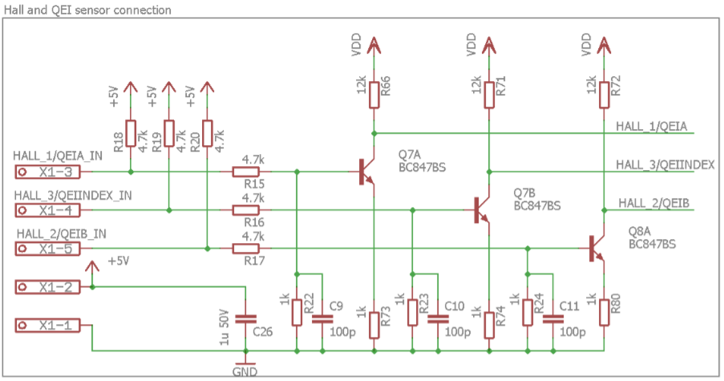

8. picture: Hall and QE sensor's circuit

A quadrature encoder is a type of incremental encoder used in many general automation applications where sensing the direction of movement is required. If your motor is used a large vector, a bearingless or magnetic encoder will provide the most reliable feedback. This part of circuit is contained a 5V output supply connectors.

### CAN Bus

The ATA6563 is a high-speed CAN transceiver that provides an interface between a controller area network (CAN) protocol controller and the physical two-wire CAN bus. The transceiver is designed for high-speed Can applications and providing differential transmit and receive capabillity to a CAN protocol controller.

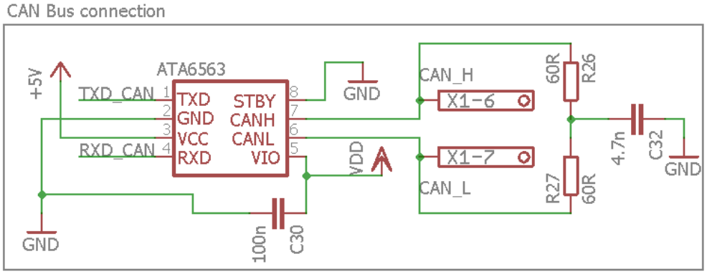

9. picture: Can bus circuit

The pin 5 is the VIO pin and should be connected to the microcontroller supply voltage. This allows direct interfacing to microcontrollers with supply voltages down to 3V and adjusts the signal levels of the TXD, RXD, and STBY pins to I/O levels of the microcontroller.

## Pin configuration

Summarizes the Pin configuration for the X2C Motorshield MIC4607 driver. This table shows the dsPIC Digital Signal Controller Pin configuration. These Pins use the main board, the MOSFET driver or part of the Motorshield panel.

|  |  |  |  |  |  |
| --- | --- | --- | --- | --- | --- |
| **dsPIC** | | **Motorshield** | | **User tool** | **Description** |
| **Pin number** | **Pin name** | **Pin number** | **Signal name** |
| 1 | MCLR | L1 | GND | Used both panel | Connect to GND |
| 2 | AN0/RA0 | L2 | Phase_I_V_2 | Used both panel | Measure voltage on Phase B or current on Phase C |
| 3 | AN1/ RA1 | L3 | POT | X2C Board | Potenciometer |
| 4 | PGED3/VREF-/AN2/RB0 | L4 | Phase_I_V_3 | Used both panel | Measure voltage on Phase C or current on common source point |
| 5 | PGEC3/VREF+/RPI33/RB1 | L5 | PGEC | No connection |  |
| 6 | PGEC1/AN4/RPI34/RB2 | L6 | Phase_I_V_1 | Used both panel | Measure voltage on Phase A or current on Phase A |
| 7 | PGED1/AN5/RP35/RB3 | L7 | DC_BUS | Motorshield panel | Communicating supply |
| 8 | VSS | L8 | GND | Used both panel | Connect to GND |
| 9 | RA2 | L9 | EN | Motorshield panel | Active high enable input |
| 10 | RA3 | L10 | FLT | Motorshield panel | Fault/pin goes low when overcurrent |
| 11 | RP36/RB4 | L11 |  | No connection |  |
| 12 | RP20/RA4 | L12 |  | No connection |  |
| 13 | VDD | L13 | NC | X2C Board | Not connected |
| 14 | PGED2/RP37/RB5 | L14 | RXD_CAN | Motorshield panel | Serial receive pin from MCU |
| 15 | AVDD | R1 | VDD | X2C Board | Supply as 3.3V |
| 16 | AVSS | R2 | GND | Used both panel | Connect to GND |
| 17 | RPI47/PWM1L /RB15 | R3 | PWM1_L | Motorshield panel | Low-Side Input for Phase A |
| 18 | RPI46/PWM1H/RB14 | R4 | PWM1_H | Motorshield panel | High-Side Input for Phase A |
| 19 | RPI45/PWM2L/RB13 | R5 | PWM2_L | Motorshield panel | Low-Side Input for Phase B |
| 20 | RPI44/PWM2H/RB12 | R6 | PWM2_H | Motorshield panel | High-Side Input for Phase B |
| 21 | RP43/PWM3L/RB11 | R7 | PWM3_L | Motorshield panel | Low-Side Input for Phase C |
| 22 | RP42/PWM3H/RB10 | R8 | PWM3_H | Motorshield panel | High-Side Input for Phase C |
| 23 | VCAP | R9 | NC | No connection |  |
| 24 | VSS | R10 | VSS | Used both panel | Connect to ground |
| 25 | TMS/RP41/RB9 | R11 | TXD_CAN | Motorshield panel | Serial transmit pin from MCU |
| 26 | TCK/RP40/RB8 | R12 | HALL_1/QEIA | Motorshield panel | HaLL and QE input for Phase A |
| 27 | RP39/RB7 | R13 | HALL_2/QEIB | Motorshield panel | HaLL and QE input for Phase B |
| 28 | PGEC2/RP38/RB6 | R14 | HALL_3/  QEIINDEX | Motorshield panel | HaLL and QE input for INDEX |

## Board connectors

The next tables describes the hardware connections.

|  |  |  |
| --- | --- | --- |
| **Number** | **Designator** | **Description** |
| 1 | J1 | Input power supply connector |
| 2 | J2 | Motor power connector |
| 3 | J3 | HaLL connector |
| 4 | J4 | Output low voltage connector |

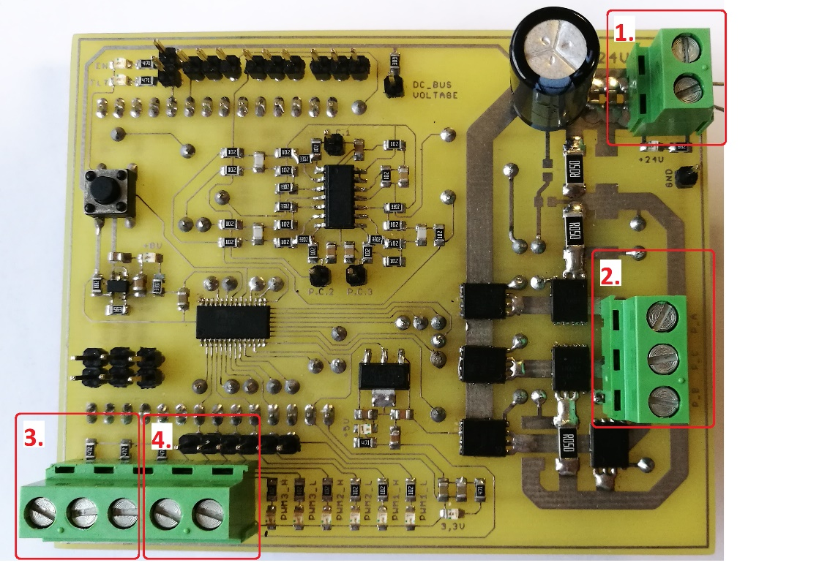

10. picture: Connectors of Motorshield

The panel is contained various test points, that next table is showed:

|  |  |
| --- | --- |
| **Test points** | **Description** |
| EN | Enable pin |
| FLT | Fault pin |
| DC BUS Voltage | DC BUS Voltage level |
| P.C.1 | Phase current 1 |
| P.C.2 | Phase current 2 |
| P.C.3 | Phase current sum |
| PWM1L | PWM low-side input level for Phase A |
| PWM1H | PWM high-side input level for Phase A |
| PWM2L | PWM low-side input level for Phase B |
| PWM2H | PWM high-side input level for Phase B |
| PWM3L | PWM low-side input level for Phase C |
| PWM3H | PWM high-side input level for Phase C |
| GND | Analog ground |

These test points are used to measure the values with oscilloscope.

## User interface hardware

### Jumpers

|  |  |  |
| --- | --- | --- |
| Designator | Position | Description |
| JP1 | 1-2 | Connects current sense to phase 1 to monitor |
| 2-3 | Connects voltage sense to phase 1 to monitor |
| JP2 | 1-2 | Connects current sense to phase 2 to monitor |
| 2-3 | Connects voltage sense to phase 2 to monitor |
| JP3 | 1-2 | Connects current sum sense to monitor |
| 2-3 | Connects voltage sense to phase 3 to monitor |

### Leds

The Motorshield has LED indicators for the supplies, PWM and FLT/EN signals. The instantaneous signals can easily check with these LEDs. Picture of 2. part 8. is showed the LEDs on board.

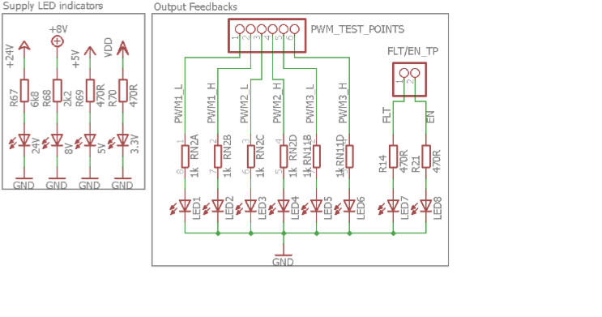

11. picture: LEDs of Motorshield

|  |  |
| --- | --- |
| **Leds name** | **Description** |
| EN | Enable status LED |
| FLT | Fault status LED |
| PWM1-6 | LEDs, which indicate the PWM pin status |
| 24V | Power-on status LED |
| 8V | Power-on status LED, which indicates the status of the 8V regulator |
| 5V | Power-on status LED, which indicates the status of the 5V regulator |
| 3.3V | X2C power-on status LED |

# Operating requirements

To set up and run the board, following items are recommended:

1. MPLAB X IDE installed on the PC
2. dsPIC33EP256MC502 Digital Signal Controller
3. 24V power supply
4. BLDC or PMSM motor
5. X2C Development Board
6. X2C Motorshield Board

# Electrical specifications

## DC input ratings

|  |  |  |  |
| --- | --- | --- | --- |
| Parameter | Min. | Max. | Unit |
| Power supply | 24 | 30 | V |

## DC output ratings

|  |  |  |  |  |
| --- | --- | --- | --- | --- |
| Parameter | Min. | Typical | Max. | Unit |
| Voltage | 0 | 24 | 48 | V |
| Current | 0 | 5 | 15 | A |
| Power rating | 0 | 120 | 720 | Watts |

The output current is depended from the shield and other parts.

# Diagram lists

1. picture: X2C Development Board 4

2. picture: Parts of Motorshield 5

3. picture: Supply and regulators 6

4. picture: MOSFET driver 7

5. picture: Output stage 9

6. picture: Phase voltage feedback 10

7. picture: Current gain 11

8. picture: Hall and QE sensor's circuit 12

9. picture: Can bus circuit 12

10. picture: Connectors of Motorshield 14

11. picture: LEDs of Motorshield 15

12. picture: X2C Motorshield 20

13. picture: The schematic circuit 21

# Attachments

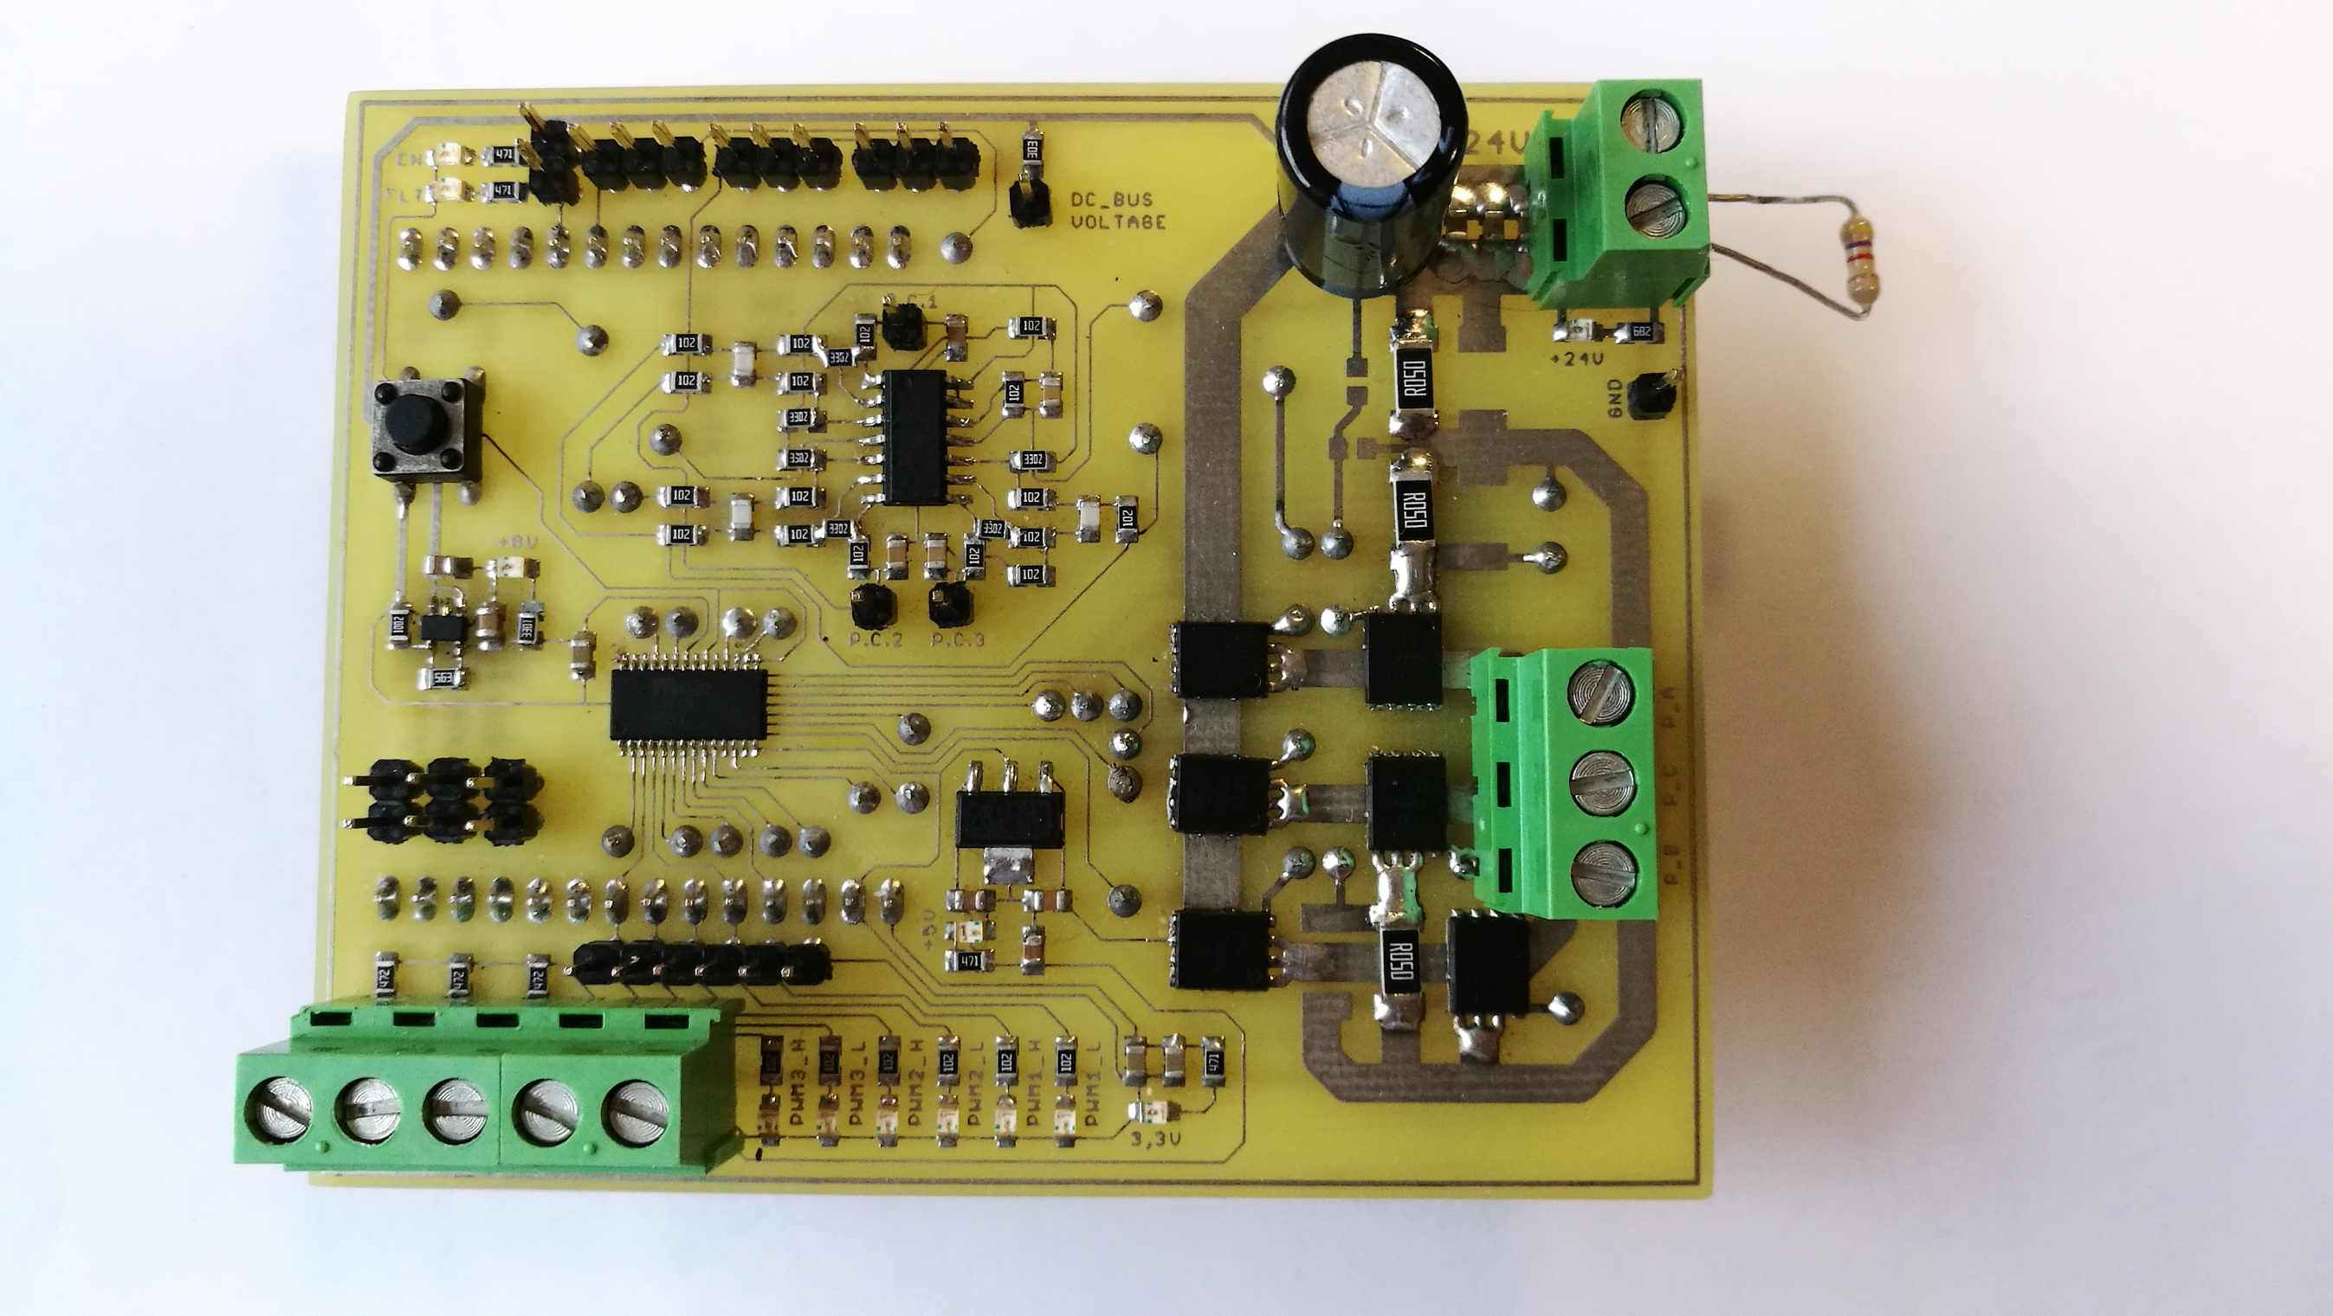

12. picture: X2C Motorshield

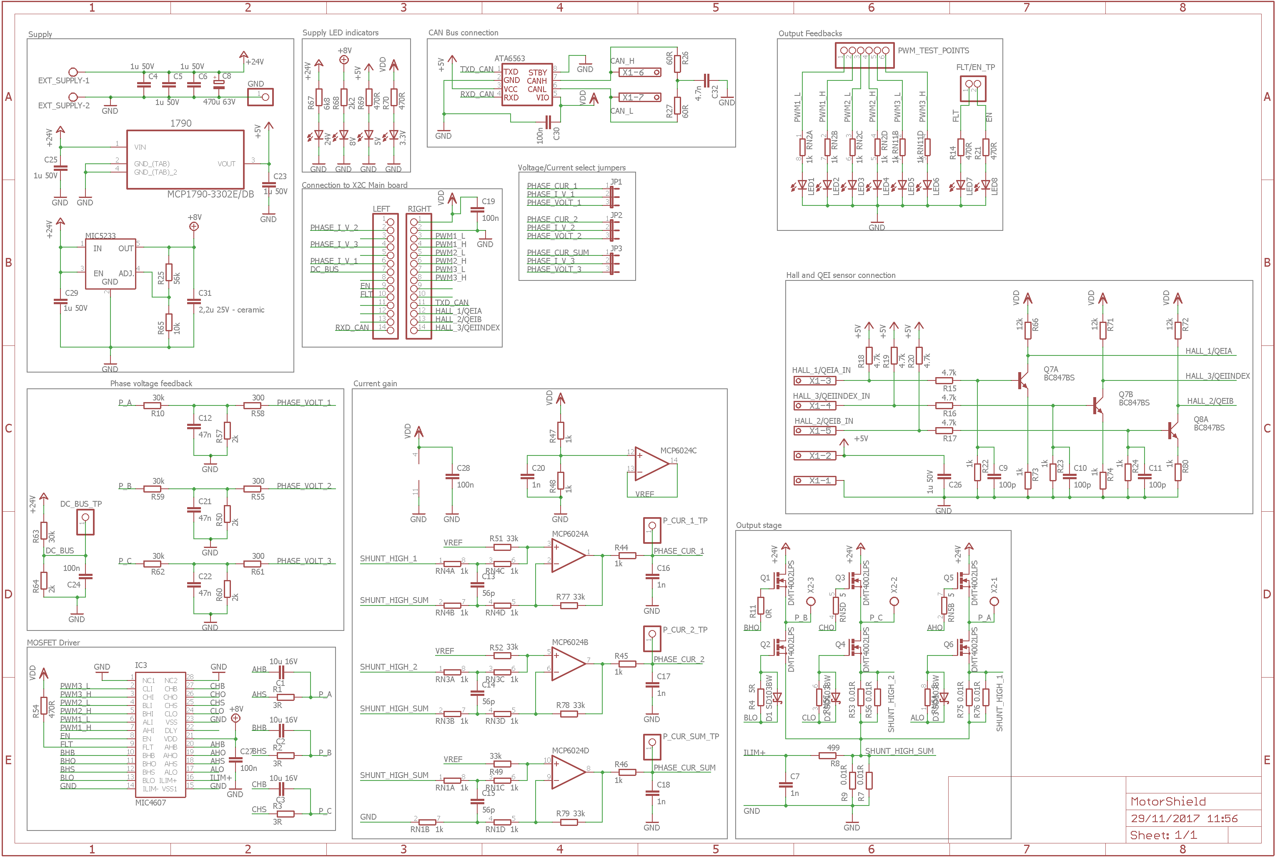

**13**. picture: The schematic circuit

# Sources

High Voltage Regulator - MCP1790:

<http://ww1.microchip.com/downloads/en/DeviceDoc/22075b.pdf>

Voltage Regulator - MIC5233:

<http://ww1.microchip.com/downloads/en/DeviceDoc/mic5233.pdf>

X2C Development Board:

<http://x2c.microstickplus.com/>

CAN Transceiver - ATA6563:

<http://ww1.microchip.com/downloads/en/DeviceDoc/20005790B.pdf>

Microchip of X2C - dsPIC33EP256MC502:

<http://ww1.microchip.com/downloads/en/DeviceDoc/70000657H.pdf>

MOSFET driver - MIC4607:

<http://ww1.microchip.com/downloads/en/DeviceDoc/20005610A.pdf>

MCLV-2 Development Board:

<http://ww1.microchip.com/downloads/en/DeviceDoc/DS-52080a.pdf>

I/O operational amplifier - MCP6024:

<http://ww1.microchip.com/downloads/en/DeviceDoc/20001685E.pdf>

NPN transistor - BC847BS:

<https://assets.nexperia.com/documents/data-sheet/BC847BS.pdf>

N-channel MOSFET - DMT4002LPS:

<https://www.diodes.com/assets/Datasheets/DMT4002LPS.pdf>