1. Your accepted abstract title: Targeting ocular WHO priority Multidrug and extensively drug-resistant Gram-negative pathogens by combining conventional antimicrobials with membrane-active peptides

2. A brief description of poster: This study aimed to evaluate whether membrane-active peptides, including Mel4 and colistin, can enhance the activity of conventional antimicrobials against multidrug-resistant and extensively drug-resistant Gram-negative ocular pathogens. Using clinically relevant ocular isolates, including P. aeruginosa, A. baumannii, and K. pneumoniae, we assessed antimicrobial activity against planktonic and biofilm-associated bacteria, as well as mammalian cell cytotoxicity and hemolysis.
Our findings show that many isolates exhibited high-level resistance to conventional antibiotics when used alone. However, combining membrane-active peptides with antibiotics, particularly ciprofloxacin, ceftazidime, or meropenem, markedly improved antibacterial and antibiofilm activity, reduced effective MIC values, and maintained good selectivity toward bacterial cells with minimal mammalian toxicity. These results suggest that membrane-disrupting peptides may restore or potentiate the activity of existing antibiotics against difficult-to-treat ocular pathogens.

3. Photos: 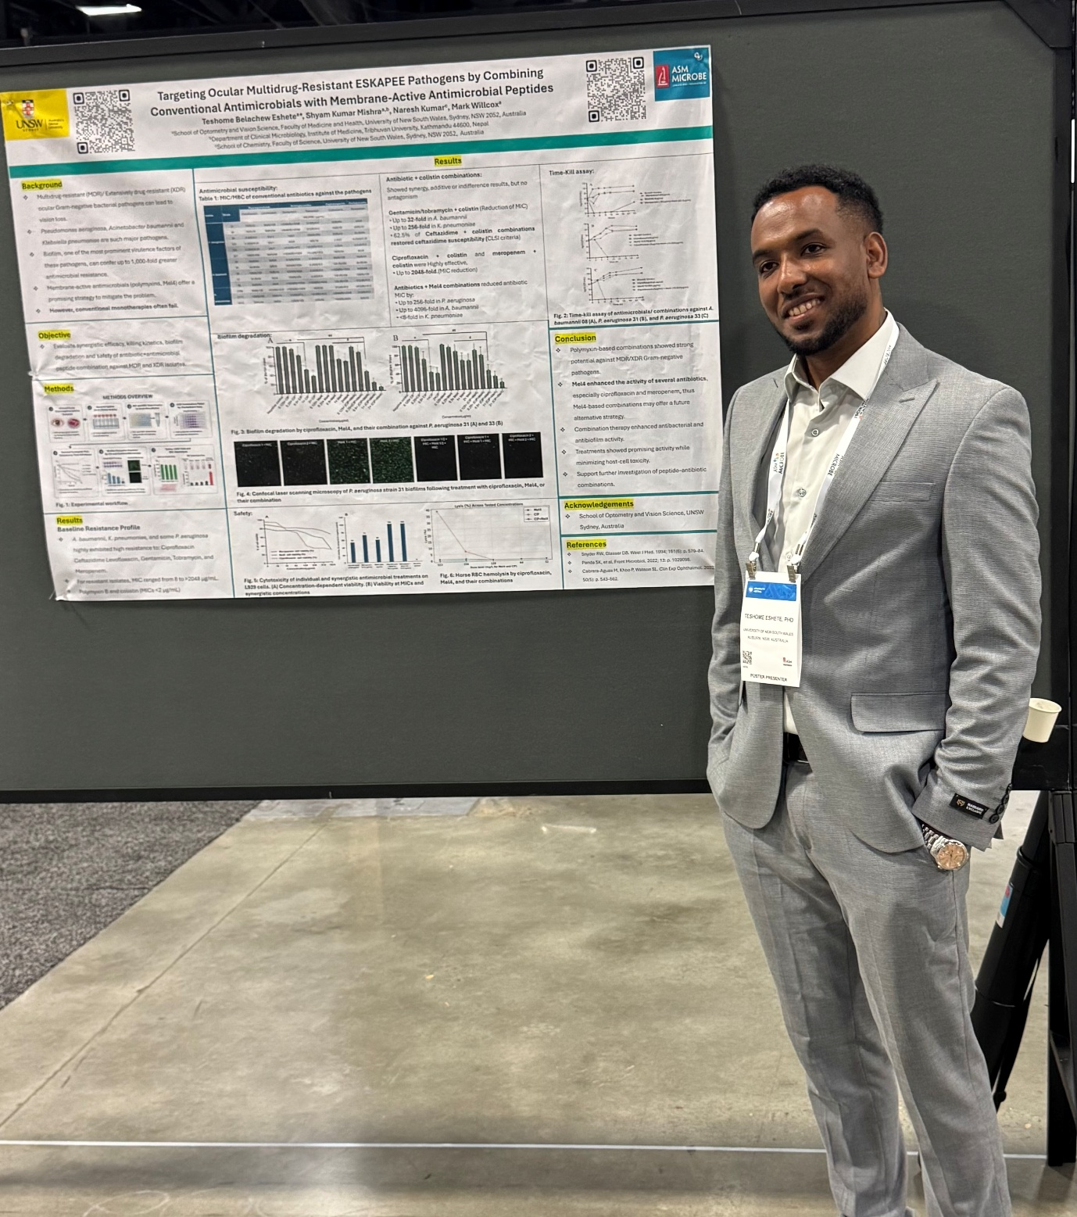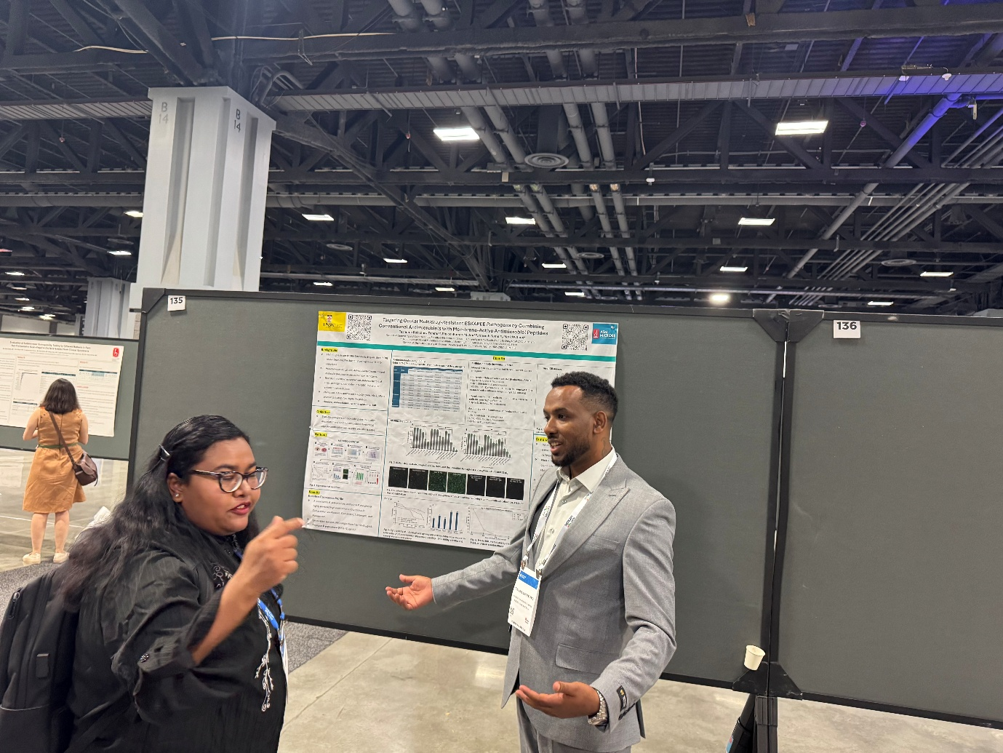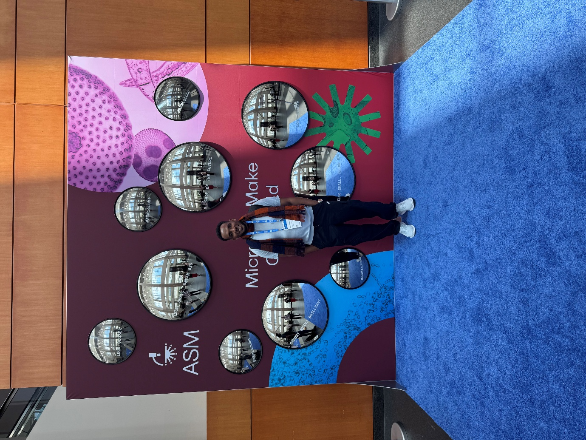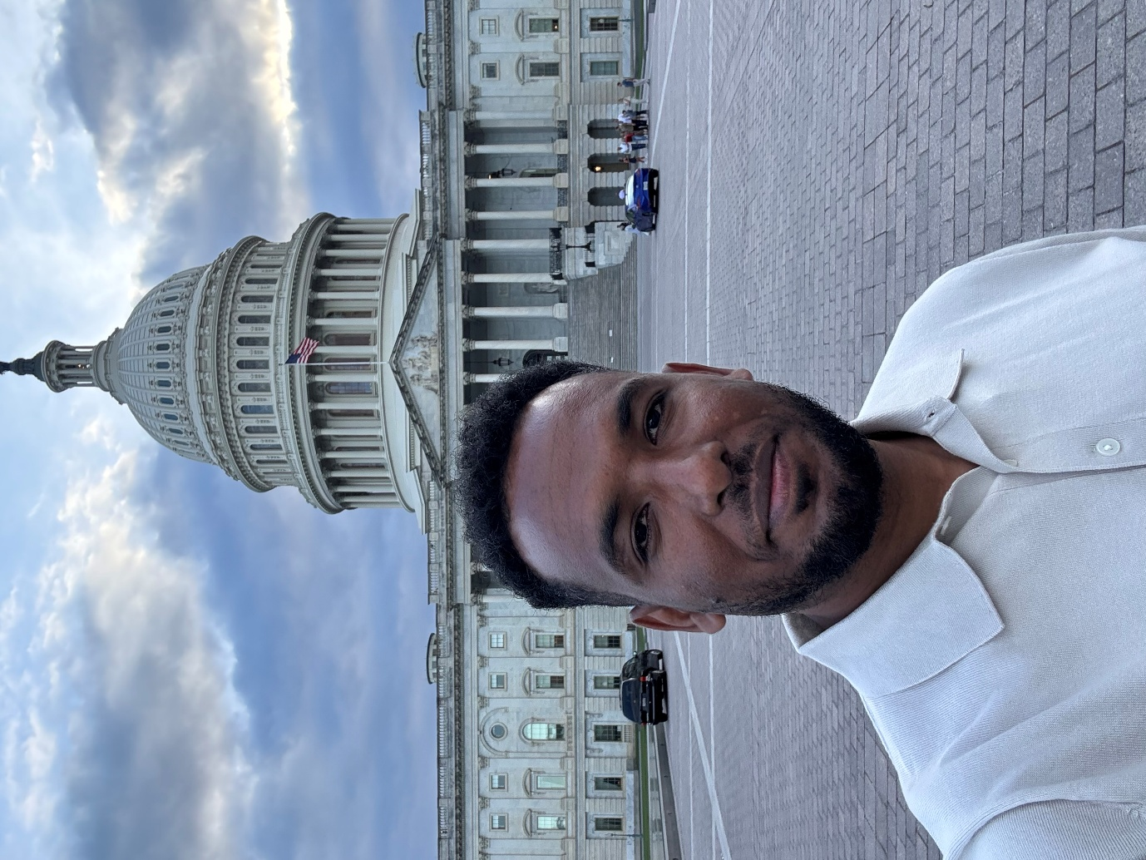

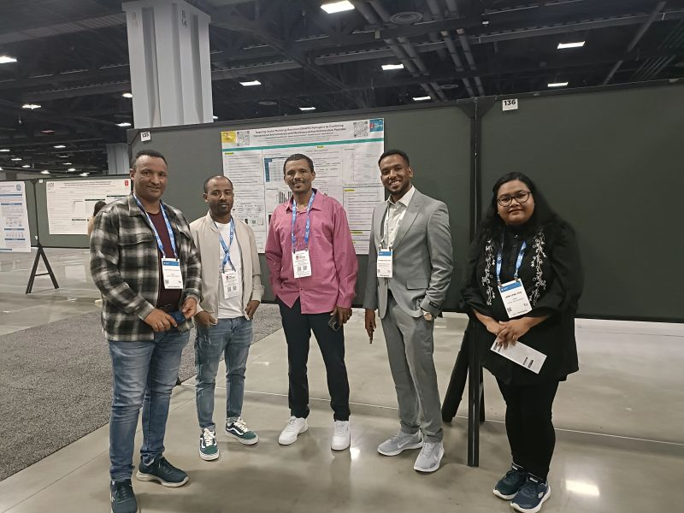

4. (optional) a short reflection on your conference experience:
Attending ASM Microbe 2026 in Washington, D.C. was an inspiring and rewarding experience. It provided me with the opportunity to engage with some leading researchers, learn about the latest advancements in microbiology and antimicrobial research, and gain valuable insights into emerging scientific challenges and innovations.
Presenting my research and discussing it with experts from diverse backgrounds enhanced my understanding of my field and provided constructive feedback that will help strengthen my future work. The conference also allowed me to build professional networks and explore potential collaborations with researchers from around the world.
Overall, ASM Microbe 2026 broadened my scientific perspective, reinforced my passion for research, and motivated me to continue contributing to the fight against antimicrobial resistance and infectious diseases. I am grateful for the opportunity to participate in such a prestigious international scientific event.

