Conference
- ISER-Mark:
I attended the recent International Society for Eye Research meeting in Valencia Spain (ISER 23-27th August 2026). ISER is one of the premiere eye research meetings and in 2026 it was its 27th meeting. Our School of Optometry and Vision Science was very well represented at the meeting this year, with A/Prof Nicole Carnt, Dr Jerome Ozkan, A/Prof Michele Madigan, Dr Daisy Shu all attending as well. I gave a talk entitled "The Neonatal Ocular Surface Microbiome" from Jerome and my research with Manipal Academy of Higher Education. Jerome gace a talk entitled "Comparative Analysis of the Ocular Microbiome in MGD and Healthy Eyes across Multiple Ocular Sites", and Nicole gave one entitled "Clinical and Microbiome Profiles of Acanthamoeba Keratitis in Sydney, Australia". Jerome and Nicole also chaired a session each. Great conference.
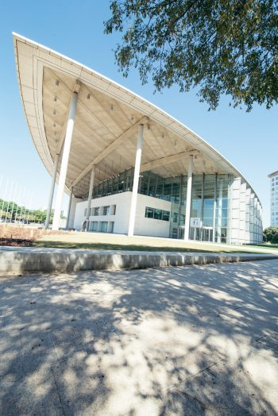

- IMAP-Elias: waiting

Award/Grant:
- Mark Willcox-Cornea & Contact Lens Society of Australia (CCLSA) Brien Holden Memorial Award
https://lnkd.in/p/gKbN3Vwa
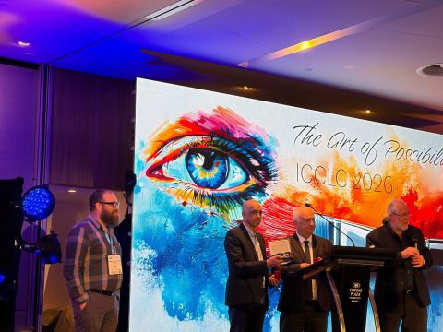

- Mukesh Kumar- 2026 Dorothy Carlborg Research Award from the Cornea and Contact Lens Society of Australia (CCLSA)
https://www.linkedin.com/posts/unswoptomvissci_congratulations-to-dr-mukesh-kumar-on-receiving-activity-7513756676877877248-E_f3?utm_source=share&utm_medium=member_desktop&rcm=ACoAAEkXt44BztaFbPxriep8K1-MHo0pjqJGAOM

- Tanzina Akter and Mukesh Kumar-2026 Ezell Fellowships by the American Academy of Optometry Foundation
https://lnkd.in/p/gngU3jMg

- Elias Shiferaw Mekonen- Global Mobility Grant

Other news

https://lnkd.in/p/geMNvkkv
1.
Our research is featured as the Issue Cover of Antibiotics, Volume 15, Issue 8!
🔬 We are pleased to share our latest publication exploring strategies to combat drug-resistant pathogens responsible for severe eye infections.
👏 Teshome Belachew Eshete, Shyam Kumar Mishra, Dr. Naresh Kumar, and Dr. Mark Willcox.
📖 Read the article: https://brnw.ch/21x6zoI
🖼️ View the full issue: https://brnw.ch/21x6zoH

One of our papers published in Scientific Reports has been featured in Sciworthy.
The article highlights our study on the computational discovery of potential MvfR inhibitors that could help disarm drug-resistant Pseudomonas aeruginosa. It’s exciting to see our research reaching a wider audience.
https://lnkd.in/p/gdiEvaCd

