Release Candidate Testing (Integrated CC + JVector) – AWS v1
Last updated: March 02, 2026

Overview
This document defines the standard environment, datasets, regression policy, and test matrices used for JVector + CC release candidate validation in AWS.

Testing Environment (AWS)
Component | AWS Standard
Cluster topology | 3-node Cassandra + JVector
Instance type (all nodes) | i4i.4xlarge (standard)
Dataset source | S3 bucket: jvector_infratest
Similarity function | Dot product (vectors pre-normalized)
Network | Single AWS VPC; Cassandra nodes in one security group
Client placement | Separate EC2 instance inside the same VPC but outside the cluster SG

Test Clients
A dedicated test client instance is deployed inside the same AWS VPC to emulate real client access patterns while remaining outside the Cassandra cluster boundary. Test clients need to broadly cover both the capability to test the JVector library in isolation and the capability to test Converged Cassandra including the JVector library.
Both testing tools are deployed to a separate instance in the testing ecosystem, modeling the topology of an actual client interacting remotely with the deployed cluster to provide an “outside in” perspective on test results.
- jvector-bench: exercises JVector library options standalone and supports a limited Cassandra-facing suite
- NoSQLBench: flexible end-to-end workloads defined by YAML; integrates with Grafana for visualization
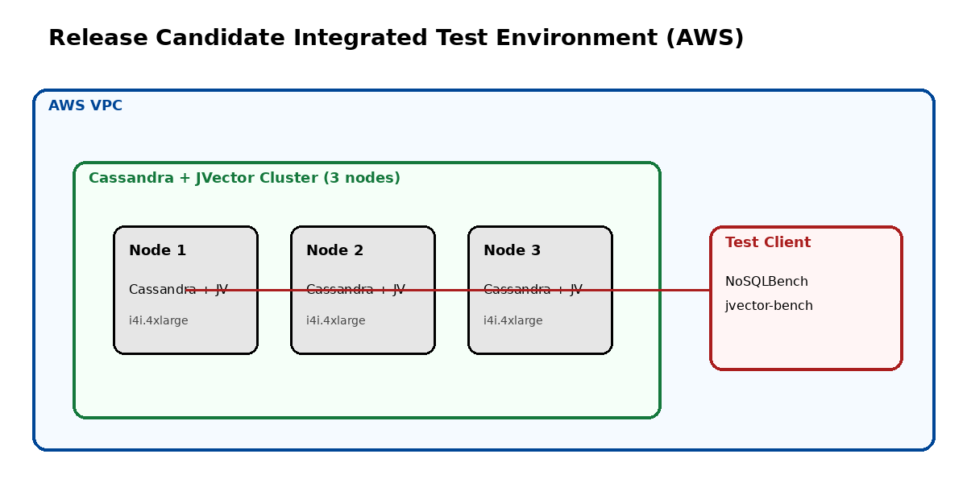

Load and Warmup Policy
- Cold-run reporting applies only to data loading and index build behavior
- After the dataset is loaded, query workloads run in warmed conditions; the first query run is discarded as warmup
- All reported query metrics are computed from subsequent runs

Regression Policy (Current Working Rule)
Results are compared against the most recent prior release candidate. Any regression of 5% or more in transactions/second, latency, or recall is flagged as a failure requiring investigation.

Datasets
Core datasets (always run):
- cohere-english-v3-10M
- dpr-10M
- cap-6M
- ibm-datapile-20M
Large dataset category:
- ibm-datapile-50M
- ibm-datapile-100M

RC Readiness Checklist (Pre-Flight Gate)
Before executing the RC test matrix, the following checklist must be completed.

Release Metadata
- CC RC branch or tag identified and recorded
- JVector version identified and recorded
- Commit SHAs captured in run manifest
- Feature delta summary provided for this RC

New Functionality Coverage
- New or changed features enumerated
- At least one targeted validation test per new feature
- JV team review of new-feature tests completed
- RC signoff blocked if new functionality lacks coverage

Environment Verification
- Instance type verified as i4i.4xlarge
- NVMe mounted and formatted with XFS
- cassandra.yaml validated for test environment
- All nodes reach UN state before testing
- Monitoring endpoints reachable

Dataset Readiness
- Datasets successfully pulled from S3 bucket jvector_infratest
- Vector counts match expected dataset sizes
- Vectors confirmed pre-normalized (dot-product assumption)
- Ground-truth files present where required

Baseline Selection
- Most recent prior RC identified for comparison
- Baseline metrics available and accessible
- Regression thresholds confirmed (≥5% rule)

Test Plan Confirmation
- Core dataset matrix enabled
- Large dataset plan recorded (run vs skip)
- Soak test decision recorded
- Degraded-mode tests enabled

Artifact Configuration
- Results directory configured
- Environment manifest capture enabled
- Log retention configured (location TBD)

Testing
- Each test should be defined in its own yaml file. One test may be composed of multiple phases, ie. “load”, “test TPS”, “test recall”, etc.
- Repository of tests should be kept somewhere accessible for team to add/modify such as in a github repo
- Include loading as a separate activity or part of a test? The issue is that performance will be impacted by the continuing index build after the load is done, how do we want to handle that?

Functional Testing
- Each release candidate should have a clearly defined list of new functionality. Anything that is not covered by existing tests should have a new test created for it as part of the RC testing. For each RC all existing (old) tests should be run as part of the functional test suite unless a review of existing tests at the start of testing determines that one or more tests should be removed as no longer applicable.
  - Whose responsibility is it to add new tests? What should the process be?
  - Who grooms the existing tests to determine if anything needs to be removed?

Performance Testing
- Run a standard battery of tests across the entire list of datasets. Check for improvement and/or regression in the following areas:
  - Index construction / load time
  - Throughput
  - Latency
  - Recall
  - Memory Usage
  - Disk usage

Fallback Testing
TBD

Release Candidate Test Matrix
The matrices below define which verification suites are executed per dataset group. They focus on the system properties we want to validate (performance, resilience, accuracy), not workload implementation details.

Suite applicability by dataset category
Suite | Core Datasets | Large Datasets
S0 – Sanity & Reproducibility  Environment health, provenance capture, dataset integrity | Yes | Yes
S1 – Build/Load (Cold)  Load + index build time/resource profile (cold reporting) | Yes | Yes
S2 – Query Baseline (Warm)  Latency/throughput at nominal load; basic saturation behavior | Yes | Yes
S3 – Tradeoff Curves  Latency vs throughput curve; concurrency sweep; knee point | Yes | Yes
S4 – Accuracy  Recall@K baseline + stability under load | Yes | Yes (Sampled)
S5 – Mixed Workloads  Vector queries mixed with representative non-vector activity | Yes | Optional
S6 – Degraded Mode  Single node loss during steady query load; coordinator loss | Yes | Optional
S7 – Recovery  Node rejoin/repair behavior; rolling restart | Yes | Optional
S8 – Resource Tripwires  CPU/query, disk IO patterns, memory footprint, GC characteristics | Yes | Yes
S9 – Soak (Optional)  6–12 hour steady workload stability | Optional | Optional

Execution order
Fail fast on environment and baseline regressions before running longer suites.
• Core datasets: S0 → S1 → S2 → S4 → S3 → S8 → S5 → S6 → S7 → S9(optional)
• Core datasets: S0 → S1 → S2 → S4 → S3 → S8 → S5 → S6 → S7 → S9(optional)
• Large datasets: S0 → S1 → S2 → S4(sampled) → S3 → S8 → S6(optional) → S9(optional later)

