3D Generative-Adversarial Modeling of Electron Microscope Images of Protein Complexes

April 2019

Mark Rozanov

markroza@tau.ac.il

marik.s79@gmail.com

314059098

Introduction

We propose to learn the non-linear mapping from atomic protein structures to images obtained from an electron microscope at medium resolution ( 6A). In the first phase we will train GAN on fixed size patches of protein structures (structure fragments).

## Motivation

While there is a high demand for realistic cryo-EM simulation, the most popular existing tool (callled  **molmap)** perform Gaussian Blurring on atoms.

On the figure below we show experimental and simulated of protein 6nt8 (<https://www.rcsb.org/structure/6NT8>). While the synthetic map represents “ideal” universe, in the experimental map the noise is not gaussian and different regions have different volume density. Moreover, it is assumed that some of physico-chemical properties which affect experimental cryo-EM map, such as charge and atomic bonds, are not captured by the existing simulation.



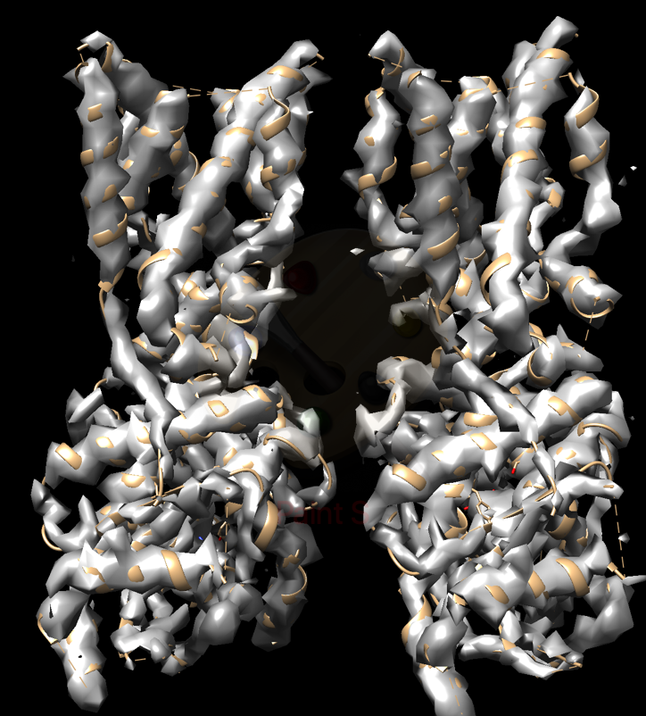

**SYNTHETIC (MOLMAP) MAP**

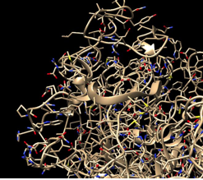 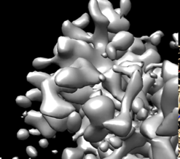

**Figure 1: 3D image of protein Structure Fragment Figure 2: Fragment of EM map, resolution 6.1 A**

Network :

We used 3D-GAN network, where the Encoder, Decoder and Discriminator are Convolutional Neural Nets. Network Architecture is shown in the figure below: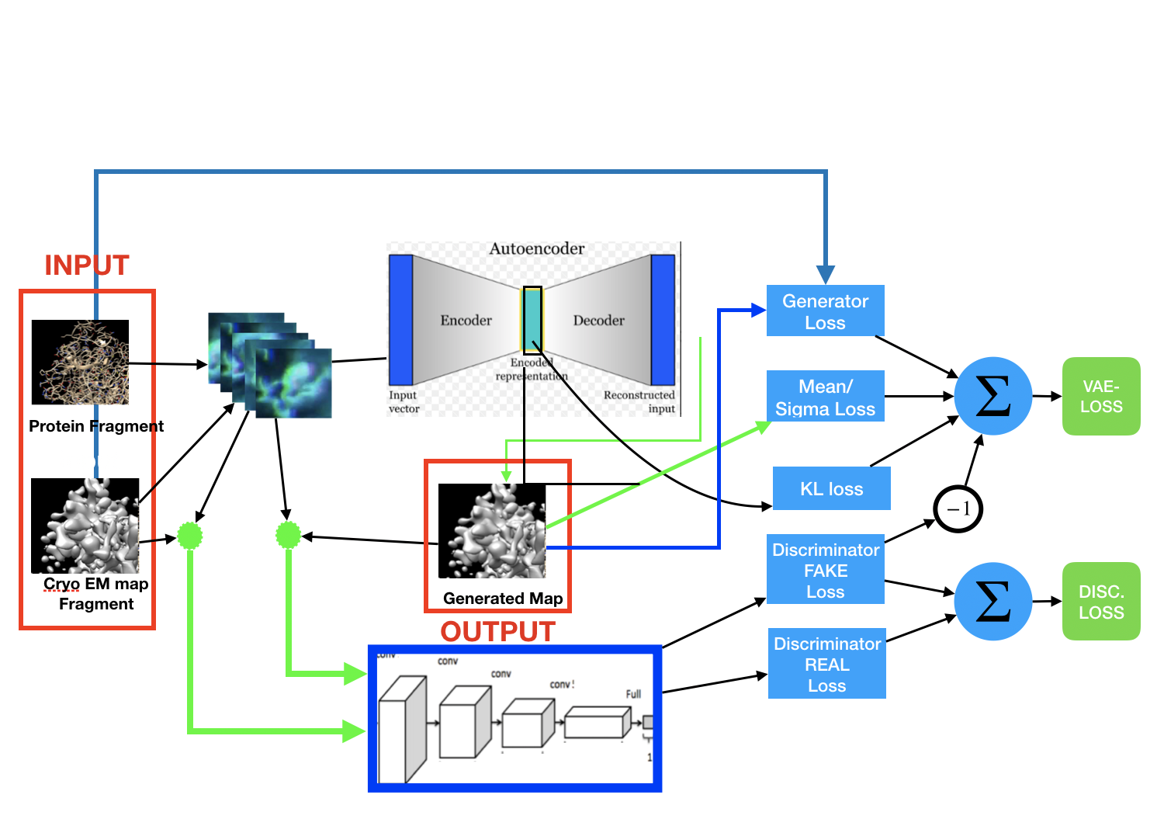

**3D Conv GAN architecture**

## Details

### Voxalization:

We converted list of protein atoms to five 3D matrices, according to five different atom types:

Carbon, Oxygen, Nitrogen, Sulphur and Hydrogen.

A value of a voxel x is the sum of the exponents of the reciprocal distances from the voxel to the atoms of a specified type

## Discriminator:

**INPUT:**

* Protein Fragment after vocalisation:
* Map patch from corresponding location in cryoEM map

**OUTPUT:**

* : scalar , zero for fake maps and one of real

**LAYERS**:

|  |  |  |  |
| --- | --- | --- | --- |
| 1 | Conv 3D+elu | Input Channels:6, Out Channels 32 | Kernel [1,1,1], Strides [1,1,1 |
| 2 | Conv 3D+elu | Input Channels:32, Out Channels 32 | Kernel [3,3,3], Strides [1,1,1 |
| 3 | Conv 3D+elu | Input Channels:32, Out Channels 32 | Kernel [2,2,2], Strides [1,1,1 |
| 4 | Conv 3D+elu | Input Channels:32, Out Channels 128 | Kernel [2,2,2], Strides [2,2,2 |
| 4 | Full Conn + sigmoid | Input Channels:128, Out Channels 1 |  |

## VAE:

**ENCODER INPUT:**

* Protein Fragment after vocalisation:

**ENCODER OUTPUT:**

* Mean and Sigma - 3D Matrices

**DECODER INPUT:**

* Latent variabels matrix

**DECODER OUTPUT:**

* Map Patch:

**LAYERS**:

|  |  |  |  |
| --- | --- | --- | --- |
| ENC 1 | Conv 3D+elu | Input Channels:5, Out Channels 32 | Kernel [2,2,2], Strides [1,1,1 |
| ENC 2 | Conv 3D+elu | Input Channels:32, Out Channels 128 | Kernel [2,2,2], Strides [1,1,1 |
| ENC 3:1  Mean | Conv 3D+elu | Input Channels:128, Out Channels 128 | Kernel [2,2,2], Strides [1,1,1 |
| ENC 3:1  Sigma | Conv 3D+elu | Input Channels:128, Out Channels 128 | Kernel [2,2,2], Strides [1,1,1 |
|  |  |  |  |
| DC 1 | deConv 3D+elu | Input Channels:128, Out Channels 125 | Kernel [2,2,2], Strides [1,1,1 |
| DC 2 | deConv 3D+elu | Input Channels:125, Out Channels 126 | Kernel [2,2,2], Strides [1,1,1 |
| DC 3 | deConv 3D+elu | Input Channels:126, Out Channels 127 | Kernel [2,2,2], Strides [1,1,1 |
| DC 4 | deConv 3D+elu | Input Channels:126, Out Channels 127 | Kernel [2,2,2], Strides [1,1,1 |
| DC 5 | deConv 3D+elu | Input Channels:127, Out Channels 1 | Kernel [2,2,2], Strides [1,1,1 |

## GAN Loss

Standard GAN loss consists of:

* Discriminator Output on fake images (with opposite sign)
* KL loss of the Endcoder
* Reconstruction Loss.

Following Changes were implemented.

* Reconstruction Loss - we used mean squared value of the difference between the generated and the referenced map
* Mean +. Sigma. An input map patch was normalised to mean 0.5 and standard deviation of 0.16. Best convergence result was obtained when we add differences in mean and sigma to the loss function

## Training:

The training strategy suggested in [3] was implemented

* GAN Loss variables is not backpropagated to the discriminator
* Discriminator is training by minimising the discriminator loss
* Discriminator was updated only if its accuracy is less then 80%

EVALUATION:

* We trained additional discriminator ton distinguish between real and “molmap” maps
* We generated map from 6nt8 protein - see the image below:

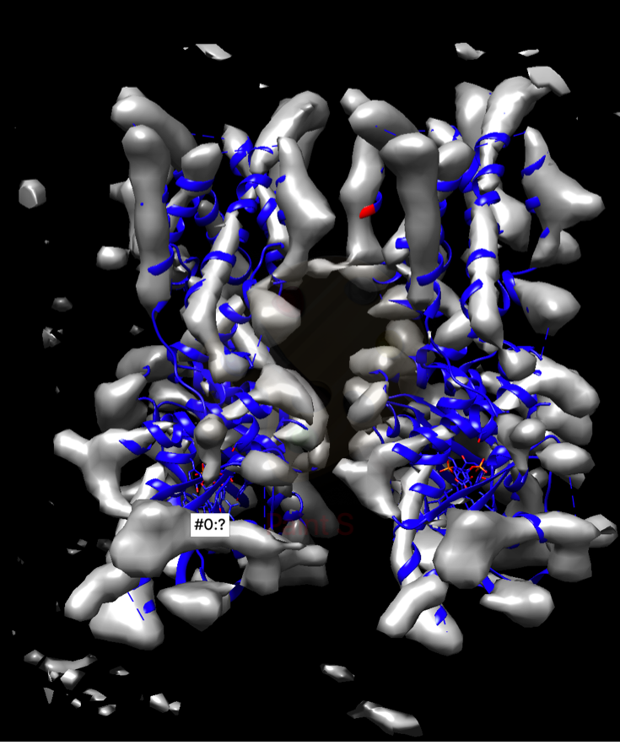

**MAP GENERATED by VAE from PDB**

* Visual Expection Shows that the generated map has the features of experimental map.
* The REAL/SYM discriminator labels as real 41000 from 73000 test points from map

Training Results Graphs:

Discriminator :Trained to Distinguish between the real and molmap(old method) maps



VAE-GAN

**Reconstruction loss**

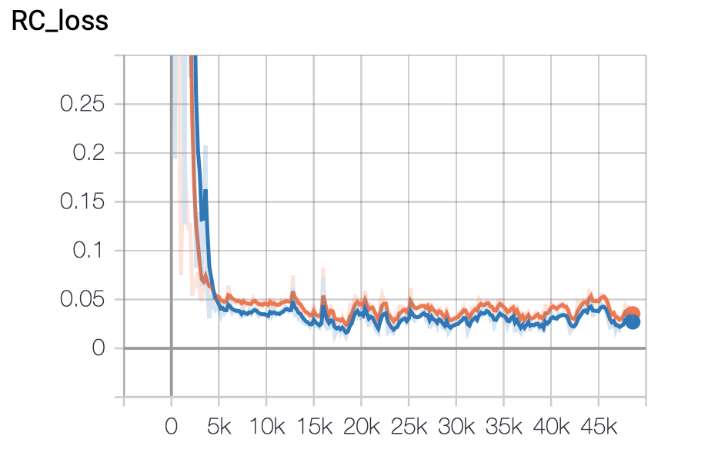

**Discriminator Accuracy:**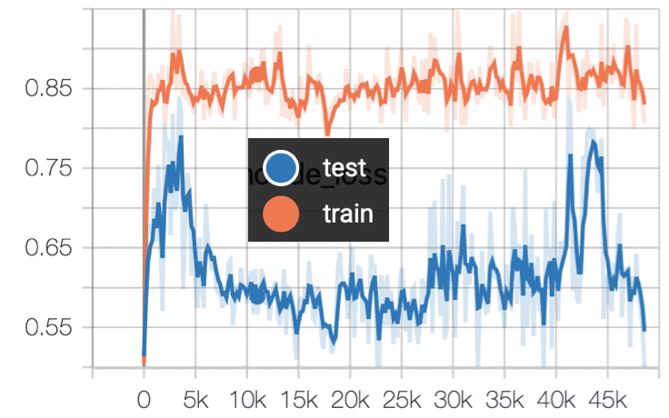

### **Encoder Loss:**

**MEAN and SIGMA:**

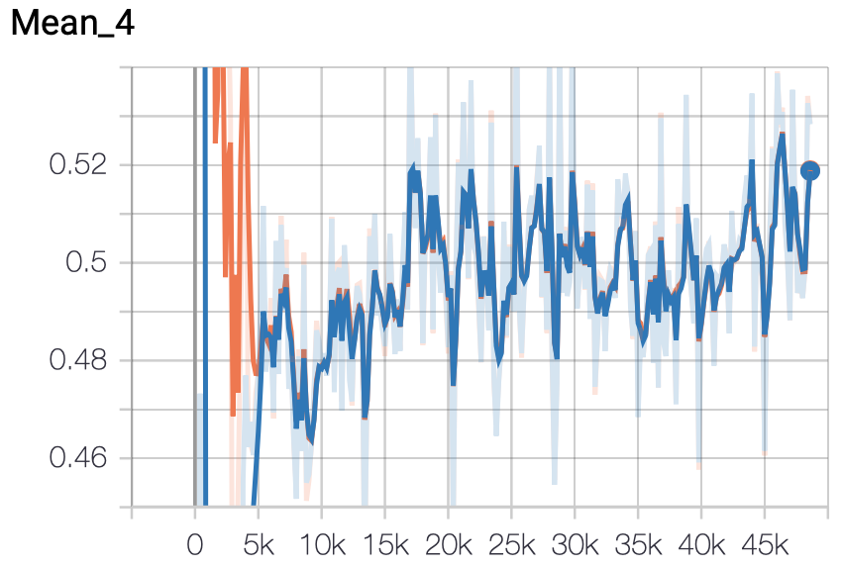

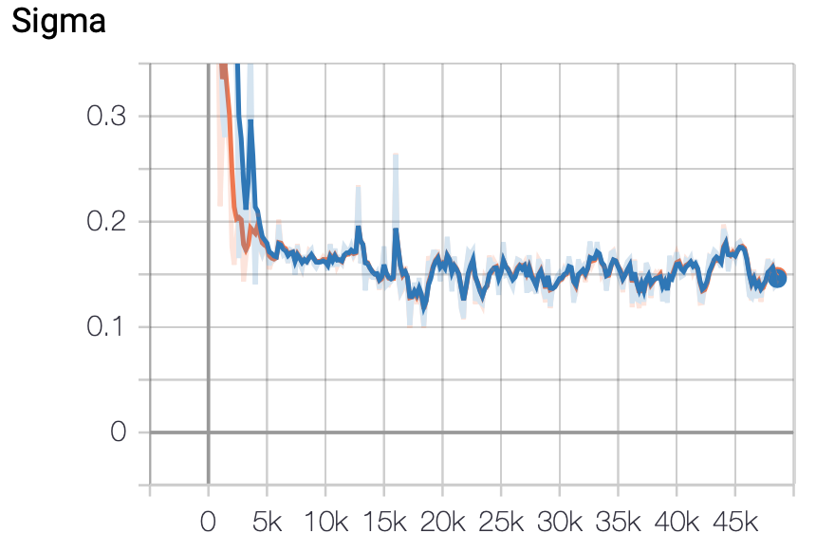

**Datasets:**

|  |  |  |  |
| --- | --- | --- | --- |
|  | **MAP** | **PDB_ID** | **RESOLUTION** |
| VALIDATION | EMD-05050 | 6nt8 | 6.5 |
| TRAIN | EMD-3169 | 5fik | 6.4 |
| TEST | EMD-3213 | 5flc | 5.9 |
| TRAIN | EMD-2845 | 4uer | 6.47 |
| TRAIN | EMD-2925 | 5a31 | 5.7 |
| TRAIN | EMD-3433 | 5l9t | 6.0 |
| TRAIN | EMD-0366 | 6n88 | 6.2 |

**Table of used cry EM maps from EMDB database**

Code:

github folder:

https://github.com/MarkYinonEitan/work_from_home/tree/master/NNproject/code

The code is in TensorFlow, is based on 2D vaegan [2] from <https://github.com/zhangqianhui/vae-gan-tensorflow>.

We implemented 3D convolutions and inverse convolutions.

# References

[1] Lawson, C. L., Patwardhan, A., Baker, M. L., Hryc, C., Garcia, E. S., Hudson, B. P., Lagerstedt, I., Ludtke, S. J., Pintilie, G., Sala, R., Westbrook, J. D., Berman, H. M., Kleywegt, G. J., and Chiu, W. EMDataBank uni ed data resource for 3DEM. Nucleic Acids Research (2016).

[2] Shin, H. C., Roth, H. R., Gao, M., Lu, L., Xu, Z., Nogues, I., Yao, J., Mollura, D., and Summers, R. M. Deep Convolutional Neural Net-works for Computer-Aided Detection: CNN Architectures, Dataset Char-acteristics and Transfer Learning. IEEE Transactions on Medical Imaging (2016).

[3] Wu, J., Zhang, C., Xue, T., Freeman, W. T., and Tenenbaum, J. B. Learning a Probabilistic Latent Space of Object Shapes via 3D Generative-Adversarial Modeling. Tech. rep.

3