**Instructions for cell annotations from an existing project (QuPath v0.2.2)**

1. Install and open the latest version (v0.2.2) of QuPath: <https://qupath.github.io/>
2. From the menu, go to File -> Project -> Open Project and select the project.qpproj file that was shared with you (make sure to create a copy of the project directory if it is being shared across multiple collaborators). The first time you open the project, you should be prompted with an “Images may have been deleted or moved!” error (because the existing image locations are different on your computer). Click “Search…” to select a folder on your computer containing the relevant filenames and apply the changes. 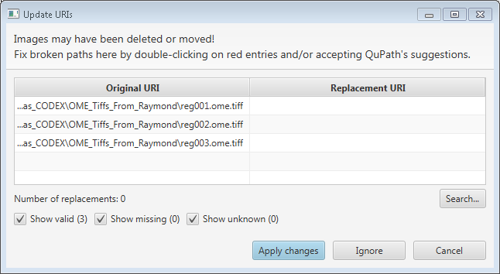  
   If, for some reason, you are *not* prompted with the above message, you can access it by going to File -> Project -> Check Project URIs.
3. You should see the images now in the Project pane of the left sidebar. You can double-click to open the image in the main window. For reg001, you should also see several blue boxes corresponding to where you should be annotating: 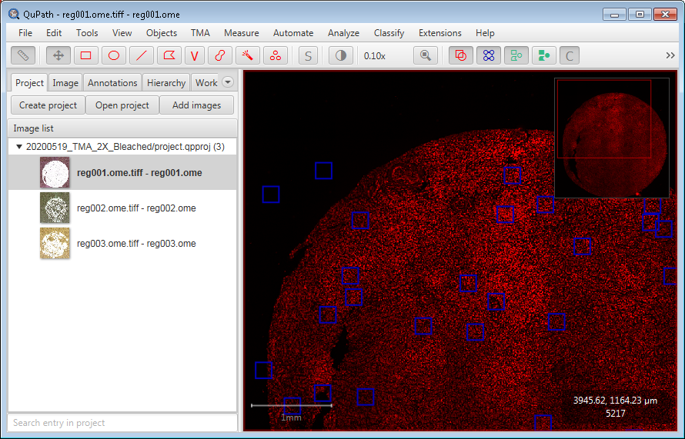
4. To adjust view settings (turning channels on/off, adjusting min/max settings) go to View -> Brightness/Contrast, which should open a “Brightness & contrast” window. Check/uncheck the relevant channels as needed. If you want to change a channel’s colour, double-click on its label to bring up a popup where you can select a different colour.
5. On the left sidebar, navigate to the “Annotations” tab, which is populated with different rectangles showing where to annotate. Double-click on the annotation that you would like to annotate and it will be highlighted in yellow in the main viewer. 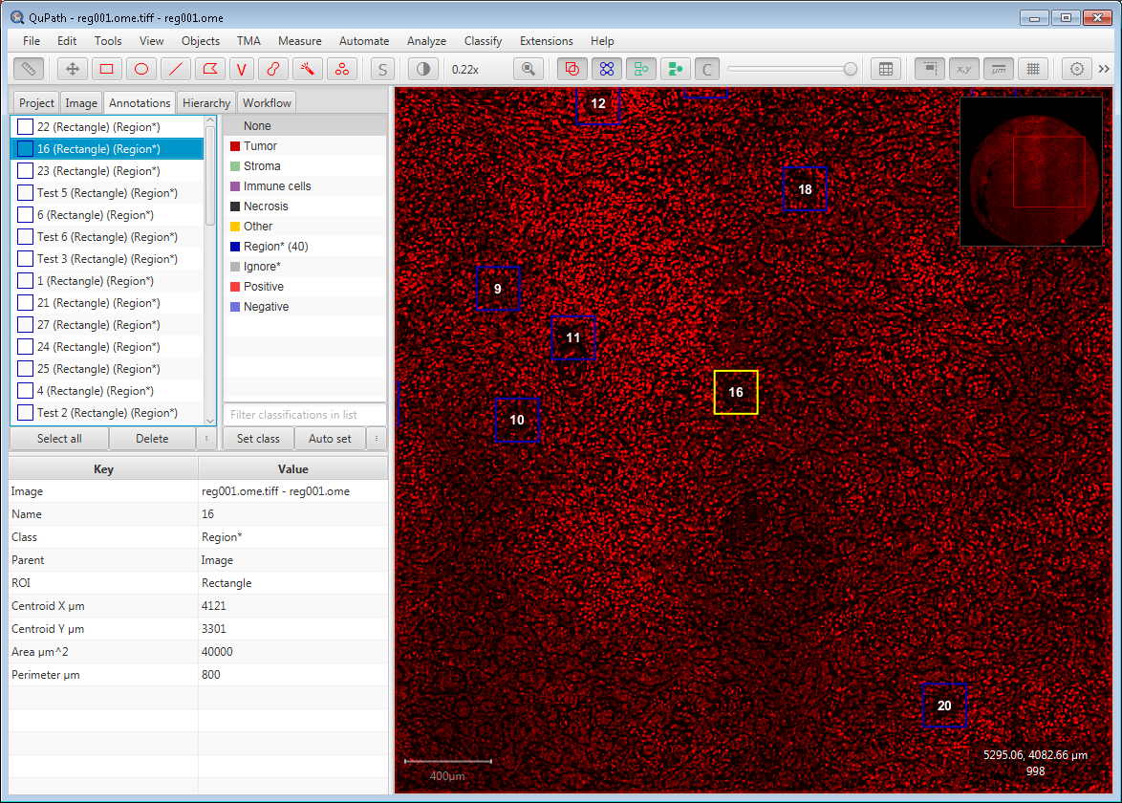
6. To annotate cells, on the toolbar, click the “Points” icon: . A blank window titled “Counting” should appear. Your cursor will turn into a crosshair and you can now annotate points by clicking in the main window. The points are represented by small circles (note that the points are stored as coordinates and the size of the circles is purely visual---you can use the “point size” slider in the Counting window to adjust it).
   1. You can move existing point annotations by clicking on them and dragging (make sure that the annotation item for the cell type you’re working on is selected, the point should be highlighted in yellow if it is).
   2. You can delete point annotations holding ALT on your keyboard and clicking (again, make sure that the annotation item is selected).
7. The goal is to annotate all cells in the red boxes in which the centre of the nucleus is within the box (even if part of the rest of the cell is not). Please try to annotate the centres of the cells/nuclei as much as possible.
8. To save your work, go to File -> Save or use the shortcut CTRL+S.
9. When complete, you simply need to share the project directory with us again.