Mark Ayoub | Ruby On Rails | August 11, 2016

Ruby on Rails Test

Miss Louise’s Class (she’s the best)



# Answer the following questions:

### 13. What is the difference between Ruby and Ruby on Rails?

***a) Ruby on Rails is a framework build on top of the Ruby language***

b) Ruby is a backend language and Ruby on Rails is a frontend language.

c) Ruby on Rails is a library for the Ruby language.

d) Ruby on Rails is open source, Ruby is not.

### 14. What is the purpose of a view in a Rails application?

a) To organize a Rails application.

b) To inspect bugs in a Rails application.

***c) To display information in human readable format.***

d) To start the server.

### 15. In the following code, what does ‘pages#home’ mean?

get 'welcome' => 'pages#home'

***a) The /welcome route points to pages controller's home action.***

b) The pages controller is now replaced with a welcome controller.

c) The pages route now points to the root 'welcome' route

d) The application now displays a welcome message.

### 16. Which of these commands starts a new Rails project?

a) rails new Project myproject

***b) rails new project MyProject***

c) rails new

d) rails new MyProject

### 17. What are the three main components of a static Rails application?

a) A model, a controller, and gems.

b) A server, controller, and view.

c) A new application, a controller, and view.

***d) A controller, a route, and a view***

### 18. What command should you run after creating a new project to make sure that project has the gems it needs?

a) gem install

b) rails install gemfile

c) gem install all

***d) bundle install***

### 19. What command will start a rails server?

a) rails new server

b) rails- S

***c) rails server***

d) server –p8080

### 20. What is another name for methods in the controller of a Rails Application?

a) Controls

***b) Actions***

c) Means

d) Directives

# Quiz for Ruby Rails - Part 2

1. Using the terminal create a site called MySite

2. Install bundle

3. Run server

4. Test on your browser

5. Close server

6. Okay using the terminal again generate controller Pages

7. Now open up your text editor and go to the new controller

8. App/ controller/…

9. In the PagesController add the method home

10. Open your config/routes.rb and make a get called ‘welcome’ and point it to the ‘pages#home’

Hint it should look something like this

  get 'welcome' =>

    'page#home'

11. Now Open the app/views/pages/home.html.erb and fill in your own name adding div tags etc.

12. Add bootstrap to your project

Push the code to the Github account and send me the link please.

# Steps Taken for Part 2

* $ **rails new MySite**
* $ **cd MySite**
* $/MySite **bundle install**
* $/MySite **rails server**
* 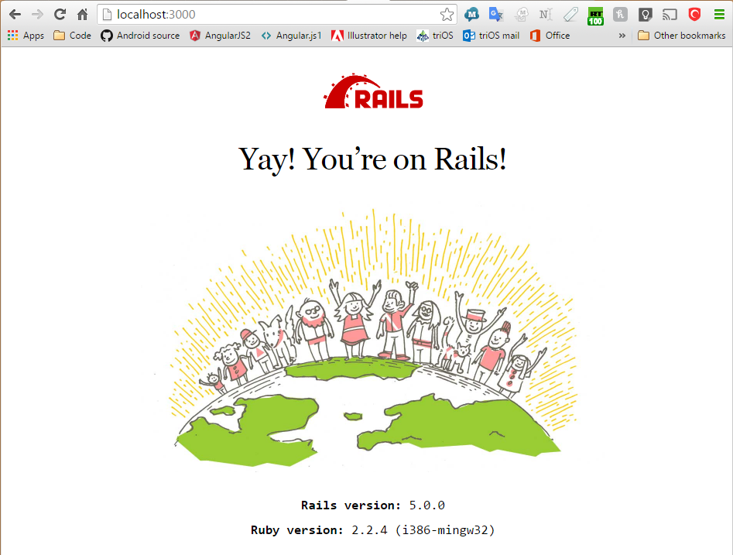
* <ctrl-c>
* $/MySite/bin/rails touch **app/controllers/pages_controller.rb**
  + class PagesController < ApplicationController
  + def show
  + render template: "pages/#{params[:page]}"
  + end
  + end
* $MySite/config **notepad++ routes.rb**
  + Rails.application.routes.draw do
  + get "/pages/:page" => "pages#show"
  + End
* $MySite **touch app/views/pages/home.html.erb**
  + <!DOCTYPE html>
  + <html lang="en">
  + <head>
  + <meta charset="utf-8">
  + <title>Mark's Ruby home page</title>
  + </head>
  + <body>
  + <h1>Hello Miss Louise</h1>
  + <p>My name is Mark ;)</p>
  + <p>&copy; <%= Date.today.year %> <a href="http://www.iitcsglobal.com">IITCSGlobal.com</a>.</p>
  + </body>
  + </html>
* 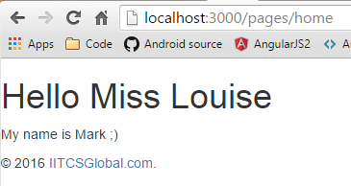
* $MySite **echo “gem 'bootstrap-sass', '~> 3.3', '>= 3.3.7'” >> gemfile**