IDECIDE — Ultimate Signature Design Language (SDL)

Single source of truth for visual grammar, interactions, and exports.

# Graph Canvas (Hi‑Fi)

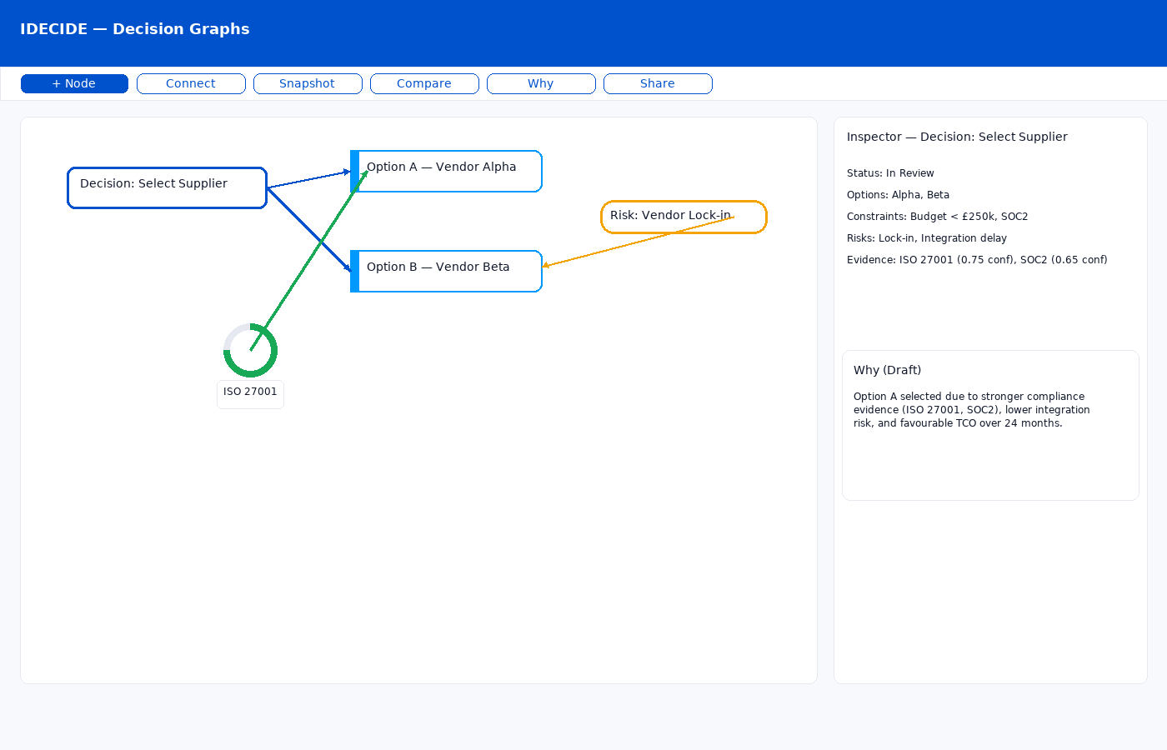

# Compare Mode (Hi‑Fi)

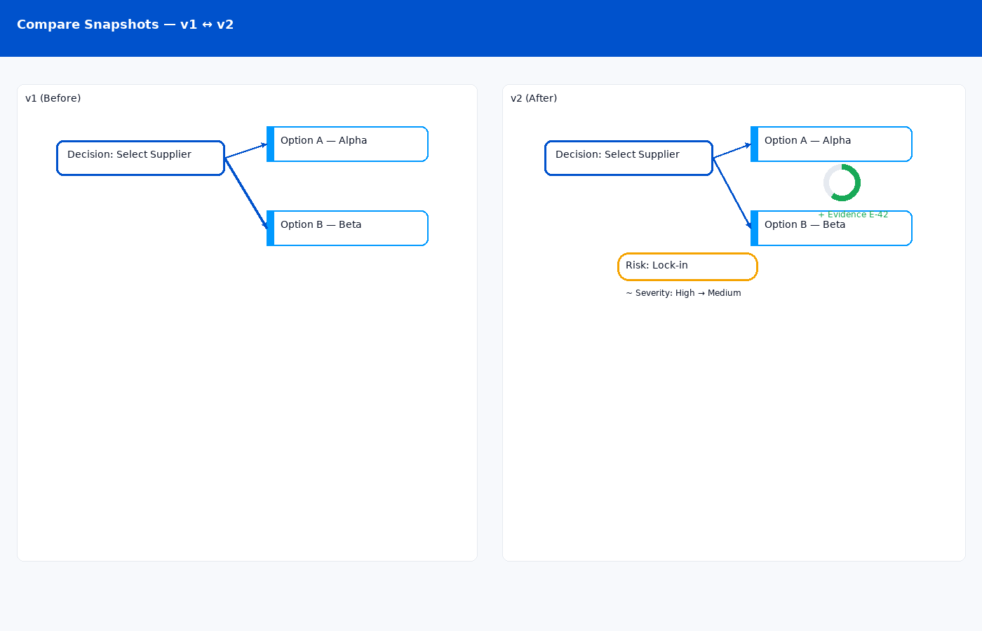

# Why Narrative Export (Preview)

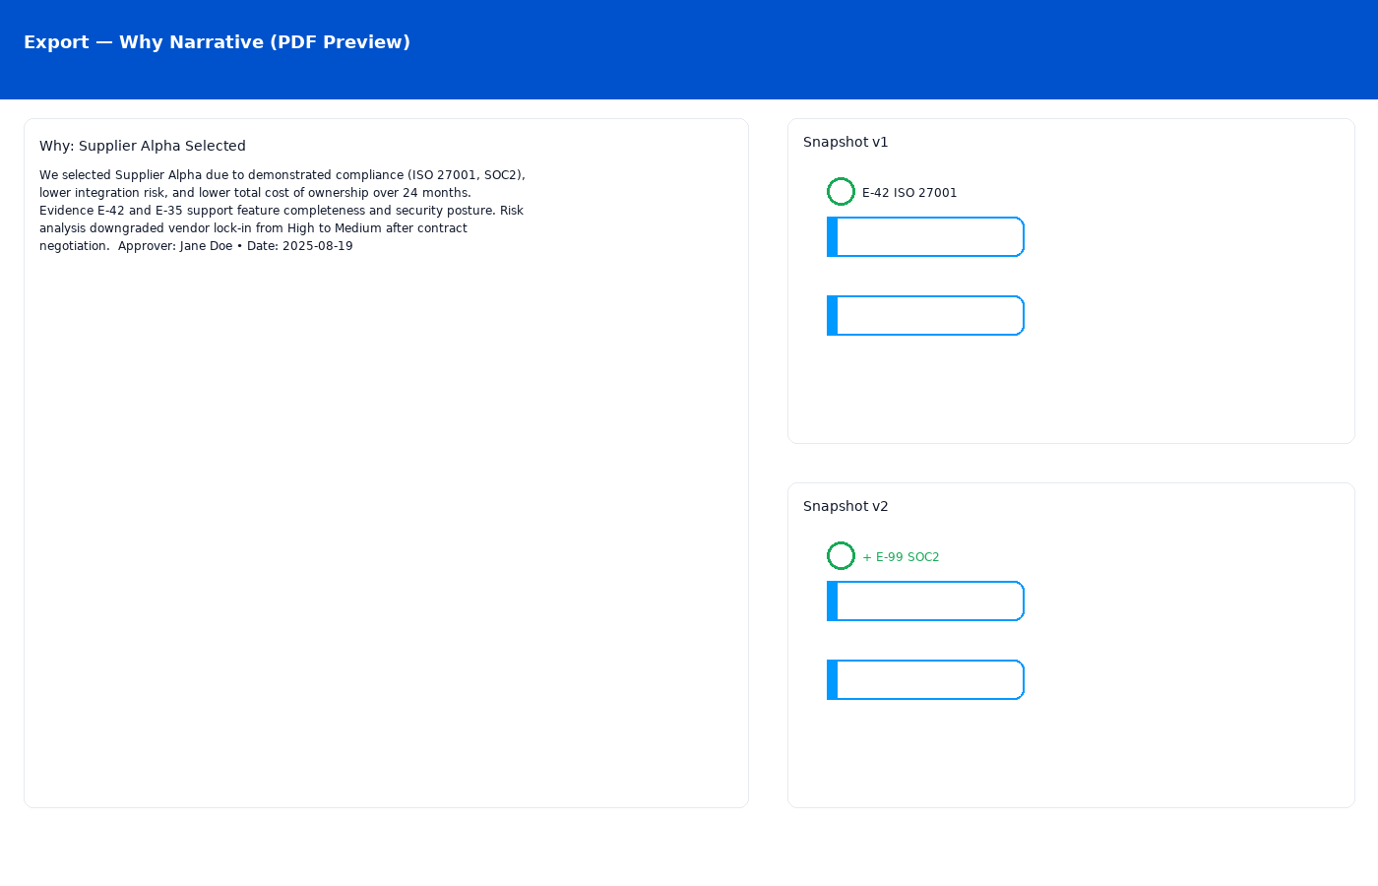

# Node & Edge Grammar

- Decision (hex): brand outline; status & approver

- Option (rounded): left accent rail; supports badges

- Evidence (ring): confidence ring; provenance chips

- Risk (lozenge): severity meter; mitigation link

- Edges: solid=considers; dashed=AI-suggested; green=supports; orange=risk; bold=chosen