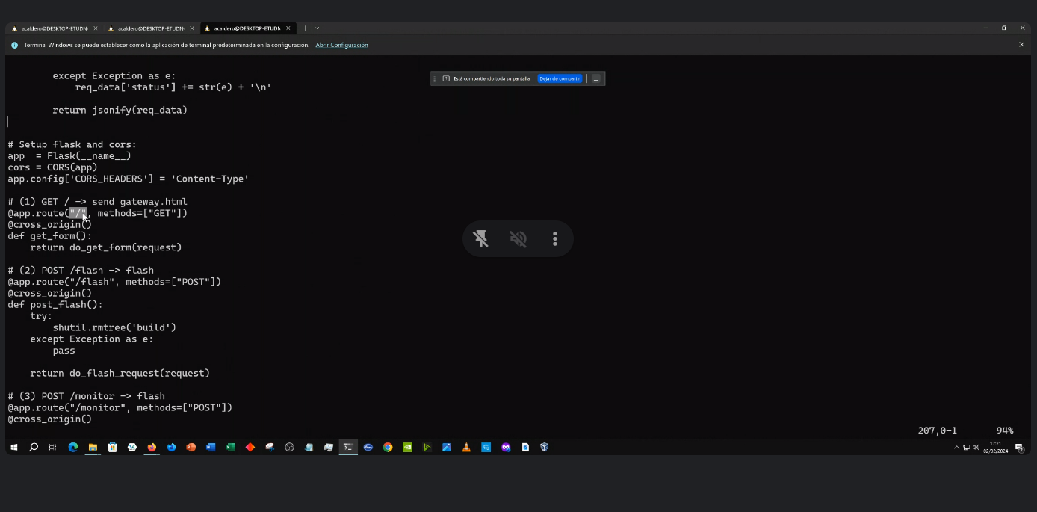

<https://stackoverflow.com/questions/18586921/how-to-launch-html-using-chrome-at-allow-file-access-from-files-mode>

<https://auth0.com/blog/developing-restful-apis-with-python-and-flask/>