Log In A1

**\* The log in window will include the “Sign Up” option for the members that are not yet registered!!!**

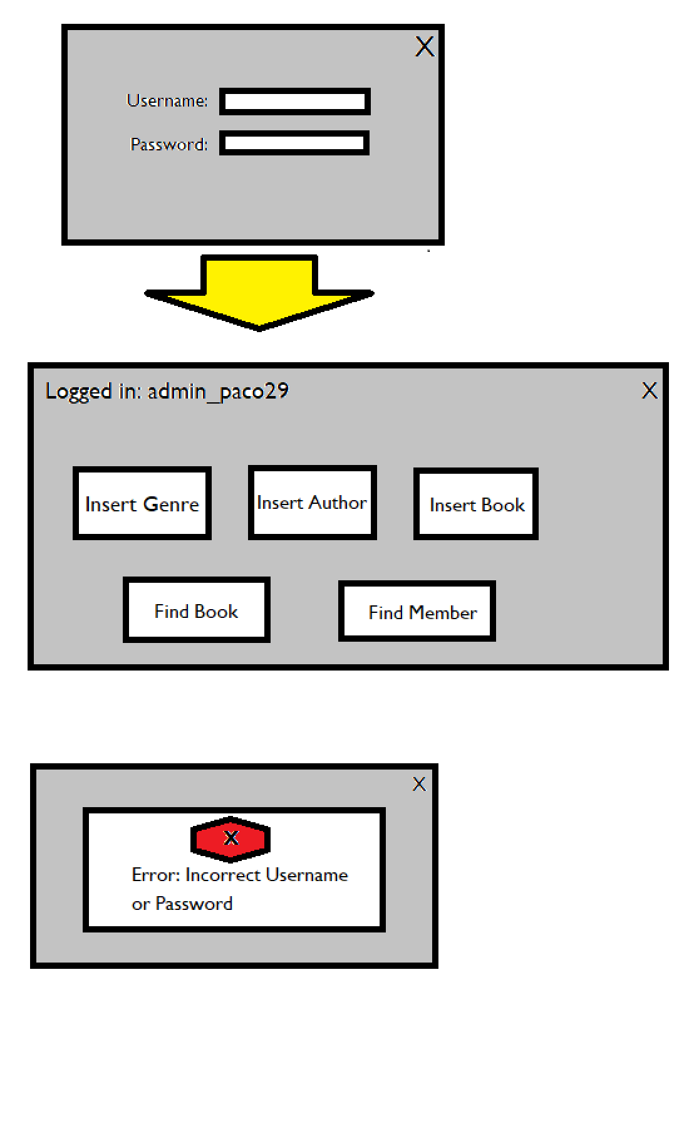

Insert Book A4

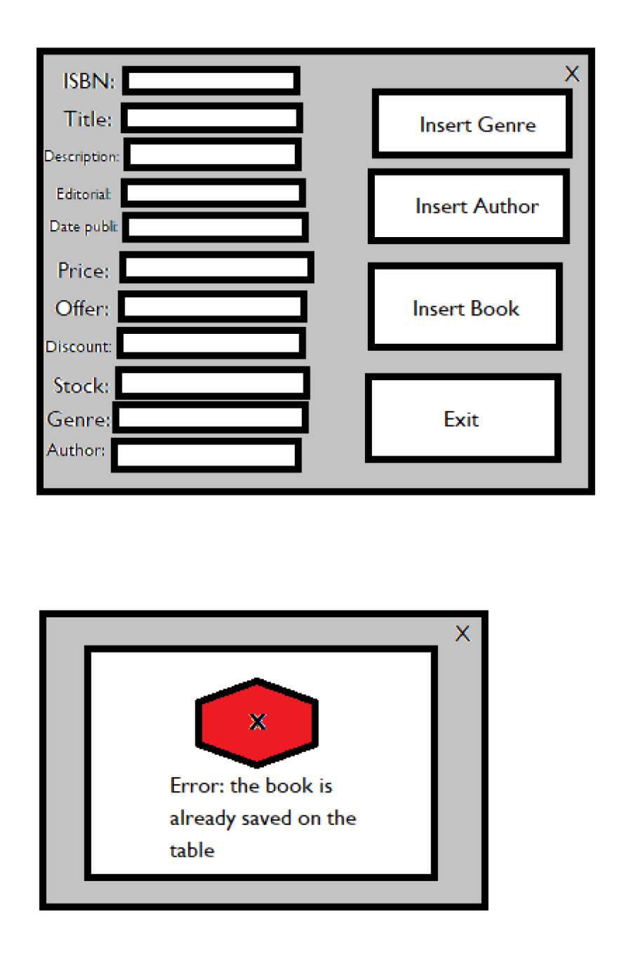

**\* We’ve decided that the “Insert Genre” button will not exist!!!**

Find Member A6

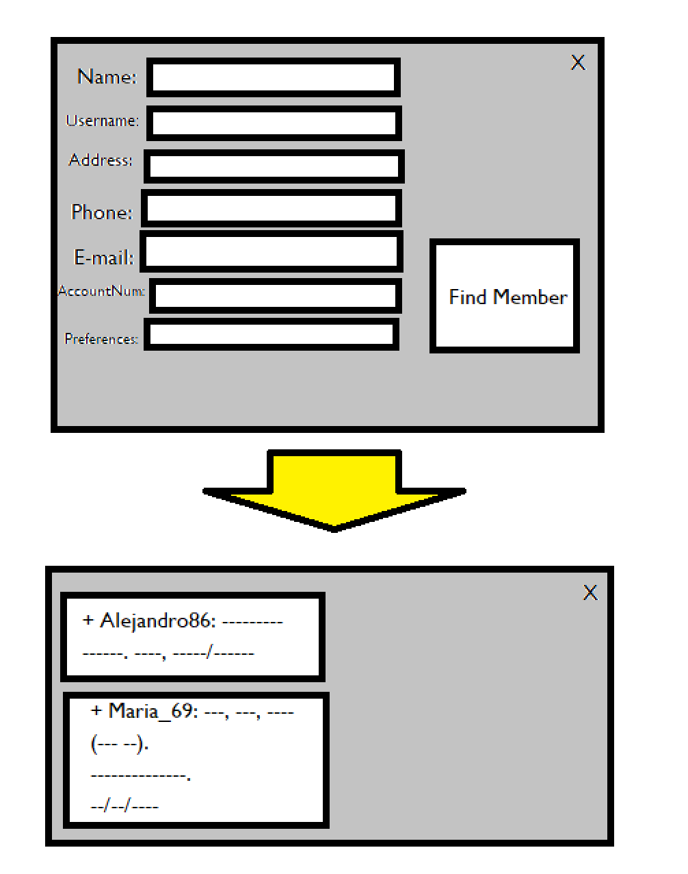

Modify Book A7

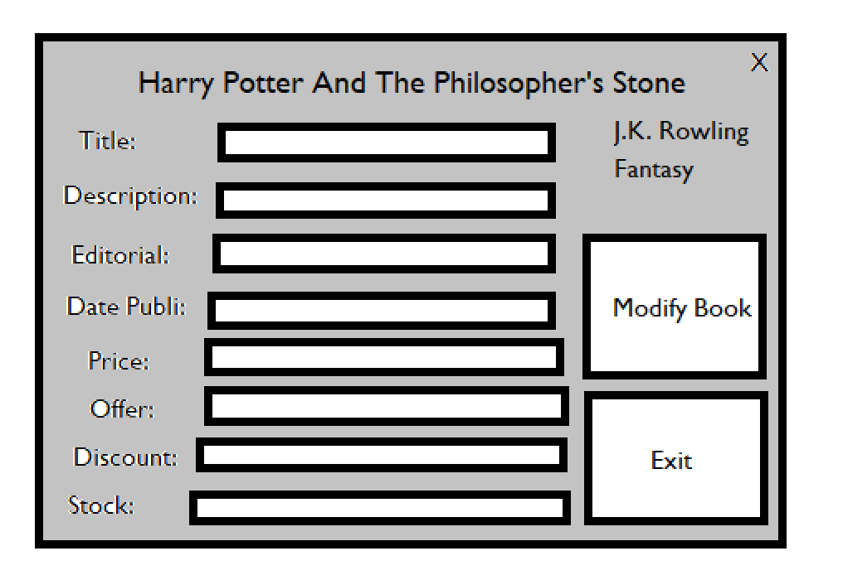

Drop Member A9

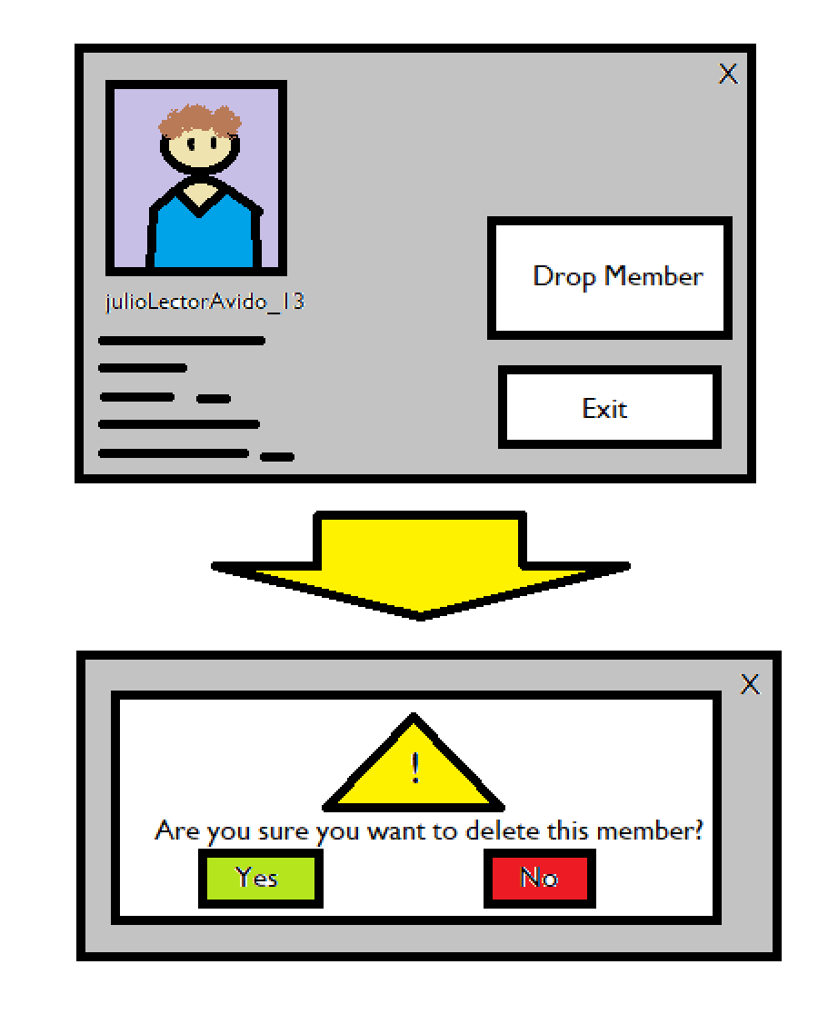

Sign Up M1

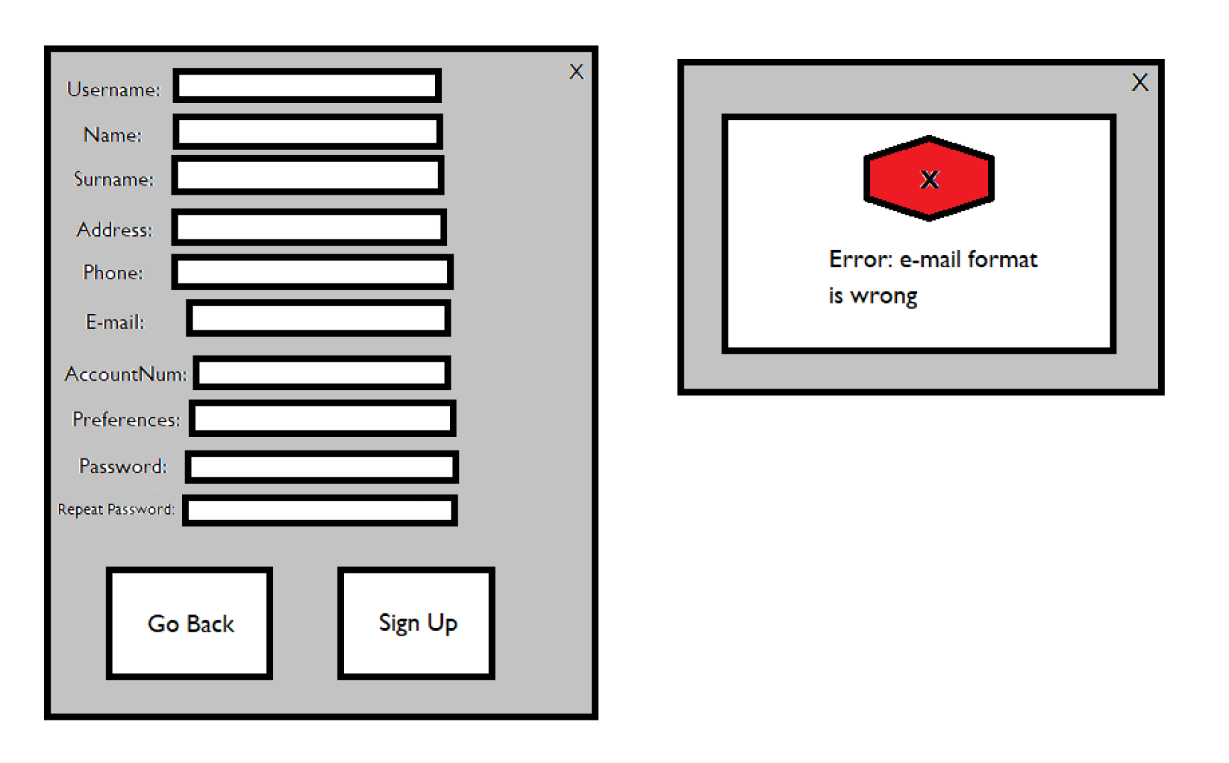

Check Purchases M3

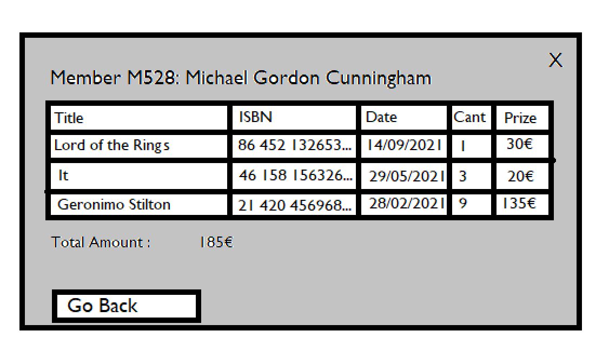

**\* Option “Check Purchases” will be reached from option “Check Basket” (which is in the main menu of the member). “Check Purchases” can also be accessible from “View Profile”!!!**

View Profile M5

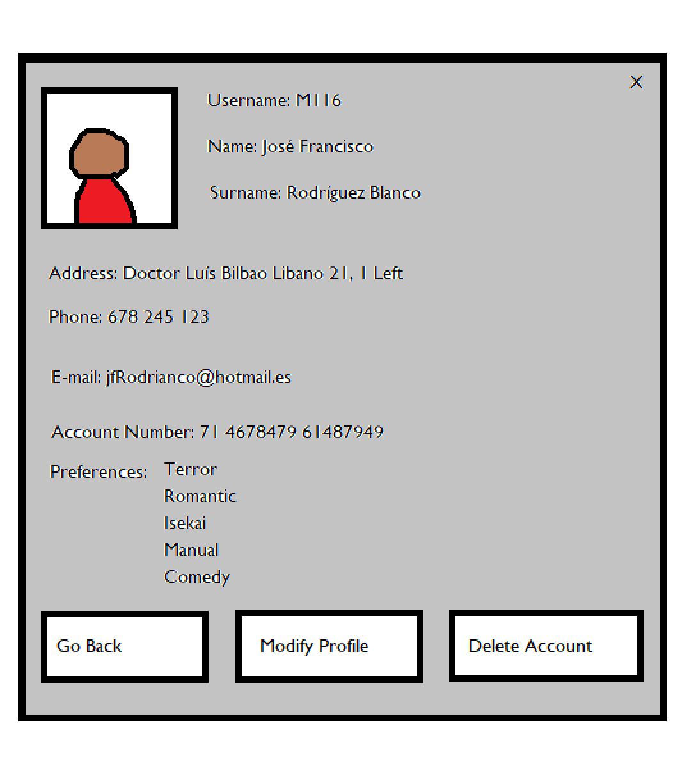

Buy Book M6

**\* The “Buy Book” button will be replaced for “Add To Basket”!!!**

