Market Forecast Group RC
Technical Documentation

Modification Date: 26.09.2011
Status: internal

Prepared By: Jamel Gasmi
© MFG - 2011
Revision History

Version | Date Updated | Revision Author | Brief Description of Changes
0.1 | 26.09.2011 | Jamel Gasmi | Initial Draft

Preface

Abstract
This document describes the overall architecture of MFG Rich Client Application.

Conventions
To help you using this manual, we set some conventions for typography and graphical symbols.

Character Presentation

Bold | All menus and commands are in bold.
Bold Italics | All references to chapters are in bold italics.
Italics | All dialog boxes names are in italics.
Arial | All cell names are depicted in this font.

Graphical Symbol Presentation

 | Any text indented with this symbol in front of it indicates important remarks.
 | Any text indented with this symbol in front of it indicates important warning.
 | Any text indented with this symbol in front of it indicates an example.
 | Any text indented with this symbol in front of it indicates a definition.
 | Any text indented with this symbol in front of it indicates a reminder.

Reference
Please find below other documents and technical references for further details:

Table of Contents

1 Preface 1
1.1 Abstract 1
1.2 Conventions 1
1.3 Reference 1
2 Plug-ins Architecture 1
2.1 Plug-ins 1
2.2 DFSA RC Architecture 1
3 UI Specification 1
3.1 DFSA UI 1
3.1.1 Explorer View 1
3.1.2 New DB Wizard 1
3.1.3 Run Configuration Editor 1
3.1.4 Run Configuration Dialog 1
3.1.5 Search Dialog 1
3.1.6 Schedules View 1
3.1.7 User Management View 1
3.1.8 User Editor 1
4 Plug-ins Specification 1
4.1 Common Data Provider Plug-in 1
4.2 eSignal Connector 1
4.3 IB Connector 1
4.4 DB Connector 1
4.5 MFG SDK 1
4.6 DFSA UI 1
4.6.1 User Access 1

Plug-ins Architecture

Plug-ins
Name | ID
Common Data Provider | com.mfg.cdp
eSignal Connector | com.mfg.esignal
Interactive Broker Connector | com.mfg.ib
Database Connector | com.mfg.db
MFG SDK | com.mfg.sdk
DFSA UI | com.mfg.dfsa.ui
Strategy Builder | com.mfg.strategy.automatic

DFSA RC Architecture
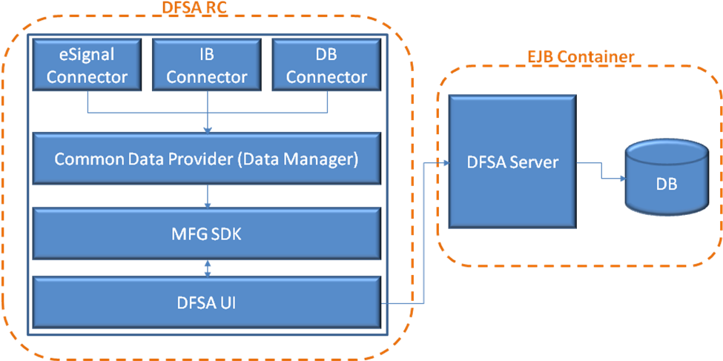

UI Specification

DFSA UI

Explorer View
The Explorer View will display all the existing databases. The user can choose only one database to work on and to set as default.

The default database will be used to save all the ticks coming from the data providers.

In the local toolbar of the explorer view, there is 3 buttons:
- New database: The “New Database” will open a wizard dialog allowing the user to create a new data base (see New DB Wizard)
- Import: The “Import” button will open the import dialog which will allow to import CSV files and save it into the data base
- Export: The “Export” button will open the export dialog which will allow to export data from the database to CSV

When the user right clicks on a database, a contextual menu will be shown, and the below actions could be performed:
- New/Run Configuration: open the DFSA Run Configuration Dialog
- Connect: open the connection to the database
- Disconnect: close the database connection
- Ping: test if the connection with the database could be opened
- Rename: rename the database
- Delete: delete the database
- Duplicate: clone the database with all its data
- Refresh: refresh the content of the explorer view

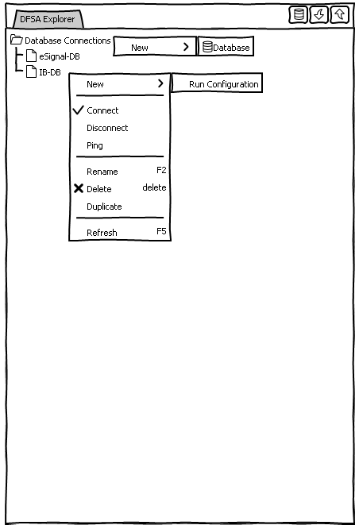
Figure 1: DFSA Explorer

New DB Wizard
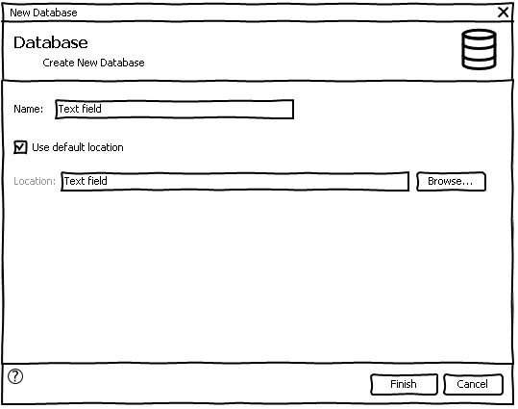

Run Configuration Editor
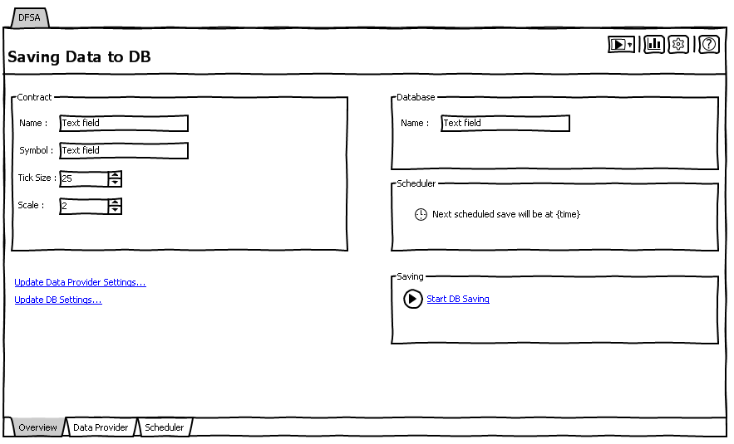

Run Configuration Dialog
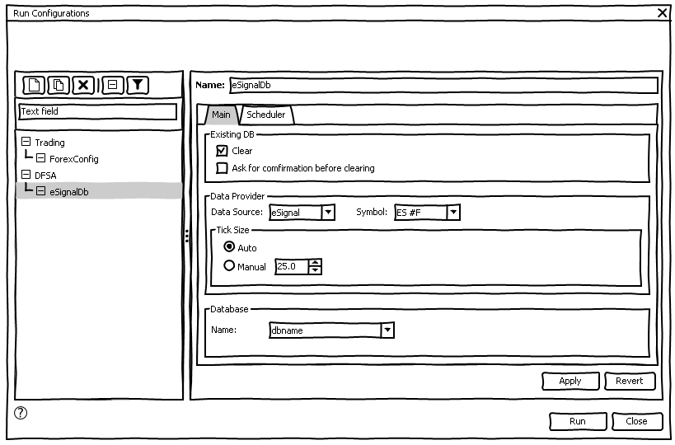

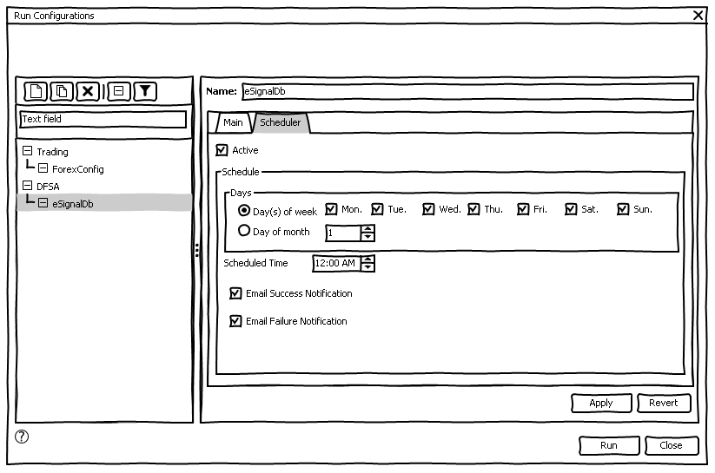

Search Dialog
Search for available data within the mentioned interval.

Show gaps: if the existing data within the chosen interval is not completed, all the missing interval will be shown as gap objects, and for each gap object we could right click on it and create an automatic run configuration which could be used to fill the gap.

It’s possible to select all gaps and create run configurations at once for all.

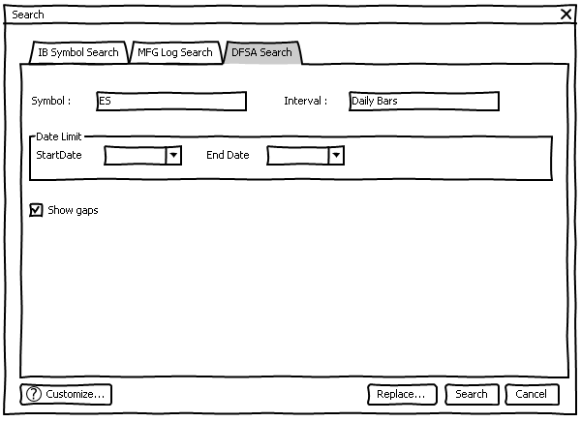

Schedules View
This view allows the schedules management
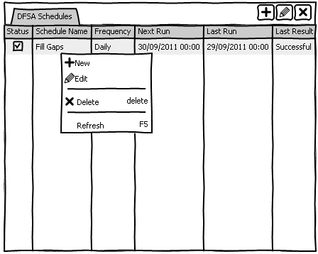

User Management View
T.B.D

User Editor
T.B.D

Plug-ins Specification

Common Data Provider Plug-in

It is a plugin which allows to be extended by other plug-ins(connectors) via an extension point.
Eclipse provides the concept of “extension points” and “extensions” to facilitate that functionality can be contributed to plug-ins. Plug-ins which define extension point open themselves up for other plug-ins. An extensionpoint defines a contract how other plug-ins can contribute.

Connectors which defines an “extension” contributes to the defined “extension point” in the DM plug-in.
The extension point provider for DM has the ID “com.mfg.dm.dataprovider”.

To add a contributing plug-in to the dm, you have to follow theses steps:
- Create a new plug-in project.
- Add “com.mfg.dm” to the dependencies.
- Switch to “Extensions” tab in MANIFEST.MF and add extension point “com.mfg.dm.dataprovider”.
- Add “dataprovider” to your extension point.
- Create your class “XDataProvider.java” which will be associated to the “dataprovider” extension oint created.
- Implement your code according to your spec.
- Now your plug-in is ready to go, don’t forget to add it to the projects that will be considered in the run configuration.

eSignal Connector

It is a plug-in which defines an “extension” to the dm plug-in “extension point” “com.mfg.dm.dataprovider”, it allows to get prices using ESignal data type.

ESignal Preferences:
Host: mfgserver.bounceme.net
Port: 2010

IB Connector

It is a plug-in which defines an “extension” to the dm plug-in “extension point” “com.mfg.dm.dataprovider”, it allows to get prices using IB data type.

IB Preferences:
Max requested prices: 100
Max client id: 5
Port: 7496

DB Connector

It is a plug-in which defines an “extension” to the dm plug-in “extension point” “com.mfg.dm.dataprovider”, it allows to get prices using DB data type.

MFG SDK

DFSA UI

User Access
DFSA UI will only be used by granted users.

User should mention his credentials to be able to use the DFSA Run Configuration or even the Scheduler if his account will allow him otherwise he will get a message informing him that his account is not granted to that action.

User credentials should be mentioned in the DFSA Preference page.

