USAIndiaCFO / BNG Advisors
Tax Return Review Center
Box-Powered End-to-End Specification
Grounded in a live inspection of the firm's Box repository
Prepared for: Karan Narania, Technology & Automation Lead
Prepared by: Akshay Nahar, CA · CPA — Co-Founder & Chief Growth Officer
6 September 2026

0 Verdict
Box is already the system of record, and it is in better shape than expected. The folder convention is deterministic — Clients / alphabetical bucket / client name / Permanent Documents and Tax Years / YYYY / Internal Working, Tax Documents, Tax Return. It holds roughly two thousand clients and over 133,000 return PDFs, with a consistent file naming convention. This means the ingestion layer is a mapping exercise, not a data-modelling exercise. That is a significant saving.
Text extraction works, but not universally. I pulled a complete 1040-NR out of Box as clean text — every form, every figure, plus a form inventory from the PDF bookmarks. I also hit a return where no text representation was available at all. The pipeline therefore needs a fallback ladder ending in a manual queue, never a silent gap.
One issue outranks every feature on the roadmap: the extracted text contains live Social Security numbers in clear text. Before this platform is opened to all partners, a redaction gate and an access model must exist. This is not a phase-two item.

1 What is actually in Box
Finding | Detail | Consequence for the build
Deterministic folder convention | Clients → A-D / E-H / I-L / M-P / Q-S / T-Z / 0-9 → client → Permanent Documents + Tax Years → YYYY → Internal Working, Tax Documents, Tax Return | Folder resolution can be pure code. No AI needed to find a client's return
Scale | 297 clients in the A-D bucket alone; search returned 133,003 files matching the return-copy naming pattern | Batch review is feasible; also means any per-file cost must be modelled before switching it on broadly
Consistent file naming | "YYYY Tax Return Documents (NAME - Client Copy).pdf", "Acknowledgement Receipt.pdf", "YYYY Signature Return Documents (NAME).pdf" | Document classification is a regex-and-rules job, not a model job
Individuals and entities share one convention | "Agarwal, Adiya" and "A3 Logics Inc" have identical internal structure | One ingestion path serves both 1040 and business returns
Permanent Documents encodes entity facts | BOI, Charter Documents, Owner Documents, Form W-8/W-9, EFTPS and bank details, per-state SOS and payroll folders, and a Compliance Calendar spreadsheet | This is the S0 and determination source. It is the difference between a real review and a form check
State footprint is in folder names, with status | "Home State- California SOS and Payroll Documents", "Maryland SOS (Dissolved) and Payroll Documents", "Texas Payroll (Account closed) & SOS Documents", "NJ SoS and Payroll Registration" | Nexus and registration status are already recorded. S3-STATE can be seeded from this rather than asked from scratch
Tax Documents is rich | Bank Statement, Credit Card Statement, Financials, MIS, Payroll Returns & Review, Payroll Summary, 1099 Working, Projected P&L, Notices, CA_SOI Filings | S1 and S2 have real source material. The books connectors are valuable but not a blocker — the financials are already filed here
Foreign and Indian entities are in the same tree | Pvt Ltd, GmbH and BV entities sit alongside US LLCs and Inc; a separate India Docs folder exists at root | S3-INTL and S3-INDIA have a real population to test against, which the demo data never provided

Data quality issues found in the sample
Issue | Example | Why it matters
Duplicate client folders | "Agarwal, Nishant" and "Agarwal, Nishant(1)" both exist as separate folders | A review run against the wrong folder silently reviews the wrong history. Needs a dedupe pass and a canonical client ID before batch review
Some returns have no text representation | A 2024 corporate client-copy PDF returned no markdown or text representation on repeated attempts, while the signature document from the same folder extracted perfectly | Confirms the fallback ladder is mandatory. Assume a meaningful minority of files need OCR
Year folders exist without content guarantees | Year folders run 2019 through 2026 for most clients regardless of whether work was done | Presence of a year folder is not evidence of a filing. The engine must check contents, not folder existence

2 Folder-to-stage mapping
This is the core of the build. Every review stage already has a source folder. The mapping below should be encoded as configuration, so that a change in folder convention is a config edit rather than a code change.
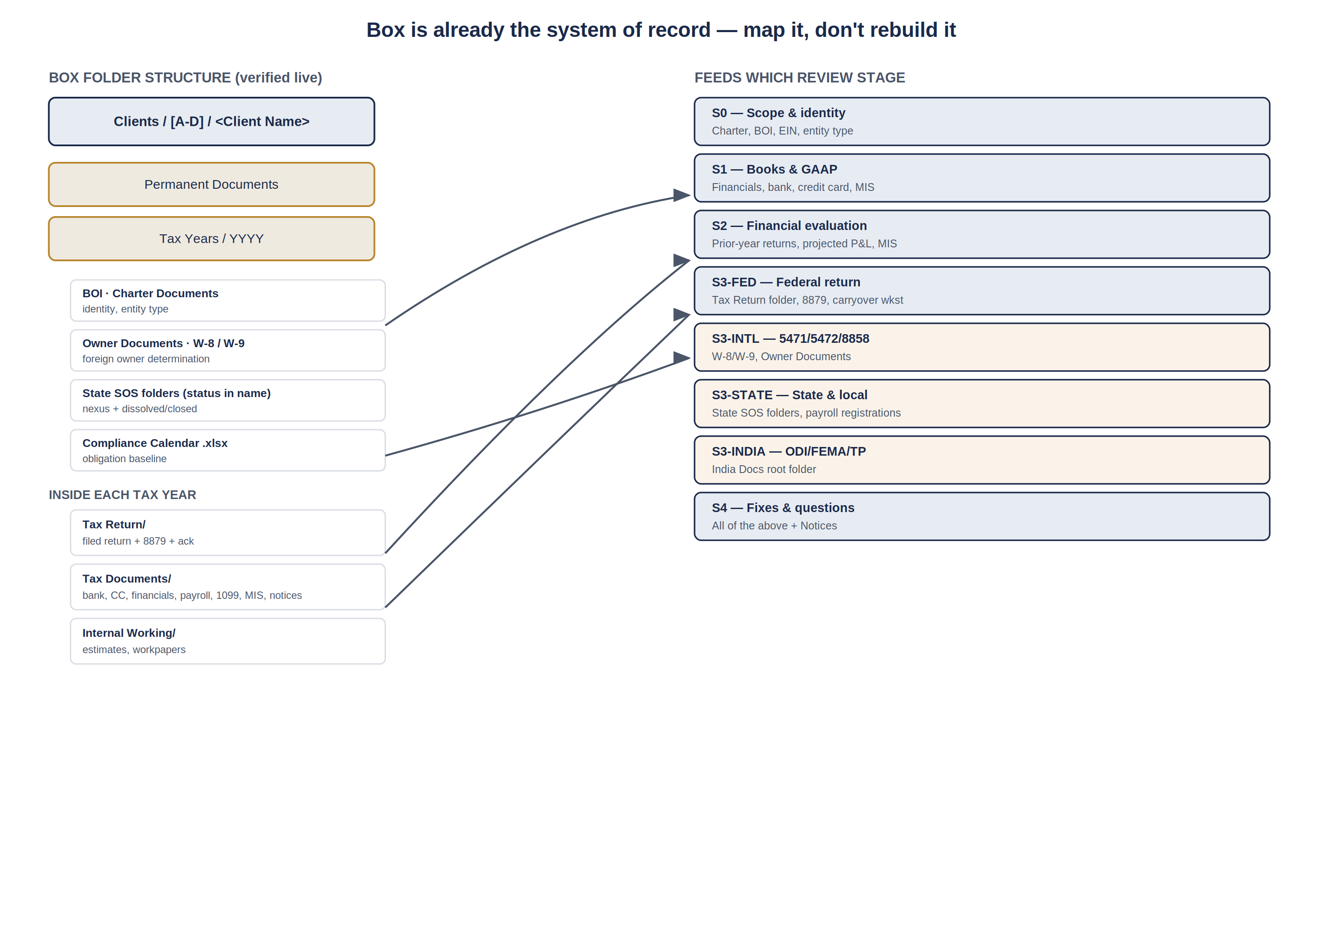
Figure 1 — the existing Box structure, mapped to the review stages it feeds.
Stage | Reads from | What it establishes
S0 — Scope and identity | Permanent Documents / Charter Documents, BOI; Tax Return / signature forms | Legal name, EIN, entity type, state of formation, correct return type
S1 — Books and GAAP | Tax Documents / Financials, Bank Statement, Credit Card Statement, MIS | Trial balance integrity, reconciliations, classification sweep
S2 — Financial evaluation | Prior-year folders, Projected P&L, MIS, Payroll Summary | Variance, ratios, cross-document matching against payroll and 1099 totals
S3-FED — Federal | Tax Return / client copy and signature documents; carryover worksheets | Form-level checks, tie-outs, carryforward continuity
S3-INTL — International | Permanent Documents / Form W-8 W-9, Owner Documents | Foreign owner determination, 5471/5472/8858/8865 triggers
S3-STATE — State and local | Permanent Documents / per-state SOS and payroll folders; CA_SOI Filings | Registered states, live versus dissolved, payroll registration by state
S3-INDIA — India symmetry | India Docs root folder; entity names indicating Pvt Ltd | ODI/FEMA mirror, Form 3CEB symmetry, Indian ITR consistency
S4 — Fixes and questions | All of the above, plus Notices folders | Fix instructions, open questions, evidence pointers

3 Ingestion, extraction and the PII gate
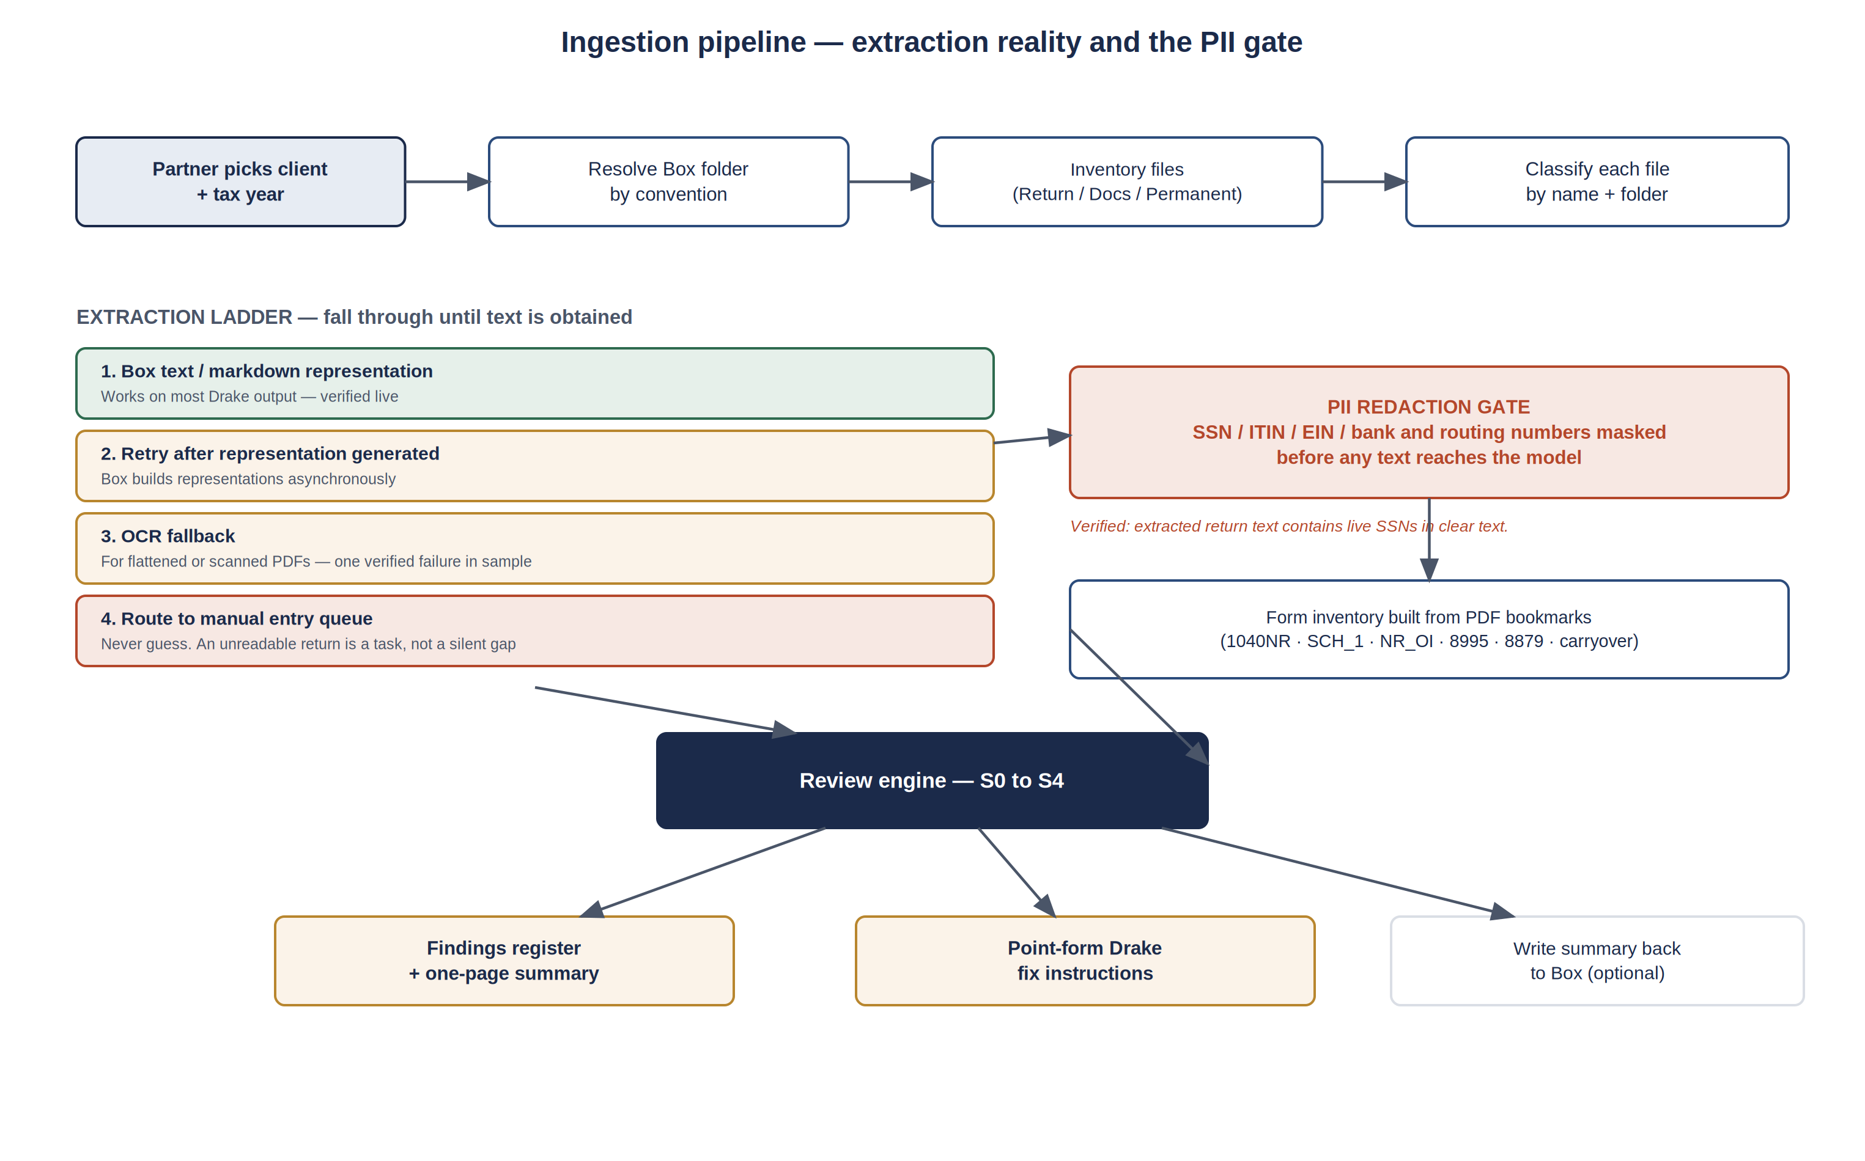
Figure 2 — ingestion pipeline. The redaction gate sits before the model, not after.

The extraction ladder
Verified behaviour, not assumption. A 1040-NR client copy extracted cleanly — Form 1040-NR, Schedule 1, Schedule OI, Schedule E, Form 8995, Form 172, Form 8879 and the carryover worksheets, with figures intact. A corporate client copy from a different folder returned no representation at all on two attempts.
Step | When it applies | Rule
1. Box text or markdown representation | Default. Works on most Drake output | Prefer markdown — it preserves structure the model can use
2. Retry once after a delay | Representation not yet generated | Box builds representations asynchronously; a single retry resolves some failures
3. OCR fallback | Flattened or scanned PDFs | Attach a confidence score per extracted field. Low confidence goes to step 4, never to the register
4. Manual entry queue | Everything else | An unreadable return becomes a visible task with an owner. It must never become a silently incomplete review

A free capability worth exploiting
The extracted text ends with the PDF's bookmark list — a complete inventory of the forms in the return. For the 1040-NR sample this read: engagement letter, client letter, 9325, 1040NR, Schedule 1, Schedule OI, Schedule E, 8995, 172, 8879, carryover worksheet, NOL worksheet, 172 AMT. That inventory answers the completeness question directly: compare forms present against forms the obligation engine says are required, and every gap is a finding. This is the cheapest high-value check in the whole system and should be built first.

4 Access and privacy — settle before opening to all partners
Verified during inspection: the text extracted from a client return contained the taxpayer's Social Security number in clear text, alongside address, bank routing fields and preparer PTIN. Any pipeline that sends raw extracted text to a model, writes it to logs, or caches it in a database is moving unmasked taxpayer identifiers into new systems. The Centre is about to be opened to every partner. This must be settled first.

Control | Requirement
Redaction before inference | Mask SSN, ITIN, EIN, bank account and routing numbers in extracted text before it reaches any model. Keep a token map so findings can still reference "the SSN on page 1" without carrying the value
No PII in logs or prompts retained | Prompt and response logging must store redacted text only. This is the most common accidental leak in AI pipelines
Box permissions are the source of truth | The Centre must respect existing Box collaboration permissions per client folder, not grant blanket access because a user is a partner. Box already records collaborations per item — read them, do not re-implement them
Access is per client, logged | Every open of a client's review is recorded with user, client, timestamp. A firm handling IRS representation should be able to answer who looked at what
Written-back artefacts inherit the client folder | If a review summary is written back to Box, it goes inside that client's folder and inherits its permissions — never to a shared reviews folder

5 Output format for the Drake operator
The brief is specific: a new preparer, including someone new to Drake, must be able to read a finding and make the change without interpretation. That means every finding carries the same five point-form lines, in the same order, every time. Prose paragraphs are the failure mode here.

The five-line finding format
Line | Content | Rule
WHAT | One sentence, plain English, naming the figure and the account | No jargon without a gloss. "Member draws written up as a consulting expense", not "misclassified distribution"
WHERE | Form, schedule and line, then the source account it came from | Always both. The operator needs the form location and the book location
CHANGE | The exact entry or edit, with the amount and its source document | Amounts come from a document, never estimated. Name the document
THEN | The line that must agree after the change is made | This is how the operator knows they are finished
WHY | One line | Keeps it short enough to be read. Detail belongs in the register, not the fix card

Worked example, in the required format
S1-001 · Critical · Bookkeeping issue
WHAT: 86,000 paid to a member is recorded in account 6300 Consulting fees. A payment to an owner is not a business expense.
WHERE: Form 1065, page 1, line 20 (Other deductions) — from GL 6300 "Consulting fees".
CHANGE: Move 86,000 out of 6300 and into distributions to members. If the operating agreement treats it as a guaranteed payment instead, enter it on the partner screen as a guaranteed payment so it reaches Schedule K line 4 and K-1 box 4.
THEN: Confirm page 1 line 20 has fallen by 86,000, and that either M-2 distributions or Schedule K line 4 has risen by 86,000. Total assets must still equal liabilities plus capital.
WHY: Partners cannot be paid as contractors by their own partnership. Left as is, ordinary income is understated by 86,000.

Two rules that keep this usable. First, never instruct the operator to override a Drake computation — change the input, not the result; if Drake still disagrees, that is an escalation, not an override. Second, if the correct treatment depends on a fact nobody has (here, what the operating agreement says), the fix does not guess. It states both branches and raises a question, exactly as the CHANGE line above does.

6 Build backlog for the Box layer
Fourteen items. These sit alongside the roadmap already issued for the review engine itself; where they conflict, the privacy items here take precedence.
Phase 1 — Privacy and access — before any partner-wide rollout
1. Build the PII redaction gate with a token map
Why: Extracted return text carries live SSNs. Nothing else on this list matters if unmasked taxpayer identifiers are flowing into prompts, logs and caches
2. Enforce Box collaboration permissions per client folder
Why: A partner-wide Centre must not silently widen access beyond what Box already grants. Read the existing collaborations rather than inventing a second permission model that will drift
3. Log every client-review access with user and timestamp
Why: A firm that does IRS representation should be able to say who accessed which client file and when
Phase 2 — Ingestion — make Box the front door
4. Encode the folder convention as configuration, not code
Why: The convention is deterministic today, but it will change. A config-driven resolver survives that; hard-coded paths do not
5. Build the document classifier from names and folders
Why: File naming is highly consistent. Classification is a rules job — using a model here would be slower, costlier and less reliable than a regex
6. Build the four-step extraction ladder ending in a manual queue
Why: One return in the sample had no text representation at all. Without an explicit fallback, that becomes a silently incomplete review
7. Build the form inventory check from PDF bookmarks
Why: This is the cheapest completeness check available — forms present against forms required. It should ship before any deeper analysis
8. Seed S3-STATE from the per-state folders in Permanent Documents
Why: The state footprint, including dissolved and closed registrations, is already recorded. Reading it beats asking the team to re-enter it
9. Seed S3-INTL determination from Form W-8/W-9 and Owner Documents
Why: The foreign-owner determination has a real source. This is what makes the international modules run in the positive case rather than always concluding not applicable
Phase 3 — Data quality — before batch review
10. Build a canonical client ID and dedupe pass
Why: Duplicate folders exist. Reviewing the wrong folder produces a confident review of the wrong history, which is worse than no review
11. Treat folder existence as no evidence of a filing
Why: Year folders run to 2026 for most clients regardless of activity. The engine must check contents
12. Reconcile the existing Compliance Calendar spreadsheets against the obligation engine
Why: Clients already carry a compliance calendar in Permanent Documents. Where the two disagree, that is a finding about the firm's own records and worth surfacing early
Phase 4 — Output
13. Implement the five-line finding format exactly as specified
Why: Consistency is what lets a new Drake operator act without interpretation. Variation in format is variation in comprehension
14. Write the one-page summary back into the client's Box folder
Why: Closes the loop — the review becomes part of the permanent client record, inheriting the right permissions, visible to whoever handles that client next year

7 Risks
Risk | Assessment | Mitigation
Unmasked PII reaching models, logs or caches | High likelihood, high consequence. Confirmed present in extracted text | Item 1. Do not roll out to partners before this exists
Cost at scale | 133,000 return files. A per-file model cost that is trivial in a demo is material across a client base this size | Model the per-run cost before enabling batch review. Populate the cost-to-run field that is currently blank
Wrong-folder reviews from duplicates | Medium likelihood, high consequence — a clean review of the wrong entity year | Item 10, before any bulk run
Extraction failures treated as clean results | Medium likelihood, high consequence. One failure already observed in a small sample | Item 6. Absence of text must produce a task, never an empty finding set
Convention drift | Certain over time. Folder conventions always change | Item 4, plus a monitor that reports folders which no longer match the expected shape
Scope creep from partner-wide access | Every partner will want a variation. Karan is part-time | Ship the five-line format and the one-page summary unchanged for everyone first. Variations only after the base is proven

What I could not verify: whether the Centre currently reads from Box at all, since the application's Settings and New review screens were unreachable during the last walkthrough. If a Box connection already exists, strike the items above it already implements rather than rebuilding them.

