USAIndiaCFO / BNG Advisors
Tax Return Center
Build Guidance for Karan — Reaching Senior-CPA-Grade AI Review
Prepared for: Karan Narania, Technology & Automation Lead
Prepared by: Akshay Nahar, CA · CPA — Co-Founder & Chief Growth Officer
3 September 2026

0 Verdict
Where the platform stands today: a working chat-first shell at taxcentre-five.vercel.app, gated to @usaindiacfo.com via Google SSO. That is the right foundation — access control and a clean UI shell are usually the last things built, not the first.
What closes the gap to a senior-CPA-grade review: four build blocks, in order — (1) read-only connectors into Tally, QuickBooks, Zoho, and Xero so the review has real books to check against; (2) a structured parser for Drake and ProConnect exports so the review reads return data, not PDF text; (3) the review engine itself, run in the fixed four-stage sequence set out in Section 2; (4) a one-to-two-page audit summary UI with drill-down, versioning, and a question-and-answer loop back into the register.
Where this beats TaxGPT and SurePrep for this firm specifically: neither tool carries cross-border symmetry — TaxGPT is explicitly US-only with limited international support, and SurePrep's review layer is US-domestic data verification. Section 5 details the comparison. The firm's dual-jurisdiction capability is the moat; the platform should encode it, not abandon it for a generic US review tool.

How to read this document
- Section 1 — what a senior CPA's AI review actually requires, and how TaxGPT, SurePrep, and Blue J each solve pieces of it.
- Section 2 — the four-stage review architecture and the exact sequence every return runs through.
- Section 3 — the one-to-two-page audit summary format, with the six issue categories the firm asked for.
- Section 4 — connector integration: Tally, QuickBooks, Zoho, Xero, and the Drake / ProConnect parsers.
- Section 5 — competitive benchmark against TaxGPT, SurePrep, and Blue J, with the specific features worth adapting.
- Section 6 — Karan's build checklist: 24 items, each with why it matters, in build order.
- Section 7 — versioning, question-and-answer workflow, and re-run mechanics.
- Section 8 — guardrails that must not be relaxed, regardless of build pressure.

1 What a senior-CPA AI review actually requires
Before any build decision, it is worth being precise about what makes a review feel like a senior partner did it, rather than a checklist ran. Three qualities, consistently, across every tool researched for this document:
- It reasons from source, not from pattern-matching on form fields. A senior partner looking at Schedule L asks whether the number is right, not whether the field is populated. That means the AI needs the trial balance and the return side by side, not the return alone.
- Every claim is traceable to something verifiable. TaxGPT's stated differentiator is that its answers tie to primary authority, so a preparer can check the source before relying on it. This firm's own AI guardrails require exactly the same thing — a citation with no retrieved source is a build failure, not a style issue.
- It tells the preparer what to do next, not just what is wrong. SurePrep's diagnostic layer flags items requiring careful review — classifications, carryovers, missing information — and routes them into a review queue rather than a wall of red text.

The three-tool landscape, and where each stops short
Tool | What it does well | Where it stops for this firm
TaxGPT | Cited research answers tied to IRC / Treasury Regs / rulings  Return review that reconciles filed returns to source documents and flags audit-risk mismatches  "Cowork" agentic workflows that run inside the firm's existing software | Explicitly US-federal / state / local focus, with limited support for international jurisdictions — no cross-border, no transfer pricing depth  No ODI/FEMA layer, no Form 3CEB / TP symmetry check — the exact gap this firm's platform must fill
SurePrep (TaxCaddy / 1040SCAN) | Mature OCR-to-data-entry pipeline for 1040 season  "Tax Summary" panel — a high-level overview auto-populated on delivery, without opening the full return  Client-facing collection portal with e-signature, well-adopted by clients | 1040-centric; not built for 1065 / 1120 / 1120-F / 5472 complexity  The review layer is document-to-return verification, not a books-to-GAAP-to-return chain
Blue J / CoCounsel Tax | Strong tax-research and prediction engine for contested positions  Multi-state comparison exports | Research-and-drafting tool, not a return-review-and-QC platform  No bookkeeping or GAAP layer at all

The takeaway for Karan's build: no single competitor tool does what this firm needs in one place — a books-to-GAAP-to-return chain, with US and India symmetry, ending in a one-to-two-page summary. That combination is the product. The individual mechanisms below (cited answers, a review queue, a delivered summary panel) are worth adapting; the overall shape is not available off the shelf, which is exactly why building in-house is the right call.

2 The review architecture — four stages, fixed order
The review engine the firm already has in reference form (the tax-return-review skill previously delivered) defines the sequence a senior CPA follows, and the platform should encode it literally rather than re-derive it. The reason for a fixed order, not a checklist the AI can reorder: most return errors are book errors that were faithfully copied onto the form. Fixing the form without fixing the books means the same error returns next year.
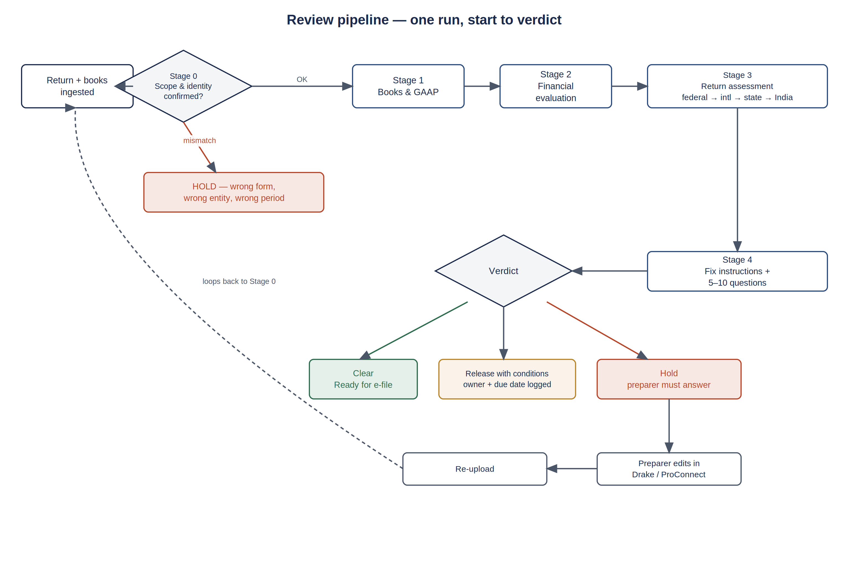
Figure 1 — every return runs this exact sequence, every time. A Critical or High finding halts progress at Stage 4, not silently downstream.

Stage 0 — Scope and identity
Confirms entity, EIN, period, and return type against the engagement record before any content review starts. A wrong return type (an LLC taxed as a partnership filing 1120) is caught here, not three stages later.

Stage 1 — Books and bookkeeping
Trial balance integrity, bank and AR/AP reconciliation, fixed assets, and the GAAP expense-classification sweep (meals, travel, related-party rent, owner distributions coded as expense, and 15 other recurring misclassifications). This stage produces a reconciled trial balance with every proposed adjusting entry sourced to a document — never estimated.

Stage 2 — Financial evaluation
Current-vs-prior variance on every line, five diagnostic ratios (gross margin, payroll/revenue, rent/revenue, interest/average-debt, net-income/distributions), and cross-document matching — gross receipts to 1099-K, wages to W-3, related-party payments to Form 3CEB and TDS certificates. This is the stage that catches the number that is correctly posted, correctly reconciled, and simply wrong for this business.

Stage 3 — Return assessment
Runs in a fixed sub-sequence per return type: federal form checks → international information returns (5471/5472/8858/8865/8621/FBAR) where any foreign fact exists → state and local → India-side symmetry (ODI/FEMA, TP, TDS, GST, Indian ITR) where any Indian owner or affiliate exists. Full form-by-form detail is in the firm's tax-return-review skill; the platform's job is to call each module in this order and never skip one.

Stage 4 — Fix instructions and questions
Every finding gets a plain-English fix (where in Drake/ProConnect, what to change, what to re-check after) and, where the fact is genuinely unknown, a question for the preparer. The output is capped at 5–10 questions, ranked Critical/High first, each answerable with a fact or a document — never "please explain."

Severity drives the verdict, not the reviewer's mood
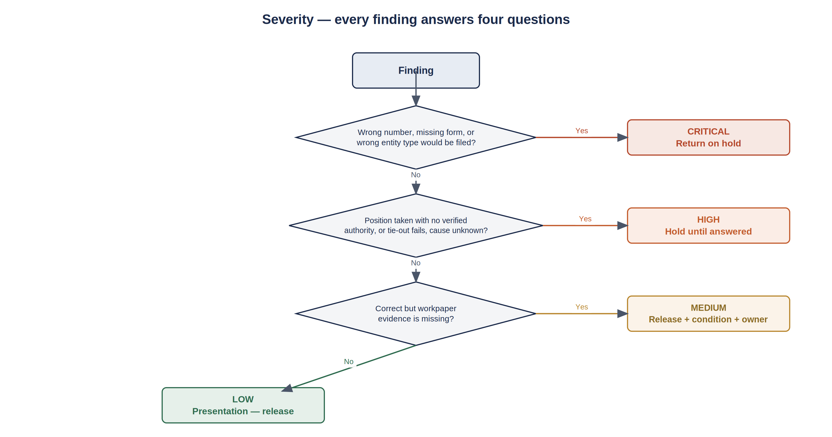
Figure 2 — the same four questions, asked of every finding, in every module. This is what makes the summary consistent across a 1065 and a 1120-F reviewed by different team members.
Severity | Meaning | Effect on the return
Critical | Wrong number, wrong classification, missing form, or wrong entity type would be filed | Return is on hold — no verdict short of Hold is possible
High | A position is taken with no verified authority, or a tie-out fails and the cause is unknown | Return is on hold until the linked question is answered
Medium | Figure is right but workpaper evidence is missing — would not survive an IRS query | Can release with a logged condition, owner, and date
Low | Presentation, rounding, naming, statement wording | Release; fix if time permits

3 The one-to-two-page audit summary
This is the deliverable the team actually reads. Everything in Section 2 exists to produce this page well. The pattern to copy — and the one genuinely good mechanism in the SurePrep suite — is the "Tax Summary" panel: a high-level overview that auto-populates on delivery, so the reviewer never has to open the full return to know where it stands. The firm's version needs six categories, not SurePrep's generic summary, and needs a verdict banner a novice can act on without interpretation.

Required layout — page 1
Zone | Content | Why it is placed there
Header band | Entity name, EIN, return type, tax year, preparer, reviewer, run date, run number | Identity confirmation before anything else — matches Stage 0
Verdict banner | Clear / Release with Conditions / Hold, in the severity colour, with the count of open Critical + High items | The single fact a partner needs before opening anything else
Six-category flag strip | One row per category (below), each with an open-item count and colour | Lets the team route work by specialism — bookkeeping vs. cross-border vs. TP — without reading every line
Top 5 findings | The five highest-severity open items, one line each, in the plain-English fix format | Most reviews resolve around 3–5 real issues; surfacing them first respects the reader's time
Tie-out strip | Pass/fail icons for the mandatory tie-outs (K-1 total = Schedule K line, L = M-2, 5472 Part IV = ledger, etc.) | A single glance confirms the return is internally consistent, independent of any individual finding

The six categories — mapped to the review architecture
The firm asked for six flag categories. They map directly onto the Stage 1–3 modules already defined, so no new review logic is needed — only a tagging and grouping layer on the existing findings register.
Category | Source stage / module | Typical finding
Bookkeeping issues | Stage 1 — books and GAAP | TB does not balance; bank reconciliation gap; suspense account non-zero; owner distribution coded as expense
Financial fixes | Stage 2 — financial evaluation | Gross margin fell 15 points with no stated reason; payroll/revenue ratio inconsistent with headcount; stale balance unchanged from prior year
IRS tax return fixes | Stage 3 — federal + state return assessment | M-1 reconciling item missing; K-1 box totals do not sum to Schedule K; missing state return for a nexus state; wrong entity-type box
Cross-border issues | Stage 3 — international information returns | Missing 5472 for a 25%+ foreign owner; 5471 category not re-tested; FBAR account list narrower than 8938; PFIC fund not disclosed
Transfer pricing issues | Stage 3 — India symmetry, TP sub-check | 5472 Part IV / 5471 Schedule M amount does not match Form 3CEB; related-party rate inconsistent between the two TP files; a payment on one side with no mirror on the other
High-flag issues | Cross-cutting — every Critical, regardless of source module | Anything that would stop the return from being filed as prepared — pulled up from wherever it originated so nothing Critical is buried inside a category the reviewer skips

Design rule: "High-flag issues" is a view, not a source. A Critical finding from Stage 1 (a negative cash balance) appears in both "Bookkeeping issues" and "High-flag issues." The register tags severity once; the summary UI filters the same tagged data into two lenses. Never let the AI independently decide what counts as "high-flag" separately from the severity it already assigned — that creates two sources of truth for the same fact.

Page 2 (only if needed) — drill-down and question queue
Page 2 exists only when Page 1's Top-5 does not cover every open Critical/High item. It lists the remainder in the same plain-English fix format, followed by the 5–10 preparer questions (Section 2, Stage 4) with their branching consequences. A return with three or fewer open High/Critical items should never need a second page — that itself is a useful signal to the team about return complexity.

4 Connector integration — Tally, QuickBooks, Zoho, Xero, Drake, ProConnect
Two categories of integration, with different risk profiles. Books connectors are read-only and feed Stage 1–2. Return connectors read prepared work and feed Stage 3; they never write back to Drake or ProConnect directly — every fix is applied by a human preparer inside the tax software itself, per the firm's existing AI guardrails (client correspondence and filed work are never AI-authored end to end).
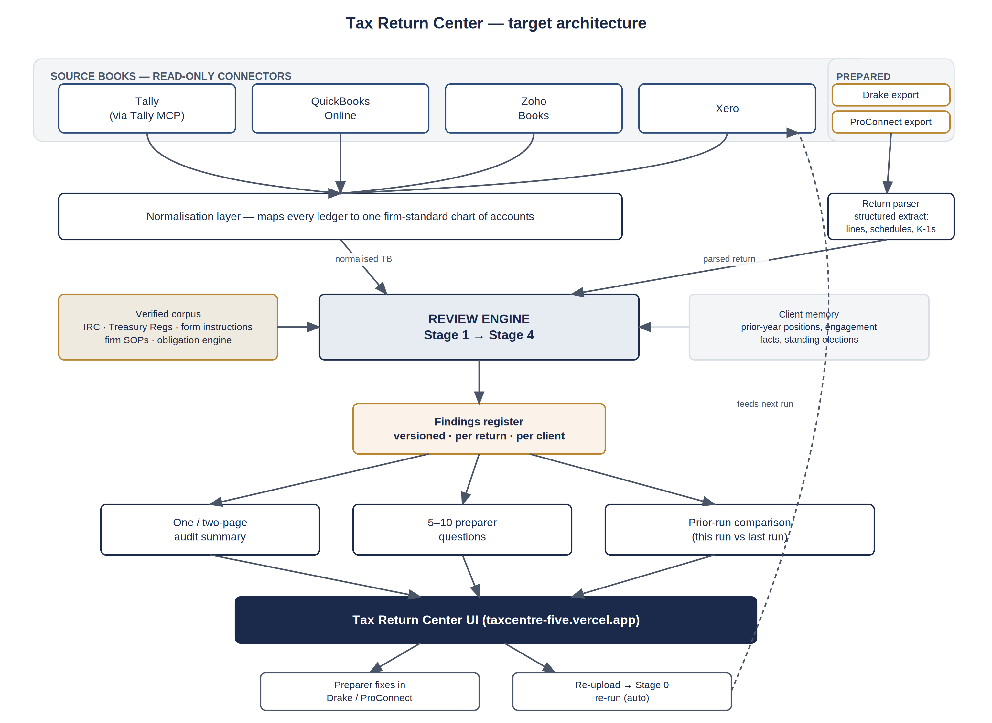
Figure 3 — target architecture. The review engine never writes to source systems; every arrow leaving the engine goes to a register, a summary, or a question — never back into Tally, QuickBooks, Drake, or ProConnect.

Books connectors
System | Integration path | What Stage 1–2 needs from it
Tally | The firm already has a Tally MCP connector in its architecture (per the firm's tally-mcp-connector work) — reuse it rather than building a second Tally integration. It exposes ledgers, vouchers, masters, and statement reports. | Trial balance at year end and prior year end; ledger transaction detail for the GAAP sweep; GST/TDS views for India-side entities
QuickBooks Online | QuickBooks Online has a documented MCP server (already listed among the firm's connected tools) exposing reports, transactions, and lists via the standard OAuth 2.0 flow. | Same as Tally — TB, GL detail, AR/AP aging, fixed asset detail if tracked
Zoho Books | Zoho Books has both a REST API and an existing MCP connector already in the firm's toolset — read-only scopes only (reports, transactions, contacts). | Same as above; Zoho's own reporting API returns P&L, balance sheet, and trial balance directly, which reduces normalisation work
Xero | Xero's Accounting API is OAuth 2.0 with read-only scopes available per report type — no MCP connector currently in the firm's toolset, so this is a net-new build. | Same as above; Xero's Reports endpoint returns trial balance and P&L in a structured format suited to the normalisation layer

The normalisation layer is the real engineering work
Four systems means four charts of accounts, four ways of naming "meals and entertainment," and four different fiscal-year conventions. The connectors themselves are the easy part — OAuth and a GET request. The work worth budgeting properly is a mapping layer that reduces every client's ledger to one firm-standard chart of accounts before Stage 1 runs, so the GAAP sweep logic (Section 2) is written once and works against all four sources. Building four parallel sweep implementations, one per accounting system, is the single most likely way this project quietly triples in scope.

Return connectors — Drake and ProConnect
System | Extraction path | Fidelity note
Drake | Drake's own export/import formats (and DoubleCheck's flagging data, if the firm wants to surface preparer-flagged items alongside AI findings) give structured field-level data — far more reliable than PDF text extraction for the return-to-K-1 tie-outs in Section 2. | PDF-only ingestion is a fallback, not a target — OCR error on a single K-1 percentage silently breaks every downstream tie-out check
ProConnect | ProConnect (used by the firm for the more complex 1040/1040-NR work) has its own export mechanics; confirm current API/export options directly with Intuit before committing to a parsing approach, since this changes without notice. | Complex individual returns (GILTI, PFIC) carry the highest stakes for a parsing error — prioritise this path even though volume is lower than Drake
Open item to resolve with Karan before Stage 3 build starts: does the platform currently ingest Drake/ProConnect output as PDF or as a structured export? This was flagged at the end of the prior document and remains unanswered from what is visible at the public URL. It is the single decision that most changes Section 3's build cost — a structured export makes the tie-out checks (K-1 totals, L = M-2, 5472 Part IV) a data comparison; PDF-only makes them an OCR-and-hope exercise.

5 Competitive benchmark — specific mechanisms worth adapting
This is not a build-vs-buy analysis; the firm has already decided to build in-house. It is a targeted list of mechanisms, observed in the tools named in the brief, that are worth deliberately copying because they solve a UX or reliability problem the firm's platform will also face.
Mechanism | Source | Why it is worth adapting | Where it fits the firm's architecture
Cited, source-linked answers — every claim traceable to primary authority, checkable before relying on it | TaxGPT | This is not a nice-to-have; it is the firm's own Rule 0 (partner-review skill) — no citation without a verified primary source. TaxGPT built it as a product feature; the firm needs it as a hard gate. | Output-schema validation layer (Section 6, item 14) — reject any citation not tied to a retrieved corpus span
Delivered "Tax Summary" panel — auto-populates on delivery, viewable without opening the full return | SurePrep TaxCaddy | Directly answers the one-to-two-page requirement — the firm should not reinvent this pattern from scratch, just build the firm's six categories into it | Section 3, Page 1 layout
Review queue that routes only flagged items to a human, rather than a full re-read | SurePrep 1040SCANverify / diagnostics | This is what makes AI review actually save time — the reviewer's attention goes to the 5–10 real questions, not a re-read of everything | Section 2, Stage 4 question generator
Agentic workflows that execute inside the firm's existing software rather than replacing it | TaxGPT Cowork | Validates the firm's own design choice — the platform reads Drake/ProConnect and writes findings; it does not attempt to become a tax-prep engine itself | Section 4 — connectors read-only; fixes applied by the human preparer inside Drake/ProConnect
Weekly ingestion of new IRS/regulatory guidance so recommendations reflect current law | TaxGPT | The firm's obligation engine already exists for due dates and thresholds; the corpus underlying Stage 3 citations needs the same discipline — a versioned, dated corpus, not a static one built once | Corpus versioning, Section 6 item 15

What not to adapt: none of the three tools researched carry a cross-border symmetry layer or a transfer-pricing tie-out — TaxGPT states this limitation directly, and SurePrep and Blue J were not built for it at all. This is confirmation, not a gap to apologise for: it is the reason the firm is building rather than buying, and Sections 2–3's India-symmetry module is the differentiated part of the product. Do not let competitive research pull the roadmap toward matching a US-only tool's feature list at the expense of the moat.

6 Karan's build checklist — 24 items, in build order
Grouped into four phases matching the architecture in Figure 3. Each item states what to build and why it matters — not how to code it; the firm's existing usaindiacfo-build-conventions and usaindiacfo-integration-contract standards govern implementation detail (repo layout, secrets handling, OAuth token refresh, idempotency).
Phase 1 — Connectors and normalisation (books side)
1. Confirm reuse of the existing Tally MCP connector for the review platform, rather than a second integration
Why: The firm already has this connector; a duplicate build wastes the tightest resource on this project — Karan's own time
2. Build QuickBooks Online, Zoho Books, and Xero connectors as read-only, report-scoped OAuth integrations
Why: Read-only scopes are both a security control and a design statement — the review platform observes, it does not touch the books
3. Build the chart-of-accounts normalisation layer, mapping every source system's ledger to one firm-standard taxonomy
Why: This is the highest-leverage engineering investment in the whole project — every downstream Stage 1 check is written once against the normalised data, not once per source system
4. Version-stamp every books import with source system, extraction timestamp, and period covered
Why: A review run must be reproducible — if a finding is questioned six months later, the platform needs to show exactly what data it saw
Phase 2 — Return parsing (Drake / ProConnect side)
5. Resolve, with Karan, whether current ingestion is PDF-based or structured-export-based
Why: This is the single highest-impact open decision in the whole roadmap — flagged in Section 4 and unresolved from what is visible at the public URL
6. Build a structured Drake export parser that extracts every form, schedule, and K-1 as typed data, not raw text
Why: Enables the mandatory tie-outs (K-1 sum = Schedule K line, L = M-2, 5472 Part IV = ledger) as exact data comparisons rather than fuzzy text matching
7. Build the equivalent ProConnect extraction, prioritised for complex 1040/1040-NR work even though volume is lower
Why: GILTI, PFIC, and treaty positions carry the highest per-error stakes in the firm's return book
8. Build a parser confidence score per extracted field, with anything below threshold routed to manual entry rather than guessed
Why: Matches the firm's AI guardrails (Gate 4) — a system that defers 15% of the time beats one that is confidently wrong 5% of the time
Phase 3 — Review engine (the core AI work)
9. Implement Stage 0–4 as a fixed pipeline, not a single prompt — each stage is a separate call with its own inputs and outputs
Why: A single large prompt cannot reliably enforce "do not skip Stage 1 to reach Stage 3"; a pipeline can, because the orchestration code — not the model — decides what runs next
10. Wire the Stage 1 GAAP expense sweep, Stage 2 ratio/variance engine, and Stage 3 return-type modules to the firm's tax-return-review skill content directly
Why: The domain logic (which accounts to check, which ratios matter, which forms trigger which check) is already written and firm-reviewed — the platform should consume it, not re-derive it
11. Build the severity classifier as a deterministic decision tree (Figure 2), not a model judgment call
Why: Consistency across reviewers and across time depends on every finding answering the same four questions in the same order — this belongs in code, with the model supplying the finding, not the severity
12. Route every numeric value in a finding through the calculation layer or the source document — never let generated text originate a number
Why: This is the firm's Gate 1 (AI guardrails): the model reads and flags numbers, it does not compute them. Enforce this in the schema, not by instruction
13. Build the international-forms determination grid (5471/5472/8858/8865/8621/FBAR/3520) as a rules table keyed off ownership and account facts, re-run every year per return
Why: A category or requirement determined last year and carried forward without re-testing is the most common real-world miss in cross-border practice — the platform should structurally prevent "carry forward" as a default
14. Build a citation verifier: every statutory/regulatory reference in output is checked against the retrieved corpus before the finding is accepted; unmatched citations are rejected, not flagged
Why: This is the exact mechanism TaxGPT markets as its differentiator, and it is also the firm's own Rule 0 — a fabricated-but-plausible citation is the single most dangerous AI failure mode in a tax practice
15. Version and date-stamp the corpus itself (IRC, Treasury Regs, form instructions, firm SOPs, obligation engine) — never let the review run against an undated snapshot
Why: Tax authority is time-bound; a March review and a September review of the same year's return may need different corpus states if law changed mid-year
16. Build the India-symmetry module as a genuinely separate pass that checks for a matching Indian filing per foreign-fact — not a note appended to the US findings
Why: This is the platform's actual differentiator versus every competitor researched; treat it as first-class, not an afterthought bolted onto the US review
Phase 4 — Summary UI, workflow, and QA
17. Build the one-page summary layout exactly as specified in Section 3 — header band, verdict banner, six-category strip, top-5 findings, tie-out strip
Why: This is what the team actually reads; get this page right before investing further in the drill-down views
18. Build the six-category tagging as a filter over the single severity-tagged findings register, not a second classification pass
Why: Two independent classifications of the same fact will eventually disagree, and nobody will know which one is right — one tag, multiple views
19. Build the 5–10 question generator per the firm's question-generator reference — capped, ranked by severity, each answerable with a fact or document
Why: An open-ended "please explain" question defeats the purpose; the format constraint is what makes this fast for the preparer to close out
20. Build the answer-and-re-run loop: preparer answers a question, only the affected checks re-run, not the full pipeline
Why: A full re-run on every answer is slow and wastes compute on checks the answer did not touch — this is a meaningful cost and latency decision, not a nice-to-have
21. Build return versioning: every run is stored with a version number, and the UI can show run N vs run N-1 side by side
Why: Directly answers the requirement to "save previous returns for comparison, ensuring changes have been implemented" — this is a database design decision to get right early, not a feature to retrofit
22. Build a named-approval gate: nothing is marked Clear without a specific logged-in user, timestamp, and the exact register version they saw
Why: Matches the firm's AI guardrails (Gate 5) — an AI verdict is a first-pass, not a sign-off; a human approval with visible provenance is what actually clears a return
23. Build a golden-return regression test set (minimum 30 returns across all return types, per the output-schema eval requirements) before any version goes near a live client file
Why: An AI review component without an eval suite is a prototype regardless of how well it demos — this is the firm's own standard and should not be skipped under sprint pressure
24. Build fabrication and arithmetic probes into the same eval suite — inputs designed to invite a plausible-but-wrong citation or a computed number — as pass/fail gates, not soft warnings
Why: These two failure modes are the ones that reach a client or a tax authority looking completely correct; they are the reason the eval suite exists at all

7 Version comparison and the question-answer loop
The brief asks for three specific team behaviours: independent correction, re-run after adjustment, and comparison against prior runs. All three depend on the same underlying design decision — every review run is immutable once created, and a new run is a new version, never an edit of the old one.

Version comparison — what "compare to prior run" actually means
Comparison | What it shows | Why the team needs it
Run N vs Run N−1, same return | Which findings closed, which are new, which are unchanged, verdict change | Confirms the preparer's fix actually resolved the finding — not just that the number changed, but that the specific check now passes
This year vs prior year, same client | Which findings recur year over year | A finding that recurs every year is a process problem, not a one-off error — worth raising with the client or changing the firm's own intake checklist, not just fixing silently each season
Question answered vs question ignored | Whether an open question from Run N was addressed in Run N+1's inputs | Prevents a return being re-run and re-cleared without the actual fact the question asked for ever being supplied

The answer-and-re-run mechanic
- Preparer opens a finding's linked question in the UI and supplies an answer — a fact, a document, or both.
- The platform records the answer against the specific finding, with who answered and when.
- Only the checks affected by that answer re-run — not the full four-stage pipeline. If the answer resolves a Stage 1 bookkeeping question, Stage 3's return-level checks that depend on the corrected figure re-run; unrelated Stage 3 checks (a different form entirely) do not.
- The finding's status updates: closed (evidence supports the answer), changed (fix applied, downstream re-verified), or escalated (the answer itself needs reviewer judgment, not just data entry).
- The verdict banner recalculates from the updated register — a return only reaches Clear when every Critical and High item carries a closed status with evidence attached, not merely an answer with no document.

Design constraint worth holding firm on: a finding closed by a verbal or typed explanation with no attached evidence should stay technically "open" in the data model, even if the UI shows it as answered-pending-evidence. This mirrors the firm's own question-generator standard — verbal explanations do not close High findings. It is tempting to let a quick text answer silently clear a Critical item under deadline pressure; the platform should make that structurally harder to do by accident, not easier.

8 Guardrails that must not be relaxed under build pressure
Five points, each already established as firm policy (usaindiacfo-ai-guardrails), restated here because a 30-day sprint is exactly the condition under which a team quietly cuts a validation step to hit a deadline. Cutting any of these produces a platform that looks finished and is not safe to rely on.
Guardrail | What it prevents
The model never originates a number that reaches a finding — depreciation, tax, penalties, thresholds, due dates come from the calculation layer or the source document | A fluent, confident, wrong figure that reads as authoritative because it is well-formatted
Every citation is either grounded in the retrieved corpus with a source pointer, or absent — never a plausible guess | The single highest-risk failure mode in a tax practice: correct reasoning attached to a fabricated authority
Structured output only — every field typed, nullable stated explicitly, confidence and source recorded per extracted fact | Silent corruption of the findings register from an extraction that "usually parses"
A confidence threshold routes uncertain items to a human queue — it does not proceed with a guess | A system that is confidently wrong 5% of the time, which is worse than one that defers 15% of the time, because the 5% is invisible until it is too late
Nothing reaches Clear without a named human approval, recorded with what they saw at the time | An AI verdict being treated as a sign-off rather than a first-pass review — the platform's role is to make the senior review faster, not to replace it

One firm-specific rule that applies to this platform's own output
Client correspondence remains human-written. If a finding needs a fact from the client, the platform's job stops at generating the internal question and routing it to the preparer or partner. It does not draft the client-facing email. This is an existing firm-wide rule (and matches the user's own stated preference that all client-facing email is written personally, in the partner's own voice) — the review platform should never be the exception that quietly reintroduces AI-drafted client text through a side door.

9 Summary for Karan — where to start Monday morning
If the 30-day sprint model from the RAG-assistant build applies here too, the sequencing below fits a similar phased structure without assuming a specific timeline that has not been confirmed with Karan directly.
Priority | Items | Rationale
Resolve first — before any other build work | Item 5: PDF vs structured-export ingestion for Drake/ProConnect | Every downstream Stage 3 tie-out check's implementation approach depends on this answer
Build in parallel — books side | Items 1–4: connectors and normalisation | Independent of the return-parsing decision; can start immediately
Build in parallel — engine core | Items 9–12: pipeline structure, severity classifier, number-origination gate | The architectural spine everything else attaches to — get this right before layering domain checks on top
Build once the spine exists | Items 13, 16: international-forms grid, India-symmetry module | This is the differentiated part of the product — worth building carefully once the engine's plumbing is proven, not rushed alongside it
Build last, but do not skip | Items 17–24: summary UI, versioning, approval gate, eval suite | The UI is what the team judges the project by, but the eval suite (23–24) is what keeps the project trustworthy after launch — both matter, and neither should be cut to hit a date

This document, and the tax-return-review skill it builds on, are both living references — as Karan's build clarifies actual data availability from Drake and ProConnect, the specifics here should be revisited rather than treated as fixed.

