Introduction to Programming: Mini-Project 2

Following the American Psychological Association’s Guidelines

Markham M. Shofner

Johns Hopkins University

Introduction to Programming: Mini-Project 2

Design and Analysis:

1. General program design.
   1. The program – which mimics a game of blackjack that a user can play through a simple command line interface – aims to follow the patters and best practices laid out in the first eight modules of Intro to Programming. The program is written in an object-oriented manner, defining classes and instances, where the data contained therein in manipulated and managed by methods within those structures.
   2. The major data/logic structures used are:
      * The main() method, which initiates an instance of the BlackjackGameSimulator class, and triggers the init() function.
      * The init() method, which initiates the player, the dealer, and manages the state of the game.
      * The Contestants (Player and Dealer subclasses of the Contestant superclass), which can return int score values as needed based on the progression of a turn and the overall game.
      * The Card class, which returns an int rank that signifies a cards value.
2. Alternative approaches considered and reason for rejection:
   1. I considered using a Hand class that could contain multiple cards, but it seemed unnecessary to go that distance in terms of abstraction, when the contestant class would be able to manage a hand (of Cards) with simple getter and setter methods.
   2. I could potentially have created a class that would manage the state of the game (turn order and management, overall game flow, score checking, etc…) but the program seemed fine enough as is with the bulk of the logic/data living near it’s pertinent classes.

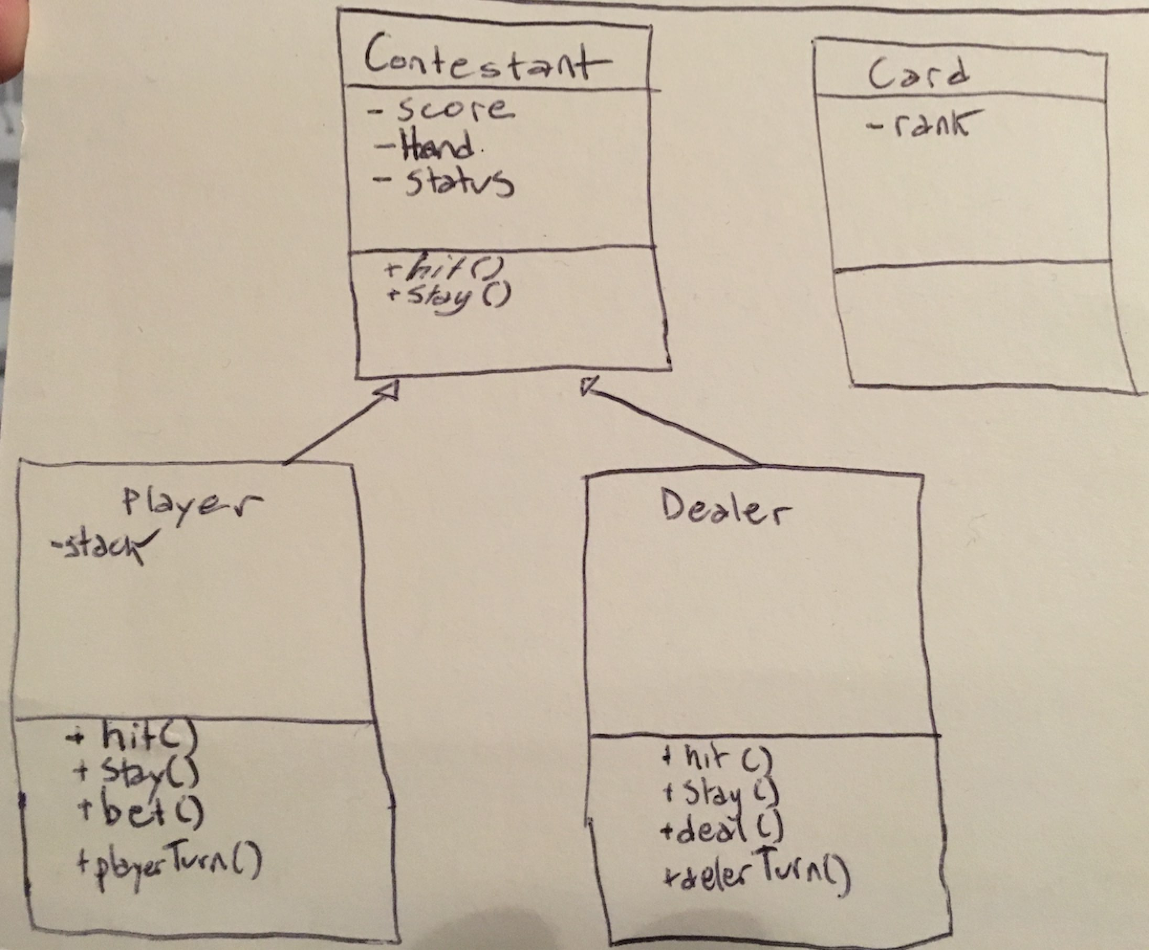

*UML class diagram.*

References

Schildt, Herbert (2014). Java The Complete Reference – Ninth Edition.