ReColor Ground-Truth Evaluation

Injection Content for Chapter IV
This document contains three (3) pre-formatted subsections to be inserted into the manuscript RECOLOR - as of APR 46.docx. Each section includes:
- A highlighted injection instruction specifying exactly where to insert
- Pre-formatted heading, tables, figures, and narrative text
- Table and figure captions using placeholder numbers (replace with your sequence)

⚠️ INJECTION INSTRUCTION: INSERT THIS SECTION after the "Comparative Analysis: Daltonization vs. Hue Rotation" subsection (currently ends around the paragraph that says "Determining true effectiveness requires measuring discrimination gain between confused colors, identified as future work."). Also REVISE that sentence to: "This discrimination gain analysis is presented in the following subsection."

Ground-Truth Validation: Enhancement Discrimination Gain
The comparative analysis in the preceding subsection evaluated enhancement algorithms using faithfulness metrics (SSIM and ΔE relative to normal vision). However, the clinically relevant question is whether enhancement restores discriminability between colors that CVD users confuse. To address this, 54 synthetic color pairs were generated (20 Protan, 20 Deutan, 14 Tritan) such that each pair is clearly distinguishable under normal vision (ΔE > 15) but confused under CVD simulation (ΔE < 5). Each color was enhanced using both algorithms, re-simulated under the corresponding CVD condition, and the post-enhancement ΔE measured. A gain exceeding 2 ΔE was defined as meaningful perceptual improvement.
Table 4.X — Enhancement Discrimination Gain Summary
CVD Type | Pairs | DAL Mean Gain | HUE Mean Gain | DAL Median | HUE Median | DAL %>2 | HUE %>2 | Winner
Protan | 20 | +22.06 | +8.39 | 17.64 | 0.00 | 95.0% | 45.0% | DAL
Deutan | 20 | +12.72 | +4.65 | 8.12 | 0.00 | 90.0% | 25.0% | DAL
Tritan | 14 | +3.36 | +1.19 | 3.00 | 0.10 | 64.3% | 35.7% | DAL
Daltonization achieved substantially higher discrimination gain than Hue Rotation across all three CVD types. For Protan, Daltonization produced a mean gain of +22.06 ΔE with 95.0% of pairs showing meaningful improvement, compared to Hue Rotation's +8.39 ΔE and 45.0%. For Deutan, the figures were +12.72 ΔE (90.0%) versus +4.65 ΔE (25.0%). Tritan showed a smaller but still significant advantage: +3.36 ΔE (64.3%) versus +1.19 ΔE (35.7%). Median gain analysis confirmed the advantage was robust and not driven by outliers (Protan median: 17.64 vs 0.0; Deutan: 8.12 vs 0.0).
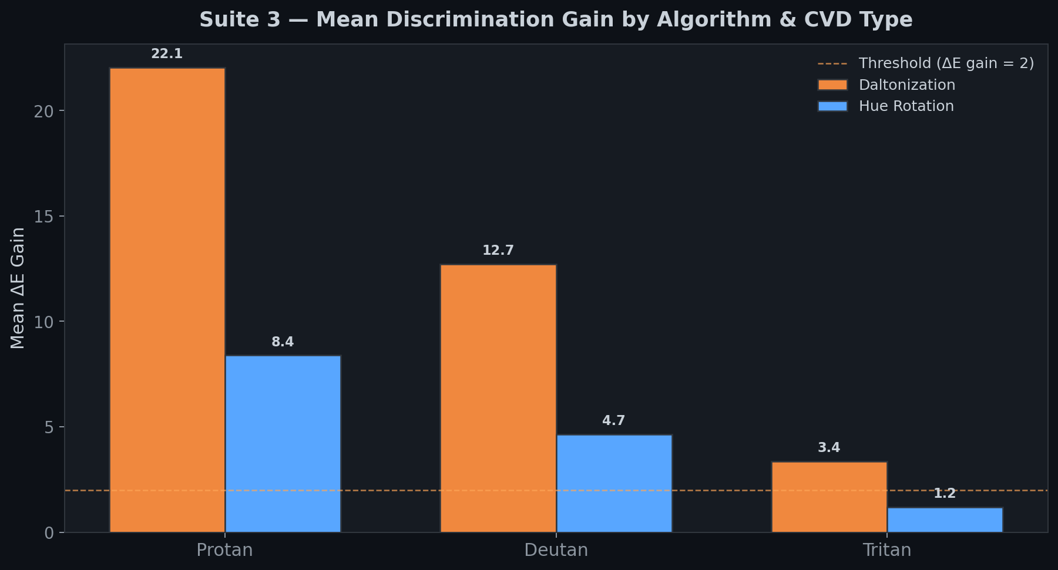
Figure 4.X — Mean Discrimination Gain by Algorithm and CVD Type
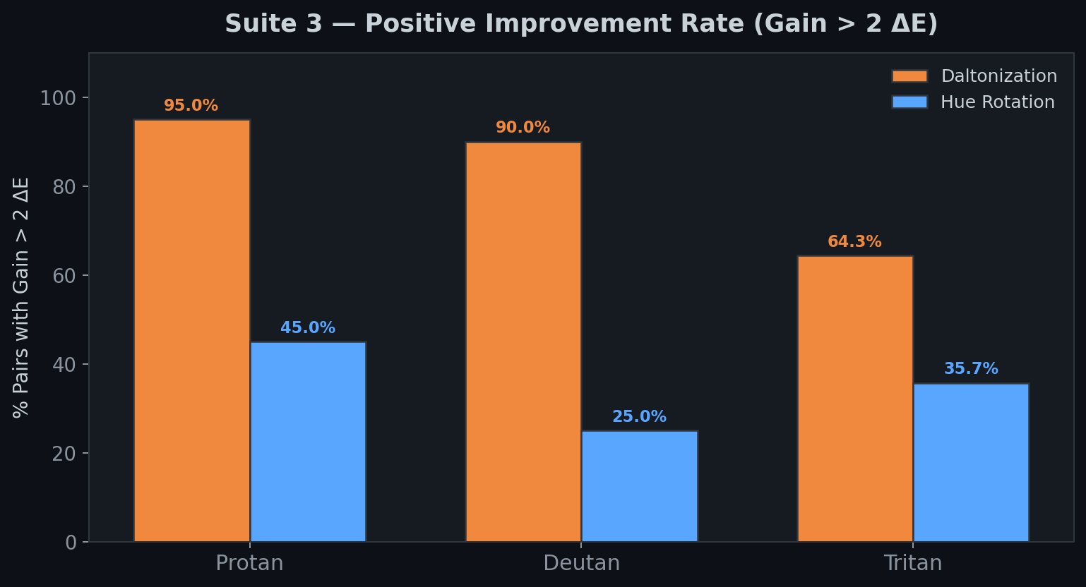
Figure 4.X — Positive Improvement Rate (Gain > 2 ΔE)
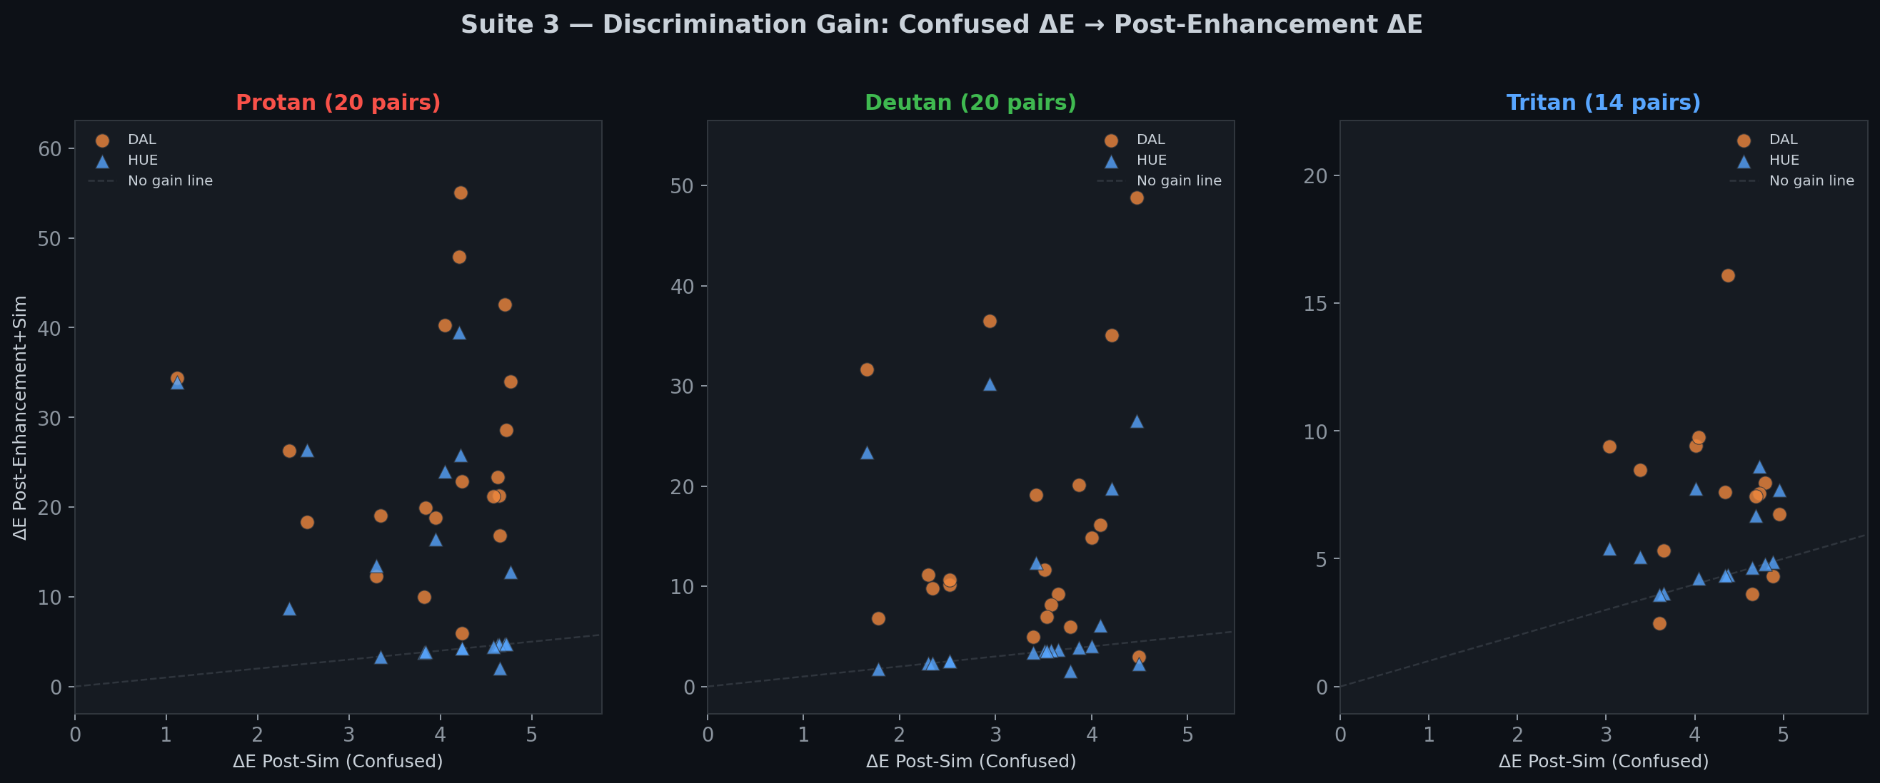
Figure 4.X — Scatter Plot: Confused ΔE vs Post-Enhancement ΔE
These results resolve the limitation identified in the faithfulness-based evaluation, where Hue Rotation appeared competitive with Daltonization on ΔE and SSIM metrics. The discrimination gain test reveals that Daltonization is substantially more effective at the task that matters most to CVD users—making confused colors distinguishable. Hue Rotation's advantage in structural preservation (higher SSIM) reflects its narrower corrections, which consequently restore less discriminability. This supports ReColor's dual-algorithm design, with Daltonization recommended as the primary enhancement mode for users seeking maximum color discrimination improvement.

⚠️ INJECTION INSTRUCTION: INSERT THIS SECTION after the "Edge Case Analysis" subsection under "Evaluation of Color Enhancement Accuracy" (after the paragraph about boundary colors achieving 55.0% accuracy).

Ground-Truth Validation: X-Rite ColorChecker 24
To validate the color identifier against a physically standardized reference, the algorithm was evaluated on the X-Rite ColorChecker Classic 24-patch target using published sRGB values (ISO 17321-1). This benchmark provides industry-standard color samples spanning the full gamut, including chromatic, neutral, and boundary colors.
Table 4.X — ColorChecker 24 Identification Results
Patch | RGB | Expected | Predicted | Conf (%) | Result
Dark Skin | (115, 82, 68) | Brown | Brown | 90 | PASS
Light Skin | (194, 150, 130) | Orange | Pink | 77 | MISS
Blue Sky | (98, 122, 157) | Blue | Blue | 89 | PASS
Foliage | (87, 108, 67) | Green | Green | 78 | PASS
Blue Flower | (133, 128, 177) | Violet | Violet | 78 | PASS
Bluish Green | (103, 189, 170) | Cyan | Cyan | 78 | PASS
Orange | (214, 126, 44) | Orange | Orange | 81 | PASS
Purplish Blue | (80, 91, 166) | Blue | Violet | 73 | MISS
Moderate Red | (193, 90, 99) | Red | Red | 84 | PASS
Purple | (94, 60, 108) | Violet | Violet | 82 | PASS
Yellow Green | (157, 188, 64) | Green | Green | 71 | PASS
Orange Yellow | (224, 163, 46) | Orange | Yellow | 88 | MISS
Blue | (56, 61, 150) | Blue | Violet | 67 | MISS
Green | (70, 148, 73) | Green | Green | 66 | PASS
Red | (175, 54, 60) | Red | Brown | 87 | MISS
Yellow | (231, 199, 31) | Yellow | Yellow | 77 | PASS
Magenta | (187, 86, 149) | Pink | Pink | 65 | PASS
Cyan | (8, 133, 161) | Cyan | Cyan | 65 | PASS
White | (243, 243, 242) | Neutral | Neutral | 94 | PASS
Neutral 8 | (200, 200, 200) | Neutral | Neutral | 96 | PASS
Neutral 6.5 | (160, 160, 160) | Neutral | Neutral | 83 | PASS
Neutral 5 | (122, 122, 121) | Neutral | Neutral | 96 | PASS
Neutral 3.5 | (85, 85, 85) | Neutral | Neutral | 87 | PASS
Black | (52, 52, 52) | Neutral | Neutral | 92 | PASS
The identifier correctly classified 19 of 24 patches (79.2%). All five misclassifications occurred at perceptual boundaries between adjacent hue categories: Light Skin was classified as Pink instead of Orange, Purplish Blue and Blue as Violet instead of Blue, Orange Yellow as Yellow instead of Orange, and Red as Brown instead of Red.
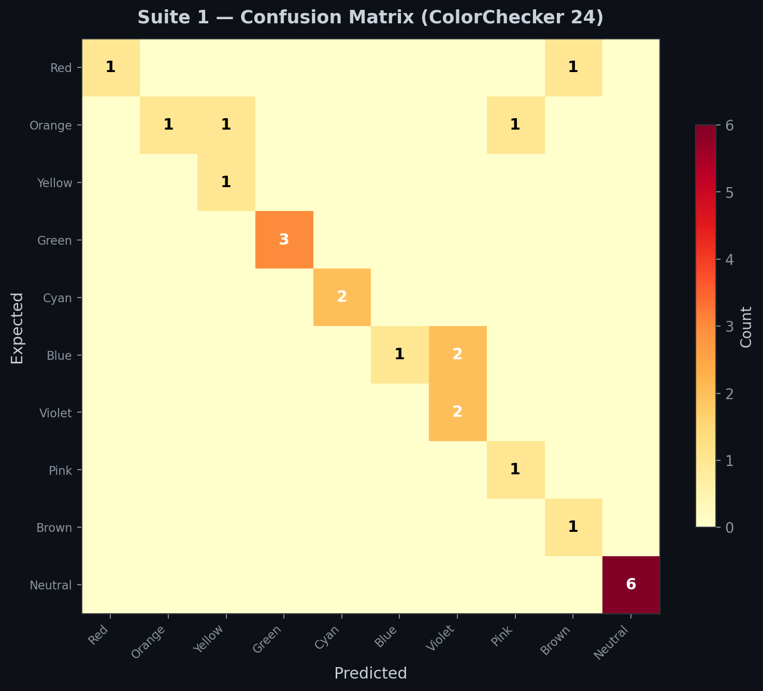
Figure 4.X — Confusion Matrix for ColorChecker 24 Ground-Truth Validation
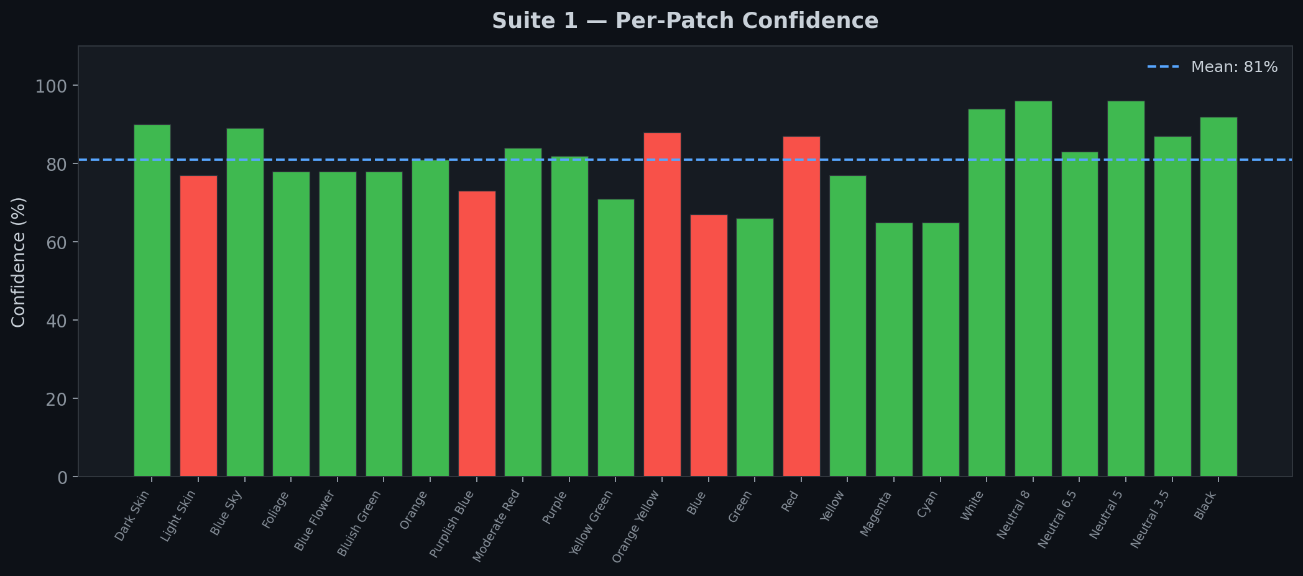
Figure 4.X — Per-Patch Confidence Scores (ColorChecker 24)
These boundary confusions are consistent with the synthetic-swatch results reported in the preceding Edge Case Analysis, where boundary colors achieved 55.0% accuracy. The ColorChecker results confirm that the identifier's primary limitation is inter-class ambiguity at hue-space boundaries rather than systematic algorithmic error—a known property of nearest-neighbor CIELAB classifiers operating on a 10-class taxonomy. The 79.2% accuracy on standardized reference patches, combined with the 84.6% accuracy on synthetic swatches, provides convergent evidence that the identifier performs reliably for its intended assistive purpose.

⚠️ INJECTION INSTRUCTION: INSERT THIS SECTION after the existing interpretation paragraph under "Evaluation of CVD Simulation Fidelity (GPU vs. CPU)" (after the paragraph that says "the float16 GPU shader introduces no perceptible precision loss").

Ground-Truth Validation: Viénot Reference Computation
To complement the GPU-versus-CPU fidelity test, a second validation compared the app's simulation output against a Viénot 1999 reference implementation using the IEC 61966-2-1 sRGB piecewise transfer function for linearization. Twelve test colors (six pure primaries/secondaries plus six naturalistic colors) were evaluated across all three CVD types.
Table 4.X — Simulation Fidelity: Viénot Reference vs App Output
CVD Type | Max Ch. Error | Max ΔE | Pure Primary ΔE
Protan | 22 | 5.595 | 0.000
Deutan | 4 | 1.849 | 0.000
Tritan | 3 | 1.819 | 0.000
Table 4.X — Protan Simulation: Per-Color Reference Comparison (Worst Case)
Color | Input RGB | Reference | App Output | Ch Error | ΔE
Pure Red | [255, 0, 0] | [108, 95, 0] | [108, 95, 0] | [0, 0, 0] | 0.0
Pure Green | [0, 255, 0] | [255, 229, 0] | [255, 229, 0] | [0, 0, 0] | 0.0
Pure Blue | [0, 0, 255] | [0, 89, 255] | [0, 89, 255] | [0, 0, 0] | 0.0
Yellow | [255, 255, 0] | [255, 243, 0] | [255, 243, 0] | [0, 0, 0] | 0.0
Cyan | [0, 255, 255] | [237, 241, 255] | [237, 241, 255] | [0, 0, 0] | 0.0
Magenta | [255, 0, 255] | [0, 126, 255] | [0, 126, 255] | [0, 0, 0] | 0.0
Orange | [255, 165, 0] | [194, 170, 0] | [195, 171, 0] | [1, 1, 0] | 0.487
Forest Green | [34, 139, 34] | [141, 124, 22] | [142, 125, 0] | [1, 1, 22] | 5.595
Sky Blue | [135, 206, 235] | [189, 201, 236] | [190, 203, 237] | [1, 2, 1] | 0.921
Mid Gray | [128, 128, 128] | [127, 127, 127] | [128, 128, 128] | [1, 1, 1] | 0.392
White | [255, 255, 255] | [255, 255, 255] | [255, 255, 255] | [0, 0, 0] | 0.0
Dark Brown | [101, 67, 33] | [79, 71, 35] | [78, 70, 29] | [1, 1, 6] | 3.027
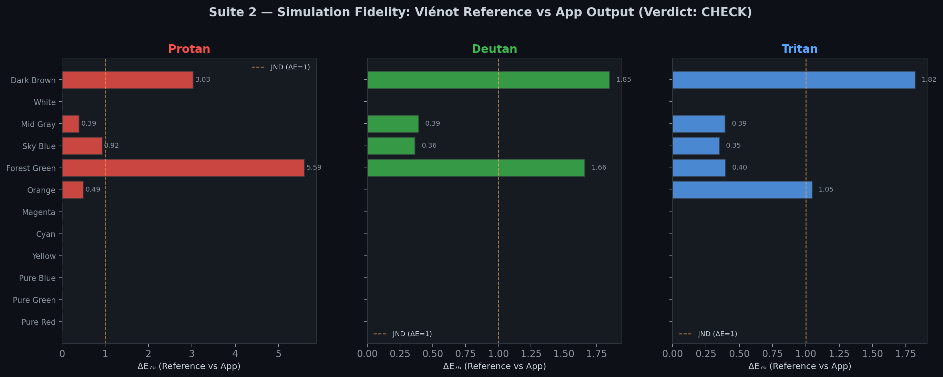
Figure 4.X — ΔE per Color per CVD Type (Viénot Reference vs App)
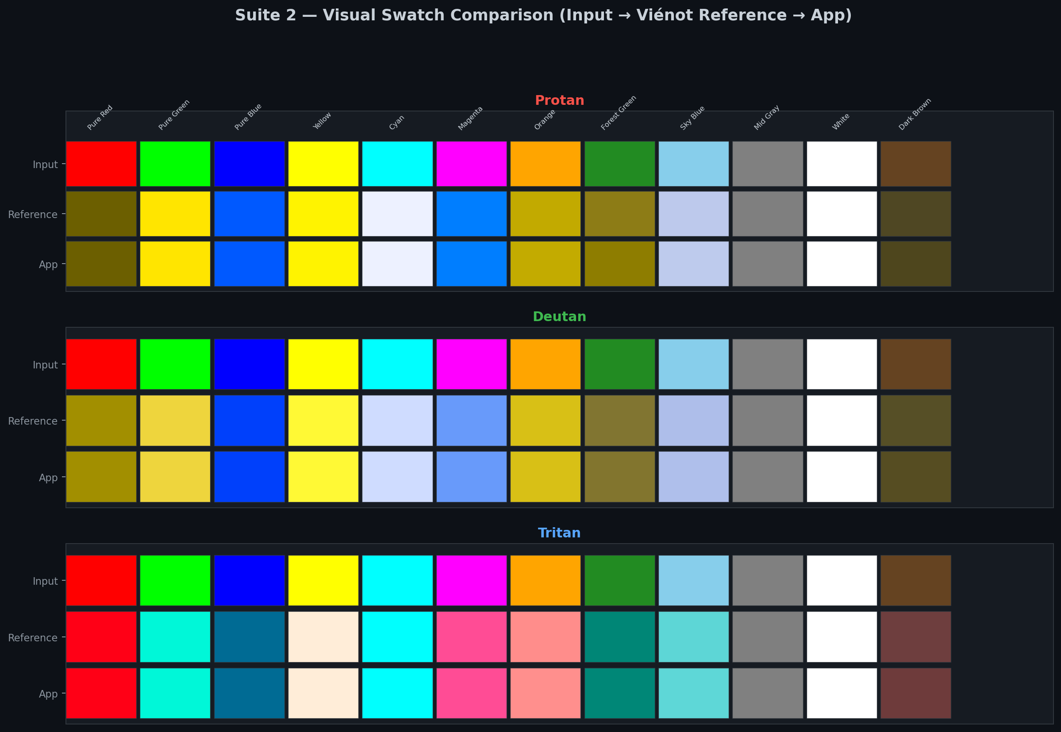
Figure 4.X — Visual Swatch Comparison (Input → Reference → App)
Pure primaries and secondaries produced exact matches (ΔE = 0) across all CVD conditions, confirming matrix-level correctness. Non-zero errors arose exclusively from the app's use of a simplified γ = 2.2 power-law linearization versus the piecewise sRGB curve used in the reference. The maximum channel error was 22 (blue channel, Forest Green under Protan), corresponding to ΔE = 5.595. For Deutan and Tritan, maximum channel errors were 4 and 3 respectively.
These deviations are attributable to the gamma approximation's divergence at low-luminance values, where the piecewise linear segment of sRGB (below 0.04045) differs most from the power law. Critically, the GPU-versus-CPU test in the preceding subsection confirmed that the shader faithfully reproduces the app's own pipeline with mean ΔE < 0.07, meaning the gamma discrepancy is a deliberate design simplification for computational efficiency, not a precision-loss artifact. The two-layer validation thus confirms: (1) the app's pipeline is mathematically faithful to Viénot matrices (pure primary ΔE = 0), and (2) the GPU shader faithfully reproduces that pipeline (mean ΔE = 0.027).

⚠️ INJECTION INSTRUCTION: REVISION REQUIRED — In the "Comparative Analysis: Daltonization vs. Hue Rotation" subsection, find the sentence that reads: "Determining true effectiveness requires measuring discrimination gain between confused colors, identified as future work." REPLACE it with the text below:
To determine true effectiveness, a discrimination gain analysis was conducted using synthetically generated confused color pairs. The methodology and results are presented in the following subsection (Ground-Truth Validation: Enhancement Discrimination Gain).

