Klasicna linearna regresija
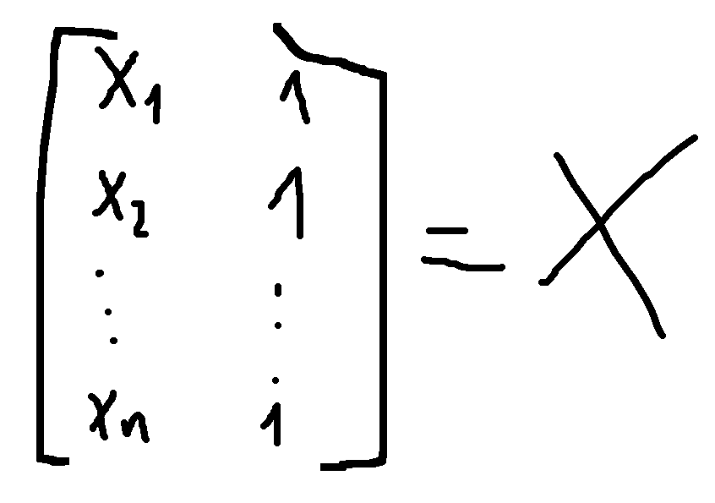
from numpy import linalg
m,c = linalg.lstsq(x,y)[0]
plt.plot(x,m*x+c) plt.plot(x,y)

from sklearn.model_selection import LinearRegression
model = LinearRegression()
model.fit(xTrain,yTrain)
y = model.predict(x)
from sklearn.metrics import mean_squared_error, mean_absolute_error,r2_score

