Project: My Available Time (MAT) Part one – Publishing of MAT by the mailing and sharing by Google+

WEB Application with possibility porting to the mobile applications

Front-end Server

Beck-end Server

* Web service for maintaining MATT (My Available Time Table)
* Web service for working with Social Networks (Google+)

1. Accounting on MAT
   1. Name
   2. Family Name
   3. Email address (MVP Assumption: MAT’s user should have account on Gmail)
   4. Password
   5. Login (MVP Assumption: Login only through Gmail account for SSO (Single Sign On) initial implementation. Otherwise the user should manipulate with several passwords and the MAT account should have several passwords that is not so acceptable)
2. Creation of new MATT
   1. Parameters:
      1. Name
      2. Number of days
      3. Start date (using calendar widget) /ending date will be added automatically
      4. Starting hour
      5. Ending hour
      6. Time slot (1 hour or half an hour)
      7. Password (if the MATT is a private)
   2. Getting available time from Google
      1. Creating MAT calendar in Google by sync all Google calendars
   3. Updating available time by demarking free time slots
      1. Updating MAT calendar in Google
3. Getting of existing MATT by name
   1. Password for private tables
4. Editing of existing MATT (all parameters except name may be edited)
5. Deleting of existing MATT
6. Sharing via Google+
   1. Creating circle
   2. Sending mail with URL of MATT into circle of contacts
   3. iFrame creation ???
7. Invitation of the booking event by Email
   1. Adding email addresses from the Gmail contacts

Questions:



MAT DB will contain MATT’s in the form of views and the time slots marked as occupied by the MAT user

MAT is formed on basis of sync with all Social Network (SN) calendars of the MAT’s user and MAT DB

Pros: Actual up to now information

Cons: Timing and authorization against all Social calendars per each request

Interface 1 – between FES and BES1

Interface 3 –between FES and BES2

* Registration

Standard registration through email

User’s profile (First name, Last name, email, password , SN name, username (unique))

* Login

Username/password of MAT account ***mat_login(String username, String password): bool***

Username/password of SN ***sn_login(String sn_name***, ***String username): bool***

* Creation of MATT

***create_matt(MattData data, String username):bool***

* Getting of MATT

***get_matt(String matt_name, String username):MattData***

* Update MATT

***update_matt(String matt_name, String username, MattData data):bool***

* Sharing MATT (interface 3)

***share_matt(SocialNetwork network, String matt_name, String username):bool***

Sharing MATT by email (interface 3)

***getContacts(String username):String[]***

***share_matt_email(String username,String urlMatt, String [] to):void***

Interface 2 – between BES1 and BES2

* Identity Service

***setIdentity(String snUsername, String matUsername, String snName):bool***

* Getting calendars

***getCalendars(String username, String [] snName, DayInterval interval): MyCalendar;***

22/09/14

1. Discussed Demo
   1. Registration/Login – Component test FES/BES1
   2. Authorization –Component test inside BES2
   3. Viewing/sharing URL – ***http://localhost:8080/myavailabletime/viewMatt?table=<MATT name>&username=<username>***
   4. Sergey Z is responsible for controller function with @RequestMapping (“/viewMatt”). This function will call getMatt with parameters: MATT name and user name and show MATT
   5. Person contains all authorized and selected Social calendars
   6. No polling for viewing updated and synchronized MATT’s
   7. Functions createMatt and getMatt are checking Social networks for the person. In the case if none social networks exists the function getSlotes is not called
   8. Function setMatCalendar implies working with Google Calendar
   9. Function setMatCalendar is called from the function saveMatt. List of actual MATT’a is passed to the function setMatCalendar

Oct. 14

1. Password should be entered with stars not as plain text (Screen Registration)
2. Screen Login (Name should be replaced with e-mail)
3. Login screen : registry should be replaced with Sign Up
4. Ending date should be got from Start day and number days computation
5. All fields should be filled – Screen Home
6. Doesn’t work in the case Calendar contains event for whole day-Resolved
7. URL is created wrongly (Blank replace with +, @ - %40)
8. Set calendar
9. Serious : Object of the class controller is created not for session but for all session one object.-resolved
10. Doesn’t work in the case Google is not authorized

New Test:

1. Font in the Login screen
2. Exit in the case of wrong login is improper

20/10/14

Intermediate demo:

1. Button for calendar creation.
2. Deployment

[ftp.definiteimage.com](http://ftp.definiteimage.com/)

user: myavailable

pw: Mat#2014

Database MySQL version 5.5

Access: <https://mysqladmin.secureserver.net/112>

User: myavailabletime

Pw: Mat#2014DB

Hostname

[myavailabletime.db.8717386.hostedresource.com](http://myavailabletime.db.8717386.hostedresource.com/)

1. New development
   1. Edit MATT
      1. Adding callback on the Edit button.

|  |  |  |  |
| --- | --- | --- | --- |
| **Public DNS** | | ec2-54-87-14-226.compute-1.amazonaws.com | |
| **User name** | | Administrator | |
| **Password** | | AobMB7a&ten | |

11/10/2014

Invitation

Invitation owner – Mat user invites other users, owner of MATT

Invitation guest

Invitation is a collabaration process with URL of the following functionality:

URL will contain email for response

1. Screen with MATT of the owner and all invited people
2. Actions depend on a role:
   1. User signed in the system
      1. Confirm
      2. Decline
      3. Update
      4. Synch
   2. User signed up but not signed in
      1. Confirm
      2. Decline
      3. Sign in
   3. User not signed up
      1. Confirm
      2. Decline
      3. Sign up
3. Home page will contain cretaed tables and tables for invitation. If the table is the invitation table then the table name will contain (Invitation)
   1. Invitation table will contain the following functionality
      1. View
      2. Update
      3. Invite (the same functionality as after URL access)
      4. Delete
4. Invited user is not signed up
   1. Sign Up (Assumption at the same time the user may have only one invitation)

Sign Up after invitation will keep on invitation MATT. Such way that during registration in the DB there will be info about the invitation MATT

20/11/14

1. Owner of MATT makes an invitation:
   1. Button on the MATT bar with two options: Option of sending mails and option of setting meeting
   2. Sending mails with invitation to log in
   3. Void setGuests(String username, String tableName, String [] guestEmails)

***class Notification {***

***public String username;***

***public String tableName;***

***};***

* 1. List<Notification> getNotifications(String guestName)
  2. Update of DB with info about invitation guests
  3. Setting meeting:
     1. Sending mail to all invited guests with time of meeting
     2. Set in Google calendar event with name of meeting (
     3. FES-BES2 interface:

Void setEvent(String eventName, int startHour, int endHour);

|  |  |  |
| --- | --- | --- |
| Zavodskikh Sergey | FES | Editting of MATT |
| Geletyuk Artem | FES | button-invitation /sharing invitation |
| Krasnov Alexander | FES | setting meeting |
| Dvoyashov Konstantin | FES | button-invitation /sharing invitation |
| Patrikeev Yegor | BES1 | Interface functions and DB |
| Kazanskay Aliaksandra | BES1 | Interface functions and DB |
| Shilko Evgeny | BES1 |  |
| Molchan Ivan | BES2 | setEvent on Google |
| Lopatin Dmitry | BES2 | setEvent on Google |

24/11/14

Defined main flows of invitatios:

1. The editting should be added
2. Owner of the invitation is the owner of the MATT
3. Guests of the invitation may update the owner’s MATT
   1. Synchronization of the free slotes is done authomatically
   2. Guest may reject the invitation and then the sync updates are note saved
4. Setting of meeting is done as marking free time of the MATT by owner

27/11/14

Flow Editting:

1. Edit Action icon
   1. Pressing – action : action_edit. It means Request mapping for action_edit. Parameters: username, table
   2. Getting MATT per parameters; JSON creation; attribute name JSON; file – savedMatt.jsp (This JSP allows the user to edit MATT with showing all data but with no data update enabling)
2. Invitation Action Icon
   1. Pressing –actioin: action_invitation. -> two optional actions:
   2. Adding guests: sending invitation to selected guests
      1. Screen of guests selection: IfesBes1 intrface function setGuests
      2. Sending mail to all selected guests (shareByMail()):

Dear <mail address>,

You are invited to participate in <MATT name> meeting

Please log in myavailabletime.com for a collaboration

* 1. Setting meeting:
     1. Action: action_setmeeting; Parameters: username, table; Returns meeting.jsp file name, attribute JSON:
     2. Meeting.jsp : action setMeeting; RequestMapping “setMeeting”. Call two functions: saveMatt (Interface IFesBes1) and setEvent(String table, String username, Matt matt) (Interface IFrontConnector)

1. Login
   1. Tab: Invitations
      1. Pressing Tab Invitations: showing all tables in which the user has been invited
         1. Function call getNotifications from interface IFesBes1
         2. Showing similar screen as for existing calendars but with no sharing, no calendar creation. Only view, colaboration,delete
      2. Colaboration: getMatt for username and createMatt for guest; synch of two MATT’s ; showing synched MATT; editing; save. Function save will receive old MATT (MATT taken from getMatt), new MATT (MATT after synch and editting)

3/12/2014

Feedback from marketing person:

**IMPORTANT:**

* Default = everything is not available
* Selected time slots = Available time
* add a radio button Select All Available

**TO CHANGE:**

1. **Syncing with other calendar | One way syncing**

Never receive information from other calendars onto MAT, always push information to other calendars

Not synching between MATs schedules

1. **Process to be change**
   1. Create a name
   2. choose intervals (15 min, 30 min, 1)
   3. select day/s of the week (visual with boxed)

M T W T S S

* 1. Select time slots of each day (grid of 00:00 - 24:00 (dropdown)
  2. Choose starting date (calendar icon)
  3. Choosing ending date (calendar icon)
     1. give an option of Repeat (dropdown 1 month to 12 months)
  4. Save

1. **Registration**
   1. On screen message once user registered:

Thank you for registering,

Please check your email to confirm

Updated flows:

* + 1. Login/Registration – the same + alert : ***Thank you for registering,***

***Please check your email to confirm***

* + 1. Creating Calendar:
       1. Menu : Options: 7 checkboxes: Mon Tue Wed Thu Fri Sat Sun

Repeat : pull down menu with periodicity either week or month.

Start Date: <standard calendar gadget >

End Date: <standard clendar gadget>

Assumed that months are counted from the start date and not from the first day of the month. Month is 4 weeks exactly.

* + - 1. FES doesn’t call createMatt function from the IFesBes1 interface
      2. saveMatt function from IFesBes1 gets null as first parameters instead of old matt
    1. Collaborations
       1. Synch with Google and marking by yellow all conflicts for available time



SaveMat flow

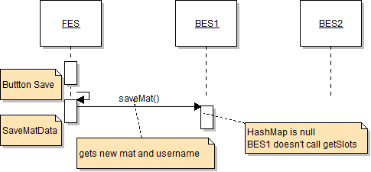

Upload Flow

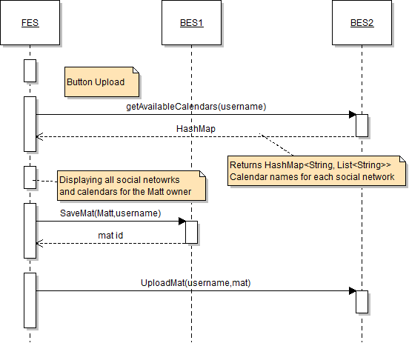

UploadMat – fistly deleting all events with the same name. Name of event from MATT will contain prefix MAT

Download Flow

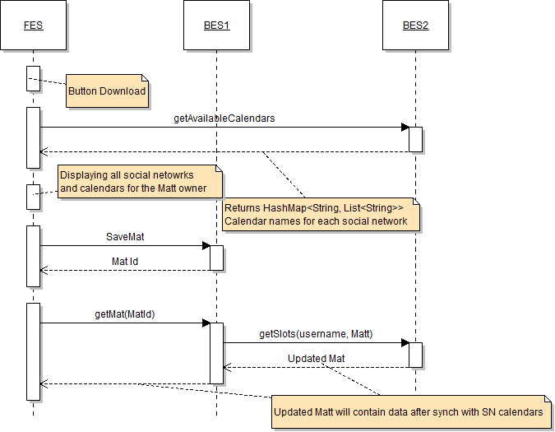

View Flow

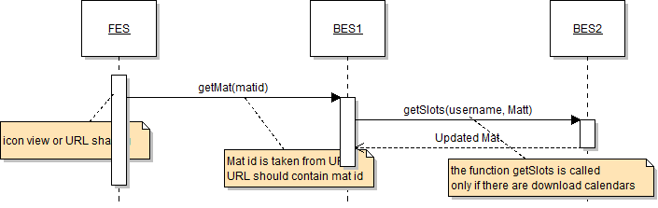

Editting Flow

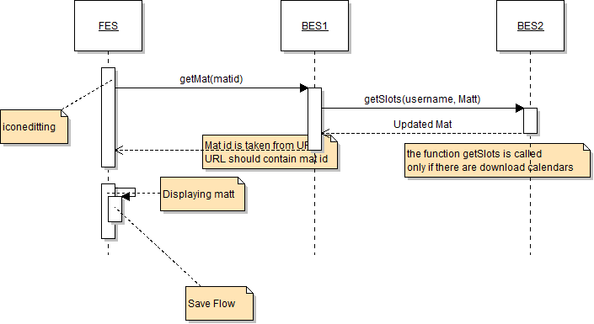

* + - * 1. Save – one button solution. Assumed DB works ok.
        2. View mat – JSP
        3. Weeks - possible
        4. Repeat – possible
        5. Issue with slot ID for big MATT’s – possible
        6. Download - ?
        7. Upload - ?
        8. Select in Range. – optional

