CLASSIFICATION PUBLIC
NTU SPACE DATA CENTER
NTU SPACE DYNAMICS
Software Module Design Report
Orbit • Attitude • Solar Environment • Power and Thermal • Access Analysis
Document ID | NTU-SD-SDD-001
Version | 1.0
Status | Design Baseline
Prepared by | NTU Space Data Center
Review state | Prepared for Technical Review
Issue date | 17 August 2026
Ningbo University / NTU Space Data Center

Document Summary
This report defines the architecture, algorithms, public interfaces, data contracts, verification approach, and deployment constraints of the NTU Space Dynamics Python module. The module provides auditable computation services for orbit propagation, high-order Earth gravity, reference-frame conversion, attitude dynamics, solar geometry, eclipse and radiation pressure, solar-array thermal power, and ground-target access analysis.
The structure and engineering-document conventions are derived from the Overall Design Report for the Group-Cooperative Autonomous Mission-Planning Computing Service Platform. The content, interfaces, model fidelity statements, and validation evidence in this report describe the current ntu-space-dynamics implementation.
Table 1 Document metadata
Item | Value
Module | ntu-space-dynamics 0.1.0
Language | Python 3.10 or later
License | MIT software license; gravity coefficients retain their source data terms
Primary audience | Software developers, simulation engineers, mission analysts, technical reviewers
Primary input contract | SI units, timezone-aware UTC, explicit reference-frame labels
Primary outputs | Orbit and attitude ephemerides, thermal-power histories, access windows, diagnostic plots

Table 2 Revision history
Version | Date | Description | Status
1.0 | 17 Aug 2026 | Initial English software module design baseline | Issued for review

Keywords: orbital dynamics, HPOP, EGM2008, SGP4, attitude, Sun geometry, thermal power, access analysis

TABLE OF CONTENTS
1 Document Overview 1
1.1 Purpose 1
1.2 Scope 1
1.3 Intended readers 1
1.4 Normative terminology 1
2 Requirements and Design Objectives 2
3 Overall Design 3
3.1 Layered architecture 3
3.2 Package decomposition 3
3.3 Shared data flow 4
4 Concise Orbital-Dynamics Background 4
4.1 State propagation and model hierarchy 4
4.2 Classical orbital elements 5
4.3 Non-spherical gravity 5
4.4 Frames, Sun geometry, and events 5
5 Detailed Functional Design 5
5.1 Common data models 5
5.2 Orbit propagation 6
5.2.1 Two-body propagator 6
5.2.2 J2 propagator 6
5.2.3 SGP4 propagator 6
5.2.4 High-precision propagator 7
5.3 High-order Earth gravity 7
5.4 Element and Cartesian-state conversion 8
5.5 Coordinate and frame transformations 8
5.6 Attitude conversion and dynamics 9
5.7 Solar environment and radiation pressure 9
5.8 Power considering panel temperature 9
5.9 Access propagation and interpolation 10
6 Public Interface Design 10
6.1 General contracts 10
6.2 Primary calling interfaces 11
6.3 Minimal end-to-end call 11
7 End-to-End Operational Workflow 11
8 Numerical Design and Performance 13
9 Verification and Validation 13
10 Deployment and Configuration 14
10.1 Runtime 14
10.2 Installation and VS Code interpreter 14
11 Limitations and Planned Evolution 14
12 Requirements Traceability Matrix 16

Appendix A — Public API Inventory 18
Appendix B — Model-Selection Guidance 19
Appendix C — References 19

Document Overview

Purpose
The purpose of this report is to provide an implementable and reviewable design baseline for the current NTU Space Dynamics software module. It explains what the module computes, how the major algorithms are composed, which frames and units are accepted, what each public interface returns, and where the present engineering models deliberately stop.

Scope
- Orbit-state and classical-element conversion, analytical and numerical orbit propagation, and TLE-based SGP4 propagation.
- Static high-order Earth gravity from bundled EGM2008 or external fully normalized ICGEM/GRACE coefficient files.
- GCRS, ITRS, and TEME state transformation, plus WGS-84 geodetic/ECEF conversion.
- Euler-angle conversion, quaternion rigid-body dynamics, Sun position and beta-angle analysis.
- Conical eclipse, solar irradiance, cannonball solar-radiation pressure, and one-node solar-panel thermal power.
- Ground-target access from direct orbit propagation or Hermite interpolation of sampled states.
- End-to-end computation and diagnostic plotting of position, velocity, beta angle, illumination, power, temperature, quaternion, and body-rate histories.

Intended readers
The report is written for spacecraft simulation developers, mission-analysis engineers, software integrators, verification personnel, and reviewers who need enough orbital-dynamics context to evaluate the design without requiring a full astrodynamics textbook treatment.

Normative terminology
Table 3 Terminology and frame conventions
Term | Meaning in this module
GCRS | Geocentric Celestial Reference System; the numerical-propagation inertial-frame contract.
ITRS / ECEF | Earth-fixed frame used for gravity synthesis and ground geometry.
TEME | True Equator, Mean Equinox frame returned by the SGP4 implementation.
Osculating elements | Instantaneous Keplerian elements derived from a Cartesian state.
Mean elements | Averaged orbital parameters represented by a TLE and interpreted by SGP4.
HPOP | Composable high-precision Cowell propagation architecture; not a single undeclared fidelity level.
Access | Time interval satisfying Earth-clear line of sight, minimum elevation, sensor FOV, and optional range.

Requirements and Design Objectives
The software was designed around explicit model semantics and auditability. A calculation result must identify its time system, units, frame, force-model selection, gravity data, and numerical tolerances. The module therefore favors a small set of composable Python interfaces over an opaque monolithic simulation service.
Table 4 Principal design objectives
ID | Objective | Design response
DO-01 | Complete requested functional coverage | Public APIs cover all requested orbit, attitude, solar, power, pressure, gravity, and access functions.
DO-02 | Safe data contracts | SI units, aware UTC datetimes, and explicit GCRS/ITRS/TEME labels are enforced at public boundaries.
DO-03 | Fidelity is selectable | Two-body, J2, SGP4, and HPOP represent distinct model semantics instead of a single hidden propagator.
DO-04 | Reproducibility | EGM2008 provenance and SHA-256 are documented; IERS, ephemeris, truncation, and tolerance settings are task inputs.
DO-05 | Offline operation | Astropy built-in ephemeris and locally available IERS tables support deterministic disconnected runs.
DO-06 | Extensibility | HPOP accepts custom force models and gravity coefficients; torque can be constant or callable.
DO-07 | Verification | Twenty-three unit tests cover invariants, reference vectors, transforms, gravity synthesis, solar geometry, thermal trends, and access events.

Design rule: A frame label is part of the numerical value. A TEME vector must never be renamed GCRS without a real transformation, and a velocity transform must include transport terms caused by Earth rotation.

Overall Design

Layered architecture
The module is organized as a layered scientific library. User applications and batch workflows call analysis services. Those services reuse common types, frame transformations, gravity synthesis, force models, integration, interpolation, and event-search utilities. External scientific libraries are isolated behind explicit frame and model contracts.
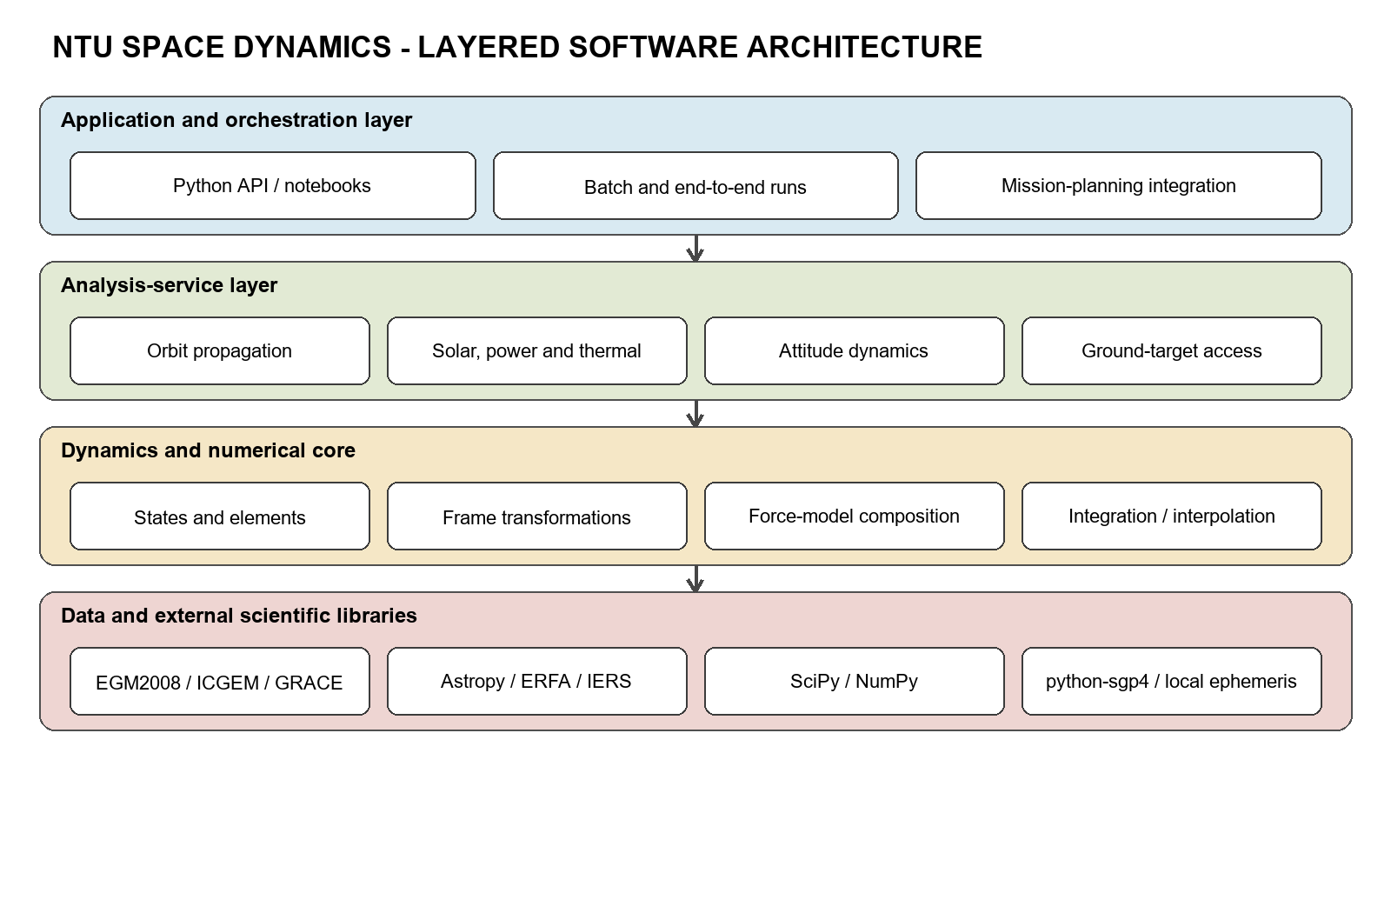
Figure 1 Layered software architecture

Package decomposition
Table 5 Package-level decomposition
Package or module | Responsibility | Principal public API
types.py | Validated immutable data contracts | OrbitState, Ephemeris, ClassicalElements, AttitudeEphemeris
orbits/ | Element conversion and propagation | oe_to_rv, rv_to_oe, TwoBodyPropagator, J2Propagator, SGP4Propagator, HighPrecisionPropagator
gravity.py | ICGEM loading, Earth orientation, spherical harmonics | GravityFieldCoefficients, EarthOrientationCache, SphericalHarmonicGravity
coordinates.py | Celestial/terrestrial transformations | eci_to_ecef, ecef_to_eci, transform_ephemeris, geodetic/ECEF conversion
attitude.py | Euler conversion and rigid-body propagation | ypr_to_euler, euler_to_dcm, EulerDynamics
solar.py | Sun, eclipse, beta angle, irradiance, SRP | sun_position_analytical, sun_position_ephemeris, eclipse_fraction, sun_intensity, sun_radiation_pressure
power.py | One-node panel thermal and electrical model | SolarPanel, power_considering_thermal
access.py | Ground target/sensor geometry and event refinement | GroundTarget, NadirSensor, access_propagation, access_interpolation

Shared data flow
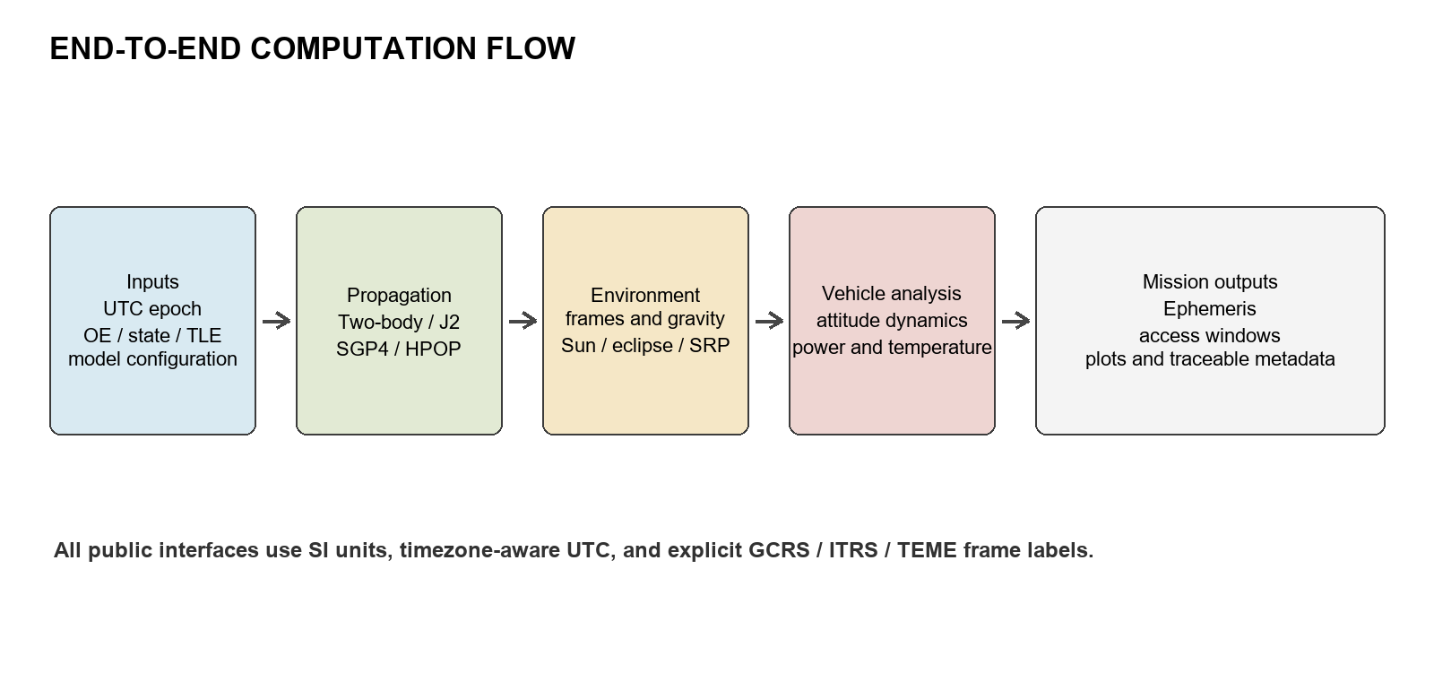
Figure 2 End-to-end computation flow
Orbit outputs are reused rather than re-derived by each subsystem. The same epoch sequence drives Sun vectors, eclipse, panel irradiance, attitude propagation, and access analysis. This alignment prevents hidden interpolation and frame mismatches between otherwise independent calculations.

Concise Orbital-Dynamics Background

State propagation and model hierarchy
An orbit is represented by position r and velocity v at an aware UTC epoch. Numerical propagation integrates the first-order state equations. The central term produces ideal Keplerian motion; each additional acceleration represents a declared perturbation.
dr/dt = v, dv/dt = −μ r / |r|³ + Σ aₚ
Two-body propagation keeps only the central term. J2 adds the dominant oblateness effect. HPOP integrates a configurable sum of high-order gravity, third-body gravity, drag, solar pressure, relativity, and custom forces. SGP4 is different: it propagates the mean elements encoded in a TLE using the SGP4 analytical theory and returns TEME states.

Classical orbital elements
For elliptic motion the six classical elements are semi-major axis a, eccentricity e, inclination i, right ascension of the ascending node Ω, argument of periapsis ω, and true anomaly ν. They provide a compact geometric description, but Ω and ω become singular for equatorial and circular orbits. The implementation uses deterministic conventions so that OE→RV→OE→RV reconstructs the original state.

Non-spherical gravity
Earth's mass distribution is represented by normalized spherical-harmonic coefficients C̄nm and S̄nm. J2 is the dominant degree-two zonal contribution. Higher degrees and orders represent progressively finer latitude/longitude structure. Gravity synthesis is performed in ITRS; the acceleration is then rotated back to GCRS for integration.
U(r, φ, λ) = μ/r · Σₙ (R/r)ⁿ Σₘ P̄ₙₘ(sin φ)[C̄ₙₘ cos(mλ)+S̄ₙₘ sin(mλ)]
The packaged EGM2008 subset is fully normalized and tide-free through degree/order 120. The HPOP default truncation is 70×70. Increasing degree improves spatial detail but increases computation cost approximately with the number of retained coefficients.

Frames, Sun geometry, and events
GCRS is used for numerical orbit states, ITRS for Earth-fixed gravity and targets, and TEME for raw SGP4 results. Sun beta angle is the signed elevation of the Sun direction above the orbital plane.
β = asin(ĥ · ŝ), ĥ = (r × v)/|r × v|
Eclipse fraction is the visible fraction of the apparent solar disc after Earth occultation. Access is an event problem: a window is open only while the target elevation, sensor off-boresight, optional range, and Earth-clear line-of-sight margins are simultaneously non-negative. Sampled sign changes are refined with a scalar root solver.

Detailed Functional Design

Common data models
Table 6 Core data objects
Object | Stored data | Invariant or behavior
OrbitState | epoch, position_m[3], velocity_m_s[3], frame | Aware UTC; SI; frame is GCRS, ITRS, or TEME.
Ephemeris | times[N], positions_m[N,3], velocities_m_s[N,3], frame | Aligned lengths; monotonic time; state(i) reconstruction.
ClassicalElements | a, e, i, Ω, ω, ν, optional epoch | Elliptic osculating elements; radians and metres.
AttitudeEphemeris | times_s, quaternion xyzw, body rates | Body-to-inertial active quaternion; rates in body frame.
ThermalPowerResult | temperature, electrical power, incident power | Arrays aligned to input elapsed times.
AccessWindow | start, end | Positive duration property.
AccessResult | windows plus sampled margins and geometry | Provides traceable event-search diagnostics.

Orbit propagation
Table 7 Propagator selection and model semantics
Propagator | Model | Frame | Primary use
TwoBodyPropagator | Exact elliptic Kepler solution from the initial osculating state | GCRS | Baseline, initialization, unit tests, short arcs
J2Propagator | Central gravity + J2, integrated by DOP853 | GCRS | Dominant node/perigee drift and a light numerical baseline
SGP4Propagator | Vallado SGP4/SDP4 applied to TLE mean elements | TEME | Catalog/TLE propagation and operational screening
HighPrecisionPropagator | Cowell integration with composable force stack | GCRS | Engineering high-fidelity prediction and sensitivity studies

Two-body propagator
TwoBodyPropagator converts the initial Cartesian state to elliptic elements, advances the mean anomaly with the Keplerian mean motion, solves Kepler's equation, and converts the result back to Cartesian position and velocity. It is analytical and does not accumulate numerical integration error over a single ideal orbit, but it deliberately omits all perturbations.

J2 propagator
J2Propagator composes central gravity and the standard J2 acceleration and integrates the six-state Cartesian equations with SciPy DOP853. Users configure relative tolerance, position and velocity absolute tolerances, and maximum integration step. It excludes atmosphere, third bodies, SRP, and higher harmonics.

SGP4 propagator
SGP4Propagator accepts two TLE lines, validates the epoch and satellite record through python-sgp4, and returns SI-unit TEME states. TLE age and element quality normally dominate the prediction error. The interface therefore keeps TEME explicit and requires transform_ephemeris for GCRS or ITRS use.

High-precision propagator
HighPrecisionPropagator uses adaptive DOP853 Cowell integration. The default force stack is central gravity plus EGM2008 70×70, Sun/Moon third-body gravity, and Schwarzschild correction. When area-to-mass is positive, the stack also enables segmented exponential-atmosphere drag and cannonball SRP. The Sun and Moon ephemerides are shared across forces using sampled interpolation. Additional objects implementing acceleration(elapsed_s, state, epoch) can be appended through extra_forces.
Table 8 HPOP configuration
Parameter | Default | Design meaning
gravity_degree / order | 70 / same as degree | Static harmonic truncation; None selects the J2 baseline path.
area_to_mass_m2_kg | 0.0 | Enables drag and SRP when positive.
drag_coefficient | 2.2 | Cannonball aerodynamic coefficient.
reflectivity_coefficient | 1.3 | Cannonball SRP coefficient.
include_third_body | True | Sun and Moon point-mass differential gravity.
include_relativity | True | Schwarzschild correction used by the engineering stack.
relative_tolerance | 1e-11 | DOP853 relative error control.
position / velocity tolerance | 1 mm / 1 μm·s⁻¹ | Component-wise absolute error scaling.
max_step_s | 120 s | Upper bound on adaptive integration step.

High-order Earth gravity
GravityFieldCoefficients stores fully normalized static cosine/sine coefficient matrices, model GM, reference radius, tide system, and provenance. from_icgem reads static gfc records and supports explicit degree/order truncation. load_builtin_egm2008 verifies and loads the packaged 0–120 subset.
SphericalHarmonicGravity computes the non-central potential and acceleration in the fixed frame. It intentionally excludes the degree-zero central term because HPOP adds central gravity separately using the model's GM. EarthOrientationCache precomputes GCRS→ITRS rotations and interpolates them with SLERP; the default node interval is 300 s.
Table 9 Bundled EGM2008 data contract
Attribute | Value
Packaged coverage | Degree and order 0–120
HPOP default | 70×70
Normalization | Fully normalized
Tide system | Tide-free
Model GM | 3.986004415 × 10¹⁴ m³/s²
Reference radius | 6,378,136.3 m
Subset SHA-256 | 6ae505fcd7acfed84c5f69ff3e729be9cbb450162fd6bcf9116584c5b00570f2
External static models | ICGEM gfc records; GRACE monthly/static files after epoch reduction if required

Model limitation: The loader does not directly evaluate time-variable gfct, trnd, asin, or acos records. A GRACE monthly solution or other time-variable field must first be reduced to static coefficients for the task epoch.

Element and Cartesian-state conversion
oe_to_rv converts elliptic osculating classical elements to an inertial Cartesian state. rv_to_oe performs the inverse conversion and applies fixed conventions in singular cases: argument of periapsis is zero for circular inclined orbits; RAAN is zero for equatorial eccentric orbits; both are zero for circular equatorial orbits. The returned anomaly then represents argument of latitude or true longitude as appropriate.

Coordinate and frame transformations
eci_to_ecef converts a GCRS OrbitState to ITRS; ecef_to_eci performs the inverse. Both transport velocity, including the rotational contribution. transform_ephemeris extends the same contract to sampled GCRS, ITRS, or TEME ephemerides through Astropy/ERFA. WGS-84 geodetic_to_ecef and ecef_to_geodetic support target definition and ground geometry.
Operational data: Astropy transformations depend on UT1−UTC, polar motion, and leap seconds. Production runs should archive the controlled IERS Bulletin A/B table used for the calculation.

Attitude conversion and dynamics
ypr_to_euler interprets yaw-pitch-roll as aerospace intrinsic Z-Y-X rotation and converts it to a requested Euler sequence. Upper-case sequences are intrinsic and lower-case sequences are extrinsic, matching SciPy Rotation. euler_to_dcm returns the active direction-cosine matrix.
EulerDynamics integrates the body-to-inertial quaternion in SciPy xyzw order and the rigid-body Euler equation. Inertia may be supplied as principal moments or a matrix. Torque is expressed in the body frame and may be constant or a callable of time, quaternion, and body rate.
q̇ = 1/2 · q ⊗ [ωx, ωy, ωz, 0], Iω̇ = τ − ω × (Iω)

Solar environment and radiation pressure
Table 10 Solar functions
Function | Method | Output
sun_position_analytical | Low-order geocentric analytical Sun model; native MOD, optional GCRS conversion | Earth-to-Sun vector [m]
sun_position_ephemeris | Astropy built-in ephemeris or controlled local JPL kernel | GCRS-aligned Earth-to-Sun vector [m]
sun_beta_angle | Signed Sun elevation above the instantaneous orbit plane | rad or deg
eclipse_fraction | Apparent-disc overlap with conical umbra/penumbra geometry | Visible solar-disc fraction 0–1
sun_intensity | Solar constant scaled by actual Sun distance and optional eclipse fraction | Direct irradiance [W/m²]
sun_radiation_pressure | Cannonball SRP, directed away from the Sun, optionally eclipsed | Acceleration [m/s²]

The analytical and ephemeris Sun functions are separate because they serve different traceability and fidelity needs. The analytical model is small and deterministic. The ephemeris path can use Astropy's offline built-in solution or a task-controlled JPL binary kernel when jplephem is installed.

Power considering panel temperature
SolarPanel contains area, reference conversion efficiency, temperature coefficient, absorptivity, emissivity, radiating area, heat capacity, and deep-space sink temperature. power_considering_thermal integrates a one-node lumped thermal balance. Incidence cosine is clipped to [0,1]; irradiance is expected to include eclipse before entering the model.
Pincident = A · I · max(0, cos θ)
Pelectric = ηref[1 + kT(T − Tref)] · Pincident
C dT/dt = αPincident − Pelectric − εσArad(T⁴ − Tspace⁴)
The panel is isothermal. Absorbed solar energy raises the node temperature after exported electrical power is removed; radiation to deep space cools the panel. Structural conduction, Earth infrared, albedo, battery behavior, and MPPT dynamics are outside the current model.

Access propagation and interpolation
GroundTarget defines a fixed WGS-84 latitude, longitude, altitude, and name. NadirSensor defines a fixed VVLH boresight through pitch and roll, a half-cone field of view, minimum target elevation, and optional maximum range. Access is the intersection of the target local-horizon margin, sensor off-boresight margin, range margin, and Earth-clear geometry.
access_propagation first samples any compatible orbit propagator and then searches for events. access_interpolation receives an existing GCRS Ephemeris and uses cubic Hermite interpolation with the stored velocity derivatives. Both scan at scan_step_s and refine each sign-changing boundary with Brent's method to boundary_tolerance_s.
Table 11 Access outputs
Output | Description
windows | Tuple of AccessWindow(start, end) objects with duration_s.
sample_times | Times used by the event scan.
combined_margin_rad | Minimum of all active geometric margins; positive means accessible.
elevation_rad | Target elevation in the local topocentric frame.
off_boresight_rad | Angle between sensor boresight and target line of sight.
slant_range_m | Spacecraft-to-target distance.

Public Interface Design

General contracts
- Lengths are metres, velocities are metres per second, elapsed times are seconds, torque is N·m, temperature is kelvin, and power is watts.
- Angles are radians unless degrees=True or a from_degrees constructor is explicitly used.
- datetime values must be timezone-aware; UTC is the operational convention.
- Numerical propagation initial states must be GCRS; SGP4 outputs TEME; Earth-fixed calculations use ITRS.
- Functions validate dimensions, finite values, monotonic time arrays, physical parameter ranges, and compatible frames.

Primary calling interfaces
Table 12 Interface families
Family | Primary call | Input | Output
Orbit | propagator.propagate(initial, times) / propagate_grid(...) | OrbitState + epochs | Ephemeris
Elements | oe_to_rv(elements); rv_to_oe(r,v) | ClassicalElements or Cartesian state | Cartesian state or elements
Gravity | from_icgem(...); acceleration_fixed(r) | Coefficient file + ITRS position | Coefficients / acceleration
Frames | eci_to_ecef(state); transform_ephemeris(eph, target) | State or ephemeris | Transformed state/ephemeris
Attitude | EulerDynamics(...).propagate(q0, ω0, times) | Inertia, torque, initial attitude | AttitudeEphemeris
Solar | Sun/beta/eclipse/intensity/SRP functions | Epoch, orbit state, area/mass | Vectors, angles, fractions, acceleration
Power | power_considering_thermal(times,I,cosθ,panel) | Time histories + SolarPanel | ThermalPowerResult
Access | access_propagation(...) / access_interpolation(...) | Orbit, target, sensor, event settings | AccessResult

Minimal end-to-end call
from datetime import datetime, timedelta, timezone
from ntu_space_dynamics import (
ClassicalElements, HighPrecisionPropagator, OrbitState,
SolarPanel, oe_to_rv, sun_position_ephemeris,
eclipse_fraction, sun_intensity, power_considering_thermal,
)
epoch = datetime(2026, 1, 1, tzinfo=timezone.utc)
oe = ClassicalElements.from_degrees(
7_000_000.0, 0.001, 97.5, 20.0, 0.0, 0.0, epoch
)
r0, v0 = oe_to_rv(oe)
initial = OrbitState(epoch, r0, v0, "GCRS")
eph = HighPrecisionPropagator(gravity_degree=70).propagate_grid(
initial, epoch + timedelta(hours=3), step_s=60.0
)

The full example in examples/end_to_end.py adds Sun geometry, illumination, thermal power, rigid-body attitude, interpolated access, summary statistics, and multi-format plots.

End-to-End Operational Workflow
- Create an aware UTC epoch and define the initial Cartesian state, classical elements, or TLE record.
- Select the propagation semantics: two-body, J2, SGP4, or a declared HPOP force stack.
- Generate one aligned ephemeris and transform frames only through the public coordinate interfaces.
- Evaluate Sun vectors, beta angle, eclipse fraction, irradiance, SRP, thermal power, and attitude at the same epochs.
- Evaluate access from the generated ephemeris, refining each open/close event boundary.
- Export numerical results, model metadata, and diagnostic plots for engineering review.
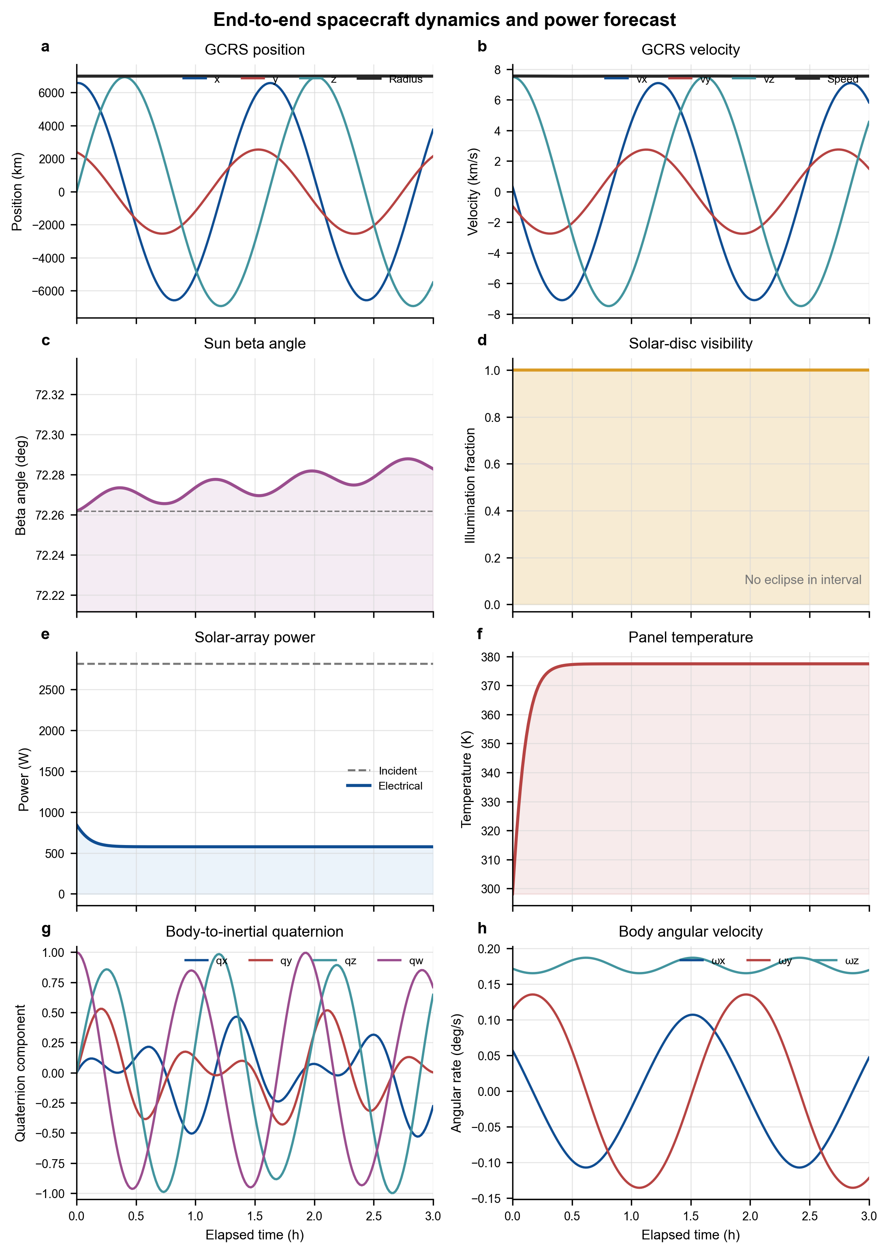
Figure 3 End-to-end propagation, solar, thermal-power, and attitude histories
The diagnostic figure is an engineering sanity-check surface rather than a formal orbit-determination validation product. It makes state discontinuities, eclipse transitions, unexpected power saturation, thermal divergence, quaternion normalization problems, and body-rate instability visible in one view.

Numerical Design and Performance
Table 13 Numerical methods and controls
Area | Method | Primary controls
Two-body | Analytical elliptic Kepler solution | Epoch grid and gravitational parameter
J2/HPOP | SciPy solve_ivp DOP853 | rtol, position/velocity atol, max_step_s
Attitude/thermal | Adaptive non-stiff integration | Input sampling and tolerance configuration
Earth orientation | Astropy/ERFA rotation nodes + SLERP | IERS data and sample_step_s
Sun/Moon | Shared sampled ephemeris interpolation | Ephemeris source and sampling interval
Access state | Cubic Hermite interpolation | Orbit sample spacing and velocity quality
Access events | Fixed scan + Brent root refinement | scan_step_s and boundary_tolerance_s
Gravity | Normalized harmonic summation | Coefficient source, degree, order, tide system

High-order gravity is the main controllable cost in typical HPOP runs. Raising the degree/order increases both coefficient count and recurrence work. The recommended practice is to demonstrate convergence for the mission altitude and forecast duration, then select the lowest truncation that meets the error budget. Access scan_step_s must be smaller than the shortest window that must be detected.

Verification and Validation
The current baseline passes 23 unit tests under Python's unittest runner. Tests use analytical invariants, round trips, Vallado reference vectors, published gravity metadata, finite-difference checks, model degeneration, and event-boundary refinement. This is implementation verification; mission-specific validation still requires comparison with authoritative ephemerides, tracking data, or a trusted tool.
Table 14 Automated verification summary
Test group | Count | Representative evidence
Elements and propagators | 7 | OE/RV round trips including singular cases; two-body period closure; J2 energy; HPOP/J2 equivalence; Vallado SGP4 vector
Gravity | 8 | EGM metadata and zonals; C̄20→J2 reduction; finite-difference potential gradient; high-degree effect; ICGEM truncation; HPOP arc
Coordinates and solar | 4 | GCRS/ITRS position-velocity round trip; analytical/ephemeris Sun direction; eclipse; beta and SRP direction
Attitude, power, access | 4 | YPR rotation equivalence; torque-free invariants; thermal trend; refined access boundaries

Executed baseline: 23 tests passed on 17 August 2026. The end-to-end example also generated PNG, PDF, SVG, and TIFF diagnostic figures.

Deployment and Configuration

Runtime
- Python 3.10 or later.
- Required: NumPy ≥1.24, SciPy ≥1.10, Astropy ≥5.3, Matplotlib ≥3.7, python-sgp4 ≥2.23.
- Optional: jplephem ≥2.18 for a controlled local JPL binary ephemeris kernel.
- Packaged data: EGM2008 tide-free static coefficients through degree/order 120 and SHA-256 sidecar.

Installation and VS Code interpreter
cd E:\MyProject\NTU_Space_Data_Center
python -m venv .venv
.\.venv\Scripts\python.exe -m pip install -e .
.\.venv\Scripts\python.exe -m unittest discover -s tests -v

In Visual Studio Code select Python: Select Interpreter and choose E:\MyProject\NTU_Space_Data_Center\.venv\Scripts\python.exe. Production deployments should archive the exact coefficient file, IERS table, local ephemeris kernel if used, package versions, and model configuration alongside each result.

Limitations and Planned Evolution
Table 15 Present limitations and recommended extensions
Subsystem | Current boundary | Recommended extension
Gravity | Static fully normalized field; no tides or in-run time-variable coefficients | Solid/ocean/pole tides; task-epoch GRACE evaluation; EOP/data version manager
Atmosphere | Segmented exponential density; no space weather response | NRLMSISE-00/JB2008 with archived F10.7, F10.7a, and Ap/Kp
SRP | Cannonball area/mass and single reflectivity coefficient | Faceted geometry, self-shadowing, Earth albedo and IR
Ephemerides | Astropy built-in by default | Controlled DE440/DE441 or SPICE kernel bundle
Thermal/power | One isothermal panel node; no conduction or electrical storage/control | Multi-node thermal network, Earth IR/albedo, battery, EPS, MPPT
Attitude | Rigid body with external torque; no actuator/sensor models | Reaction wheels, magnetorquers, disturbances, guidance and control loops
Access | Fixed target and fixed VVLH sensor; no terrain/refraction/cloud/maneuver time | Terrain horizon, atmosphere, keep-out constraints, slew and payload modes
Validation | Unit tests and engineering sanity plots | Cross-tool campaigns and mission-tracking residual analysis

Requirements Traceability Matrix
The matrix maps every requested capability to its implemented interface, computational model, primary output, and verification status.
Table 16 Functional requirements response
ID | Requested capability | Implemented interface | Design model | Primary output | Status
F-01 | Twobody | TwoBodyPropagator | Elliptic Kepler analytical propagation | GCRS Ephemeris | Implemented / tested
F-02 | J2 | J2Propagator | Central gravity + J2, DOP853 | GCRS Ephemeris | Implemented / tested
F-03 | SGP4 | SGP4Propagator | Vallado SGP4/SDP4, TLE mean elements | TEME Ephemeris | Implemented / Vallado vector tested
F-04 | HPOP | HighPrecisionPropagator | Cowell + declared perturbation stack | GCRS Ephemeris | Implemented / baseline tested
F-05 | High-order gravity | GravityFieldCoefficients; SphericalHarmonicGravity | EGM2008 70×70 default, packaged to 120; external static ICGEM/GRACE | Potential / acceleration / HPOP | Implemented / 8 gravity tests
F-06 | OE2RV | oe_to_rv | Elliptic osculating elements to Cartesian state | r [m], v [m/s] | Implemented / round-trip tested
F-07 | RV2OE | rv_to_oe | Cartesian state to elements with singular conventions | ClassicalElements | Implemented / singular cases tested
F-08 | ECI2ECEF | eci_to_ecef; ecef_to_eci; transform_ephemeris | GCRS↔ITRS and TEME transforms with velocity | OrbitState / Ephemeris | Implemented / round-trip tested
F-09 | YPR2EULER | ypr_to_euler; euler_to_dcm | Intrinsic Z-Y-X YPR and arbitrary Euler sequence | Euler angles / DCM | Implemented / rotation tested
F-10 | EULERDYNAMICS | EulerDynamics | Quaternion kinematics + rigid-body Euler equation | AttitudeEphemeris | Implemented / invariants tested
F-11 | SUN POSITION Analytical | sun_position_analytical | Low-order MOD model with optional GCRS conversion | Sun vector [m] | Implemented / direction tested
F-12 | SUN POSITION ephemeris | sun_position_ephemeris | Astropy built-in or local JPL kernel | Sun vector [m] | Implemented / direction tested
F-13 | SUN BETA ANGLE | sun_beta_angle | Signed Sun elevation above orbit plane | Angle | Implemented / sign tested
F-14 | SUN INTENSITY | eclipse_fraction; sun_intensity | Conical eclipse and Sun-distance correction | 0–1 fraction; W/m² | Implemented / eclipse tested
F-15 | Power considering thermal | SolarPanel; power_considering_thermal | One-node energy balance and temperature-dependent efficiency | ThermalPowerResult | Implemented / thermal trend tested
F-16 | Sun radiation pressure | sun_radiation_pressure | Eclipsed cannonball SRP | Acceleration [m/s²] | Implemented / direction tested
F-17 | ACCESS PROPAGATION | access_propagation | Propagate then scan/refine target/sensor geometry | AccessResult | Implemented / event tested
F-18 | ACCESS INTERPOLATION | access_interpolation | Cubic Hermite state interpolation + Brent refinement | AccessResult | Implemented / boundary tested
F-19 | End-to-end diagnostics | examples/end_to_end.py | Aligned orbit, solar, power, thermal, attitude, access and plots | Statistics + PNG/PDF/SVG/TIFF | Implemented / executed

Appendix A — Public API Inventory
Table A-1 Exported names in ntu_space_dynamics.__all__
Public name | Kind | Contract summary
AccessResult | Type | Access windows and sampled geometry/margins.
AccessWindow | Type | Start/end UTC and derived duration.
AttitudeEphemeris | Type | Quaternion and body-rate time history.
ClassicalElements | Type | Elliptic osculating elements.
Ephemeris | Type | Sampled orbit positions and velocities.
EulerDynamics | Class | Rigid-body attitude propagation.
EarthOrientationCache | Class | Cached GCRS→ITRS rotations with SLERP.
GroundTarget | Type | Fixed WGS-84 ground point.
GravityFieldCoefficients | Type | Static fully normalized harmonic coefficients.
HighPrecisionPropagator | Class | Composable Cowell HPOP.
J2Propagator | Class | Central + J2 numerical propagation.
NadirSensor | Type | Fixed VVLH sensor and access constraints.
OrbitState | Type | Single-epoch SI Cartesian state.
SGP4Propagator | Class | TLE propagation to TEME.
SolarPanel | Type | Thermal/electrical panel parameters.
SphericalHarmonicGravity | Class | Static non-central gravity synthesis.
ThermalPowerResult | Type | Temperature and power histories.
TwoBodyPropagator | Class | Exact elliptic Kepler propagation.
access_interpolation | Function | Access from a sampled GCRS ephemeris.
access_propagation | Function | Propagate then compute access.
ecef_to_eci | Function | ITRS/ECEF to GCRS state.
ecef_to_geodetic | Function | WGS-84 ECEF to latitude/longitude/altitude.
eci_to_ecef | Function | GCRS to ITRS/ECEF state.
eclipse_fraction | Function | Visible solar-disc fraction.
euler_to_dcm | Function | Euler angles to active DCM.
geodetic_to_ecef | Function | WGS-84 latitude/longitude/altitude to ECEF.
load_builtin_egm2008 | Function | Load packaged EGM2008 to degree 120.
oe_to_rv | Function | Elements to Cartesian state.
power_considering_thermal | Function | Panel temperature and electrical power.
rv_to_oe | Function | Cartesian state to classical elements.
sun_beta_angle | Function | Signed Sun/orbit-plane angle.
sun_intensity | Function | Direct irradiance with optional eclipse.
sun_position_analytical | Function | Analytical Sun vector.
sun_position_ephemeris | Function | Ephemeris Sun vector.
sun_radiation_pressure | Function | Cannonball SRP acceleration.
transform_ephemeris | Function | GCRS/ITRS/TEME sampled state transform.
ypr_to_euler | Function | Aerospace YPR to arbitrary Euler sequence.

Appendix B — Model-Selection Guidance
Table B-1 Recommended model selection
Question | Recommended starting point
Need a clean algorithm baseline or short initialization? | TwoBodyPropagator.
Need the dominant oblateness drift with a small force stack? | J2Propagator.
Starting from a TLE or catalog product? | SGP4Propagator; keep TEME explicit.
Need perturbation composition and high-order gravity? | HighPrecisionPropagator with declared coefficients, tolerances, and environmental inputs.
Need fast repeated access on an existing orbit? | access_interpolation with sufficiently dense samples.
Need access while selecting or comparing propagators? | access_propagation.
Need deterministic offline Sun calculations? | Astropy built-in ephemeris or the analytical model, depending on the error budget.
Need higher solar-system accuracy? | Local controlled JPL kernel with jplephem.

Appendix C — References
Pavlis, N. K. et al. (2012). The development and evaluation of the Earth Gravitational Model 2008 (EGM2008). Journal of Geophysical Research, 117, B04406.
Vallado, D. A. et al. (2006). Revisiting Spacetrack Report #3. AIAA/AAS Astrodynamics Specialist Conference.
IERS Conventions (2010), IERS Technical Note 36.
Montenbruck, O. and Gill, E. (2000). Satellite Orbits: Models, Methods and Applications.
Astropy, ERFA, SciPy, NumPy, Matplotlib, and python-sgp4 project documentation.
NTU Space Dynamics source documentation: README.md, docs/model-fidelity.md, docs/open-source-evaluation.md, and data/gravity/README.md.

